1.Introduction

In this study, synchronous reluctance machine (SynRM) design is detailed. General structure of SynRM is given firstly. Reluctance concept will be detailed. Working principle of this machine is detailed as well.

SynRM was developed in 1930s firstly. However, it suffers from high torque ripple, low power factor and poor high speed performance. After dramatical increase in magnet prices and development in power electronics devices, researchers pay attention to SynRM design again due to the benefits as follows:

* High efficiency (due to absence of field)
* Low cost (due to absence of PMs)
* High torque ratio

In this study, overall design will be presented and Finite Element Analysis will be performed. Syr-e which is optimization tool for SynRM will be used by the author. Syr-e uses FEMM and MATLAB/OCTAVE paralelly. By using GUI in MATLAB, design parameters can be determined and optimized by using FEMM numerically. Beside this, any design with defined parameters can be drawn and simulated by using this program.

2.Design process

2.1. Design Parameters

In this study, 22 kW and 1500 rpm machine with 2 pole pairs will be designed. It is driven by 50 Hz. By calculating, output torque of the desired machine is 140 N.m. In this design, all parameters are determined step by step in following parts. Rated voltage of the machine is 400 Volt line to line.

2.2. Machine Constant

In order to calculate machine constant, approximate electrical loading and magnetic loading should be chosen. Electrical loading is chosen as 40 kA/m and magnetic loading is chosen as 0.8 Tesla. Then machine constant can be calculated as follows

,where fill factor of the winding is taken 0.96. This value is compared the table given in lecture notes and it is sensible.

2.3. Determining air gap clearance, rotor diameter and stack length

In order to determine air gap clearance, the formula given in lecture notes will be used and it is calculated as follows:

This value is actually generally used value for synchronous machines. It can be manufactured and it increases saliency ratio (Ld/Lq) of the machine and correspondingly increase torque constant of the machine.

After that, in order to calculate rotor diameter, let’s alculate sheer stress of the machine as follows:

Then, desired torque for the machine is 140 N.m and it is calculated as follows:

In this case, l is chosen as 160 mm and corresponding rotor diameter is calculated as 156 mm. Then, shaft radius is chosen as 20 mm.

2.4. Determining of Winding Parameters

Before determining slot number in the machine, slot per phase per pole (q) should be determined. Then total slot number can be calculated easily. If q is taken 1, winding factor is higher. However, in order to decrease effects of harmonics, q should be taken higher. For this case, q is taken 4 due to the geometric constraints.

In order to define turn number in each slot, back emf formula is used. Flux per pole can be determined by using magnetic loading determined above and pole area calculated by using rotor diameter and stack length of the machine. Flux per pole can be calculated as follows:

Then frequency of the machine is 50 Hertz and winding factor is taken 0.96. So, by using back emf equation, turn per phase can be calculated as follows:

There are 16 slots for each phase and for each slot is taken 9 (68/8=8.5). For 50 Hz machine, skin depth is not a concern so we can choose AWG18 wit a 1 mm diameter.

2.5. Slot teeth ratio and Back core thickness

In this machine, rectangular teeth is used. Slot teeth ratio is chosen as 0.5 in order to avoid saturation in tooth. Then thickness of tooth is 5 mm and slot opening width is 5 mm. In order to find slot height, turn number which is calculated above is used and wire diameter is considered. Firstly total wire area in the slot is calculated and by considering fill factor, slot area is considered and slot height is considered where fill factor is taken 0.5 and double layer

If the height of the slot is parametrized as h, slot area can be calculated as follows:

By solving it, slot height is calculated as 17.98 mm. In order to calculate back iron thickness, yoke flux density is taken as 1.5 Tesla and it is calculated as follows:

Then, outer diameter of the machine is (156+0.5*2+17.98*2+32.7*2=258.36mm).

2.6. Material Selection and Rotor Barrier Shapes

In his machine type, permanent magnet is not used generally. In this study, it is not used as well. Permanent magnet is used in order to increase power factor of the machine. Pure steel material and copper for windings are used in this machine. Steel is chosen form Syre library and it is M530-65A-OK whose B-H curve is given in Figure 1. On the other hand, copper is used for coils.

Another critical parameter is flux barrier number in the rotor. Flux barrier is the air barriers in the rotor. It decreases Lq and increases difference between Ld and Lq. So, saliency of the machine increases and torque output of the machine increases. First critical parameter is chosen of iron and air portions in the q axis of the machine. Another critical parameter is the number of air barriers in q axis and their positions. Their positions have strong influence on torque ripple of the machine. Also, air distribution over the air barriers are another critical parameter.

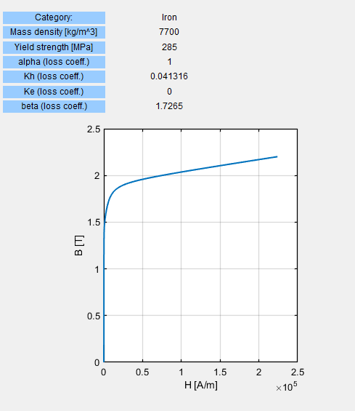

Figure : Properties of chosen steel material

Some parameters of the SynRM machine is defined in Figure 2 and shown. In any flux path, iron width should be stay constant due to saturation conditions. Given alpha degrees determine position of air barriers. By arranging Beta, alpha is changed and torque ripple can be optimized. However, in this study, general design of the machine will be presented.

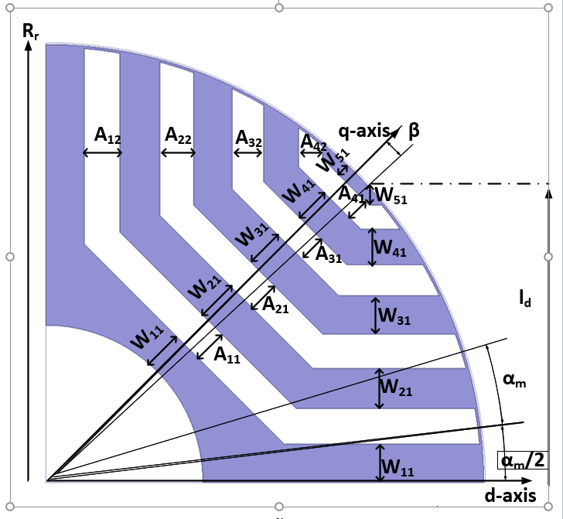

Figure 2: Rotor parameters of SynRM

In this case, 4 flux barriers is chosen. It is common barrier numbers. Generally, it is chosen as 4 or 5. This machine is smaller comparatively and 5 air barrier is not chosen.

2.7. Electrical Parameters

Electrical circuit parameters of the machine is calculated in this case. Induced voltage, flux per pole and phase resistance of the machine will be calculated However, phase inductance of the machine can not be calculated easily by the author and it is not given. It will be examined numerically.

Induced voltage and flux per pole of the machine is calculated as follows:

In order to find resistance of the machine, psychical parameters of the machine should be calculated such as length and cross area. Length of the wire is N*l and it is equal to 10.88 m and its cross section area is 0.785 mm^2. Resistivity of the copper is 1.72*10^-8 ohm.meter. Then resistance can be calculated as follows:

3. FEA Results

In this section, FEA results of the designed machine will be given. For this purpose , Syre tool is used. Syre is a GUI which is in MATLAB and used FEMM. It takes parameters as an input and draw the machine. According to the desire of the user, it is optimized the machine or it simulates the desired machine in FEMM. For this study, just one machine is simulated. Optimization part optimizes torque ripple of the machine. For this study, it is not aimed. In this section, field drawings of the machine will be given such as magnetic field density in the air gap and flux desities on the rotor and stator. On the orher hand, inductance and d and q axis flux linkages will be given. Furthermore, torque output of the machine and power factor of the machine will be given.

3.1. Air gap flux density and rotor and stator flux density:

In this machine type, there is not field excitation such as electrical winding in the rotor or permanent magnet. This machine uses the difference of d and q axis inductances in order to create torque. However, current excitation in the stator has load angle which causes d axis current. This current creates field in the air gap and this field is given in Figure 4. It is obtained by using FEMM by help of Syre. The drawn machine by help of Syre is given in Figure 3.

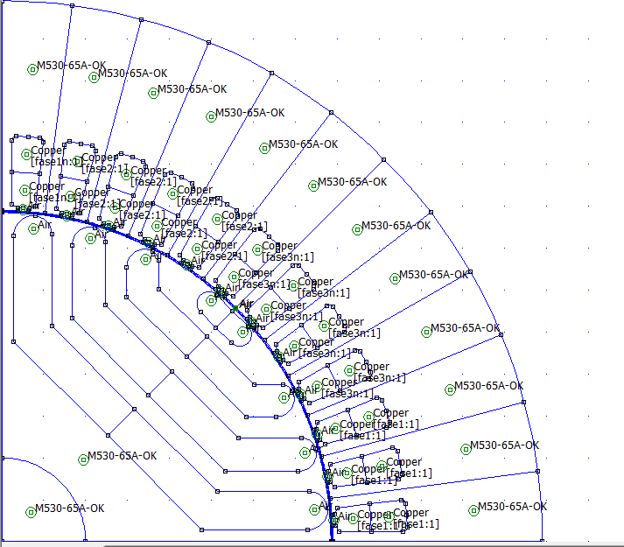

Figure 3: Cross section of one pole of the motor

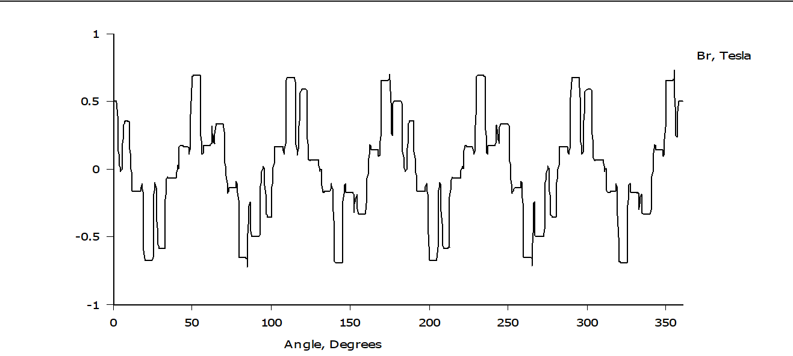

Figure 4: Air gap magnetic field of the machine

By using FEMM, magnetic field in the air gap is obtained. Mesh is increases as much as high, but results are same. If there is a trick about meshing the machine, it will be researched by the author.

Then another critical issue is flux density on the rotor and stator yoke. By this way, it can be checked whether there is any saturation in the machine or not. The possible saturation may occur in the tooth and iron barriers in the stator. In Figure 5, the result is given and it can be observed that there is not critically saturated region by inspecting Figure 4 and Figure 1.

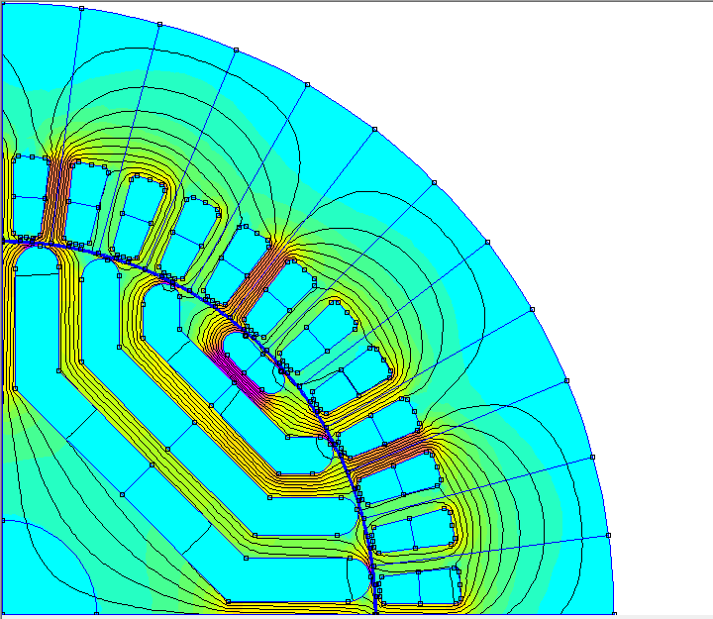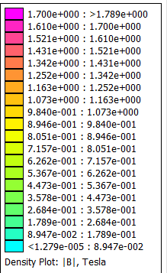

Figure 5:Flux density in the rotor and stator

3.2. Phase Resistance

Phase resistance of the machine can be observed by using FEMM. However, it does not include end winding effects. It is given in Figure 6 for one turn. If the result is multiplied by 72, result is 21.79 mH which is approximately equal t analytical result.

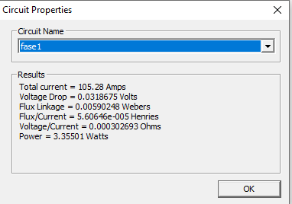

Figure 6: Phase resistance for one turn

3.3. Phase Inductance

In the syre, flux linkage in d and q axis. By using these values, the inductances in the machine can be calculated easily. Flux linkages of d and q axis are given in Figure 7. By dividing flux linkage to d and q axis currents, d axis inductance is calculated as 2.64 mH and q axis inductance is calculated as 10.75 mH.

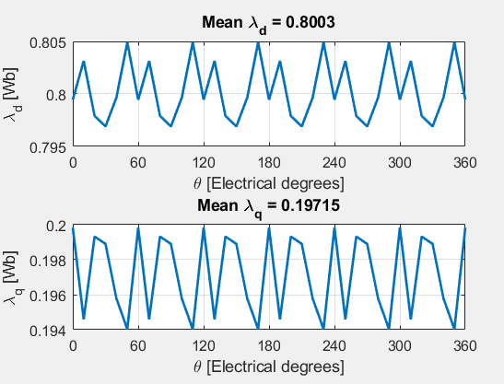

Figure 7: Flux linkage in d and q axis

3.4 Torque Output and Power Factor

For this machine, torque output and power factor is given in Figure 8. Power factor is critical because this machine suffers from low power factor. In this design, power factor can not be optimized. The analytical and numerical torque have little difference in order to assumptions which are made in analytical calculations.

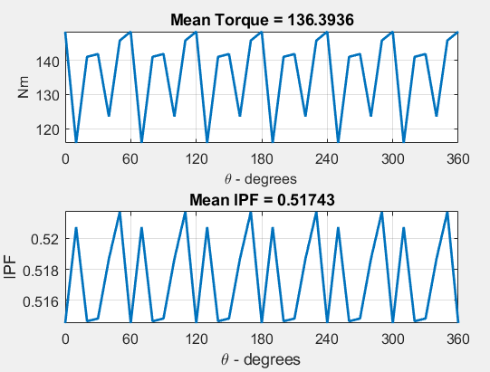

Figure 8: Mean torque and power factor of the machine

4.Comparison of the machine

Analytical and numerical results have little difference. Torque output and resistance are almost equal to each other. However, FEMM does not include end effect while calculating resistance. As a result, analytical and numerical results are approximate. However, firstly they are not sensible values when they are compared. Then, errors in analytical results are detected and corrected.

In this part, this machine will be compared with the machine designed by me before. This machine has 140 N.m torque output with 100 Ampere input. Other machine has 240 N.m torque output with 200 Ampere input. So, this machine has higher torque density. On the other hand, higher torque has other disadvantages such as higher torque ripple and lower power factor. Other machine’s power factor is around 0.7 while it is 0.51 for this machine. The main reason is that the lower saliency ratio which is proportion of Lq to the Ld. If it is increases proporely, power factor can be increased. Also, adding permanent magnets to the air barriers in the q axis which is magnetized in -q direction improves power factor of the machine.

On the other hand, as can be seen in Figure 8, torque ripple of this machine is 21%. However, other machine has 8% torque ripple. Torque ripple can be decreases by arranging the position of air barriers. Also, it can be decreased by skewing in the rotor. Skewing increases phase resistance of the windings and it increases volume and cost of the copper. Dimensions of the machines are approximately equal to each other. However, speed of the other machine is higher and its power density is higher as a result. So, this machine can be optimized in order to decrease torque ripple and increase power factor. This can be done by optimizing of the positions of the barriers. This can be future work of this study.

4.1. Output Parameters of the Machine

Mechanical and electrical parameters of the machine will be given in Table 1.

Table 1: Parameters of the machine

|  |  |  |  |
| --- | --- | --- | --- |
| Parameters | Value | Parameters | Value |
| Outer diameter (mm) | 258 | Speed (rpm) | 1500 |
| Stack length (mm) | 160 | Power (kW) | 22 |
| Aspect ratio | 0.62 | Iron mass (kg) | 32 |
| Torque (N.m) | 140 | Copper mass (kg) | 0.91 kg |
| Torque density (N.m/kg) | 4.25 | Power density (kW/kg) | 668 |