**Night Pharmacy in Ankara**

**IBM Data Science Module 9 Final Project Report**

# Introduction

## Business Problem

There are around 1400 pharmacy in Ankara. The regular working hours for a pharmacy is between 8 am and 6 pm. However for some emergency situations around 20 pharmacy are open during all night. These night-pharmacies are selected on daily basis from the population. The current main selection criteria is official boundaries of districts in Ankara. There are 8 districts in Ankara. District boundaries criteria some times can cause inconvenient situations for the patients in emergency. Sometimes these night-pharmacies are not distributed homogeneously through the city.

I believe that if this distribution would be made based on the proximity of pharmacies, It would be easier for everyone to reach them during the night.

Therefore I suggest that Ankara should be clustered in 16 different group according to the proximity of the pharmacies.

## Interest

A better way of organizing night pharmacy will serve at first the patients who in emergency needs in medicines. Also pharmacies will get benefit from this approach. This approach may present a more convenient job burden for night pharmacies.

# Data acquisition and preparing

The first data we need is the full pharmacy list including the address. The data source is below.

https://www.eczaneler.gen.tr/eczaneler/ankara-sincan

I have combined the final data according to the central districts of Ankara via this web page.

Second thing we need for analysis is the geographical coordination of these pharmacies. These data have been produced by using geocoder in python.

The total number of pharmacies by district is shown the table below.

Figure 1: The Total Number of Pharmacies by District

|  | **District Name** | **Number of Pharmacies** |
| --- | --- | --- |
| 1 | Altındağ | 128 |
| 2 | Etimesgut | 137 |
| 3 | Keçiören | 211 |
| 4 | Mamak | 116 |
| 5 | Pursaklar | 34 |
| 6 | Sincan | 116 |
| 7 | Yenimahalle | 178 |
| 8 | Çankaya | 419 |

# Data Analysis

The first step to see the locations of pharmacies on the map is using “Folium” maps.

The distribution of pharmacies throughout the city is shown the figure below.

Figure 2: The Locations of Pharmacies in Ankara

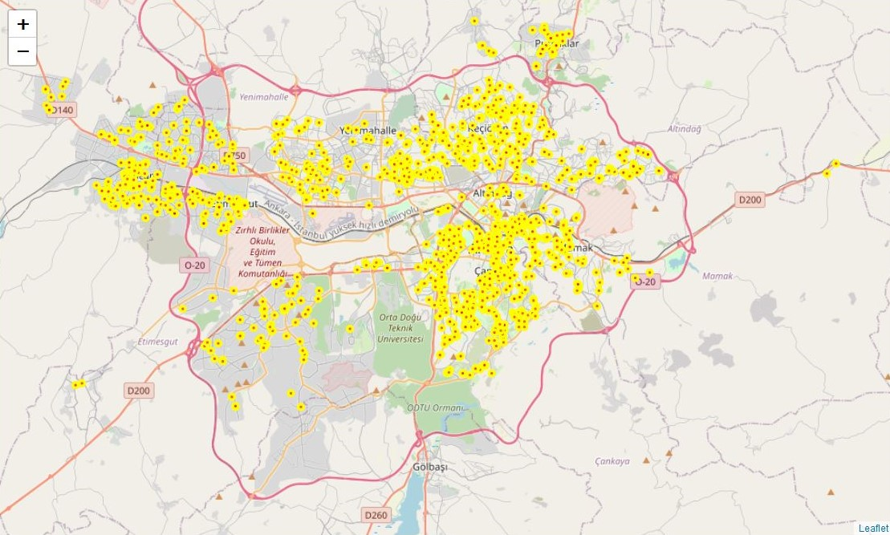

The map by coloring locations by districts is below:

Figure 3: The Total Number of Pharmacies by District - Map

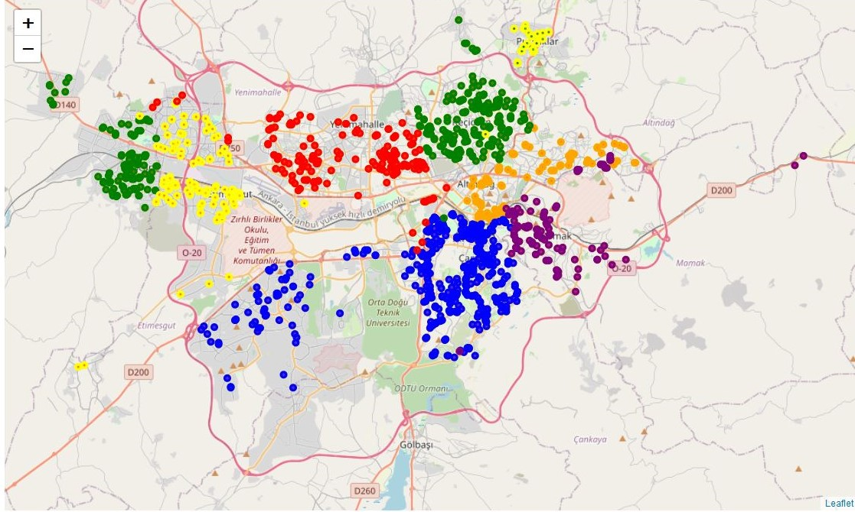

As it is shown in the Figure 3, some pharmacies in a district are closer to another district. You can see the example of these with red color in yellow or blue areas or purple color in orange areas. Also the location information in a boxplot in “Matplotlib” is shown below.

Figure 4 The Total Number of Pharmacies by District - Scatterplot

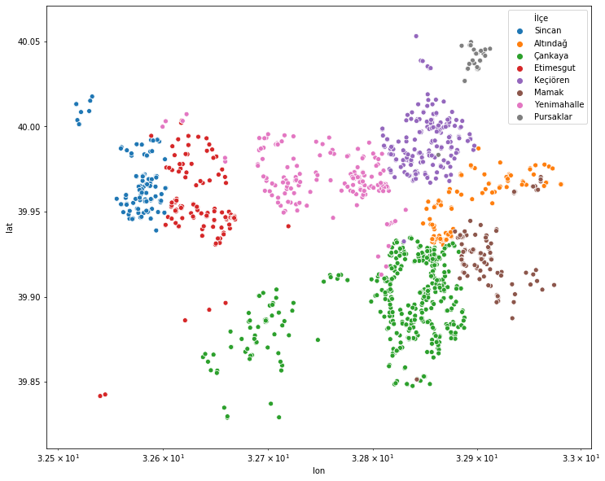

Our purpose is clustering pharmacies according to geographical proximity in 16 different groups.

## k-means cluster

For k-means cluster analysis we need to convert our data frame to a Numpy array.

The code for this conversion is

X = np.array(X)

We define 16 clusters for pharmacies in Ankara

k_means = KMeans(init="k-means++", n_clusters=16, n_init=12)

The new clusters are shown the figure below:

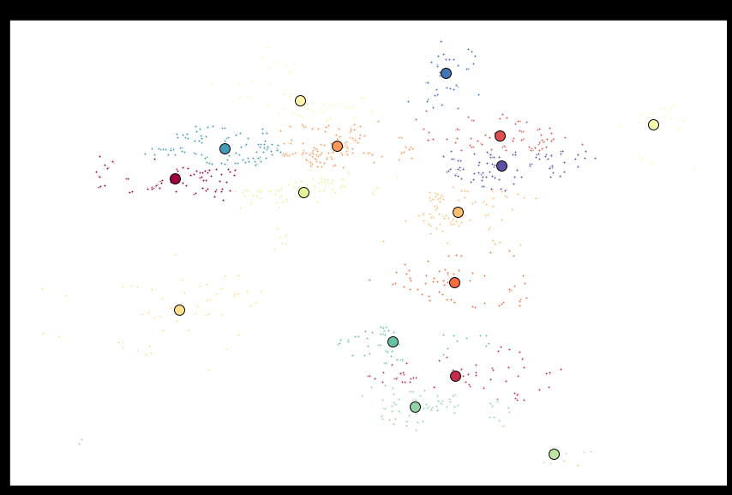

After the clustering the new map will be like this:

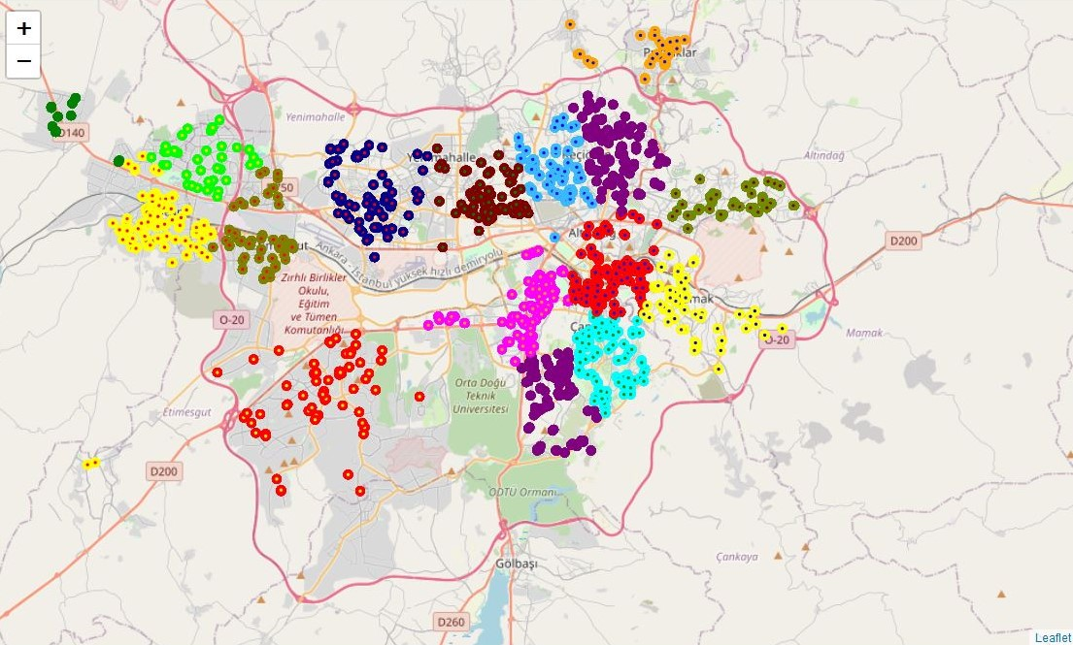

The new scatterplot is like this

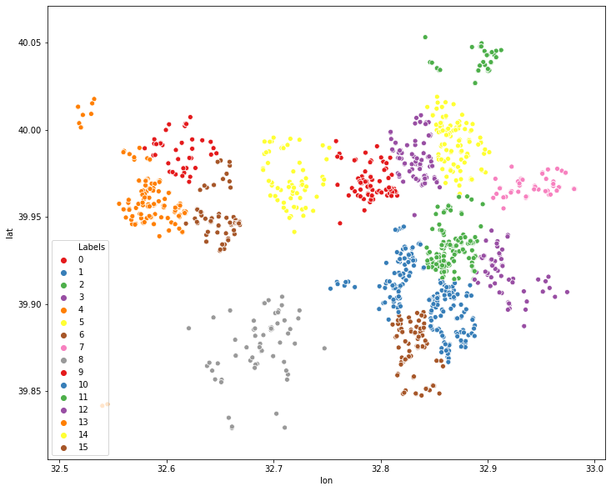

## Comparison between District based and Clusters based

**District Based**

|  | **District Name** | **Number of Pharmacies** |
| --- | --- | --- |
| 1 | Altındağ | 128 |
| 2 | Etimesgut | 137 |
| 3 | Keçiören | 211 |
| 4 | Mamak | 116 |
| 5 | Pursaklar | 34 |
| 6 | Sincan | 116 |
| 7 | Yenimahalle | 178 |
| 8 | Çankaya | 419 |

**Cluster Based**

|  | **Labels** | **Number of Pharmacies** |
| --- | --- | --- |
| **0** | 0 | 120 |
| **1** | 1 | 184 |
| **2** | 2 | 91 |
| **3** | 3 | 107 |
| **4** | 4 | 123 |
| **5** | 5 | 77 |
| **6** | 6 | 64 |
| **7** | 7 | 55 |
| **8** | 8 | 89 |
| **9** | 9 | 96 |
| **10** | 10 | 39 |
| **11** | 11 | 73 |
| **12** | 12 | 99 |
| **13** | 13 | 13 |
| **14** | 14 | 44 |
| **15** | 15 | 65 |

## Solution of the Problem

The table below shows how districts divided into clusters. For example in Etimesgut district pharmacies are divided into 5 different clusters (numbered 0, 5,6,11, and14).

| **İlçe** | **Labels** | **Sıra** |
| --- | --- | --- |
| Altındağ | 1 | 74 |
| Altındağ | 4 | 13 |
| Altındağ | 7 | 41 |
| Etimesgut | 0 | 31 |
| Etimesgut | 5 | 75 |
| Etimesgut | 6 | 3 |
| Etimesgut | 11 | 2 |
| Etimesgut | 14 | 26 |
| Keçiören | 4 | 109 |
| Keçiören | 9 | 95 |
| Keçiören | 10 | 6 |
| Keçiören | 12 | 1 |
| Mamak | 1 | 36 |
| Mamak | 7 | 14 |
| Mamak | 8 | 1 |
| Mamak | 15 | 65 |
| Pursaklar | 4 | 1 |
| Pursaklar | 10 | 33 |
| Sincan | 0 | 89 |
| Sincan | 13 | 13 |
| Sincan | 14 | 14 |
| Yenimahalle | 2 | 91 |
| Yenimahalle | 5 | 2 |
| Yenimahalle | 9 | 1 |
| Yenimahalle | 11 | 71 |
| Yenimahalle | 12 | 9 |
| Yenimahalle | 14 | 4 |
| Çankaya | 1 | 74 |
| Çankaya | 3 | 107 |
| Çankaya | 6 | 61 |
| Çankaya | 8 | 88 |
| Çankaya | 12 | 89 |

The table below shows the sources of clusters.

For example cluster number 0 is combined from Etimesgut (31) and Sincan(89) districts.

| **Labels** | **Districts** | **Number of Pharmacies** |
| --- | --- | --- |
| 0 | Etimesgut | 31 |
| 0 | Sincan | 89 |
| 1 | Altındağ | 74 |
| 1 | Mamak | 36 |
| 1 | Çankaya | 74 |
| 2 | Yenimahalle | 91 |
| 3 | Çankaya | 107 |
| 4 | Altındağ | 13 |
| 4 | Keçiören | 109 |
| 4 | Pursaklar | 1 |
| 5 | Etimesgut | 75 |
| 5 | Yenimahalle | 2 |
| 6 | Etimesgut | 3 |
| 6 | Çankaya | 61 |
| 7 | Altındağ | 41 |
| 7 | Mamak | 14 |
| 8 | Mamak | 1 |
| 8 | Çankaya | 88 |
| 9 | Keçiören | 95 |
| 9 | Yenimahalle | 1 |
| 10 | Keçiören | 6 |
| 10 | Pursaklar | 33 |
| 11 | Etimesgut | 2 |
| 11 | Yenimahalle | 71 |
| 12 | Keçiören | 1 |
| 12 | Yenimahalle | 9 |
| 12 | Çankaya | 89 |
| 13 | Sincan | 13 |
| 14 | Etimesgut | 26 |
| 14 | Sincan | 14 |
| 14 | Yenimahalle | 4 |
| 15 | Mamak | 65 |

# Conclusions

Night-pharmacies have a crucial role in the society. They are selected daily basis and open during the night. Patients who need medicine in emergency situations can buy it from night pharmacies. Therefore it is important how night pharmacies are selected. The current application in Ankara is district based selection. There are 8 central district in Ankara and night pharmacies are appointed in certain numbers in each district. This approach sometimes causes problems for patients. Because district boundaries don’t represent how pharmacies are distributed within the districts. Therefore a location proximity approach will be a better way to cluster pharmacies instead of district boundaries. In this analysis we have used k-means clustering approach to group pharmacies based on locations.

# Future directions

K-means cluster method helps us to group pharmacies based on locations geographical proximity. However in real life geographical proximity sometimes doesn’t give the best solution. For example if a city is divided in two parts by a train road and if there is very limited passing through this line in the city , the commuting time between the two parts of city will be different. Therefore future analysis should regard the commuting time between points and cluster accordingly.