Mutations in the Long-Term Evolution Experiment
  - Variant calling on three E. coli clones from population Ara-3
Yusuf
2026-11-10

Question
How many mutations did E. coli accumulate over 50,000 generations of the Long-Term Evolution Experiment (Tenaillon et al. 2016), and is that answer robust to how strictly we filter the variant calls?

Data
# Number of reads per file used for the length, GC and quality summaries.
# Change it without editing the report: quarto render ... -P max_reads:5000
max_reads = 10000
import sys
import matplotlib
import matplotlib.pyplot as plt
import pandas as pd
from scripts.fastq_stats import quality_by_position, summarize
samples = pd.read_csv("metadata/samples.tsv", sep="\t")
fastq_files = list(samples["fastq_1"]) + list(samples["fastq_2"])
We use a subset of the reads prepared by Data Carpentry (Tenaillon et al. 2019): three clones of population Ara-3, frozen at generations 5,000, 15,000, 50,000 (Table 1).
samples[["sample", "strain", "generation", "mutator", "cit"]]
Table 1: The three LTEE clones in this project.
 | sample | strain | generation | mutator | cit
0 | SRR2589044 | REL2181A | 5000 | NaN | unknown
1 | SRR2584863 | REL7179B | 15000 | NaN | unknown
2 | SRR2584866 | REL11365 | 50000 | plus | plus

Reads
reads = pd.DataFrame([summarize(f, max_reads) for f in sorted(fastq_files)])
reads.round(1)
Table 2: Reads per FASTQ file. Length, GC content and mean base quality are computed on the first reads of each file (parameter max_reads).
 | file | reads | mean_length | gc_percent | mean_quality
0 | SRR2584863_1.trim.sub.fastq | 175000 | 130.4 | 50.5 | 35.4
1 | SRR2584863_2.trim.sub.fastq | 175000 | 121.7 | 50.5 | 34.8
2 | SRR2584866_1.trim.sub.fastq | 175000 | 128.5 | 50.5 | 35.2
3 | SRR2584866_2.trim.sub.fastq | 175000 | 130.6 | 50.7 | 35.5
4 | SRR2589044_1.trim.sub.fastq | 175000 | 130.1 | 50.5 | 35.5
5 | SRR2589044_2.trim.sub.fastq | 175000 | 123.1 | 50.4 | 34.9

Each file has 175,000 reads, so each sample has 175,000 read pairs. The mean read length is 127 bases because the reads were trimmed before subsampling. Figure 1 shows that base quality stays high along the reads.
colors = ["#2a78d6", "#eb6834", "#1baf7a"] # one per sample, in generation order
fig, ax = plt.subplots(figsize=(7, 4.2))
for color, (_, row) in zip(colors, samples.sort_values("generation").iterrows()):
for read, style in [("fastq_1", "-"), ("fastq_2", "--")]:
quality_by_position(row[read], max_reads).plot(
ax=ax, color=color, linestyle=style, linewidth=1.5,
label=f"{row['sample']} (gen. {row['generation']:,}) read {read[-1]}")
ax.set_xlabel("Position in read (bases)")
ax.set_ylabel("Mean Phred quality")
ax.grid(alpha=0.3)
ax.legend(fontsize=7, ncol=3, frameon=False, loc="upper center", bbox_to_anchor=(0.5, -0.18))
fig.tight_layout()
plt.show()
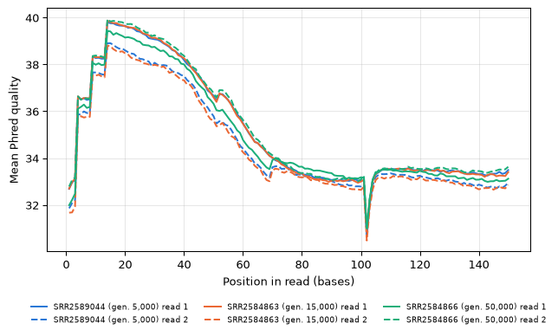
Figure 1: Mean base quality along the reads (first max_reads reads of each file). Colour shows the sample, line style the read of the pair.

Software
print(f"Python {sys.version.split()[0]}, pandas {pd.__version__}, matplotlib {matplotlib.__version__}")
Python 3.13.18, pandas 3.1.0, matplotlib 3.11.2
The exact versions of every package are in pixi.lock.
Tenaillon, Olivier, Jeffrey E. Barrick, Noah Ribeck, et al. 2016. “Tempo and Mode of Genome Evolution in a 50,000-Generation Experiment.” Nature 536: 165–70. https://doi.org/10.1038/nature18959.
Tenaillon, Olivier, Jeffrey E. Barrick, Noah Ribeck, et al. 2019. Data Carpentry Genomics Curriculum Example Data. Dataset, version 3; figshare. https://doi.org/10.6084/m9.figshare.7726454.v3.

