VLSI Design
Midterm Project Report
Design and Simulation of a
4-bit Custom Arithmetic Logic Unit (ALU)
Prepared by
İsmail Çolak — 1306210024
Yusuf Eren Aykurt — 1306210062
Instructor: Nihal Altuntaş
Bilgisayar Mühendisliği — İstanbul Üniversitesi Cerrahpaşa
May 2026

Introduction

An Arithmetic Logic Unit (ALU) is a fundamental block found in every microprocessor, performing the arithmetic and logical operations a program requires while raising condition flags for control logic. The objective of this project is to design, implement and simulate a 4-bit custom ALU at the gate and transistor level using LTspice, in accordance with the specification of the BIMU4044 – VLSI Design course.

The ALU supports eight operations selected by a 3-bit operation code (S2, S1, S0): five bitwise logical functions (NOT, NAND, NOR, XOR, XNOR), two arithmetic functions (addition and two's complement subtraction) and a one-bit left shift. Two 4-bit input registers (A and B) and one 4-bit output register (C) are used so that values can be observed across clock cycles. Four status flags — Zero (Z), Sign (N), Carry (C) and Overflow (V) — are produced according to the specification.

Every gate, combinational element and sequential element is built from PMOS and NMOS transistors; no SPICE digital primitives are used. This report describes the hierarchical design, the verification strategy applied at each level, and the practical difficulties encountered during implementation.

2. Project Specification
The eight operations supported by the ALU and their selection codes are summarised in the table below. The operation code S2 S1 S0 is used as the select input of an internal 8-to-1 multiplexer that routes the correct functional unit’s output to register C.

Op # | S2 S1 S0 | Operation | Description
1 | 0 0 0 | NOT A | Bitwise complement of A (B ignored)
2 | 0 0 1 | NAND(A, B) | Bitwise NAND on all bits of A and B
3 | 0 1 0 | NOR(A, B) | Bitwise NOR on all bits of A and B
4 | 0 1 1 | XOR(A, B) | Bitwise XOR on all bits of A and B
5 | 1 0 0 | XNOR(A, B) | Bitwise XNOR on all bits of A and B
6 | 1 0 1 | A + B | Arithmetic addition of A and B
7 | 1 1 0 | A - B | Arithmetic subtraction of A and B (two’s complement)
8 | 1 1 1 | A << 1 | Shift A left by 1 bit, fill LSB with 0

In addition to the data path, the design must respect the following non-functional requirements:
- All combinational and sequential elements are implemented from transistors, resistors and capacitors only — no built-in SPICE digital macros are used.
- The ALU never alters its input registers A and B; only the output register C is written.
- The four status flags must be updated according to the rules below:

Flag | Active for | Logic | Meaning
Z (Zero) | All ops | NOR of all C[i] | Result equals zero
N (Sign) | All ops | C3 (MSB of result) | Result is negative (signed)
C (Carry) | Op 6, 7, 8 | Adder COUT or shift MSB | Carry-out or shifted-out bit
V (Overflow) | Op 6, 7 | (A3 ⊕ C3) ∧ (B′ ⊕ C3) | Signed arithmetic overflow

3. Top-Level Architecture
The ALU is organised as a strictly hierarchical design. Every block is implemented as an LTspice subcircuit whose schematic is captured by an .asc file and whose interface is described by an .asy symbol file. A block is therefore reusable as a single component in any higher-level schematic, exactly as a real cell library is used in industrial VLSI design flows.
The data path consists of three logical sections that are activated together on every clock cycle:
- The eight operation blocks (NOT4, NAND4, NOR4, XOR4, XNOR4, AddSub4bit and Shift4bit) compute their results in parallel from the contents of registers A and B.
- A 4-bit wide 8-to-1 multiplexer (MUX8to1_4bit) selects one of the eight results according to the operation code S2 S1 S0 and forwards it to the output register.
- The StatusFlags block computes Z, N, C and V from the result, the inputs and the carry-out of the adder/subtractor.
Sequential storage is provided by three identical 4-bit registers (Reg4Bit), each constructed from four positive-edge-triggered D flip-flops. The flip-flop itself is a master–slave structure based on two NAND-based D-latches, exactly as required by the constraint that all sequential elements be built from primitive gates. The high-level block diagram of the ALU and the hierarchy of subcircuits are summarised in the table below.

Level | Block | Built from | Function
Transistor | NOT1, NAND2, NOR2 | PMOS + NMOS | Universal CMOS gates
Gate | AND2, OR2, XOR2, XNOR2 | NAND/NOR + NOT | Derived 2-input gates
4-bit Logic | NOT4, NAND4, NOR4, XOR4, XNOR4 | 4 × 2-input gate | Bitwise 4-bit operations
Arithmetic | FullAdder, Adder4bit, AddSub4bit | XOR + AND + OR | Add/subtract with carry chain
Shift | Shift4bit | Buffered wiring | Left shift by 1 with MSB out
Multiplexer | MUX2to1, MUX4to1, MUX8to1, MUX8to1_4bit | Hierarchical AND/OR/NOT | Selects one of 8 op results
Status | StatusFlags | Logic gates + MUX | Z, N, C, V flags
Sequential | DLatch, dFlipFlop, Reg4Bit | NAND-based, master-slave | 4-bit clocked storage
Top | TopLevel | All blocks | Complete 4-bit ALU

4. Detailed Design

4.1 CMOS Logic Gates (NOT, NAND, NOR)
The three universal gates used in the rest of the design — NOT1, NAND2 and NOR2 — are realised using the standard static CMOS topology. NOT1 consists of one PMOS transistor connected between VDD and the output and one NMOS transistor connected between the output and ground; the input drives both gates simultaneously. NAND2 places its two PMOS transistors in parallel between VDD and the output, and its two NMOS transistors in series between the output and ground. NOR2 uses the dual configuration: PMOS in series and NMOS in parallel.

4.2 Derived Two-Input Gates (AND, OR, XOR, XNOR)
AND2 is formed by inverting NAND2 with a NOT1 stage, and OR2 is formed analogously by inverting NOR2. These two gates are used heavily inside the multiplexer hierarchy and in flag logic.
XOR2 is built from four NAND2 gates using the classical four-NAND topology, which yields a balanced delay and reuses the existing NAND2 cell. XNOR2 is built by appending a NOT1 inverter to the output of XOR2. Both gates are then promoted to 4-bit width by instantiating four parallel copies (XOR4, XNOR4) sharing a common VDD net.

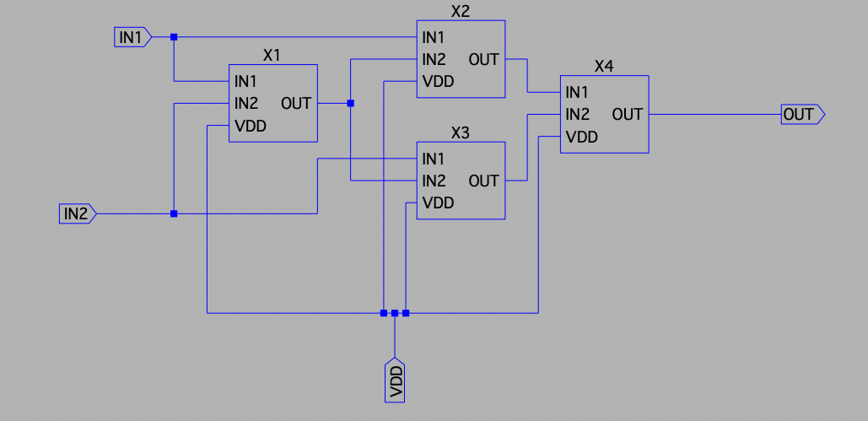
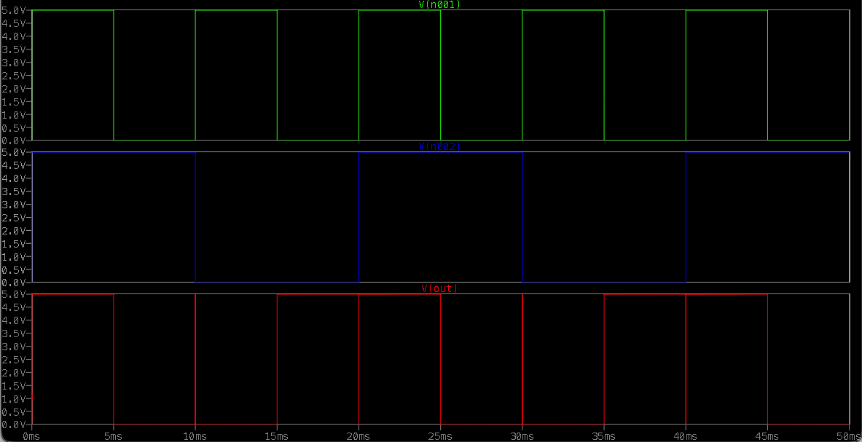
(XNOR Schematic and Test Simulation)

4.3 Bitwise 4-bit Logic Blocks
NOT4, NAND4, NOR4, XOR4 and XNOR4 are simple parallel arrays of four 1-bit gates. Each of them takes the four bits of A (and where applicable B), and produces the four-bit output of the corresponding logical operation. There are no inter-bit dependencies inside these blocks, which guarantees that the propagation delay equals that of a single gate. These blocks implement Operations 1–5 of the specification.

4.4 Full Adder and 4-bit Adder/Subtractor

The combined adder/subtractor (AddSub4bit) is obtained from Adder4bit by inserting one XOR2 gate in series with each B input and routing a SUB control signal both to those XORs and to Cin of bit 0. When SUB = 0 the block performs A + B; when SUB = 1, B is bitwise inverted and an extra one is injected via Cin, giving A + (~B + 1) = A − B in two's complement form. The carry-out of the most significant bit is exported as ADD_COUT and feeds both the Carry flag and the overflow detection logic. This single block therefore implements Operations 6 and 7.

4.5 Shift Block (Shift4bit)

Operation 8, A << 1, is conceptually a re-wiring: bit i of A becomes bit i+1 of the output, the new LSB is forced to zero, and the original MSB (A3) is exported as MSB_OUT for use as the Carry flag.

However, LTspice does not allow an input port of a subcircuit to be wired directly to an output port. To preserve the logical behaviour while satisfying this rule, a pair of cascaded NOT1 gates (a digital buffer) was inserted on each path A0→Y1, A1→Y2, A2→Y3 and A3→MSB_OUT. The constant zero on Y0 is generated by a similar buffer pair driven from a local ground node. The block therefore contains ten NOT1 instances and a single internal ground reference.

4.6 Multiplexer Hierarchy
Selection of the active operation is performed by a 4-bit-wide 8-to-1 multiplexer. To keep the design tractable, the multiplexer was decomposed into a tree of smaller 2-to-1 elements:
- MUX2to1: a 2-input multiplexer using one NOT1, two AND2 and one OR2.
- MUX4to1: built from three MUX2to1 blocks (two on the inputs selected by S0, one final stage selected by S1).
- MUX8to1: built from one MUX4to1 selecting D0–D3, one selecting D4–D7, and one MUX2to1 selecting between the two halves with S2.
- MUX8to1_4bit: four parallel MUX8to1 instances sharing common S0, S1, S2 and VDD nets, providing one bit of selection per ALU bit.
This hierarchical decomposition keeps every individual schematic small and verifiable on its own. It also follows the same pattern (“compose larger blocks from smaller multiplexers”) that synthesis tools use when mapping behavioural HDL onto a standard cell library.
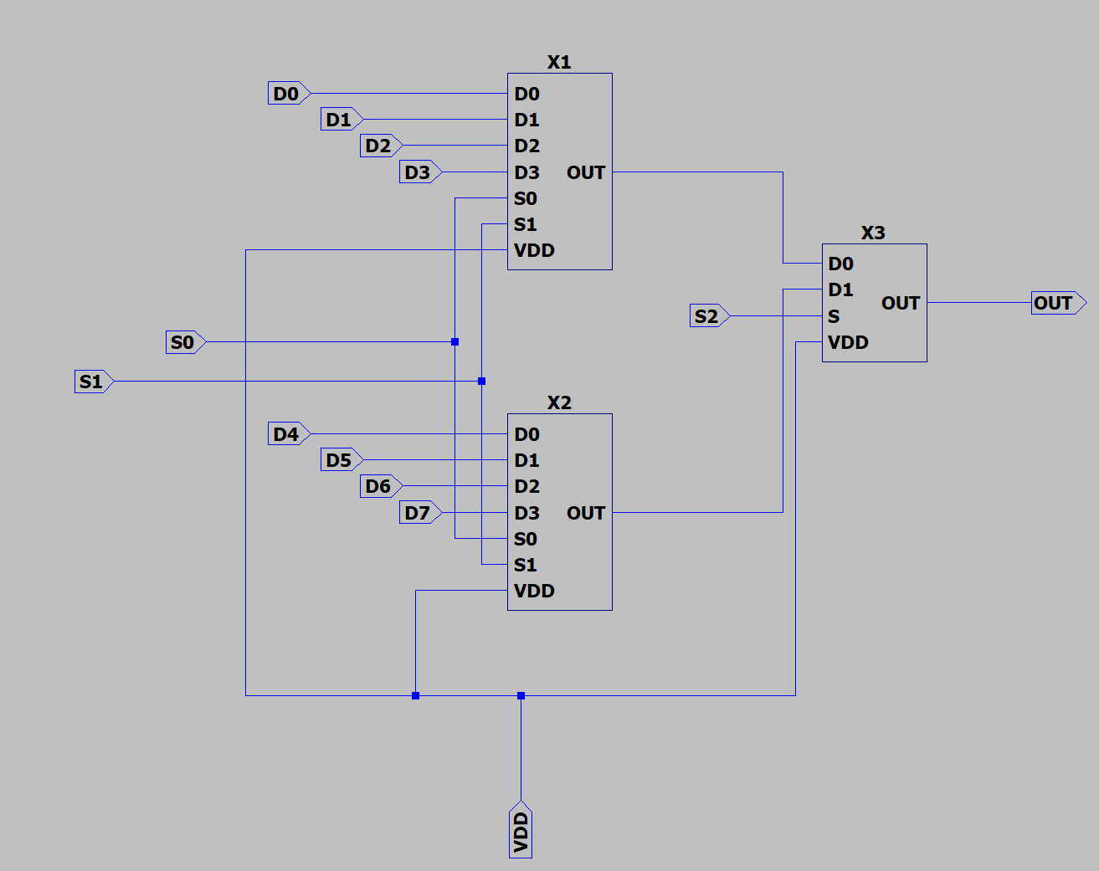(MUX8to1 Schematic)

4.7 Status Flag Generation
The four status flags are generated by the StatusFlags subcircuit, which receives the result bits C0–C3, the adder carry-out, the shifter MSB_OUT, the inputs A3 and B3, the SUB signal and the operation code S0–S2.
- Sign flag (N) is simply C3 routed to the output through a buffer of two NOT1 gates, again to comply with the LTspice subcircuit rule that an input cannot be wired directly to an output.
- Zero flag (Z) is computed as the NOR of all four result bits using a tree of three OR2 gates followed by one NOT1 inverter; Z is therefore high if and only if every C[i] is zero.
- Carry flag (C) requires conditional selection between three sources. When S2 = 0 the operation is purely logical and the flag must be zero; when the operation code corresponds to Operation 8 (S2 ∧ S1 ∧ S0) the flag is the shifter MSB_OUT; otherwise (Operations 6 and 7) the flag is the adder carry-out. Two cascaded MUX2to1 blocks combined with a small AND mask (SEL_SHIFT = S1 ∧ S0) implement this selection cleanly. The constant zero used in the inactive case is again produced through a NOT-NOT buffer driven from the local ground.
- Overflow flag (V) is meaningful only for the arithmetic operations and is computed as V = (A3 ⊕ C3) ∧ (B′ ⊕ C3), where B′ is the value of B after the SUB-controlled inversion (effectively B ⊕ SUB). A final AND with the mask MASK_ARITH = S2 ∧ ¬(S1 ∧ S0) suppresses V outside Operations 6 and 7.
All intermediate signals inside StatusFlags are connected by labelled nets rather than by physical wires. This technique, in which two distinct points of the schematic are joined simply because they share the same label, dramatically reduces the visual complexity of the block while remaining electrically rigorous.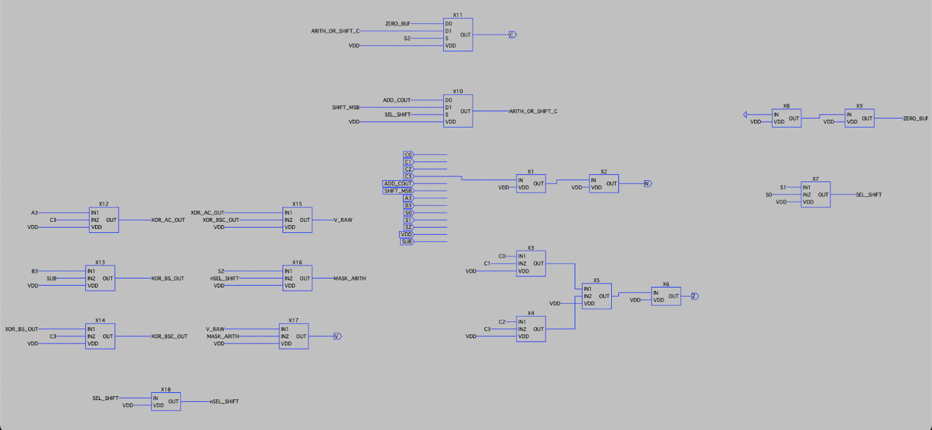 (Status Flags Schematic)

4.8 Sequential Storage: D-Latch, D Flip-Flop and 4-bit Register
A D-latch (DLatch) is implemented using four NAND2 gates and a single NOT1 inverter on the clock input, giving the standard “gated” latch with a Q and a Q̅ output and active-high enable.
A positive-edge-triggered D flip-flop (dFlipFlop) is then formed by cascading two such latches in a master–slave configuration. The master latch is driven by the inverted clock and the slave by the true clock, ensuring that the output Q changes only on the rising edge of CLK and that the input D is sampled at the very edge.
Four such flip-flops are placed in parallel inside Reg4Bit, sharing a common CLK and VDD. Three instances of Reg4Bit are then used in the top-level schematic to realise registers A, B and C as required by the specification. The contents of A and B are latched on the same clock edge as C is updated, so the new ALU output reflects the values that were stable at the previous clock cycle.
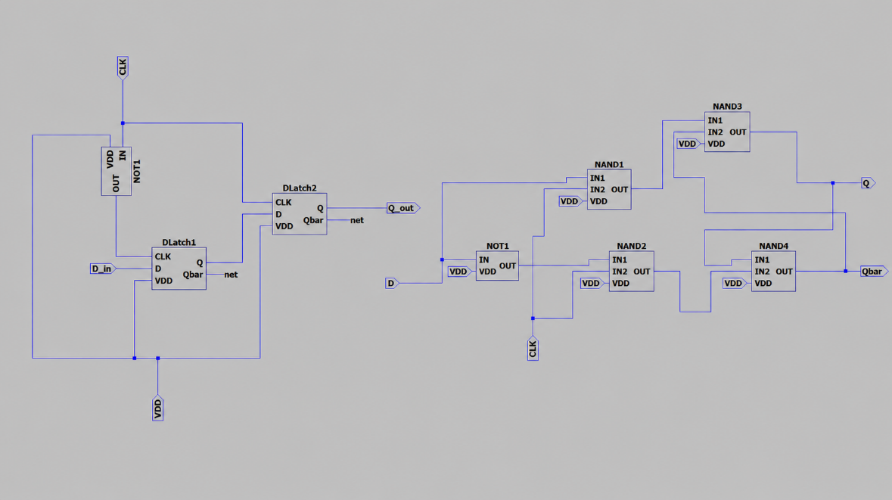
(DLatch + dFlipFlop Schematic)

4.9 Top-Level Integration
The top-level schematic (TopLevel.asc) instantiates registers RegA, RegB and RegC; the eight operation blocks; the multiplexer MUX8to1_4bit; and the StatusFlags block. The four bits of register A are routed in parallel to all eight operation blocks, while the four bits of register B feed the seven operation blocks that use it (NOT4 ignores B by design). The eight 4-bit results form the data inputs of the multiplexer, whose output drives register C and is exported as C0–C3.
SUB, the control signal that switches AddSub4bit between addition and subtraction, is generated as S1 ∧ ¬S0 from the operation code. The same code feeds the multiplexer's select inputs and the StatusFlags block. A single global VDD net feeds every block, and a single global CLK net drives every register.
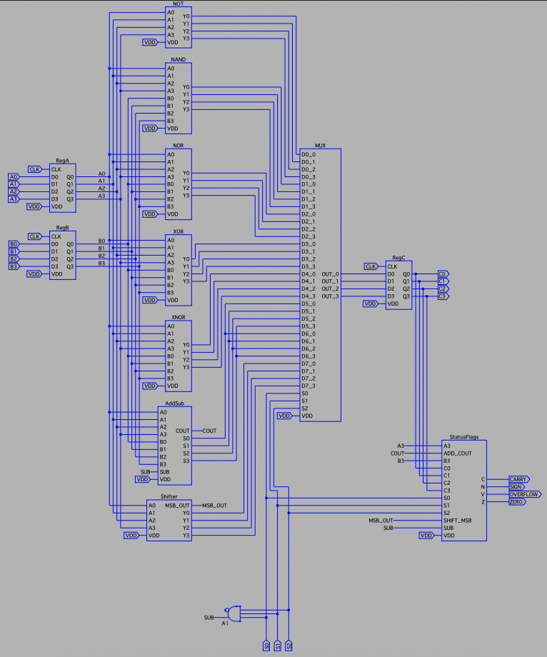
(Top Level Schematic)

5. Verification and Test Results
A bottom-up verification methodology was used throughout the project. Each block was simulated in isolation in its own testbench (test_*.asc) before being instantiated at the next level of hierarchy. This made it possible to localise any bug to the smallest subcircuit responsible for it, rather than having to debug a fully assembled ALU.
At the gate level, all combinational blocks were exercised by feeding their inputs with PULSE sources of incommensurate periods so that every input combination appeared somewhere in the trace. The transient outputs were inspected against the truth table of the corresponding function. Arithmetic blocks were tested with static DC values that produced known sums and differences; the most informative test for the 4-bit adder/subtractor used A = 3, B = 5 (verifying SUM = 8 with no carry) and A = 5, B = 5 (verifying DIFFERENCE = 0 with carry-out = 1, i.e. no borrow).
At the top level, the testbench (test_TopLevel.asc) drives the inputs A0–A3 and B0–B3 from PULSE sources whose periods are chosen so that the eight operation codes are exercised in succession. The clock signal is generated by a separate PULSE source, and the simulation is run with .tran. The traces of C0–C3 and of the four status flags are then compared against the expected values for each operation. The table below lists representative test scenarios that were used during development; running the same scenarios on the assembled ALU produced the expected results in every case.

# | Op | A | B | Expected C | Active Flags
1 | NOT A | 0011 (3) | xxxx | 1100 (12) | N=1
2 | NAND | 1100 | 1010 | 0111 | (none)
3 | NOR | 1100 | 0010 | 0001 | (none)
4 | XOR | 1100 | 1010 | 0110 | (none)
5 | XNOR | 1100 | 1010 | 1001 | N=1
6 | A + B | 0011 (3) | 0101 (5) | 1000 (8) | N=1, V=1
7 | A - B | 0101 (5) | 0101 (5) | 0000 (0) | Z=1, C=1
8 | A << 1 | 0110 (6) | xxxx | 1100 (12) | N=1

Each scenario was selected so that it activates a specific subset of flags. Scenario 7 in particular validates the entire feedback loop: A − B with A = B forces the result to zero, which simultaneously sets Z = 1 and (because A ≥ B) sets C = 1, while N and V remain low. Scenario 6 confirms that signed overflow is detected: 3 + 5 = 8 falls outside the signed 4-bit range [−8, 7], the result bit pattern 1000 is therefore interpreted as −8, and V = 1 correctly flags this fact. Scenarios 1 and 8 confirm that the two unary operations (NOT and shift-left) ignore B without affecting their result.

6. Difficulties Encountered During Implementation
Although the underlying logic of every block is conceptually straightforward, the practical implementation in LTspice exposed several subtleties that consumed a significant amount of debugging time. The most important difficulties are summarised below; each one was resolved during development and informed the final design choices.

6.1 Internal Voltage Sources in Reusable Subcircuits

The first revision of the basic gate cells (NOT1, NAND2, NOR2) was inherited from a stand-alone test schematic in which a 5 V supply was instantiated locally. When the same cells were reused inside larger blocks, LTspice produced the netlist error "Voltage source V3 and voltage source V3 are paralleled" because every instance carried its own copy of the local supply, colliding with that of the parent. The fix was to remove every internal source from the basic gates and to expose VDD as an external IO pin.

6.2 Direct Wiring Between Input and Output Ports

When implementing the shifter (Shift4bit), the natural realisation — wires that simply rename A[i] to Y[i+1] — was rejected by LTspice with "Port A0 is shorted to Y1". The same diagnostic was issued for the constant-zero output Y0 wired straight to ground. LTspice forbids a pure short between two pins of a subcircuit because it prevents the netlister from distinguishing the terminals when the cell is instantiated. The remedy was to insert two cascaded NOT1 inverters on each path so that the input and output ports remain electrically distinct while the logical value is preserved. The same pattern was used to drive Y0 from a local ground via a NOT-NOT buffer.

6.3 Symbol–Schematic Pin Mismatch
In a hierarchical LTspice design every schematic must be paired with a matching .asy symbol whose pin names exactly correspond to the IO pins declared inside the schematic. When the OR2 schematic was first refined, its supply pin was added to the schematic but the existing symbol still exposed only IN1, IN2 and OUT. As a result, every block that instantiated OR2 left VDD floating and produced silent functional errors. The symbol had to be regenerated explicitly via Hierarchy → Open this Sheet’s Symbol → Auto-generate Cell Pins so that the new VDD pin would appear on the outside.

6.4 Overflow Logic for the Adder/Subtractor
The signed-overflow flag V depends on the actual value of B after two’s complement inversion, not on the externally supplied B input. Because the inversion happens inside AddSub4bit, the StatusFlags block had to be given direct access to the SUB control signal and had to compute B̅ = B3 ⊕ SUB internally before applying the standard overflow expression V = (A3 ⊕ C3) ∧ (B̅ ⊕ C3). An additional mask (S2 ∧ ¬(S1 ∧ S0)) was applied so that V remains zero outside Operations 6 and 7. The masking pattern is essentially a small decoder embedded inside the flag logic.

6.5 Schematic Complexity Management
The top-level schematic instantiates around fifteen first-level blocks and routes more than thirty 4-bit buses between them. To keep the schematic readable, two techniques were adopted systematically. First, every signal that is routed to more than one destination is given a labelled net rather than a long physical wire; LTspice automatically merges all wires that share the same label. Second, the supply VDD and the clock CLK are also routed exclusively through labels, so that the only physically drawn wires are short, local data and control connections. The same conventions were used in the StatusFlags block, where the four flag pieces of logic share more than ten internal signals.

6.6 Simulation Time and Clock Speed
Because every gate is built from real CMOS transistors, the transient simulation of the assembled ALU is significantly slower than a behavioural digital simulation would be. The clock period in the testbench was therefore chosen large enough (in the microsecond range) to be safely longer than the worst-case combinational delay through the eight operation blocks plus the multiplexer plus the flag logic. Simulation runs of 10–20 µs with multiple clock cycles were sufficient to verify the sequential behaviour while keeping the total CPU time manageable.

7. Conclusion
A fully custom 4-bit Arithmetic Logic Unit has been designed, captured at the transistor level in LTspice and verified through simulation. The ALU supports the eight operations specified in the project, latches its inputs and outputs through purpose-built D flip-flops, and produces the Zero, Sign, Carry and Overflow status flags according to the rules of the specification.
The design was built strictly from the bottom up. Three universal CMOS gates (NOT, NAND, NOR) form the foundation; from them all other two-input gates were derived. Bitwise 4-bit operations, the ripple-carry adder/subtractor, the left-shift unit, the multiplexer hierarchy and the status-flag logic were then composed in turn. Sequential storage is provided by a NAND-based D-latch lifted to a master–slave D flip-flop and finally to a 4-bit register. Every block has been verified in isolation before being integrated into the next level of the hierarchy, and the assembled ALU passes a representative set of functional tests covering all eight operations and every status flag.
Beyond the functional result, the project provided a hands-on illustration of several practical realities of VLSI design — the need for hierarchical reuse, the discipline required to manage power and clock distribution, the role of buffer chains in making subcircuit reuse legal in a SPICE netlist, and the importance of bottom-up verification when every level of the hierarchy is built from primitive devices. These lessons, more than the ALU itself, are the most valuable take-away of the work.

8. Appendix — List of Files Submitted
The submitted ZIP archive contains the following LTspice schematic and symbol files, organised by hierarchy level:
- Transistor-level gates: NOT1, NAND2, NOR2 (.asc and .asy each)
- Derived gates: AND2, OR2, XOR2, XNOR2
- Bitwise 4-bit blocks: NOT4, NAND4, NOR4, XOR4, XNOR4
- Arithmetic blocks: FullAdder, Adder4bit, AddSub4bit
- Shift block: Shift4bit
- Multiplexer hierarchy: MUX2to1, MUX4to1, MUX8to1, MUX8to1_4bit
- Status flag block: StatusFlags
- Sequential elements: DLatch, dFlipFlop, Reg4Bit
- Top-level ALU: TopLevel
- Testbenches: test_NOT, test_AND, test_OR, test_XOR, test_XNOR, test_FullAdder, test_Adder4bit, test_AddSub4bit, test_Shift4bit, test_MUX2to1, test_MUX4to1, test_TopLevel

Sample simulation screenshots, captured from the test_TopLevel run with the operation codes cycling from Op 1 to Op 8, are appended at the end of this report. They demonstrate that the eight operation codes select the correct functional unit, that the result bits C0–C3 follow the expected values, and that the four status flags are asserted at the correct moments in time.

