I have create lab4 folder and 3 files inside:
create_pc.c file uses fork(), wait() and variable address for wait() function
fork1.c uses only fork()
fork2.c uses fork() and wait() functions that create a process and observe the status of the parent and child processes
Code & Outputs
Class: Operating System
Student Name: Akhmedov Yusufjon
Student ID: 202438404

Lab Exercise 4

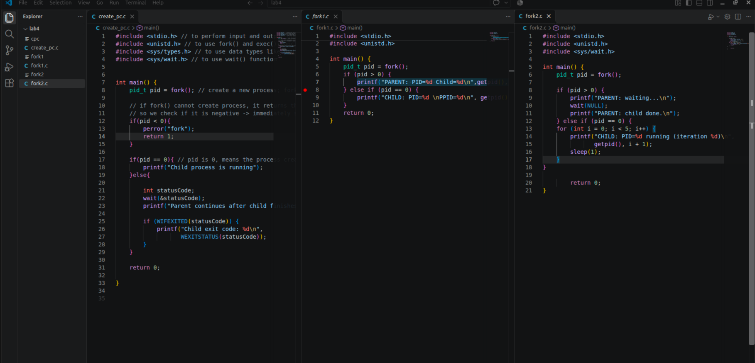

Task 2

Task 1
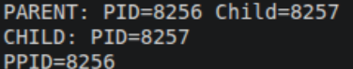

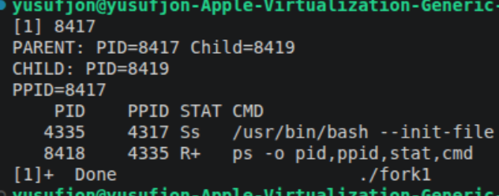

Task 3
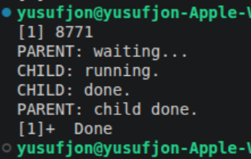

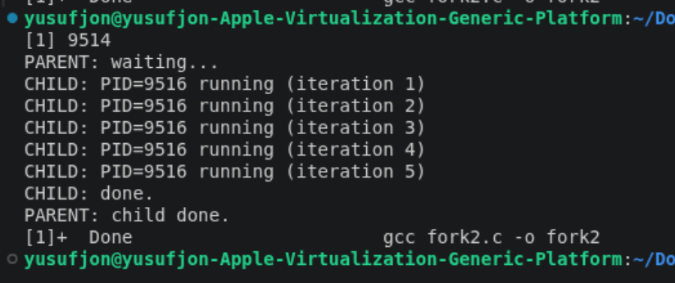
Task 5

Task 4.
I removed the wait and yes parent ran before child process ends

