Data structure - Final Exam
Name: Akhmedov Yusufjon Muhammad ugli
Major: Computer Engineering
Student Number: 202438404

Question 1
Explain the difference between open addressing and separate chaining in hash table collision resolution. In your answer, include their advantages and disadvantages
Answer: In open addressing, all data stays inside the hash table. If a spot is taken, the program looks for the next empty one. This is done using methods like linear probing. It saves memory because no extra space is used. But if many spots are full, finding a free one takes time. Also, deleting data is more difficult.
In separate chaining, each index has a linked list. If multiple keys go to the same index, they are added to the list. This makes it easy to insert and delete data. The table never gets full. But it uses more memory and can be slower if the list gets long.

Question 2
Describe the four rotation cases in AVL Trees and explain which insertion scenarios lead to each rotation. Illustrate your answer with simple tree examples or diagrams.
Answer: AVL Trees maintain balance by performing rotations when insertions cause imbalance. There are four rotation cases.
Left-Left (LL) Case occurs when insertion happens in the left subtree of the left child, causing imbalance. It is fixed by a single right rotation on the unbalanced node.
Right-Right (RR) Case happens when insertion occurs in the right subtree of the right child, causing imbalance. It is fixed by a single left rotation on the unbalanced node.
Left-Right (LR) Case arises when insertion takes place in the right subtree of the left child, causing imbalance. This requires two rotations: first a left rotation on the left child, then a right rotation on the unbalanced node.
Right-Left (RL) Case happens when insertion happens in the left subtree of the right child, causing imbalance. This also requires two rotations: first a right rotation on the right child, then a left rotation on the unbalanced node.

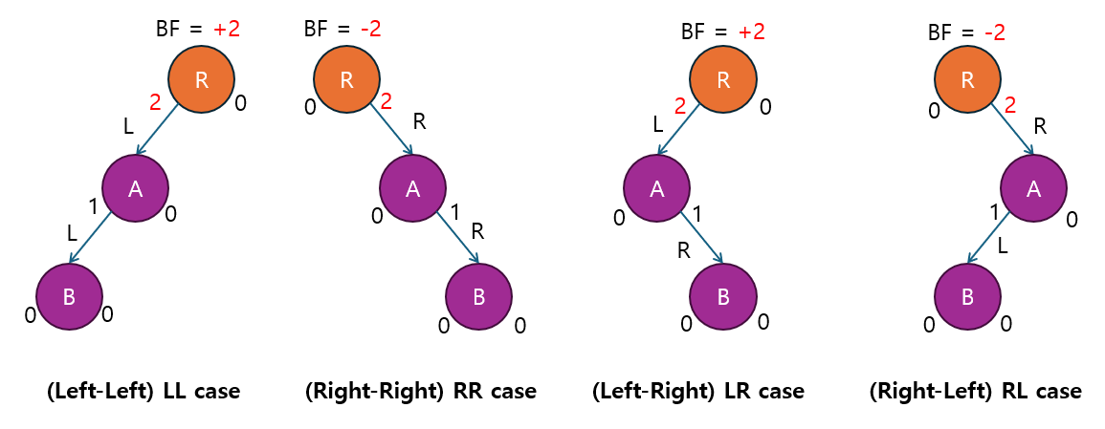
Question 3
Explain the difference between inorder, preorder, and postorder traversal in a binary tree. For the binary tree shown below, write the output of each traversal: | 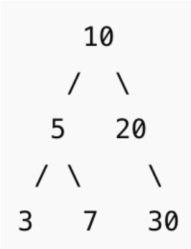

Answer: Inorder traversal visits nodes in the order left subtree, root, then right subtree, producing sorted output for binary search trees. Preorder traversal processes the root first, followed by the left and right subtrees, making it useful for copying tree structures. Postorder traversal explores the left and right subtrees before the root, which is ideal for safely deleting nodes.
Inorder result is 3 5 7 10 20 30
Preorder result is 10 5 3 7 20 30
Postorder result is 3 7 5 30 20 10
The core difference lies in whether the root is visited before, between, or after its subtrees.

Coding Answer 1
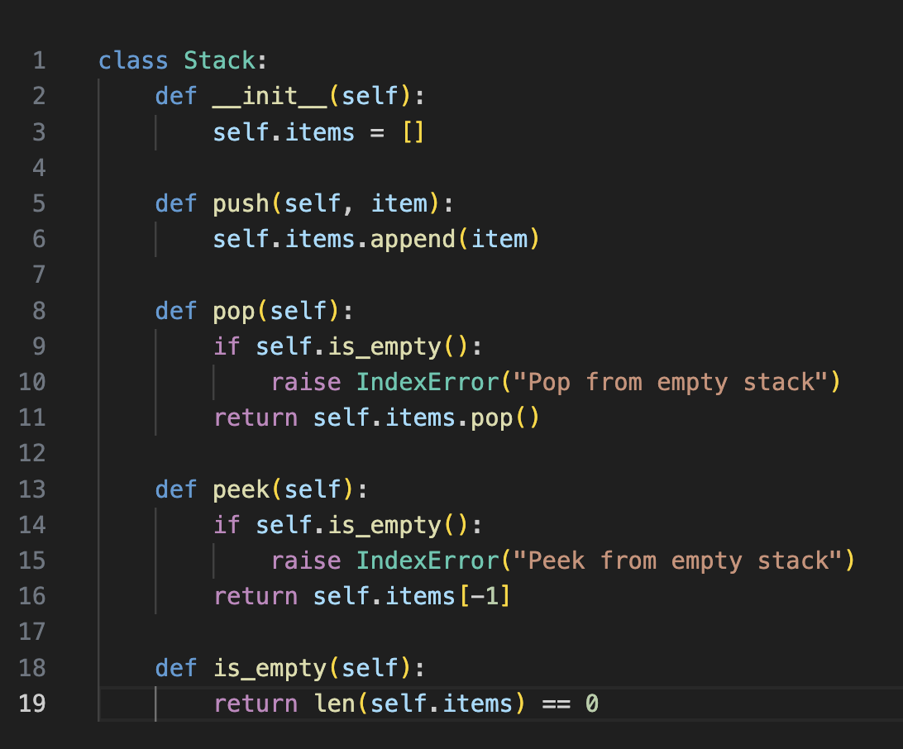

Coding Answer 2
