Database Management System – Homework #2
Student Full Name: 유수프존 (YUSUFJON AKHMEDOV MAKHAMMAD UGLI)
Student ID: 202438404
Due Date: 2025-9-28

HW1.
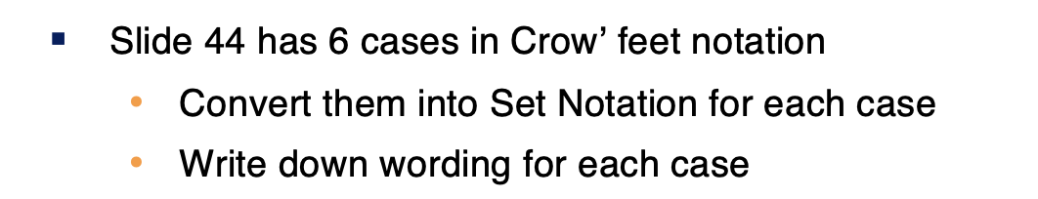
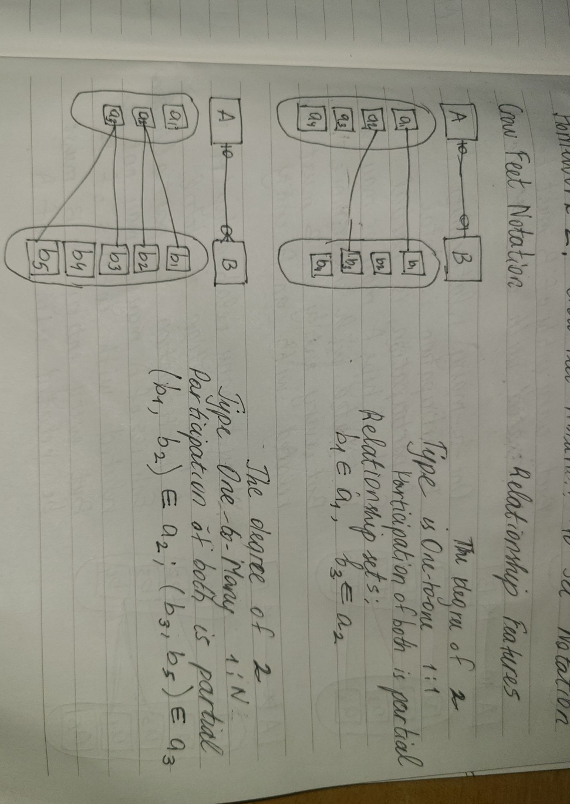
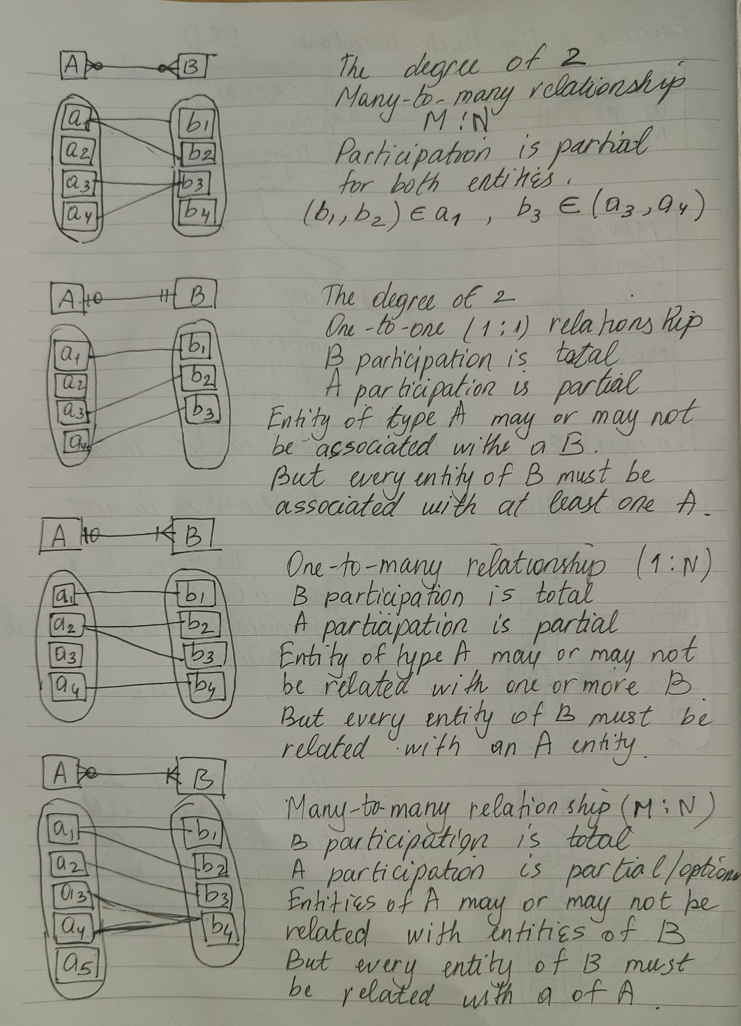
HW2.
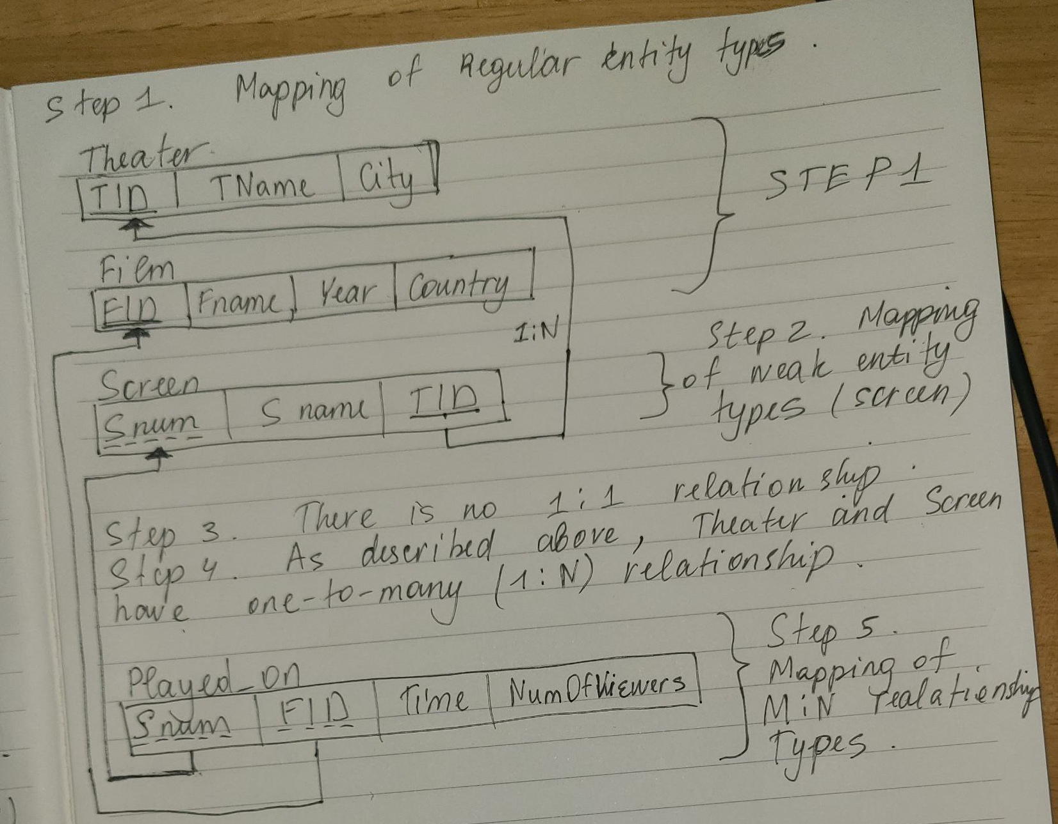
Step1: Regular Entity Types are Theater and Film, including the PKs such as TID and FID respectively
Step2: Weak Entity Type is only Screen, including Partial keys of SNum.
Step3. There is no 1:1 relationship that can be mapped
Step4: Theater and Screen ETs have 1:N relationship. Therefore, TID in Screen ET is referencing to PK of Theater Entity Type.
Step5. Played_ON(show) M:N Relationship was mapped.
This relationship includes SNum and FID Partial and Foreign Keys.
SNum in Played_ON ET is referencing to Snum of Screen Entity Type. Also FID in Played_ON ET is referencing to FID (PK) of Film ET.

