Data Modelling Projects Report

Course: Big Data / Data Modelling
Student Name / ID: AKHMEDOV YUSUFJON 202438404
Date: April 4th 2026

Projects Covered
1. Wine Quality Prediction (Regression) | 2. Titanic Survival Analysis (Classification)

1. Introduction
Data modelling is a core component of big data analytics, enabling practitioners to uncover patterns, build predictive systems, and derive actionable insights from large datasets. This report documents two applied data modelling projects carried out using Python.

The two projects address fundamentally different problem types:
- Project 1 – Wine Quality Prediction: A regression task that estimates a continuous quality score for red and white wines based on physicochemical features.
- Project 2 – Titanic Survival Analysis: A correlation and classification-oriented task that identifies factors influencing passenger survival using demographic and ticket data.

Both projects follow the same pipeline: data collection, preprocessing, exploratory analysis, modelling, and visualization of results.

2. Project 1: Wine Quality Prediction

2.1 Dataset Description
The dataset consists of two CSV files — one for red wine (1,599 records) and one for white wine (4,898 records) — sourced from the UCI Machine Learning Repository. After merging, the combined dataset contains 6,497 records with 13 columns (including the added type column). All 11 physicochemical input features are float64 with no missing values, and the target quality is int64.

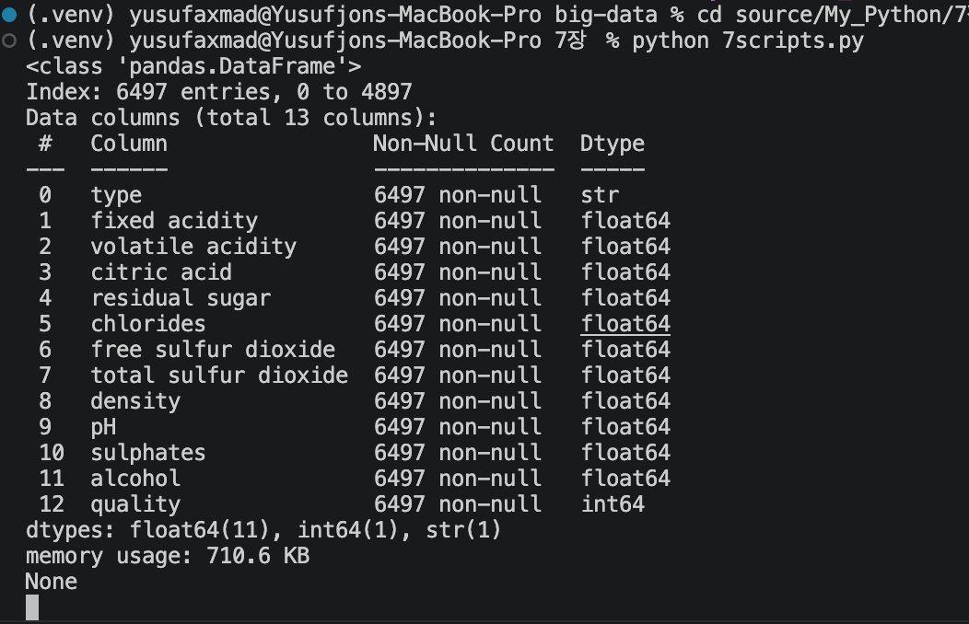
Figure 1: Wine dataset info() output — 6,497 records, 13 columns, no missing values

2.2 Data Preprocessing
- Semicolon-delimited CSV files were read using pandas with sep=';'.
- Column names with spaces were replaced using underscores for compatibility.
- Both datasets were merged using pd.concat() after inserting a type column.
- No missing values were present; the dataset required no imputation.

2.3 Model Used
An Ordinary Least Squares (OLS) linear regression model was applied via the statsmodels library using the formula API. The model was built on all 11 physicochemical features as predictors. An independent samples t-test was also conducted to compare mean quality between red and white wines before regression.

2.4 Results

Metric | Value
Model Type | OLS Linear Regression
Key Predictor | Alcohol (positive effect on quality)
Also Significant | Volatile acidity (negative), sulphates (positive)
T-test Result | Significant quality difference between red and white (p < 0.05)
Prediction Output | Continuous quality score (e.g., 5.62, 6.03)

The histogram below shows the quality distribution for red and white wines. Both peak at scores 5 and 6, with white wine having a sharper concentration around 6. The KDE curves confirm that both distributions are roughly bell-shaped, with red wine showing a slightly lower modal quality.

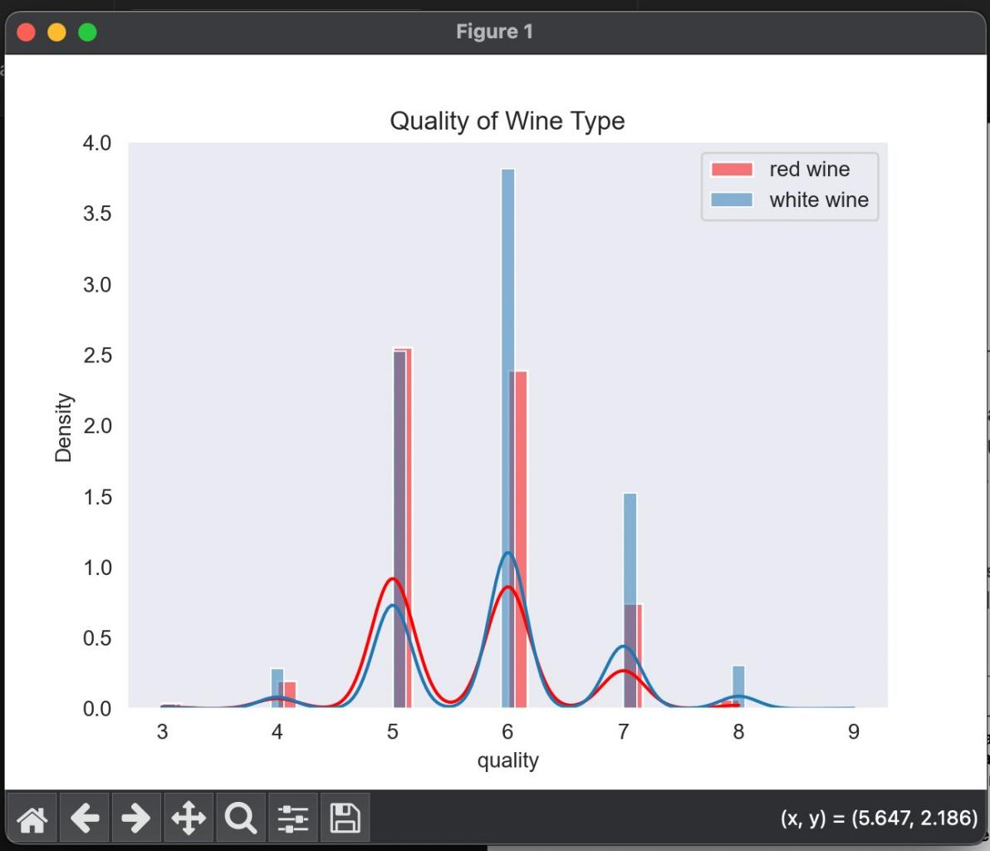
Figure 2: Quality distribution of red vs. white wine — density histogram with KDE overlay

2.5 Short Analysis
The linear regression model captured general trends in wine quality but has limitations. Wine quality is subjective and ordinal in nature, meaning that treating it as fully continuous introduces approximation error. The model explains directional feature impact but does not capture non-linear interactions. A more flexible model such as Random Forest would likely yield lower prediction error.

3. Project 2: Titanic Survival Analysis

3.1 Dataset Description
The Titanic dataset was loaded directly from the seaborn library (sns.load_dataset('titanic')). It contains 891 records with 15 features covering demographic information (age, sex), ticket details (pclass, fare, deck), and embarkation data. The binary target variable survived indicates whether a passenger survived (1) or did not (0).

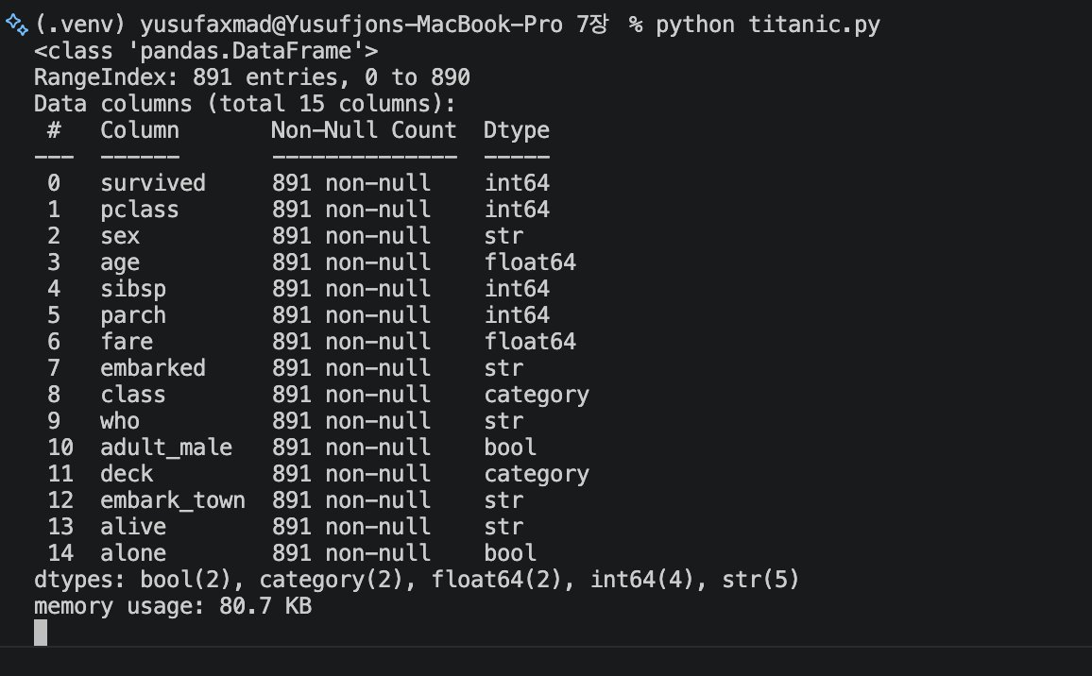
Figure 3: Titanic dataset info() output — 891 records, 15 columns after preprocessing

3.2 Data Preprocessing
- Missing age values (177 records) were filled with the median age.
- Missing embarked and embark_town values were filled with 'S' / 'Southampton' (most frequent).
- Missing deck values were filled with category 'C'.
- sex was encoded numerically (male=1, female=0) for correlation analysis.
- A new family feature was engineered as sibsp + parch + 1 (family size including self).
- age was bucketed into 10-year categories (age2) for heatmap analysis.

3.3 Model Used
The project focused on correlation analysis using Pearson's correlation coefficient rather than a supervised classifier. Pairwise correlations between numeric features and the survival outcome were computed and visualized. Pie charts, count plots, and a heatmap were the primary analytical tools.

3.4 Results

Feature | Correlation with Survival | Interpretation
sex (encoded) | High negative | Females survived at much higher rates
pclass | Moderate negative | Higher class number = lower survival
fare | Moderate positive | Higher fare = higher survival rate
adult_male | Strong negative | Adult males had the lowest survival
age2 | Weak negative | Younger passengers slightly more likely to survive
family | Weak positive | Small families had marginally better outcomes

The pie charts below clearly illustrate the survival disparity by sex. Among males, only 18.9% survived, while 74.2% of females survived — confirming sex as the strongest predictor.

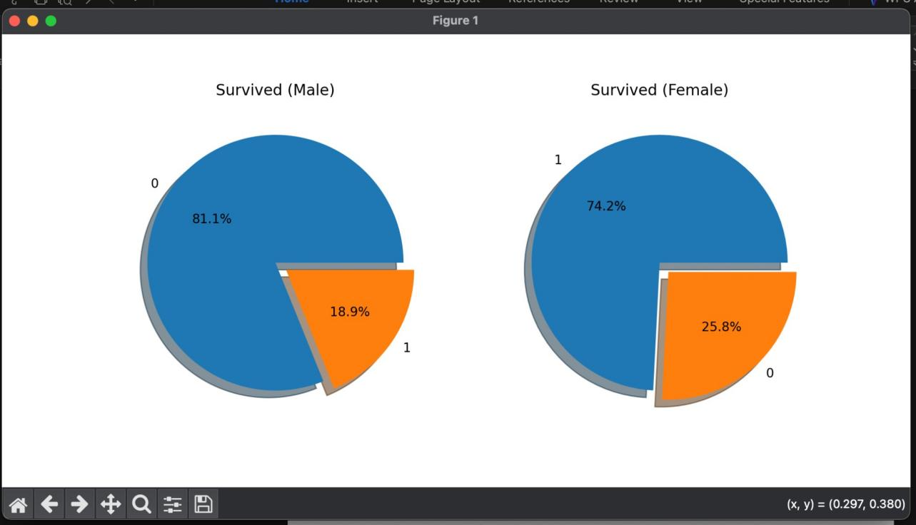
Figure 4: Survival rate by sex — male (18.9% survived) vs. female (74.2% survived)

3.5 Short Analysis
Correlation analysis provided clear insight into survival determinants. However, correlation does not imply causation, and several features are inter-correlated (e.g., sex and adult_male). A formal classifier such as Logistic Regression or Decision Tree would provide accuracy metrics. The dataset size (891 records) also limits generalizability.

4. Comparison of Both Projects

Dimension | Wine Quality (Project 1) | Titanic Survival (Project 2)
Problem Type | Regression (continuous target) | Correlation / Classification (binary)
Target Variable | Quality score (3–9) | Survived (0 or 1)
Preprocessing | Merge two CSVs, rename columns | Impute missing values, encode categories, engineer features
Model / Method | OLS Linear Regression | Pearson Correlation + Visualizations
Dataset Size | 6,497 records | 891 records
Main Finding | Alcohol strongest positive predictor | Sex and class are dominant factors
Visualization | Histogram + partial regression plots | Pie charts, heatmap, pairplot

Project 1 required merging heterogeneous data sources while Project 2 focused more heavily on feature engineering and imputation. Both projects confirmed that thoughtful preprocessing is as important as the modelling step itself.

5. Conclusion
These two projects illustrated how different data modelling approaches apply to different problem types. Linear regression suits continuous targets with quantifiable feature relationships, while correlation analysis and visualization are effective for understanding binary classification outcomes.

Key takeaways:
- Data preprocessing — missing value handling, encoding, feature engineering — directly determines model quality.
- Feature selection is critical: not all variables contribute equally.
- Visualization (histograms, pie charts, heatmaps) validates findings and communicates results clearly.
- Real-world datasets require substantial preparation before modelling can begin.

Future work could apply Random Forest for wine quality and Logistic Regression or XGBoost for Titanic survival, evaluated with cross-validation and formal metrics such as RMSE and AUC-ROC.

