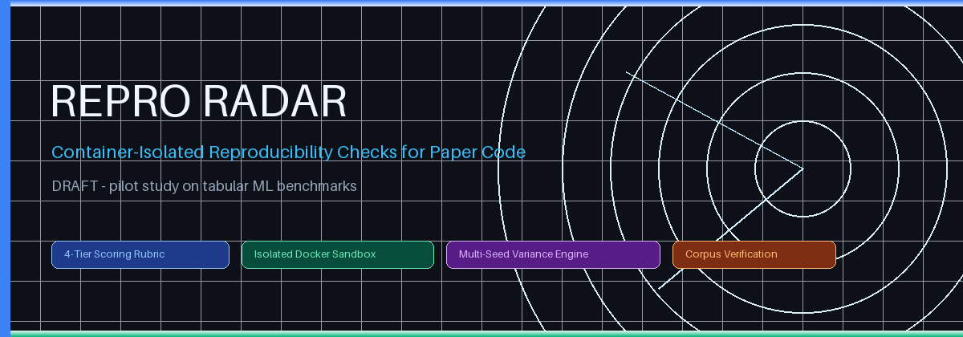
DRAFT — Repro Radar: Container-Isolated Reproducibility Checks for Computational Paper Appendices
A sandboxed audit tool and 4-Tier reproducibility rubric, evaluated as a pilot study on tabular ML benchmarks
Author & Lead Architect:  Yusuf Kartal (yusufkartal0009-eng)  Autonomous Systems & Empirical AI Research | Repository & Artifact Target:  appendix_controller_for_articles  GitHub: yusufkartal0009-eng/appendix_controller_for_articles
Scope:  Pilot study on tabular ML benchmarks (6 seed papers) | Evaluation Standard:  4-Tier Weighted Rubric (Build, Metrics, Stability, Artifacts)

📌 ABSTRACT (DRAFT)
Computational results can only be checked if the code, data, and environment behind them can be run again. Repro Radar is a tool that stages the code of a published paper, runs it inside a restricted Docker container, and compares the numbers it produces with the numbers the paper reports, using a 4-Tier rubric (build, metric agreement, seed stability, software hygiene). This draft describes a pilot study on tabular ML benchmarks. The sandbox's isolation properties are checked against a real Docker daemon in continuous integration; the seed corpus of 6 papers passes automated checks of links, repositories, licenses, and pinned scripts; no paper has been run end to end yet, and the rubric has so far only been exercised with simulated outputs. An AI component for diagnosing failed runs is planned but not implemented.

1. The Crisis of Empirical Reproducibility in Scientific Literature
Scientific results that depend on computation are only as checkable as the code behind them. Jon Claerbout argued for reproducible computational research in the early 1990s [1]. Donoho later recalled Claerbout's point, in a form paraphrased by Buckheit and Donoho [2]: “an article about computational result is advertising, not scholarship. The actual scholarship is the full software environment, code and data, that produced the result” [3]. Practices and tools for implementing reproducible research have since been collected in book form [4].
Concern about reproducibility is widespread: a Nature survey of 1,500 scientists described a ‘crisis’ in research reproducibility [5], and the NeurIPS 2019 reproducibility program published a report on improving reproducibility in machine learning research [6]. In deep reinforcement learning, reproducing state-of-the-art results is “seldom straightforward” because of non-deterministic benchmark environments and variance intrinsic to the methods [7]. The obstacles this project addresses, with evidence from its own pilot corpus, are:
- Code that moved or changed: in this project's seed corpus, repositories had been renamed and one target script had been deleted by a later rewrite of its code base, so papers must be pinned to an exact commit (docs/CORPUS_VERIFICATION.md).
- Numbers that do not trace to the paper: in the same corpus, only 2 of 16 recorded claims could be found in their papers; the rest must be re-extracted before they are compared (docs/CORPUS_VERIFICATION.md).
- Run-to-run and seed variance: results can vary between runs and random seeds, which makes a single reported number hard to interpret [7].
- Manual effort: re-running a paper requires reconstructing its environment, data, and hardware; this project aims to automate the parts that can be automated and to report the rest.

2. Architectural Principles of Container-Isolated Sandboxing
Running third-party code carries risks: it may make network calls, exhaust memory, or write to the host file system. Repro Radar mitigates these risks by running paper code only inside a restricted Docker container, and it refuses to run the code when Docker is unavailable. Each property in the table below is checked against a real Docker daemon in continuous integration (docs/SANDBOX_ACCEPTANCE.md). The container still shares the host kernel, so these measures reduce the risk but do not eliminate it.
Security Dimension | Implementation Mechanism | Operational Defense
Network | Docker '--network none' | Outbound TCP, DNS, and HTTPS fail inside the container (acceptance check 2).
Filesystem | '--read-only' root; repository mounted read-only | Writes to /, /usr, and the paper's repository fail with EROFS (check 3).
Writable scratch space | tmpfs /tmp and /workspace/home: noexec, nosuid | Code can write scratch files but cannot execute or load what it wrote (check 7).
User | Non-root UID:GID 1000:1000, no-new-privileges | Code runs without root privileges (check 1); this alone does not prevent container escapes.
Resources | --cpus=2.0, --memory=8g, --pids-limit=100 | Memory and process limits are enforced, and an out-of-memory kill is reported as OOM_KILLED (checks 8, 9); the CPU limit is set but not tested.

3. The Four-Tier (4-Tier) Reproducibility Rubric
Binary classifications of reproducibility ('reproduced' vs. 'not reproduced') fail to capture the nuanced realities of scientific software engineering. A codebase that compiles effortlessly, adheres to open-source licensing standards, and produces metrics within tolerance of the reported claims differs profoundly from one that crashes on import or yields wildly conflicting predictions. Repro Radar evaluates replication fidelity across four weighted tiers. The rubric is implemented in the code base, but at the time of writing it has only been exercised with simulated outputs, not with real paper runs:
Evaluation Tier | Weight | Evaluated Criteria | Target Objective
Tier 1: Build & Execution | 35% | Git cloning, dependency resolution, execution exit code 0 | Deterministic codebase compilability
Tier 2: Metric Alignment | 35% | Empirical claim concordance (default 5% tolerance) | Validation of quantitative findings
Tier 3: Seed Stability | 15% | Multi-seed variance (CV <= 2%), coefficient of variation | Mitigation of cherry-picked seeds
Tier 4: Software Hygiene | 15% | OSI license compliance, pinned environment files, logs | Long-term open-science sustainability

4. Scope and Current Status
This work is a pilot study on tabular ML benchmarks. The seed corpus contains 6 papers. All 6 pass automated checks of their paper link, repository, license, and target script at a pinned commit, but none has been run end to end yet, and only 2 of their 16 recorded claims have been found in the papers so far (docs/CORPUS_VERIFICATION.md). Other scientific fields are out of scope for this pilot.
Planned next steps are a small pilot run of the seed papers in the sandbox, extraction of claims directly from the papers with quoted evidence, and a report of which papers could and could not be reproduced and why.

5. References
[1] Claerbout, J. F., & Karrenbach, M. (1992). Electronic documents give reproducible research a new meaning. SEG Technical Program Expanded Abstracts 1992, 601–604. https://doi.org/10.1190/1.1822162
[2] Buckheit, J. B., & Donoho, D. L. (1995). WaveLab and reproducible research. In Wavelets and Statistics (Lecture Notes in Statistics, pp. 55–81). Springer. https://doi.org/10.1007/978-1-4612-2544-7_5
[3] Donoho, D. L. (2010). An invitation to reproducible computational research. Biostatistics, 11(3), 385–388. https://doi.org/10.1093/biostatistics/kxq028
[4] Stodden, V., Leisch, F., & Peng, R. D. (Eds.). (2014). Implementing reproducible research. CRC Press. https://doi.org/10.1201/b16868
[5] Baker, M. (2016). 1,500 scientists lift the lid on reproducibility. Nature, 533(7604), 452–454. https://doi.org/10.1038/533452a
[6] Pineau, J., et al. (2021). Improving reproducibility in machine learning research (a report from the NeurIPS 2019 reproducibility program). Journal of Machine Learning Research, 22(164), 1–20. https://jmlr.org/papers/v22/20-303.html
[7] Henderson, P., Islam, R., Bachman, P., et al. (2018). Deep reinforcement learning that matters. Proceedings of the AAAI Conference on Artificial Intelligence, 32(1). https://doi.org/10.1609/aaai.v32i1.11694

