*Preparation of Papers in Two Column Format for the Journal Inform*

First Author1, Second Author2, Third Author3

*1 Informatics Engineering Department, Dr. Soetomo University Surabaya, Indonesia*

*2,3 School of Electrical and Informatics Engineering Bandung Institute of Technology, Indonesia*

1 [author1@unitomo.ac.id](mailto:author1@unitomo.ac.id) (*)

2,3 [author2, author3]@stei.ac.id

Received: xx-xx-xxxx; Accepted: xx-xx-xxxx; Published: xx-xx-xxxx

***Abstract*—** This document gives formatting instructions for authors preparing papers for publication in the Inform journal. The authors must follow the instructions given in the document for the papers to be published. You can use this document as both an instruction set and as a template into which you can type your own text. Abstract should be no longer than 400 words. It gives a brief summary of the content of the paper and point out the main objective, the methods employed, the results obtained and major conclusions.

***Keywords***— **Include 5 – 6 keywords or phrases, keywords are separated by a semicolon.**

1. Introduction

The INTRODUCTION section discusses the background of the problem, discusses the complete literature, the purpose and objectives of the study.

1. Research Methodology

This section explains in detail the research conducted. Briefly describe the material and methods used in the study, including the subject/material studied, the tools used, the design of the experiment or design used, the sampling technique, the variables to be measured, the technique of data collection, analysis, and statistical models used. Successive quotes in parentheses [1].

1. Result and Discussion

The results of the study should be written clearly and densely. The discussion should describe the significance of the research results, not repeat them. Avoid using citations and excessive discussion of published literature.

1. *Format of Writing*

The paper size must be in accordance with A4 page size, which is 210 mm (8,27 ") wide and 297 mm (11,69") long. Margin limits are determined as follows:

• Top = 19 mm (0,75 ")

• Bottom = 43 mm (1,69 ")

• Left = Right = 14,32 mm (0,56 ")

The article discussed must be in a two-column format with a space of 4,22 mm (0,17 ") between columns.

The paragraph must be organized. All paragraphs must be flat, which are equally flat left and right and right.

1. *Number of Pages*

The number of pages submitted to the journal information is between 6 and 15 pages.

1. *Letters of Documents*

All documents must be in Times New Roman or Times font. Type 3 fonts may not be used. Other font types can be used if needed for special purposes.

1. *Title and Author*

The title must be in the Regular type 18 pt font. The author's name must be in the Regular 11 pt font. Author affiliation must be in Italic 10 pt. The email address must be at 9 pt Regular font.

Titles and authors must be in a single column format and must be centered. Each initial word in the title must be uppercase except for short words such as, "a", "and", "in", "by", "for", "from", "on", "or", and the like.

Writing the author may not indicate a position name (for example a Supervisor), any academic degree (eg Dr) or membership from any professional organization (eg IEEE Senior Members).

To avoid confusion, the surname is written in the last part of each author's name (eg John AK Smith). Each affiliate must include, at least, the name of the institution where the author is based (for example, the Informatics Engineering Study Program at Dr. Soetomo University Surabaya).

An email address is required for the corresponding author (corresponding author). Information as the correspondent writer is written with a sign (*).

1. *Heading Section*

We recommend that there be no more than 3 levels for headings. All writing must be in 10pt font. Each word for heading must be uppercase except for short words as listed in Section III-D.

1. *Heading Level-1*: Level 1 heading must be in *Small Caps*, located in the middle and using uppercase Roman numeral numbering. For example, see the title "III. RESULT AND DISCUSSION " of this document. Titles with heading 1 that are not numbered are "ACKNOWLEDGEMENTS" dan "REFERENCES".
2. *Heading Level-2:* Level 2 heading must be italicized, close to the left and number using uppercase alphabets. For example, see the heading "*E. Headings Section*" above.
3. *Heading Level-3:* Level 3 heading must be written indented, slanted and numbered with Arabic numerals followed by right brackets. Heading level 3 must end with a colon. Serials follow heading titles with the same line. For example, this verse begins with heading level 3.
4. *Pictures and Image Descriptions*

The image must be centered. Large images can be stretched in both columns. Each image that includes more than 1 column width must be positioned either at the top or at the bottom of the page. The image is not given a border (border) outside the image area.

Color graphics are possible. For colored graphics, make sure the colors are sufficiently contrasted to distinguish one line from another. For black and white graphics, use different types of lines (for example solid lines, dotted lines, dotted lines, etc.).

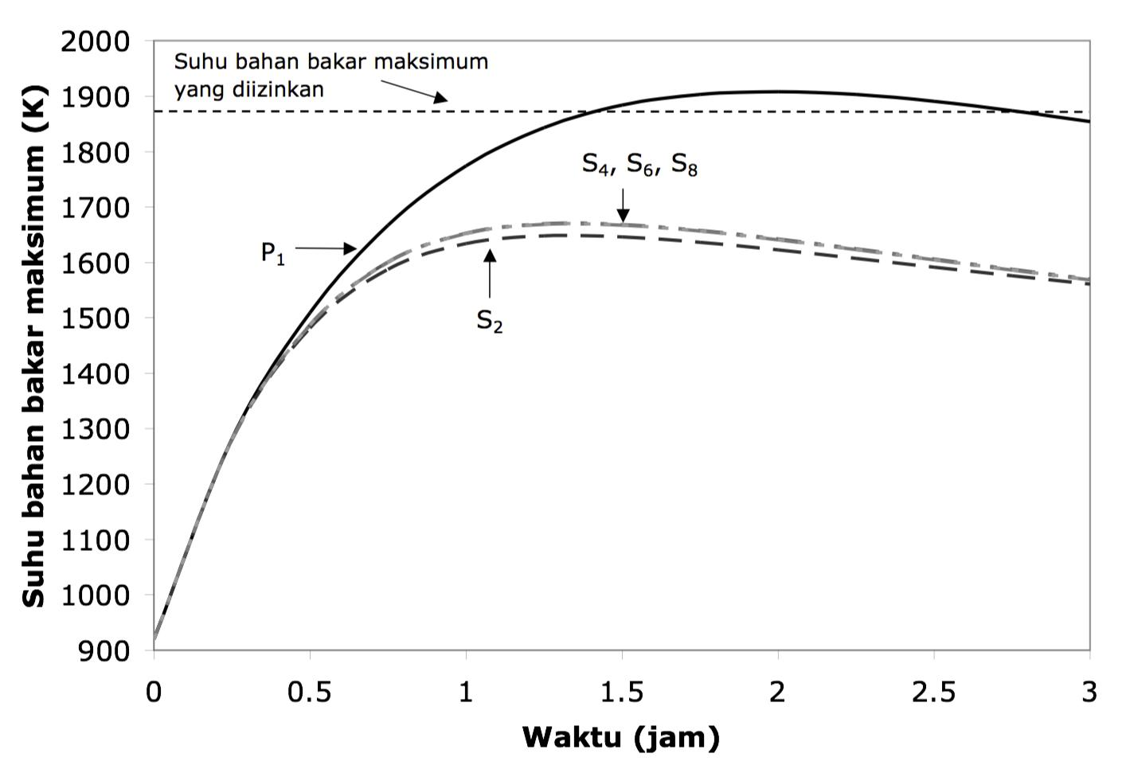

Figure 1. Example of a line graph using black and white. Note the writing of labels and units on horizontal and vertical axes.

Labels on both the horizontal and vertical axis can often be confusing. Therefore, as much as possible use words, and not just symbols. Give units in parentheses, but label writing should not only be in units without sufficient explanation. Examples of writing the right label are "Temperature (K)" or "Temperature, Tmax (K)". Examples of incorrect label writing are "Tmax" or "(K)".

Use consistent and uniform fonts on the graph. The recommended fonts are Times New Roman (or Times), Arial (or Helvetica), Symbol and Courier.

Make sure that the image resolution is enough to reveal important details on the image. For images sourced from JPG files, make sure it has a resolution of 300 dpi. Figure 2 shows an example of a low-resolution image that is not in accordance with the provisions, while Figure 3 shows an example of an image with sufficient resolution.

Image captions are placed at the bottom of the image. Captions use 8 pt Regular fonts and are numbered using Arabic numerals. Image captions in one row (for example, Figure 2) are placed in the center (centered), while image captions with more than one line must be left (eg Figure 1). Image captions with image numbers must be placed in accordance with the relevant points, as shown in Figure 1-3 unless large images exceed one column.

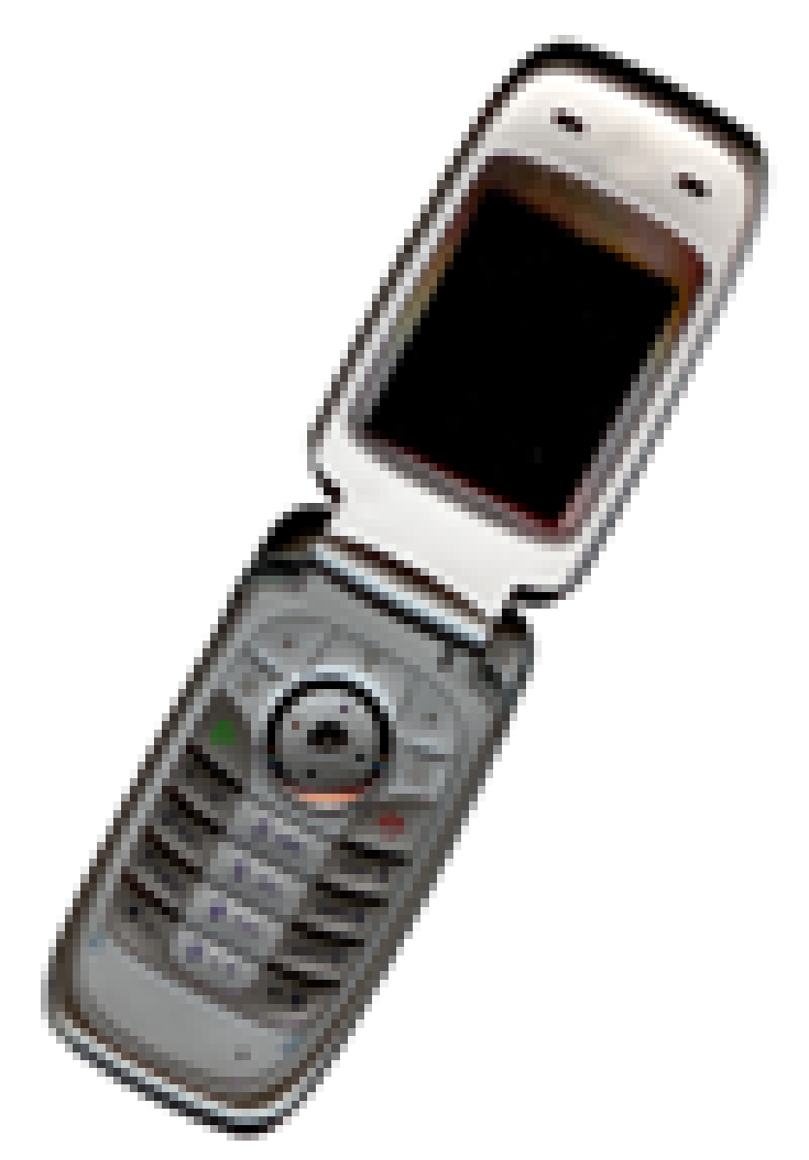

Figure 2. Examples of images with less resolution

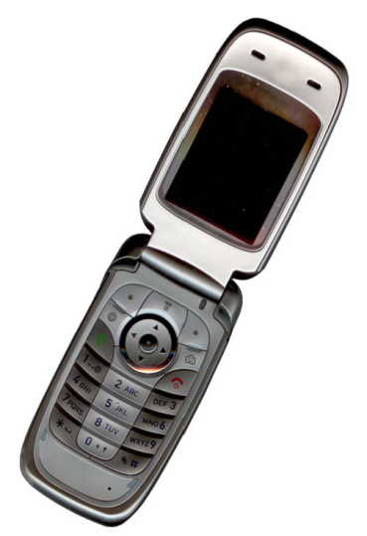

Figure 3. Examples of images with enough resolution

1. *Tables and Descriptions*

Tables must be centered. Large tables can be stretched in both columns or rotated vertically. Each table or image that includes more than 1 column width must be positioned either at the top or at the bottom of the page.

Tables and table titles are written with an 8 pt Regular font. Tables are numbered using uppercase Roman numerals. Each initial word in the table title uses uppercase letters except for short words as listed in Section III-D and written using Small Caps. Table numeric information is placed before the related table. The contents of the table are written in the middle. Note that in the table there are no vertical lines. Examples of tables can be seen in Table I.

Tabel I

Potentials Of Some Conversion Of Radionuklida

| **Nuklida** | **Energi Neutron** | | |
| --- | --- | --- | --- |
| **Termal** | **Epitermal** | **Cepat** |
| Pu-239 | 1,09 | 0,9 | 1,9 |
| U-233 | 1,20 | 1,3 | 1,5 |
| U-235 | 1,07 | 0,8 | 1,3 |

1. *Equations*

The equation is written in the middle. Use the Microsoft Equation Editor or MathType add-on. Don't copy and paste the equations from other files in the form of pdf or jpg. Equation numbering is written right-aligned with Arabic numbers in parentheses. Examples of writing equations can be seen in Equation (1) below.

 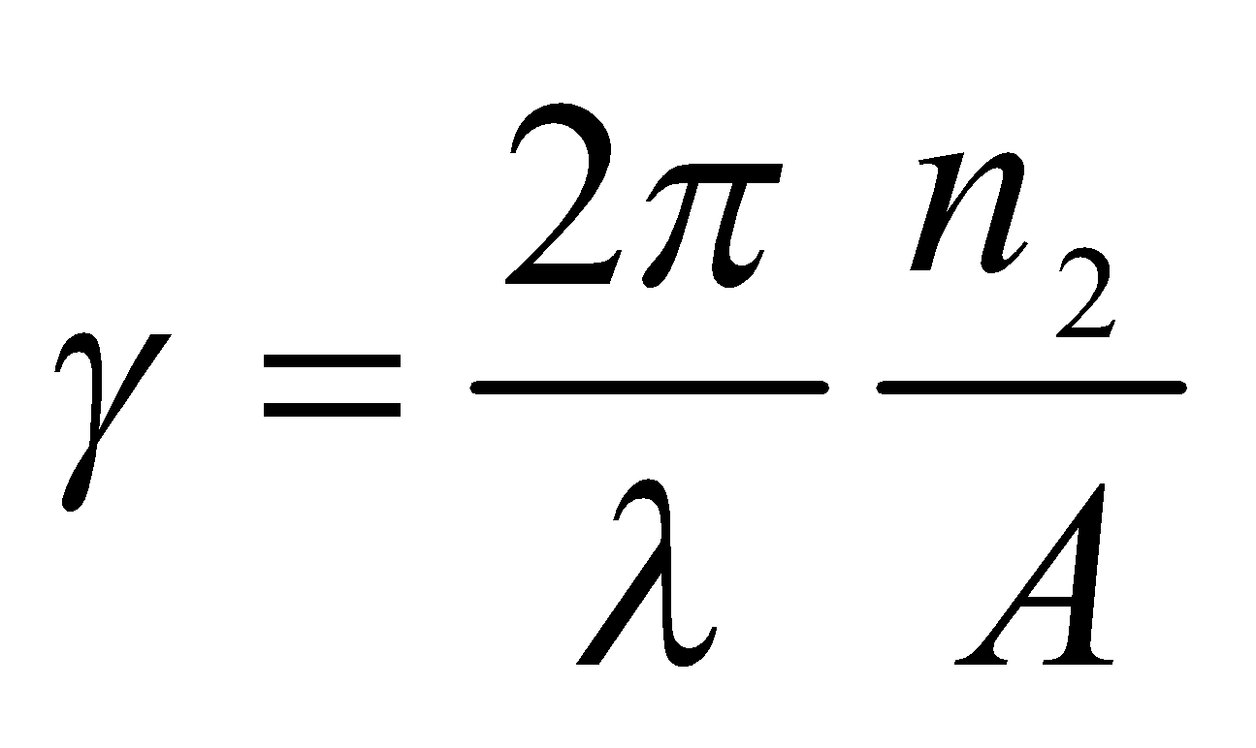 (1)

Use the following sizes in the Microsoft Equation Editor:

* Full : 10 pt
* Subscript / Superscript : 5 pt
* Sub-subscript / superscript : 3 pt
* Symbol : 16 pt
* Sub-symbol : 10 pt

1. *Page Numbers, Headers and Footers*

Page numbers, headers, and footers are only used in print editions but are not used in online publications.

1. *Links and Bookmarks*

All hypertext links and bookmark sections will be deleted. If the paper needs to refer to the e-mail address or URL in the article, the full address or URL must be written in normal font.

1. *References*

Titles in the Reference section may not be numbered. All reference items in 8 pt font. Please use Regular Italic and style to distinguish various fields as shown in the References section. The reference number must be written sequentially in square brackets (for example [1]).

When referring to a reference item, please use a reference number only, as in [2]. Don't use "Ref. [3]" or "Reference [3]" except at the beginning of the sentence, for example, "Reference [3] indicates that ...". Reference to several references by writing each number with separate brackets (for example [2], [3], [4] - [6]). Some examples of reference items with different categories displayed in the References section include:

* examples for books on [1]
* example of a book in the series in [2]
* sample journal articles in [3]
* sample seminar papers in [4]
* examples of patents in [5]
* sample websites on [6]
* an example of a web page in [7]
* sample manual database in [8]
* sample datasheet on [9]
* sample master's thesis in [10]
* sample technical reports [11]
* standard examples in [12]

1. Conclusion

Conclusions contain the main points of the article. Conclusions should not repeat what was written in the Digest section, but discussed. This section should also show whether the research objectives can be achieved.

The conclusions are written in paragraph description. Avoid using bulleted lists.

Acknowlegment

This section gives appreciation to individuals and organizations who provide assistance to the author. Thank you to the sponsors and financial support in this section.

Reference

1. S. M. Metev and V. P. Veiko, *Laser Assisted Microtechnology*, 2nd ed., R. M. Osgood, Jr., Ed. Berlin, Germany: Springer-Verlag, 1998.
2. J. Breckling, Ed., *The Analysis of Directional Time Series: Applications to Wind Speed and Direction*, ser. Lecture Notes in Statistics. Berlin, Germany: Springer, 1989, vol. 61.
3. S. Zhang, C. Zhu, J. K. O. Sin, and P. K. T. Mok, “A novel ultrathin elevated channel low-temperature poly-Si TFT,” *IEEE Electron Device Lett.*, vol. 20, pp. 569–571, Nov. 1999.
4. M. Wegmuller, J. P. von der Weid, P. Oberson, and N. Gisin, “High resolution fiber distributed measurements with coherent OFDR,” in *Proc. ECOC’00*, 2000, paper 11.3.4, p. 109.
5. R. E. Sorace, V. S. Reinhardt, and S. A. Vaughn, “High-speed digital-to-RF converter,” U.S. Patent 5 668 842, Sept. 16, 1997.
6. (2002) The IEEE website. [Online]. Available: http://www.ieee.org/
7. M. Shell. (2002) IEEEtran homepage on CTAN. [Online]. Available: http://www.ctan.org/tex-archive/macros/latex/contrib/supported/IEEEtran/
8. “PDCA12-70 data sheet,” Opto Speed SA, Mezzovico, Switzerland.
9. A. Karnik, “Performance of TCP congestion control with rate feedback: TCP/ABR and rate adaptive TCP/IP,” M. Eng. thesis, Indian Institute of Science, Bangalore, India, Jan. 1999.
10. J. Padhye, V. Firoiu, and D. Towsley, “A stochastic model of TCP Reno congestion avoidance and control,” Univ. of Massachusetts, Amherst, MA, CMPSCI Tech. Rep. 99-02, 1999.
11. *Wireless LAN Medium Access Control (MAC) and Physical Layer (PHY) Specification*, IEEE Std. 802.11, 1

This is an open access article under the [CC–BY-SA](http://creativecommons.org/licenses/by-sa/4.0/) license.