

Task 1 – Dataset (Penguins)

Neural Network



November 6, 2022

CS - H28

Students Info.

|  |  |
| --- | --- |
| Name | ID |
| عائشة سليمان فتح الله خليل | 20191700330 |
| مصطفى أيمن عوض عمر | 20191700640 |
| مصطفي اشرف برهامي محمود | 20191700639 |
| يوسف علاء الدين شاكر تركي | 20191700920 |
| يوسف ناصر صابر بيلاطس | 20191700794 |

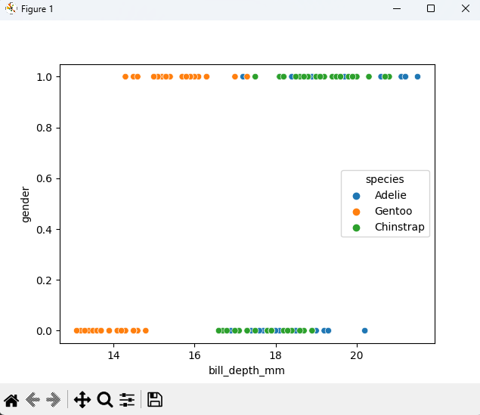

Figure 1 The data above using features "Gender " and “Bill Depth" shows that:

1. between class "Gentoo" & "Chinstrap": there is a line to separate them linearly.
2. between class "Gentoo" & "Adelie": there is no line to separate them linearly.
3. between class "Adelie" & "Chinstrap": there is no line to separate them linearly.

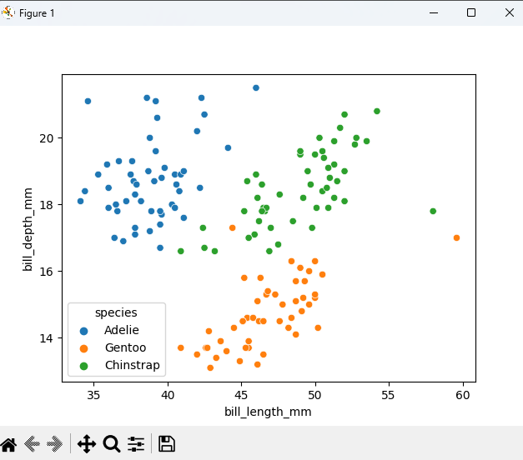

Figure 2 The data above using features "Bill length " and “Bill Depth" shows that:

between class "Gentoo" & "Chinstrap": there is a line to separate them linearly.

between class "Gentoo" & "Adelie": there is a line to separate them linearly.

between class "Adelie" & "Chinstrap": there is no line to separate them linearly.

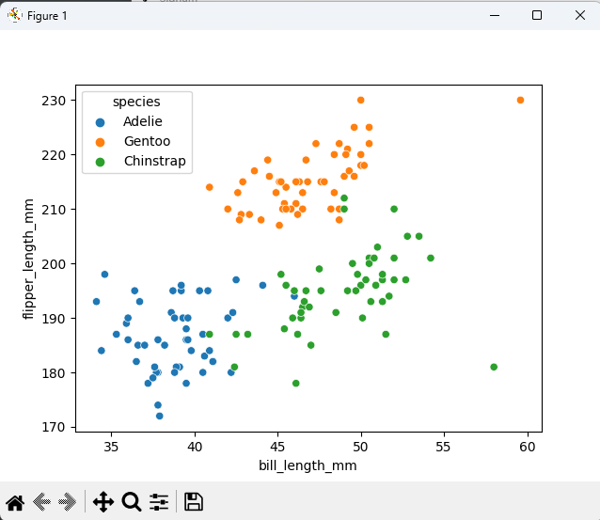

Figure 3 The data above using features " Bill Length" and "Flipper Length " shows that:

1. between class "Gentoo" & "Chinstrap": there is no line to separate them linearly.
2. between class "Gentoo" & "Adelie": there is no line to separate them linearly.
3. 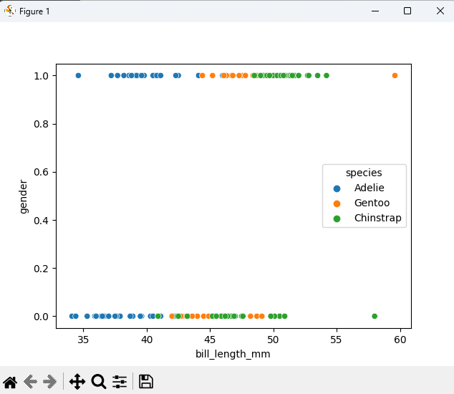between class "Adelie" & "Chinstrap": there is no line to separate them linearly.

Figure 4 The data above using features "Bill length " and “Gender" shows that:

1. between class "Gentoo" & "Chinstrap": there is no line to separate them linearly.
2. between class "Gentoo" & "Adelie": there is no line to separate them linearly.
3. between class "Adelie" & "Chinstrap": there is no line to separate them linearly.

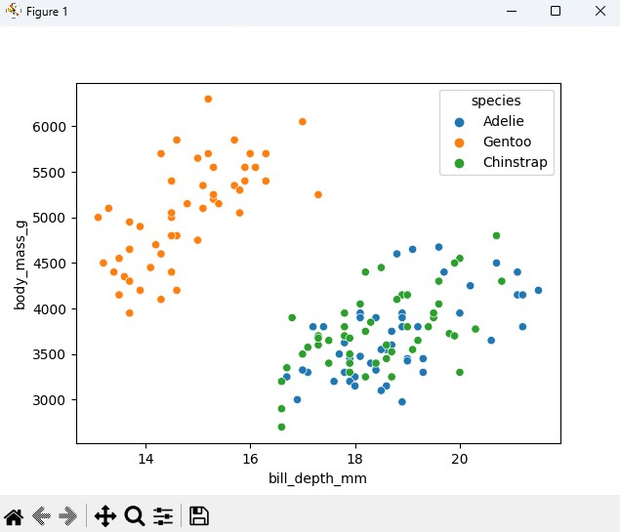

Figure 5 The data above using features " Bill Depth" and "Body Mass " shows that:

1. between class "Gentoo" & "Chinstrap": there is a line to separate them linearly.
2. between class "Gentoo" & "Adelie": there is a line to separate them linearly.
3. Chart, scatter chart

   Description automatically generatedbetween class "Adelie" & "Chinstrap": there is no line to separate them linearly

Figure 6 The data above using features " Bill Length" and "Body Mass " shows that:

1. between class "Gentoo" & "Chinstrap": there is no line to separate them linearly.
2. between class "Gentoo" & "Adelie": there is no line to separate them linearly.
3. between class "Adelie" & "Chinstrap": there is no line to separate them linearly

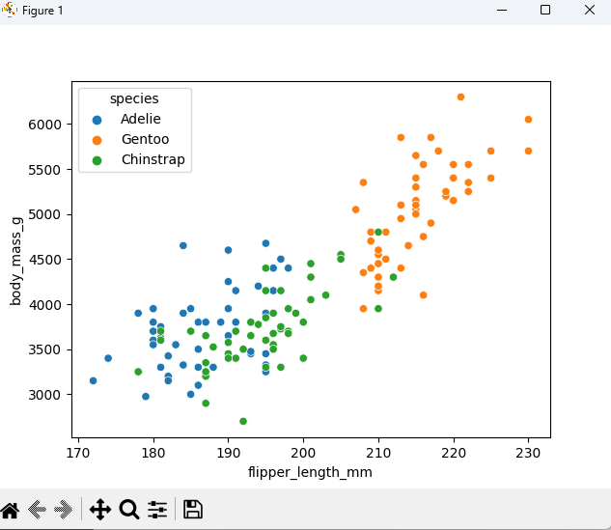

Figure 7 The data above using features " Flipper Length" and "Body Mass " shows that:

1. between class "Gentoo" & "Chinstrap": there is no line to separate them linearly.
2. between class "Gentoo" & "Adelie": there is no line to separate them linearly.
3. Graphical user interface

   Description automatically generatedbetween class "Adelie" & "Chinstrap": there is no line to separate them linearly

Figure 8 The data above using features " Gender" and "Body Mass " shows that:

1. between class "Gentoo" & "Chinstrap": there is no line to separate them linearly.
2. between class "Gentoo" & "Adelie": there is no line to separate them linearly.
3. between class "Adelie" & "Chinstrap": there is no line to separate them linearly

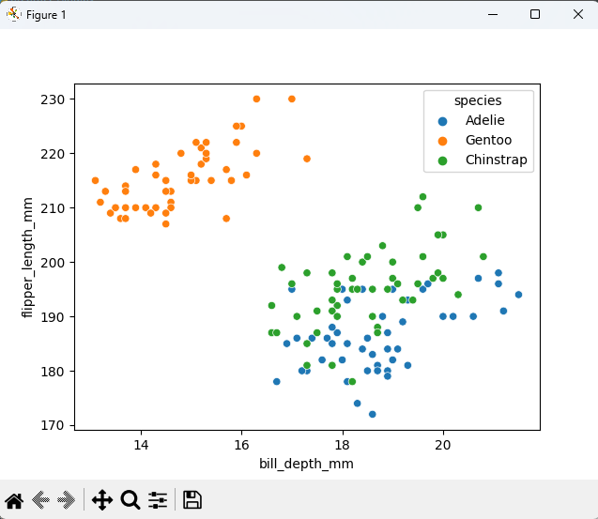

Figure 9 The data above using features " Flipper Length" and "Bill Depth " shows that:

1. between class "Gentoo" & "Chinstrap": there is a line to separate them linearly.
2. between class "Gentoo" & "Adelie": there is a line to separate them linearly.
3. 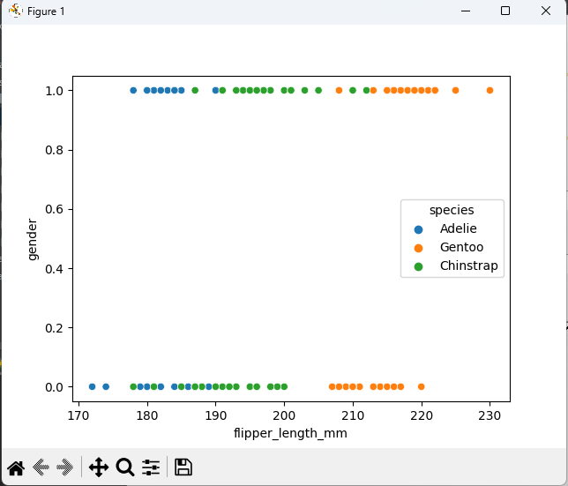between class "Adelie" & "Chinstrap": there is no line to separate them linearly

Figure 10 The data above using features " Flipper Length" and "Bill Depth " shows that:

1. between class "Gentoo" & "Chinstrap": there is no line to separate them linearly.
2. between class "Gentoo" & "Adelie": there is a line to separate them linearly.
3. between class "Adelie" & "Chinstrap": there is no line to separate them linearly

.

Analysis:

The features that achieved the highest accuracy after running our algorithm:

**Adelie and Chinstrap:**

* from this screenshot we could see that the best features to discriminate between "Adelie" and “Chinstrap” classes are “bill_length_mm” and “bill_depth_mm” which get 97.5% accuracy. We can conclude that with these features we can linearly separate the two classes.

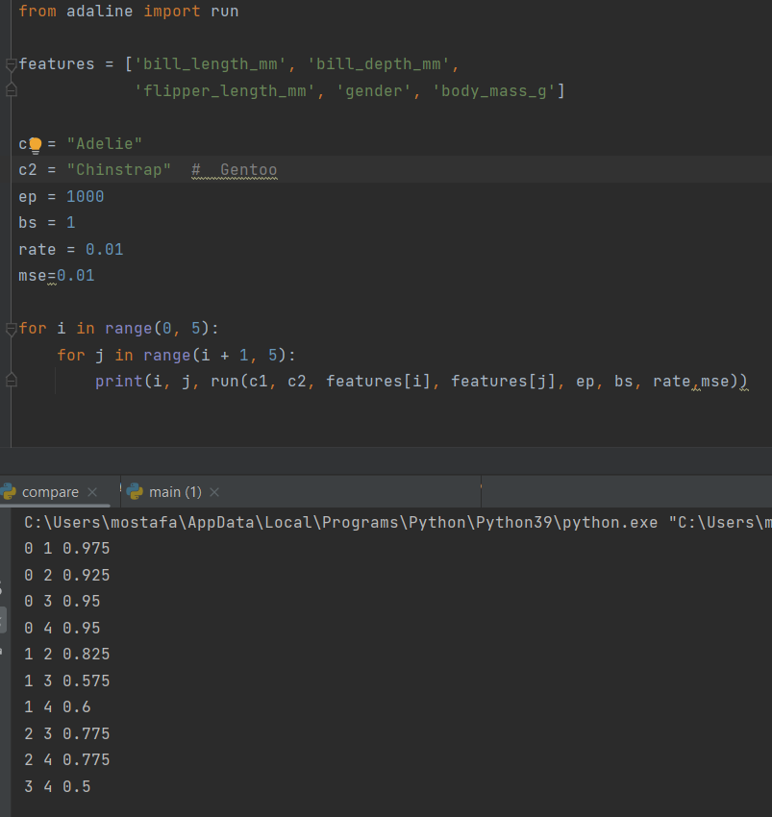

**“Gentoo" and “Chinstrap”:**

* from this screenshot we could see that the best features to discriminate between " **Gentoo**" and “Chinstrap” classes are “bill_length_mm” and “body_mass_g” which get 100% accuracy. Also features “bill_depth_mm” and “flipper_length_mm” get 100% accuracy, and features “bill_depth_mm” and “body_mass_g” get 100% accuracy.

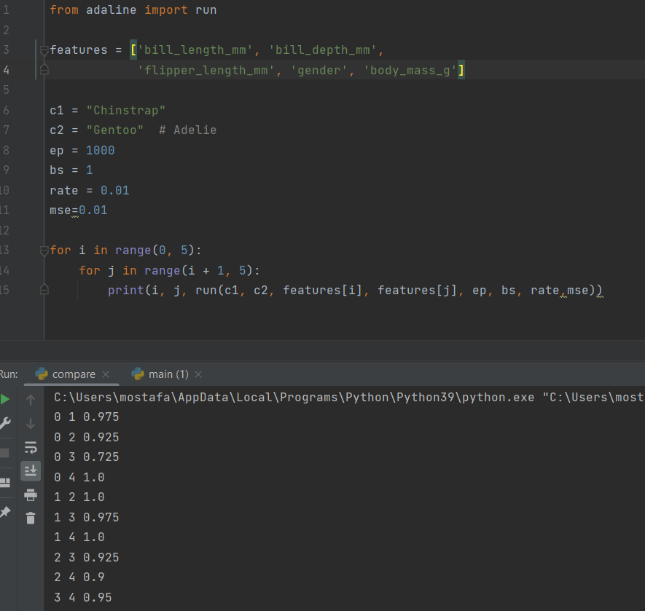

**“Gentoo" and “Adelie”:**

* from this screenshot we could see that the best features to discriminate between "Gentoo" and “Chinstrap” classes are “bill_length_mm” and “flipper_length_mm” which get 100% accuracy. Also, other features combinations get 100% accuracy as shown below.

