1. Creating and Renaming Files/Directories
Create a directory named test_dir using mkdir.
Inside test_dir, create an empty file called example.txt.
Rename example.txt to renamed_example.txt using mv
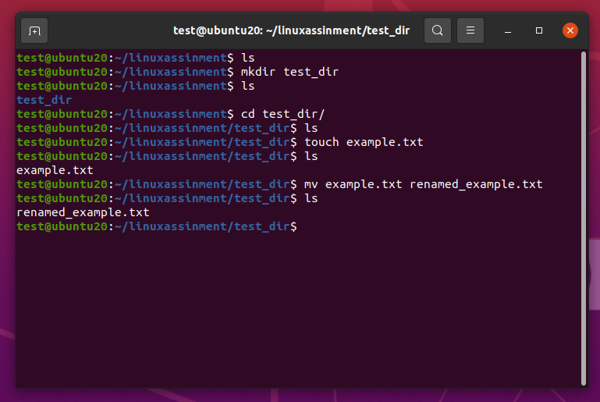
Explanation:-
First, ls command was used to list the contents of the current directory.
Then, mkdir test_dir command was executed to create a new directory named test_dir.
Next, cd test_dir command was used to inside into the newly created directory.
Inside test_dir directory, touch example.txt command was used to create an empty file named example.txt.
After that, mv example.txt renamed_example.txt command was executed to rename the file from example.txt to renamed_example.txt.

2. Viewing File Contents
Use cat to display the contents of /etc/passwd.
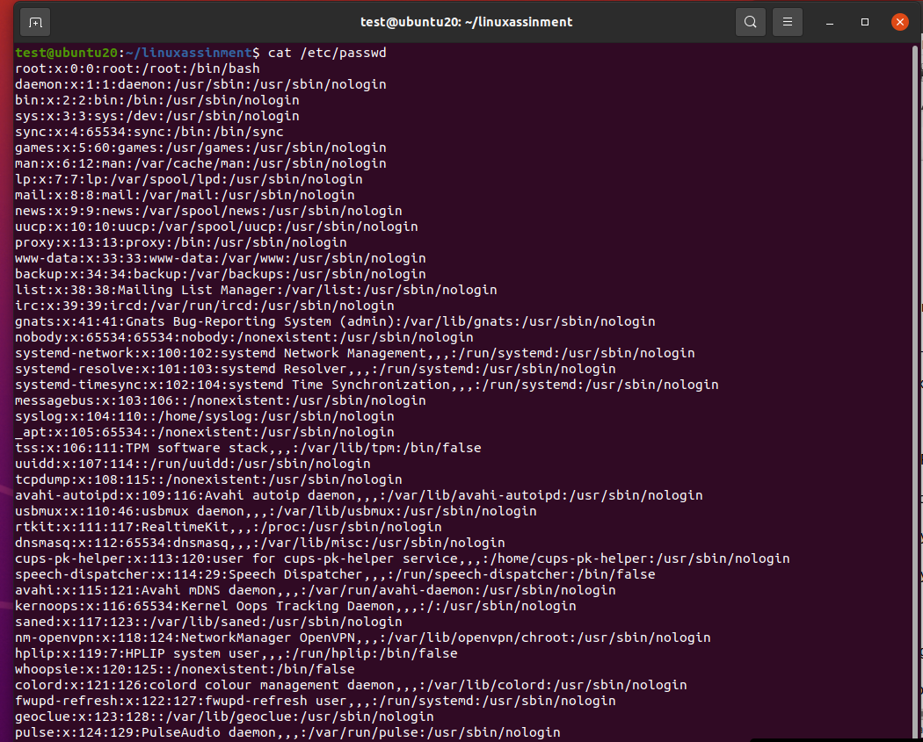
Explanation:
Cat /etc/passwd command use for show the all content of /etc/passwd file.
Display only the first 5 lines of /etc/passwd using head.
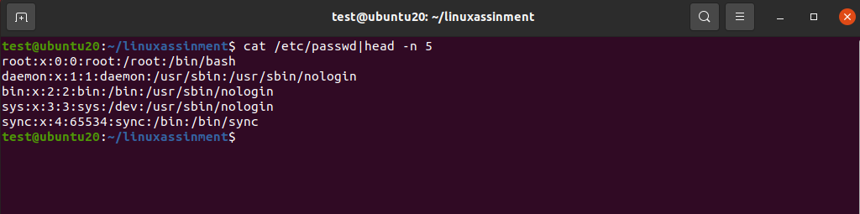
Explanation:
Cat /etc/passwd |head -n 5 command used to show the top(first) 5 line of content of /etc/passwd file.

Display only the last 5 lines of /etc/passwd using tail.
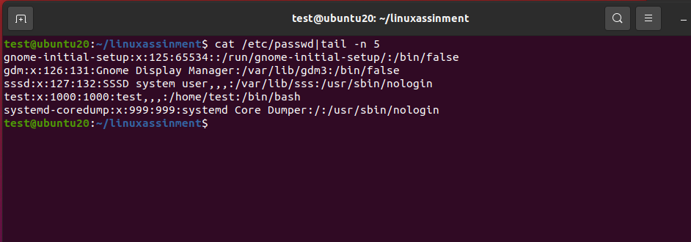
Explanation:
Cat /etc/passwd |tail -n 5 command used to show the bottom(last) 5 line of content of /etc/passwd file.

3.Searching for Patterns
Use grep to find all lines containing the word "root" in /etc/passwd.
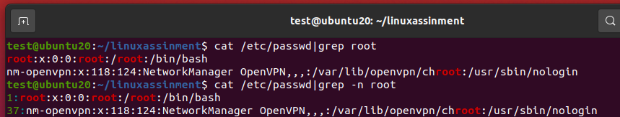
Explanation:
cat /etc/passwd | grep root is used to search and display all lines containing the word "root" from the /etc/passwd file.
cat /etc/passwd | grep -n root is used to search and display all lines containing the word "root" along with line number from the /etc/passwd file.

4. Zipping and Unzipping
Compress the test_dir directory into a file named test_dir.zip using zip.
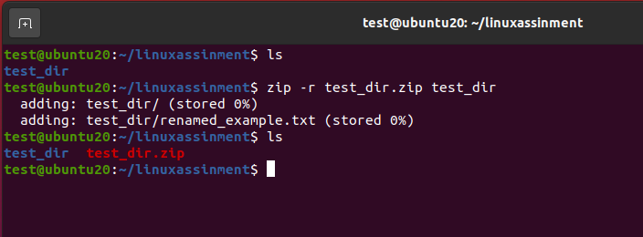
Explanation:
zip -r test_dir.zip test_dir command compresses the directory test_dir into a zip file named test_dir.zip.

Unzip test_dir.zip into a new directory named unzipped_dir.
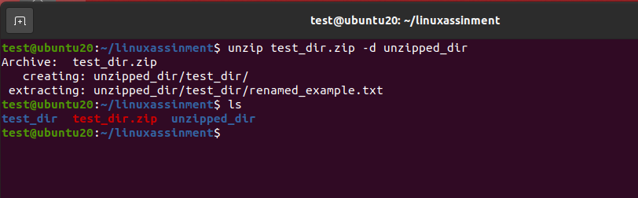
Explanation:
unzip test_dir.zip -d unzipped_dir command extracts the contents of test_dir.zip into a new directory named unzipped_dir

5. Downloading Files
Use wget to download a file from a URL (e.g., https://example.com/sample.txt).
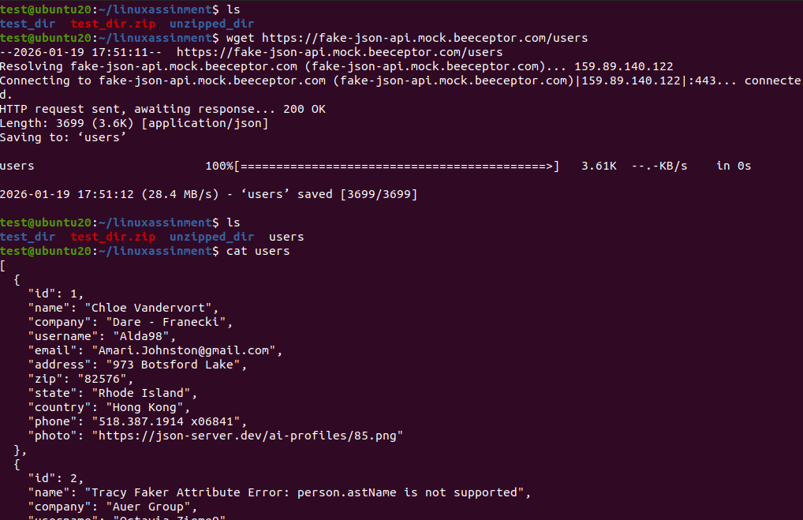
Explanation:
wget https://fake-json-api.mock.beeceptor.com/users command is used to download a file from the internet. In this example, it downloads users from the given URL. And also cat command show content of this file

6. Changing Permissions
Create a file named secure.txt and change its permissions to read-only for everyone using chmod.
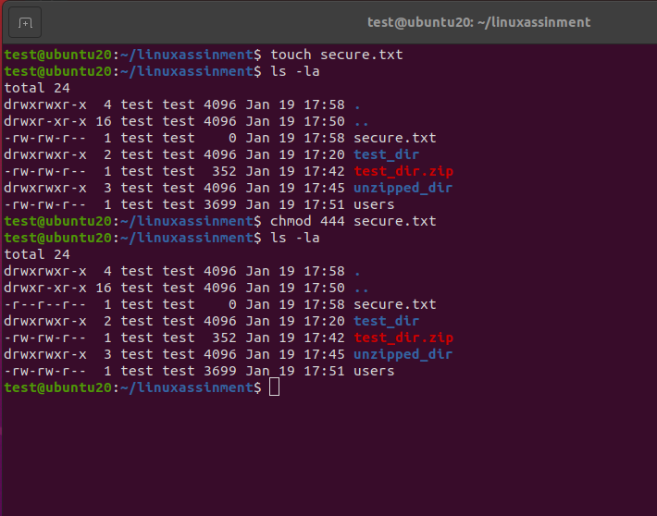
Explanation:
The first touch command creates a file named secure.txt. And then the chmod 444 secure.txt command sets the file permissions to read-only for everyone.

7. Working with Environment Variables
Use export to set a new environment variable called MY_VAR with the value "Hello, Linux!".
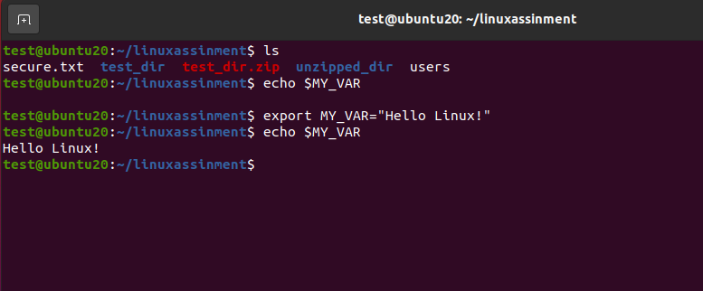
Explanation:
The export MY_VAR=”Hello Linux!” command creates a new environment variable named MY_VAR with the value Hello, Linux!.
The echo $MY_VAR command is used to display the value of the environment variable to verify it.

Submission Guidelines -: Attach Screenshots or command along with explanation and submit in doc(google doc or microsoft doc) format also attach github repo link

