
بسم الله الرحمن الرحيم
Al-Al Bayt University
Prince Hussein bin Abdullah Faculty of Information Technology
Computer Information Systems
Name Of Project : ProManager
Prepare by :
Majed Jameel Ismail Mohammed 2200902090
Yusuf Maher Wahed Saleh 2200902091
Supervisor :
Dr. Baraah Ahmad

Table of contents

- Chapter 1: Introduction --------------------------- Page (3)
  - Introduction ---------------------------------- Page (3)
  - Problem Statement -------------------------- Page (4)
  - Proposed Solution --------------------------- Page (4)
  - Beneficiaries --------------------------------- Page (5)
  - Project Objectives --------------------------- Page (5)
  - Tools & Software ---------------------------- Page (6)
- Chapter 2 : SDLC -------------------------------- Page (7)
  - Planning ------------------------------------ Page (8)
  - Analysis ------------------------------------ Page (12)
  - Design --------------------------------------- Page (13)
  - Implementation ----------------------------- Page (29)
  - Testing --------------------------------------- Page (40)
  - Maintenance -------------------------------- Page (42)

- Chapter 3 : Conclusion ---------------------------- Page (43)
3.1 Conclusion ------------------------------------- Page (43)
3.2 Results ------------------------------------------ Page (44)
3.3 Problems Encountered ------------------------ Page (44)
3.4 Future Work ------------------------------------ Page (45)
3.5 References -------------------------------------- Page (46)

Chapter 1

1.1 Introduction
“ProManager” is a web-based academic project management system designed to facilitate the organization, submission, evaluation, and monitoring of graduation projects within higher education institutions. The system targets the inefficiencies inherent in traditional academic workflows by digitizing and centralizing all interactions between students, supervisors, and administrators.
In conventional environments, project handling is fragmented across multiple channels such as email, messaging applications, and physical submissions. This fragmentation leads to poor traceability, version confusion, and inconsistent evaluation practices. “ProManager” introduces a unified digital environment where all academic activities related to project management are systematically recorded and controlled.
The system leverages server-side scripting using PHP, combined with a relational database (MySQL), to provide a structured and persistent data management solution. It ensures accessibility, accountability, and efficiency while maintaining simplicity in design and usability.

1.2 Problem Definition
The development of “ProManager” is driven by several critical challenges observed in academic institutions:

- Communication Latency: Relying solely on face-to-face meetings or informal emails often results in significant delays in feedback, hindering the student's progress.
- Unstructured Submission Methods: The use of primitive media (USB drives, social media, or unorganized email threads) for submitting reports and source code leads to file loss and versioning errors.
- Physical Attendance Hardships: Students in their final semester or summer sessions often undergo field training. Requiring their physical presence at the university for every project update creates a logistical burden.
- Administrative Complexity: Manual tracking of supervisor loads and student departmental affiliations is prone to human error.
These issues collectively reduce productivity, increase error rates, and negatively impact the academic experience for all stakeholders.

1.3 Proposed Solution
“ProManager” provides a structured web application that integrates all project-related processes into a single system.

Key Features:
- Secure Authentication System
  - Login functionality with session management
  - Password reset using OTP verification
- Role-Based Access Control
  - Separate dashboards for Admin, Doctor, and Student
  - Controlled access to system features
- Project Submission Module
  - File upload functionality
  - Storage of project metadata (title, description, timestamp)
- Evaluation Module
  - Grade assignment by supervisors
  - Feedback and notes system
- Announcement System
  - Admin-controlled publishing
  - Visible across all user dashboards
- Database Integration
  - Persistent storage of all records
  - Structured retrieval and updates
This solution transforms the academic workflow into a traceable, secure, and efficient digital system.

1.4 Beneficiaries

Students
- Submit and manage project files
- Access grades and feedback
- Receive official announcements

Doctors (Supervisors)
- Review student submissions
- Assign grades and notes
- Monitor project progress

Administrators
- Manage system users
- Publish announcements
- Oversee platform operations

1.5 Project Goals

For Students:
- Simplify project submission process
- Provide transparency in grading and feedback

For Supervisors:
- Centralize project evaluation
- Improve efficiency in reviewing submissions

For Administrators:
- Automate user and announcement management
- Reduce manual coordination effort

Technical Goals:
- Build a secure authentication system
- Ensure reliable file handling
- Maintain database integrity
- Provide scalable system architecture

1.6 Tools and Software Used

Hardware:
- Intel Core i5 (or equivalent)
- 16GB RAM
- 512GB SSD

Software:
- PHP (Backend processing)
- MySQL (Database system)
- XAMPP (Local server environment)
- HTML, CSS (Frontend structure and design)
- JavaScript (Client-side logic)

Development Techniques:
- Session management ($_SESSION)
- File handling ($_FILES)
- SQL query execution
- Form-based data processing

Chapter 2

The system follows the traditional SDLC phases:
- Planning
- Analysis
- Design
- Implementation
- Testing
- Maintenance
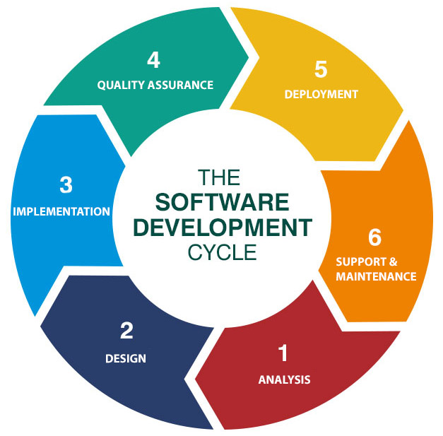

2.1 Planning

Project Scope Definition
The system was planned as a web-based application to manage graduation projects within a university environment. The scope includes:
- User authentication and role management (Admin, Doctor, Student)
- Project submission and file management
- Supervisor evaluation and grading system
- Announcement management
- Basic security features such as session handling and password reset

Pic from the questionnaire


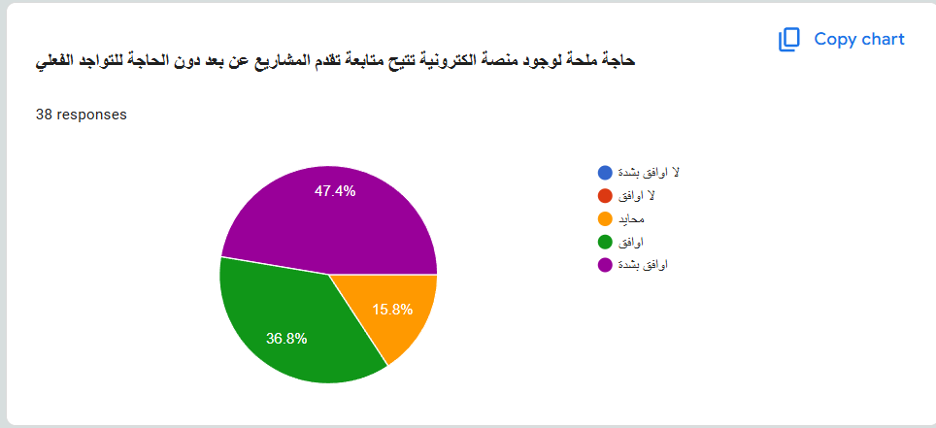

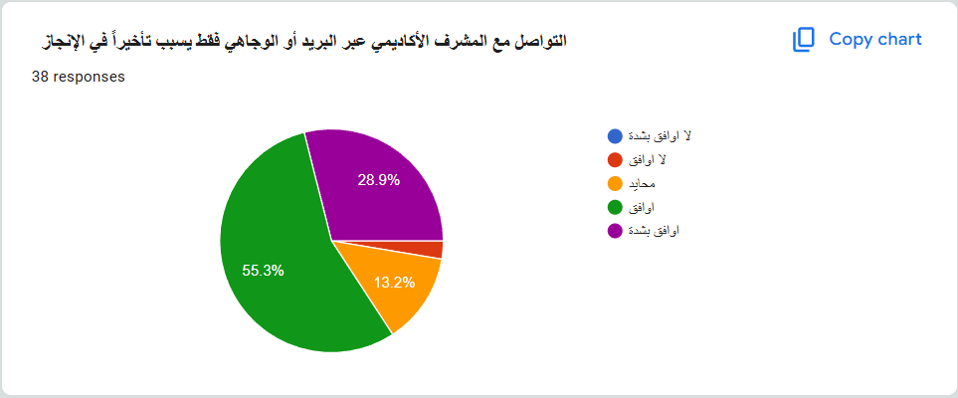

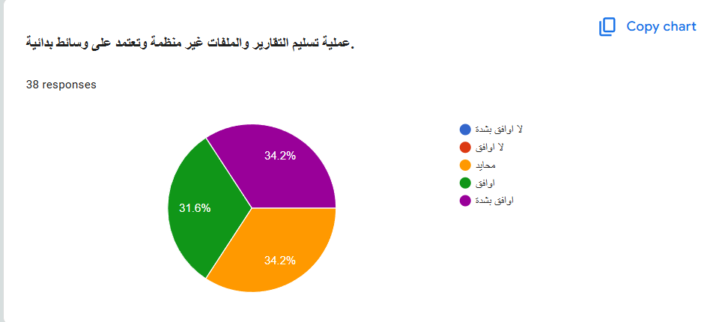




- What We Do & Learn from this questionnaire?
- Make this project from the questionnaire
- Make a supervisor of the project show your project and rate it from the website, without coming to his office
- Hand the report by online , not worth it to come to the college and hand the reports to supervisors
- Rate every phase at alone , to let the student what is good for him in his project and what is not
- Less waste of information by using Emails, Whatsapp ,etc…..

By knowing all of the above and more we had to begin our work on this project

Project Schedule :
The project schedule for “ProManager” was developed to organize the development process into manageable phases and ensure completion within the academic timeline. The schedule follows the main stages of the System Development Life Cycle (SDLC), beginning with planning and ending with testing and documentation.
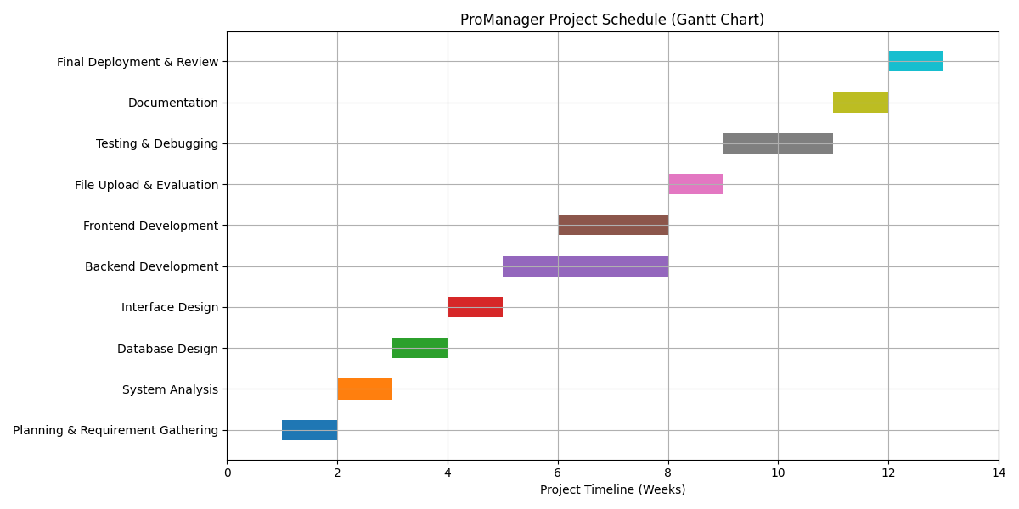

2.2 Analysis

Functional Requirements:
- User login and authentication
- Role-based redirection
- Project upload functionality
- File storage and retrieval
- Project grading and feedback
- Announcement creation
- Password reset via OTP

Non-Functional Requirements:

Security
- Session-based authentication
- OTP verification mechanism
- Risks identified:
  - Lack of input sanitization
  - Possible SQL injection vulnerabilities

Performance
- Lightweight PHP structure ensures fast execution
- Minimal server resource consumption

Usability
- Simple navigation
- Clear role-based dashboards

Scalability
- Limited due to monolithic design
- Can handle small to medium user base

2.3 Design

System Architecture
The system follows a three-tier structure:
- Presentation Layer (HTML/CSS)
- Application Layer (PHP)
- Data Layer (MySQL)

Presentation Layer (HTML/CSS)
User Login Page:
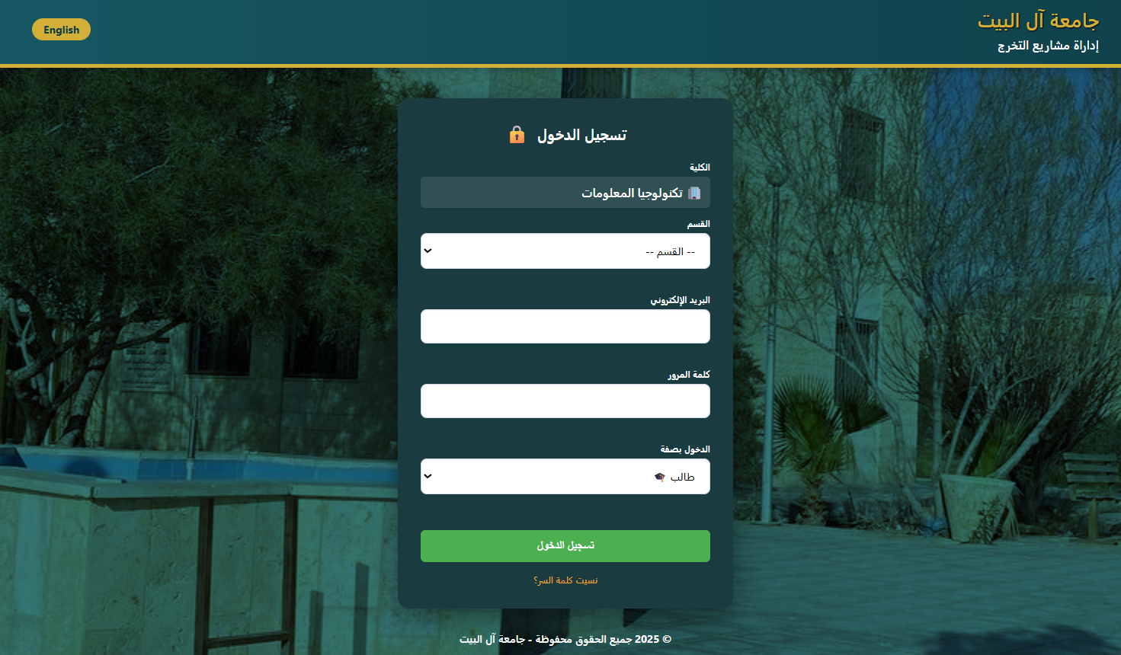

Admin Login Page :

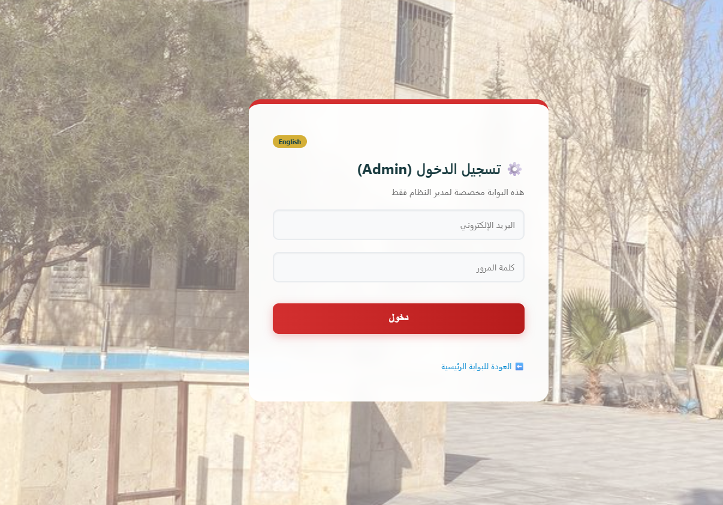

Application Layer :

Index.php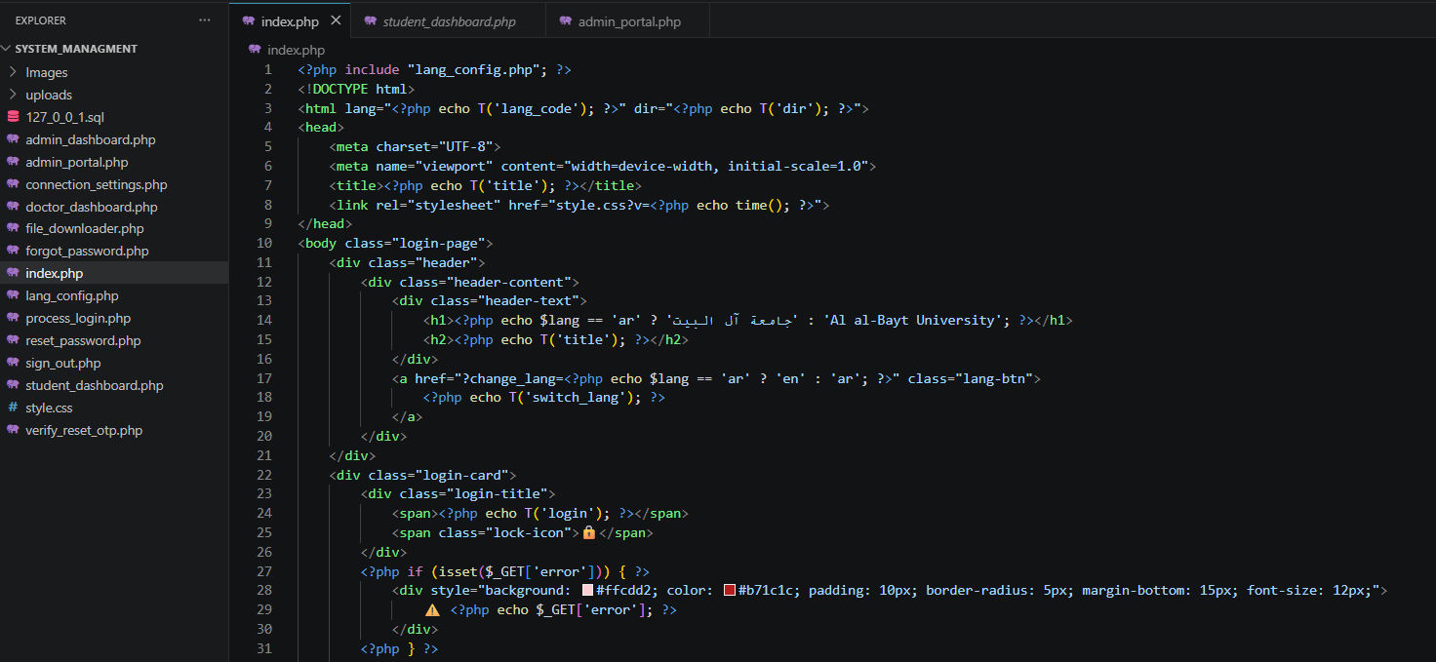Student_dashboard: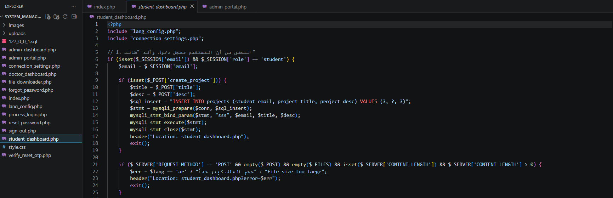Admin_portal :

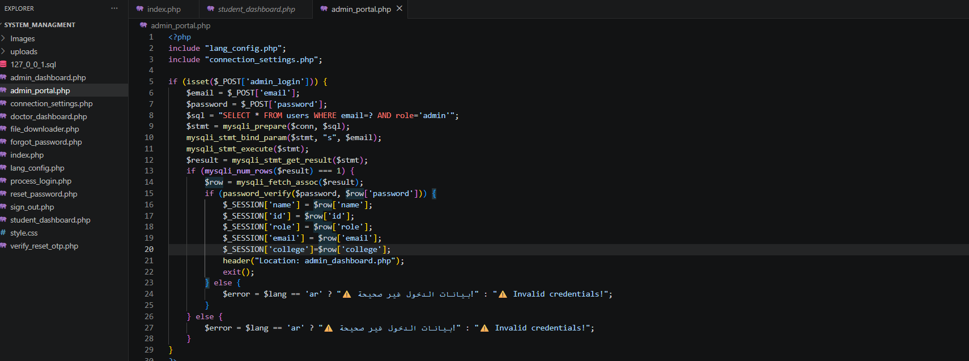

Data Layer :

Admins:
- email
  - Purpose: Acts as the Primary Key for the table. It stores the unique university email address of the administrator and serves as their primary login identifier.
- password
  - Purpose: Stores the secure, hashed cryptographic password string used to authenticate the administrator's login requests.

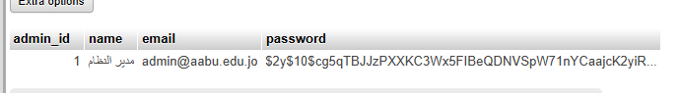

Announcements :
- id
  - Purpose: Acts as the Primary Key. It is an auto-incrementing integer (AUTO_INCREMENT) that gives a unique ID to every global notice or deadline published on the platform.
- title
  - Purpose: Stores the headline or subject title of the announcement to be displayed on user dashboards.
- content
  - Purpose: A high-capacity text field (text) that holds the full main body, instructions, or detailed guidelines of the announcement.
- date
  - Purpose: A timestamp or date field that records exactly when the announcement was posted, ensuring notices can be sorted chronologically.

college
- id
  - Purpose: Acts as the Primary Key. A unique ID number used to identify an individual department or faculty within the university structure.
- name
  - Purpose: Stores the literal text name of the department or faculty (e.g., "Computer Information Systems", "Computer Science").

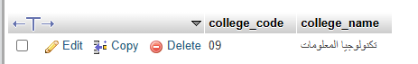

project_1 :
This table handles the initial phase of the graduation project lifecycle. It focuses on team assembly, early structural deliverables, proposal approvals, and preliminary grading metrics.
• project_id
- Purpose: Acts as the Primary Key for the table. It is a unique identification number automatically assigned by the system to distinguish each specific project entry from all others.
• student_id
- Purpose: A Foreign Key referencing the unique student database table. It identifies which student owns or is assigned to this particular graduation project.
• project_title
- Purpose: Stores the official academic name or title of the graduation project approved by the department.
• project_desc
- Purpose: Holds a text description, abstract, or summary mapping out the technical scope and goals of the project.
• project_file
- Purpose: A string-based column that stores the directory path or filename of the document uploaded to the server (such as a project documentation PDF or a compressed ZIP archive of the source code).
• supervisor_id
- Purpose: A Foreign Key mapping back to the faculty/supervisor database. It denotes which academic advisor or professor is responsible for guiding and assessing this project team.
• grade
- Purpose: Stores the numeric or letter grade awarded to the project team upon assessment. It typically remains empty (NULL) until evaluation takes place.
• notes
- Purpose: A text field where the supervisor can write qualitative feedback, correction requests, or general review comments regarding the submitted work.
• is_note_new
- Purpose: A boolean flag/indicator (often stored as a TINYINT or BIT, taking values of 0 or 1). It tracks whether a supervisor has added a new comment that the student has not yet read, facilitating an unread notification system on the dashboard.
• evaluated_at
- Purpose: A timestamp column that automatically logs the exact date and time when the project grade or final evaluation was submitted by the advisor.
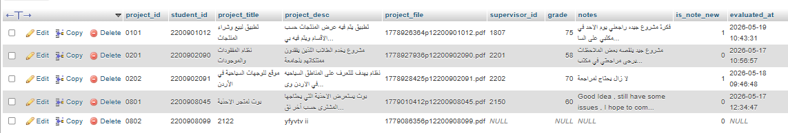

Project_2 :
• project_id
- Purpose: Acts as the Primary Key for the table. It is a unique, system-generated tracking integer assigned to each final-stage graduation project (Project 2) to keep entries completely distinct.
• student_id
- Purpose: A Foreign Key mapping directly back to the student directory table. It links the project row to the specific student who owns or is responsible for this graduation project submission.
• project_title
- Purpose: Stores the official, approved academic name or title of the graduation project during its final semester execution phase.
• source_code_file
- Purpose: A string-based path column that holds the directory location or filename of the codebase uploaded to the server. This allows students to securely submit their compressed implementation files (such as .zip or .rar packages) directly for review.
• supervisor_id
- Purpose: A Foreign Key referencing the unique identifier of the academic advisor or faculty doctor assigned to guide, inspect, and evaluate this specific project group.
• grade
- Purpose: Stores the final numeric score or assessment mark awarded to the student for their Graduation Project 2 course. This field typically defaults to empty (NULL) until the final defense takes place.
• notes
- Purpose: A flexible text field where the supervisor can provide qualitative written remarks, feedback, code correction demands, or general guidance notes regarding the submitted work.
• is_note_new
- Purpose: A boolean status flag (stored as a TINYINT or BIT, taking values of 0 or 1). It tracks whether the supervisor has posted a new comment that the student has not yet read, running an unread notification counter on the student's dashboard.
• evaluated_at
- Purpose: A timestamp column that automatically logs the exact date and time the supervisor finalized the grading action or assessment notes, providing an audit trail for the evaluation process.
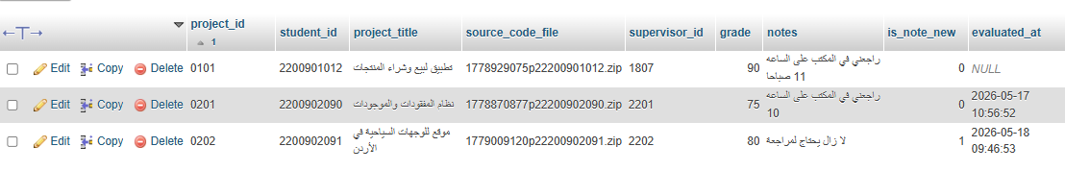

Students :

• student_id
- Purpose: Acts as the Primary Key for the table. It stores the unique university registration or serial number assigned to each individual student, ensuring every student record can be distinctly identified.
• name
- Purpose: Stores the full legal or academic name of the registered student.
• email
- Purpose: Stores the unique official university email address of the student, which typically serves as their primary login username for platform authentication.
• password
- Purpose: Stores the secure, hashed cryptographic string used to safely verify and authenticate the student when logging into their personal dashboard.
• dept_code
- Purpose: A Foreign Key linking directly back to the department or college lookup table. It identifies the specific academic subdivision (e.g., CIS, CS, SE) to which the student is officially mapped.
• last_seen_announcements
- Purpose: A timestamp or announcement ID marker column. It tracks the exact date/time or the last broadcast ID the student viewed. This allows the system's logic to compare it with newly published rows in the announcements table and trigger a "New Notice" alert badge on their dashboard.
• needs_password_change
- Purpose: A boolean status flag/indicator (typically a TINYINT taking values of 0 or 1). It is used for security management—such as when an administrator manually resets a student's password or provisions a new account. If set to 1 (True), the system forces the student to change their password immediately upon their next login before allowing them to access the rest of the system.

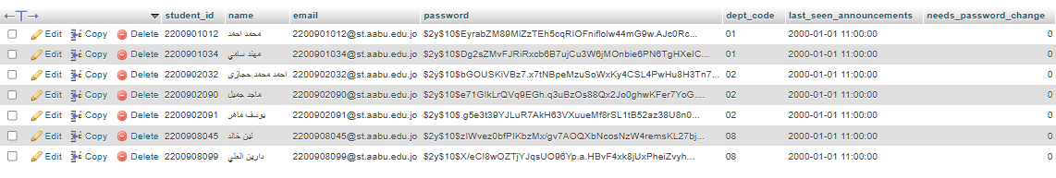

Supervisors :
- supervisor_id
  - Purpose: Acts as the Primary Key for the table. It stores a unique identification number assigned to each professor or advisor, ensuring every supervisor account can be uniquely identified across the department.
- name
  - Purpose: Stores the full legal name and academic title (e.g., "Dr.", "Prof.") of the faculty supervisor.
- email
  - Purpose: Stores the unique university email address of the supervisor, which acts as their primary login identifier for platform authentication.
- password
  - Purpose: Stores the secure, hashed cryptographic string used to safely verify and authenticate the supervisor when logging into their specialized administrative dashboard.
- dept_code
  - Purpose: A Foreign Key linking directly to the department/college reference table. It maps the supervisor to their specific academic home base (such as CIS, CS, or SE).
- last_seen_announcements
  - Purpose: A tracking field that records the timestamp or the ID of the last announcement the supervisor viewed. The backend logic uses this to highlight new announcements or add an unread notification badge on their dashboard.
- needs_password_change
  - Purpose: A boolean status flag (typically a TINYINT taking values of 0 or 1). It serves as an administrative security safeguard. If an admin manually resets a professor's password, this flag is set to 1 (True), forcing the supervisor to choose a secure, private password immediately upon their next login.

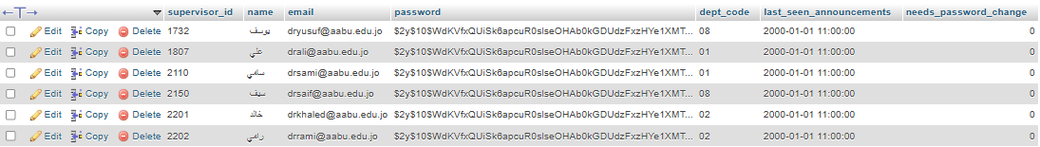

Projects Table
- Stores all project-related data
- Links student and supervisor via email

Announcements Table
- Stores system-wide messages
- Linked to admin accounts

Design Observation
- Email used as identifier instead of foreign keys
- Could be improved using normalized relational design

Dashboards

Student Interface
- Upload form
- Project history
- Feedback display

Doctor Interface
- Table of projects
- Input fields for grading
- Notes system

Admin Interface
- Announcement creation
- User control panel

CS Student :
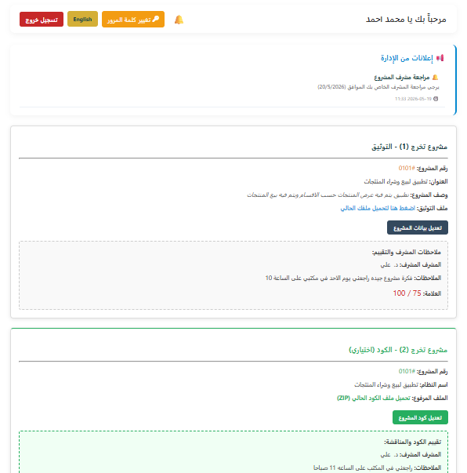
IS Student :
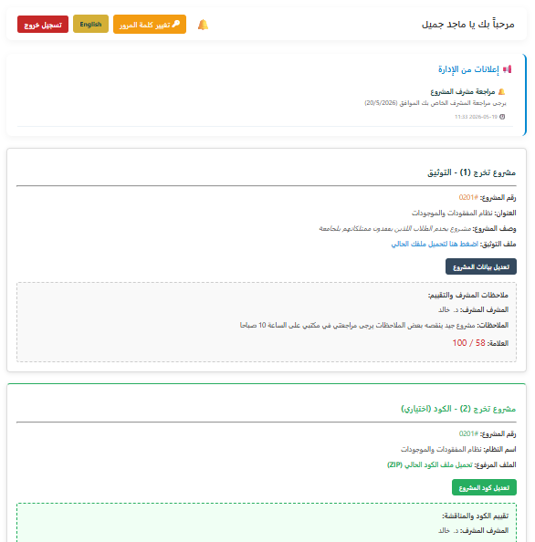

AI Student:

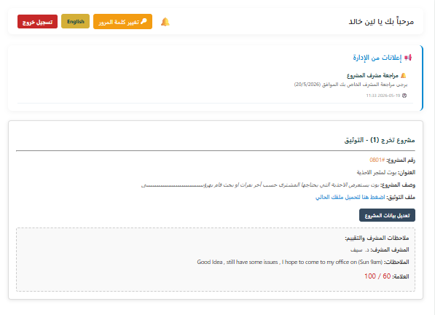

CS Doctor:
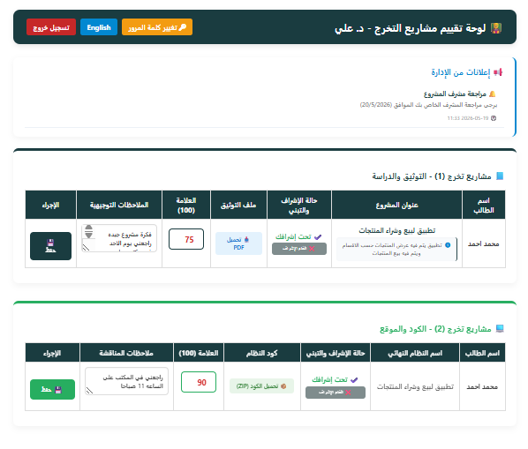
IS Doctor:
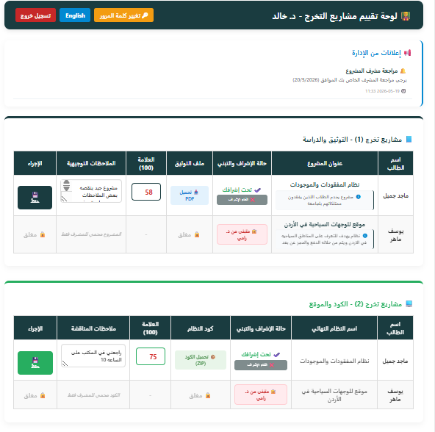
AI Doctor :
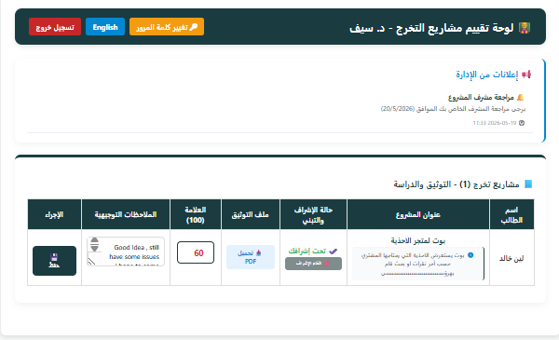
Admin Dashboard: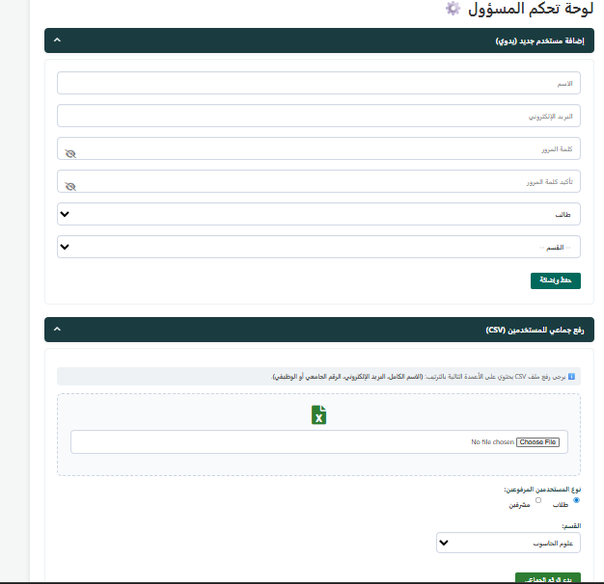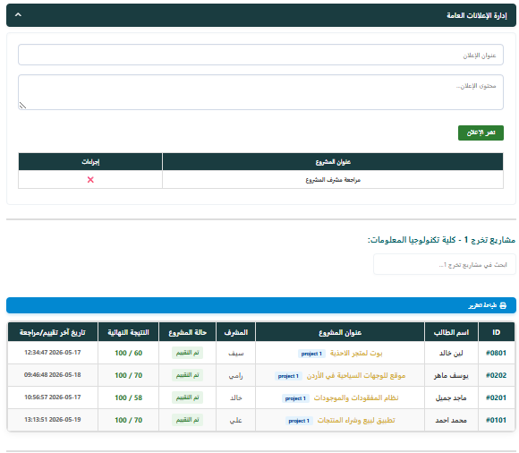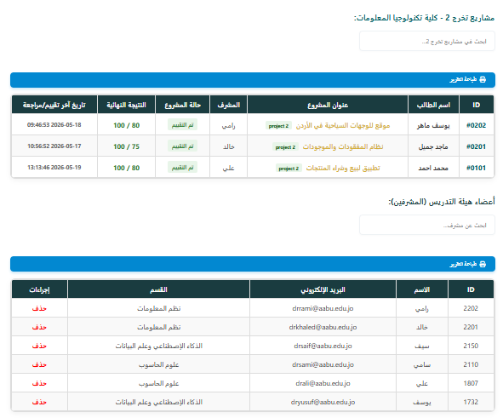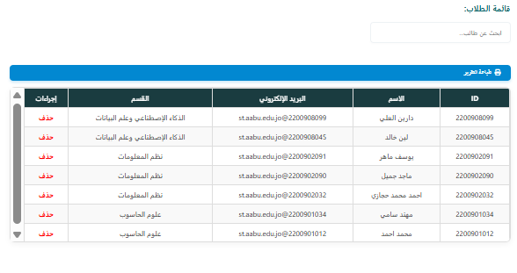

Data Flow Overview (DFD)

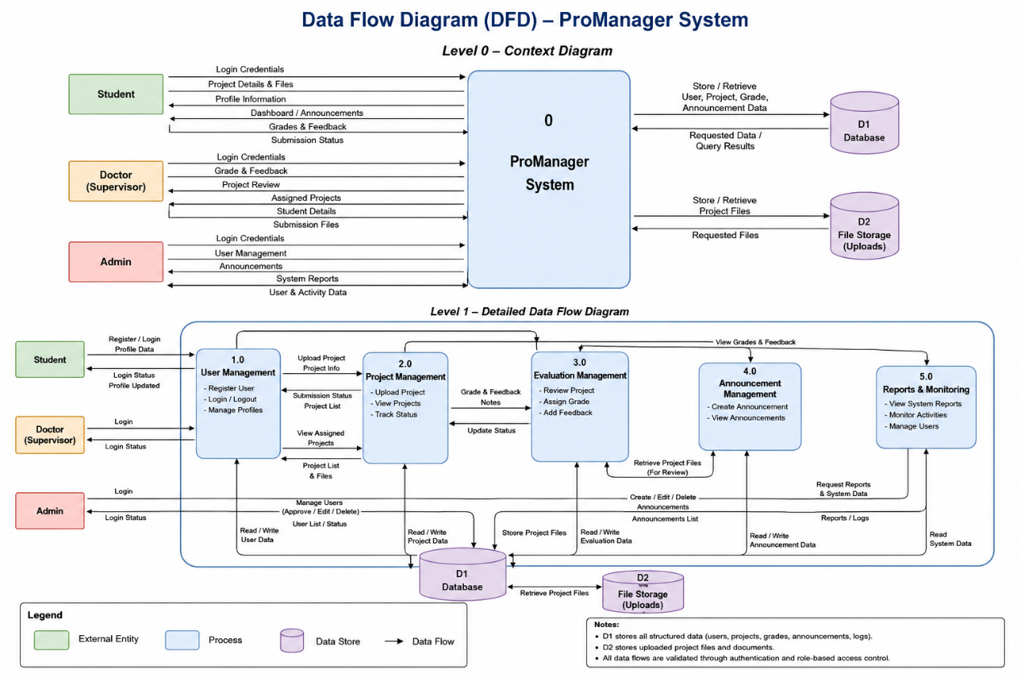Database Design (ER Diagram)

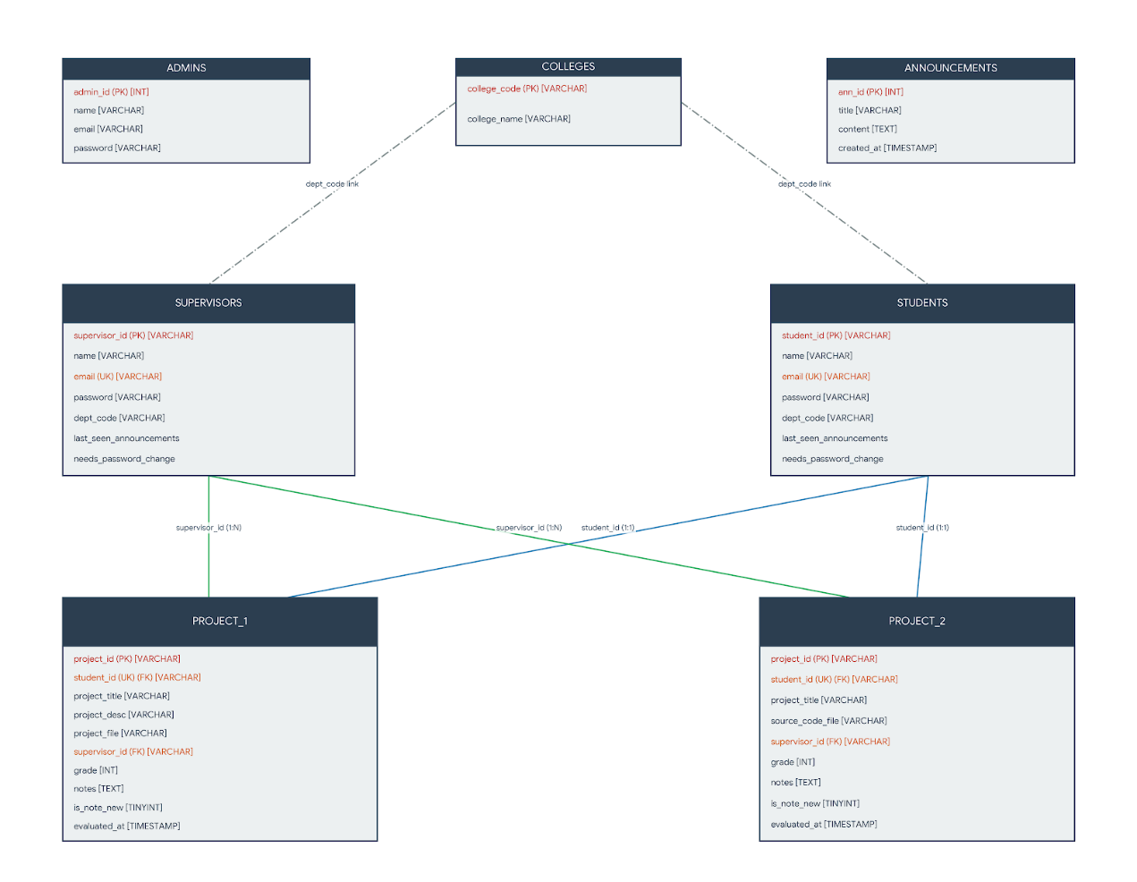

2.4 Implementation
2.4.1 Login Page :
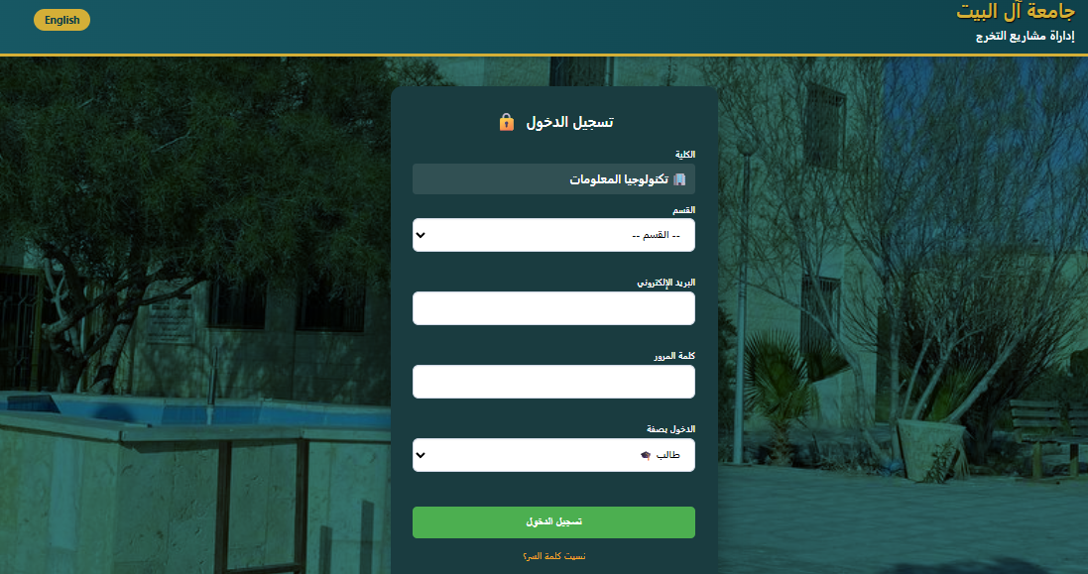
Code :
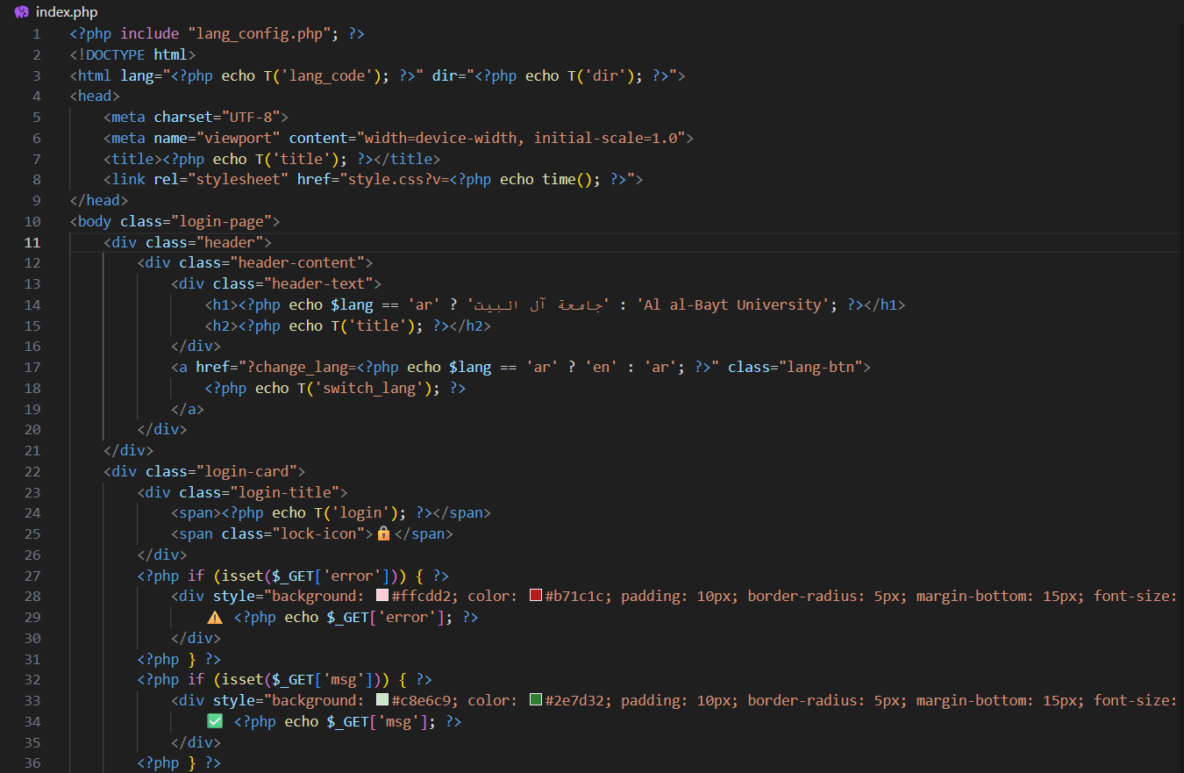
The login page allows users to authenticate using their email and password. Based on the assigned role, users are redirected to the corresponding dashboard.
2.4.2 Student_Dashboard :
Code :

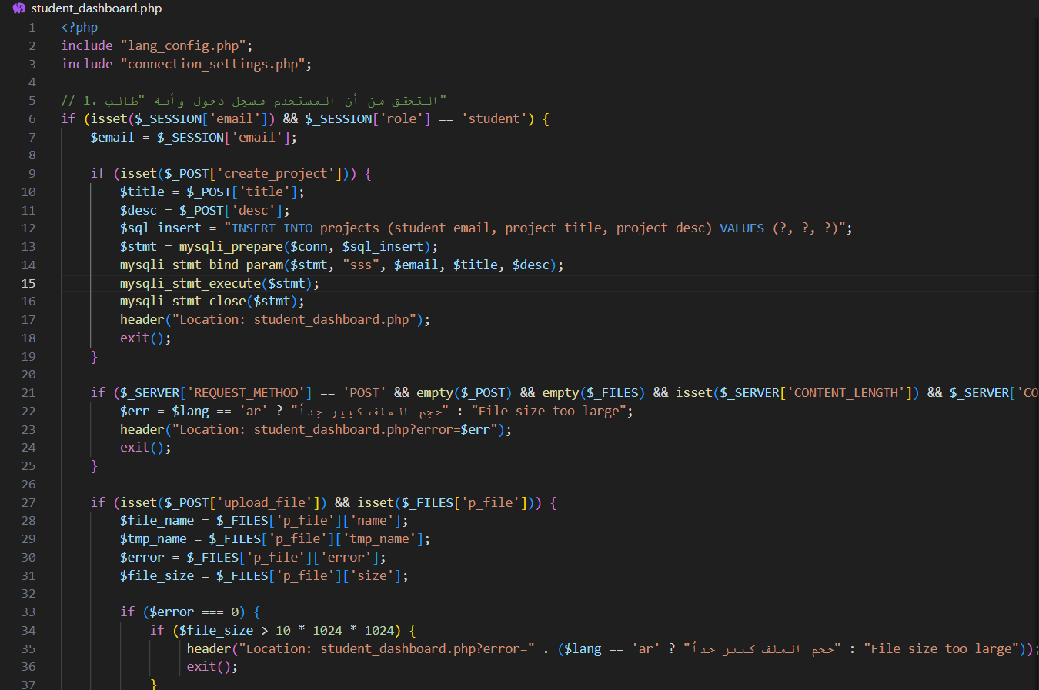
The student dashboard enables students to upload graduation projects, monitor submission status, and view grades and supervisor feedback.

2.4.3 File_Upload :

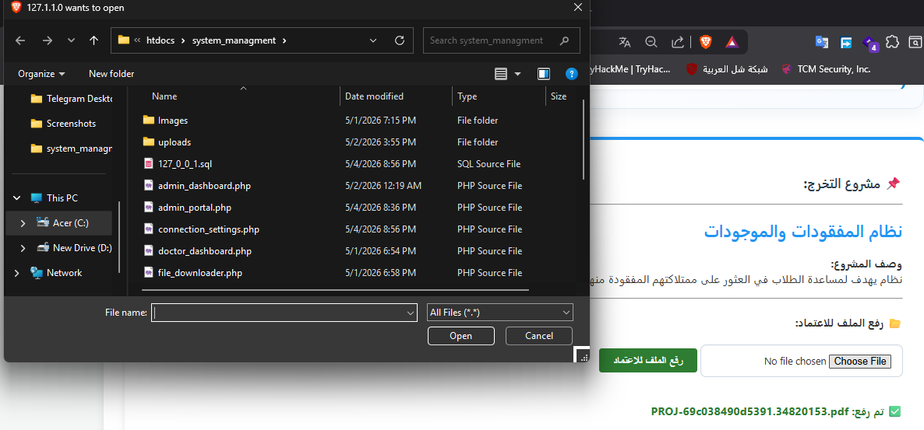

Code :

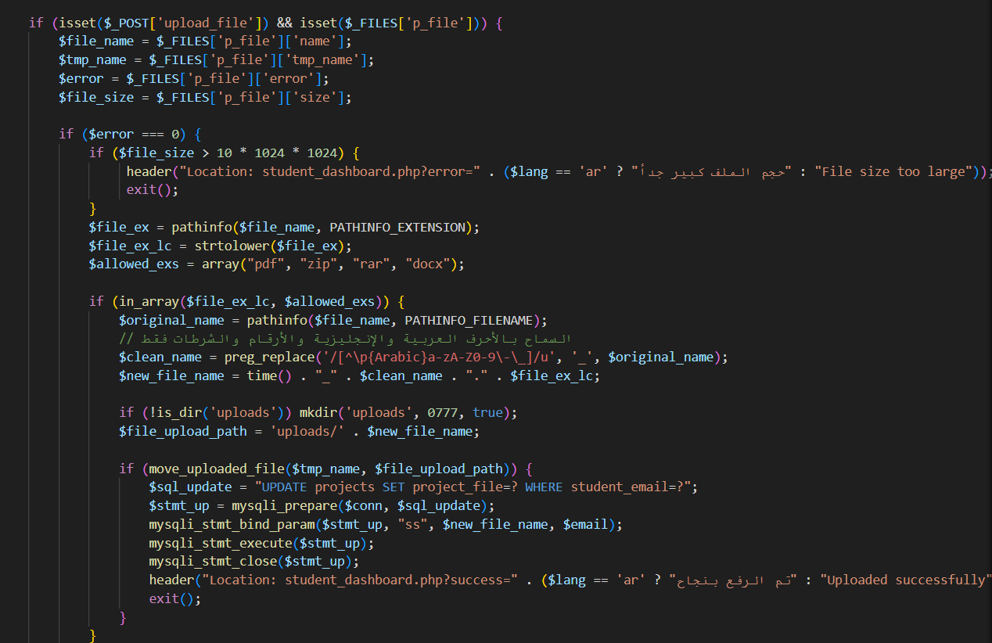
The upload interface allows students to submit project files and related information. Uploaded files are stored on the server and linked to the database.

2.4.4 Doctor_Dashboard :

Code :

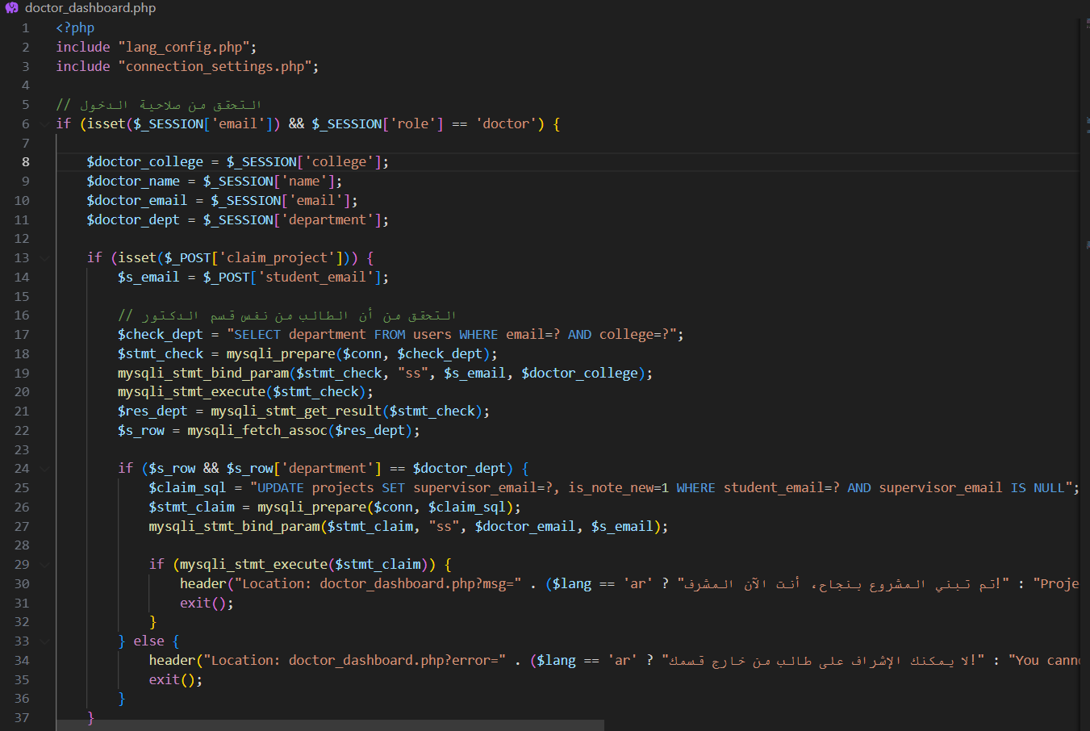

The doctor dashboard provides supervisors with tools to review projects, assign grades, and provide notes for students.

2.4.5 Grade & FeedBack :

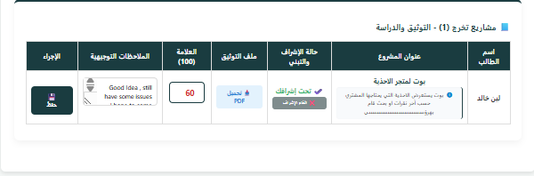

Code :
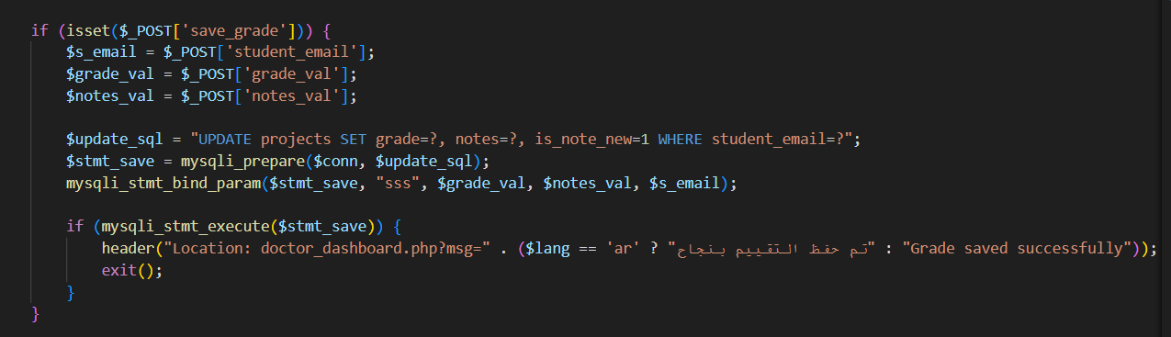 Supervisors can evaluate projects and provide academic feedback through the evaluation module.

2.4.6 Admin_Dashboard :
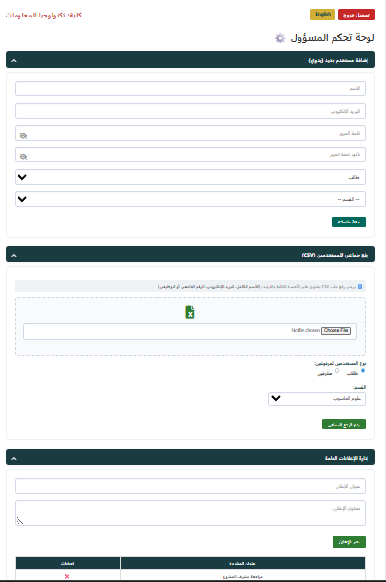

Code :

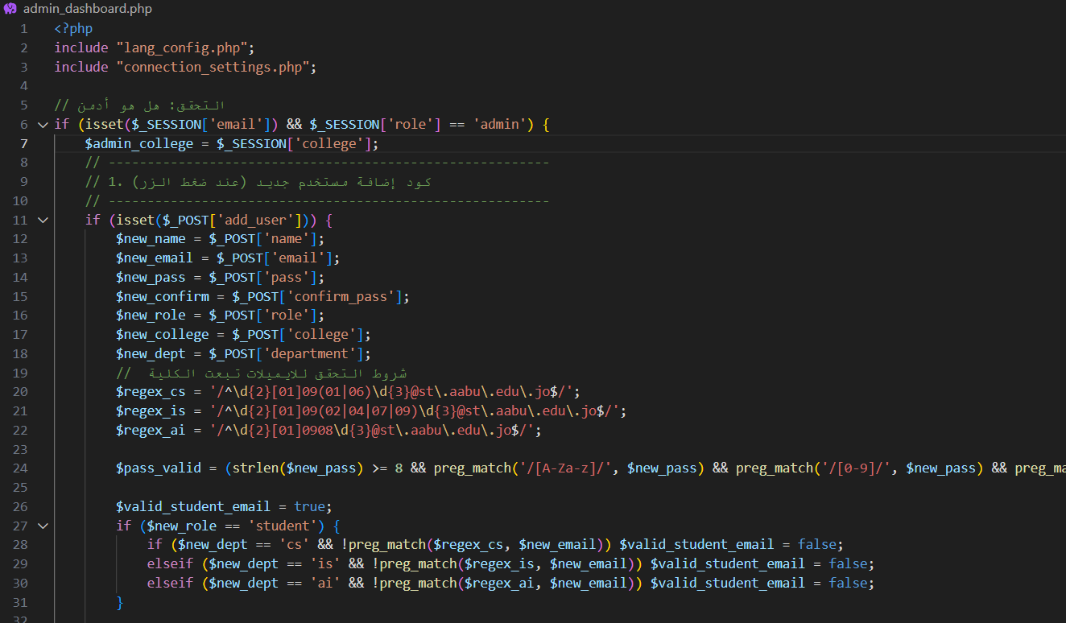

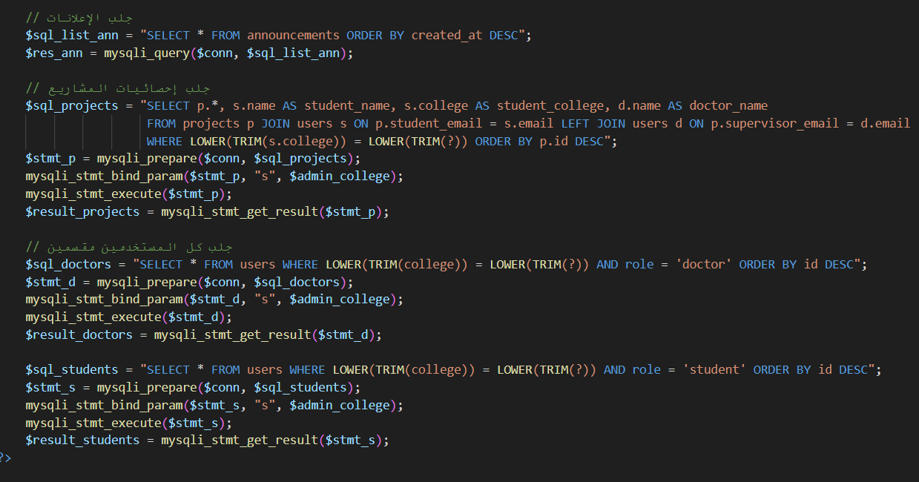
The admin dashboard allows administrators to monitor system activity, manage users, and publish announcements.

2.4.7 Announcement :

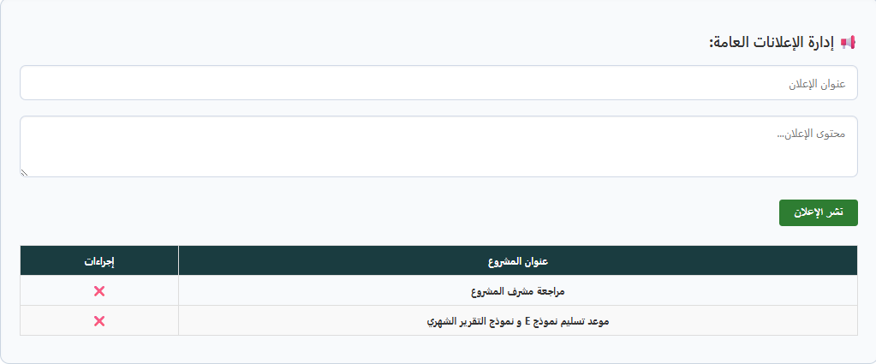

Code :

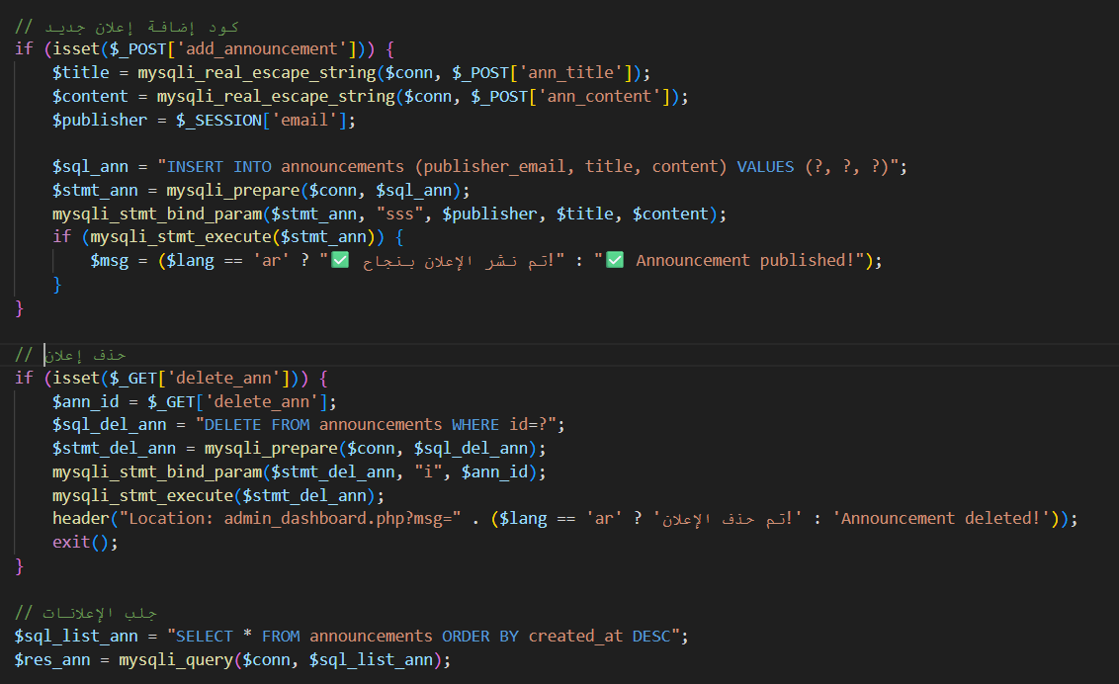
Administrators can publish announcements that become visible to all users within the system.

2.4.8 Password & Reset :

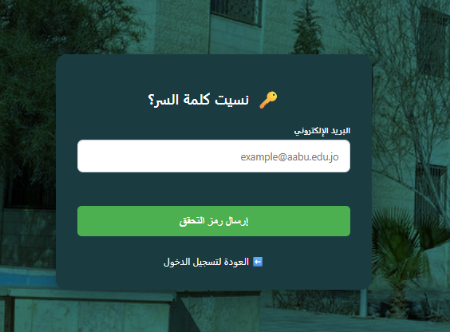

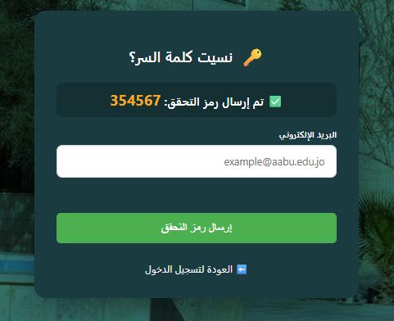

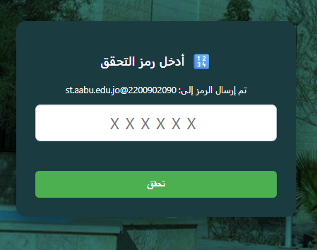

Code :

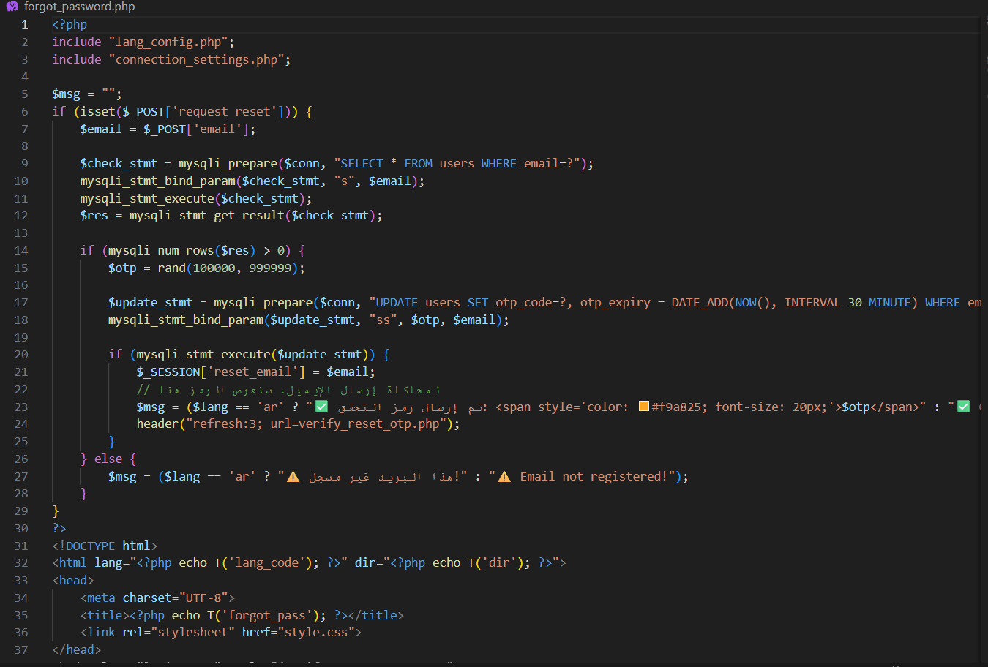

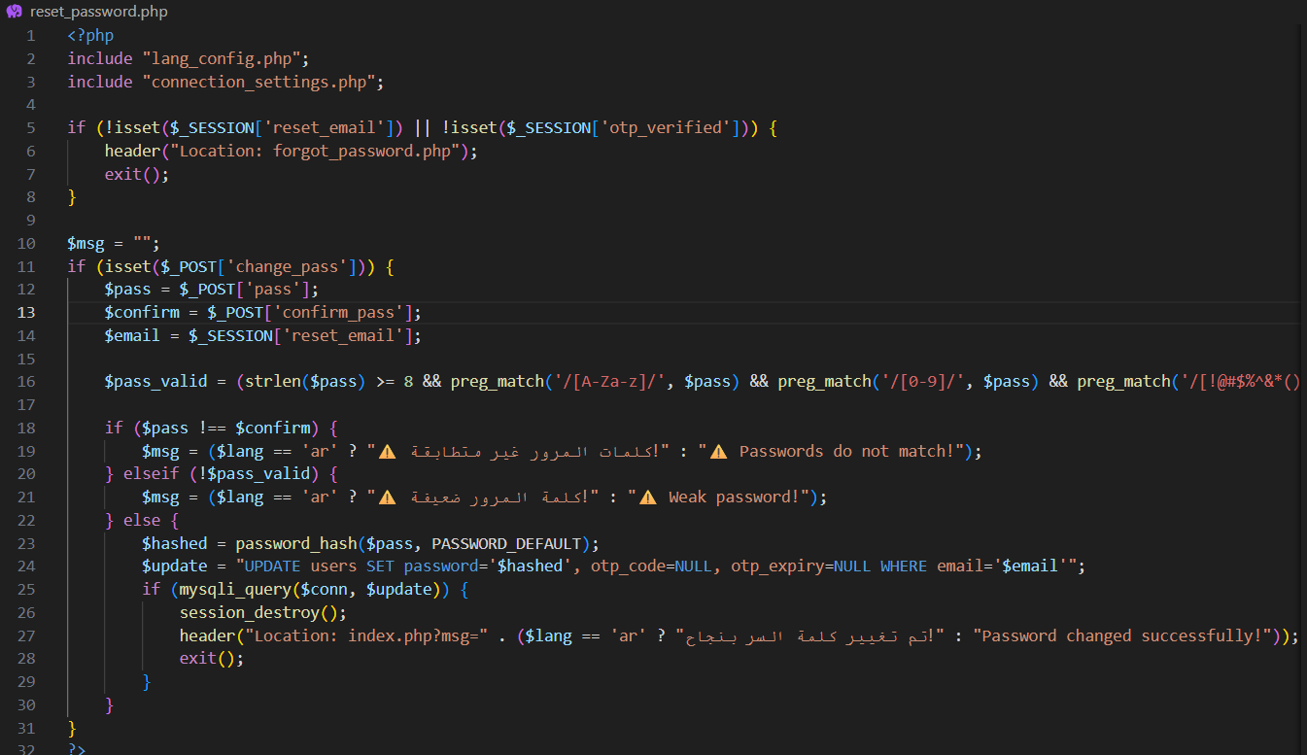

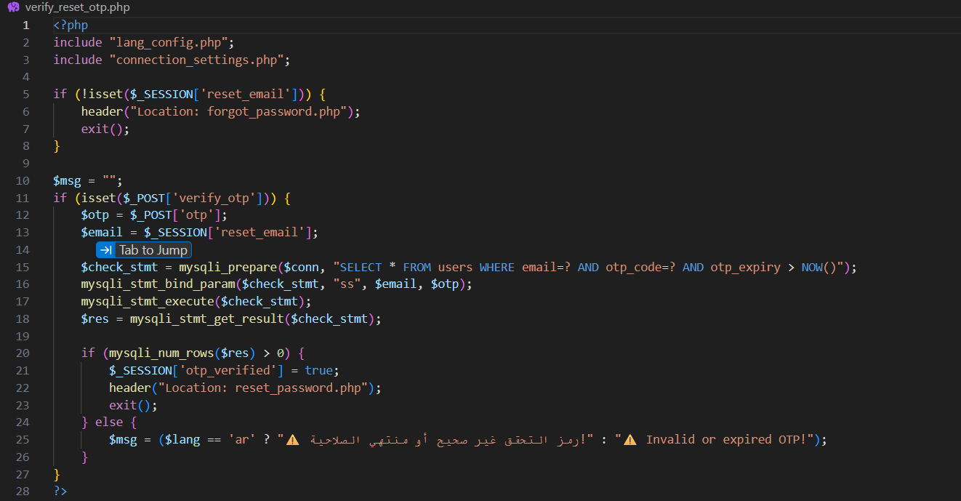
The password recovery module uses OTP verification to improve account security and allow users to reset forgotten passwords.

2.5 Testing

2.5.1 : Change the password, it wasn't in the system so we make it to let the user have change the password if it was stolen

Before :



After :

The password change :

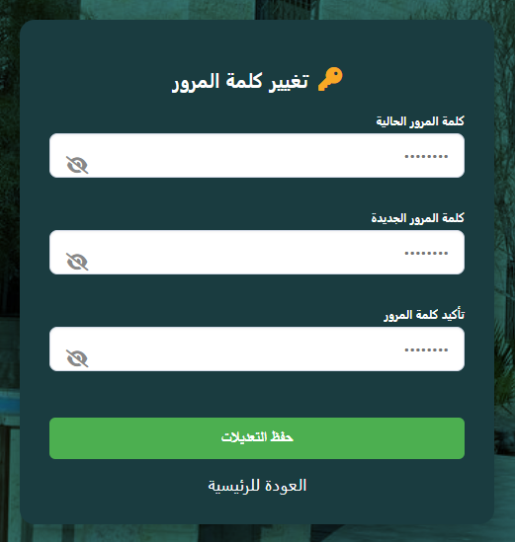

2.5.2 : The language in the student, supervisor and admin it wasn't switch from the dashboard , it was just from the login pages
before :



After :

2.5.3 : the bulk users upload for student and supervisor , it was just a manual not by file of (CSV) so we make It a file upload of the name of supervisors and students
Before :

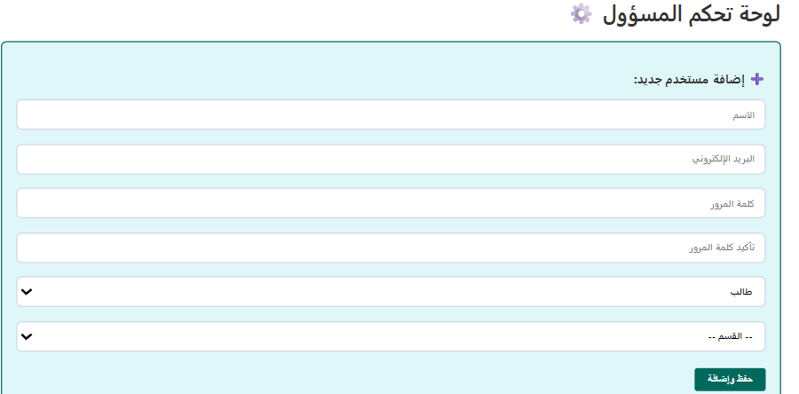

After :

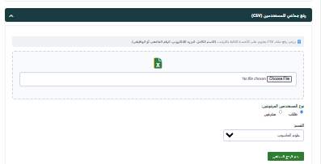

2.5 Maintenance
* In our future Maintenance we will do this following
    - : Multi-Faculty Integration :
Expand the platform to support multiple colleges and departments university-wide, allowing for a centralized management system under one unified infrastructure.
    - : Integrated Messaging Module :

Implement a real-time communication system between students and supervisors to streamline feedback and reduce reliance on external apps like WhatsApp or email.
    - : Visual Progress Dashboard :

Develop a dedicated interface to track completion percentages, project stages, and pending tasks, providing clear visibility for all stakeholders.
    - : Al-Farooq Authentication App :

is a Python-based security application that verifies whether a device is authorized to use the Al-Farooq system by generating a unique hardware fingerprint and validating it with a remote server. If the device is approved, access is granted; otherwise, it is denied. A stern little gatekeeper, because apparently even computers need to show ID

Chapter 3
3.1 Conclusion
The “ProManager” system successfully achieved its primary objective of providing a centralized web-based platform for managing graduation projects within academic institutions. The system automates essential academic processes such as project submission, evaluation, feedback management, and announcement distribution, replacing inefficient manual methods previously dependent on emails and paper-based communication.
Through the implementation of role-based access control, the system provides separate functionalities for students, supervisors, and administrators, ensuring organized workflow management and secure access to data. The integration of database-driven operations and file management mechanisms improves the reliability and accessibility of academic records.
Additionally, the project demonstrates the practical application of web development technologies such as PHP, MySQL, HTML, CSS, and JavaScript in solving real-world institutional challenges. Despite certain technical limitations, the system establishes a strong foundational structure that can be further enhanced and expanded in future versions.
Overall, “ProManager” contributes to improving communication efficiency, reducing administrative workload, and enhancing the overall management of graduation projects in educational environments.
3.2 Results
The development and implementation of the “ProManager” system produced several successful outcomes.
Achieved Results
- Developed a fully functional academic management system
- Automated project submission and evaluation processes
- Improved communication between students and supervisors
- Centralized academic data and project records
- Reduced dependency on manual administrative operations
- Provided structured access control based on user roles
- Enabled secure storage and retrieval of project files
The system demonstrated stable performance during testing and successfully handled core functionalities such as login authentication, file uploading, grading, and announcement management.
3.3 Problems Encountered
During the development process, several technical challenges were encountered.
1. Session Security Management
Maintaining secure user sessions and preventing unauthorized access required careful handling of authentication and session validation logic.
2. File Upload Security
Handling uploaded files safely was challenging due to risks associated with malicious file uploads and improper file handling mechanisms.
3. Database Query Debugging
Some SQL operations required repeated debugging to ensure proper insertion, updating, and retrieval of records from the database.
4. User Role Management
Ensuring correct permissions and dashboard access for different roles required additional testing and validation to prevent unauthorized access between users.
3.4 Future Work
Although the “ProManager” system successfully implements the core functionalities required for graduation project management, several future enhancements can be introduced to improve system efficiency, scalability, and user experience.
1. Support for Multiple Faculties and Colleges
The current system can be expanded to support additional colleges and departments within the university. This enhancement would allow centralized management of graduation projects across multiple academic faculties using a unified platform.
2. Messaging System Between Doctors and Students
A direct communication module can be added to enable real-time messaging between supervisors and students. This feature would improve collaboration, simplify feedback exchange, and reduce dependency on external communication applications.
3. Project Progress Tracking Dashboard
A dedicated dashboard can be developed to track the completion status of graduation projects. The dashboard may display:
- Current project stage
- Percentage of completion
- Pending tasks
- Supervisor review status
This would provide better visibility into project progress for both students and supervisors.
4. Project Discussion Scheduling System
The system can be enhanced by adding a scheduling module for graduation project discussions and presentations. This feature would allow administrators and supervisors to:
- Schedule discussion dates
- Assign discussion rooms
- Notify students automatically
- Organize presentation timelines
5. Team Matching Based on Project Idea and Department
An intelligent matching feature can be implemented to help students find teammates with similar project ideas or academic departments. This enhancement could encourage collaboration and improve team formation processes.
6. Digital Archive for Projects and Ideas
A digital archive system can be added to store:
- Previous graduation projects
- Project ideas
- Research documents
- Final reports
This archive would serve as a reference resource for future students and supervisors while preserving academic records in an organized manner.

3.5 References :
1. (AABU) : https://aabu.edu.jo/ar/collegesandinstitutes/it/pages/default.aspx
2. (Gemini) :
https://gemini.google.com/gem/cba2a59cfc58
3. (DFD & ER Diagram) :
https://app.diagrams.net/
4. (Google Form) :
https://docs.google.com/forms/u/0/?pli=1

