# X. Part D

### Load Calculation

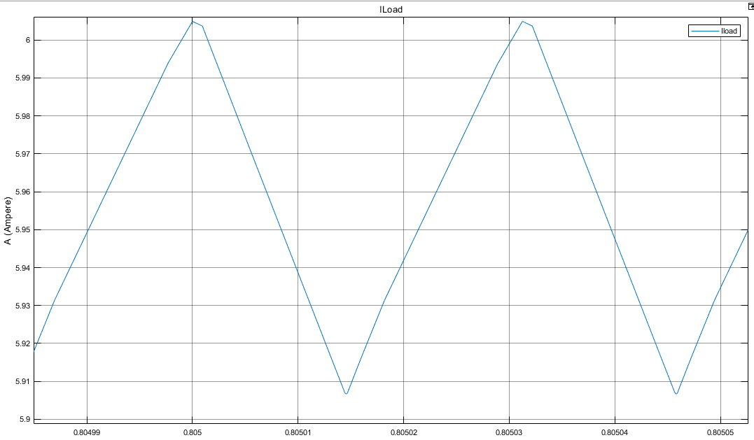

Figure 1: Simulation Result of Load Current at 24 V input Voltage

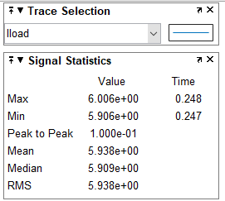

Figure 2: Simulation Statistics of Load Current at 24 V input Voltage

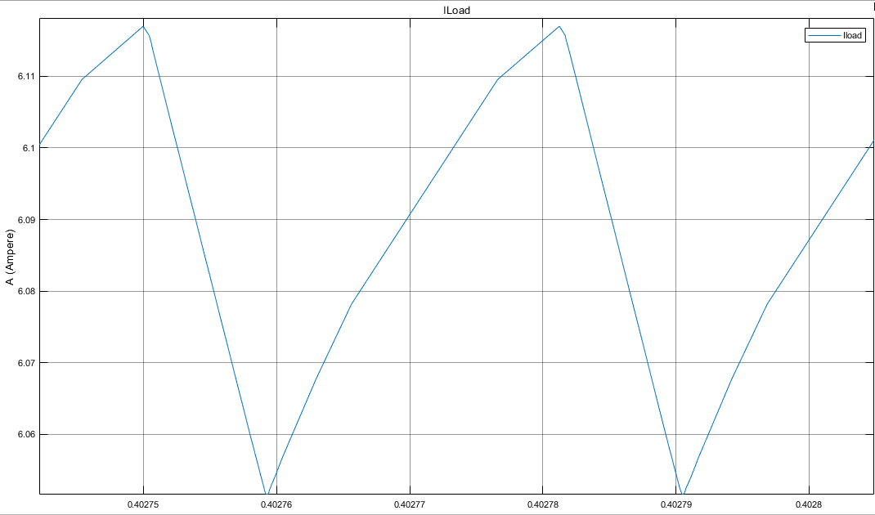

Figure 3: Simulation Result of Load Current at 48 V input Voltage

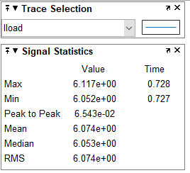

Figure 4: Simulation Statistics of Load Current at 48 V input Voltage

In our feedback design parametries, Output voltage is determined and limited as constrained 5V. Similarly, output power is determined and limited as constrained 30 W. Therefore, In our design we expect that same current value as about 6 A (30W / 5V) for both 24V and 48V input voltages.

As seen figure 2 and figure 4 , we get appoximately 6A as expected output current from both diffecent input values. Therefore our design works succesfully in simulation.

## Iprimary Current Calculation for 24 Vinput

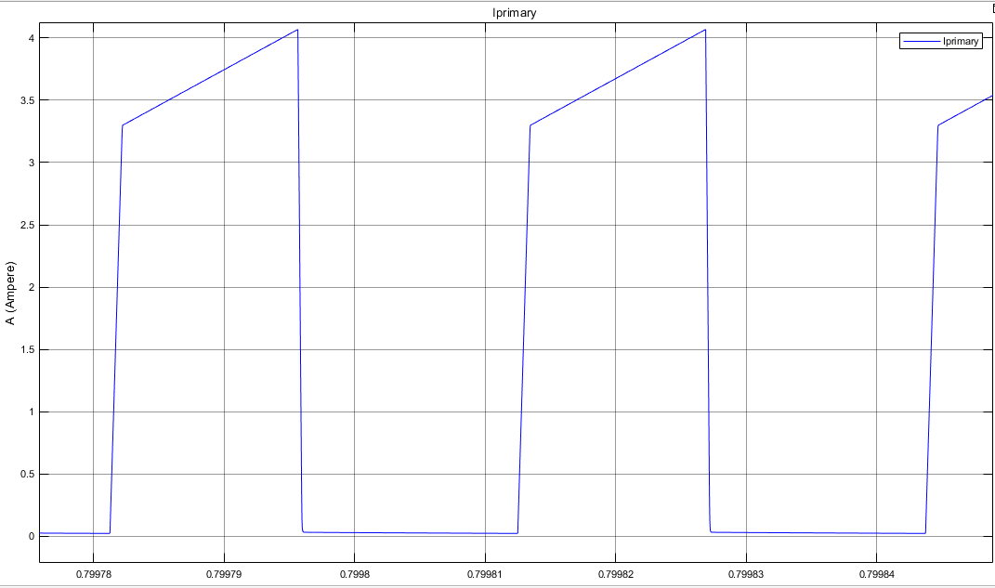

Figure 5: Simulation Result of Primary Side Current at 24 V input Voltage

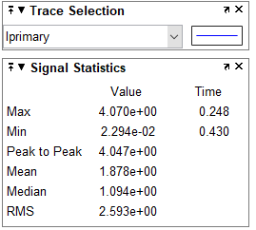

Figure 6: Simulation Statistics of Primary Side Current at 24 V input Voltage

$Vo=Vi*\left(\frac{N2}{N1}\right)*\left(\frac{D}{\left(1-D\right)}\right)$ Then $5.7=23/3*(D/1-D)) , D=0.424 for Vin= 24VDC$ Components of magnetizing current, referred to primary:

$$I_{m}=\frac{N_{1}}{N_{2}}\frac{1}{1-D}\frac{V_{0}}{R_{L}} where D=0.424, R=\left(\frac{5}{6}\right)ohm, \frac{N1}{N2}=\frac{1}{3}, Vout=5V$$

$$I_{m}=3.484 A$$

$$I= 0. 76 A for Lm= 400µH and Vin = 24 VDC$$

The rms value of the primary winding current is found as follows (this equation taken from Fundamentals of Power Electronics 2nd edition Erickson appendix A eq. (A.6));

$$I_{1rms}=I_{M}\sqrt{D}\sqrt{1+\frac{1}{3}{(\frac{{∆I}_{M}}{I_{M}})}^{2}}$$

With respect to calculation we get Irms(primary)=2.3 A which near to simulation results from figure **6**,

## Iprimary Current Calculation for 48 Vinput

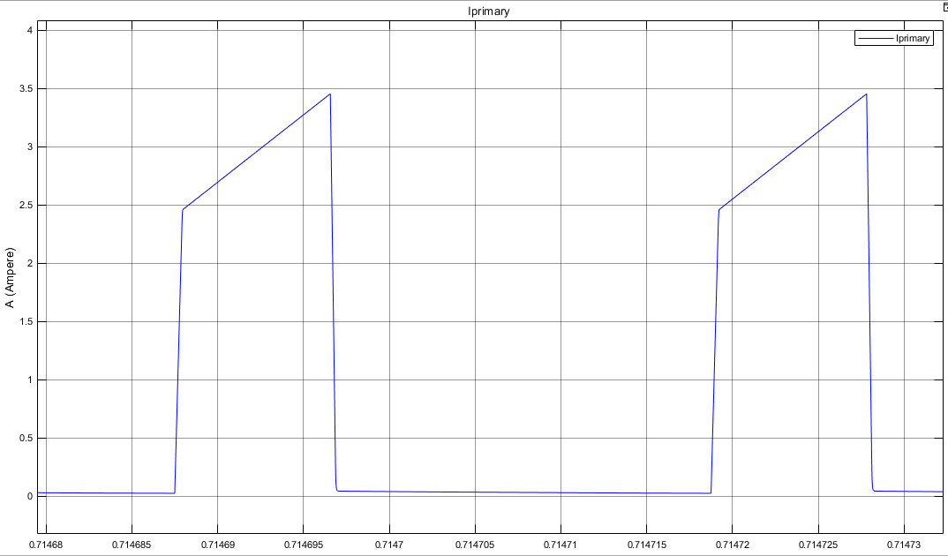

Figure 7: Simulation Result of Primary Side Current at 48 V input Voltage

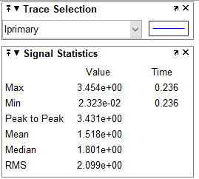

Figure 8: Simulation Result of Primary Side Current at 48 V input Voltage

$Vo=Vi*\left(\frac{N2}{N1}\right)*\left(\frac{D}{\left(1-D\right)}\right)$ Then $5.7=47/3*(D/1-D)) , D=0.265 for Vin= 48VDC$ Components of magnetizing current, referred to primary:

$$I_{m}=\frac{N_{1}}{N_{2}}\frac{1}{1-D}\frac{V_{0}}{R_{L}} where D=0.265, R=\left(\frac{5}{6}\right)ohm, \frac{N1}{N2}=\frac{1}{3}, Vout=5V$$

$$I_{m}=2.721 A$$

$$I= 1 A for Lm= 400µH and Vin = 48 VDC$$

The rms value of the primary winding current is found as follows (this equation taken from Fundamentals of Power Electronics 2nd edition Erickson appendix A eq. (A.6));

$$I_{1rms}=I_{M}\sqrt{D}\sqrt{1+\frac{1}{3}{(\frac{{∆I}_{M}}{I_{M}})}^{2}}$$

With respect to calculation we get Irms(primary)=1.43 A which near to simulation results from figure **6**,

When we compare Iprimary current, we get higher current value(2.3 A) for 24V input voltage, than used 48V input voltage condition. The main reason that Load consume constant power and Input Power=(Vinput X Iinput), because of this equilavent, when Input voltage increase, we get low input current.

## Isecondary Current Calculation for 24 Vinput

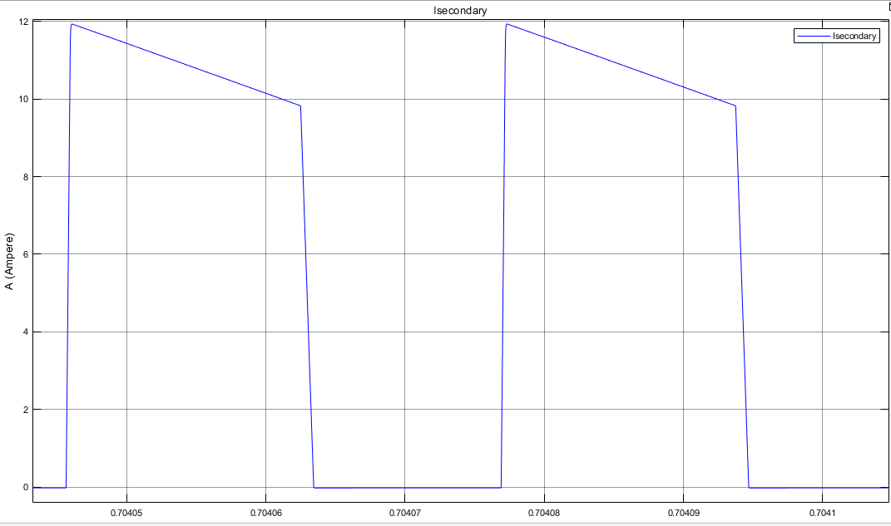

Figure 9: Simulation Result of Secondary Side Current at 24 V input Voltage

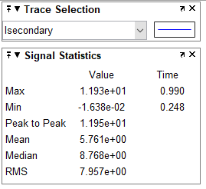

Figure 10: Simulation Statistics of Secondary Side Current at 24 V input Voltage

$Vo=Vi*\left(\frac{N2}{N1}\right)*\left(\frac{D}{\left(1-D\right)}\right)$ Then $5.7=23/3*(D/1-D)) , D=0.424 for Vin= 24VDC$ Components of magnetizing current, referred to primary:

$$I_{m}=\frac{N_{1}}{N_{2}}\frac{1}{1-D}\frac{V_{0}}{R_{L}} where D=0.424, R=\left(\frac{5}{6}\right)ohm, \frac{N1}{N2}=\frac{1}{3}, Vout=5V$$

$$I_{m}=3.484 A$$

$$I_{M}=3 X I_{m}=10.152 A$$

∆IM=2.1A from figure X.

The rms value of the secondary winding current is found as follows;

$$I_{2rms}=I_{M}\sqrt{1-D}\sqrt{1+\frac{1}{3}{(\frac{{∆I}_{M}}{I_{M}})}^{2}}$$

With respect to calculation we get Irms(primary)=7.98 A which so close to simulation results from figure **x**

## Isecondary Current Calculation for 48 Vinput

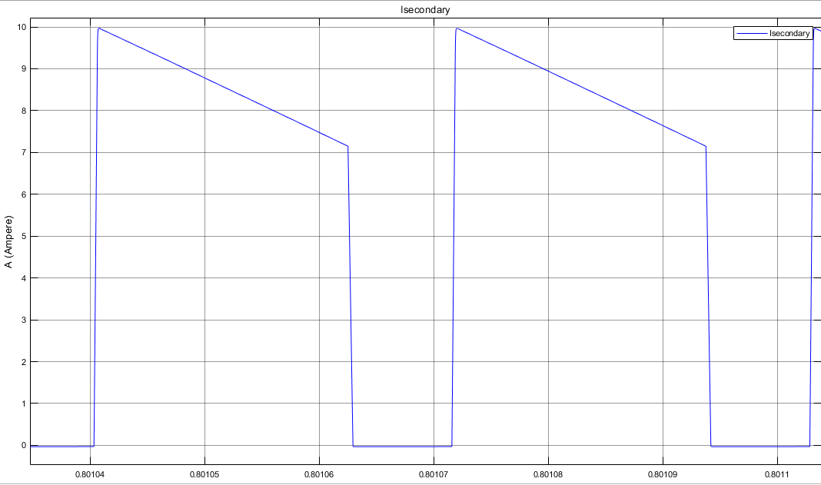

Figure 11: Simulation Result of Secondary Side Current at 48 V input Voltage

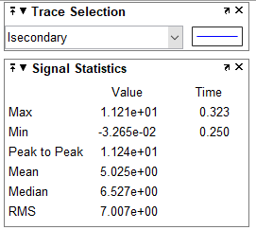

Figure 12: Simulation Statistics of Secondary Side Current at 48 V input Voltage

$Vo=Vi*\left(\frac{N2}{N1}\right)*\left(\frac{D}{\left(1-D\right)}\right)$ Then $5.7=47/3*(D/1-D)) , D=0.265 for Vin= 48VDC$ Components of magnetizing current, referred to primary:

$$I_{m}=\frac{N_{1}}{N_{2}}\frac{1}{1-D}\frac{V_{0}}{R_{L}} where D=0.265, R=\left(\frac{5}{6}\right)ohm, \frac{N1}{N2}=\frac{1}{3}, Vout=5V$$

$$I_{m}=2.721 A$$

$$I_{M}=3 X I_{m}=8.163 A$$

∆IM=2.8A from figure X.

The rms value of the secondary winding current is found as follows;

$$I_{2rms}=I_{M}\sqrt{1-D}\sqrt{1+\frac{1}{3}{(\frac{{∆I}_{M}}{I_{M}})}^{2}}$$

With respect to calculation we get Irms(primary)=7.08 A which so close to simulation results from figure **x.**