EE 464 SOFTWARE PROJECT-2

A.

$$Vo=Vi*\left(\frac{N2}{N1}\right)*\left(\frac{D}{\left(1-D\right)}\right)$$

Vimin=24 VDC, Vimax=48 VDC, Vo=5 VDC, turn ratio is chosen 3 so as not to Dmax to be higher than 0.5.

Since there will be a voltage drop on transistor around 1 VDC and on diode around 0.7 VDC. Input voltages will be taken into calculations as 23 VDC and 47 VDC while output voltage will be taken as 5.7 VDC.

$$5.7=23/3*(D/1-D)) , D=0.424 for Vin= 24VDC \\ 5.7=47/3*(D/1-D)) , D=0.265 for Vin= 48VDC$$

When a lossless conversion is assumed, input power(Pin) should be equal to the output power (Pout).

In this next step, current ripples will be calculated in primary and secondary sides by applying voltage-second law to magnetizing inductor. Switching frequency is chosen as 32 kHz since basic microcontrollers can generate maximum PWM at 32 kHz.

$$Vl=L*\left(dI/dt\right) \\ I=\left(1/L\right)*\left(Vin\right)*\left(D*Ts\right)$$

It is desired to have maximum current ripple 1 A at most.

$$1=\left(1/L\right)*23*\left(0.424\right)*\left(1/32000\right), Lm=310 µH , for Vin= 24 VDC \\ 1=\left(1/L\right)*47*\left(0.265\right)*\left(1/32000\right), Lm=390 µH , for Vin= 48 VDC \\ I= 0. 76 A for Lm= 400µH and Vin = 24 VDC \\ I= 1 A for Lm= 400µH and Vin = 48 VDC$$

Since components will be chosen according to worst case, Lm will be set as 400µH. Secondary current can be found since primary current and turn ratio are known.

$$Isec = Iin* 3 , Isec= 10.5 A , for Vin= 24 VDC \\ Isec = Iin * 3 ,Isec = 8.25 A , for Vin= 48 VDC$$

$$Isec=I*3= 2.3 A for Lm= 400µH and Vin = 24 VDC \\ Isec=I*3= 3 A for Lm= 400µH and Vin = 48 VDC$$

One important parameter which is needed to calculate is ripple current of capacitor for Δcomponent selection. We will assume that capacitor can deliver a constant 6A to load when primary switch is ON to simplify calculations.

$$Isec = Icap + I load \\ Icap = 10.5- 6 = 4.5 A for Vin= 24 VDC when switch is OFF \\ Icap = 8.25- 6 = 2.25 A for Vin= 48 VDC when switch is OFF \\ Icap = -6 A when switch is ON$$

Voltage ripple at the output was assumed as constant before to simplify calculations. Since it is an important design parameter it will be calculated by calculating capacitor voltage which is connected parallel to load.

Table . Electrical parameters of the convertor circuit

|  |  |  |
| --- | --- | --- |
|  | 24 VDC | 48 VDC |
| Dmax | 0.424 | 0.265 |
| Iin (A) | 3.5 | 2.65 |
| ΔIin(A) | 0.76 | 1 |
| Iin-max(A) | 3.88 | 3.15 |
| Iin-min(A) | 3.12 | 2.15 |
| Isec (A) | 10.5 | 8.25 |
| ΔIsec(A) | 2.3 | 3 |
| Isec-max(A) | 11.65 | 9.75 |
| Isec-min(A) | 9.35 | 6.75 |
| Icap (A),OFF | 4.5 | 2.25 |
| ΔIcap(A),OFF | 2.3 | 3 |
| Icap-max(A),OFF | 5.65 | 3.75 |
| Icap-min(A),OFF | 3.35 | 0.75 |
| Icap(A),ON | -6 | -6 |
| ΔVout(V) | 0.050 | 0.016 |
| Vrip(%) | 1% | 0.32 % |

B.

In this step, a transformer will be designed for flyback convertor according to previous calculations. In flyback convertor topology, energy is deposited during duty cycle and sent to the load in remaining time. It is highly important to transformer having ability to deposit such a high magnetic energy, so as core K 4022E090 is chosen which I an E-core. Some important parameter in the datasheet of the core is shared in the **Table XX below.**

Table 2. Core parameters

|  |  |
| --- | --- |
| Core Parameters | Values |
| AL (nH/N2) | 280 |
| Permeability ,µ | 90 |
| Window Area, Wa(mm2) | 276 |
| Cross Section, Ae(mm2) | 237 |
| Path Length, Le(mm) | 98.4 |
| Volume, Ve(mm3) | 23300 |
| Watt Loss (mW/cm3) @100kHz, 100mT | 902 |

In electrical parameter calculation in step a, to keep current ripple in primary under 1A a high inductor was selected as 400 µH. In first step, number of turns to reach this inductance on this core will be calculated.

$$L=Al*N^{2} \\ 400*{10}^{-}6=280*{10}^{-}9*N^{2} , N=38.1$$

This is a good way to start number of primary winding calculation, but it is not enough. In datasheet of the magnetic core, AL vs MMF graph is attached which is also given in **Figure XX.** We can see that AL value is not 280 for all MMF values. Under this condition, produced MMF by primary windings is around 175 A-T at which AL value decreases to 225. Now with 39 number of primary winding only 342µH and it is less than designed value. So as to shift it to a more secure operating point, we will assume primary turn number as 42 and check it whether it is enough or not.

$$L=Al*N^{2} \\ L=240*{10}^{-}9*{\left(42\right)}^{2},L=423µH$$

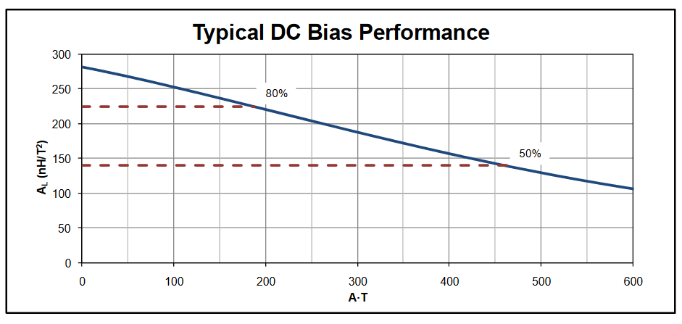

Figure 1. Dc Bias performance of magnetic Core

$$N1/N2=3 \\ N1=42 ->N2=14$$

$MMF=N*I=R*Φ=B*A*\left(\frac{l}{µr*µo*A}\right)$ $$42*3.8=Bmax*\frac{98*10-3}{4π*103-7*90}, Bmax= 190 mT \\ 42*3.12=Bmin*\frac{98*10-3}{4π*103-7*90}, Bmax= 156 mT \\ B=34 mT @ 32 kHz$$

Now core loss will be estimated roughly by using datasheet value. It is given that the core loss is 902 mW/cm3 at 100 kHz and 100 mT.

$$Core Loss=902*Ve=902*23.3=21 W @ 100 kHz and 100 mT \\ Core Loss= 3 W @ 32 kHz and 34 mT$$

Next step is choosing primary and secondary winding cables. Since both sides have different current characteristics, different cables will be chosen by using peak current values. As current density we used 4 A /mm2. Also to calculate corresponding resistances, required length of cable will be calculated.

|  |  |  |  |  |  |  |
| --- | --- | --- | --- | --- | --- | --- |
|  |  |  |  |  |  |  |
| I1 | 3.88 A | 1.15 mm | 2.05 mm | 16 Ω/km | 2.7 m | 43 mΩ |
| I2 | 11.65 A | 1.04 mm2 | 3.31 mm2 | 5.2 Ω/km | 0.9 m | 5 mΩ |