# X) Part F

## Full Load Condition , at 24V (Rating Voltage)

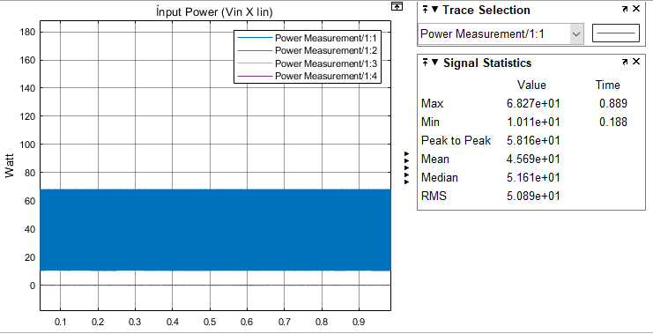

Figure 1: Input Power at Full Load Condition, (24V rating Voltage)

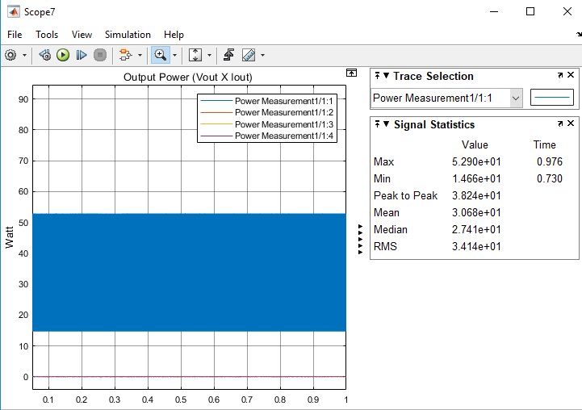

Figure 2:Output Power at Full Load Condition, (24V rating Voltage)

## %75 Load Condition , at 24V (Rating Voltage)

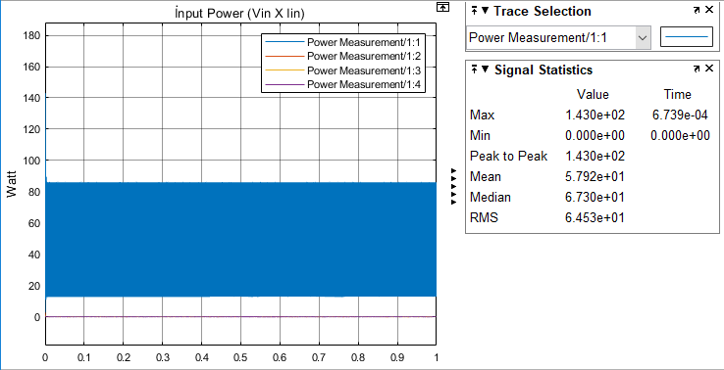

Figure 3:Input Power at %75 Load Condition, (24V rating Voltage)

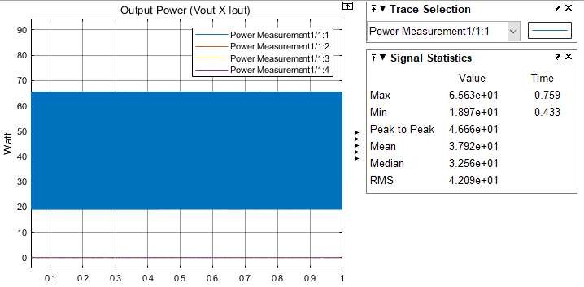

Figure 4: Output Power at %75 Load Condition, (24V rating Voltage)

## %50 Load Condition , at 24V (Rating Voltage)

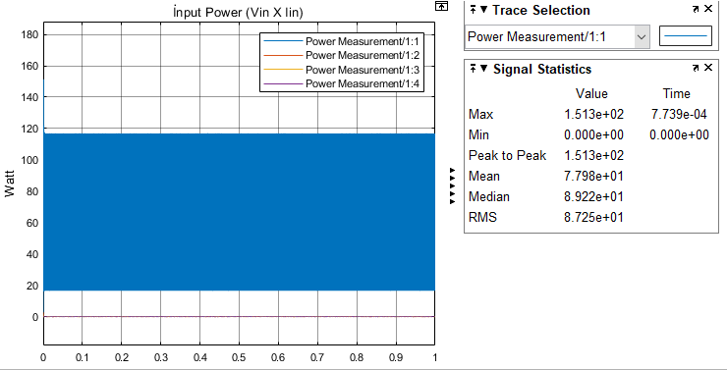

Figure 5:Input Power at %50 Load Condition, (24V rating Voltage)

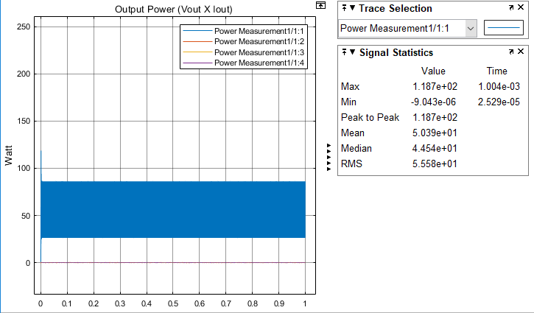

Figure 6:Output Power at %50 Load Condition, (24V rating Voltage)

## %25 Load Condition , at 24V (Rating Voltage)

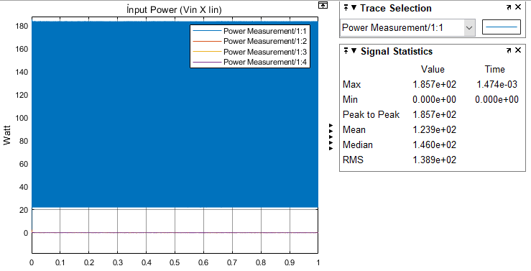

Figure 7: Input Power at %25 Load Condition, (24V rating Voltage)

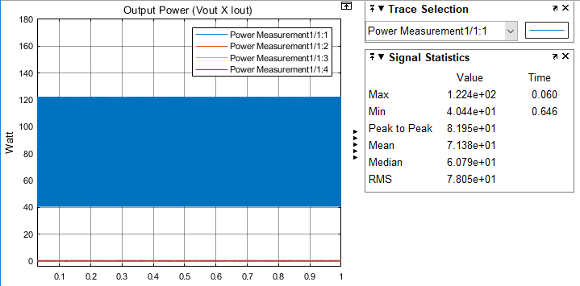

Figure 8: Output Power at %25 Load Condition, (24V rating Voltage)

## No Load Condition , at 24V (Rating Voltage)

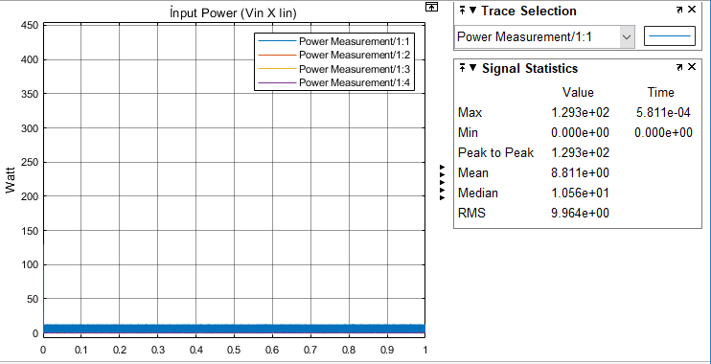

Figure 9: Input Power at No Load Condition, (24V rating Voltage)

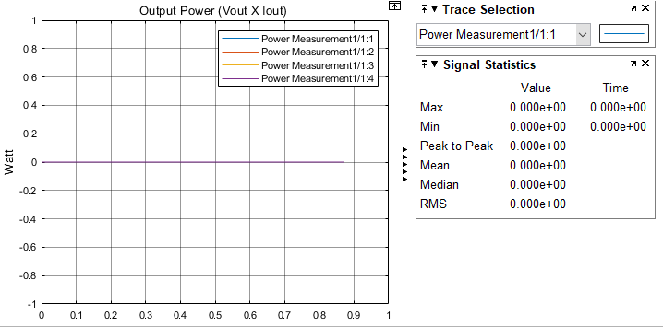

Figure 10: Output Power at No Load Condition, (24V rating Voltage)

|  |  |  |  |
| --- | --- | --- | --- |
|  | P_input (W) | P_out(W) | Efficiency (%) |
| Full Load | 50.8 | 32.1 | 63.2 |
| %75 Load | 64.5 | 42.1 | 65.3 |
| %50 Load | 87.2 | 55.6 | 63.7 |
| %25 Load | 138.9 | 78.1 | 56.3 |
| No Load | 9.9 | 0 | 0 |

Table X. Test Results obtained with different loads

With respect to Table X, efficiency aproximately about %60 . Also in No Load condition, there is no current flow on load, therefore output power is equal to 0. Moreover, input power is power loss at No Load.