**g)**

For Vin = 48 V;

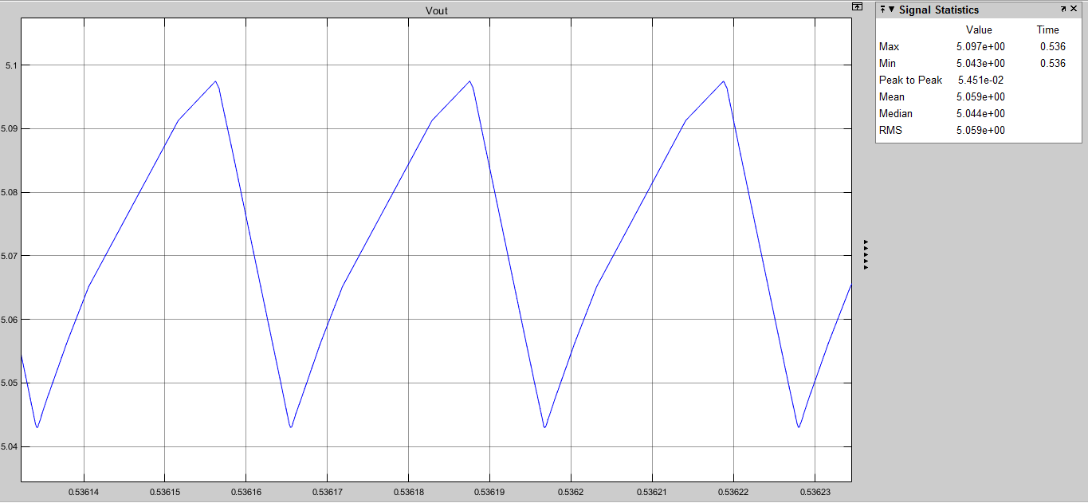

**Figure x1**. Output Voltage of the Converter for Vin = 48 Volts

Ripple Voltage: ΔVout = 54.5 mV as it can be seen from the figure.

100 *(ΔVout/Vout) = 1.08 % ripple is observed at the output of the converter at max Vin.

For Vin = 24 V;

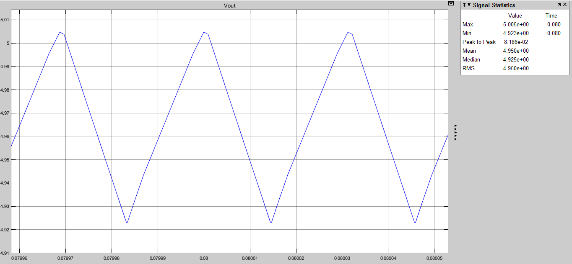

**Figure x2**. Output Voltage of the Converter for Vin = 24 Volts

Ripple Voltage: ΔVout = 81.6 mV as it can be seen from the figure.

100 *(ΔVout/Vout) = 1.63 % ripple is observed at the output of the converter at min Vin.

**For Line Regulation:** At 24 volts given to the input, the output voltage is 4.95 Volts and when at 48 volts input, the output voltage is 5.059 volts as it can be seen from **Fig x1 and x2**. When we subtract these values we get the output voltage deviation: Vo,dev = 0.109 V

$$Line Regulation \% = \frac{Vo,dev}{ΔVi}*100$$

$$Line Regulation \%=\frac{0.109}{24}*100= 0.45 \%$$

**For Load Regulation:** For 5/6 and 50/6 Ohm Loads, we measure the voltage difference between the output voltages of these loads.

$$Load Regulation \% =\frac{Vo,dev}{Vout}*100$$

$$Load Regulation \% =\frac{6.6-5}{5}*100=32 \%$$

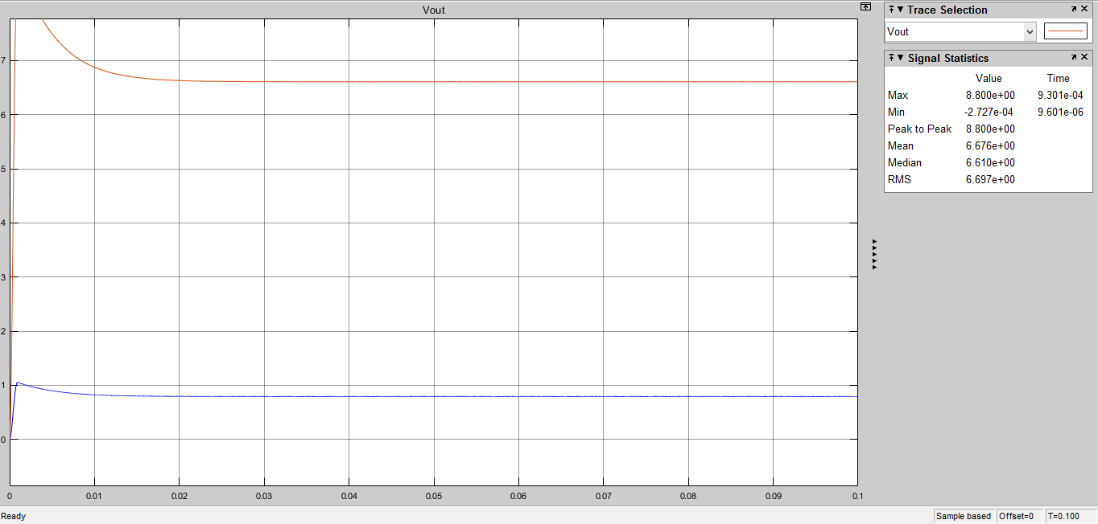

Figure x. Vout at 10% Current

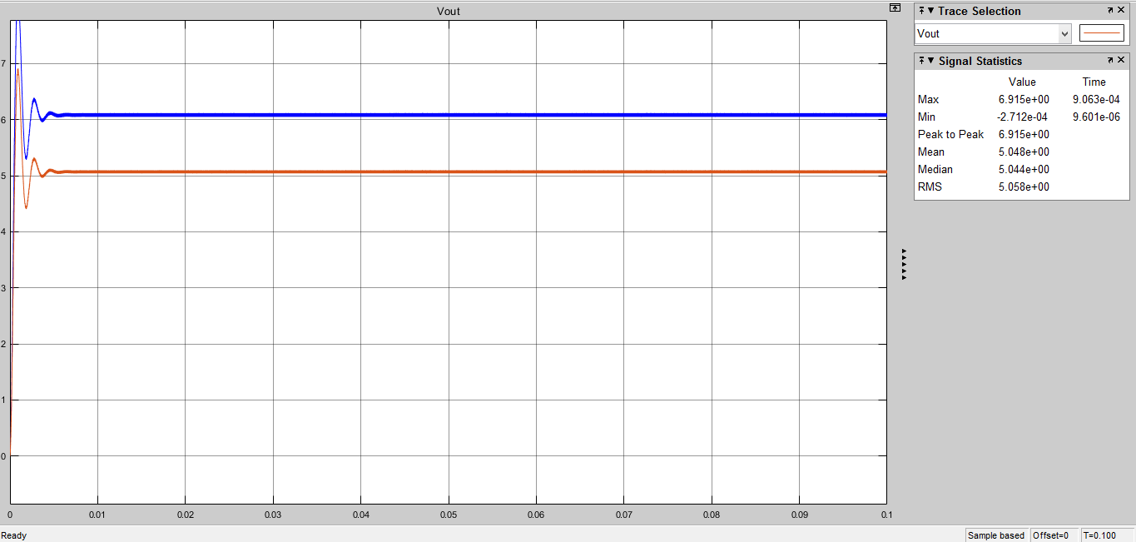

Figure x. Vout at 100% Current

Load regulation seems high for now. The reason for that is because feedback is taken from the simulation’s input and this input does not change in this ideal simulation. In the future the feedback will be taken from the hardware output and the problem will be fixed. Other than this situation, all ripple conditions seems to be in the accepted tolerance intervals.