**e-)** According to our calculations, we found Lm as 400 µH and Lleakage as 12 µH (% 3 of Lm). We set forward voltages of switch and diode as 0.8 V. Firstly, we simulated our flyback converter without snubber with these parasitic parameters.

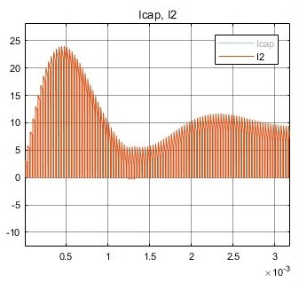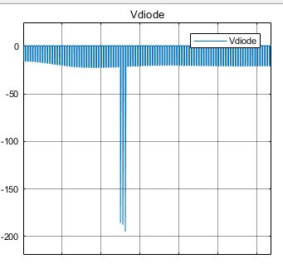

**Figure X:** Voltage-Current oscillations of diode without snubber at initial time

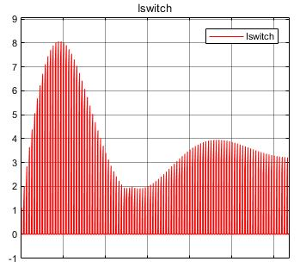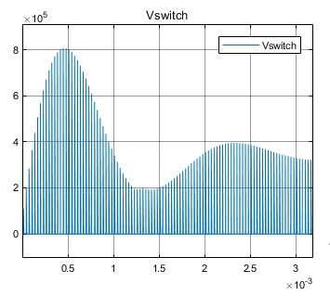

**Figure X:** Voltage-Current oscillations of switch without snubber at initial time

In Figure X and X, we saw that snubber is must for flyback converter because voltage stress on the switch which is up to 800000 V is too much. Switches cannot endure that much voltage. We designed RCD snubber for avoiding these stresses. For RCD snubber, we used 5 kΩ resistor and 47 nF ceramic capacitor. After that we simulated our converter with snubber. For calculation of snubber values:

$$P=1/2 * L_{leakage} * {I }^{2}* f = ½ * 12 *{10}^{-6} * 8^{2} * 32 * {10}^{3}= 12.3 W$$

$$R= \frac{V^{2}}{P}=\frac{{250}^{2}}{12.3}=5 kΩ$$

$$C≫\frac{T_{s}}{R}=\frac{1}{5000*32000}=6.25 nF$$

**Figure X:** Voltage-Current oscillations of diode with snubber at initial time

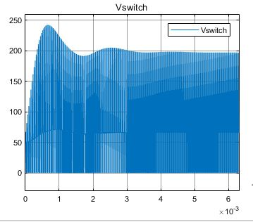

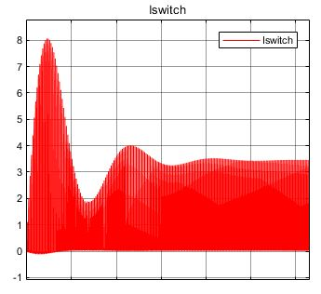

**Figure X:** Voltage-Current oscillations of switch with snubber at initial time

As seen in Figure X and X, current stresses are same with previous case but voltage stresses on diode and switch is reduced very much as we expected. Voltage stress on diode decreased to 23 V and voltage stress on switch decreased to 250 V. Finally, our diode is capable of carrying 25 V and 25 A and our switch is capable of carrying 8 A and 250 V.