Eklenebilir ise aşağıdaki algoritmalar hatta H20 veya Tpot’da eklenebilir onlar ile ilgili eğitim süresi. İlave olarak Hibrit bir yöntem örnek AutoGloun+CNN gibi.

Table 2. Approximate Training Time per Model
Model | Training Time
Logistic Regression (BoW/TF-IDF) | ~1 minute
Naive Bayes (BoW/TF-IDF) | ~1 minute
Random Forest (BoW/TF-IDF) | ~5 minutes
Support Vector Machine (BoW/TF-IDF) | ~20 minutes
LSTM (3 epochs) | ~10 minutes
DistilBERT (3 epochs) | ~6 hours
BERT (3 epochs) | ~15 hours
RoBERTa (3 epochs) | ~15.5 hours
AutoGluon | ~20 hours

Algoritma başarım oranları

Table 4. Model Evaluation Metrics (Accuracy, Precision, Recall, F1)
Model | Accuracy | Precision | Recall | F1 Score
LogReg (BoW) | 0.85 | 0.85 | 0.85 | 0.85
Naive Bayes (BoW) | 0.89 | 0.91 | 0.89 | 0.89
Random Forest (BoW) | 0.85 | 0.85 | 0.85 | 0.85
SVM (BoW) | 0.88 | 0.89 | 0.88 | 0.88
LogReg (TF-IDF) | 0.87 | 0.88 | 0.87 | 0.87
Naive Bayes (TF- IDF) | 0.89 | 0.90 | 0.89 | 0.88
Random Forest (TF- IDF) | 0.85 | 0.85 | 0.85 | 0.85
SVM (TF- IDF) | 0.88 | 0.89 | 0.88 | 0.88
LSTM | 0.88 | 0.90 | 0.88 | 0.87
DistilBERT | 0.89 | 0.89 | 0.89 | 0.89
BERT | 0.90 | 0.90 | 0.90 | 0.90
RoBERTa | 0.90 | 0.91 | 0.90 | 0.90
AutoGluon | 0.93 | 0.93 | 0.93 | 0.93

En başarılı modelin con mat

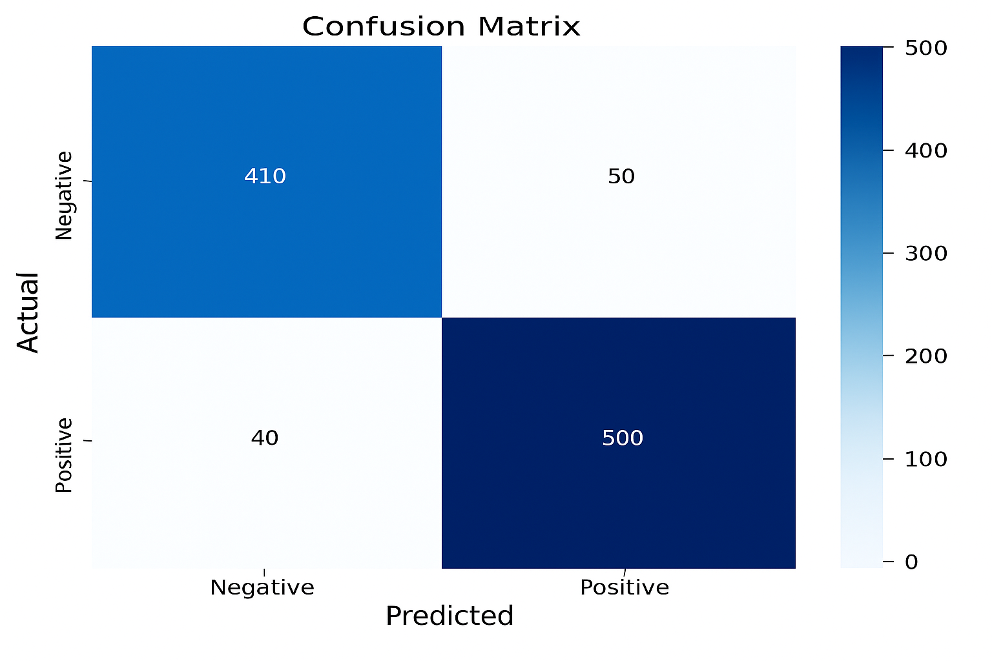
Roc

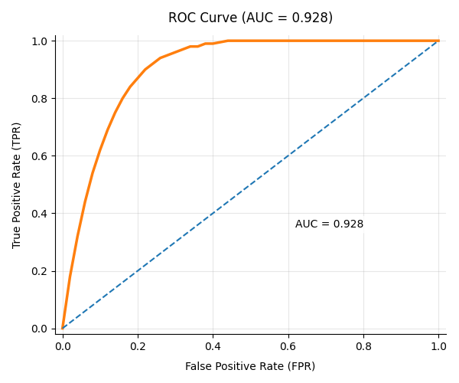
Modelin çalıştığı uygulama ekranı

