Choose an ordinary object that could provide useful information from sensors.

1. Describe the object that you selected.

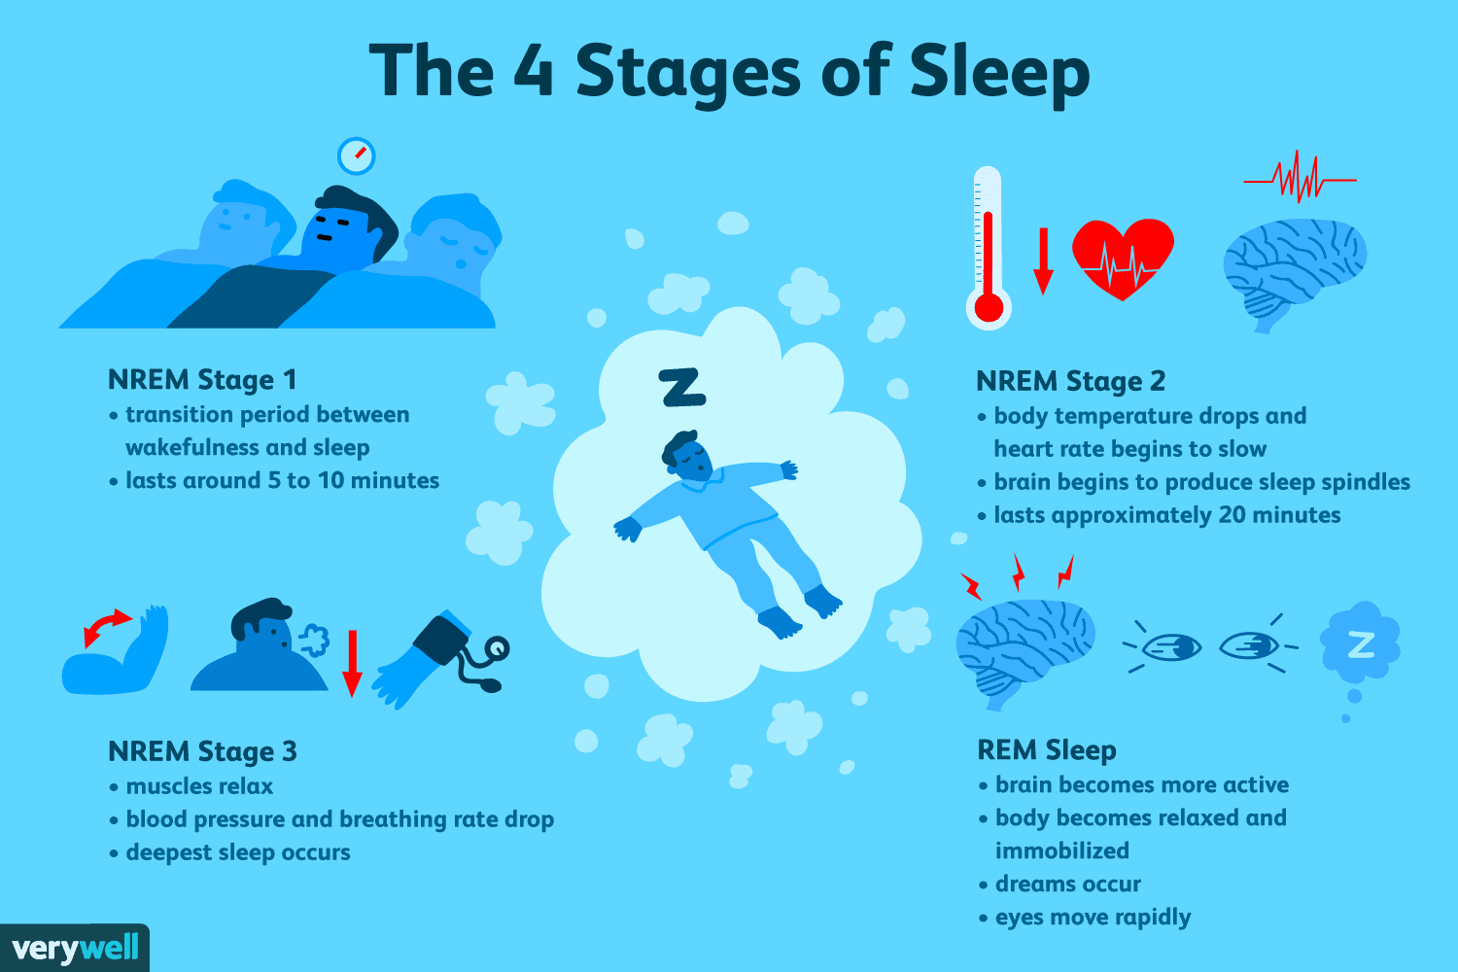**Smart Bed (Better sleeping and happier people)**

2. What kind of data would sensors in this object gather?

**Motion sensor, sensor connected to brain, temperature sensor, energy like sensor**

3. How could the gathered data be useful and to whom would it be useful?

**How many hours each stage of sleeping take place?**

**What is the body movement during each stage?**

**How could sleeping quality be increased?**

**Body temperature vs room temperature**

**Best time to go to bed**