EMT 2480L HE62[30147]

Crutches Lab Report

Instructor: Prof. L. Hamilton
Name: Heng Zheng Ni, Mohammed Imad, Yusuf Smaili
Date: Dec 1st – Dec 19th

Table of Contents
EMT 2480L HE62[30147] 1
Crutches Lab Report 1
Objective: 1
Product Description: 2
Procedure: 2
Timeline 3
3D model and 2D drawing of Crutch Parts: 4
Rubber Properties: 16
Mesh of Cap (Rubber): 17
Cap Fixed (Rubber): 18
Cap Load (Rubber): 18
Mass Properties (Rubber): 19
Stress of Cap (Rubber): 20
Strain of Cap (Rubber): 21
Factor of Safety (Rubber): 22
Displacement (Rubber): 23
Moment of Inertia of the Area of the Cap: 24
Calculation: 25
Percent Error: 26
Silicon Properties: 27
Mesh of Cap (Silicon): 27
Cap Fixed (Silicon): 28
Cap Load (Silicon): 29
Mass Properties of Cap (Silicon): 30
Stress of Cap (Silicon): 31
Strain of Cap (Silicon): 31
Factor of Safety (Silicon): 32
Displacement (Silicon): 33
Moment of Inertia of the Area for the Cap: 34
Calculation: 35
Percent Error: 36
Primary material for Cap 36
Mass & Cost of Crutch 37
Technical Problems & Observation 37
Conclusion: 38

Objective:
Using Solidworks CAD, design each assigned part of a crutch. Then, create an assembly, as well as a 2D drawing for each part, as well as the assembly, being sure to add an exploded view of the crutch. Also, simulate the mass, stress, strain, displacement, area, moment of intertia, and factor of safety. For this simulation, a specific material must be applied to the cap of the crutch, since that’s the assigned part of the crutch in which the simulation must occur.

Product Description:
The product being designed is a mobility aid designed to support individuals with limited ability to walk due to injury, surgery, or disability. Typically made of lightweight materials like aluminum or wood, crutches provide stability and reduce weight-bearing on the lower body. It features padded underarm rests, ergonomic hand grips, and adjustable height settings for comfort and proper fit. Crutches are available in various styles, including underarm, forearm, and platform, catering to different needs and preferences.
The material used in this case is 7075-T6 Aluminum Alloy. Why? Simply because out of all aluminum alloy materials, it's easily strong enough to withstand heavy loads (300lbs+), while remaining light enough to stay well under 3.5lbs. It also can stay very durable for long-term use without failing.

Tubes: 7075-T6 (SN) aluminum alloy – Strong and lightweight for the main structural components.
Caps: Silicon – Durable and impact-resistant for end caps.
Tee: ABS plastic – Lightweight and strong for non-structural components.
Sleeve Roller: Nylon 101 – High wear resistance and a smooth surface for rolling functionality.
Sleeve: Nylon 101 – Durable material for smooth operation.
Pins: 7075-T6 aluminum alloy – Lighter than stainless steel but strong enough for load-bearing pins.
Armrest: Natural Rubber – Soft and shock-absorbing for comfort.

Procedure:
1. Use SOLIDWORKS to create both a 3D model and a 2D drawings for each part of the crutch.
2. Use SOLIDWORKS to create an assembly for the crutch, with an exploded view. Be sure to include a 2D drawing of the assembly with the exploded view.
3. For the first material, use Polyethylene Cross Linked. Define one end of the cap as fixed, and apply a tensile load of 1.3345kN or 300 lbf (Pound-force) to the opposite end.
4. Run a simulation in SOLIDWORKS to evaluate the following properties: mass, stress, strain, displacement, area, moment of intertia, as well as factor of safety (FOS).
5. Perform manual calculations for stress, strain, factor of safety (FOS), moment of inertia, and mass.
6. Compare the manually calculated values with the SOLIDWORKS data and calculate the percentage error.
7. Change the cap material to Silicon in SOLIDWORK and rerun simulation. Record the values for stress (normal and Von Mises), strain, factor of safety (FOS), and displacement.
8. Compare the Polyethylene results with Silicon data. Describe the data and include stress and displacement plots, focusing on differences in stress distribution, deformation, and material properties.

Timeline
This shows a rough timeline based on certain assignments we all worked on as a group. Most were done on time, and a few were done a day late. At the end, we came together and were able to do the tasks provided.

3D model and 2D drawing of Crutch Parts:
Assembly:

Armrest:
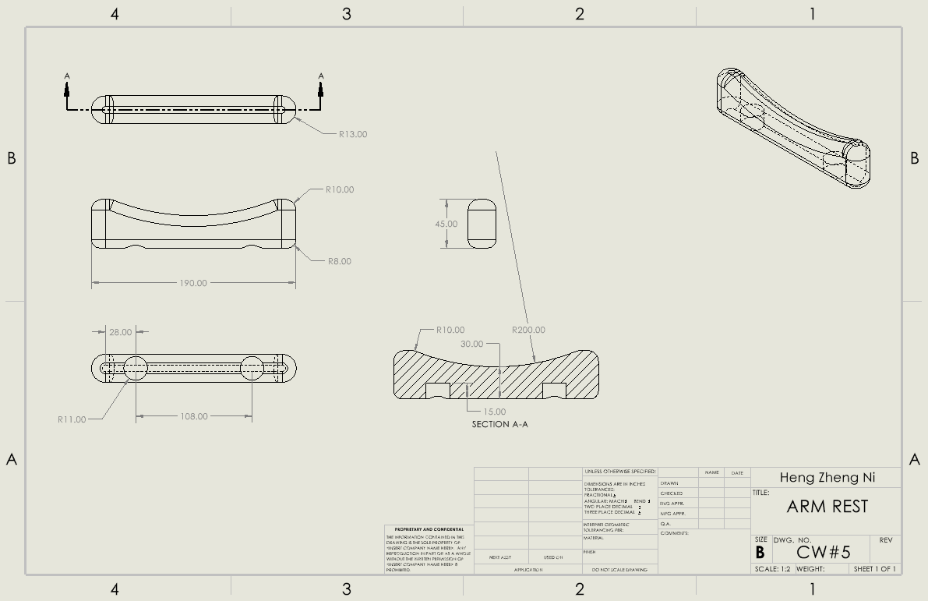

Sleeve Roller:
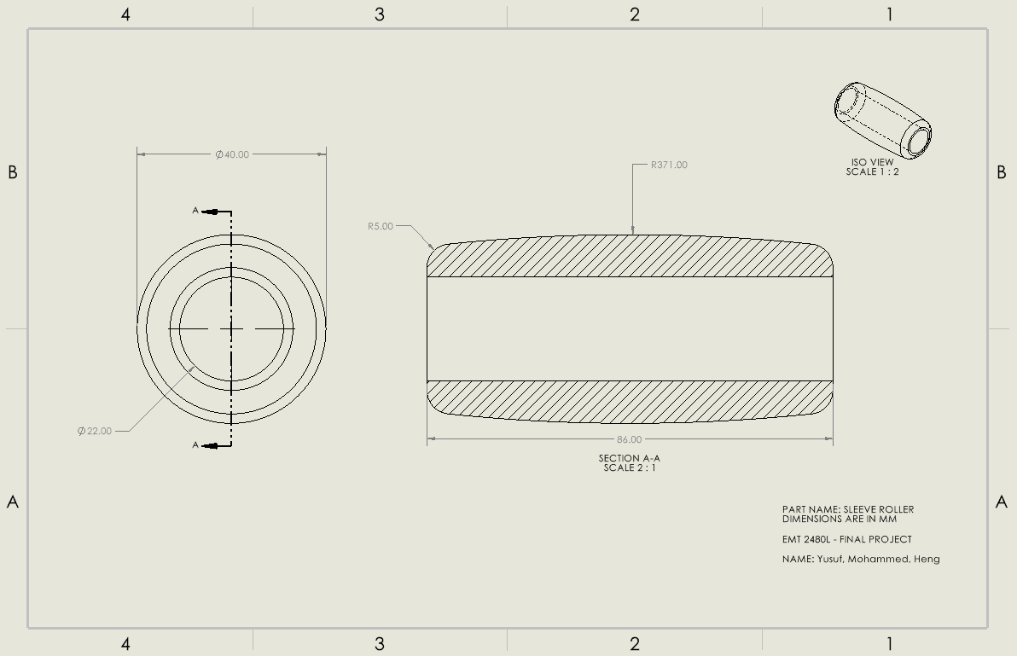

Tube:
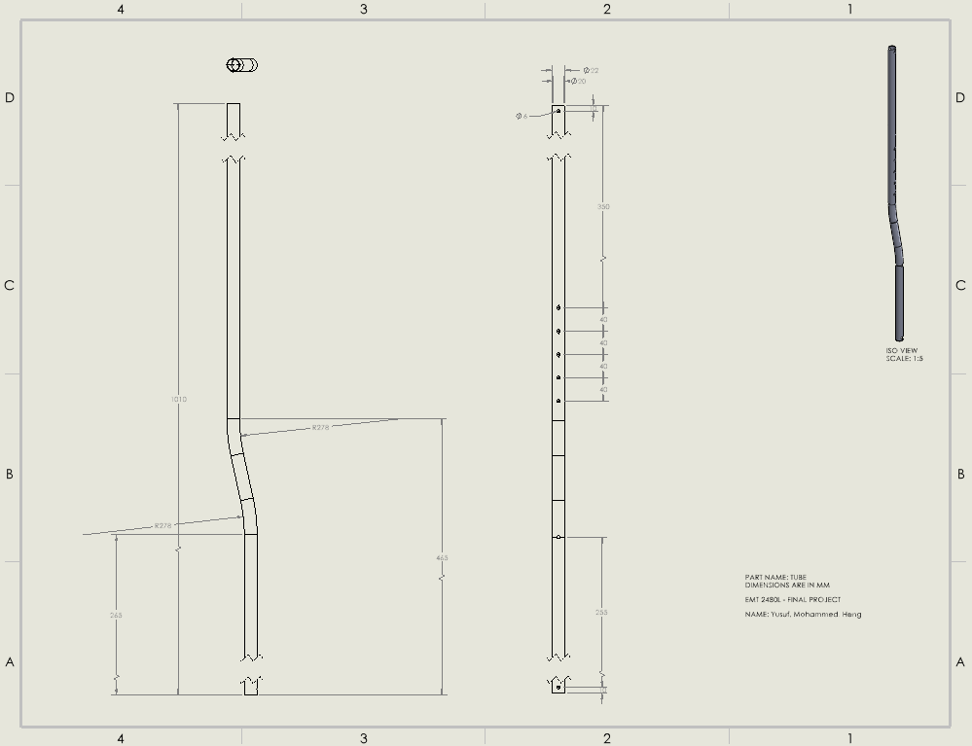

Tube – Short:
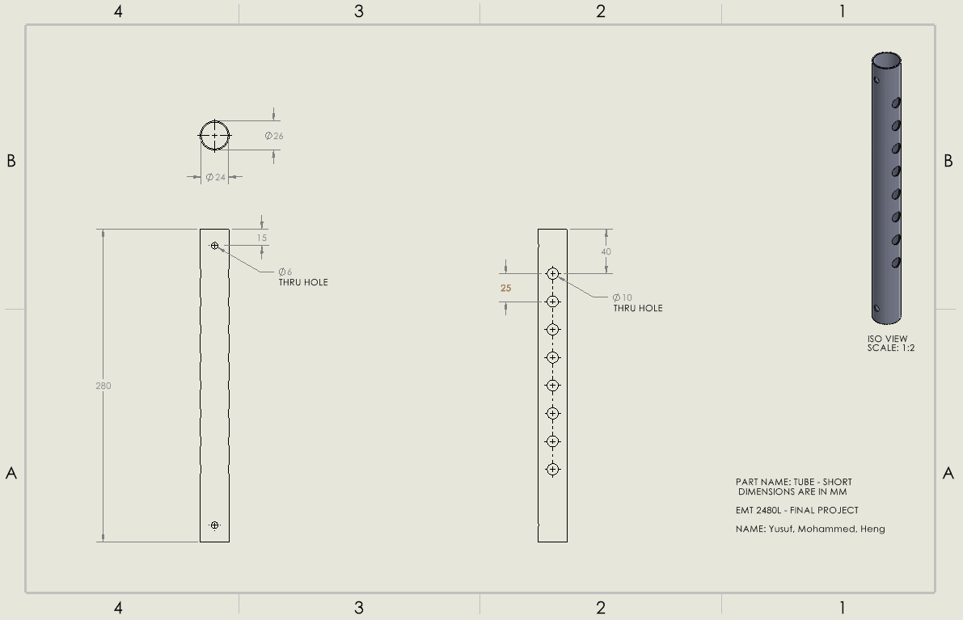

Tube – Short #2:
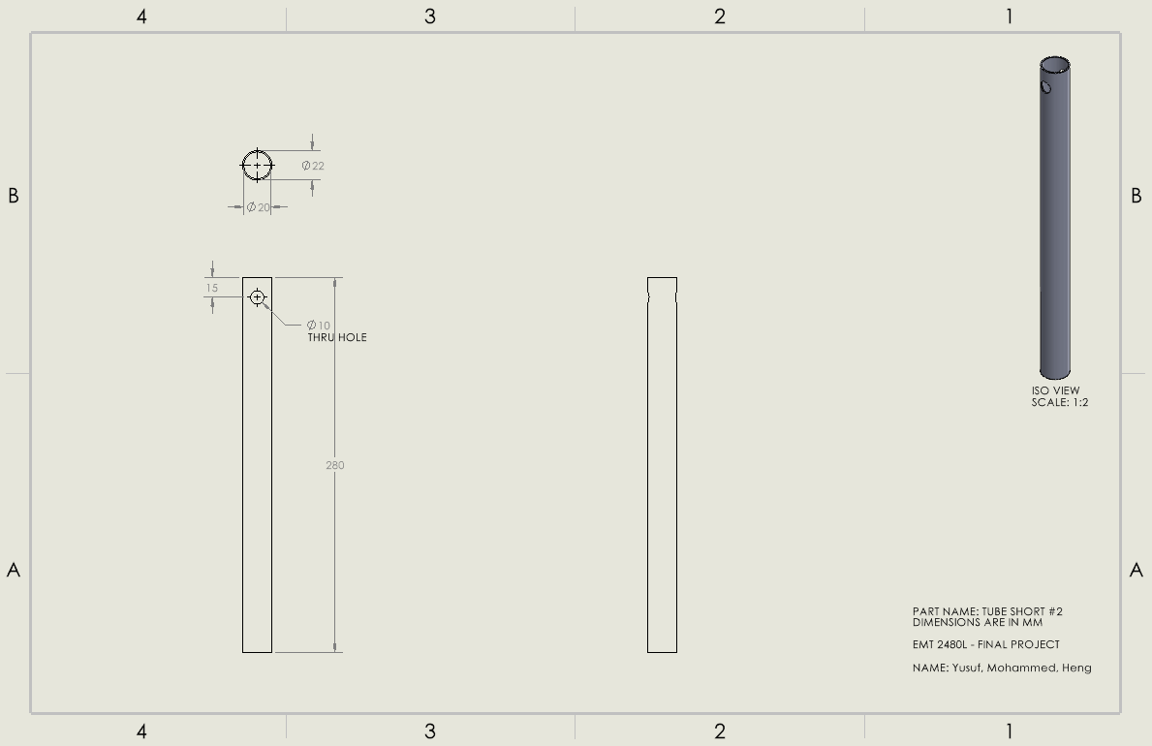

Cap:
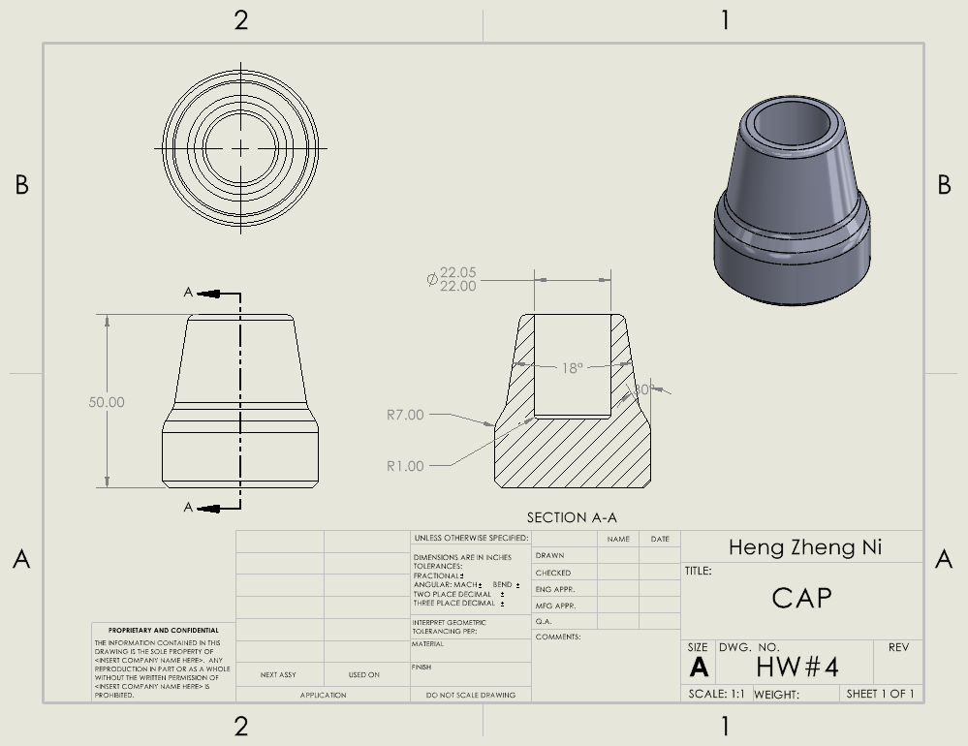

Tube Cap:
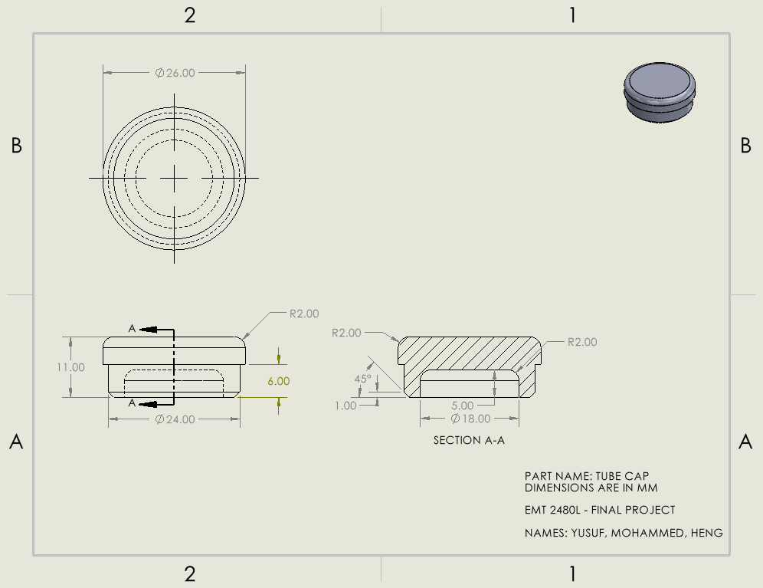

Pin #1:
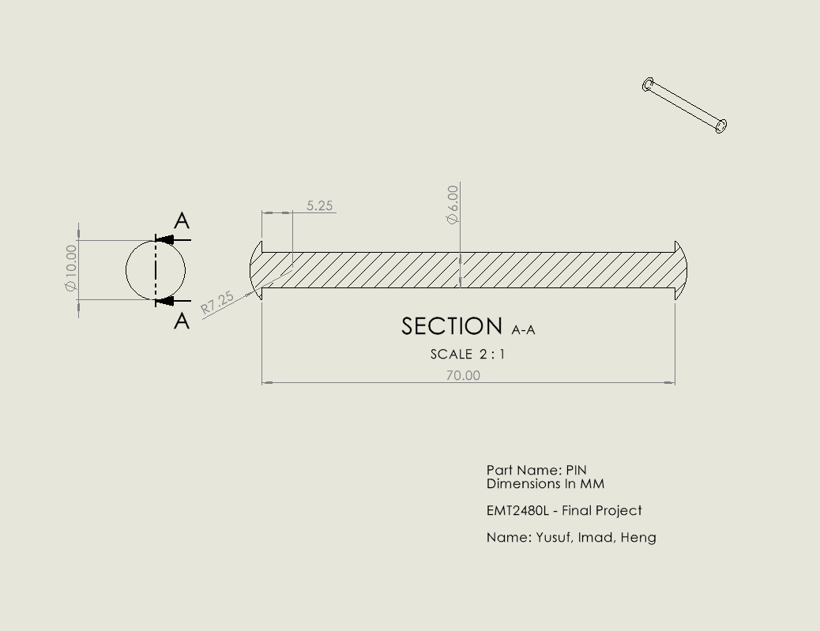

Pin #2:
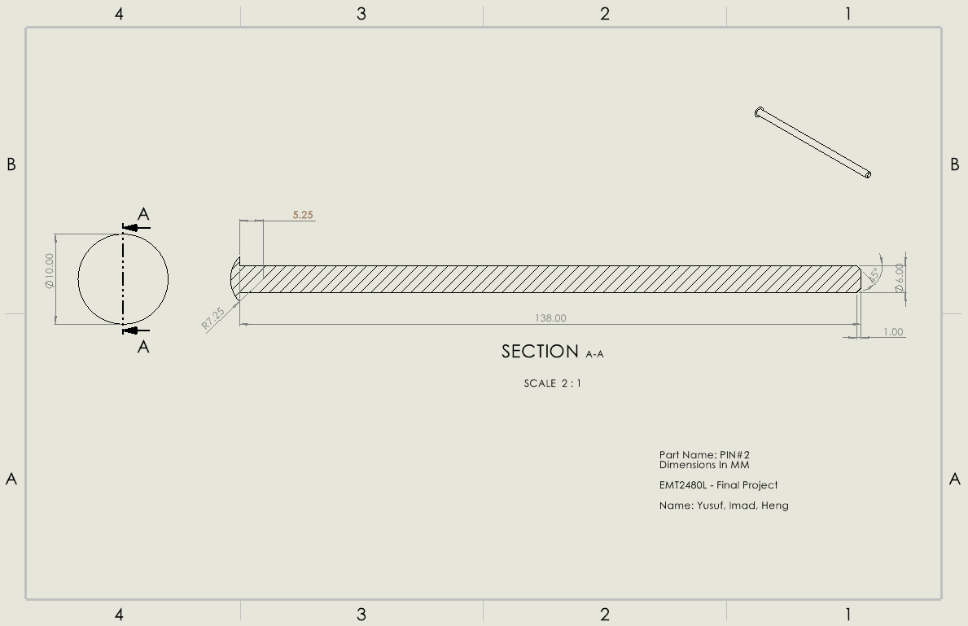

Pin #3:
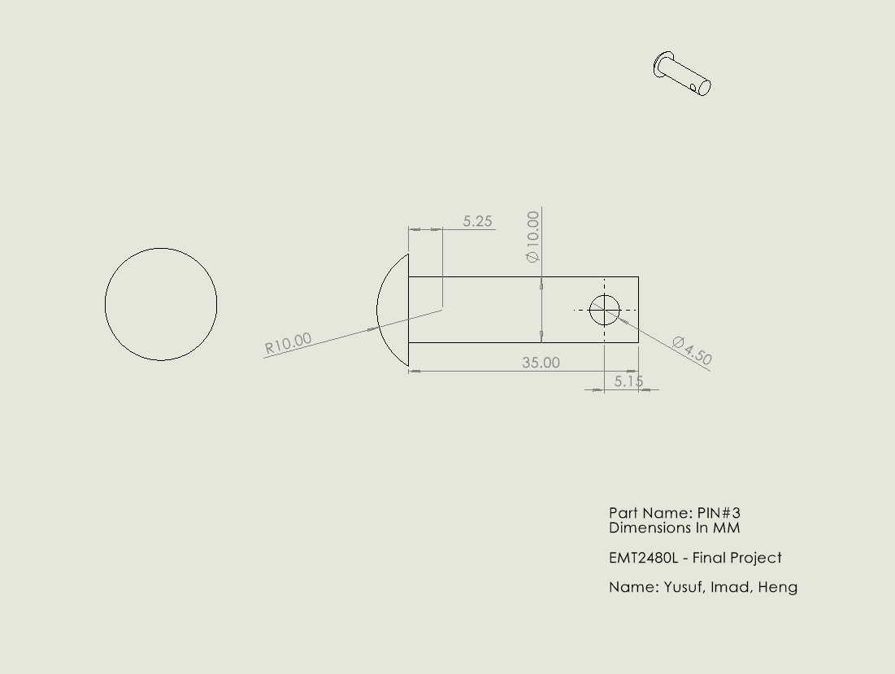

Sleeve:
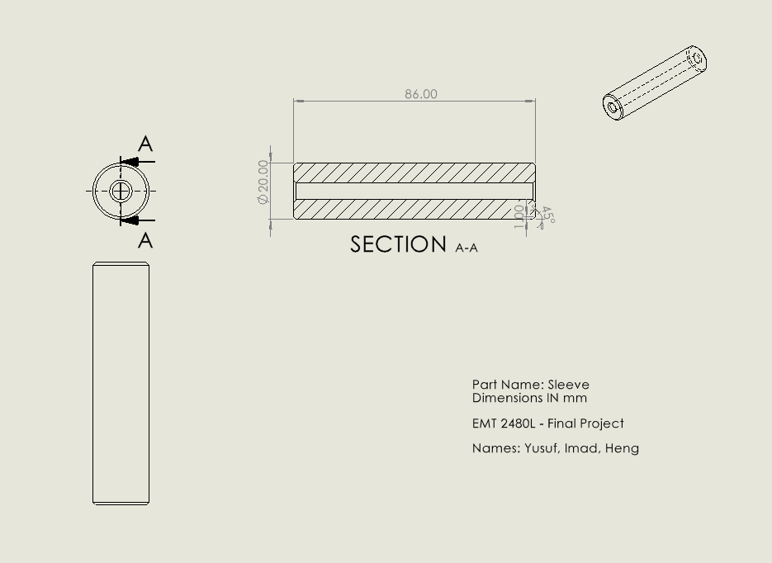

Tee:
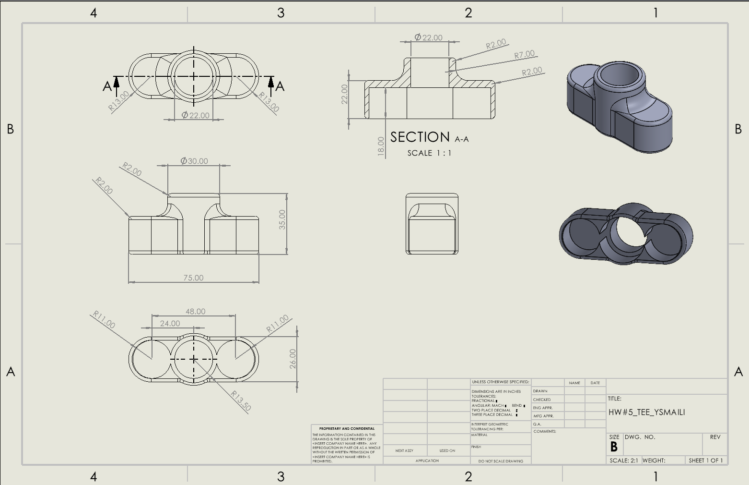

Rubber Properties:
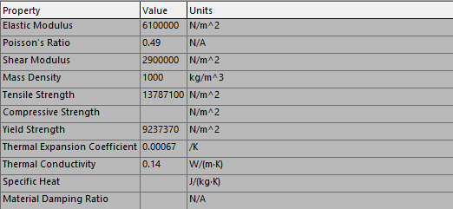
The table above shows the materials (Rubber) properties. This table is extremely important because it can help calculate things like Strain & Factor of Safety (FOS). The two properties we’ll be using in this table will be the “Elastic Modulus”, as well as the “Yield Strength”.

Mesh of Cap (Rubber):
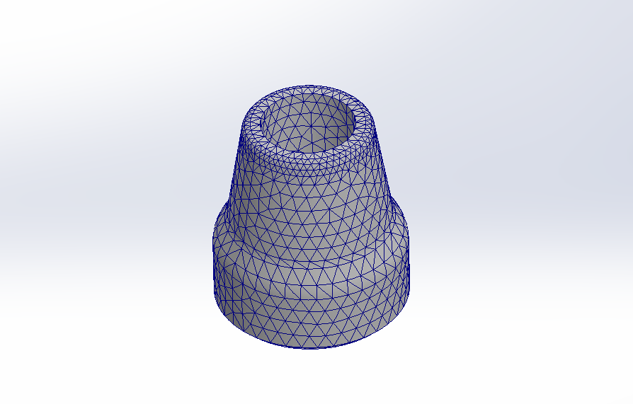
The photo above shows a visual representation of the Mesh of the Cap (Rubber). It was achieved by SolidWorks software.

Cap Fixed (Rubber):
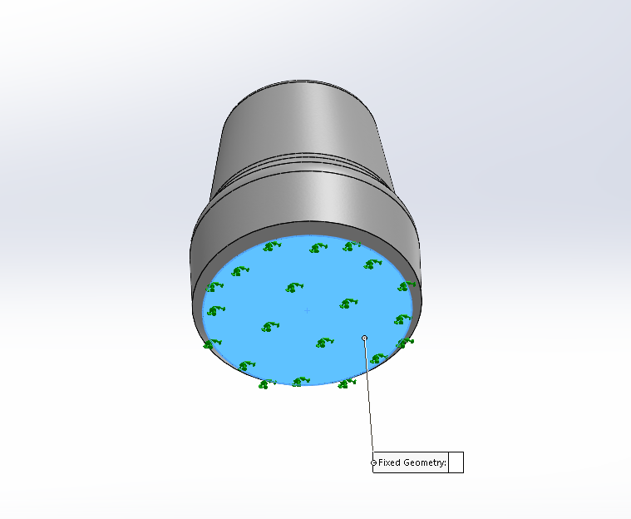
The green arrow indicates where the fixed load is, meaning the load magnitude does change for the cap.

Cap Load (Rubber):
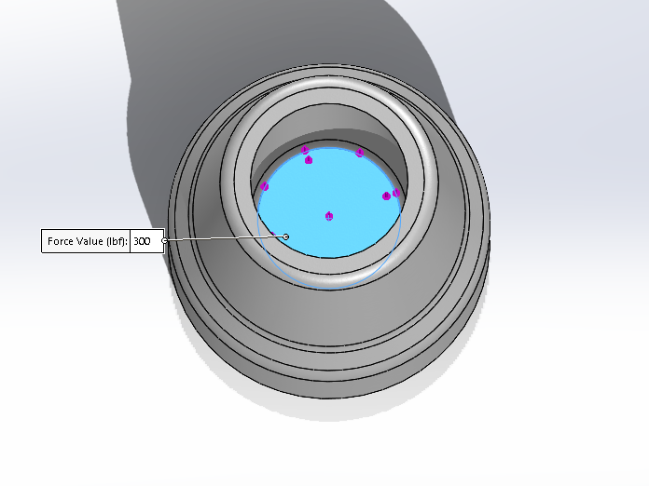
The purple arrow indicates where the 300lbf compressive load is being applied to the cap. It is being applied to the top opening.

Mass Properties (Rubber):
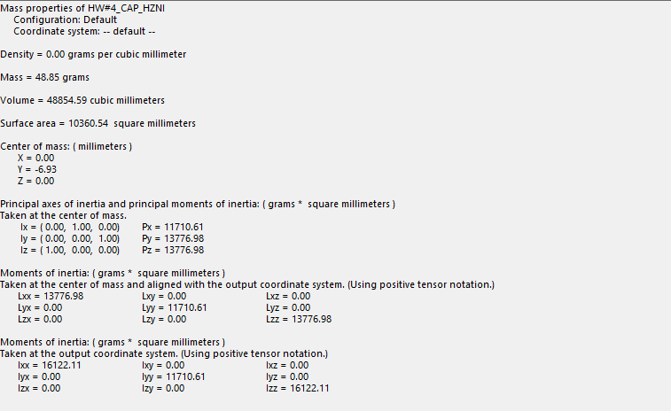

Stress of Cap (Rubber):
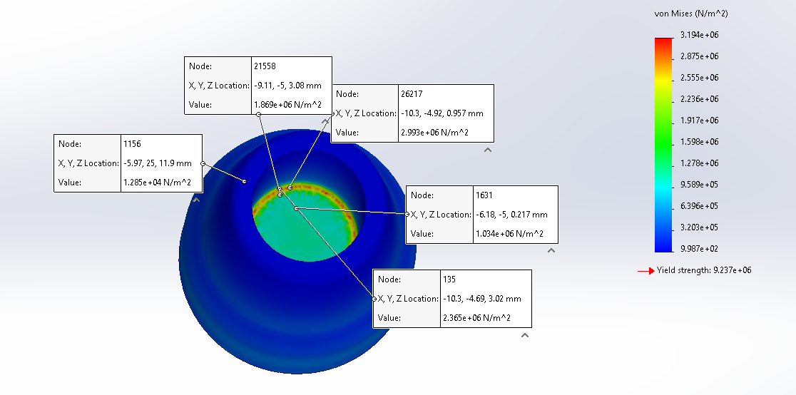
The von Mises (N/m²) color coded index represents the different values of stress. Red being the highest stress and blue being the lowest stress. The cap has a majority blue around its body indicating low stress value. The most stress is being applied to the top part of the cylinder where a load of 300lbf is being applied.

Strain of Cap (Rubber):
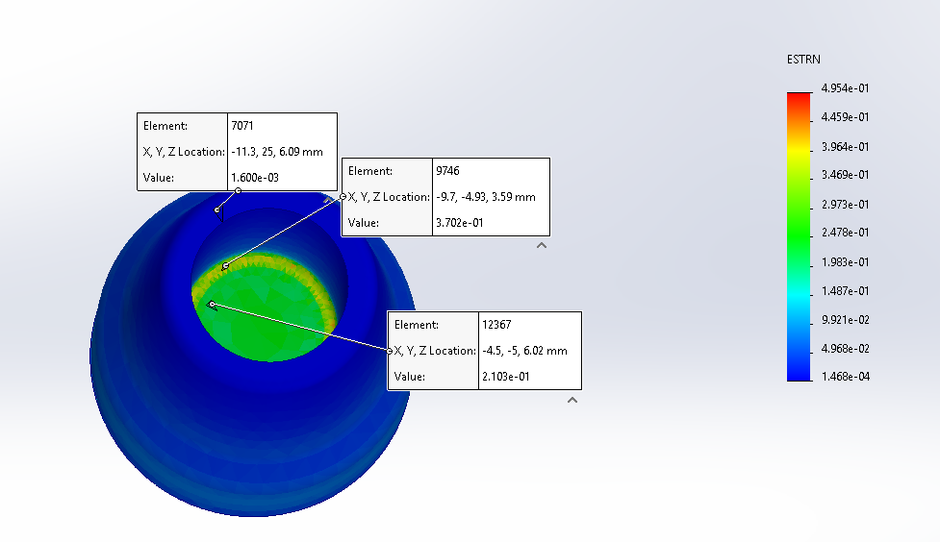
The most strain being put on the cap is on the top of the cylinder as indicated by the red color. This is due to the 300 lbf.

Factor of Safety (Rubber):
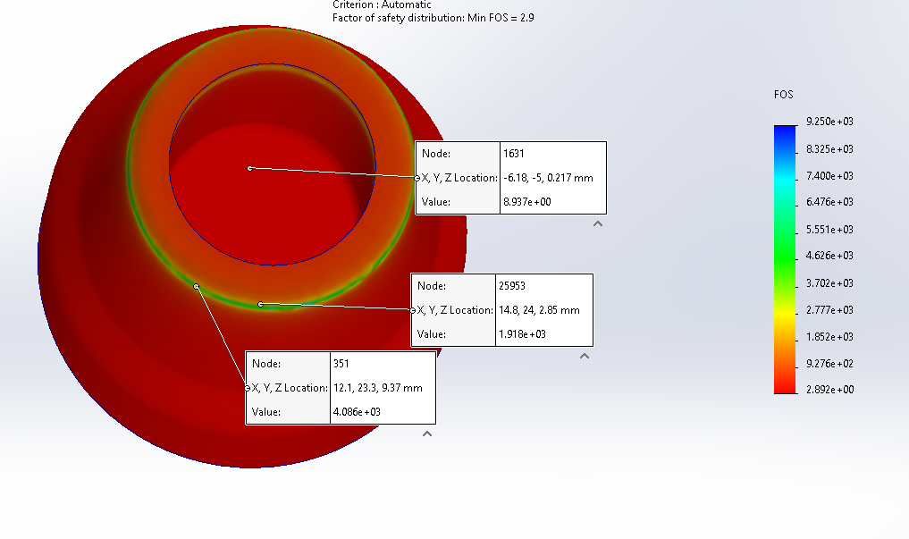
The standard value for factor of safety for the Cap is around 2.9. We measured the value for factor of safety as 2.892. Since our factor of safety is lower than the standard value, the Rubber Cap has a chance of not being able to withstand the force being applied.

Displacement (Rubber):
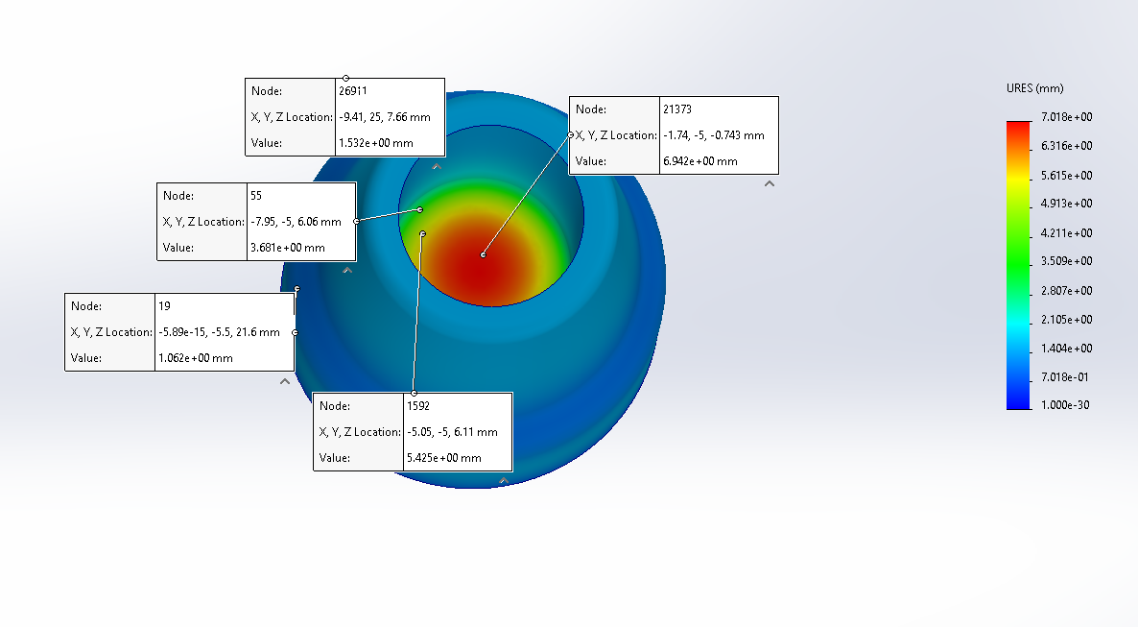
In the Cap, the most displacement is on the top of the cap (open part) where the compressive load is. The center of the cap is red, which means it has the most displacement and then the displacement value starts to decrease as it goes away from the center, which can be shown by the transition of color. You can follow the URES color code scale to see how the color transitions from the center to outward.

Moment of Inertia of the Area of the Cap:
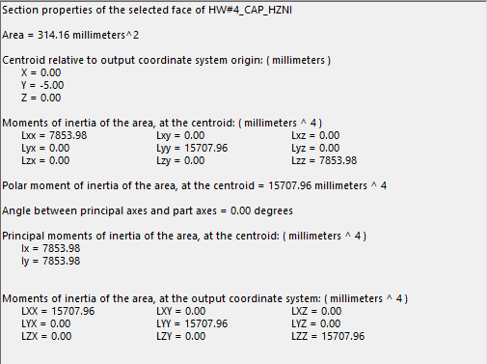

Calculation:
300lbf × 4.44822N/lbf = 1334.47N
Area = πr²
Area = π(10mm)² = 314.16 mm²

Stress (σ) = Force / Area
Stress = 1334.47 N / 314.16 mm² = 4,248,569.6N/mm${}_{}^{2}{}$, 4.25 MPa
Strain (ε) = Stress / Elastic Modules
Strain = 4.25 MPa / 6,100,000 N/mm² = 0.697
Factor Of Safety = Yield Strength / Stress = 2.174

Area Moment of Inertia:
Lx = Ly = πr⁴ / 4 = π(10)⁴ / 4 = 7853.98mm⁴

Percent Error:
Percent Error Formula = |Calculated Value – Measured Value / Measured Value| ⋅ 100%
Stress % Error = ∣4.25−3.194 / 3.194∣ ×100 = 33.06%
Strain % Error = ∣0.697−0.4954 / 0.4954∣ ×100 = 40.64%
Factor Of Safety % Error = ∣2.892−2.174 / 2.892∣ ×100 = 24.83%

Silicon Properties:
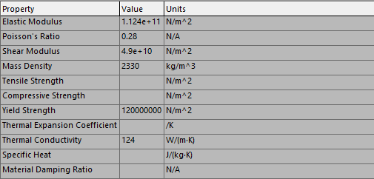
The table above shows the materials (Silicon) properties. This table is extremely important because it can help calculate things like Strain & Factor of Safety (FOS). The two properties we’ll be using in this table will be the “Elastic Modulus”, as well as the “Yield Strength”.

Mesh of Cap (Silicon):
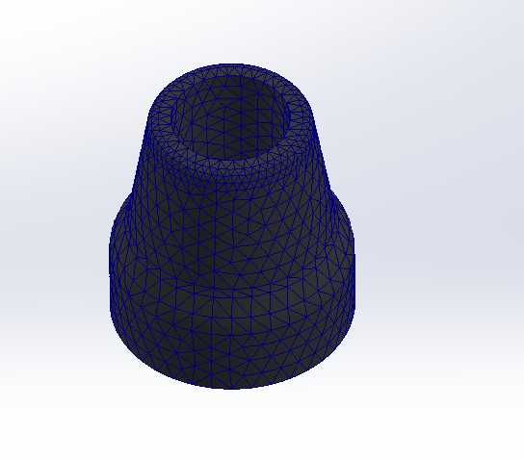
The photo above shows a visual representation of the Mesh of the Cap (Silicon). It was achieved by the SolidWorks software.

Cap Fixed (Silicon):
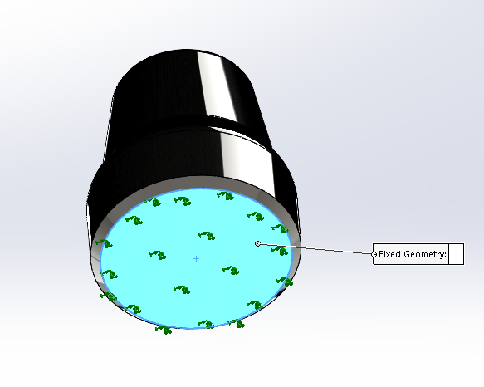
The green arrow indicates where the fixed load is, meaning the load magnitude does change for the Cap.

Cap Load (Silicon):
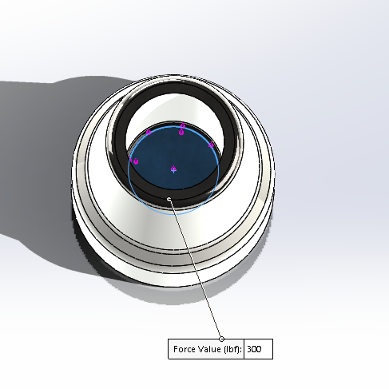
The hub load for Silicon has a compressive load force, the value of it is 300lbf. It is indicated by the purple arrows in the photo.

Mass Properties of Cap (Silicon):
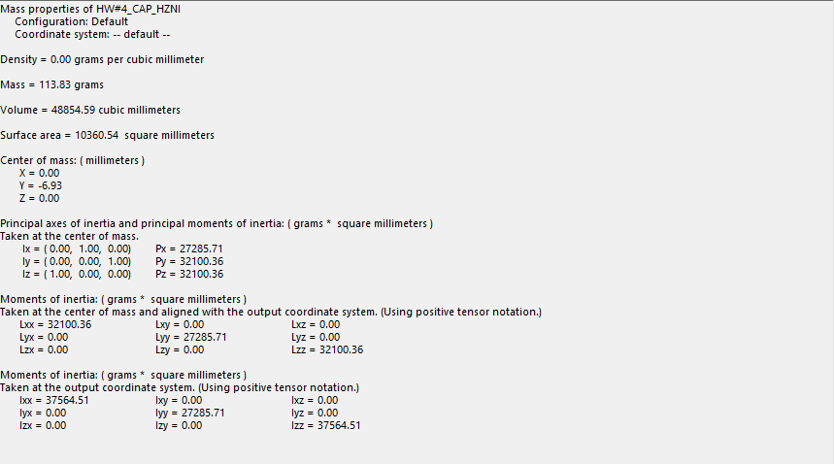

Stress of Cap (Silicon):
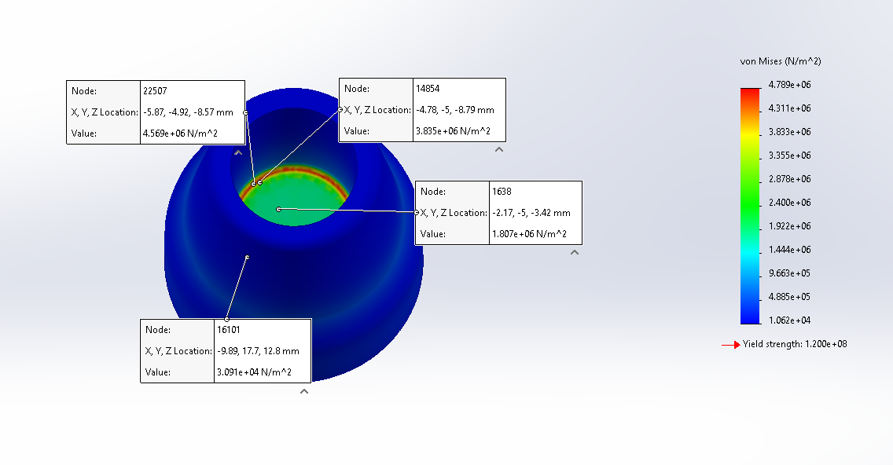
The most stress on the Silicon Cap is where the caps load’s compressive force is located. As you can see by the four nodes, they all represent four different colors and four different values.

Strain of Cap (Silicon):
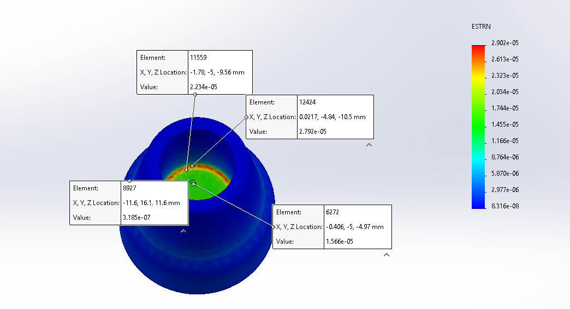
The biggest strain on the Silicon Cap is on the top part of the cap. The photo has four different nodes.

Factor of Safety (Silicon):
The standard factor of safety is 25, and our measured value of 25.06 falls within the typical range. This confirms that the silicon meets the required safety standards for the expected load conditions. The minimal difference indicates no substantial improvement over the standard.

Displacement (Silicon):
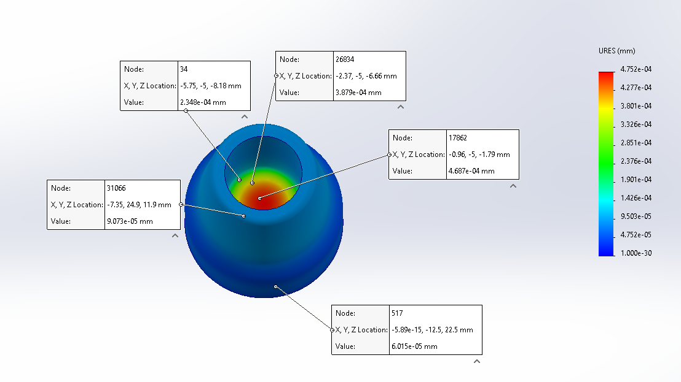
For Silicon, the highest point of displacement is 4.687e-04 mm by the node in the photo above. The red color indicates the most displacement and as you go more outwards from the center the displacement resultant value starts to go down. Using the URES (mm) color scale as a reference the more outwards you go from the center the colors start to go down in the scale. We also referenced it in our nodes point.

Moment of Inertia of the Area for the Cap:
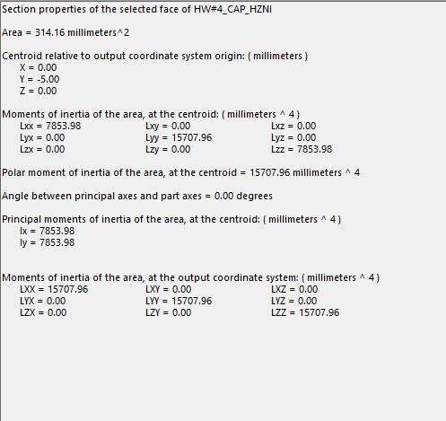

Calculation:
300lbf × 4.44822N/lbf = 1334.47N
Area = πr²
Area = π(10)² = 314.16 mm²

Stress (σ) = Force / Area
Stress = 1334.47N / 314.16 mm² = 4.25 MPa

Strain (ε) = Stress / Elastic Modules
Strain = 4.25MPa / 1.124 ×10¹¹ N/m² = 0.0000378

Factor Of Safety = Yield Strength / Stress
Factor Of Safety = 1.2 × 10⁸ N/m² / 4.25 MPa = 28.24

Area Moment of Inertia:
Lx = Ly = πr⁴ / 4 = π(10)⁴ / 4 = 7853.98mm⁴

Percent Error:
Percent Error Formula = |Calculated Value – Measured Value / Measured Value| ⋅ 100%

Stress % Error = |4.25 MPa – 4.789MPa MPa / 4.789MPa MPa| ⋅ 100%
Stress % Error = 11.26%

Strain % Error = |0.0000378 – 0.00002902 / 0.00002902 | ⋅ 100%
Strain % Error = 30.26%

Factor of Safety % Error = |28.24 – 25 / 25| ⋅ 100%
Factor of Safety % Error = 12.96%

Primary material for Cap
After closely looking at our data, we concluded that Silicon was the much better option as compared to Rubber. The reason for this was simple. If we look at the Factor of Safety (FOS) for both materials, we learn that the FOS for the Rubber material was lower than the standard, as opposed to the Silicon material where the value was higher than the standard. Basically, when the value is higher than the standard, this makes the material a safer choice, meanwhile the rubber was slightly lower than the standard. Though it wasn’t significant, Silicon did prove to be the better choice.

Mass & Cost of Crutch
Crutch Parts | Material |  | Mass (lbs)
Tube (x2) | 7075-T6 Aluminum Alloy |  | 0.82
Cap | Silicon |  | 0.25
Tee | ABS Plastic |  | 0.04
Sleeve Roller | Nylon 101 |  | 0.17
Tube short | 7075-T6 Aluminum Alloy |  | 0.13
Tube Cap | Silicon |  | 0.02
Tube Short #2 | 7075-T6 Aluminum Alloy |  | 0.11
Sleeve | Nylon 101 |  | 0.06
Pin#1 | 7075-T6 Aluminum Alloy |  | 0.01
Pin#3 | 7075-T6 Aluminum Alloy |  | 0.02
Pin#2 | 7075-T6 Aluminum Alloy |  | 0.02
Armrest | Natural Rubber |  | 0.32
Material |  | Total Amount of Material Used in lbs |  |  | Price (USD/lbs) | Cost ($)
7075-T6 Aluminum Alloy |  | 1.11 |  |  | $4.59 | $5.09
Silicon |  | 0.27 |  |  | $1.56 | $0.42
ABS Plastic |  | 0.04 |  |  | $0.91 | $0.04
Nylon 101 |  | 0.23 |  |  | $6.26 | $1.44
Natural Rubber |  | 0.32 |  |  | $1.19 | $0.38
TOTAL |  |  |  |  |  | $7.37

The total mass comes out to be around 1.97 lbs. The total cost comes out to be around $7.37. This means it would cost around $7.37 to make each crutch.

Technical Problems & Observation
Mohammed had done half of the assembly for the crutch, Yusuf was going to do the other half later. The issue we faced was that I could not open Imads file, therefore I ended up having to create a new assembly.
Another issue we had was the original material we had picked (Silicon Rubber) did not have any Elastic Modulus. This did not allow us to run any simulation, therefore we had to go with Silicon instead.
Another issue was that when doing manual calculations, our % error was coming out way too high as compared to the actual data itself. We had to find the mistakes in the calculation and re-calculate.
Lastly, the last issue we had was we had chosen a material that did not have a yield strength value, and unfortunately for us, we went far in with this material and ran all the simulations. Sadly, we had to change this material to rubber instead.

Conclusion:
The crutch design project offered meaningful experiences in material selection, structural analysis, and all-around engineering problem-solving. It was an excellent application of the theoretical knowledge we had gained in these areas. Similarly, the tools used in the project were a direct application of what we had learned. For example, we used SOLIDWORKS for not only modeling the crutch, but also for simulating and performing structural analyses on the modified crutch cap assembly under specified load conditions. What resulted from all of this was a correlated understanding, bolstered by manual calculations, which allowed us to determine that Silicon performed better in the application, with a greater safety factor, than did Polyethylene Cross Linked.
This project emphasized that material characteristics, like Elastic Modulus and Yield Strength, are crucial in deciding whether a material is right for bearing loads. It also brought to light some practical limitations—like file compatibility and the availability of certain material properties—that require engineers to be flexible and to solve problems iteratively when designing something.
The final design of the crutch turns out to be quite different from the initial prototypes. This design better meets our criteria of strength, durability, and cost. The completed crutch weighs around 1.97 pounds and costs $7.37 to manufacture. It is not quite as strong as the initial design, which was tested to failure and survived around midway up our failure scale. The crutch is still strong enough to fulfill its requirements and is much more cost-effective. In the future, we intend to optimize our material usage, shrink our between-model error, and get some actual user experience data to inform design decisions.

