
Marmara University
Faculty of Engineering
Electrical and Electronics Engineering

EE4065.1: INTRODUCTION TO EMBEDDED IMAGE PROCESSING#

Homework #6 Report & Results

Name Surname | Student ID
Yusuf Yiğit Söyleyici | 150723524
Mehmet Açar | 150719020

1. Introduction
The objective of this assignment was to deploy Deep Learning models on a resource-constrained embedded system to classify handwritten digits from the MNIST dataset. The project involved training Convolutional Neural Networks (CNNs) in Python, quantizing them for embedded usage, and generating C code using the STM32 X-CUBE-AI expansion pack. Two distinct model architectures were implemented and tested: SqueezeNet and EfficientNet.

2. Part 1: SqueezeNet Implementation
Objective: Implement a lightweight model designed for efficiency.
Methodology:
- Training: A SqueezeNet model was trained on the MNIST dataset (resized to 32x32 RGB images) using TensorFlow/Keras.
- Quantization: We applied Post-Training Quantization to convert the model from 32-bit floating-point to 8-bit integers (int8). This was crucial to fit the model parameters into the STM32's flash memory.
- Deployment: The quantized .tflite model was imported into STM32CubeMX, and C code was generated using X-CUBE-AI.
Challenges & Troubleshooting:
- Direct .h5 Deployment Failure:
  - Issue: We initially attempted to generate code directly from the standard Keras .h5 model files.
  - Failure Reason: The .h5 format stores weights in 32-bit floating-point (float32). Even for a small network like SqueezeNet, the unquantized size exceeded the STM32’s available Flash memory (512 KB). Furthermore, the X-CUBE-AI tool optimizes significantly better when provided with TensorFlow Lite flatbuffers.
  - Solution: We utilized a Python script (quantize_model.py) to convert the .h5 file into a quantized .tflite file (int8). This reduced the model size by approximately 4x, making it compatible with the microcontroller's memory constraints.
Results: The SqueezeNet model was successfully deployed. The board received images via UART and returned correct predictions.
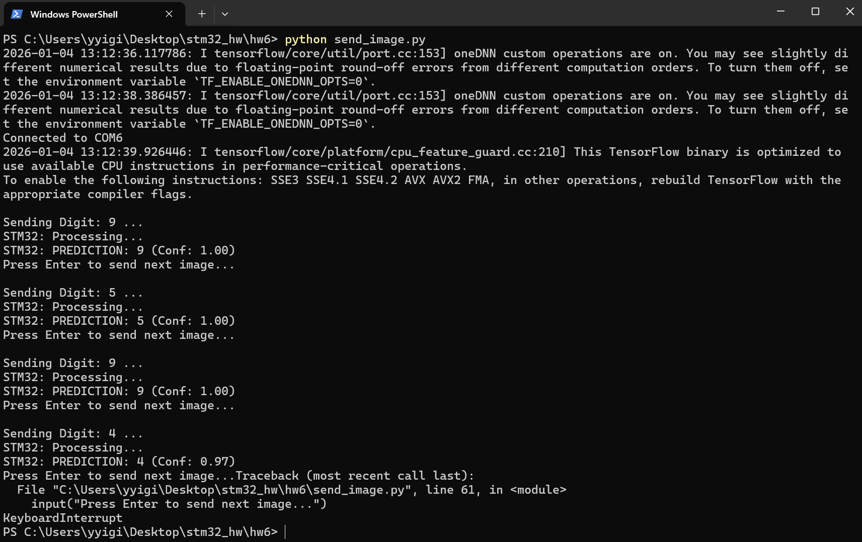
3. Part 2: EfficientNet Implementation
Objective: Implement the advanced EfficientNet architecture.
Challenges & Failed Methods: Our initial attempt to use the standard EfficientNetB0 architecture failed due to strict hardware limitations.
- Software Compatibility: We faced ValueError: Lambda layer errors in Python due to incompatibilities between the newer Keras 3 library and the legacy EfficientNet file format.
- Model Size Mismatch: The standard EfficientNetB0 model (even when quantized) was approximately 4.8 MB.
- Hardware Constraint: The STM32F446RE only has 512 KB of Flash memory.
- Result: The model was physically too large to fit on the chip, making standard deployment impossible.
The Solution: Custom "Mini-EfficientNet" To resolve this, we wrote a custom script (create_mini_efficientnet.py) to build a scaled-down version of the architecture. We retained the specific architectural features of EfficientNet (MBConv blocks and Swish activation) but reduced the network depth to produce a model size of ~46 KB, which fit comfortably within the 512 KB Flash limit.
System Integration Issues: Running EfficientNet introduced runtime crashes that were not present with SqueezeNet:
- Stack Overflow: The board crashed silently upon startup. We diagnosed this as a memory overflow and solved it by increasing the Heap Size to 16KB (0x4000) and Stack Size to 8KB (0x2000) in the linker settings.
- CRC Requirement: The application failed to initialize because the X-CUBE-AI library requires the hardware CRC (Cyclic Redundancy Check) peripheral for verification. Enabling CRC in the .ioc file resolved the crash.
Results: The custom Mini-EfficientNet was successfully deployed and correctly classified digits with high confidence.
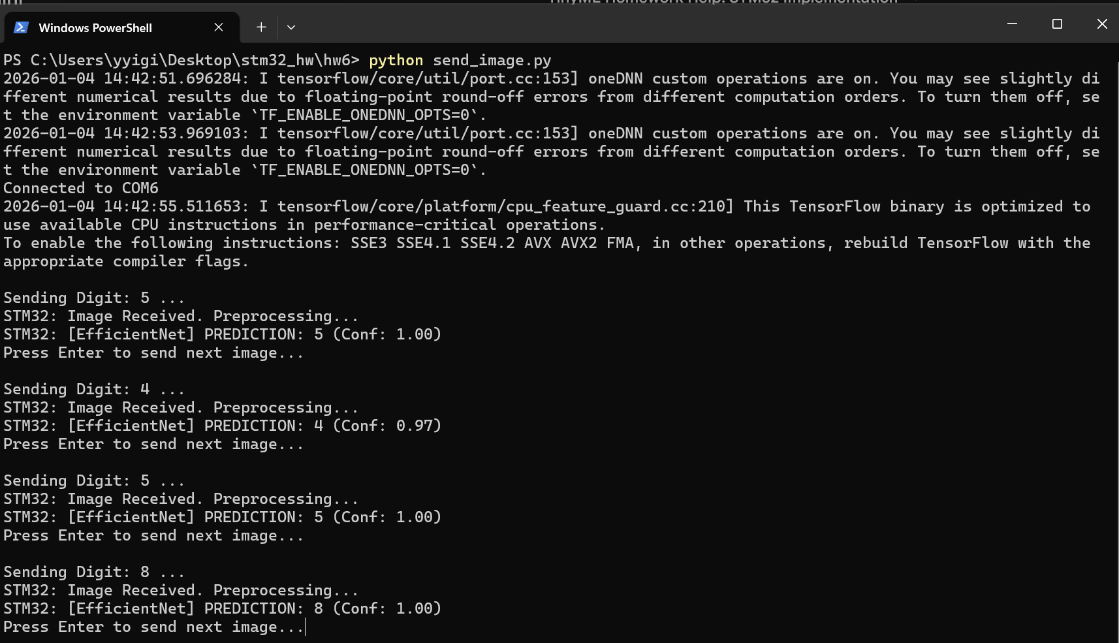
4. Description of Key Scripts
- create_mini_efficientnet.py: A custom script developed to solve the memory constraint issue. It defines, trains, and quantizes a miniature version of EfficientNet specifically for the STM32F446RE.
- send_image.py: A PC-side Python utility that establishes a UART connection, sends 3072 bytes of raw image data to the microcontroller, and prints the classification result received from the board.
- main.c: The embedded C application. It features a compile-time switch (#ifdef) to toggle between SqueezeNet and EfficientNet logic. It handles the UART data reception, pixel normalization, and execution of the X-CUBE-AI engine.

5. Conclusion
This assignment demonstrated the complete workflow of embedded AI, from high-level model design in Python to low-level hardware optimization in C. By diagnosing file format incompatibilities (.h5 vs .tflite), memory overflows, and architectural constraints, we successfully deployed two distinct Deep Learning models on a resource-constrained microcontroller.

