ARTIFICIAL INTELLIGENCE IN EDUCATION

Rakhimova Kamolakhon Masudjon qizi

¹ State Testing Center under the Cabinet of Ministers
Republic of Uzbekistan, Tashkent city Yunusabad district, st. Bagishamol 12
E-mail: Kamolaxon.kayumova@gmail.com
Государственный центр тестирование при Кабинете Министров
Республики Узбекистон, г.Ташкент Юнусабадский рай, ул. Багишамол 12
E-mail: Kamolaxon.kayumova@gmail.com

Qisqacha mazmuni. The article provides information on the development of artificial intelligence around the world, its application in various fields, types and mechanisms of operation, as well as improving the quality of education through its use in the educational process. In order to ensure the implementation of the Resolution of the President of the Republic of Uzbekistan dated February 17, 2021, No. PP-4996 "On measures to create conditions for the accelerated introduction of artificial intelligence technologies" There is a brief overview of information systems developed using intelligence. Despite a number of shortcomings of artificial intelligence, it is noted that if it is perfectly implemented in practice, it is possible to achieve some advantages in each area.

Kalit so‘zlar: Artificial Intelligence, Systems, Education, Proctoring Artificial Intelligence Software, Online Testing System

Introduction. Artificial intelligence has become one of the most important technologies in the world today. At the beginning of the last century, many of the scenes that we can only see in movies and various science fiction novels are becoming a reality with the introduction of artificial intelligence into our lives. According to the UN, in the current situation, where by 2022, almost a quarter of the world's GDP is expected to depend on digital technologies, it is best to focus on accelerating and developing work in this area. is a complaint. Today, in world practice, countries such as Canada, Singapore, the United Arab Emirates, Finland, Japan, China, Italy, Tunisia, the United Kingdom, the United States, Sweden, Mexico, the European Union, Kenya, Denmark, France, Australia, the Republic of Korea, India and Germany announced strategies to develop artificial intelligence.
The main part. John McCarthy, the author of the term artificial intelligence, has given several definitions of artificial intelligence. He described artificial intelligence as "the science and engineering of human-like intelligent machines, especially the creation of smart computer programs." Accordingly, the computer is humane to think, solve problems, create meaning, and generalize a computer can be described as artificial intelligence if it demonstrates behavior, i.e., can use a high level of cognitive ability. According to Nils Nilsson, another great scientist, author of his research on artificial intelligence and numerous scientific publications in the field, "Artificial intelligence is a theory designed to create an imitation of natural intelligence." It can also be described as a sequence of algorithms that mimic artificial intelligence - the human mind. From the above, it can be seen that research on artificial intelligence has shown that everything in the universe works within a certain algorithm. Therefore, consciousness is the result of a mathematically complex algorithm. For most authors of artificial intelligence today, the brain is a structure that performs its functions according to the laws of the external world. This means that artificial intelligence is rational. The development and evolution of artificial intelligence go hand in hand with the development of computers, that is, transistors. However, this idea should not lead to the conclusion that artificial intelligence is only related to computer technology. On the contrary, it shows that artificial intelligence is a field that is directly related to many disciplines, from medicine, engineering and industry to psychology, and all of them are structured according to their needs [3].
If we focus on world education in the field of work in this area, according to the Russian Ministry of Education, from 2021, there will be begun testing "Artificial Intelligence" training modules at schools. By 2024, artificial intelligence classes will be taught in half of all schools under the regular curriculum. Artificial intelligence classes will be introduced in Korean public schools from the second semester of 2021. When topics are included in the school curriculum next year, 2nd and 3rd graders in high school can take an artificial intelligence course or take artificial intelligence math classes [4]. China and the United States are leaders in research and education in the field of artificial intelligence. In addition to the location of the world's leading universities and research institutes in these countries, the states have fully regulated the mechanisms to support innovation and provide significant financial support to institutions. As a result, China and the United States are attracting more and more educated professionals from around the world. Life has shown that great strides have been made in the development of science in our country, and great results can be achieved in the socio-economic spheres through the use of digital technologies in every field [1]. As noted in the Address of the President of the Republic of Uzbekistan Shavkat Mirziyoyev to the Oliy Majlis, the development of the digital economy is one of the most important and priority areas for Uzbekistan in the coming years. In accordance with the Strategy "Digital Uzbekistan - 2030" and the rapid introduction of artificial intelligence technologies and their widespread use in our country, ensuring access to digital data and their high quality, favorable conditions for training qualified personnel in this field In order to create conditions for this, the President of the Republic of Uzbekistan adopted Resolution No. PP-4996 of February 17, 2021 "On measures to create conditions for the accelerated introduction of artificial intelligence technologies." The resolution aims to develop a regulatory framework that defines uniform requirements, responsibility, security and transparency in the development and use of artificial intelligence technologies in the economy and social sphere of the country, in public administration [5]. The State Testing Center under the Cabinet of Ministers of the Republic of Uzbekistan has developed a Proctoring system based on the capabilities of the first artificial intelligence systems in the education system of the Republic of Uzbekistan. It should be noted that the Proctoring program, based on artificial intelligence systems, has several advantages in controlling the examination process.
Remote control of the applicant. Artificial intelligence can offer several ways to do this. Although it cannot completely replace human control, it can be closer in quality. Proctoring software based on artificial intelligence systems also ensures that test takers do not use additional tools, do not communicate with each other (Figure 1) and focus on the entire test task without being distracted by external factors.
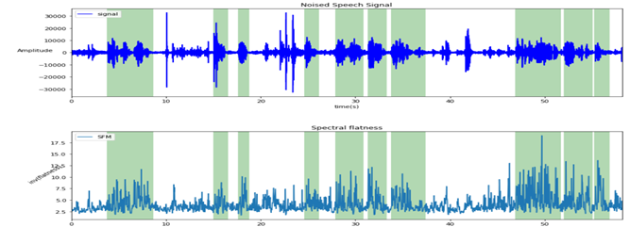
Figure 1. Recognize additional sounds.

As a result, exams are conducted accurately, efficiently, transparently and fairly.
Proctoring software also has some benefits for supervisors. For example, one supervisor can remotely monitor any applicant anywhere at the same time, and the supervisor provides online alerts if an applicant is found to be violating the exam rules (Figure 2). One of the most important advantages is that all the actions of the candidates are monitored, violations are recorded and stored in a database. Allows you to use it as evidence in future operations if you have any questions.
 |  | 
Figure 2. Remote warning of deficiencies detected by artificial intelligence.
The State Testing Center is currently working on the development of another "Online Testing System". The program is being developed for biometric identification using an artificial intelligence system (Figure 3).

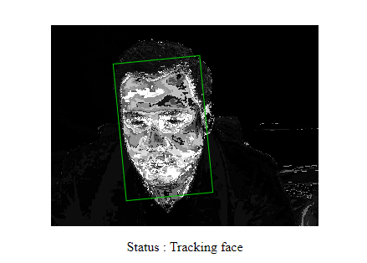 | 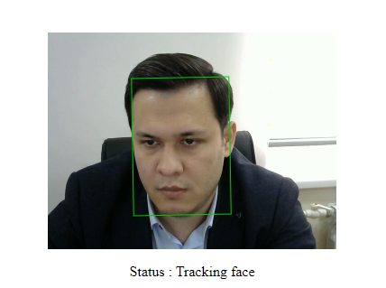
Figure 3. Recognize human faces using artificial intelligence.
The introduction of artificial intelligence systems in education will optimize and automate much of their work. This will make it easier for users to work on their knowledge and improve the quality of education. Many scientists are debating the future of artificial intelligence. The fact is that while some cars are concerned that they could invade people’s private lives and even be armed, other scientists are positive about it. They argue that self-driving machines in artificial intelligence systems can be used to calculate the most beneficial, least harmful option with the least risk and the least loss [2].
Another controversial situation with artificial intelligence is the employment of people. Many industries that seek to automate certain jobs with the help of intelligent technology are stepping up efforts to reduce the workforce. This also gives people a bad impression of artificial intelligence.
Conclusion. Artificial intelligence continues to transform education in the form of the following processes:
● In the process of globalization and scientific and technological progress, the importance of artificial intelligence in the education system is growing;
● Through testing and assessment systems, new dimensions and criteria can be created for students and learners using artificial intelligence;
● More effective and widespread use of differentiated and individualized education;
● Development and improvement of distance learning;
Artificial intelligence technologies can change anything, but the possibilities are endless.
Given the above shortcomings, it can be said that systems are designed to perform a single specific task, and they are far from multitasking as human beings. But the quality of artificial intelligence technology that we see on TV and movie screens is coming into our lives day by day. The judicious and skillful use of them will lead to the further development of every sphere of our state, as well as the creation of great conveniences for the people.

ADABIYOTLAR

[1] Akhmedov. B. A., & Khasanova. S. K. (2020). Distance learning methods in improving the skills of employees of the public education system. Journal of Innovations in Engineering Research and Technology. Pp. 252-256.
[2] Ahmedov.B.A. (2020). Mathematical models for evaluating software quality and reliability characteristics. Journal of Eurasian Education Science and Innovation, pp. 97-100.
[3] Muhamedov.G’.I. and Akhmedov B. A. (2020). Cluster Mobile Application Innovation. Journal of Academic Research in Educational Sciences,
Pp. 140-145.
[4] Ahmedov. B. A. (2020). On the development of interactive online course skills in the periphery of modern society (a model program for teachers of educational institutions). Universum: Engineering Sciences, Pp. 11-14.
[5] Resolution of the President of the Republic of Uzbekistan No. PP-4996 of February 17, 2021 "On measures to create conditions for the accelerated introduction of artificial intelligence technologies."

WRITE YOUR ARTICLE TITLE HERE

A.A. Eshmamatov¹, K.M. Toshmatov²

¹⁾State Test Center under the Cabinet of Ministers of Republic Uzbekistan,
Tashkent 100084, Bogishamol st. 12.
²⁾Scientific-study Practical Center under the State Test Center under the
Cabinet of Ministers of Republic Uzbekistan

Abstract. Text
Keywords:Words

