ESTABLISHING PHYSICAL CULTURE AS THE CORNERSTONE OF A HEALTHY STUDENT LIFESTYLE
Bolbekov Elyor. Guliston state pedagogical institute, teacher of physical culture of the department of pedagogy
Abstract. The article examines students' perspectives on health, healthy lifestyles, and physical education, while emphasizing the significance of physical culture as a fundamental pillar of well-being. It underscores the necessity for ongoing advocacy of physical culture both on a governmental scale and within university environments, highlighting the importance of consistent promotion.
Keywords: physical education, sports, health, healthy lifestyle, students, propaganda
JISMONIY TARBIYA FANI TALABALARNING SOG‘LOM TURMUSH TARZI ASOSI SIFATIDA SHAKLLANISHI.
Annotatsiya. Maqolada o‘quvchilarning salomatlik, sog‘lom turmush tarzi va jismoniy tarbiya haqidagi qarashlari o‘rganiladi, shu bilan birga jismoniy madaniyatning farovonlikning asosiy ustuni sifatidagi ahamiyati ta’kidlanadi. Bu jismoniy madaniyatni davlat miqyosida ham, universitet muhitida ham doimiy ravishda targ‘ib qilish zarurligini taʼkidlab, izchil targ‘ib qilish muhimligini taʼkidlaydi.
Kalit so‘zlar: jismoniy tarbiya, sport, salomatlik, sog‘lom turmush tarzi, talabalar, propaganda
INTRODUCTION
Students, as a social cohort, have consistently garnered heightened scrutiny, being recognized as the future backbone of the nation. Regrettably, recent years have witnessed a concerning trend characterized by declining levels of physical fitness and deteriorating health among student populations. This phenomenon is not solely attributed to adverse shifts in social, economic, and environmental domains, but also to a failure to adequately recognize the significance of widespread advocacy for physical culture.
A lack of personal commitment to physical culture inevitably results in a decline in health. Broadly speaking, overall health status is predominantly influenced by lifestyle choices, familiarity with the fundamentals of physical culture, and their diligent integration into daily life.
Study Objective: To investigate students' perceptions of "health" and "healthy lifestyle" and their attitudes toward these concepts. Additionally, the study aims to pinpoint strategies that foster the cultivation of a conscientious approach toward personal health and physical culture among students.
METHODS
Research Methodology: The study involved analysis and synthesis of relevant scientific and methodological literature. Pedagogical observation techniques were employed, alongside a survey administered to students, focusing on the subject of "Health and Healthy Lifestyle."
RESULTS AND DISCUSSION
Human health is intricately layered and multifaceted, as acknowledged by the World Health Organization, which defines health as not merely the absence of disease, but a state encompassing physical, mental, and social well-being [1]. It is widely accepted that health is a complex construct influenced by various physiological, psychological, and social factors, often intertwined with philosophical beliefs. Physical health contributes to overall well-being, mental health fosters tranquility and positive disposition, while social health facilitates academic achievement, social integration, and personal growth [2].
The authors carried out a sociological inquiry regarding the concept of "Health and a Healthy Lifestyle," with the participation of 74 individuals. The initial inquiry posed the question: "In your view, what does 'health' mean?" Respondents were encouraged to provide their responses freely. Subsequently, typical responses were categorized and analyzed:
- 31% of participants perceive health as engagement in physical activity or sports.
- 22% indicated that health is characterized by a vibrant and fulfilling existence.
- 20% defined health as experiencing minimal or no illness.
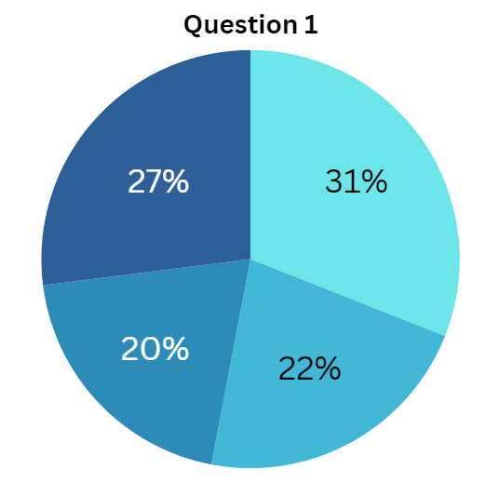
The remaining 27% of responses were diverse, encompassing notions such as "positive mood," "strong social connections," "love," "the ability to pursue personal goals," "academic and career achievements." See Figure 1 for a graphical representation of the results:
Figure 1 – “Health for you is...?”
Answers to the second question: “What are students willing to do to maintain their health?” distributed as follows:
- 43% of participants indicated their willingness to engage in sports activities.
- 17% expressed a general willingness to do whatever is necessary to maintain their health, potentially without a clear understanding of what specific actions are required.
- 15% showed a preference for cold-weather exposure as a method to support their health.
- 14% expressed willingness to abstain from alcohol and tobacco.
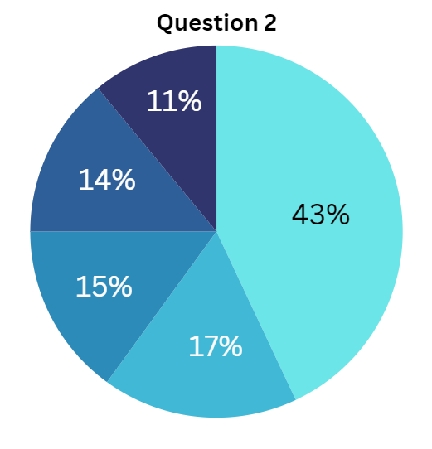
- 11% provided miscellaneous responses, including sentiments such as "I feel fine as I am and unwilling to change my lifestyle," "I aspire to good health but lack motivation to take action," and "prioritizing sufficient sleep." See Figure 2 for a visual representation of the response distribution:
Figure 2 – “What are students willing to do to maintain their health?”
It's noteworthy that among the surveyed students, perspectives on methods to preserve and enhance health appear fragmented and lacking in systematic organization. The predominant response centered around the importance of engaging in sports activities. The authors observed that when students refer to sports, they typically conceptualize it not as competitive endeavors, but rather as encompassing physical exercise and physical education. This insight prompted a focused inquiry into the perception of sports and physical education among students. The results indicated that, in the collective consciousness, sports are associated with attributes such as physical fitness, health, success, and the enjoyment of movement, rather than emphasizing competition, systematic training, or rigorous preparation. Contrary to this perception, the domestic theory and methodology of physical culture define sport as involving competitive activities, specialized training, as well as interpersonal dynamics and norms inherent in such activities [3]. In our country, sports enjoy significant development, extensive media coverage, and substantial state support across various forms. However, it's important to recognize that while sports entail aspects of overcoming challenges and perseverance, excessive effort, especially in the realm of professional sports, may not always align with the pursuit of health. Hence, while it's not accurate to equate sports with illness or injuries, a clear equivalence between sports and health cannot be established.
Regarding physical culture, attitudes toward it tend to be more varied. Frequently, it is perceived negatively for various reasons, often seen as something obligatory and imposed, yet unnecessary. However, it's crucial to recognize that physical culture is oriented towards the holistic enhancement and fortification of the human body through the utilization of physical exercises, natural elements, and hygienic practices [4].
It is a universally accepted truth that every nation holds high aspirations for its new generation, envisioning them as healthy, productive contributors capable of defending their homeland and organizing their lives in alignment with societal demands and personal aspirations. Consequently, primary focus in promoting health should be directed towards children, adolescents, and young adults—the pivotal stage when individuals embark on shaping their life trajectories and cultivating fundamental habits and psychological dispositions.
However, a significant issue arises as a considerable portion of the younger generation lacks motivation to embrace a healthy lifestyle. Regrettably, or perhaps fortunately, many young individuals fail to perceive the detrimental effects of an unhealthy lifestyle on their health, as the body's compensatory mechanisms are robust during youth [5]. Nevertheless, it is well-established that the majority of illnesses are acquired during youth.
The worldview of individuals evolves and adapts in response to societal influences. It is directly shaped by the opinions of others, current events, familial upbringing, and personal biases. Initially, our parents and immediate social circles wield significant influence over the formation of our worldview.
While prioritizing a healthy lifestyle and elevating the overall physical fitness of the populace are essential objectives, they are challenging to attain. The majority of older Uzbeks, while not opposed to these goals, demonstrate limited enthusiasm and personal engagement in their pursuit [6]. However, it is noteworthy that the younger generation often looks to the older generation for guidance and sets their examples accordingly.
The issue extends beyond the indifference of the older generation; negative aspects also permeate the teaching of physical education within educational institutions, particularly at the university level.
Conducting comprehensive practical training sessions with a general preparatory focus isn't always feasible due to various challenges. These challenges include students' irregular attendance, initial low levels of physical fitness, non-adherence to schedules, unfavorable living conditions, and inadequately planned class schedules. As a result, the requirement to attend classes, manage workloads, and meet curriculum standards often evokes negative sentiments among students. As educators, our primary objective is to cultivate the personal physical culture of each student. This involves imparting scientific knowledge, fostering interest, and instilling a desire for a structured and systematic approach to physical education and healthy habits.
Practical training sessions in physical culture and sports at the university level often tend to have a hygienic focus rather than a purely preparatory one. It's posited that this approach could better align with students' current capabilities and accelerate the attainment of the discipline's objectives. The requirement to meet test standards frequently elicits feelings of apprehension, anxiety, and fear among students. To alleviate this apprehension, it's essential to reframe the nature of performance assessment. For instance, during standard assessments, students could be encouraged to strive for personal improvement, with their individual results compared against the required "pass" benchmarks. This approach allows students to view their progress as a clear indicator of their physical fitness development over the course of their training. Results such as the number of repetitions completed, performance in technical exercises, and heart rate indicators not only serve as motivational tools for students but also provide valuable feedback on their health and well-being. As one student aptly put it, "if you struggle to complete a given exercise or fail to make progress, perhaps it's time to listen to yourself and reconsider your lifestyle."
When it comes to lectures within this discipline, we believe they should closely align with the content covered in practical sessions. Fostering a conscious attitude toward one's body and the process of physical education serves as the cornerstone for engaging young individuals in a healthy lifestyle. Consequently, attitudes toward physical culture can undergo positive transformations. Statements like "I don’t see the point in doing physical education, depressing your body with meaningless physical training" would become less prevalent among students.
However, there is still ample room for research on this topic.
Emphasizing the targeted promotion of physical culture as an integral aspect of societal and individual culture is paramount. This initiative is aimed at preserving and enhancing human health and achieving psychophysical well-being. Implementing this task, at the very least, should begin within educational institutions.
Developing a comprehensive strategy and executing a large-scale outreach program is imperative. This initiative should utilize a diverse array of methods and be consistently implemented over time.
One of the most powerful tools for propaganda and influencing mass consciousness in the modern world is advertising. Advertising technologies leverage advancements across various fields of knowledge, notably sociology, psychology, and psychoanalysis. The age-old adage "advertising is the engine of trade" succinctly encapsulates its primary function: conveying information about a product, acquainting potential consumers with it, and persuading them of its necessity. What sets advertising apart from mere informational messages is its focused pursuit of a specific end result. It addresses the most pressing needs of society while also being capable of shaping those needs. By harnessing the full potential of advertising technologies to cultivate public "demand" for physical education and a wholesome lifestyle, significant outcomes can be anticipated. Engaging athletes, alumni, and dedicated students can elevate advertising to an art form in this endeavor.
Given that young people constitute the largest demographic of internet users today, it is crucial to prioritize them as the primary audience for information about physical education. Presently, the majority of students predominantly equate physical education with physical activity, exercise, or "sport" [7]. However, physical culture encompasses a broader spectrum of practices. It is imperative to delve deeper into this concept, elucidating its essence through concrete examples. Only by fully leveraging all its facets can the desired outcome of preserving and enhancing health be achieved. Neglecting natural and hygienic factors in their broadest sense — encompassing not only cleanliness but also considerations of physical exercise — may render efforts, at best, ineffective and, at worst, lead to injuries.
One cost-effective approach to popularizing physical culture could involve establishing and promoting various thematic groups and communities on popular social media platforms. Additionally, the development and dissemination of entertaining social videos that comprehensively explore all aspects of physical culture could prove effective [8].
CONCLUSION
In conclusion, the authors possess significant expertise in teaching physical education at universities and are thoroughly familiar with the associated challenges. However, they believe that elevating the status of physical education is the most viable approach to fostering a values-based attitude toward health among youth.
LITERATURE
- Петрова, Е. В. (2008). Здоровье и проблема адаптации человека. Философия науки и техники, 13(1), 114-123.
- Тарасова, Н. С. (2020). ВЛИЯНИЕ ФИЗИЧЕСКОЙ КУЛЬТУРЫ НА ПОТРЕБНОСТЬ В ЗДОРОВОМ ОБРАЗЕ ЖИЗНИ У СТУДЕНТОВ. In Донецкие чтения 2020: образование, наука, инновации, культура и вызовы современности (pp. 338-340).
- Матвеев, Л. (2022). Теория и методика физической культуры. Litres.
- Валеева, Г. В., & Кутепова, Е. А. (2019). ФИЗИЧЕСКАЯ КУЛЬТУРА КАК СРЕДСТВО СБЕРЕЖЕНИЯ ПСИХОЛОГИЧЕСКОГО ЗДОРОВЬЯ ШКОЛЬНИКОВ И УЛУЧШЕНИЯ СОПРОТИВЛЯЕМОСТИ ОРГАНИЗМА К НЕБЛАГОПРИЯТНЫМ ФАКТОРАМ ОКРУЖАЮЩЕЙ СРЕДЫ. In ПСИХОЛОГИЧЕСКИ БЕЗОПАСНАЯ ОБРАЗОВАТЕЛЬНАЯ СРЕДА: ПРОБЛЕМЫ ПРОЕКТИРОВАНИЯ И ПЕРСПЕКТИВЫ РАЗВИТИЯ (pp. 235-237).
- Bandura, A. (2013). Health promotion from the perspective of social cognitive theory. In Understanding and changing health behaviour (pp. 299-339). Psychology Press.
- Мусаева, О. Т., & Халилова, Б. Р. (2022). Основы Здорового Образа Жизни Среди Населения-Главная Критерия Качество Жизни. Central Asian Journal of Medical and Natural Science, 3(5), 223-229.
- Питкин, В. А., Иванова, Д. Д., & Холодная, Л. А. (2019). Повышение мотивации к занятиям физической культурой. Проблемы современного образования, (5), 171-177.
- Жаброва, Т. А., & Прилипко, Ю. П. (2019). ПОПУЛЯРИЗАЦИЯ КУЛЬТУРЫ ЗДОРОВОГО ОБРАЗА ЖИЗНИ СРЕДИ МОЛОДЕЖИ ПОСРЕДСТВОМ СОЦИАЛЬНЫХ СЕТЕЙ. А 43 Актуальные вопросы физического воспитания молодежи и студенческого, 78.

