ENHANCING READING COMPREHENSION TEST DESIGN: INTEGRATING AUTHENTIC VISUAL MATERIALS TO IMPROVE ASSESSMENT
Fayziyeva K.O‘. and Nishonboyev Sh.Sh.
Agency for Assessment of Knowledge and Competences under the Ministry of Higher Education, Science and Innovations of the Republic of Uzbekistan, 100084, Tashkent., Bogishamol str., 12
Abstract: Entrance exams play crucial role in determining students’ academic futures. However, there has been inappropriacy in the test format and content which fails to reflect real-world language use when traditional testing methods are used. This article attempts to explore how authenticity features can bridge this gap when applied in reading comprehension tests. In response to this concern, this article attempts to clarify how the authenticity and its application can address this issue in tailoring test items designed to assess reading skills in English language in the entrance exams.
Keywords: reading comprehension, authenticity, closed-ended test items, test details, infographics
In particular, it examines the notion of authenticity, the characterization thereof and its application in designing test items which better assess reading comprehension. It also mentions that, the term authenticity has long and thoroughly been studied in countries abroad but awaits more meticulous investigation and practical application in the language testing environment in Uzbekistan.
Authenticity is one of the most important qualities of language test items as it is a distinctive feature which should be present in the relationship between the passage and the reader. In this sense, authenticity is defined as a ‘genuine input’ when using the texts which are not simplified and corresponding tasks are used to encourage test takers to perform in a ‘real-world’ context [1].
Bachmen and Palmer, experts in the field of language assessment, raised concerns about the content that test takers would perform in the test, claiming that it will define to what extent they would engage in the language use outside the test environment. Building on this idea, they further introduced the term target language use (TLU) to identify the context used in real world, wherein test taker will use the language [2].
Expanding on this perspective, it is claimed that authenticity is a characteristic which shows to what extent test tasks are similar or look like target language use (TLU) tasks. In this regard, an authentic assessment entails activities and tasks which students are likely encounter in real life situations [3].
In terms of designing test items for reading comprehension there is a need to point out the fact that texts that are produced or available in the real world are quite different (inter alia) when the complexity, target audience and the amount of information are considered [4]. This underscores the need to carefully select reading materials that maintain an authenticity.
There are a number of contributing factors involved in maintaining authenticity of the task, as follows [5]:
- the language of the test should be kept natural;
- providing a context for the items rather than making it isolated;
- choosing meaningful – relevant and interesting topics for the learner;
- presenting items in a storyline or in episodes so as to keep thematic organization;
- tasks should resemble real world tasks.
In recent years, the shift to authenticity in the language testing environment in Uzbekistan has seen a number of noticeable changes. Several decades ago, foreign language testing items designed to assess applicants consisted of boring and contrived grammar-based multiple-choice items accompanied by short reading passages that mostly lacked spontaneity and natural language. Since then, following developments in language assessment research, numerous alterations and approaches have been implemented to improve the quality of test materials. One of the recent changes was to integrate authentic graphics, charts, diagrams, and infographics together with reading passages to simulate the test taker to analyze and simultaneously synthesize the given content.
A related argument is made by proposing various approaches which can be applied to increase the authenticity of the tasks: reports, drawings and diagrams, interviews, inventories of work place items, logs, simulations and models with descriptions. Following the guidance of this and other studies resulted in several modifications of the reading test items intended to assess the applicants pursuing university entrance exams [6].

Sample 1. Read the guide about the fare system in the West of England and answer the questions according to it.
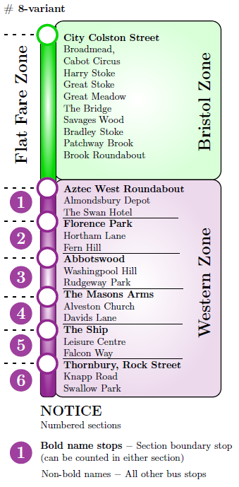
A flat fare structure is in place in the Bristol Zone. This means that wherever you travel in that zone,
the price of a single journey will be the same – £2.00. Single fares in the Western Zone are based on the distance you are travelling.
Distances are calculated using 'fare stage' sections rather than individual bus stops, with each section being one mile long. If you travel up to 3 miles it'll be £2.30, 4-6 miles will be £3.30. Here is an example route and some of the fares along it:
From Aztec West Roundabout to the Rudgeway Park would cost £2.30 as you are travelling in three sections (numbers 1, 2 and 3 - the Rudgeway Park is classed as section 3 in this example as it’s where you are getting off the bus). From the Masons Arms to Thornbury, Rock Street would also be £2.30 as you are again travelling in three sections (4, 5 and 6 - The Masons Arms is counted as section 4 in this example as it’s your boarding point). In the other direction, from Swallow Park to Rudgeway Park would cost £3.30 as you are travelling in four sections (6, 5, 4 and 3).

- A passenger wants to travel from Almondsbury Depot to Washingpool Hill.
How much will he have to pay for his trip?

- £2.30 B) £2.00 C) £3.00 D) £3.30
- As stated in the guide, within the Western Zone … .

- the distance is calculated for every section you pass
- you should pay the same fare as in the Bristol Zone
- the fare system requires passengers to pay £2.00
- every bus stop is counted as one mile long

- How much will the fare be for the route starting from Knapp Road to Abbotswood?

- £2.00 B) £2.30 C) £3.00 D) £3.30

- As stated in the guide, in the Bristol Zone … .

- the same fare is on regardless of the bus stop
- passengers pay for every bus they pass
- single journey will cost less than £2.00
- three bus stops are equal to one section

The above presented infographic and the text (Sample 1) are taken from an authentic – real life guidebook for the passengers travelling in the territories of West of England and Bristol city [7]. Certain differentiations and adaptations have been implemented to this material such as replacing a few difficult words in the text with B1 level alternatives and changing complex sentences into simple versions. Overall, the names of bus sections, the length and the content of the text and graphic remain almost unchanged. The multiple choice items created based on this material are intended to test scanning skills and simulate the applicant to choose the correct option from the given stem presented as a problem-solving scenario. This approach aligns with “constructivist learning principles” which suggests that integrating assessment tasks into situations involving problem-solving scenarios improves engagement and fosters deeper cognitive processing [8].
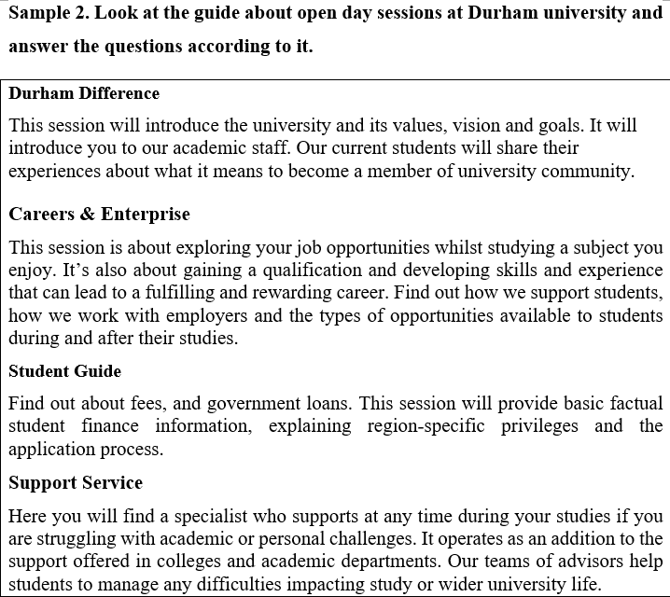
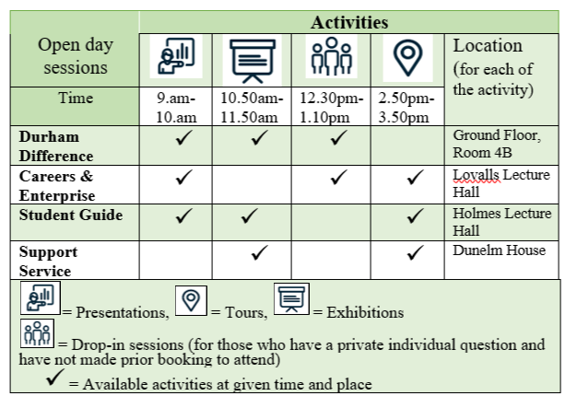
- A student would like to know more about the expenses of studying at this university and whether there are any financial benefits.
Which of these sessions is the most suitable for him?

- Durham Difference B) Careers & Enterprise
C) Student Guide D) Support Service
2. Students who have problems with their studies or personal life need advice. Which session should they attend?
A) Durham Difference- Exhibition
B) Careers & Enterprise - Presentation
C) Student Guide - Drop-in session
D) Support Service - Tour

3. A parent wants to take his child to a session to learn about the university goals and student life. What time and where should they go?
A) Holmes Lecture Hall at 9:00 am
B) Lovalls Lecture Hall at 12:30 pm
C) Dunelm House at 10:50 am
D) Ground Floor, Room 4B at 9:00 am

The chosen reading passage (Sample 2) is taken from an open day guidebook [9] and the items correspond to the criteria of providing authenticity in the task [5]:
- It maintains authenticity through the use of relevant topic area ‘university open day sessions’ that applicants are most likely to encounter in the future;
The items are composed based on the passage together with appropriate visual and real-life context, not being confined in the text format;
- multiple choice questions mainly pose students to analyze the problematic case and make informed decision by scanning both text and table (visual);
Improving the authenticity of language tests is crucial for both building learner’s real world language proficiency and ensuring the validity of test results. This article attempts to address this case by presenting a strong evidence that using real-world visual aids may enhance reading comprehension. It analyses the approach of using real world examples with theoretical foundation. However, key points for improvement include avoiding the dependence on multiple choice forms, the absence of empirical validation and the limited discussions of context. Future research should concentrate on measuring the efficiency of authenticity-based evaluation. Alternative question formats should be explored to better capture the complexity of real-world language use. Comparative studies between different educational systems would also be valuable in understanding how authenticity can be adapted to diverse testing environments.

References
- Widdowson, H. 1978: Teaching language as communication. Oxford: Oxford University Press
- Bachman, L and Palmer, A. 1996: Language testing in practice. Oxford:
Oxford University Press.
- Bachman, L. 1991: What does language testing have to offer? TESOL Quarterly 25, 671–704.
- Seliger, H. W., & Shohamy, E. (1989). Second Language Research Methods. Oxford University Press.
- Brown, D. H. (2004). Language assessment: Principles and classroom practices. White Plains, New York: Pearson Education.
- O’Malley, J. M. & Valdez Pierce, L. (1996). Authentic assessment for English language learners: Practical approaches for teachers. Addison-Wesley Publishing.
http://www.amazon.com/Authentic-Assessment-English-Language-Learners/dp/0201591510
- https://www.firstbus.co.uk/uploads/node_images/J13039%20Ticket%20Guide%20AW2.pdf
- Jonassen, D. H. 1997. Instructional design models for well-structured and ill-structured problem-solving learning outcomes. Educational Technology Research and Development, 45(1), 65–94.
- https://www.durham.ac.uk/media/durham-university/visit-us/documents/open-days/open-day-presentations/Preparing-for-your-Open-Day-Visit-June-2023.pdf

INGLIZ TILI FANIDAN O‘QIB TUSHUNISH BO‘YICHA YOPIQ TEST TOPSHIRIQLARINI TAKOMILLASHTIRISH: AUTENTIK VIZUAL MATERIALLLAR ORQALI SAMARALI BAHOLASH
© 2025-yil * Fayziyeva K.O‘. va Nishonboyev Sh.Sh.
Oliy ta’lim, fan va innovatsiyalar vazirligi huzuridagi
Bilim va malakalarni baholash agentligi, 10084, Toshkent sh., Bog‘ishamol k.,12

Qisqacha mazmuni: Talabalarning ta’limdagi kelajagini belgilashda kirish imtihonlari muhim ahamiyatga ega. Ammo ko‘pincha an’anaviy test usullari qo‘llanilganda, test formati va mazmunida kamchiliklar yuzaga keladi va real hayotda tilni qo‘llanilishini to‘laqonli aks ettira olmaydi. Ushbu maqolada oliy ta’lim muassasalari bakalavriat bosqichi kirish test sinovlarida ingliz tili fanidan abituriyentlarning o‘qib tushunish ko‘nikmasini baholovchi yopiq test topshiriqlarining autentlik xususiyatlarini tatbiq qilish orqali ushbu muammoni qanday qilib bartaraf etish mumkinligi muhokama qilinadi.
Kalit so‘zlar: o‘qib tushunish ko‘nikmasi, autentlik, yopiq test topshiriqlari, test tafsiloti, infografiklar.

