SOCIO-COGNITIVE FRAMEWORK IN PRACTICE: A COGNITIVE PROCESSING APPROACH TO DEFINING THE READING CONSTRUCT

A.A. Abbosov

Agency for Assessment of Knowledge and Competences under the Ministry of Higher Education, Science and Innovations of the Republic of Uzbekistan,
100084, Tashkent., Bogishamol str., 12

Abstract. This article deals with the application of socio-cognitive framework of validation of language tests. The socio-cognitive framework was first outlined by Cyril Weir in 2005 and since then, it has been applied to validate different tests and examinations. The article further discusses the cognitive processing approach to defining the reading construct, a model proposed by Khalifa and Weir. Moreover, the article gives a brief outline of the use of the model in Multilevel Reading test conducted by the Agency for Assessment of Knowledge and Competences.
Keywords: Socio-cognitive framework, test validation, reading construct, cognitive validity, cognitive processing

Introduction

The socio-cognitive framework of test validation is a theoretical model that seeks to explain how social and cognitive factors interact in the process of test validation (Bachman & Palmer, 2010). This framework is based on the idea that test validation is not just a technical process, but also a social and cultural process that is influenced by a range of factors.
According to the socio-cognitive framework, test validation is influenced by three key factors: social context, cognitive processes, and the interaction between social and cognitive factors. Social context refers to the broader social and cultural context in which a test is developed and used. This includes factors such as the cultural values and norms of the society in which the test is developed, as well as the social and institutional context in which the test is used (Bachman & Palmer, 2010).
Cognitive processes refer to the mental processes that are involved in the development and use of tests. This includes processes such as test construction, item analysis, and test administration. Cognitive processes are influenced by a range of factors, including the cognitive abilities of test developers and users, as well as the cognitive demands of the test itself (Bachman & Palmer, 2010).
The interaction between social and cognitive factors refers to the ways in which social and cognitive factors interact with each other in the process of test validation. For example, the cultural values and norms of the society in which a test is developed may influence the cognitive processes that are used to construct the test, while the cognitive demands of the test may influence the way in which the test is used in different social contexts (Bachman & Palmer, 2010).
The socio-cognitive framework of test validation (Fig 1) has important implications for the development and use of tests. It suggests that tests cannot be developed and used in isolation from their social and cultural context, and that test developers and users need to be aware of the ways in which social and cognitive factors interact in the process of test validation (Bachman & Palmer, 2010).

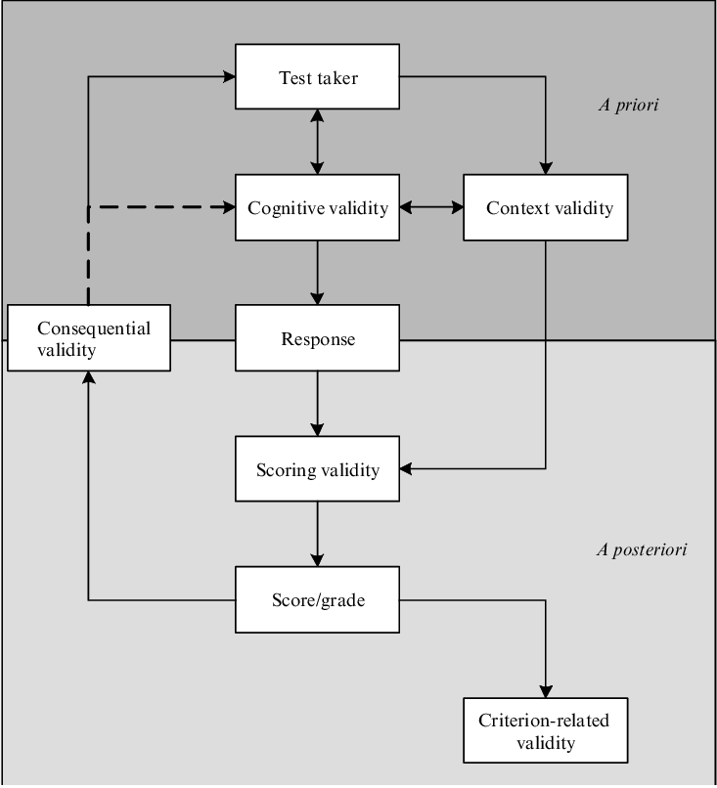

Figure 1. Socio-cognitive framework, simplified revised version
One of the key strengths of the socio-cognitive framework is that it recognizes the importance of context in the process of test validation. This means that test developers and users need to be aware of the cultural and institutional context in which the test is being used, and to take this into account when developing and using tests (Weir, 2005).
Another strength of the socio-cognitive framework is that it emphasizes the importance of cognitive processes in the process of test validation. This means that test developers and users need to be aware of the cognitive demands of the test, and to ensure that the test is suitable for the cognitive abilities of the intended users (Bachman & Palmer, 2010).
In conclusion, the socio-cognitive framework of test validation provides a useful theoretical model for understanding the complex social and cognitive factors that are involved in the process of test validation. It emphasizes the importance of context and cognitive processes, and highlights the need for test developers and users to be aware of these factors when developing and using tests.

Overview of Weir’s socio-cognitive framework

The socio-cognitive framework (Fig 2), has served as a backbone in validating the language tests. It is comprised of five types of evidences for validity: context validity, theory-based validity, scoring validity, consequential validity, and criterion-related validity. As stated by Weir (2005), the types of validity are not “alternatives, but complementary” and no single validity has the priority over others to represent the basis of a test. It is essential to highlight that the framework is socio-cognitive, meaning that the ability that we are testing is established by the individual's internal cognitive process, while the language usage in the test is viewed as a social phenomenon rather than merely a linguistic one. The framework illustrates how various validity aspects correlate with each other (Fig 1). The arrows demonstrate the primary direction(s) of any anticipated relationships 'what impacts what'. Lately, content validity and theory-based validity have become the primary focus in validating tests. However, it's crucial to take into account the test-taker who is the fundamental element in the cognitive validity process, regarding physiological, psychological, and experiential features.

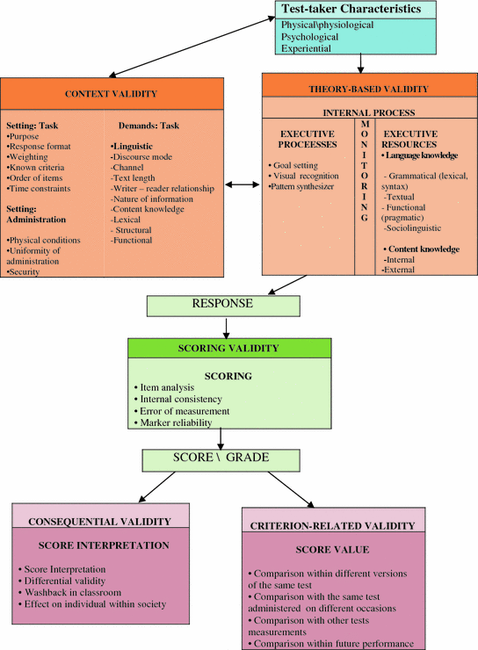

Figure 2. Socio-cognitive framework (Weir, 2005)

Context validity

McNamara (2000) states that context validity is “the extent to which the test appropriately samples from the domain of knowledge or skills relevant to performance in the criterion”. To evaluate language proficiency accurately, the context in which the test is administered should be deemed appropriate by both the test taker and the testers (Weir, 1993). As authentic texts could be frustrating for L2 learners, Baleghizadeh (2011) suggests that the texts need to be modified and simplified to enhance students’ interaction with the text. According to Douglas (2000) and O’Sullivan (2006), the authenticity of language tests should cover both the situational (contextual) and the interactional (cognitive) aspects. Although it is argued that full authenticity is practically unattainable in the language test (Weir, 2005; Khalifa & Weir, 2009), it is important to make the settings chosen for both testing and teaching as realistic as possible by incorporating various crucial contextual features.

Theory-based validity

Cognitive validity (Khalifa & Weir 2009), formerly known as Theory-based validity, focuses on the internal cognitive processes involved in acquiring linguistic knowledge, including executive processing and executive resources. Executive processing involves setting goals, monitoring progress, recognizing patterns, and synthesizing information. Executive resources include grammatical and textual knowledge, functional and sociolinguistic knowledge, as well as internal and external content knowledge. Although context validity and theory-based validity are treated separately for descriptive purposes, they are interrelated and contribute to scoring validity for construct validity. The input of the test task impacts the cognitive processes of the test takers to varying degrees, requiring them to draw on their internal and external resources for linguistic and content knowledge. The context and theory-based validity complement each other in ensuring a comprehensive understanding of language proficiency.

Scoring validity

The reliability of test scores is influenced by all aspects of the test. The framework for assessing scoring validity includes four elements: item analysis, internal consistency, error of measurement, and marker reliability. Item analysis involves analyzing the difficulty level of test items using statistics to better understand test takers and their abilities. Internal consistency is used for homogeneous tests to determine how reliable the test is. Error of measurement refers to the difference between the observed score and the true score or proficiency. Marker reliability has a significant impact on overall test reliability and refers to how test items are scored. The scoring process is influenced by factors such as the test type (objective or subjective), number of raters, and method of scoring (manual or mechanical) (Weir, 2005; Khalifa & Weir, 2009).

Consequential validity

Weir (2005) describes the consequential validity as the impact of language tests on test takers, educational systems, and society as a whole. The term "impact" has recently been used interchangeably with "washback," as described by Shaw and Weir (2007). Washback refers to the effect of tests on teaching, and it can have a positive or negative impact on learning, teaching, and testing. Positive washback occurs when tests improve teaching practices, as noted by Hughes (2003). The framework for consequential validity focuses on the impact of tests in three areas: differential validity, washback in the classroom or workplace, and the effect of tests on individuals and society.

Criterion-related validity

Criterion-related validity is established when the relationship between test scores and other external measurements assessing the same ability is demonstrated, as discussed by Weir (2005) and Khalifa & Weir (2009). This area reflects the intersection of validity and reliability. The framework for assessing criterion-related validity includes external measurements that can be used in conjunction with test scores to examine this type of validity. These measurements include comparison with different versions of the same test (parallel or equivalent forms), comparison with the same test administered on different occasions, comparison with other tests, and comparison with future performance.

Socio-cognitive framework in use

The socio-cognitive framework has been used to investigate the examination of writing (Shaw and Weir, 2007), reading (Khalifa and Weir, 2009), speaking (Taylor, 2011) and listening (Geranpayeh and Taylor (Eds), 2013). Although the socio-cognitive framework was originally developed to evaluate language tests, Weir (2005) pointed out that the model would be useful in other fields of educational assessment. According to O’Sullivan and Weir (2011), the socio-cognitive framework has been applied to examinations assessing art, physics and ophthalmology, due to its usefulness for guiding discussions of validity. The socio-cognitive framework has been used for the development, revision and validation of numerous language tests around the world, testifying to its broad applicability. Examples of such tests include:
- College English Test (CET) and the Test for English Majors in China
- Aptis by British Council
- KET, PET, FCE, CAE and CPE by Cambridge English Language Assessment
- The Graded Examinations in Spoken English (GESE) and the Integrated Skills in English (ISE) by Trinity College London
- The General English Proficiency Test (GEPT) by Language Teaching and Testing Center, Taiwan
- Test of English for Academic Purposes (TEAP) in Japan
- The National English Adaptive Test in Uruguay
- The Plan Ceibal Speaking Test in Uruguay
- QALSPELL, a generic specific-purpose test of English in higher education in the Baltic States
- The EXAVER Examinations at Universidad Veracruzana, Mexico
- National tests of Macedonian as a Foreign Language (TEMAK) in the former Yugoslav Republic of Macedonia
- Goethe-Zertifikate exams for German as a Foreign Language at the Goethe Institut
- The Graduate Admission Test of English (GATE) for postgraduate admission in Malaysia
- The Certificate of Proficiency in English (COPE), an English exemption test for entry into Turkish higher education

Cognitive processing model to defining the reading construct

Reading is a complex cognitive process that involves the interaction of various components, such as attention, memory, and language. Researchers have used various theoretical models to define the reading construct, including the cognitive processing approach developed by Khalifa and Weir (2009). This approach emphasizes the importance of cognitive processes involved in reading comprehension and highlights the role of bottom-up and top-down processing (Fig 3).
According to the cognitive processing approach, reading involves the interaction of three main components: the reader, the text, and the context (Fig 4). The reader's cognitive processes, such as attention, memory, and language, interact with the features of the text, such as letters, words, and sentences, and the context in which the text is presented, such as the reader's prior knowledge and the purpose of reading.
The cognitive processing approach suggests that reading comprehension is influenced by both bottom-up and top-down processing. Bottom-up processing refers to the processing of information from the text itself, such as letters, words, and sentences. This process involves the use of phonological, orthographic, and semantic information to recognize and understand words and sentences. Top-down processing, on the other hand, refers to the use of prior knowledge, context, and expectations to understand the meaning of the text. This process involves the use of schema, inference, and prediction to make sense of the text (Fig 3).
The cognitive processing approach also highlights the role of metacognitive strategies in reading comprehension. Metacognitive strategies refer to the reader's ability to monitor and regulate their cognitive processes during reading. For example, a reader may use self-questioning or summarization strategies to check their understanding of the text.

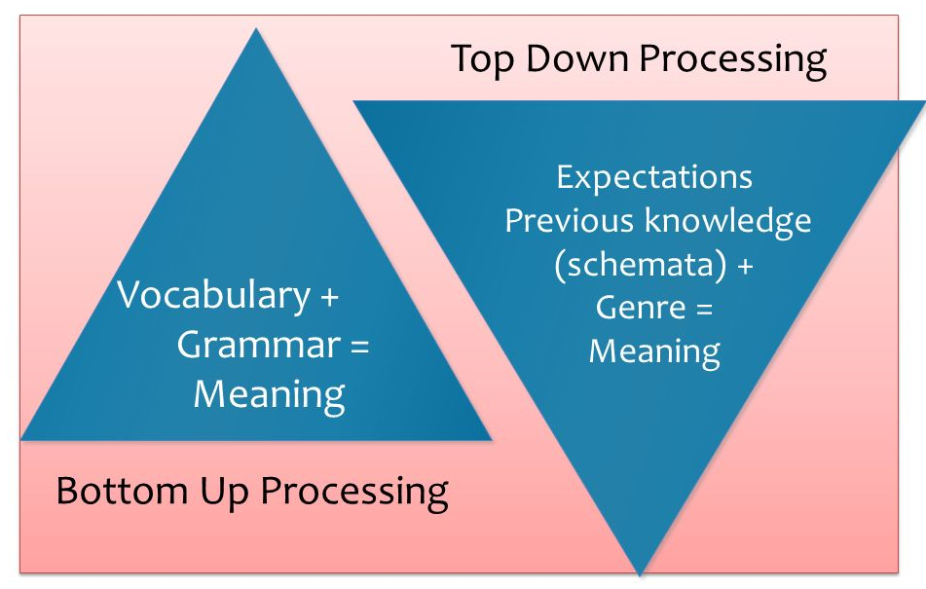
Figure 3. Bottom-up vs top-down processing simplified

Research has shown that both bottom-up and top-down processing are essential for effective reading comprehension. For example, a study by Perfetti and Roth (1981) found that skilled readers used both processes to recognize and understand words and sentences. The study also found that skilled readers were able to use context and prior knowledge to compensate for incomplete or ambiguous information in the text.
Another study by Carver and Perfetti (1981) found that bottom-up processing was more important for novice readers, while top-down processing was more important for skilled readers. The study suggested that novice readers relied more on phonological and orthographic information to recognize words, while skilled readers relied more on semantic and contextual information to understand the meaning of the text.
The cognitive processing approach has important implications for reading instruction and assessment. It suggests that reading instruction should focus on developing both bottom-up and top-down processing skills and metacognitive strategies. It also suggests that reading assessment should include measures of both decoding and comprehension skills, as well as measures of metacognitive strategies.
The model devised by Weir and Khalifa (Fig 2) could be divided into three components:
- Metacognitive activities (the left-hand side of the model)
- Central processing core (the middle part)
- Knowledge base (the right-hand side of the model)

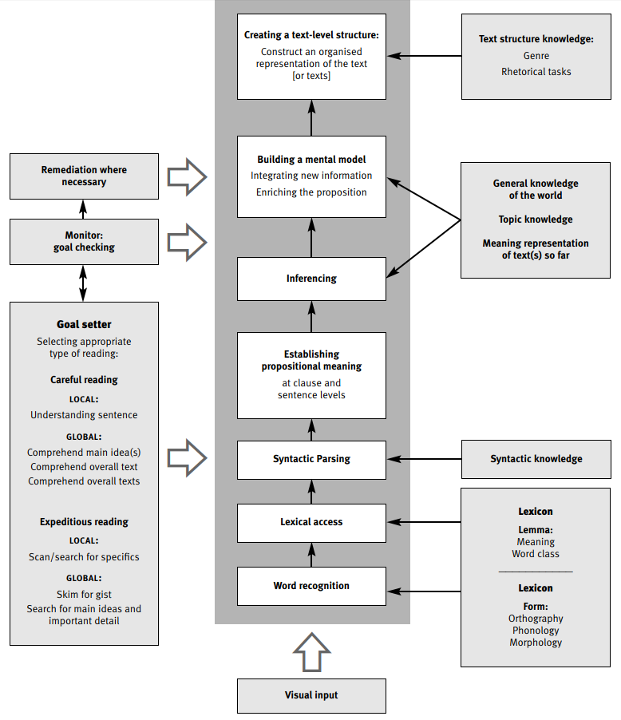

Figure 4. A model of reading (Weir & Khalifa, 2008)

The goal setter is of utmost importance because the choices made regarding the objective of the reading activity will impact the significance of certain processes within the central core of the model. Urquhart and Weir (1998) offer a comprehensive outline of the possible goals that a reader may have and classify reading as either careful or expedicious, and at either a local or global level.
The term "global comprehension" pertains to the comprehension of ideas beyond the level of individual sentences or phrases, encompassing larger concepts such as main ideas, connections between these concepts, and how smaller details contribute to these larger ideas. Whereas, local comprehension refers to the comprehension of ideas at the level of individual sentences and clauses.
Careful reading aims to fully comprehend the meanings conveyed in the presented material. This can occur at either a local or global level, meaning that it can involve understanding ideas within individual sentences or clauses, as well as concepts that span the entire text.
Expeditious reading entails the act of quickly and efficiently reading a text to locate specific information. This type of reading involves techniques such as skimming, scanning, and search reading. Skimming is typically defined as reading to obtain a general understanding of the text, including the main idea or overall impression, and is thus conducted at a global level. Scanning, on the other hand, involves reading selectively at the word or phrase level to find specific information, such as searching for items in an index. Search reading can occur at both the local and global level, depending on whether the desired information can be found within a single sentence (local) or requires piecing together information from multiple sentences (global) (Weir & Khalifa, 2008).
The processes outlined in this model aim to define the reading behaviors that proficient L1 readers exhibit, which L2 readers are expected to increasingly adopt as their proficiency level in L2 improves (Weir & Khalifa, 2008). The knowledge base on the right-hand side of the model is utilized by the central processing core, depending on the intended purpose and performance conditions of the given task.
Word recognition involves comparing the written form of a word in a text with a mental representation of the language's orthographic forms. Lexical access is described by Field (2004) as the “retrieval of a lexical entry from the lexicon, containing stored information about a word’s form and its meaning” (p.151). After comprehending the meanings of individual words, the reader must then organize these words into phrases, clauses, and larger units at the sentence level in order to fully understand the message conveyed in the text, a process called syntactic parsing.
Propositional meaning refers to a direct interpretation of the text as it appears on the page. In order to fully comprehend the message within the context in which it is presented, the reader must supplement this literal interpretation with external knowledge. Inferencing is a crucial skill for readers as the connections between ideas within a passage are often implied rather than explicitly stated, requiring the reader to make inferences and draw conclusions beyond what is explicitly presented. (Oakhill and Garnham,1988)
In the following stage, building a mental model, the new information must be connected to what has already been read in order to contribute to a coherent and relevant understanding of the text (Field, 2004). This requires the ability to identify main ideas, relate them to previous ideas, distinguish between important and less important points, and organize the information in a hierarchical structure. The primary function of monitoring at this stage is to ensure that the incoming information aligns with the established meaning representation, utilizing world knowledge in the form of schemata.
In the last step of processing (creating a text-level structure), a structure for the entire text is formed at the discourse level. A proficient reader can identify the hierarchical structure of the entire text and discern which pieces of information are crucial to its meaning. To create a thorough and precise comprehension model of a text, it is necessary to comprehend its discourse structure and recognize the broader connections between concepts. Additionally, it requires comprehension of the main ideas that are pivotal to the text's objectives and differentiation of less significant propositions.
This model serves as a valuable foundation for determining the cognitive validity of reading tests, which refers to the degree to which the tasks used by test creators can prompt the cognitive processes necessary for comprehending context beyond the test itself.

Applying cognitive processing to Multilevel Reading test

In relation to levels, Multilevel language tests are aligned with the Common European Framework of Reference for Languages. The CEFR refers to six reading stages for L2 learners of English. The A1 and A2 stages indicate the ability to read basic or uncomplicated information in a familiar area at a very slow pace, such as very simple sentences or very brief and predictable texts. The B1 level denotes the ability to understand texts comprised of everyday language that is either familiar or frequently used. According to the CEFR, learners at this level can comprehend routine information and articles, as well as the general meaning of non-routine information within a familiar area. At this level, scanning for specific information introduces a variety in reading purpose, style, and speed for the first time. As readers progress to the B2 level, they begin to focus more on integrating the content of texts, such as identifying the main ideas and the writer's attitude. Higher levels, such as C1 and C2, describe more skilled and advanced readers who can comprehend abstract texts with structurally and semantically complex language.
Table 1 shows the variety of reading types and associated processing levels demanded at B1 and B2 levels and their coverage in Multilevel Reading papers.

Reading types |  | B1 |  | B2 |  | C1
 |  | Part 1 | Part 2 | Part 3 | Part 4 | Part 5
Careful local reading | Understanding propositional meaning at clause and sentence level | +
Careful Reading Global | Comprehend across sentences | + | +
Careful Reading Global | Comprehend overall text |  |  |  | + | +
Careful Reading Global | Comprehend overall texts
Expeditious Reading Local | Scanning or search reading |  |  |  | +
Expeditious Reading Global | Skim for gist |  | + | +
Expeditious Reading Global | Search reading |  |  |  | + | +

Table 1. The variety and complexity of reading types in Multilevel Reading papers

From the table, we can see that Multilevel Reading test covers most of the reading types specified in the cognitive processing model. The only reading type neglected in the Multilevel Reading papers is “comprehending overall texts”, which require the reader to advance to a higher level of proficiency in the CEFR.

Conclusion

Weir's cognitive processing approach, which is built upon socio-cognitive framework, provides a useful framework for understanding the reading construct. The approach emphasizes the importance of both bottom-up and top-down processing in reading comprehension and highlights the interaction between these two processes. Further research is needed to explore the implications of this approach for reading instruction and assessment. In the Multilevel Reading test, the careful and expedicious reading types included in the cognitive processing model are appropriately covered, although there are some irregularities at higher levels that may require attention.

References

Bachman, L. F., & Palmer, A. S. (2010). Language assessment in practice. Oxford University Press.
Baleghizadeh, S. (2011). The Impact of Students’ Training in Questioning the Author Technique on EFL Reading Comprehension. Procedia-Social and Behavioral Sciences, 29, 1668-1676.
Carver, R. P., & Perfetti, C. A. (1981). Reading skill and the use of analogy in sentence comprehension. Memory & Cognition, 9(3), 245-255.
Douglas, D. (2000). Assessing Language for Specific Purposes: Theory and Practice, Cambridge: Cambridge University Press.
Field, J (2004) Psycholinguistics: the Key Concepts, London: Routledge.
Geranpayeh, A. and Taylor, L. (Eds) (2013). Examining Listening: Research and Practice in Assessing Second Language Listening, Studies in Language Testing volume 35, Cambridge: UCLES/Cambridge University Press.
https://www.beds.ac.uk/crella/about/socio-cognitive-framework/
https://www.researchgate.net/figure/A-revised-socio-cognitive-framework_fig1_320015404
Hughes, A. (2003). Testing for Language Teachers (2nd edition), Cambridge: Cambridge University Press.
Khalifa, H. & Weir, C. J. (2009). Examining Reading. Research and Practice in assessing second language reading, Studies in Language Testing 29, Cambridge: UCLES\Cambridge University press.
McNamara, T. (2000). Language Testing. Oxford: Oxford University Press.
O’Sullivan, B. and Weir, C. J. (2011). Test development and validation, in O’Sullivan, B (Ed) Language Testing: Theories and Practices, Basingstoke: Palgrave Macmillan, 13–32.
Oakhill, J. and Garnham, A. (1988). Becoming a Skilled Reader, Oxford: Blackwell.
O'Sullivan, B., Ed. (2006). Issues in Testing Business English: Studies in Language Testing. Cambridge: Cambridge University Press.
Perfetti, C. A., & Roth, S. F. (1981). Some of the interactive processes in reading. Language and Cognitive Processes, 1(3), 305-327.
Shaw, S. D., & Weir, C. J. (2007). Examining writing: Research and practice in assessing second language writing (Vol. 26). Cambridge University Press.
Taylor, L. (Ed) (2011). Examining Speaking: Research and Practice in Assessing Second Language Speaking, Studies in Language Testing volume 30, Cambridge: UCLES/Cambridge University Press.
Urquhart, A. H. and Weir, C. J. (1998). Reading in a Second Language: Process, Product and Practice, London: Longman.
Weir, C. and Khalifa, H. (2008). A cognitive processing approach towards deﬁning reading comprehension in Cambridge ESOL Research Notes, 31.
Weir, C. J. (1993). Understanding and developing language tests. Prentice-Hall.
Weir, C. J. (2005). Language testing and validation: An evidence-based approach. Palgrave Macmillan.

Ijtimoiy-kognitiv struktura amaliyotda: O‘qish ko‘nikmasi konstruktini aniqlashda kognitiv qayta ishlash modeli

A.A. Abbosov

O‘zbekiston Respublikasi Oliy ta’lim, fan va innovatsiyalar vazirligi huzuridagi Bilim va malakalarni baholash agentligi,
100084, Toshkent sh., Bog‘ishamol k., 12

Qisqacha mazmuni. Ushbu maqola til testlarini validatsiya qilishning ijtimoiy-kognitiv strukturasini qo‘llash yoritilgan. Ijtimoiy-kognitiv struktura birinchi marta 2005 yilda Kiril Veyr tomonidan ishlab chiqilgan va o‘shandan beri u turli testlar va imtihonlarni validatsiya qilish uchun qo‘llanilmoqda. Maqolada o‘qish konstruktini aniqlashda kognitiv qayta ishlash yondashuvi, Xalifa va Veyr tomonidan taklif qilingan model muhokama qilinadi. Shuningdek, maqolada Bilim va malakalarni baholash agentligi tomonidan o‘tkaziladigan ko‘p darajali o‘qish testida yuqoridagi modeldan foydalanishning qisqacha tavsifi berilgan.
Kalit so‘zlar: ijtimoiy-kognitiv struktura, validatsiya, o‘qish konstrukti, kognitiv validlik, kognitiv qayta ishlash

