@model LoginTutorial.Models.Users

@{

Layout = null;

}

<!DOCTYPE html>

<html>

<head>

<meta name= “viewport” content= “width=device-width” />

<link href= “//maxcdn.bootstrapcdn.com/bootstrap/4.0.0/css/bootstrap.min.css” rel= “stylesheet” id=bc

<script src= “//maxcdn.bootstrapcdn.com/ bootstrap/4.0.0/js/bootstrap.min.js”></ script>

<script src= “//cdnjs.cloudflare.com/ajax/libs/jquery/3.2.1//jquery.min.js”></ script>

<title>Login</title>

</head>

<body>

<div class="container">

<div class="row justify-content-center align-items-center" style="height:100vh">

<div class="col-4">

<div class="card">

<div class="card-body">

<h2>Giriş Formu</h2>

@ViewBag.Mesaj

@using (Html.BeginForm("Login", "Security", FormMethod.Post))

{

<div class="form-group">

<input name="userName" type="text" placeholder="Kullanıcı Adı" class="form-group">

</div>

<div class="form-group">

<input name="password" type="password" placeholder="Parola" class="form-group">

</div>

<input type="submit"class="btn btn-primary" value="Login" >

}

</div>

</div>

</div>

</div>

</div>

</body>

</html>

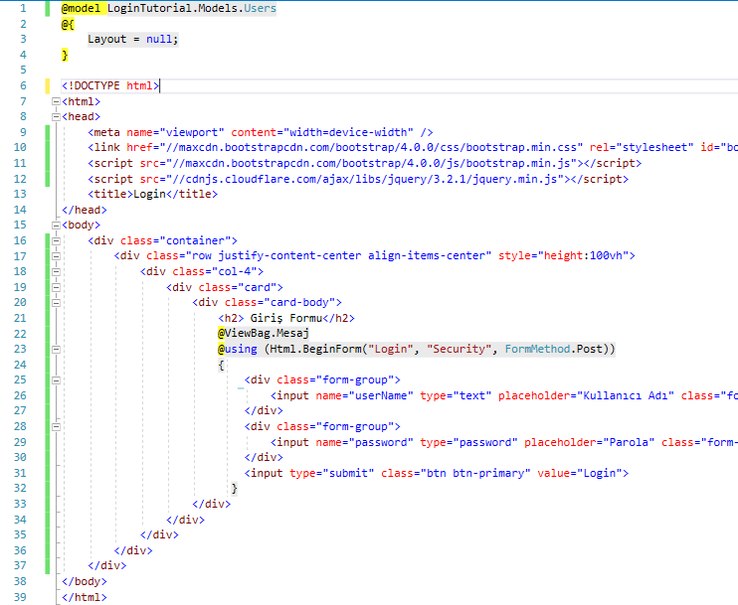

LOGİN İŞLEMİ

