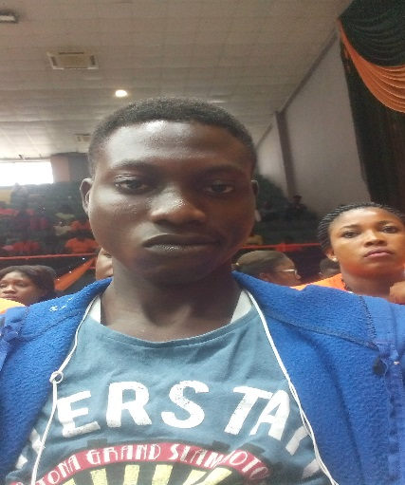**JIMOH OLUWASEUN**

**Back-End Web Developer**

Phone: 08060118558

Email: yusuphjoluwaseun@gmail.com

*Twitter:*

https://twitter.com/jimohyusuph1

*GitHub:*

https://github.com/yusuphjoluwasen  
*Instagram:*

https:Instagram.com/guruking12345

**EDUCATION**

|  |  |
| --- | --- |
| SCHOOL | University of Lagos |
| Faculty | Engineering |
| Department | Chemical Engineering |
| Level | 400 |
| Best Course so far | Chemical Engineering Analysis |