- Fu, T., Chung, F., Luk, R. and Ng, C. (2007). Stock time series pattern matching: Template-based vs. rule-based approaches. Engineering Applications of Artificial Intelligence, 20(3), pp.347-364.

- A simple method to deal with pattern matching between series is to compute the point-to-point distance so that the average error among the data points in the sequences can be measured. For mean-squared error distance measure, the distance between sequences P=(p₁,…,p_{m}) and Q=(q₁,…,q_{m}) is computed as
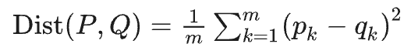
- The main problem of point-to-point distance measure is that the number of data points in the sequences has to be the same, which cannot be satisfied by most applications. A direct solution is to compress the longer time series by evenly dividing it into segments of the same number as the data points in the shorter time series and use the mean of data points in each segment to represent the whole segment. Mathematically, for sequences P=(p₁,…,p_{m}) and Q=(q₁,…,q_{n}) where n <= m, the distance measure is
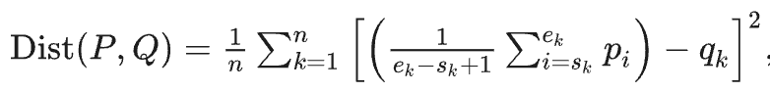
where s_{k} and e_{k}, respectively denote the starting and ending data points of the kth segment in the longer sequence P (Yi and Faloutsos, 2000; Keogh and Pazzani, 2000) and this method is called piecewise aggregate approximation (PAA) in (Keogh and Pazzani, 2000). However, this method may not capture the general shape (structure) of the sequence after the compression of the longer sequence due to the potential of smoothing out the critical (perceptual important) points.
- Recent works in time series pattern matching can be categorized into two general approaches. The first approach maps time sequences into other domains while the second one processes the time sequences directly in time domain.
- Based on the dynamic time warping (DTW) technique, the proposed method predefines some patterns to serve as templates for the purpose of pattern detection (Berndt and Clifford, 1994).
- The proposed scheme adopts the time domain approach, which is more intuitive and understandable to stock market analysts and investors. Time series pattern matching based on perceptually important point (PIP) identification is first introduced by Chung et al. (2001).
- the head-and-shoulder pattern should at least consist of a head point, two shoulder points and a pair of neck points. The proposed scheme follows this idea by locating those PIPs in the data sequence P in accordance with the query sequence Q. The whole time series pattern retrieval process can be divided into two phrases, i.e. PIP identification and similarity measure. Also, a controlled mechanism on the width of the matching results, instead of fixing the length, during the subsequence time series pattern-matching process.
- PIP Identification: PIP identification
- With sequences P and Q being normalized to a unit square (for shifting and uniform amplitude scaling invariant), the PIPs are located in order according to Fig. 2. Currently, the first two PIPs will be the first and last points of P. The next PIP will be the point in P with maximum distance to the first two PIPs. The fourth PIP will then be the point in P with maximum distance to its two adjacent PIPs, i.e., in between either the first and second PIPs or the second and the last PIPs. The PIP location process continues until the length of SP is equal to that of query sequence Q.
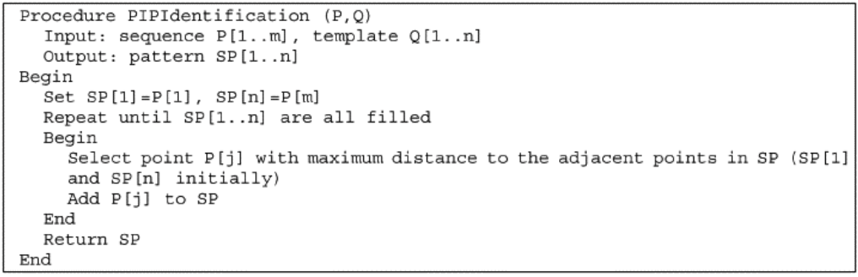
- To determine the maximum distance between the two adjacent PIPs, three distance measures are proposed. As illustrated in Fig. 3a, the first measure is the sum of the EDs of the test point p₃=(x₃,y₃) to its adjacent PIPs p₁=(x₁,y₁) and p₂=(x₂,y₂), i.e.,
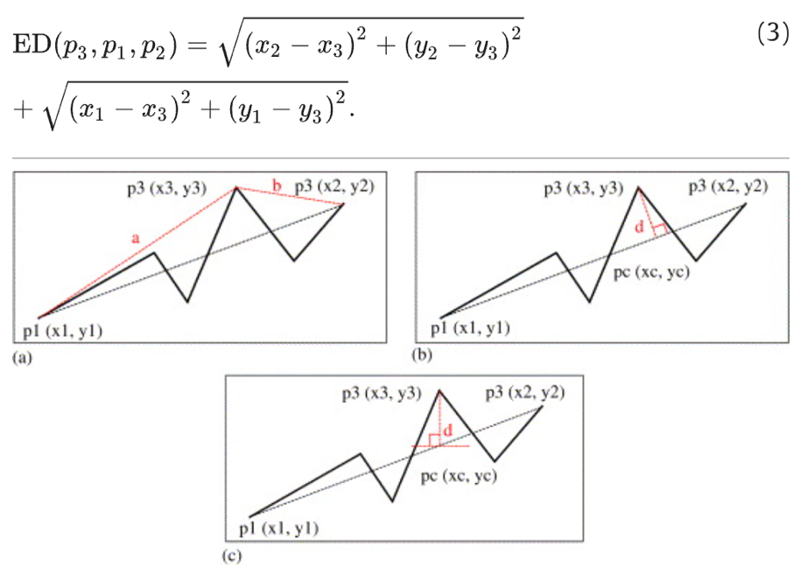
Distance measure for PIP Identification: (a) Euclidean distance based: PIP-ED, (b) perpendicular distance based: PIP-PD and (c) vertical distance based: PIP-VD.
The second measure is the perpendicular distance (PD) between the test point p₃ and the line connecting the two adjacent PIPs as shown in Fig. 3b.
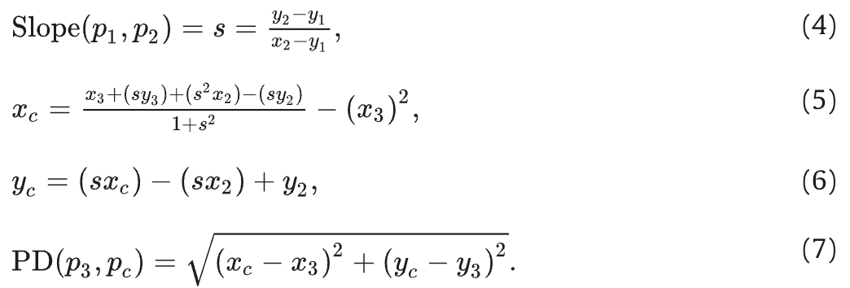

The final measure, depicted in Fig. 3c, is the vertical distance (VD) between the test point p₃ and the line connecting the two adjacent PIPs, i.e.,
where xc = x3. It is intended to capture the fluctuation of the sequence, and the highly fluctuated points would then be considered as PIPs.

To illustrate the identification process, the head-and-shoulder pattern is used and Fig. 4 shows the step-by-step result from the ED measure. Here, the number of data points in the input sequence P and query sequence Q are 29 and 7, respectively, i.e., m=29 and n=7. By using the perpendicular and VD measures, the same set of PIPs can be identified but the order in locating the fifth and sixth points, corresponding to the lower right two figure blocks, is interchanged. In both cases, the located PIPs correspond pretty well to the shape of the head-and-shoulder pattern.
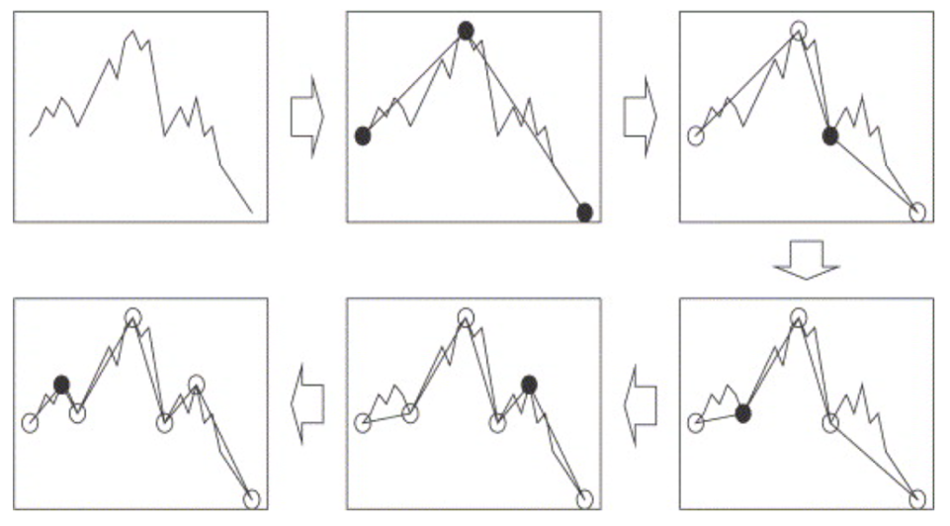
Fig. 4. Identification of 7 perceptually important points (head-and-shoulder pattern).

- After identifying the PIPs of the subsequence, a similarity measuring mechanism is essential for pattern matching. Two different approaches are introduced: template-based pattern-matching and rule-based pattern matching.
- The direct way to achieve the goal of similarity measure is template matching. By defining the shape of the query patterns (pattern templates) visually, point-to-point direct comparisons can be carried out Chung et al. (2001).
- As different sequences may have different “amplitudes”, after identifying the PIPs in the data sequence, it is necessary to re-scale the points so that the comparison between sequences in different “amplitudes” range (e.g. 0–1) can be facilitated. This is typically addressed as normalizing all the sequence values to a given range. Then, the amplitude distance (AD) between P and Q can be computed by using point-to-point direct comparison, i.e.,
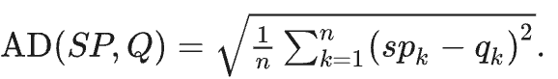
The temporal distance (TD) between P and Q is defined as
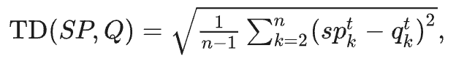
To take both horizontal and vertical distortion into consideration in our similarity measure, the distance (or similarity) measure could be modified as
- Besides defining the preferred patterns visually as pattern templates, rules can be defined to describe the shape of the preferred patterns. One of the advantages of applying rule-based pattern matching over the template-based approach is that the relationship between the points is hard to define explicitly in the template-based approach.

