About
This is a console application that will check mail from a pop3 server and dump it into a local directory. You may then set SharePoint’s incoming mail settings to check that directory for incoming email.
This application will log informational messages and errors to the SharePoint ULS.

Setup
- Create a folder where you want your email to get processed, such as C:\SPMail
- In Central Admin; operations>incoming email settings, set your implementation to retrieve mail from a drop folder and enter the folder path you used in step 1.
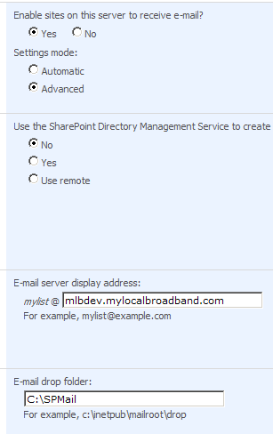
- Put the spmail utility on your machine and set up its configuration file. Any POP3 enabled email server will work, but this example uses branded Gmail (part of Google apps)
<configuration>
<appSettings>
<!-- Pop Client Settings-->
<add key="popHost" value="pop.gmail.com"/>
<add key="popPort" value="995"/>
<add key="useSSL" value="true"/>
<add key="popUser" value="youraccount@yourdomain.com"/>
<add key="popPassword" value="password"/>
<add key="traceToConsole" value="true"/>
<add key="deleteAfterRetrieve" value="true"/>

<!-- Drop Box Settings-->
<add key="dropFolderPath" value="c:\spIncomingMail"/>
</appSettings>
</configuration>
- Set up a timer job to run spmail.exe on a regular basis, like every 5 minutes.

Setup Notes
- You’ll need to get your mail into your pop account. You can do that with groups, aliases, or a catch all account.
- SharePoint ignores everything after the @ when processing incoming mail, so you may be able to use that to your advantage if you’re in a hosted environment. i.e. I can forward listname@mydomain.com to listname@hosteddomain.com and everything should work fine.
- I’ve successfully used this to pull email from GMAIL, however this application should work for any POP3 server.
- A Note on Gmail: Gmail ignores the deleteAfterRetrieve commands. You’ll need to configure this in your POP setup within your Gmail account.

References
The Net project used in this solution was originally from http://www.codeproject.com/KB/IP/NetPopMimeClient.aspx
The MyLocalBroadband.Logging.dll is a ULS logging solution that I’ve written and it is available at http://SPLogger.codeplex.com

Author
Ryan L. Miller is a SharePoint Developer/Architect in Columbus, Ohio.
rmiller@mylocalbroadband.com
Company: www.mylocalbroadband.com
Blog: www.intranoggin.com

