1. Please describe your findings in terms of the visualization in the two images below. Include the description of the data distribution of the two variables in both maps and charts. What are the commonalities and differences between the distribution of % White and % Poverty as well as the distribution of %Hispanics and % Poverty? What is the implication of your findings? What are the common findings in both maps and charts? Also, what is the difference in terms of findings between maps and charts?

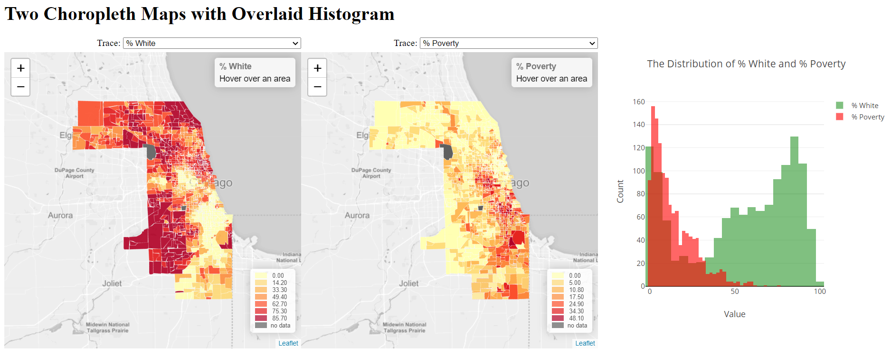

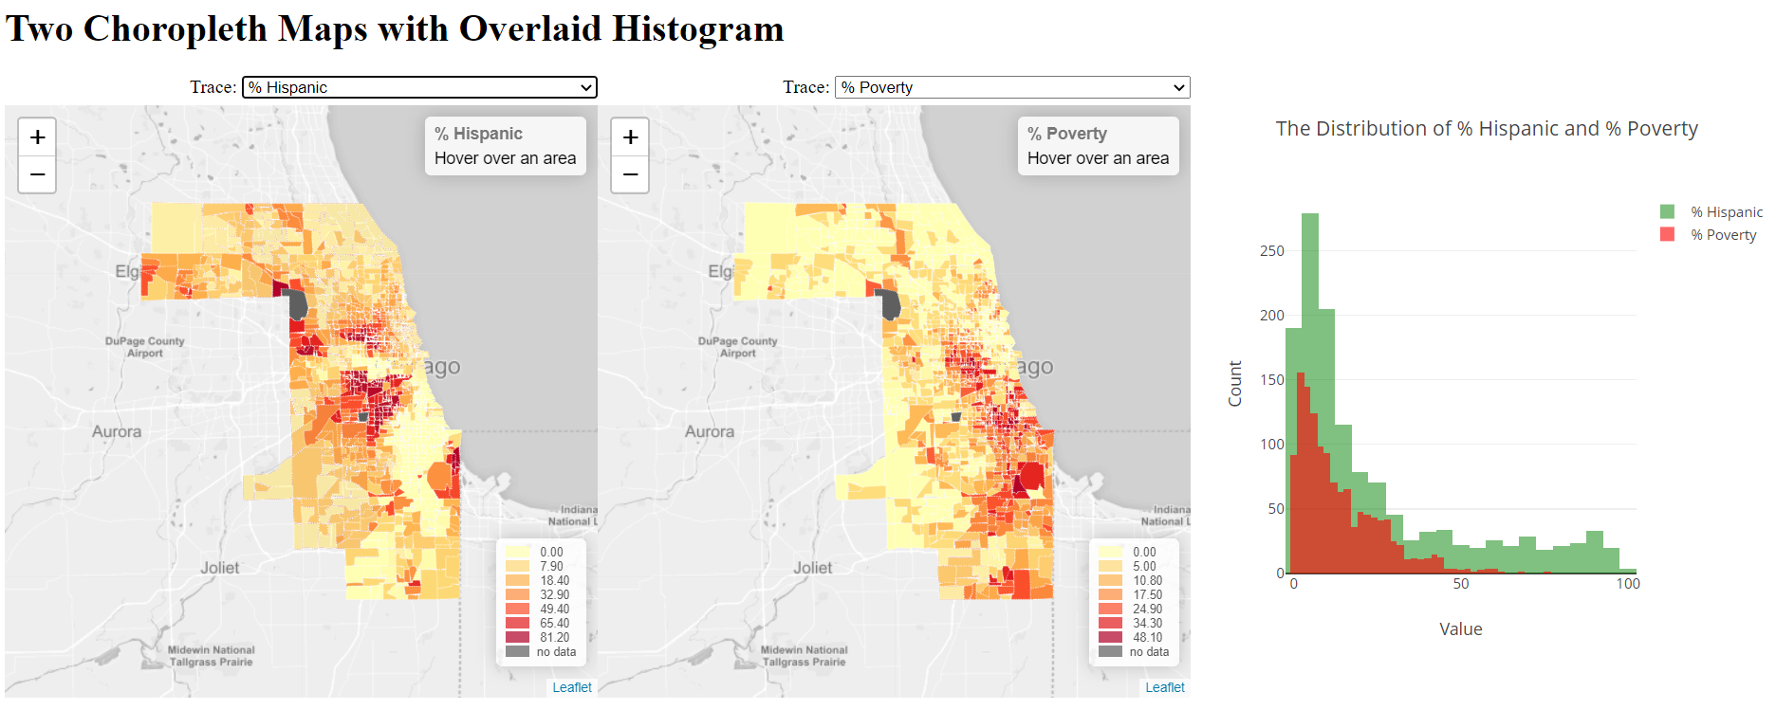

Both charts show the distribution of people in race and the poverty rate. The x-axis shows the value of rate in terms of population and poverty rate, and the y-axis shows the count of values. The map of White and poverty shows two types of distribution. First, for the white fraction lower than 50%, there are more areas with lower white fraction; and for the white fraction higher than 50%, there are more areas with higher white fraction. Plus, the overall poverty rate is low, concentrated in the low fraction range. The lower poverty rate is, the higher magnitude it is. As for Hispanic and poverty chart, the population distribution shows most areas have low Hispanic rate, and the higher the fraction is, the lower the magnitude is. The poverty rate corresponds with the population trend, that most areas have lower poverty rate.

The commonality of both charts is that the areas with lower population fraction have similar trend, decreasing magnitude with population fraction increases. The difference is that the population distributions are different, that most areas have low Hispanic rate and only small magnitude of areas have high population fraction; but white population is various, a lot of areas have low fraction while lots of areas with high fraction, but less in the medium rate.

According to the chart, we can obtain that white people have segregation that some areas have a lot of white, but some areas have less white. Also, since the population rate of Hispanic fits the poverty rate, but white not, there might exists potential poverty issues among Hispanic people.

The common findings of both maps and chart show that the poverty distribution is related with racial distribution. The difference is that for population concentrated areas, white people have lower poverty rate than Hispanic people’s poverty rate. And most whites are living in low poverty areas.

1. If you add more functions to enhance the visualization and exploratory aspect of this visualization tool, what do you want to add? Please describe the interactivity and visualizations that you would like to add.

I would like to add a scatter plot where the x-axis shows population rate, and the y-axis shows poverty rate. In this way, we can explore the relationship between racial population rate and poverty rate in different areas. Then we can find if the poverty is related to the specific race.