1. In terms of your visualization using an adaptive choropleth mapper with a scatter plot. Pick the two variables and visualize them on the maps, and create maps showing both local and global trends of your data. Take a screenshot of your visualization and describe your findings ( 200 to 250 words). The image with the description below shows one example. I am using 2010 census data as an example here, So your data/findings must be different from the example below. Also, do not pick the variables that are used in the example below. You must pick the two variables other than % white and % 4-year college degree or more. Your description of your findings from your screenshot must be more than 250 words.

Global: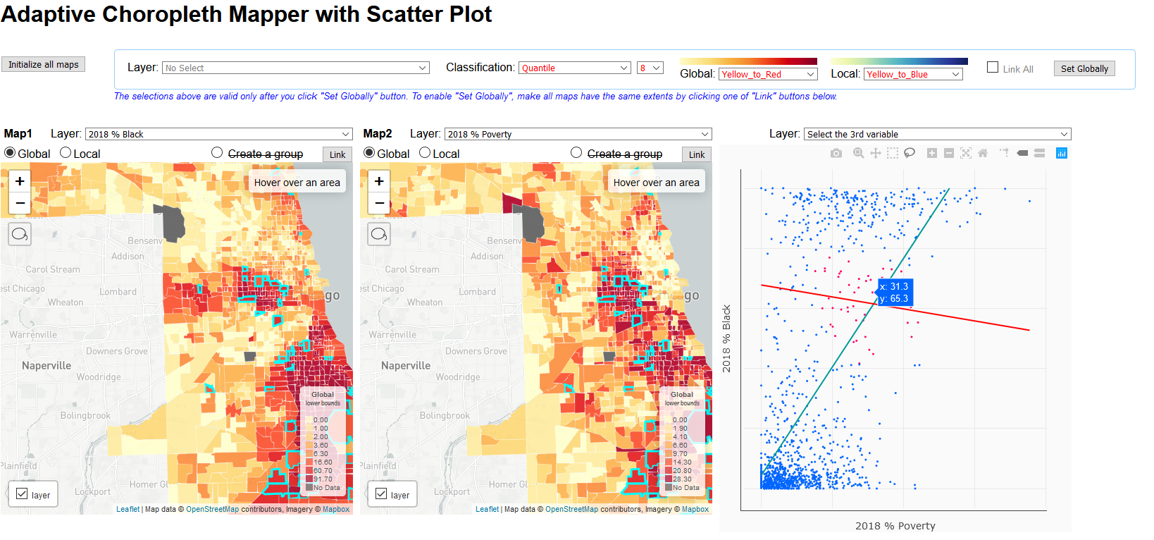

The two maps show the relationship between percentage of Black and percentage of poverty in Cook County in 2018. It shows the global classification of the map, showing the relationship in the extent of entire county.

The left map shows the distribution of the percentage of black in Cook County. We can obtain a large concentration in downtown area (center of the county) and southeast of the county. The right map shows the poverty contribution of the county. From this map, we can obtain a concentration in the center of the county and southeast of the county. In the entire Cook County, there is a positive relationship between the percentage of black population and percentage of poverty. It means that the percentage of poverty is likely to be high in areas with high percentage of black. However, in the highlighted areas on the maps, the relationship between the percentage of black and the percentage of poverty shows the reverse pattern. There is a negative relationship with low slope between them. In other words, even if the relationship is weak, the percentage of black is likely to be high with a low percentage of poverty in these areas highlighted on the maps.

Local:

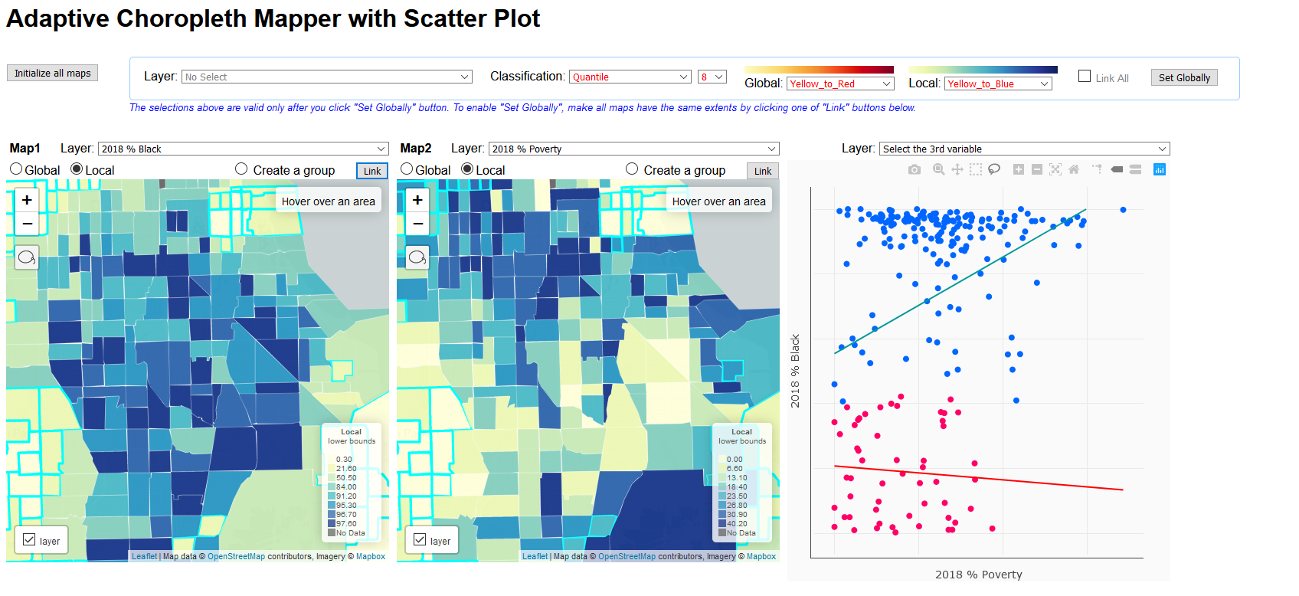

In the local maps, I focus on the data in the center of Cook County, which is the downtown areas. They have relatively higher percentage of black and percentage of poverty globally. Therefore, I zoom into this area to investigate the detailed relationship between percentage of black and percentage of poverty.

The left map shows the distribution of the percentage of black in the map extent, the center of Cook County. We can obtain a large concentration in this area with high fraction of black in the center. The right map shows the poverty contribution of the same area with the first map. From this map, we can obtain a concentration in the north and south of the extent. In the entire map region, there is a positive relationship between the percentage of black population and percentage of poverty. It means that the percentage of poverty is likely to be high in areas with high percentage of black. However, in the highlighted areas on the maps, the relationship between the percentage of black and the percentage of poverty shows the reverse pattern, and the overall percentage of black in these areas is relatively low. There is a negative relationship with low slope between them. In other words, even if the relationship is weak, the percentage of black is likely to be high with a low percentage of poverty in these areas highlighted on the maps.

1. In terms of your visualization using an adaptive choropleth mapper with the parallel coordinate plot (PCP), pick 6 variables and visualize the 6 maps with a PCP visualizing the selected 8 variables. When you pick 6 variables, you must contain % Service occupations, % Manufacturing in your visualization. Create maps having highlighted tracts in response to your election on the PCP chart. Take at least two screenshots of your visualization and describe your findings (300 to 500 words). The images below show one example (This example does not contain a description of the findings). I am using 2010 census data as an example here. Since you are using ACS 5-Year 2014-2018 estimate, your data/findings must be different. Your description of your findings from your screenshot must be more than 500 words.

The following two screenshots show the relationships among percentage of white, black, Asian, Hispanic, manufacturing, and service occupations. The first screenshot highlights the areas with high percentage of white, and the second screenshot highlights the areas with low percentage of white.

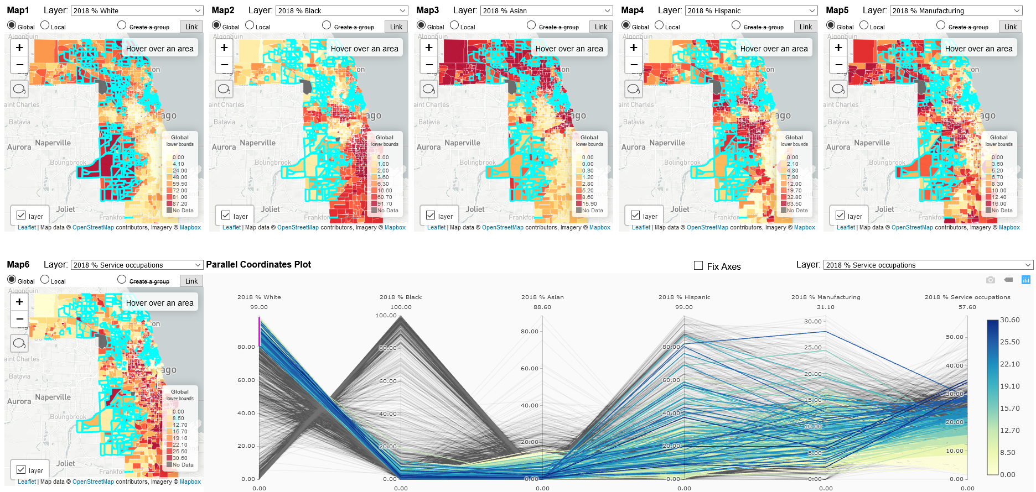

The screenshot above shows the areas with high percentage of white, where the percentage is higher than 80%. The high fraction areas are generally concentrated in the southwest and north of Cook County.

We can obtain that for these areas, the percentage of black is low, and percentage of Asian and Hispanic are relatively diverse, i.e., there is weak relationship between percentage of white and Asian and Hispanic. Additionally, for these areas, the percentage of manufacturing is relatively distributed, i.e., some areas have high fraction, but some have low fraction of manufacturing. For the percentage of service occupations, these areas are relatively low.

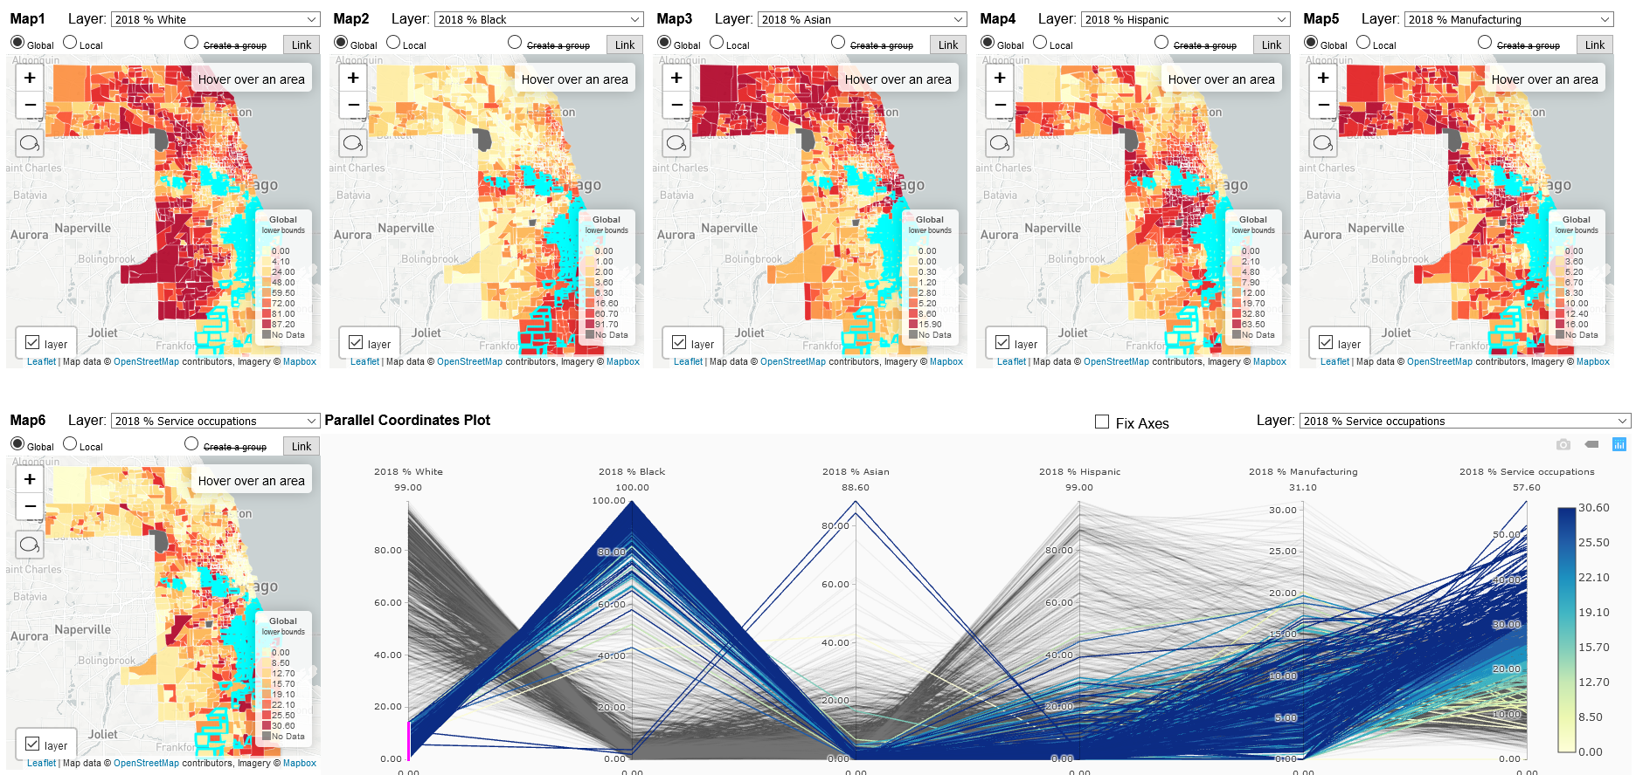

The screenshot above shows the areas with low percentage of white. We can find these areas are concentrated in southeast of Cook County.

Additionally, we can obtain that for these areas with low white percentage, the percentage of black is very high and the percentage of Asian is very low. And the fraction of Hispanic is relatively lower than areas with high white percentage. Plus, there are two outliers, which show that the areas with low white fraction have low black and Hispanic fraction but very high percentage of Asian. What is more, for these areas with low white fraction have relatively low percentage of manufacturing and high percentage of service occupations.

In brief, the percentage of white is high where the percentage of black is low, and the percentage of white and Asian is low where the percentage of black is high. Percentage of Hispanic has weak relationships with other races. Additionally, the percentage of service occupations is high where percentage of white is high, and the percentage of manufacturing is slightly low when the white percentage is low.