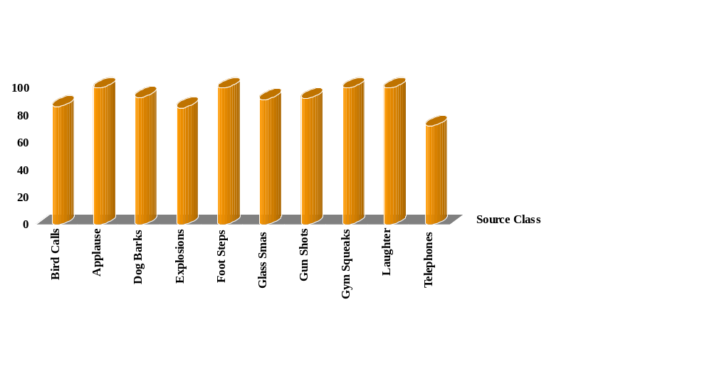

Recognizer Performance
Mean Recognition = 92.2%

