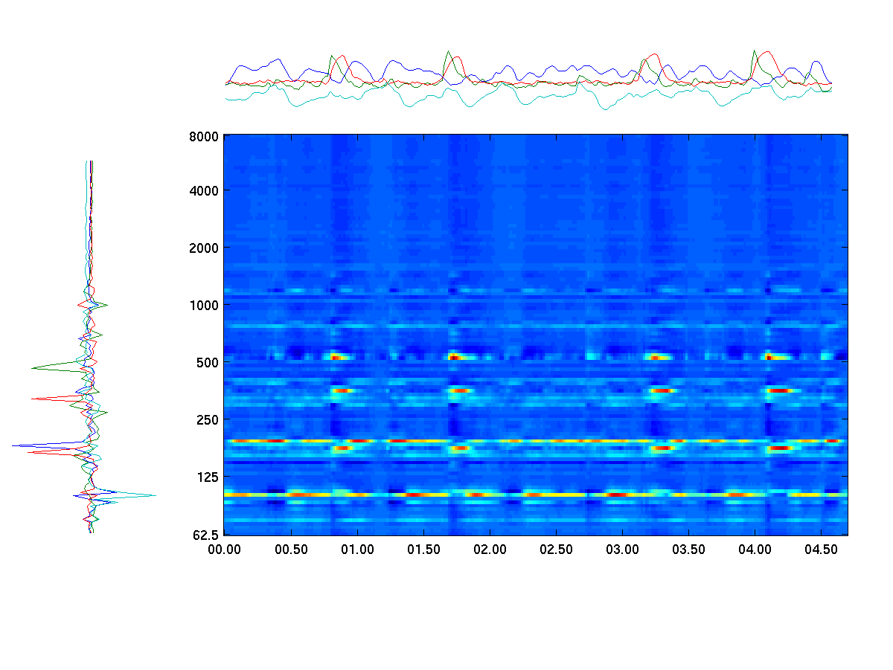
Time

Frequency
Time
Spectral Basis
Basis Projection
4-component Spectrogram Reconstruction

