HEA@CNTs Decorated Porous PDMS for Pressure Temperature Sensing and Compression Regulated Microwave Absorption

Abstract
Carbon-based porous sensors can detect mechanical and thermal stimuli, but their predominantly dielectric electromagnetic response limits their use in environments with electromagnetic interference. Here, Al–Co–Fe–Ni–Mn HEA@CNTs are incorporated into a porous PDMS platform carrying a CNT/PEDOT:PSS sensing network, adding a magnetic component and heterogeneous alloy–carbon interfaces to the microwave-loss network. Carbon encapsulation is used to spatially associate the alloy particles with the conductive carbon framework and reduce the aggregation and surface exposure expected for bare alloy particles. The HEA@CNTs-containing absorber is placed above a separate sensing layer, allowing its electromagnetic function to be combined with sensing without sharing the thermoelectric readout path. Pressure changes the resistance of the compressible CNT/PEDOT:PSS network, whereas a through-thickness temperature difference generates an open-circuit Seebeck voltage. The supplied sensing data show a piezoresistive sensitivity of approximately −0.8% kPa⁻¹ and a Seebeck coefficient of approximately 40 μV K⁻¹, with limited cross-response over the tested conditions. Compression changes the electromagnetic parameters and thickness-dependent reflection-loss response in the measured 2–18 GHz range. A 5 × 5 array further illustrates pressure–temperature recognition with an absorbing layer under the tested interference condition. This architecture combines independently read mechanical and thermal signals with a mechanically adjustable microwave-loss layer.
Keywords: electronic skin; porous PDMS foam; HEA@CNTs; CNT/PEDOT:PSS; pressure-temperature decoupling; microwave absorption

1. Introduction
Flexible electronic skins provide soft interfaces for wearable devices and robotic contact sensing. Detecting pressure together with thermal state helps distinguish contact force from a temperature change and can improve the interpretation of human–machine interactions.[1–3] Porous elastomers are useful supports because their interconnected skeletons deform under moderate loads and accommodate conductive coatings without requiring a rigid substrate. CNT/PEDOT:PSS networks can convert compression-induced changes in electrical contacts into a resistance signal. The same class of conductive networks can also generate a thermoelectric voltage when a temperature difference is maintained across the device. A useful multimodal sensor must preserve these distinct readout mechanisms during repeated deformation.
Meeting these requirements becomes more difficult in environments containing electromagnetic interference. Wireless transmitters near communication base stations, radar equipment and switching power converters in industrial robots or power facilities are representative sources of time-varying electromagnetic fields. Such fields can couple capacitively or inductively to electrodes, interconnects and readout circuits, introducing unwanted voltages or currents into the sensing channels. The weak thermoelectric signal is particularly susceptible to this pickup, although the extent of disturbance depends on the frequency, field strength, wiring and readout configuration. Carbon networks dissipate electromagnetic energy through conduction and polarization, but their response is predominantly dielectric. Increasing conductivity alone can increase reflection at the air–material interface and does not necessarily improve absorption. The resulting design requirement is therefore a compliant sensing platform with an added electromagnetic-loss component that balances wave entry with internal attenuation and preserves the independent pressure and temperature outputs.
Magnetic high-entropy alloys offer a route to introduce magnetic loss alongside the dielectric response of the carbon network. Their multicomponent composition provides opportunities to tune magnetic behavior and alloy–carbon interfacial polarization.[4] Bare nanosized HEA powders can, however, agglomerate, undergo surface oxidation and form poorly controlled contacts when dispersed directly into a polymer. These problems make a simple blend of bare HEA particles and PDMS an unattractive route for controlling the loss network while maintaining a deformable skeleton. We instead use a carbon-encapsulated HEA/CNT architecture and deposit the resulting hybrid onto the porous scaffold. The carbon framework associates the particles with a conductive network, reduces direct exposure of the alloy surface and introduces spatially distributed alloy–carbon interfaces. The alloy component supplies a possible magnetic-loss contribution, while the carbon network supports conduction and polarization losses. These are design rationales: their relative contributions must be assessed through microscopy, compositional analysis and electromagnetic measurements rather than inferred from the HEA designation alone.
Here, we combine a CNT/PEDOT:PSS-coated porous PDMS sensing layer with an Al–Co–Fe–Ni–Mn HEA@CNTs-containing porous absorber. The pressure channel measures resistance changes caused by compression of the coated pore walls, and the thermal channel measures the Seebeck voltage generated by a through-thickness temperature difference. The supplied data give a pressure sensitivity of approximately −0.8% kPa⁻¹ with R² = 0.99 and a Seebeck coefficient of approximately 40 μV K⁻¹. The thermal output varies little under pressures of 0–60 kPa in the reported cross-response test. The separate absorbing layer provides a compression-dependent reflection-loss response over 2–18 GHz and is evaluated above a 5 × 5 sensing array. Reference characterization of the carbon-encapsulated CoFeNiMnV/NCNTs system from Hassan’s doctoral thesis is included separately in Figs. S1–S15.[4] Those reference data support the choice of architecture and are not treated as measurements of the present polymer composite.

2. Experimental section

2.1 Materials
PDMS elastomer (Sylgard 184, Dow Corning) was used with a base-to-curing-agent mass ratio of 10:1, as confirmed by the author. Aladdin is selected as the supplier of dopamine hydrochloride for the revised preparation protocol; the original purchase record still requires confirmation. Tris buffer reagents, CNTs, PEDOT:PSS aqueous dispersion, copper foil or tape, the sacrificial template and dispersion solvents were used for scaffold preparation and device assembly. Their grades, suppliers and stock concentrations are listed for completion in Table S1. The alloy component is Al–Co–Fe–Ni–Mn rather than the CoFeNiMnV system in the reference thesis. Its carbon-associated powder is denoted HEA@CNTs. The reference method below is clearly distinguished from the actual preparation of this Al-containing hybrid.

2.2 Al Co Fe Ni Mn HEA CNT hybrids and reference preparation
The HEA used in the present device is Al–Co–Fe–Ni–Mn, as confirmed by the author. The Al–Co–Fe–Ni–Mn precursor identities, metal ratio, masses, encapsulation route, atmosphere and thermal history must be supplied from the actual preparation record. Substituting an Al precursor into a V-containing recipe is not assumed to give an equivalent alloy or identical carbon-shell structure. The CoFeNiMnV/NCNTs route below is included as a cited architectural and processing reference only, not as the preparation record of the Al-containing powder.
Hassan reports a CoFeNiMnV/NCNTs preparation using five acetylacetonate precursors in an equimolar metal ratio and 8 g of dicyandiamide.[4] The precursors and dicyandiamide were dispersed in an ethanol/water mixture with a reported ratio of 1:1, sonicated for 10 h, and dried at 80 °C. The dried solid was ground and pyrolyzed under N₂ for 2 h at 700, 800, 900 or 1000 °C using a heating rate of 5 °C min⁻¹. After cooling, the powder was immersed in 0.5 M H₂SO₄ for 10 h, washed with water and ethanol, and vacuum-dried at 60 °C. This is the published preparation reference for the CNT-associated HEA architecture, not an assumed record of the present batch. The actual metal-precursor masses, solvent volume, gas flow, selected temperature, acid volume and drying time are to be confirmed in Table S1. The thesis also contains inconsistent vanadium acetylacetonate formulas, so the precursor identity must be checked against the reagent label before replication. Reference characterization is collected in Figs. S1–S15.

2.3 Preparation of porous PDMS and PDA coated scaffolds
An open-cell PDMS scaffold was prepared by the sacrificial-template route. Sylgard 184 base and curing agent were mixed at a mass ratio of 10:1, infiltrated into [AUTHOR TO CONFIRM: template identity and particle or pore size], and cured at [AUTHOR TO CONFIRM: temperature and time]. The template was removed by repeated washing with [AUTHOR TO CONFIRM: solvent and washing duration], and the foam was dried at [AUTHOR TO CONFIRM: temperature and time]. The porous scaffold was then immersed in a weakly alkaline dopamine solution under stirring for 24 h, the duration indicated in the supplied fabrication schematic. The dopamine concentration, Tris concentration, pH and bath volume are required in Table S1. After PDA deposition, the scaffold was washed and dried before conductive functionalization.

2.4 Deposition of the sensing and absorbing networks
PDA-coated PDMS was treated by vacuum-assisted impregnation with a CNT/PEDOT:PSS dispersion, followed by drying, to form the pressure–temperature sensing layer. The CNT content series in Fig. 2f is labelled 0, 3, 10, 25, 50, 75, 80, 90 and 100 wt%. Following the author’s instruction to select a formulation from these data, the revised protocol uses a CNT-to-PEDOT:PSS dry-solids mass ratio of 75:25 (3:1), corresponding to the peak region in Fig. 2f. This choice defines the revised recipe; correspondence to the original experimental batch must be checked. The ratio refers to dry polymer solids, not the mass of the aqueous PEDOT:PSS stock. A separate porous layer was functionalized with an HEA@CNTs-containing dispersion to provide microwave attenuation. The electromagnetic series in Fig. 3b,c is labelled 0.5%, 1.5%, 2.5% and 3.5%, whereas the supplementary mechanical series is labelled 5% and 20%; these are distinct source-labelled series and are not interchangeable. As clarified by the author, the HEA@CNTs loading is defined by w = 100 × m(HEA@CNTs)/[m(HEA@CNTs) + m(unmodified CNTs)], using dry masses of the two CNT-containing materials. This is the fraction of HEA-modified CNT material in the combined CNT fraction, not the alloy-metal mass fraction and not the fraction of the whole PDMS composite. At a nominal loading of 2.5%, for example, a normalized 100 mg CNT-material mixture would contain 2.5 mg HEA@CNTs and 97.5 mg unmodified CNTs. This mass example defines the ratio and is not a reported batch mass. The dispersion concentrations, delivered masses, percentage definitions, vacuum pressure, impregnation time, number of deposition cycles and drying conditions are to be completed from the laboratory records in Table S1. For device tests, the sensing and absorbing foams remained separate components. The illustrated stack comprises a protective PDMS layer, the absorbing foam, an insulating PDMS layer, upper and lower electrodes, the CNT/PEDOT:PSS sensing foam and a PI support (Fig. 4b).

2.5 Pressure and thermoelectric sensing measurements
Normal pressure was applied while resistance was recorded. The relative response was defined as ΔR/R₀ = (R − R₀)/R₀, where R₀ is the unloaded resistance. The supplied calibration spans approximately 0–75 kPa (Fig. 2a), the I–V series uses 0, 20, 40, 50 and 60 kPa (Fig. 2b), and stepwise dynamic loading is labelled 10–70 kPa (Fig. 2c). Sensitivity was obtained from the slope of the percentage resistance change against pressure. Supplementary tests include periodic loading at 200 Pa (Fig. S19), a transient trace labelled 200 ms response and 110 ms recovery (Fig. S20), and waveforms near the start and around cycle 2500 (Figs. S21 and S22). The load cell, contact area, loading rate, electrical readout instrument, sampling frequency and response-time definition must be reported in Table S1.
For thermal sensing, a temperature difference ΔT was maintained across the foam and the open-circuit voltage ΔV was recorded. The Seebeck coefficient was obtained from the slope of ΔV against ΔT. The dynamic trace in Fig. 2g covers source-labelled temperature differences of 5–30 K, and the cyclic trace in Fig. 2h is labelled approximately 11.5 K. Pressure cross-response was examined at 0–60 kPa (Fig. 2i,j). The pressure response was compared at temperature differences labelled −5, 0, 10 and 15 K under pressures of 30 and 50 kPa (Fig. 2k). These are the conditions visible in the supplied plots; thermal contact geometry, temperature measurement, equilibration time, voltage acquisition and the sign convention for ΔT require confirmation in Table S1.

2.6 Structural and electromagnetic characterization
SEM, EDS, Raman spectroscopy and XPS were used to examine the functionalized porous scaffold shown in Fig. 1. The corresponding instrument models and acquisition conditions for the present composite must be supplied in Table S1; the instrument list in the doctoral thesis describes the reference powder and is not assumed to describe this study. Complex permittivity εᵣ = ε′ − jε″ and permeability μᵣ = μ′ − jμ″ were reported from 2 to 18 GHz. The source figures compare nominal compressive strains of 0%, 20% and 40%, with additional 50% and 60% curves in Fig. S23. The dielectric and magnetic loss tangents were calculated as ε″/ε′ and μ″/μ′. Reflection loss was calculated with the homogeneous, metal-backed transmission-line model in Eqs. (1) and (2). The specimen geometry, VNA model, calibration, fixture, sample orientation, method of retaining compression and thickness used for each calculation must be specified separately for the porous composite.
$$\frac{Z_{in}}{Z_{0}}=\sqrt{\frac{μ_{r}}{ε_{r}}}tanh​\left[j\frac{2πfd}{c}\sqrt{μ_{r}ε_{r}}\right]$$ (1)
$$RL=20\log_{10}\left|\frac{Z_{in}−Z_{0}}{Z_{in}+Z_{0}}\right|$$ (2)
Here, Zᵢₙ is the complex input impedance, Z₀ is the free-space impedance, f is frequency, d is the layer thickness in the state being evaluated and c is the speed of light. An effective absorption band is a continuous frequency interval satisfying RL < −10 dB at one specified thickness and compression state. This criterion corresponds to a reflected-power fraction below 0.1 in the metal-backed model. The magnitude |Zᵢₙ/Z₀| is a useful indicator of matching, but a magnitude near 1 alone does not establish complex impedance matching. Thickness-dependent calculated RL must be distinguished from device-level measurements of interference suppression.

2.7 Mechanical and electromagnetic simulations
Finite-element calculations compared the pressure and temperature fields of the porous sensing structure before and after compression (Fig. 2l). A simplified porous geometry was used. Full-wave electromagnetic calculations were conducted in HFSS for the multilayer device. Maps and line profiles are supplied at 2, 6, 10, 14 and 18 GHz. The geometric dimensions, material properties, excitation amplitude and direction, boundary conditions, mesh-convergence criterion, observation plane and line-sampling path are required in Table S1. All field comparisons must use equivalent excitation and a common numerical basis. In particular, the original with-absorber and without-absorber screenshots use different color-scale maxima, so a change of color cannot by itself be interpreted as quantitative attenuation.

2.8 Array assembly and interference tests
A 5 × 5 array was evaluated using hot water, cold water and finger pressing. Resistance and voltage outputs from 25 pixels were converted into pressure and temperature maps. Three configurations were compared: no interference, interference without the absorbing layer and interference with the absorbing layer. The supplied confusion matrices contain 90 examples per stimulus class, or 270 outcomes per configuration (Fig. 4h). The interference source, frequency, field strength or transmitted power, source–device separation, electrode wiring, array pitch, training/test separation and classification procedure are required in Table S1. These conditions define the scope of the interference test and cannot be inferred from the 2–18 GHz absorber-characterization window.

3. Results and discussion

3.1 Fabrication and structural characterization
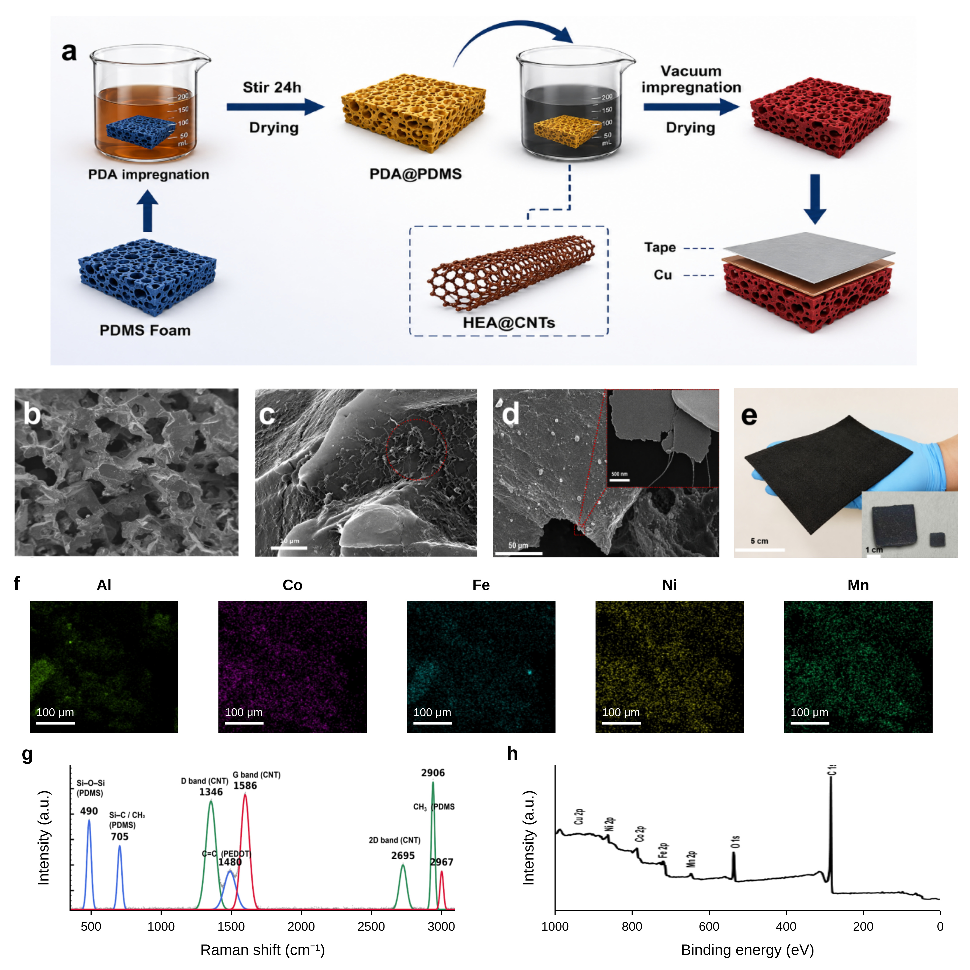
Figure 1. Porous-scaffold fabrication and composite characterization. (a) PDA treatment for 24 h, vacuum-assisted impregnation and electrode assembly. (b–d) SEM images. (e) Photograph of the foam. (f) Al, Co, Fe, Ni and Mn EDS maps; scale bars, 100 μm. (g) Raman spectrum. (h) XPS survey. The source peak labels are retained; the Cu assignment requires verification.
Figure 1a shows the preparation route. The open-cell PDMS foam provides the deformable scaffold, and the PDA treatment gives the pore walls a surface that can retain the functional dispersion. Vacuum-assisted impregnation was used because the functional components need to enter the internal pores rather than remain only on the outer surface. After drying, the foam remains free-standing and can be assembled with copper electrodes.
The functionalized composite retains interconnected pores (Fig. 1b). At higher magnification, the pore walls carry rough particulate and fibrous deposits (Fig. 1c,d). The skeleton provides space for reversible compression, while the coating introduces contacts that can reconnect under load. The stress–strain comparison and cyclic mechanical response are presented separately in Figs. S16 and S17. Their source-labelled loading fractions should be distinguished from the electromagnetic loading series.
The foam can be handled and bent, as illustrated in Fig. 1e. The supplied EDS maps in Fig. 1f are labelled Al, Co, Fe, Ni and Mn. They establish the occurrence of signals assigned to these elements in the selected region but do not alone establish a single-phase HEA, equiatomic composition or carbon encapsulation. In contrast, the thesis reference is CoFeNiMnV/NCNTs, with V rather than Al in its elemental maps (Fig. S6).[4] The author confirms that this work uses the Al–Co–Fe–Ni–Mn system. The V-containing thesis figures are therefore a separate structural reference and cannot establish the phase, composition or encapsulation of the present Al-containing powder. TEM, HRTEM and elemental mapping of the reference material are provided individually in Figs. S3–S6, with their original source scales and explicit attribution.
The supplied composite Raman spectrum contains carbon-related features labelled near 1346 and 1586 cm⁻¹, a band near 2695 cm⁻¹ and features assigned in the source to PDMS and PEDOT (Fig. 1g). These bands are consistent with the presence of carbonaceous and polymer components, but a quantitative defect ratio cannot be obtained reliably from the embedded figure alone. The supplied XPS survey includes carbon and oxygen signals together with metal-labelled features (Fig. 1h); its Cu label is not consistent with the five-element EDS list and requires verification. Reference XRD and Raman data are provided in Figs. S1 and S2. The thesis XPS survey and high-resolution Co 2p, Fe 2p, Ni 2p, Mn 2p, V 2p, N 1s, C 1s and O 1s spectra are shown separately in Figs. S7–S15.[4] They characterize the cited precursor system and do not substitute for measurements of the present foam.

3.2 Pressure-temperature sensing performance and signal decoupling
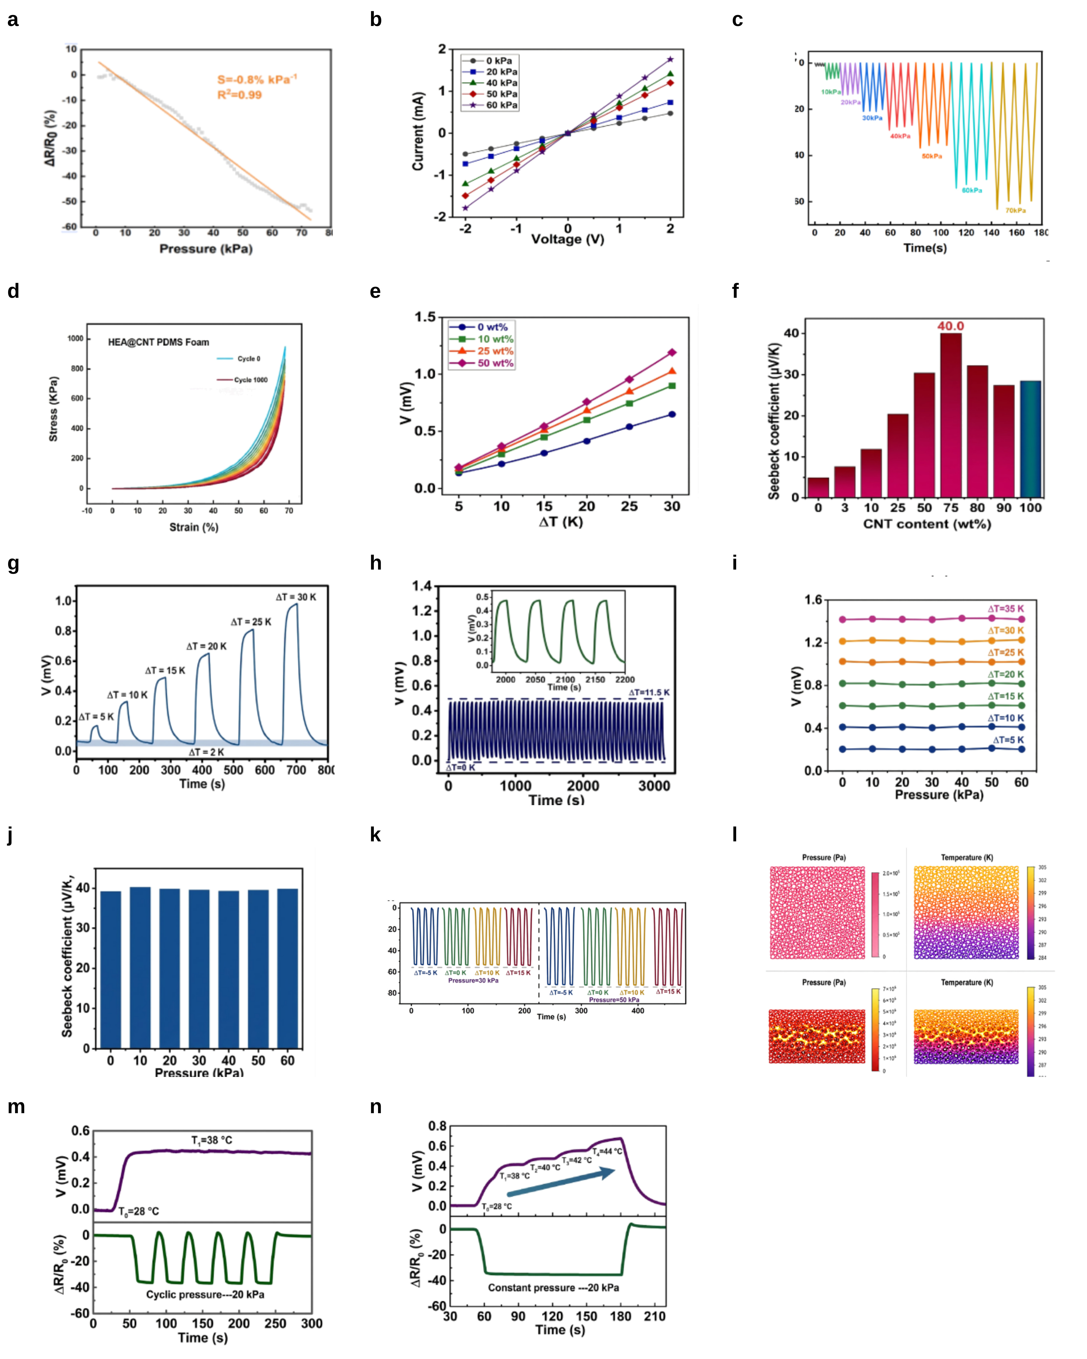
Figure 2. Pressure-temperature dual-mode sensing performance and decoupling behavior. (a) Relative resistance change as a function of pressure. (b) I-V curves under different pressures. (c) Real-time response under stepwise loading. (d) Cyclic compressive stress-strain behavior. (e) Thermoelectric voltage as a function of temperature difference for different CNT contents. (f) Corresponding Seebeck coefficients. (g,h) Dynamic and cyclic thermoelectric responses under different temperature gradients. (i,j) Thermoelectric voltage and Seebeck coefficient under different pressures. (k) Pressure response under different temperature gradients. (l) Simulated pressure and temperature distributions before and after compression. (m,n) Dual-mode responses under coupled pressure and temperature stimuli.
The resistance decreases as the porous foam is compressed (Fig. 2a). The response is approximately linear over the tested pressure range, with a sensitivity of about -0.8% kPa⁻¹ and R² = 0.99. Neighboring pore walls move closer under load and create more conductive contacts, lowering the contact resistance. The I-V curves remain close to linear while their slopes increase with pressure (Fig. 2b). Stepwise loading gives clearly separated resistance levels (Fig. 2c). The cyclic stress-strain curves in Fig. 2d show that the PDMS skeleton can return after repeated compression, which allows the conductive contacts to open and close during sensing.
The supplementary pressure measurements show a reproducible periodic response at 200 Pa (Fig. S19), demonstrating detection under that applied load rather than establishing a statistical limit of detection. The transient trace is labelled with response and recovery times of approximately 200 and 110 ms (Fig. S20); the timing criterion must be specified before comparing these values with other sensors. Waveforms near the beginning and around cycle 2500 are shown separately in Figs. S21 and S22. They support repeated contact reconstruction, although the duplicated cycle-axis labels in the source need correction from the raw record.
A temperature difference produces an open-circuit Seebeck voltage. The voltage increases with ΔT in Fig. 2e, and its slope varies with the source-labelled CNT content. Figure 2f places the largest displayed coefficient near 40 μV K⁻¹ at a source-labelled CNT content of 75 wt%. The composition basis and the difference between the original text value of 40.5 μV K⁻¹ and the plotted label of 40.0 μV K⁻¹ require confirmation. The thickness series at 3–6 mm is presented in Fig. S18. Dynamic and cyclic voltage traces are shown in Fig. 2g,h. The literature comparison formerly supplied as a raster panel is presented as editable Table S3, with the original values and citations retained for verification.
Pressure and temperature are read from different electrical variables. At a fixed temperature difference, the thermoelectric voltage changes little as pressure increases from 0 to 60 kPa (Fig. 2i), and the calculated Seebeck coefficient remains nearly constant (Fig. 2j). The resistance response also keeps a similar amplitude under different temperature gradients (Fig. 2k). Temperature can be obtained from voltage and pressure from resistance without decomposing two stimuli from the same signal.
The finite-element maps in Fig. 2l qualitatively illustrate redistribution of the mechanical field during compression and a retained through-thickness thermal gradient. The calculation is consistent with the proposed separation of mechanical contact changes from the thermal driving force. Quantitative support requires the material constants, boundary conditions and mesh-convergence results listed in Table S1; the plotted fields alone do not establish a universal pressure-independent Seebeck coefficient.
The coupled tests in Fig. 2m,n use both stimuli at the same time. Under a fixed temperature difference, cyclic pressure changes the resistance while the voltage remains close to its original level. When pressure is fixed and the temperature difference is changed, the voltage follows the thermal input and the resistance is nearly unchanged. The two signals can be collected from the same sensing region without an additional decoupling model.

3.3 Compression-regulated electromagnetic wave absorption
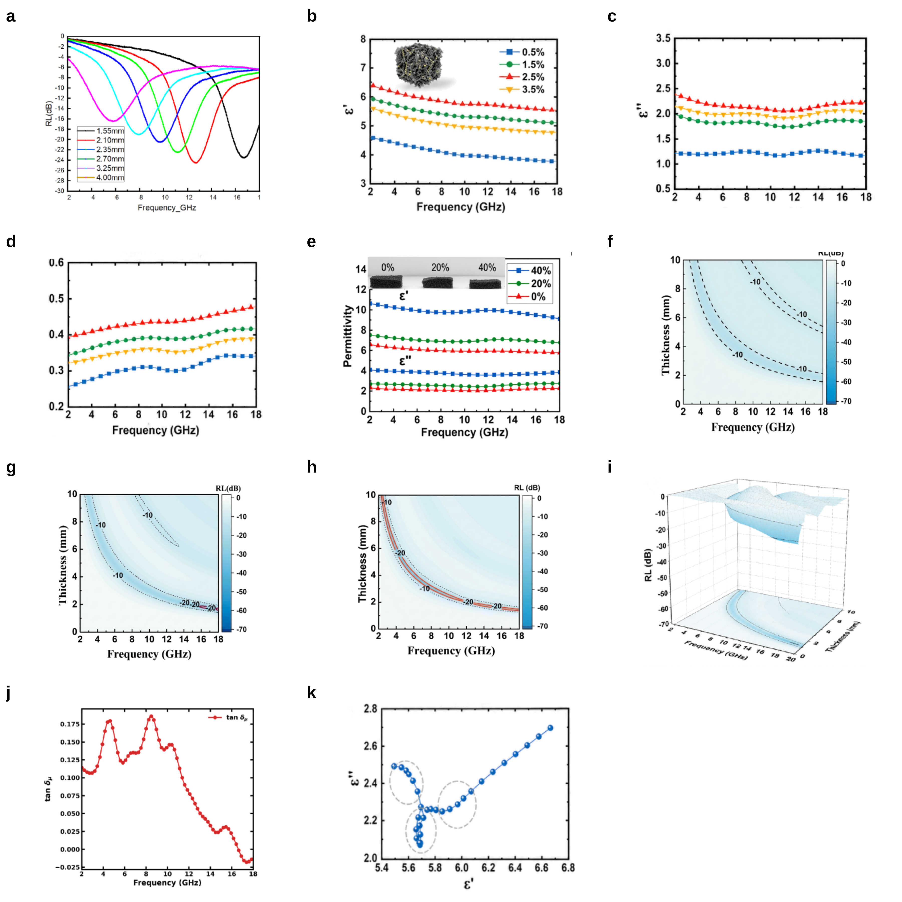
Figure 3. Supplied electromagnetic response of the HEA@CNTs-containing porous absorber. (a) Reflection-loss curves for source-labelled thicknesses of 1.55–4.00 mm. (b,c) Real and imaginary permittivity for loading series labelled 0.5%, 1.5%, 2.5% and 3.5%. (d) Dielectric loss tangent. (e) Real and imaginary permittivity at nominal strains of 0%, 20% and 40%. (f–h) Calculated RL contour maps; their specimen identities and strain assignments require confirmation. (i) Three-dimensional RL plot. (j) Magnetic loss tangent. (k) Cole–Cole plot. Each source panel is retained in a uniform frame. The original literature-comparison panel is excluded because its current-work values conflict with the supplied text and lack a reconciled dataset.
The electromagnetic response of the porous layer was measured from 2 to 18 GHz. The real and imaginary parts of permittivity change with HEA@CNTs loading (Fig. 3b,c). Increasing the functional loading raises the dielectric response because more conductive contacts and heterogeneous interfaces are introduced. The loss tangent in Fig. 3d shows that dielectric attenuation remains active across the measured band. Both conduction through the carbon network and polarization at the internal interfaces contribute to this response.
Compression changes the electromagnetic response without requiring a new nominal composition. The functionalized pore walls approach one another, increasing the density of contacts and interfaces per unit volume. The supplied ε′ and ε″ curves change between the nominal 0%, 20% and 40% states (Fig. 3e). Stronger dielectric response can increase internal attenuation, but it may also worsen the impedance discontinuity at the air–material interface. The thickness in the compressed state must therefore be used consistently when evaluating the balance between wave entry and internal loss.
The calculated RL curves and contour maps display minima that shift with frequency and layer thickness (Fig. 3a,f–i). These data demonstrate a tunable response within the measured 2–18 GHz window. The original text reports approximately −22 dB at 7.14 GHz, whereas the original comparison panel lists −28.7 dB and describes a 2–18 GHz effective band for a 1.5 mm, 40%-strain specimen. The supplied plot series does not establish that these values refer to one common specimen and condition. Accordingly, a single optimized RL minimum or 16 GHz effective absorption bandwidth is not assigned in this draft. The finalized value must be extracted from the measured complex parameters using a stated thickness, strain and continuous RL < −10 dB interval, as described in Section S3.
Additional permittivity curves at 50% and 60% nominal compression are supplied in Fig. S23. Representative permittivity and permeability spectra appear in Figs. S24 and S25. Figure S26 contains normalized-impedance curves labelled by thicknesses of 1.55–4.00 mm, not by compression state. These distinctions are necessary when interpreting changes in absorption: a thickness-dependent matching calculation cannot be used by itself to establish an optimum compressive strain. Matching and attenuation should be assessed jointly from the complex input impedance and the calculated reflected power.
The magnetic-loss-tangent plot in Fig. 3j contains positive features and also negative values near the high-frequency end of the window. Before assigning a magnetic-loss mechanism, the latter require examination of VNA calibration, parameter extraction and the adopted sign convention. The distorted arcs in Fig. 3k are consistent with a non-single-relaxation dielectric response, but they do not identify a unique microscopic mechanism. Alloy–carbon and carbon–polymer interfaces are plausible sites for interfacial polarization. The role of repeated scattering at the foam pores should remain a proposed contribution until it is supported by a suitable wave-propagation calculation or experiment.
The practical objective is a deformable absorbing layer that can be integrated above the sensing region. Establishing that objective requires the microwave-parameter data to be reconciled with specimen composition, compressed thickness and loading fraction. The comparison with other porous absorbers should be restored only after these current-work values and the literature test conditions have been checked on a common basis.

3.4 EMI-protected multimodal sensing and array recognition
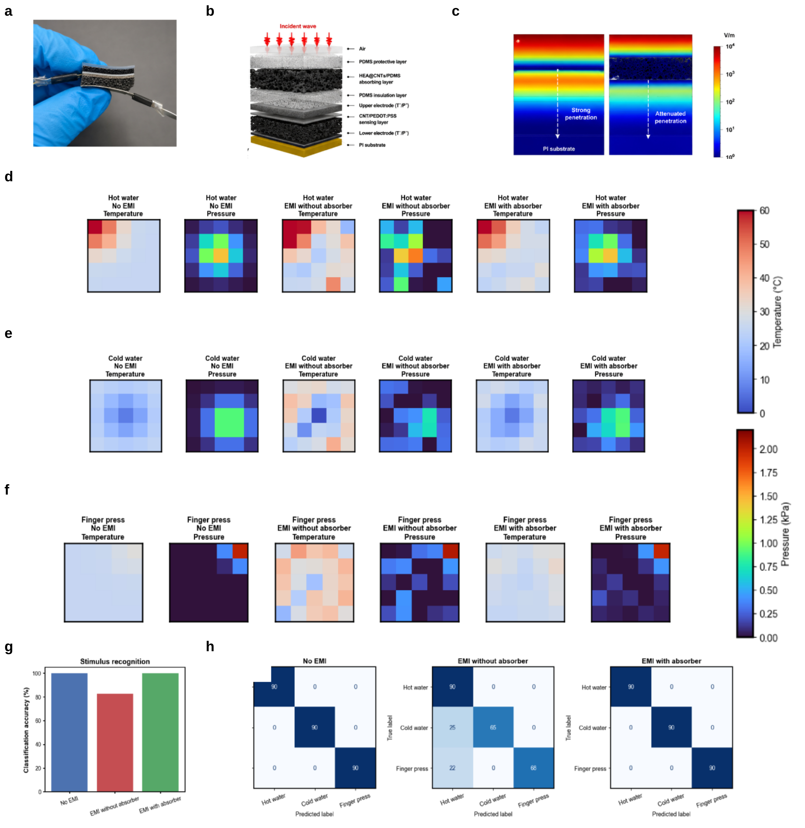
Figure 4. Pressure–temperature sensing with an absorbing layer under the supplied interference test. (a) Photograph of the multilayer device. (b) Layer-stack illustration including the CNT/PEDOT:PSS sensing layer. (c) Supplied field-distribution illustration. (d–f) Temperature and pressure maps for hot water, cold water and finger pressing across the three electromagnetic configurations. (g) Classification-accuracy plot. (h) Confusion matrices. Source-derived classification accuracies are 100%, approximately 82.6% and 100%, respectively; their scope is the supplied set of 270 outcomes per configuration.
The absorbing foam was placed on the incident-field side of a 5 × 5 pressure-temperature array (Fig. 4a,b). The HEA@CNTs-rich layer and the sensing layer are kept physically separate, so the microwave-loss network does not share the weak thermoelectric readout path. The field distribution in Fig. 4c shows the role of the upper layer: the electromagnetic field is redistributed around the absorber before reaching the lower sensing region.
The frequency-resolved HFSS electric-field maps are shown separately at 2, 6, 10, 14 and 18 GHz in Figs. S27–S31. Each figure pairs the with-absorber and without-absorber structures and retains its original numerical legend. The associated volumetric-loss maps appear individually in Figs. S32–S36, and the line profiles appear in Figs. S37–S41. Because the two field-map sets use different color-scale maxima, their colors cannot be compared as a quantitative attenuation factor. The diagrams show frequency-dependent field distributions and locations of loss. A common excitation normalization and a defined observation region are needed to calculate the field reduction at the sensing layer.
Hot water, cold water and finger pressing were used to test the array (Fig. 4d-f). Without EMI, hot water gives a local high-temperature region with a pressure footprint from the container, and cold water gives a low-temperature region with a similar mechanical contact. Finger pressing produces a stronger local pressure response and a smaller thermal change. The maps show that the resistance-voltage separation observed for a single pixel is still visible after the sensors are arranged into an array.
Under the supplied interference condition, the reconstructed maps change when the absorbing layer is removed. The temperature channel shows appreciable disturbance, consistent with the susceptibility of a small thermoelectric voltage to parasitic pickup, while the pressure channel also shows spatial changes. With the absorbing layer, the displayed maps are closer to those obtained without interference. This observation applies to the illustrated configuration. The source frequency, field strength, coupling geometry and repeated-test statistics are required before generalizing the result to other electromagnetic environments.
The supplied confusion matrices contain 90 outcomes for each of the three stimulus classes. They give 270/270 correct classifications without interference, 223/270 correct classifications under interference without the absorber, and 270/270 correct classifications under interference with the absorber. The corresponding source-derived accuracies are 100%, 82.6% and 100%, consistent with the plotted trend in Fig. 4g,h. These calculations describe the supplied matrices; without a documented split between training and test data, they should not be treated as an independently validated generalization accuracy. The experiment suggests that the upper absorbing layer can improve signal interpretation under the tested condition.

4. Conclusion
A porous PDMS platform combines a CNT/PEDOT:PSS network for pressure–temperature sensing with a separate HEA@CNTs-containing microwave-loss layer. Compression changes the resistance of the coated pore network, whereas a temperature difference produces a Seebeck voltage. The supplied sensing curves support a pressure sensitivity of approximately −0.8% kPa⁻¹ and a Seebeck coefficient near 40 μV K⁻¹, with limited cross-response under the tested conditions. The electromagnetic data show a response that varies with compression and matching thickness within 2–18 GHz. The array maps and confusion matrices indicate improved stimulus interpretation when the upper absorbing layer is present in the reported interference test. The combined architecture offers a route to mechanical and thermal sensing with an added electromagnetic-loss component. The preparation record for the confirmed Al–Co–Fe–Ni–Mn hybrid, quantitative loading definitions and optimized absorption metrics must be reconciled before the final performance claim is fixed.

References
[1] A. Libanori, G. R. Chen, X. Zhao, Y. H. Zhou and J. Chen. Smart textiles for personalized healthcare. Nature Electronics 2022, 5, 142–156.
[2] Y. Liu, M. Pharr and G. A. Salvatore. Lab-on-Skin: A Review of Flexible and Stretchable Electronics for Wearable Health Monitoring. ACS Nano 2017, 11, 9614–9635.
[3] T. R. Ray, J. Choi, A. J. Bandodkar, et al. Bio-Integrated Wearable Systems: A Comprehensive Review. Chemical Reviews 2019, 119, 5461–5533.
[4] Sibt ul Hassan. Facile Synthesis and Microwave Absorption Properties of Medium- and High-Entropy Alloy/Carbon Composite Nanostructures. Doctoral thesis, Central South University, April 2025. Chapters 2 and 6.

