Supporting Information

HEA@CNTs Decorated Porous PDMS for Pressure Temperature Sensing and Compression Regulated Microwave Absorption

S1 Reference material preparation and characterization
The alloy in the present device is Al–Co–Fe–Ni–Mn, confirmed by the author. Hassan’s thesis instead reports CoFeNiMnV/NCNTs prepared by precursor-assisted pyrolysis.[1] Figures S1–S15 are reference figures for the carbon-encapsulated architecture, explicitly attributed to the original panels. They are not measurements of the present Al-containing powder or PDMS composite and must not be used to identify its phase or chemical composition.
Hassan reports a CoFeNiMnV/NCNTs preparation using five acetylacetonate precursors in an equimolar metal ratio and 8 g of dicyandiamide.[1] The precursors and dicyandiamide were dispersed in an ethanol/water mixture with a reported ratio of 1:1, sonicated for 10 h, and dried at 80 °C. The dried solid was ground and pyrolyzed under N₂ for 2 h at 700, 800, 900 or 1000 °C using a heating rate of 5 °C min⁻¹. After cooling, the powder was immersed in 0.5 M H₂SO₄ for 10 h, washed with water and ethanol, and vacuum-dried at 60 °C. This is the published preparation reference for the CNT-associated HEA architecture, not an assumed record of the present batch. The actual metal-precursor masses, solvent volume, gas flow, selected temperature, acid volume and drying time are to be confirmed in Table S1. The thesis also contains inconsistent vanadium acetylacetonate formulas, so the precursor identity must be checked against the reagent label before replication. Reference characterization is collected in Figs. S1–S15.
Reference preparation item | Value reported in the thesis
Metal composition | CoFeNiMnV; five precursors in an equimolar metal ratio
Metal reagent source | Aldrich in thesis Table 2-1; Fe, Co and Ni acetylacetonates 98%; Mn and V entries 97%
Carbon/nitrogen precursor | Dicyandiamide 8 g; supplier not given for this reagent
Dispersion medium | Ethanol/water 1:1; ratio basis and total volume not specified
Sonication and drying | 10 h sonication; solvent evaporation at 80 °C
Pyrolysis | 700, 800, 900 or 1000 °C; 2 h; N₂; 5 °C min⁻¹
Purification | 0.5 M H₂SO₄; 10 h; water/ethanol washing
Final drying | Vacuum drying at 60 °C; duration unspecified
Reference EM specimen | 10 wt% powder and 90 wt% paraffin for a coaxial ring; not a PDMS-foam test condition

The thesis preparation paragraph lists V(acac)₂, whereas its materials table lists V(acac)₃. The reagent bottle or original batch record should resolve this inconsistency. The thesis text also interchanges N 1s and C 1s panel descriptions in one passage. Figures S13 and S14 follow the labels visible in the original figure: N 1s is original panel g and C 1s is original panel h.

S2 Materials and experimental parameter records
Table S1. Parameters needed to reproduce the present porous scaffold and device. “Author to confirm” identifies information absent from the supplied files; none of these entries is replaced by a typical recipe. Values quoted from the thesis are reference-method values only.
Item | Available information | Required laboratory record
PDMS | Sylgard 184, Dow Corning; base/curing agent 10:1 by mass, author-confirmed | Author to confirm absolute masses and curing conditions
Template | Sacrificial-template route stated | Author to confirm chemical identity, size distribution, template/PDMS ratio and removal conditions
Scaffold curing | No numerical condition supplied | Author to confirm temperature, time, dimensions and porosity
PDA treatment | 24 h; Tris buffer per author; Aladdin selected for revised protocol | Author to confirm original supplier, reagent concentrations, pH, volume and temperature
CNT and PEDOT:PSS | 75:25 dry-solids mass ratio selected from Fig. 2f with author authorization | Author to confirm original-batch correspondence, suppliers, CNT dimensions, PEDOT:PSS grade/solids and dispersion concentrations
HEA@CNTs | Al–Co–Fe–Ni–Mn, author-confirmed; thesis V system is different | Author to supply actual precursor identities/masses, source, encapsulation route and thermal history
EM loading series | 0.5%, 1.5%, 2.5%, 3.5%; author defines HEA@CNTs/(HEA@CNTs + unmodified CNTs) by dry mass | Author to confirm total dispersion mass and dry coating gain
Mechanical loading series | 5% and 20%, with the same author-defined modified-CNT mass basis | Author to confirm relation to EM specimens and coating gain
Impregnation | Vacuum-assisted deposition | Author to confirm vacuum pressure, duration, bath volume, repeated cycles and drying
Pressure acquisition | Calibration about 0–75 kPa; 200 Pa supplementary test | Author to confirm contact area, load cell, speed, readout and sampling rate
Thermal acquisition | 5–30 K dynamic steps; 0–60 kPa cross-response | Author to confirm temperatures, geometry, sensors, voltage readout and equilibration
Characterization | SEM/EDS, Raman and XPS shown | Author to confirm present-composite instrument models, accelerating voltage, laser wavelength, XPS energy calibration and scan settings
Electromagnetic measurement | 2–18 GHz; nominal strains 0–60% | Author to confirm VNA/fixture, calibration, specimen dimensions, orientation, backing and compressed thickness
Simulation | HFSS maps at 2, 6, 10, 14, 18 GHz | Author to confirm geometry, materials, boundary conditions, excitation, normalization and mesh convergence
Array and EMI | 5 × 5 pixels; 270 classifications per configuration | Author to confirm pixel pitch, EMI frequency/strength/distance, classifier, training/test separation and replicates

The author defines HEA loading as the dry mass percentage of HEA@CNTs in the combined CNT-containing material: w = 100 × m(HEA@CNTs)/[m(HEA@CNTs) + m(unmodified CNTs)]. It is not the alloy-metal fraction within one tube and not the fraction of the whole PDMS foam. A ratio-normalization example at 2.5% uses 2.5 mg HEA@CNTs and 97.5 mg unmodified CNTs per 100 mg of combined CNT material. The actual batch scale, dispersion volume and deposited mass remain laboratory-record quantities. The selected CNT/PEDOT:PSS protocol uses a 75:25 dry-solids ratio, as authorized by the author based on Fig. 2f, with correspondence to the original tests still to be checked.
Table S2. Source-labelled measurement series and the figures that show them. These labels are preserved without assigning an unreported mass basis.
Series | Labels in supplied figures | Revised location
CNT composition | 0, 3, 10, 25, 50, 75, 80, 90, 100 wt% | Main Figure 2f
EM composition | 0.5%, 1.5%, 2.5%, 3.5% | Main Figure 3b,c
Mechanical composition | 5%, 20% | Figure S16
Foam thickness | 3, 4, 5, 6 mm | Figure S18
RL matching thickness | 1.55, 2.10, 2.35, 2.70, 3.25, 4.00 mm | Main Figure 3a and Figure S26
Compression | 0%, 20%, 40%; additional 50%, 60% | Main Figure 3e and Figure S23

Table S3. Seebeck-coefficient comparison transcribed from the original supporting-information panel. Literature conditions and the reference bibliographic details require verification before submission.
Material | Seebeck coefficient μV K⁻¹ | Original reference
Present sensing foam | Approximately 40 | Main Figure 2f; source text says 40.5
PEDOT:PSS/Lycra | 16 | AFM 2018, 28, 1704285 [2]
PEDOT:PSS/NFC aerogel | 20 | Advanced Science 2019, 6, 1802128 [3]
PEDOT:PSS/spacer fabric | 25 | ACS Sensors 2020, 5, 2545–2554 [4]
PEDOT:PSS/natural rubber | 31 | ACS AMI 2021, 13, 14599–14611 [5]
PEDOT:PSS/PU | 35.5 | Nature Communications 2015, 6, 8356 [6]
PEDOT:PSS/CNC–PVA | 19 | ACS Sensors 2021, 6, 1120–1128 [7]
MXene–AgNW–PEDOT–TeNW | 25.5 | Nano Letters 2020, 20, 6176–6184 [8]
PEDOT:PSS/SWCNT/WPU | 31 | ACS AMI 2021, 13, 60498–60507 [9]
PANI/CNTs–PDMS | 16.5 | J. Mater. Chem. A 2020, 8, 15167–15176 [10]
Graphene/PDMS | 35 | Science Advances 2020, 6, eabb9083 [11]

S3 Reflection loss and consistent comparison
The calculations use measured complex relative permittivity and permeability with the exp(jωt) convention, εᵣ = ε′ − jε″ and μᵣ = μ′ − jμ″. For a uniform metal-backed layer, the normalized input impedance and reflection loss are
$$\frac{Z_{in}}{Z_{0}}=\sqrt{\frac{μ_{r}}{ε_{r}}}tanh​\left[j\frac{2πfd}{c}\sqrt{μ_{r}ε_{r}}\right]$$ (S1)
$$RL=20\log_{10}\left|\frac{Z_{in}/Z_{0}−1}{Z_{in}/Z_{0}+1}\right|$$ (S2)
Use the physical compressed thickness for d and report the corresponding composition and strain. If compression is uniaxial and thickness strain is defined by ε = (d₀ − d)/d₀, then d = d₀(1 − ε). This relation must not be assumed for an unspecified compression fixture. The effective absorption bandwidth is the width of one continuous RL < −10 dB interval at that fixed d and strain. The 2–18 GHz measurement window is not automatically a 16 GHz absorption bandwidth. Negative high-frequency magnetic loss values in the supplied plot need calibration and parameter-extraction checks.
For comparison of HFSS fields, use identical incident-field normalization, observation paths and numerical legends. Different color scales in Figs. S27–S31 are retained as source evidence; they cannot establish a numerical attenuation ratio. Field magnitude, power dissipation, reflection loss and classification accuracy are different observables and should not be treated as interchangeable measures of shielding.

S4 Individually numbered supplementary figures
Figures S1–S15 reproduce reference powder characterization with explicit source attribution. Figures S16–S41 reorganize the supplied supporting-information measurements and simulations. Each figure starts on a separate page, and the corresponding main-text citations have been updated.

Figure S1
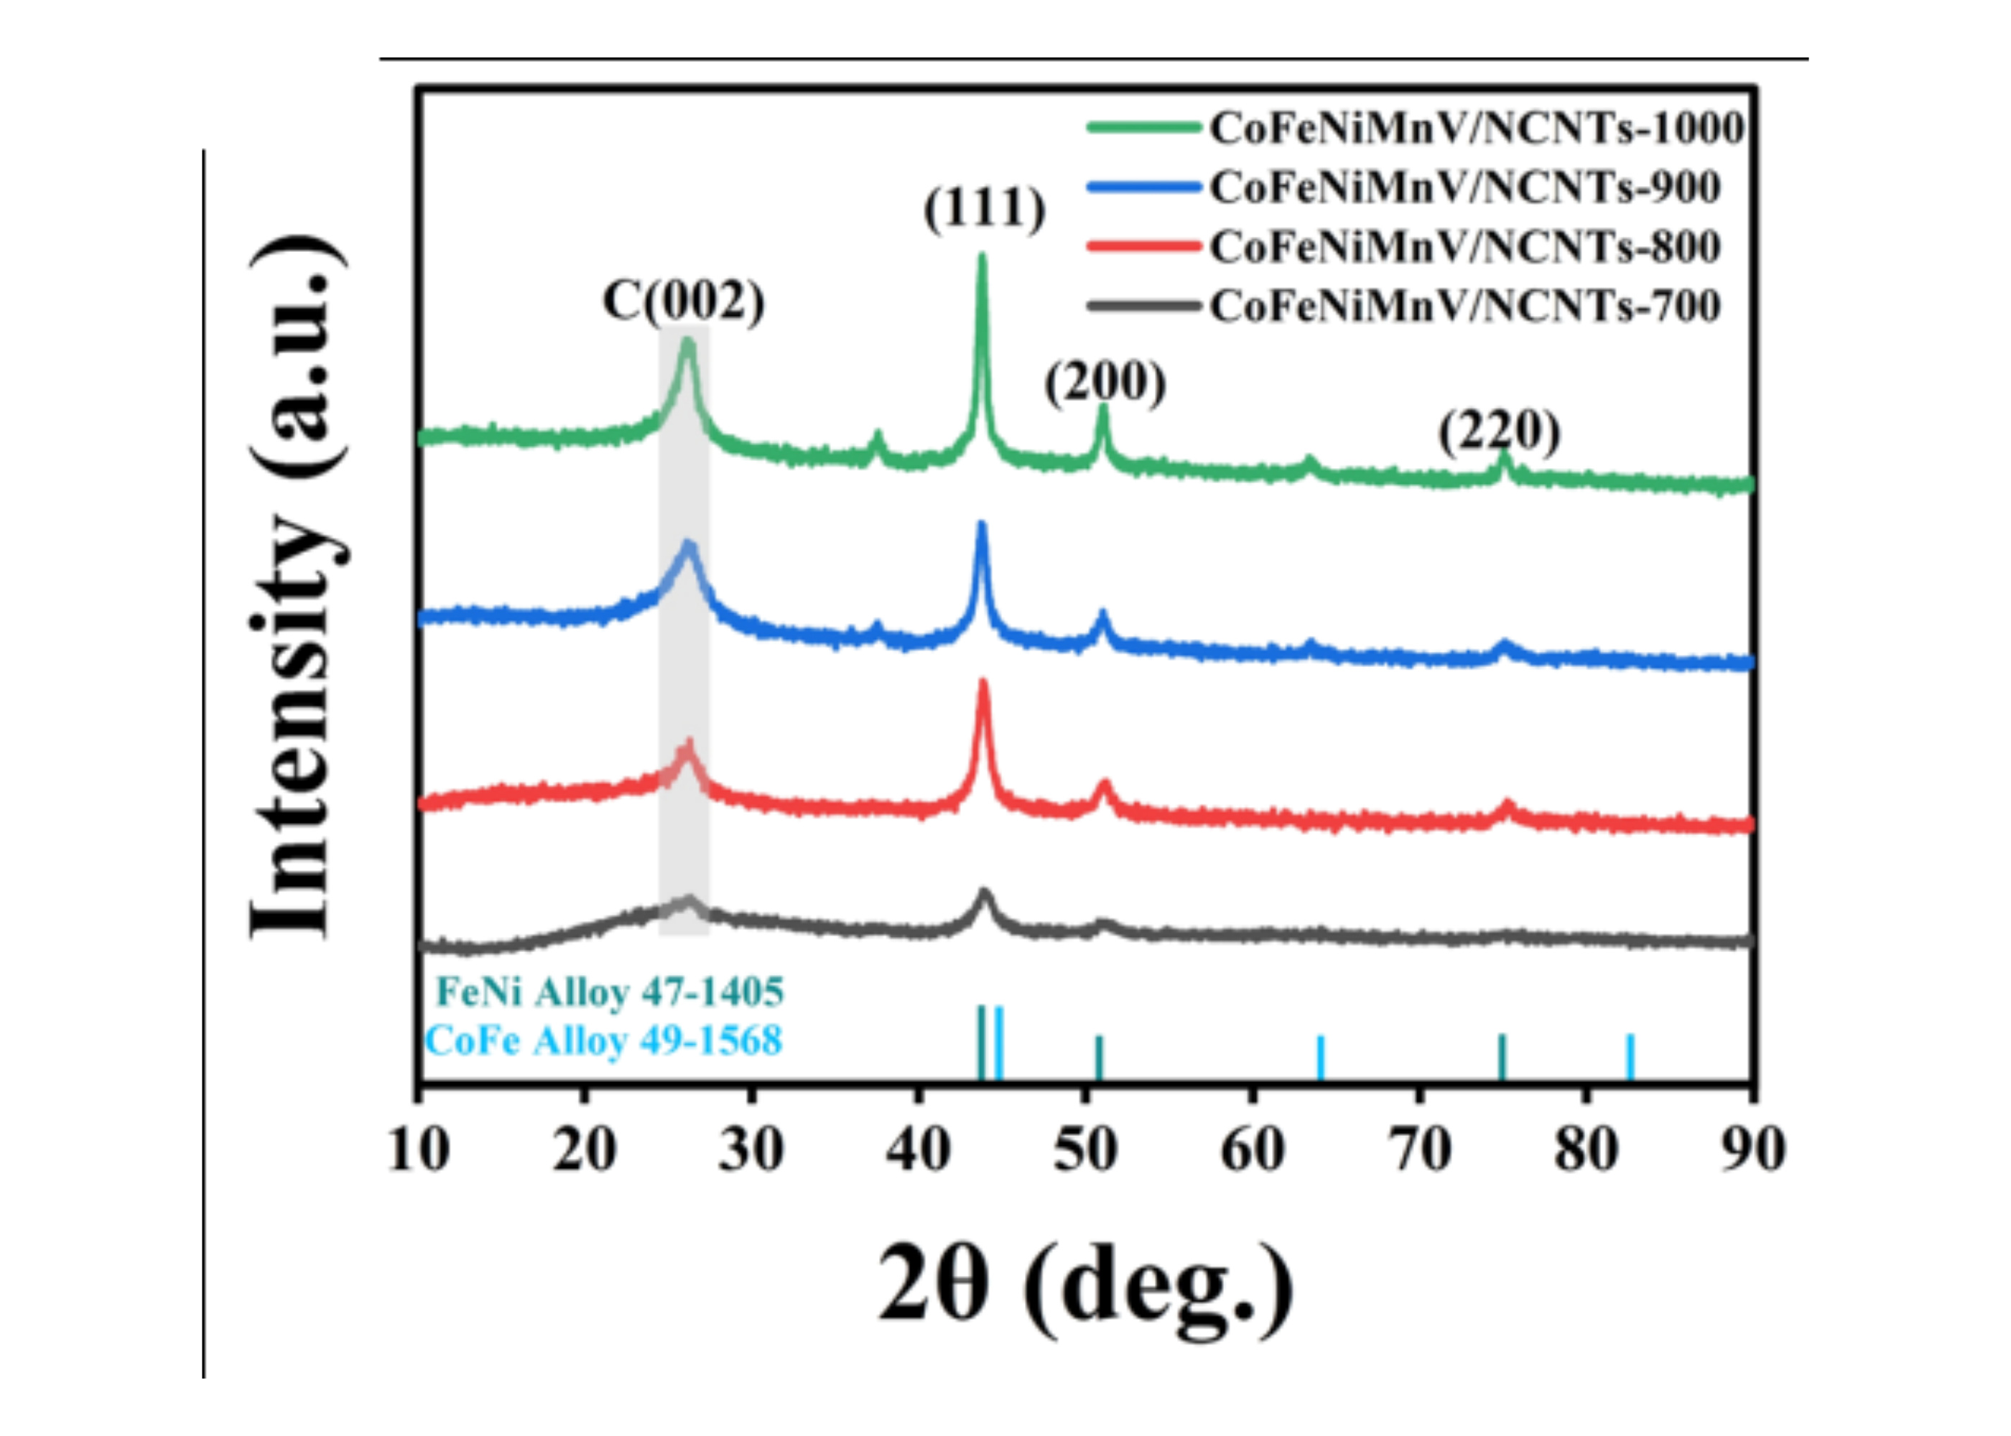
Figure S1. XRD patterns of CoFeNiMnV/NCNTs prepared at 700, 800, 900 and 1000 °C. Reference characterization, not a new measurement of the PDMS composite.
Source: Hassan thesis, Figure 6-1a, printed p. 131, PDF p. 142.
Reproduced reference characterization from [1]. Retain attribution and verify permission or the applicable reuse terms before journal publication.

Figure S2
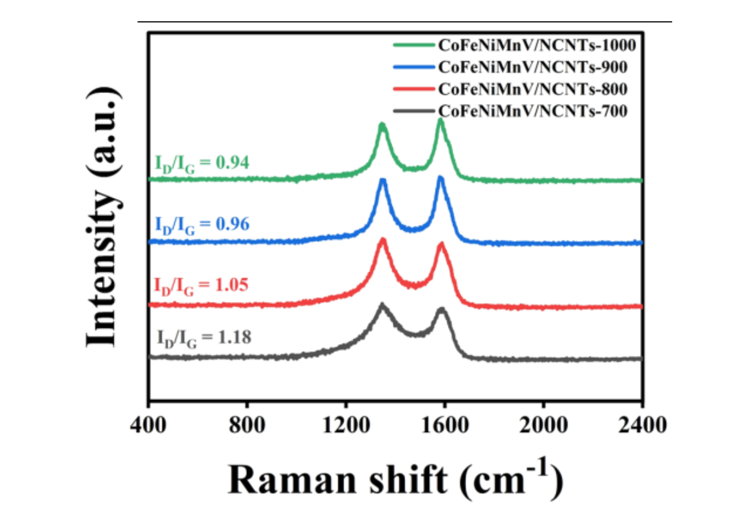
Figure S2. Raman spectra of the same reference series. The source reports I_D/I_G values of 1.18, 1.05, 0.96 and 0.94 for 700, 800, 900 and 1000 °C, respectively.
Source: Hassan thesis, Figure 6-1b, printed p. 131, PDF p. 142.
Reproduced reference characterization from [1]. Retain attribution and verify permission or the applicable reuse terms before journal publication.

Figure S3
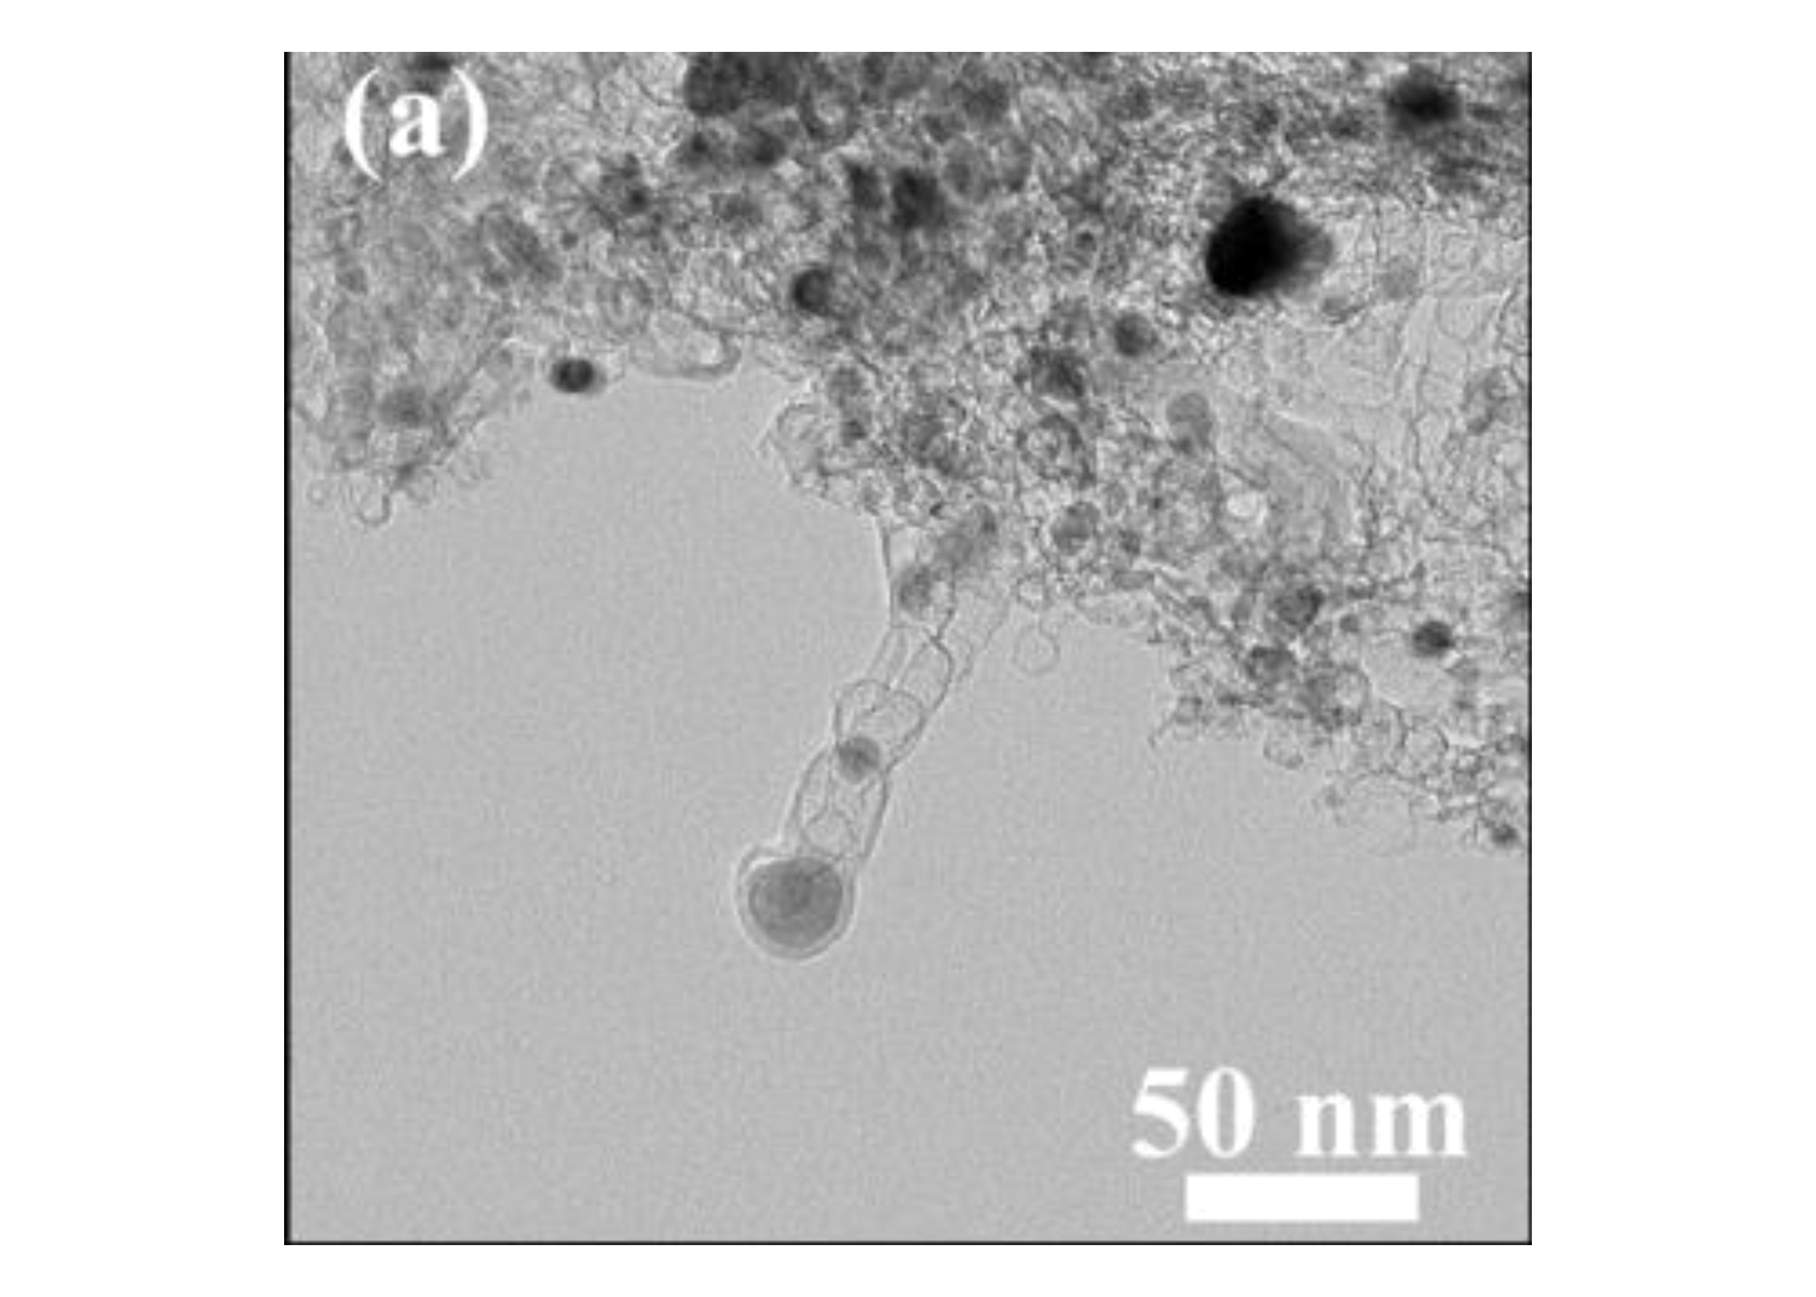
Figure S3. Reference CoFeNiMnV/NCNTs-800 nanocomposite. TEM overview with the original 50 nm scale bar. This is cited precursor characterization.
Source: Hassan thesis, Figure 6-3a, printed p. 133, PDF p. 144.
Reproduced reference characterization from [1]. Retain attribution and verify permission or the applicable reuse terms before journal publication.

Figure S4
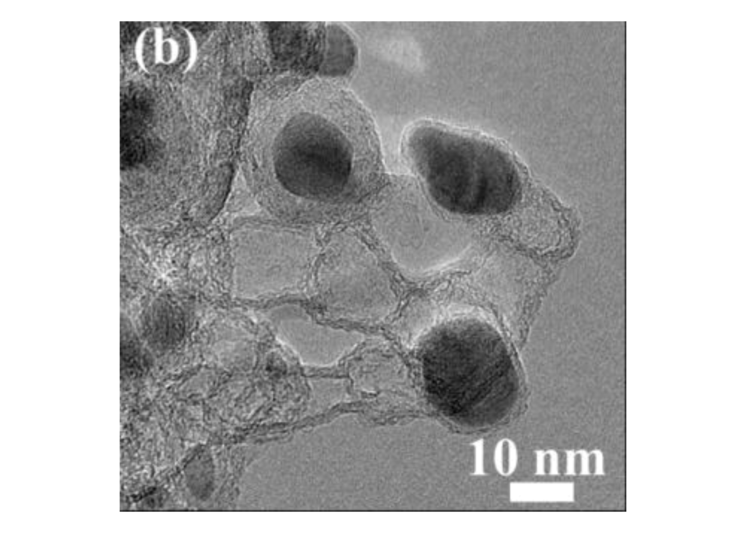
Figure S4. Reference CoFeNiMnV/NCNTs-800 nanocomposite. Higher-magnification TEM image with the original 10 nm scale bar. This is cited precursor characterization.
Source: Hassan thesis, Figure 6-3b, printed p. 133, PDF p. 144.
Reproduced reference characterization from [1]. Retain attribution and verify permission or the applicable reuse terms before journal publication.

Figure S5
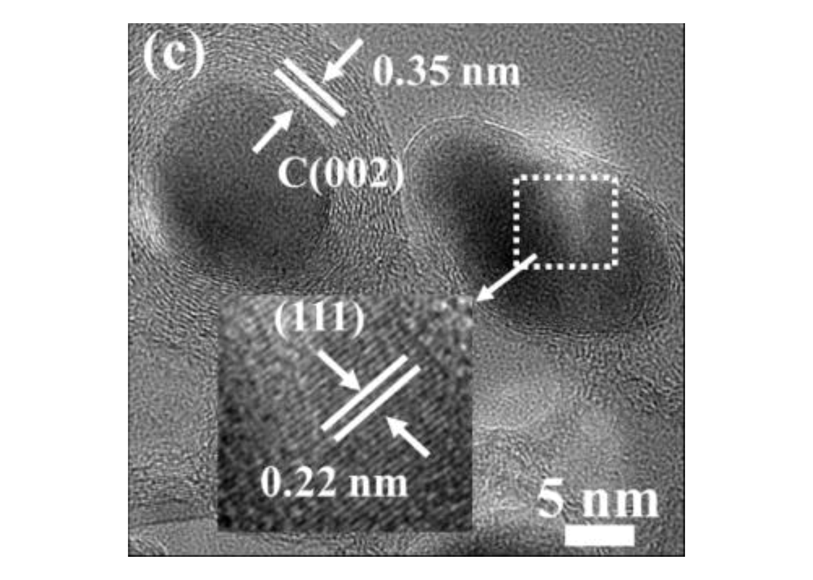
Figure S5. Reference CoFeNiMnV/NCNTs-800 nanocomposite. HRTEM image with source annotations of approximately 0.35 nm carbon-layer spacing and 0.22 nm alloy-lattice spacing. The original 5 nm inset scale bar is retained. This is cited precursor characterization.
Source: Hassan thesis, Figure 6-3c, printed p. 133, PDF p. 144.
Reproduced reference characterization from [1]. Retain attribution and verify permission or the applicable reuse terms before journal publication.

Figure S6
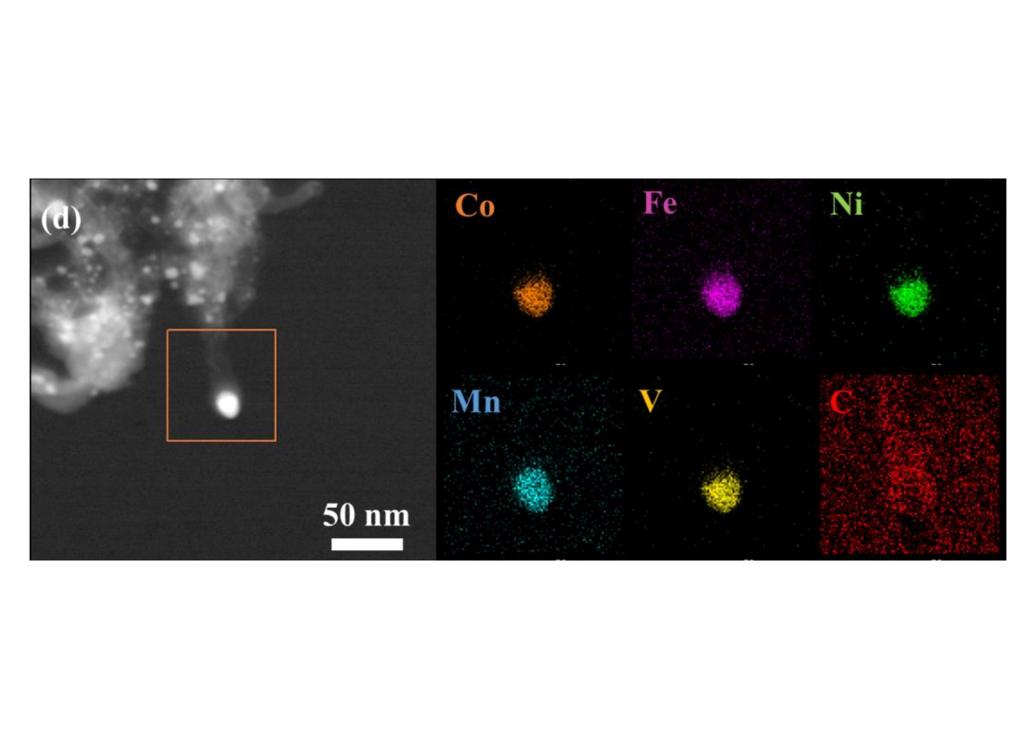
Figure S6. Reference CoFeNiMnV/NCNTs-800 nanocomposite. HAADF-STEM and elemental maps of Co, Fe, Ni, Mn, V and C. The original 50 nm HAADF scale bar is retained; no new scale is assigned to the individual maps. This is cited precursor characterization.
Source: Hassan thesis, Figure 6-3d, printed p. 133, PDF p. 144.
Reproduced reference characterization from [1]. Retain attribution and verify permission or the applicable reuse terms before journal publication.

Figure S7
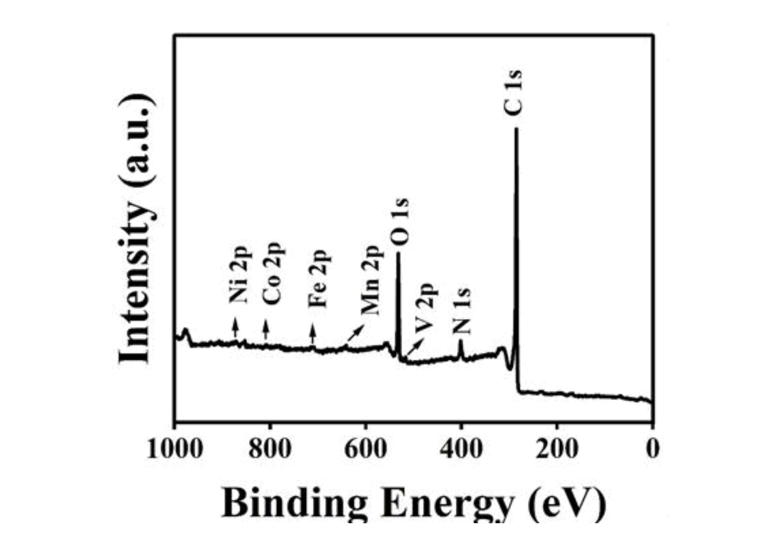
Figure S7. Reference Survey XPS spectrum of CoFeNiMnV/NCNTs-800. Original traces, fits and peak labels are retained; this spectrum is not assigned to the present PDMS foam.
Source: Hassan thesis, Figure 6-4a, printed p. 134, PDF p. 145.
Reproduced reference characterization from [1]. Retain attribution and verify permission or the applicable reuse terms before journal publication.

Figure S8
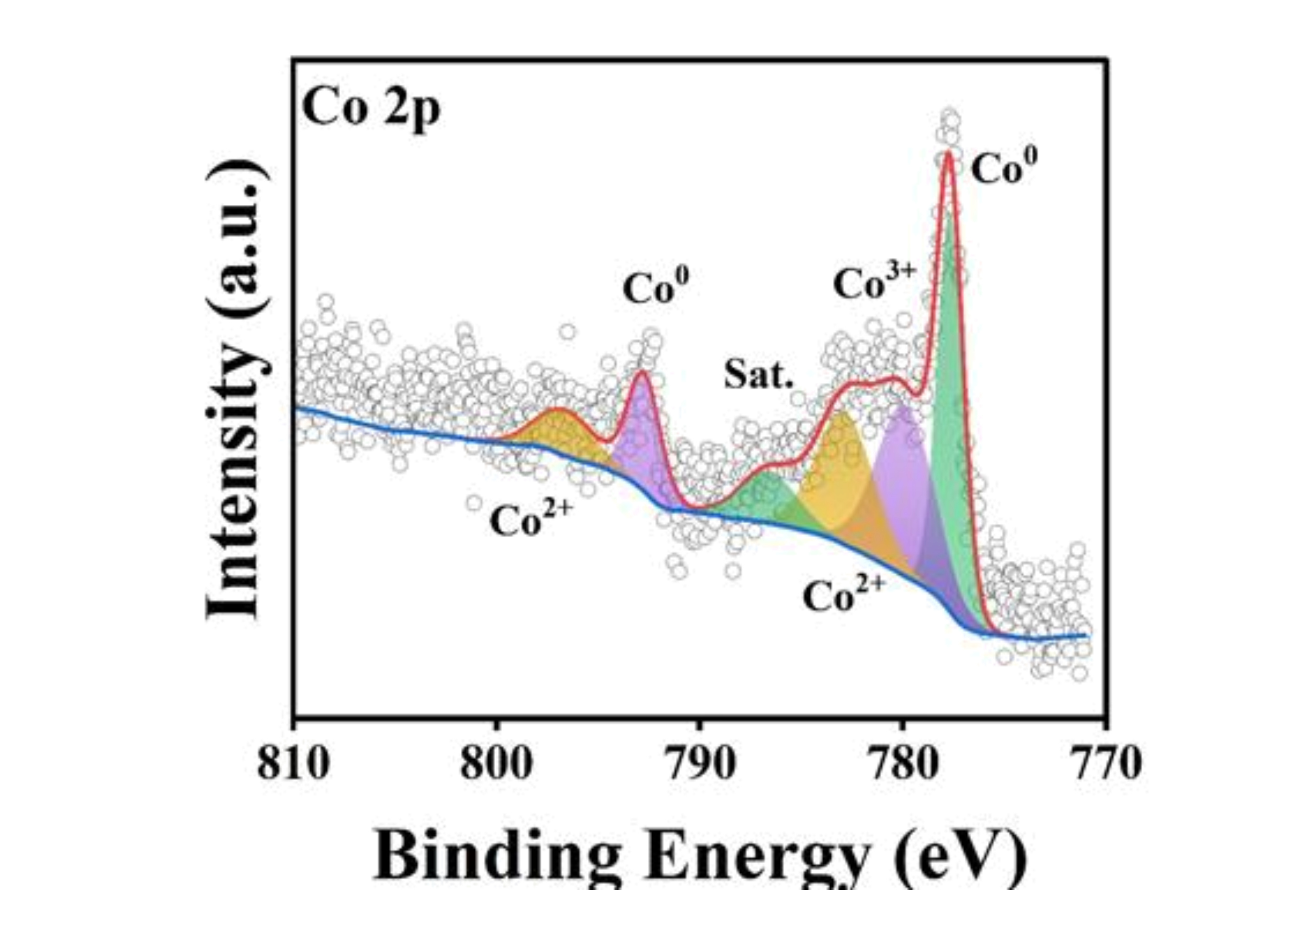
Figure S8. Reference Co 2p XPS spectrum of CoFeNiMnV/NCNTs-800. Original traces, fits and peak labels are retained; this spectrum is not assigned to the present PDMS foam.
Source: Hassan thesis, Figure 6-4b, printed p. 134, PDF p. 145.
Reproduced reference characterization from [1]. Retain attribution and verify permission or the applicable reuse terms before journal publication.

Figure S9
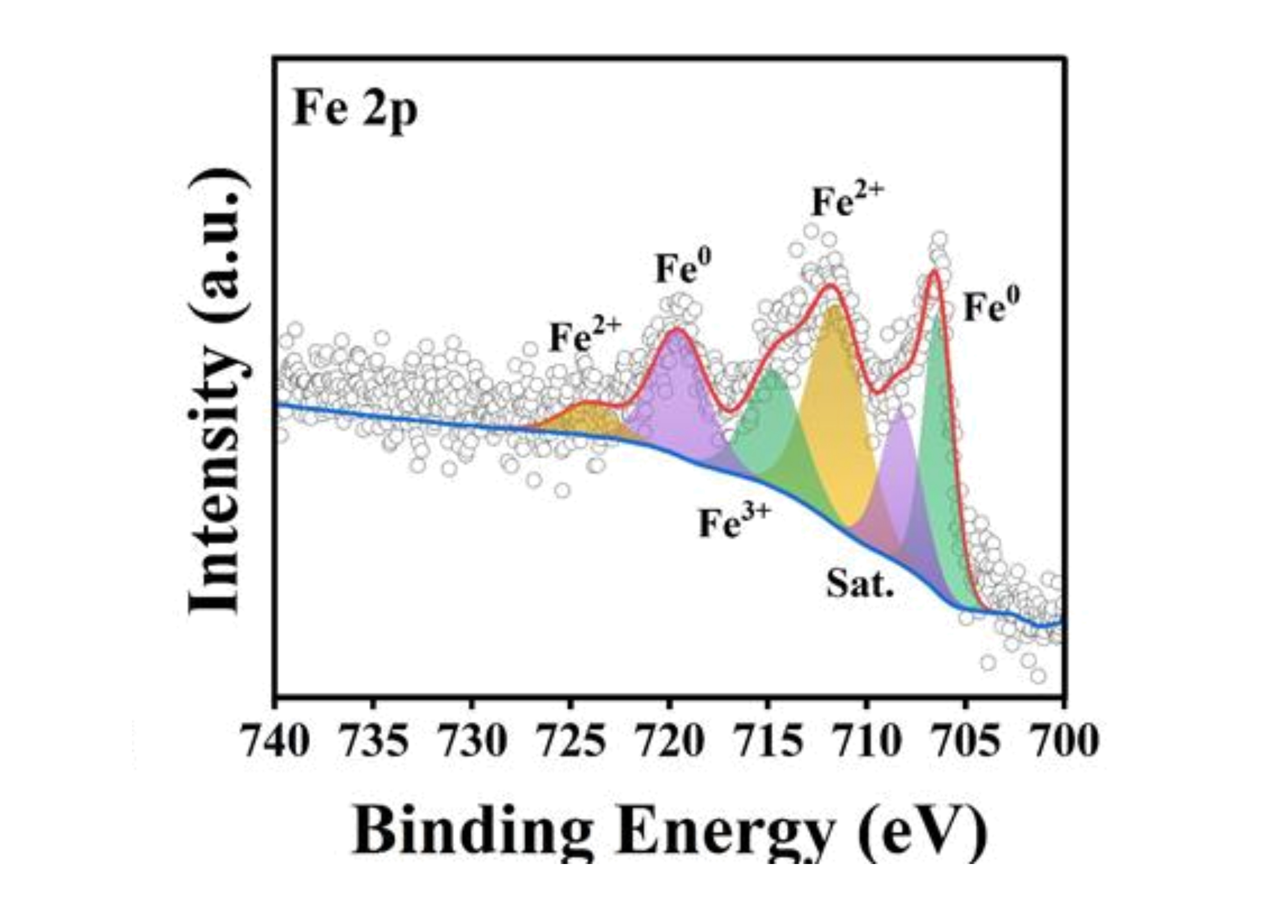
Figure S9. Reference Fe 2p XPS spectrum of CoFeNiMnV/NCNTs-800. Original traces, fits and peak labels are retained; this spectrum is not assigned to the present PDMS foam.
Source: Hassan thesis, Figure 6-4c, printed p. 134, PDF p. 145.
Reproduced reference characterization from [1]. Retain attribution and verify permission or the applicable reuse terms before journal publication.

Figure S10
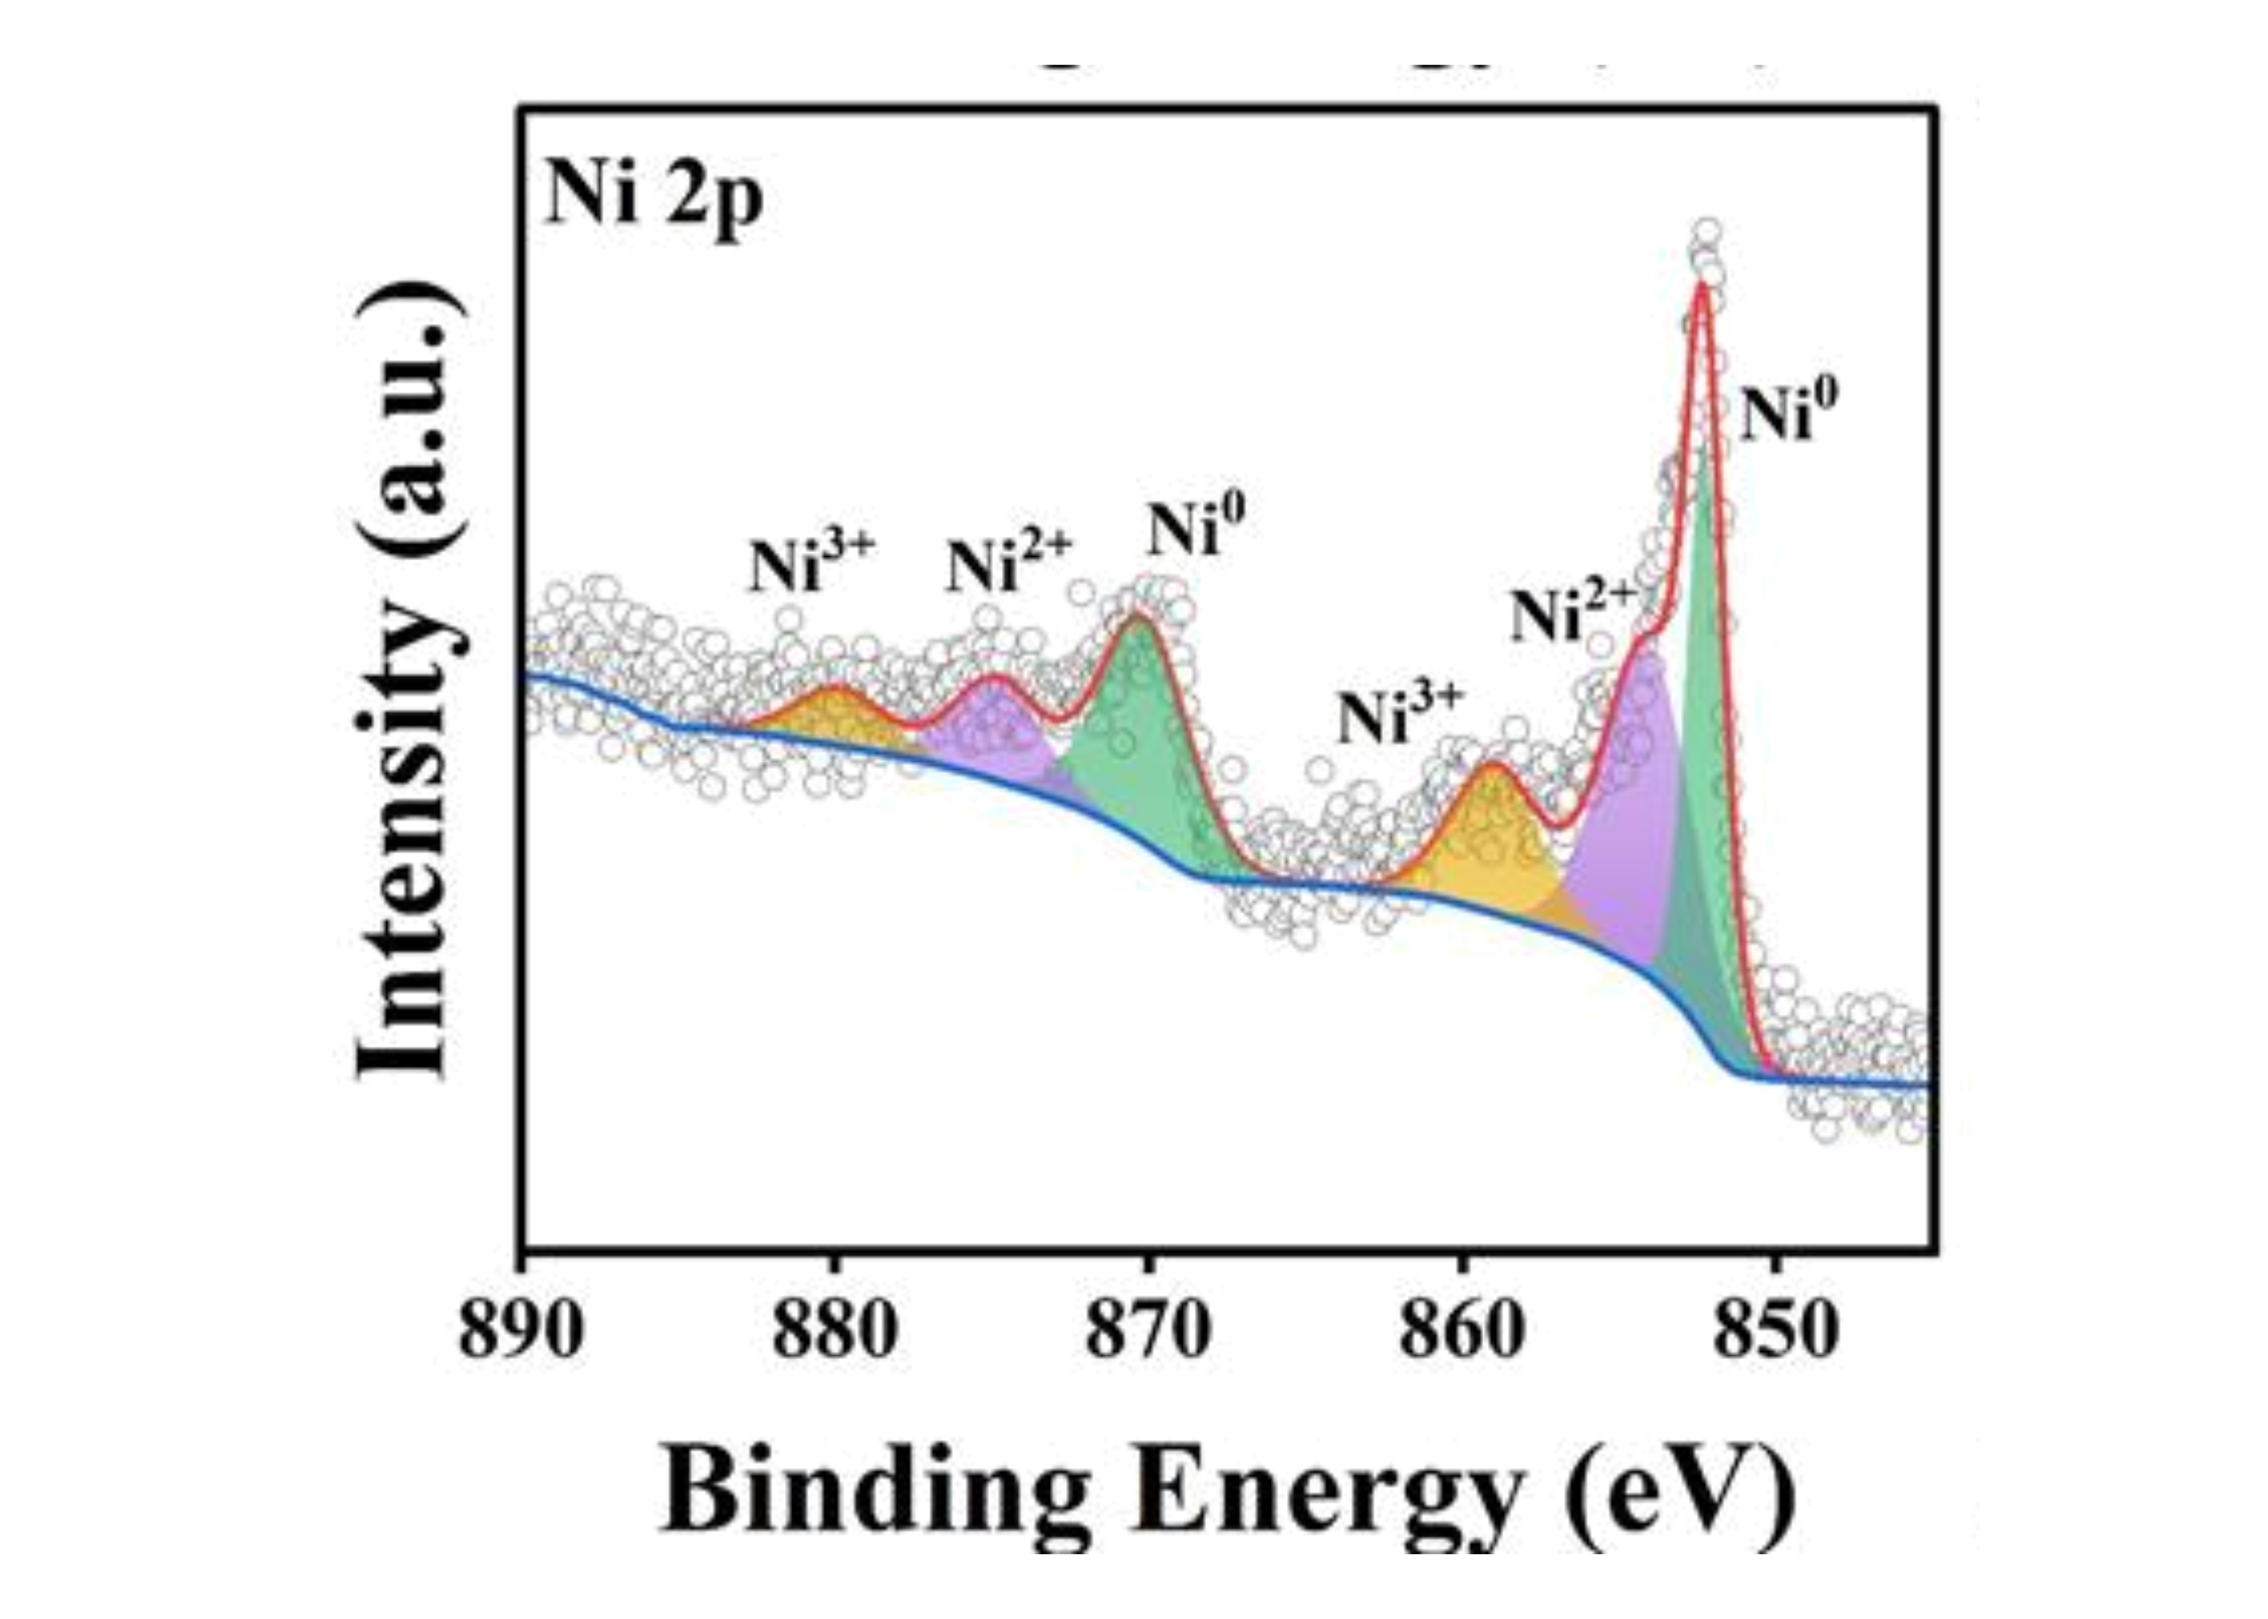
Figure S10. Reference Ni 2p XPS spectrum of CoFeNiMnV/NCNTs-800. Original traces, fits and peak labels are retained; this spectrum is not assigned to the present PDMS foam.
Source: Hassan thesis, Figure 6-4d, printed p. 134, PDF p. 145.
Reproduced reference characterization from [1]. Retain attribution and verify permission or the applicable reuse terms before journal publication.

Figure S11
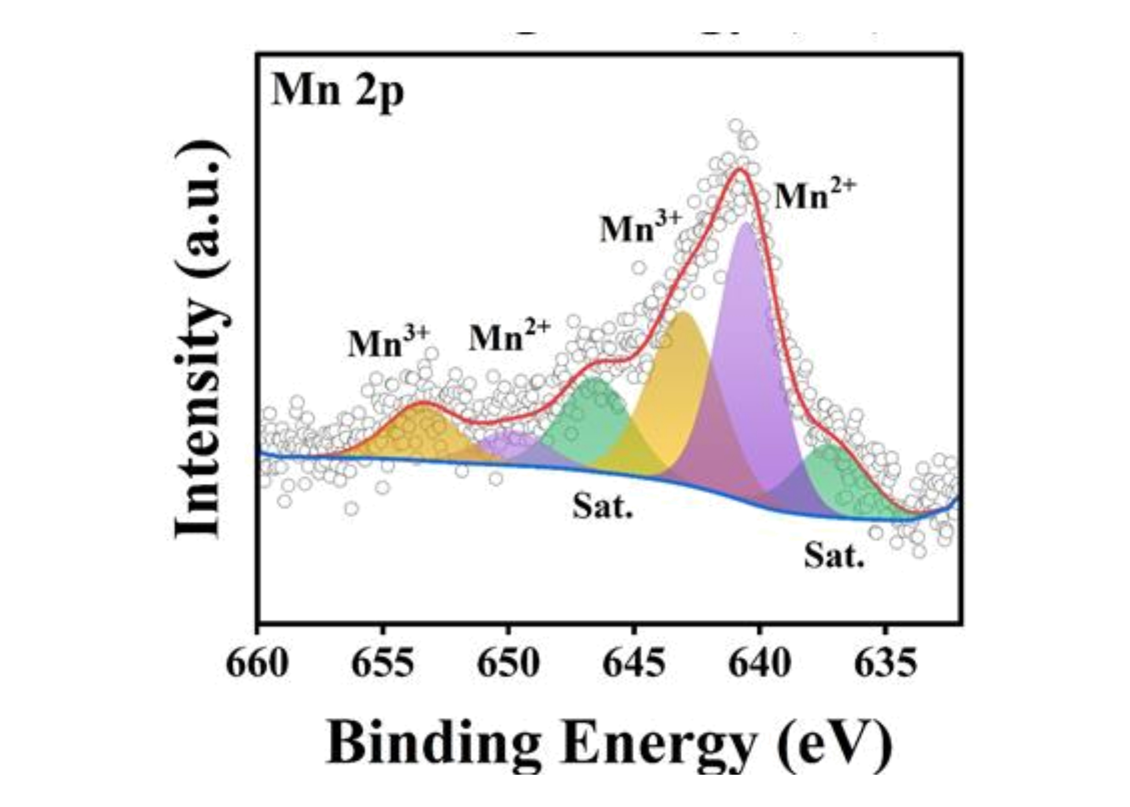
Figure S11. Reference Mn 2p XPS spectrum of CoFeNiMnV/NCNTs-800. Original traces, fits and peak labels are retained; this spectrum is not assigned to the present PDMS foam.
Source: Hassan thesis, Figure 6-4e, printed p. 134, PDF p. 145.
Reproduced reference characterization from [1]. Retain attribution and verify permission or the applicable reuse terms before journal publication.

Figure S12
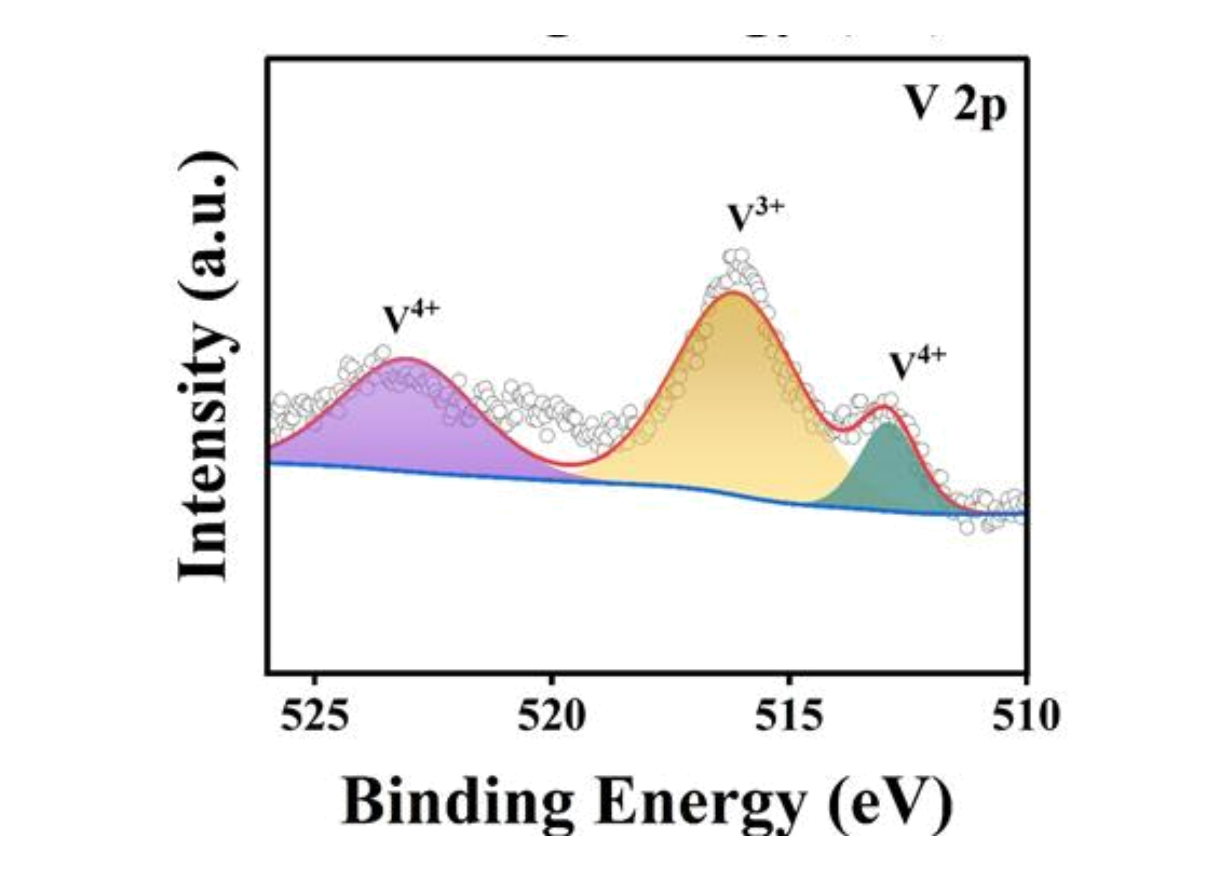
Figure S12. Reference V 2p XPS spectrum of CoFeNiMnV/NCNTs-800. Original traces, fits and peak labels are retained; this spectrum is not assigned to the present PDMS foam.
Source: Hassan thesis, Figure 6-4f, printed p. 134, PDF p. 145.
Reproduced reference characterization from [1]. Retain attribution and verify permission or the applicable reuse terms before journal publication.

Figure S13
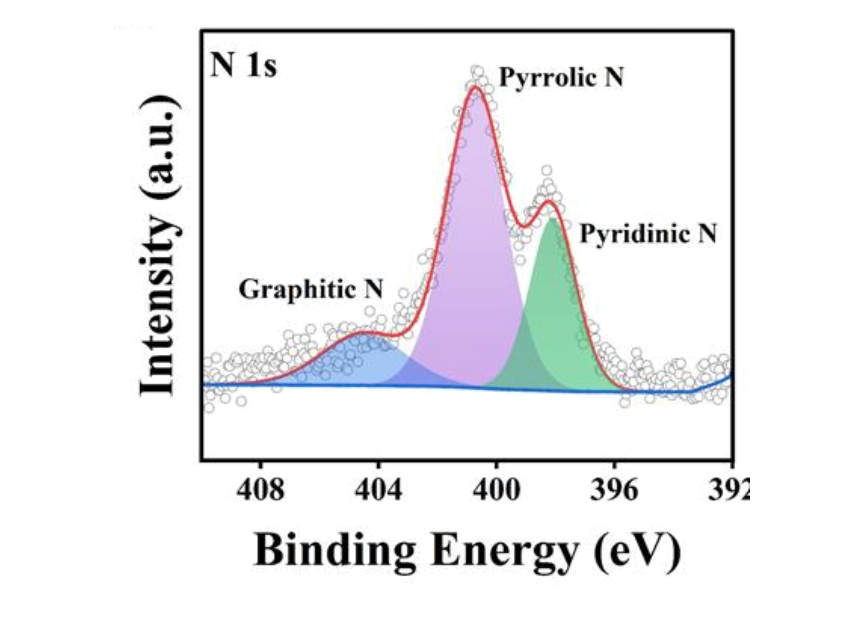
Figure S13. Reference N 1s XPS spectrum of CoFeNiMnV/NCNTs-800. Original traces, fits and peak labels are retained; this spectrum is not assigned to the present PDMS foam.
Source: Hassan thesis, Figure 6-4g, printed p. 134, PDF p. 145.
Reproduced reference characterization from [1]. Retain attribution and verify permission or the applicable reuse terms before journal publication.

Figure S14
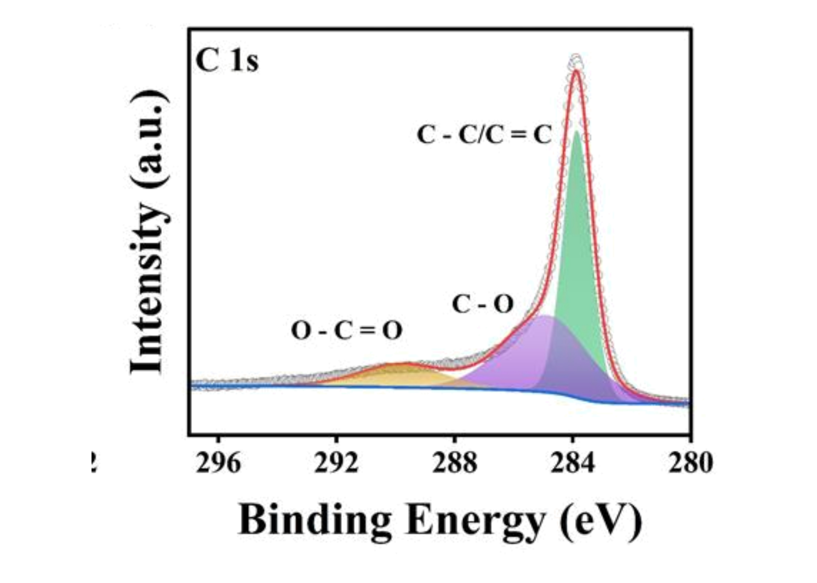
Figure S14. Reference C 1s XPS spectrum of CoFeNiMnV/NCNTs-800. Original traces, fits and peak labels are retained; this spectrum is not assigned to the present PDMS foam.
Source: Hassan thesis, Figure 6-4h, printed p. 134, PDF p. 145.
Reproduced reference characterization from [1]. Retain attribution and verify permission or the applicable reuse terms before journal publication.

Figure S15
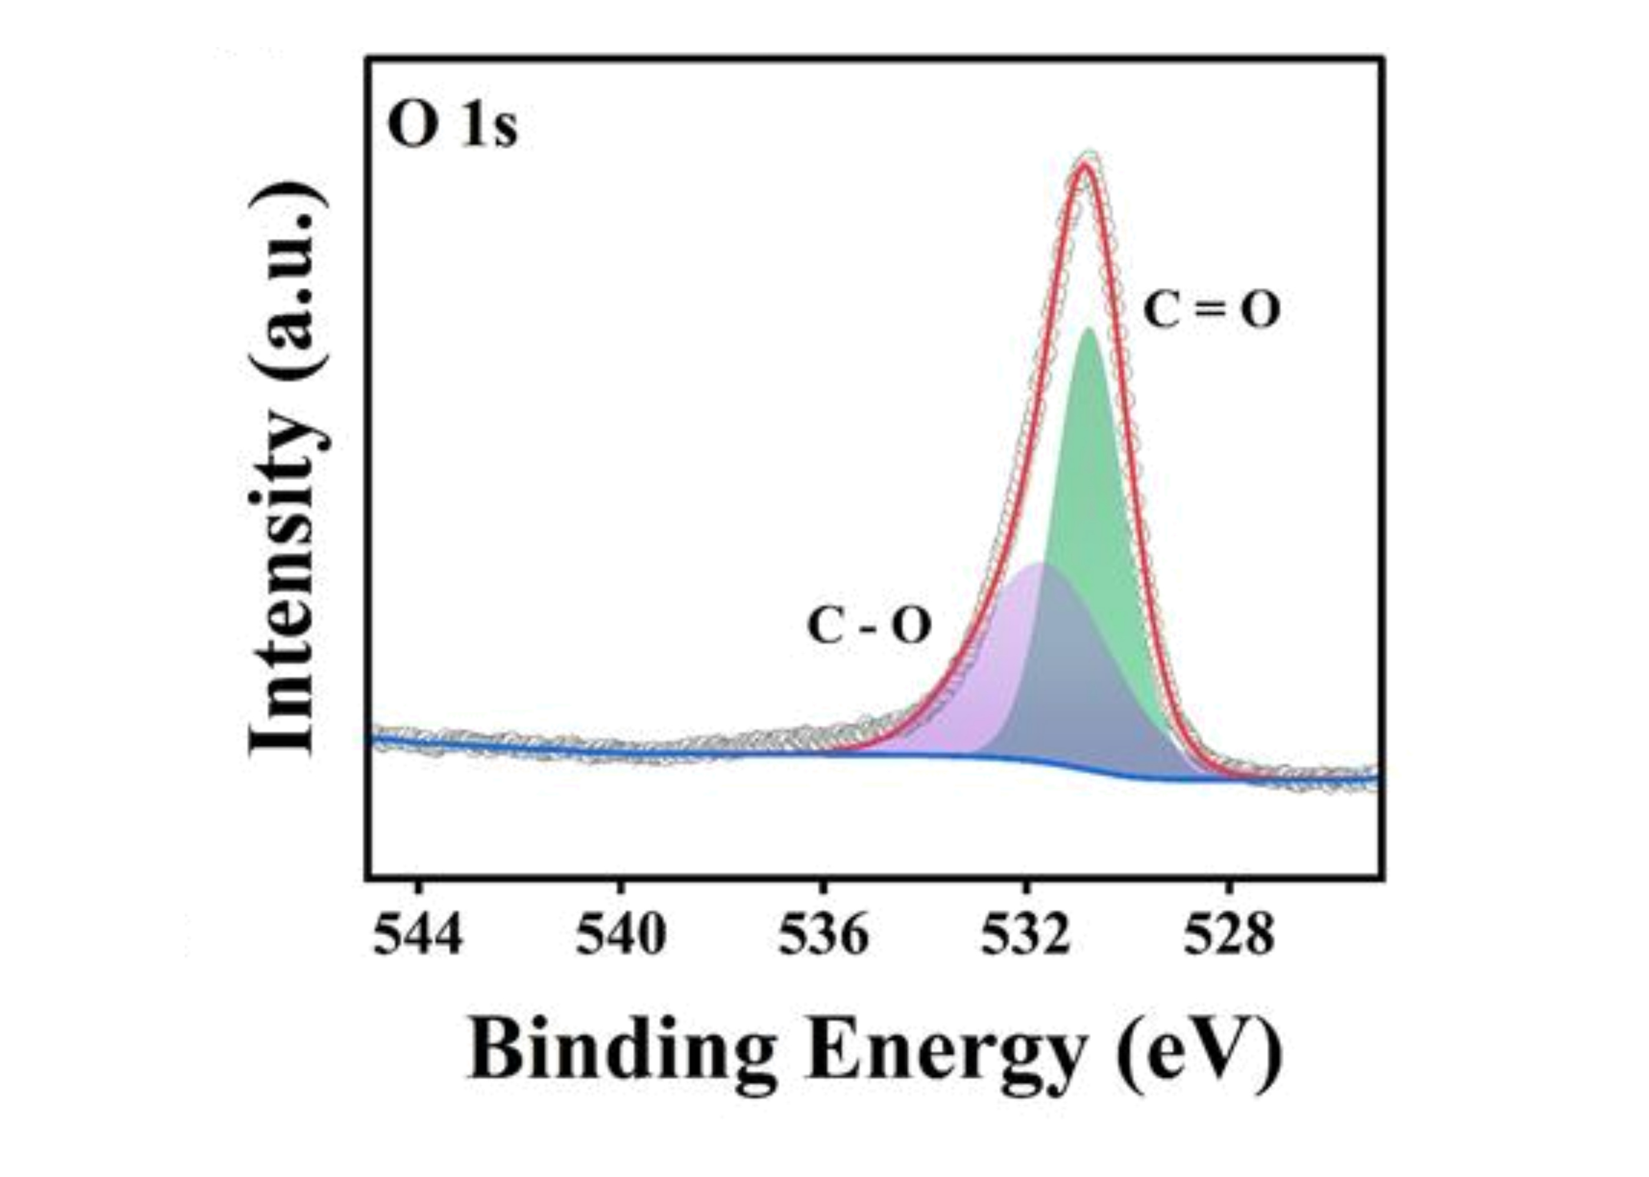
Figure S15. Reference O 1s XPS spectrum of CoFeNiMnV/NCNTs-800. Original traces, fits and peak labels are retained; this spectrum is not assigned to the present PDMS foam.
Source: Hassan thesis, Figure 6-4i, printed p. 134, PDF p. 145.
Reproduced reference characterization from [1]. Retain attribution and verify permission or the applicable reuse terms before journal publication.

Figure S16
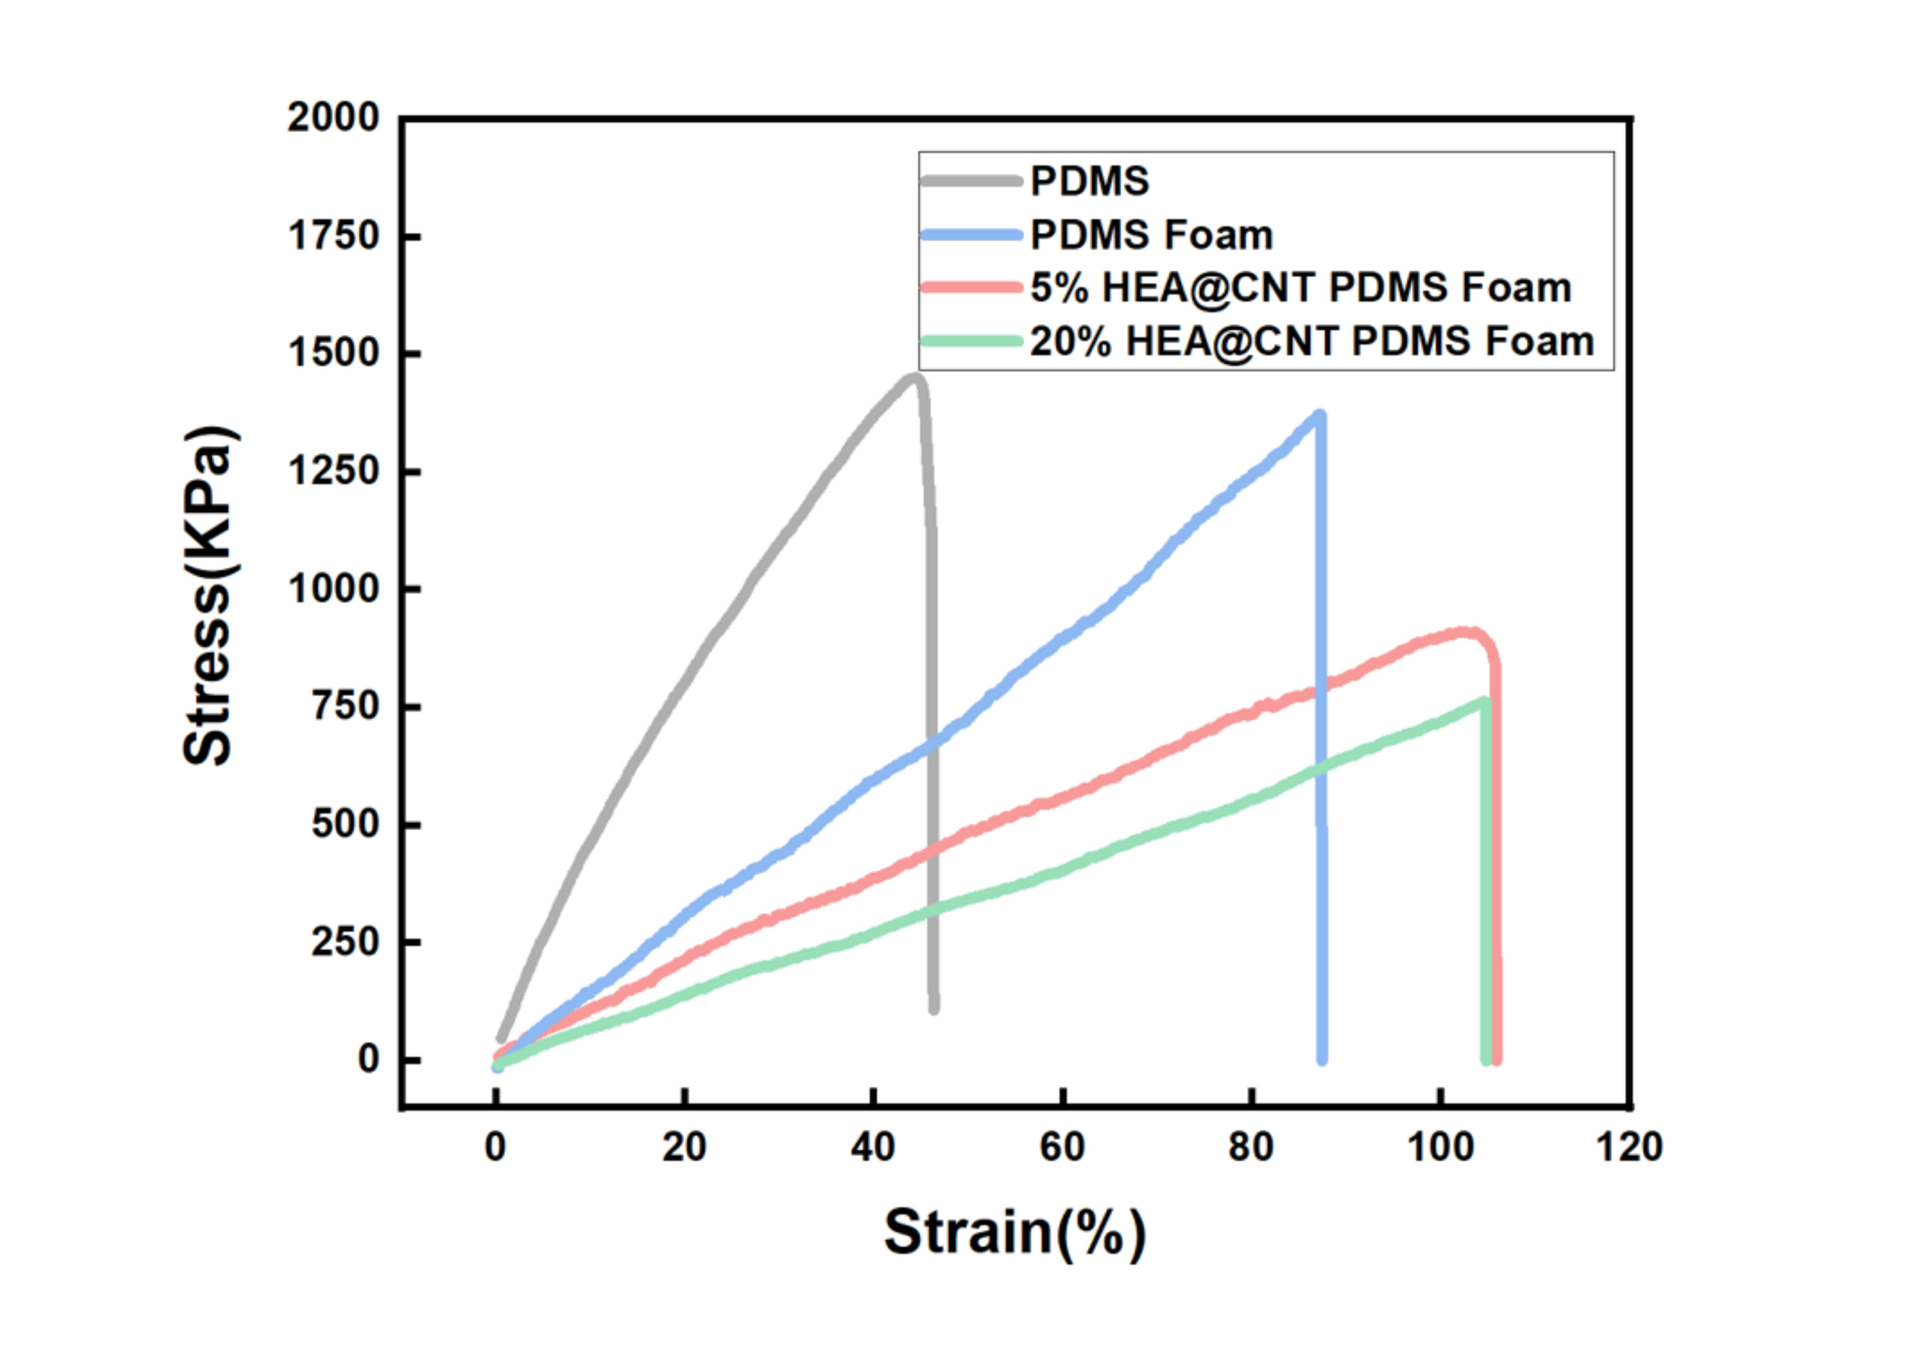
Figure S16. Compressive stress-strain curves of PDMS and functionalized foams. The source labels 5% and 20% HEA@CNTs loading, defined by the author as the mass percentage of HEA@CNTs in HEA@CNTs plus unmodified CNTs.
Source: Original Supporting Information, S1 panel a.

Figure S17
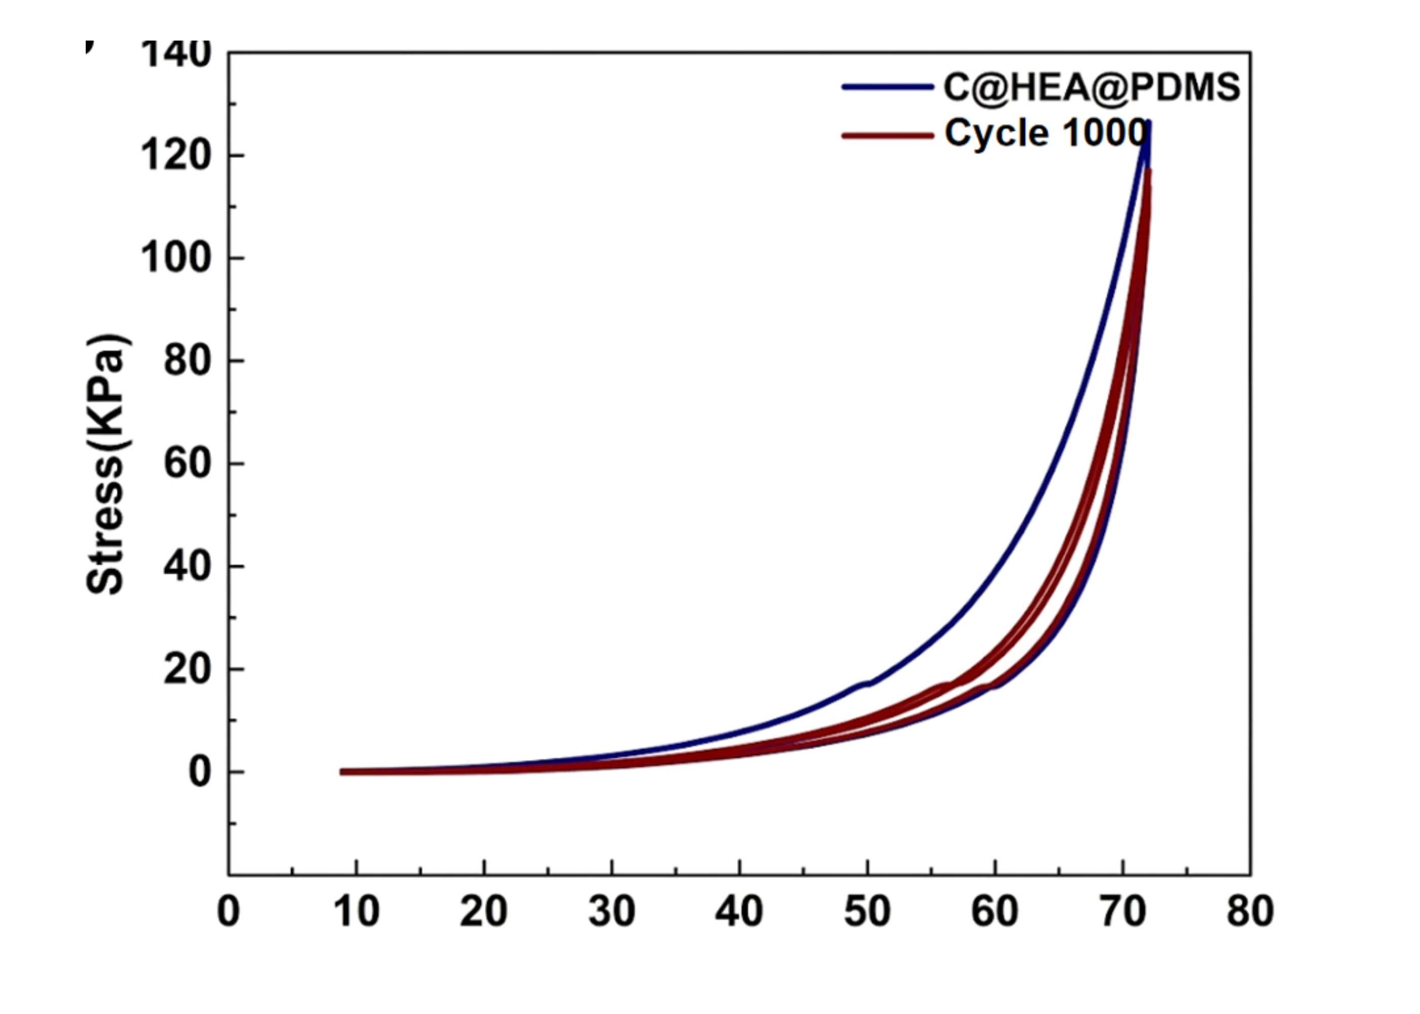
Figure S17. Cyclic compressive stress-strain response including the trace labelled Cycle 1000. The abscissa must be confirmed from the original dataset.
Source: Original Supporting Information, S1 panel b.

Figure S18
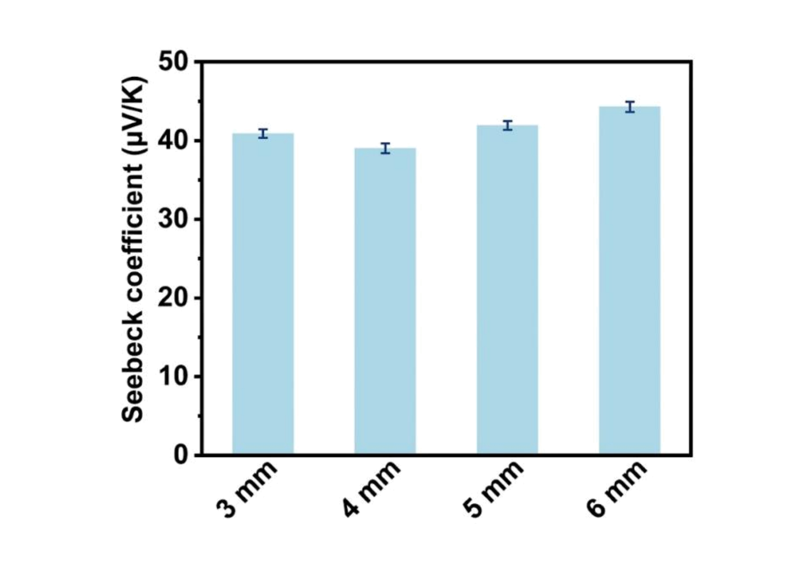
Figure S18. Seebeck coefficients at foam thicknesses of 3, 4, 5 and 6 mm. Error bars are retained as supplied; their definition and number of replicates need confirmation.
Source: Original Supporting Information, S2 panel a.

Figure S19
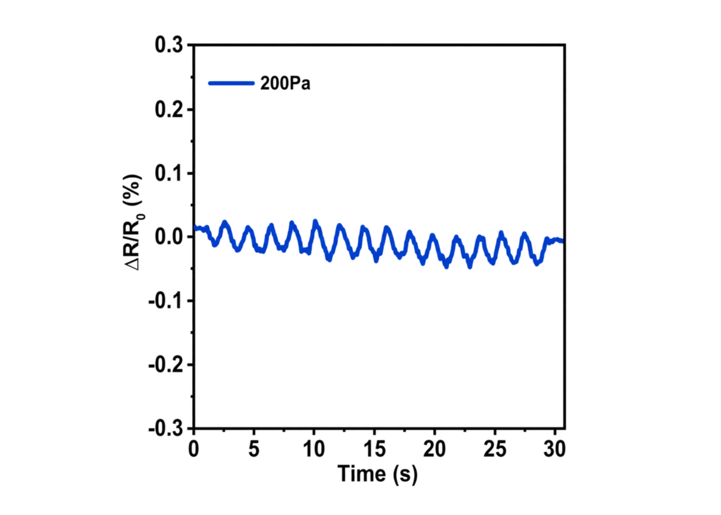
Figure S19. Resistance response under a periodic pressure of 200 Pa. This demonstrates detection at 200 Pa and does not establish a statistical detection limit.
Source: Original Supporting Information, S3 panel a.

Figure S20
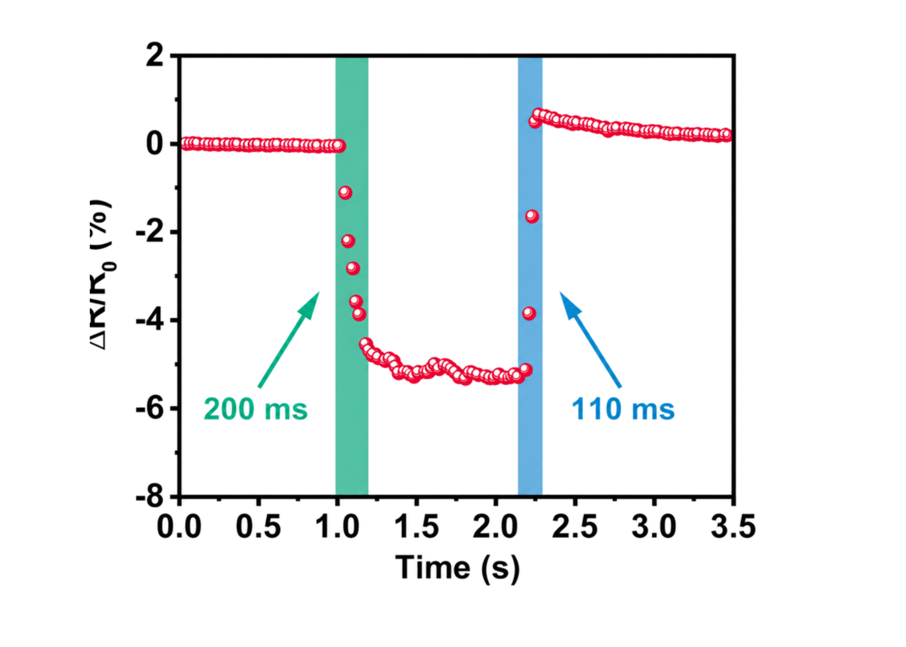
Figure S20. Transient loading and unloading response with source-labelled response and recovery times of approximately 200 and 110 ms. The response-time convention needs confirmation.
Source: Original Supporting Information, S3 panel b.

Figure S21
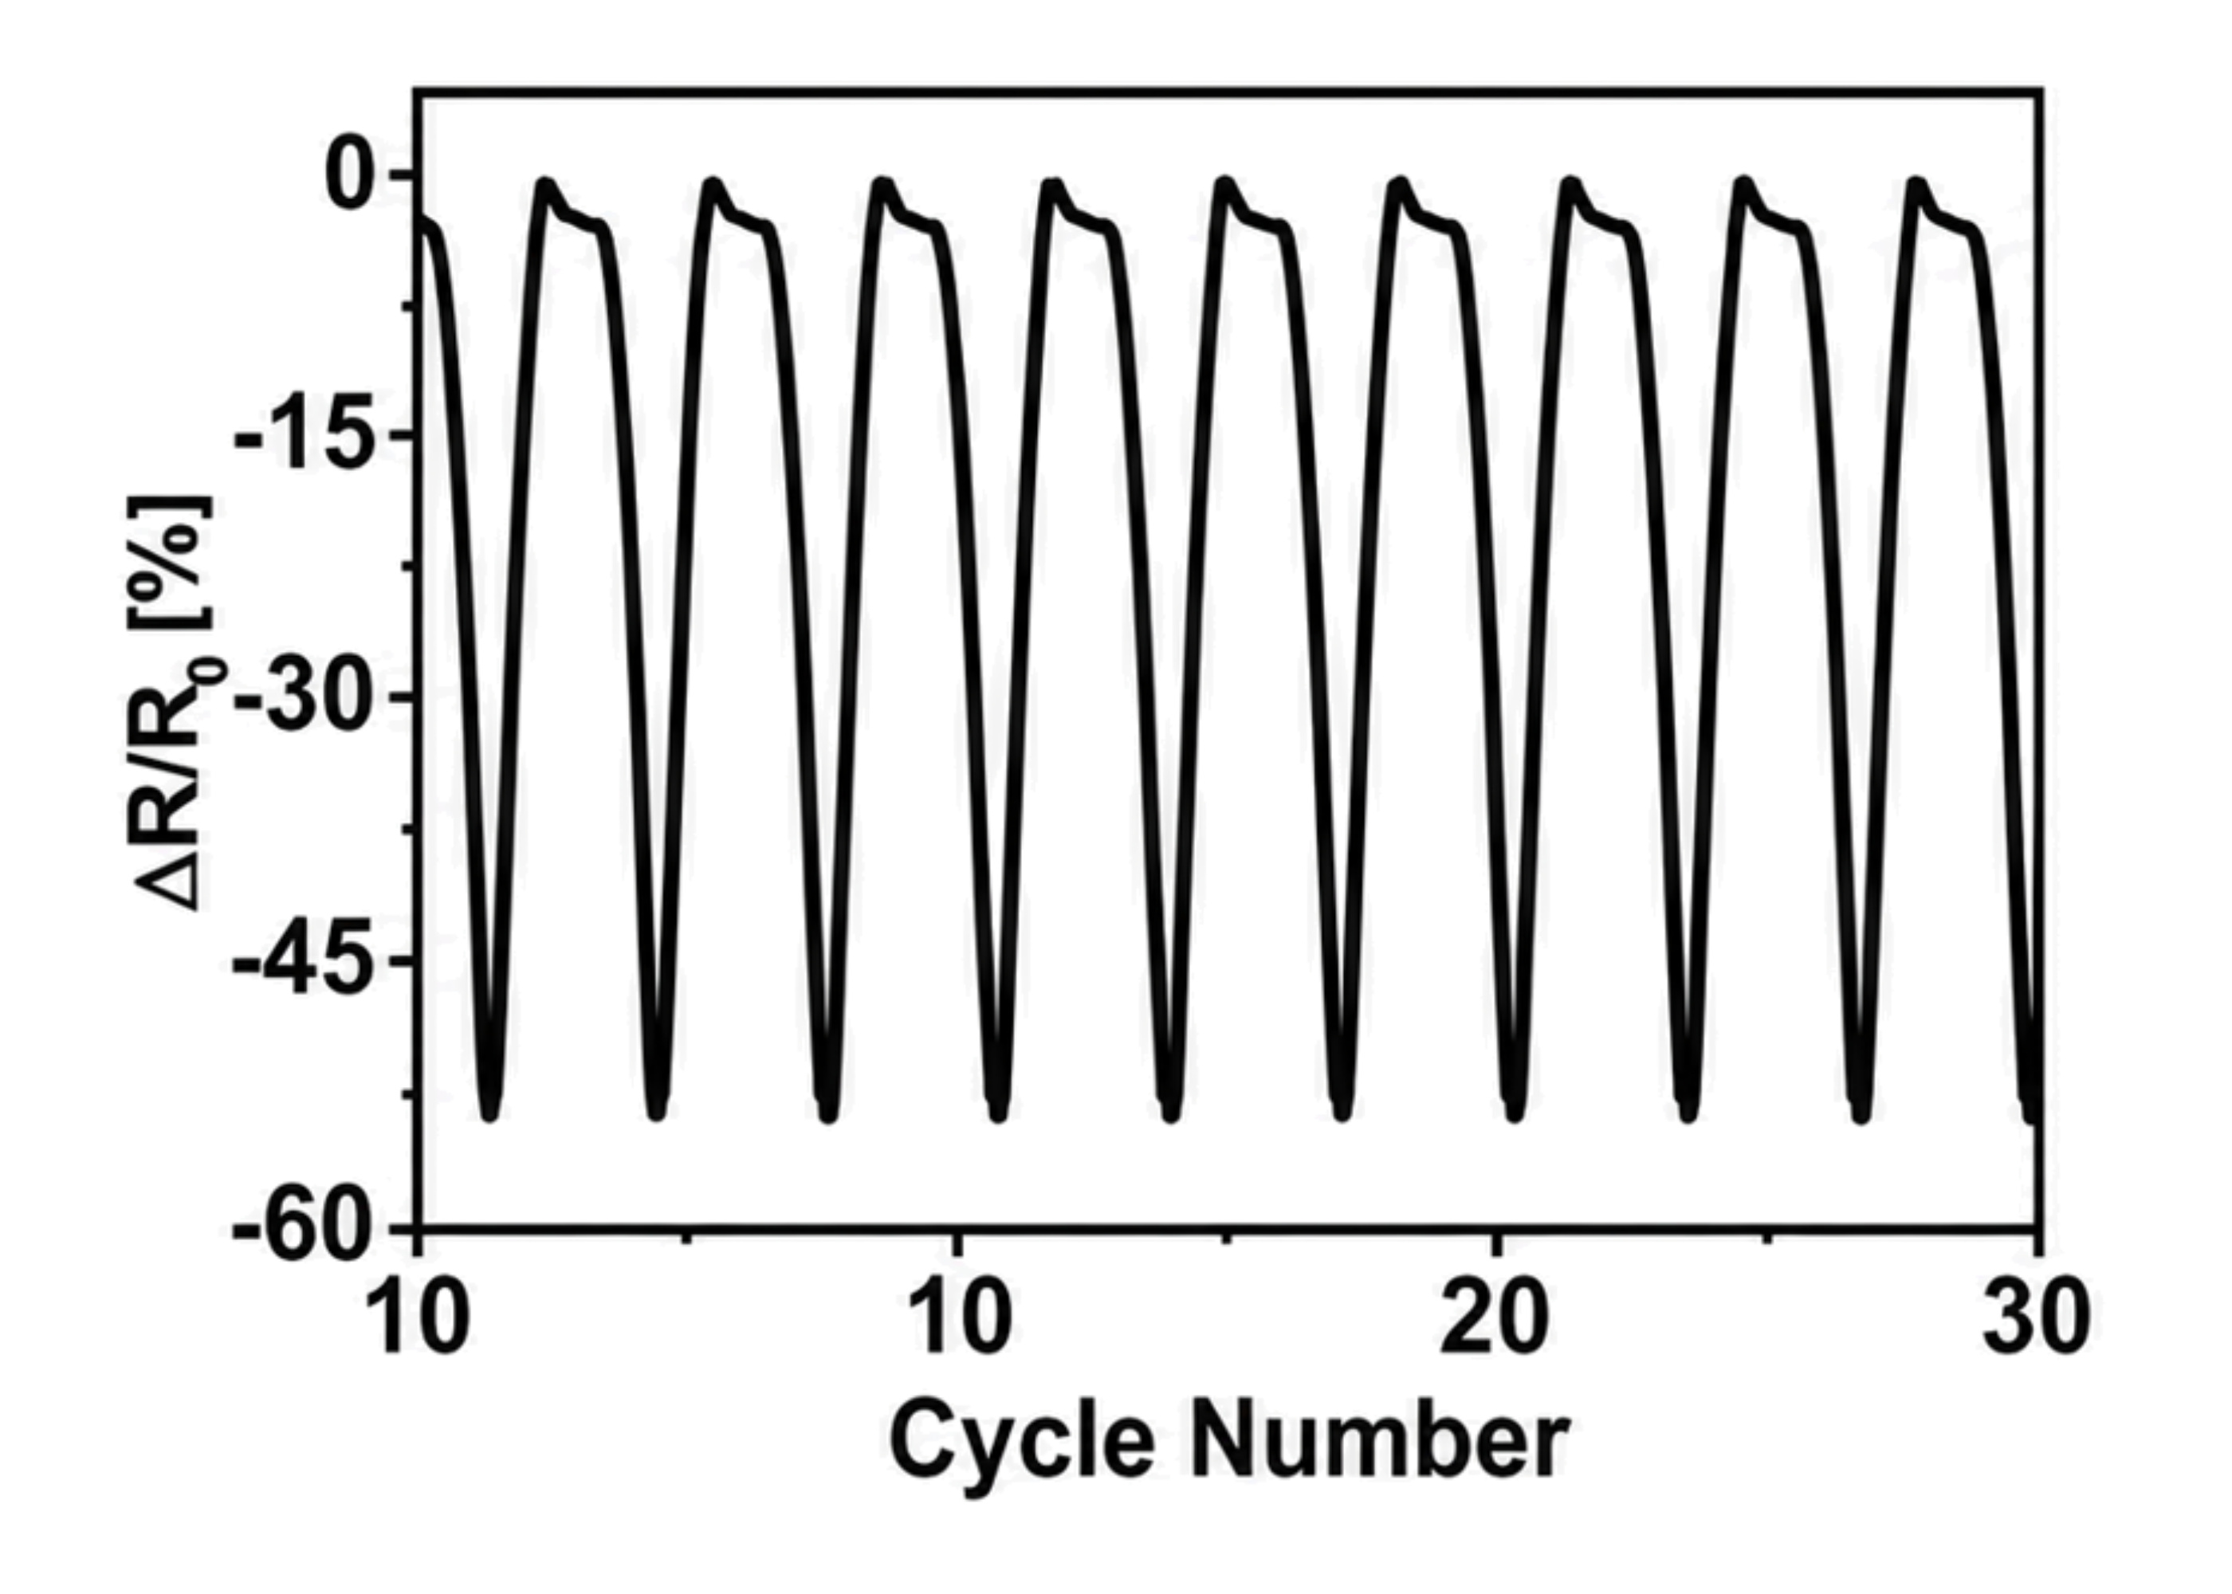
Figure S21. Pressure-response waveform near the beginning of the long-cycle test. Original cycle labels are retained; repeated tick labels require correction from the underlying data.
Source: Original Supporting Information, S4 panel a.

Figure S22
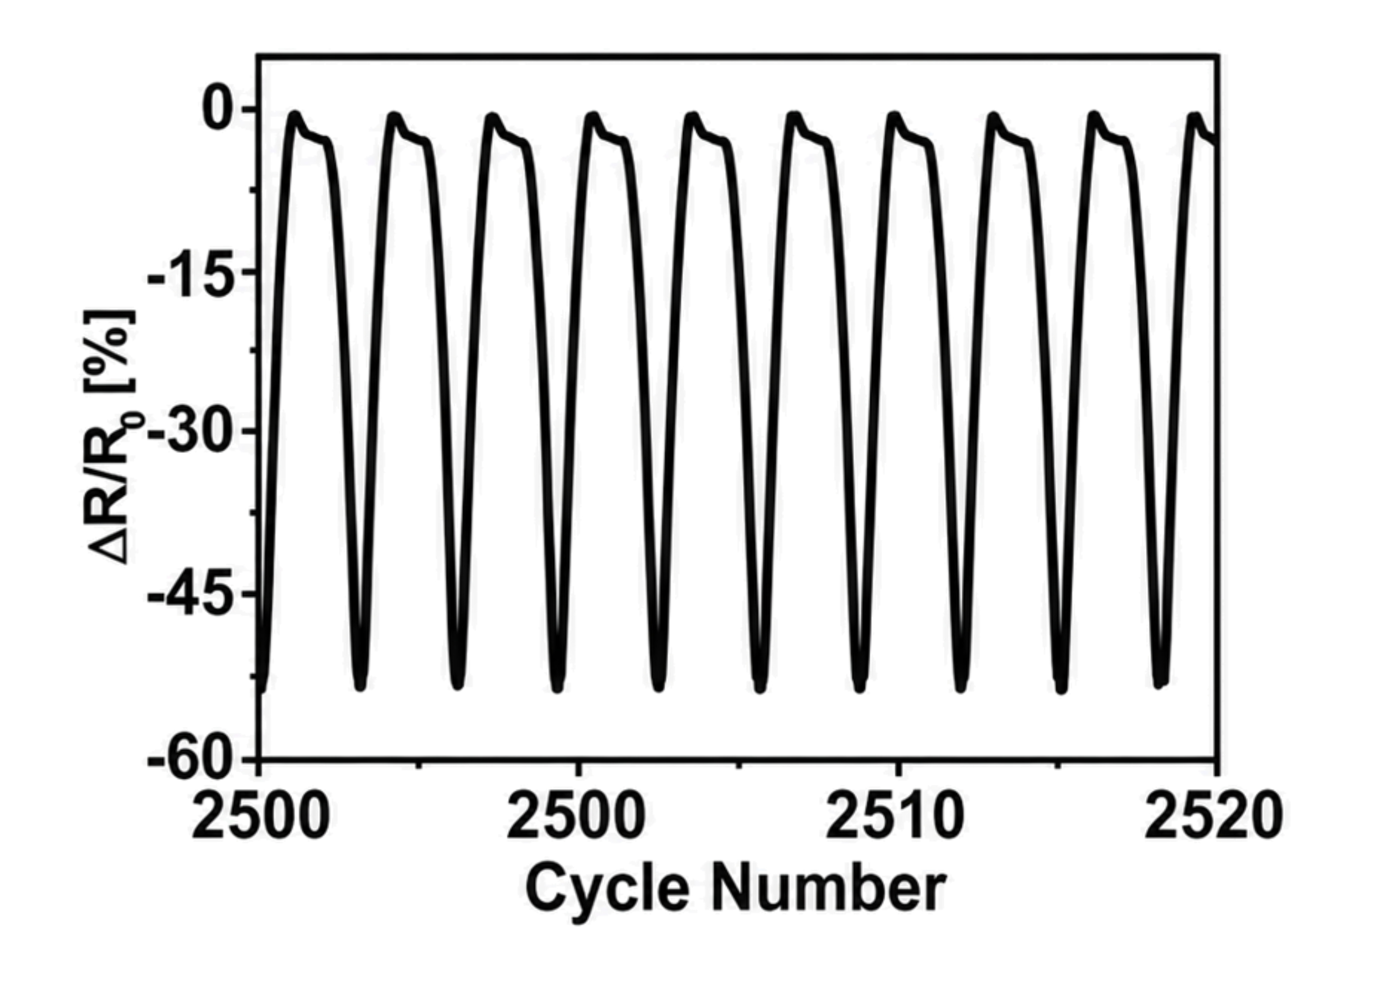
Figure S22. Pressure-response waveform around cycle 2500. Original cycle labels are retained; repeated tick labels require correction from the underlying data.
Source: Original Supporting Information, S4 panel b.

Figure S23
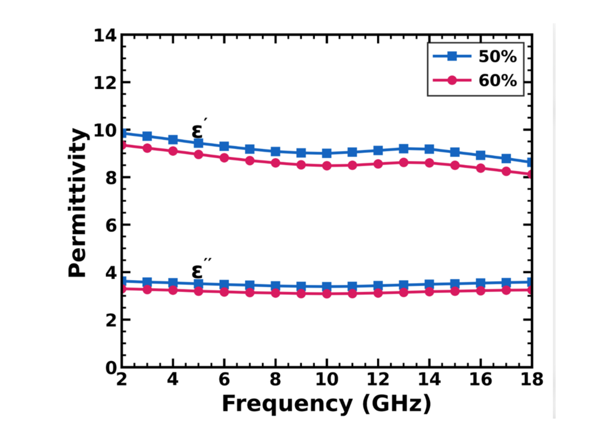
Figure S23. Real and imaginary permittivity at nominal compressive strains of 50% and 60%.
Source: Original Supporting Information, S5 panel a.

Figure S24
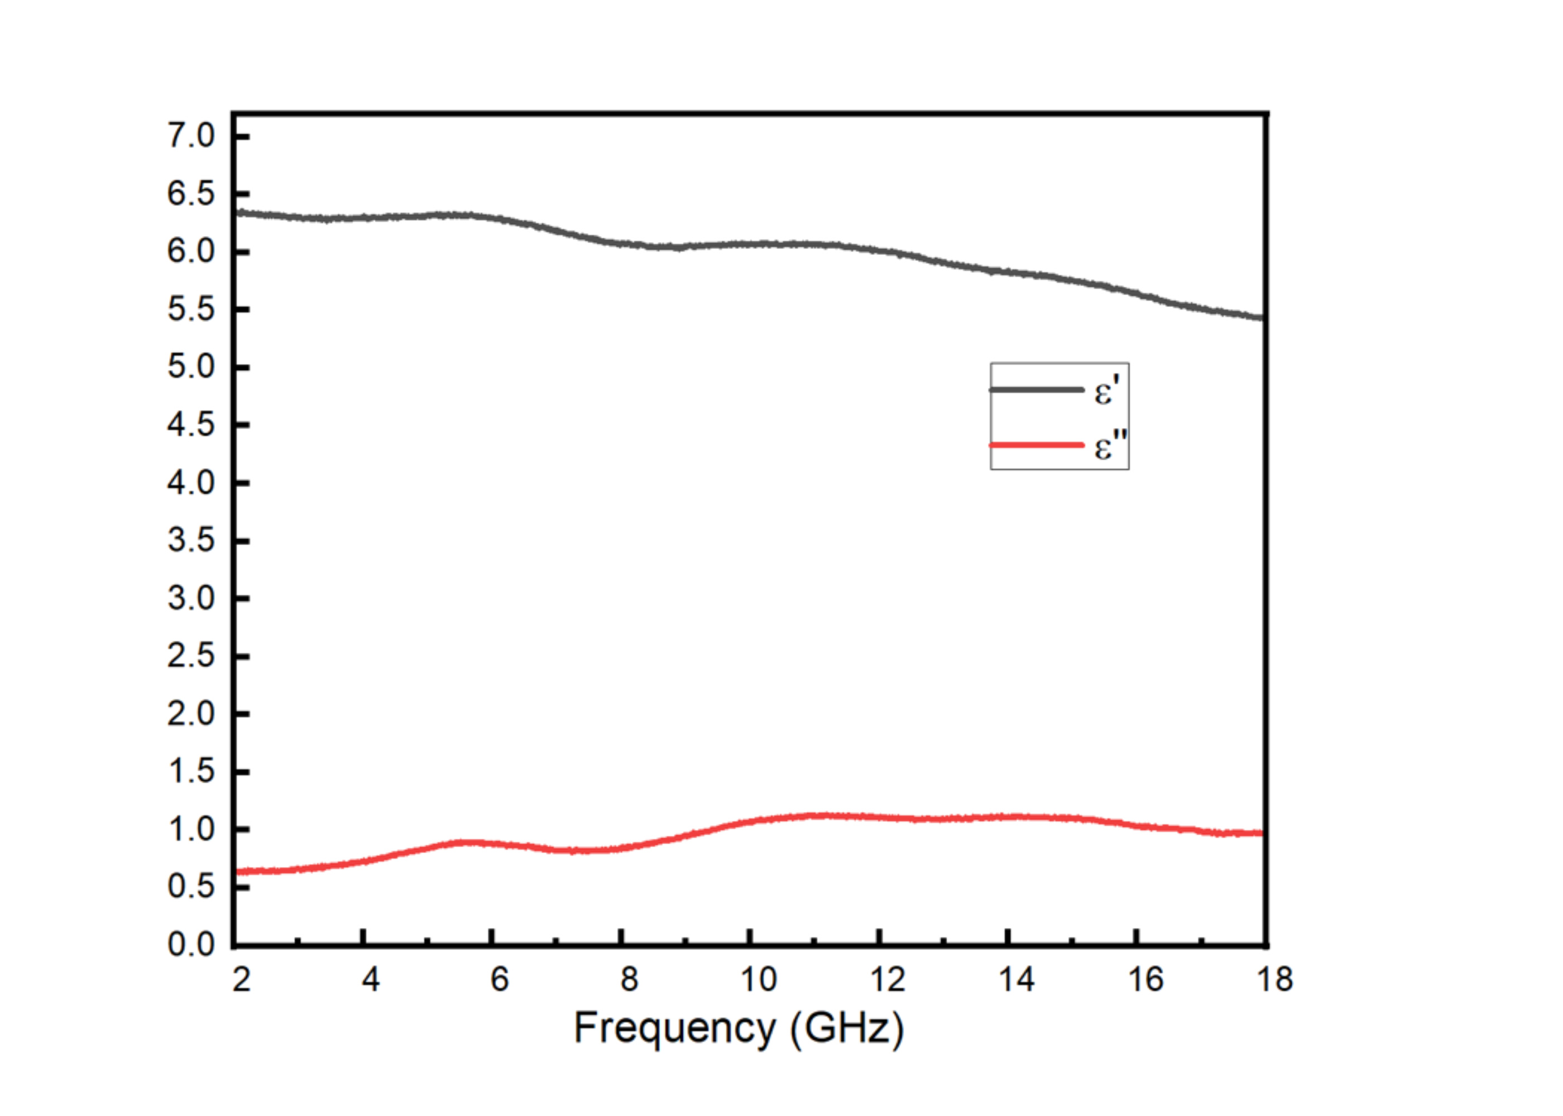
Figure S24. Representative real and imaginary permittivity. The specimen identity and compressive state need author confirmation.
Source: Original Supporting Information, S5 panel b.

Figure S25
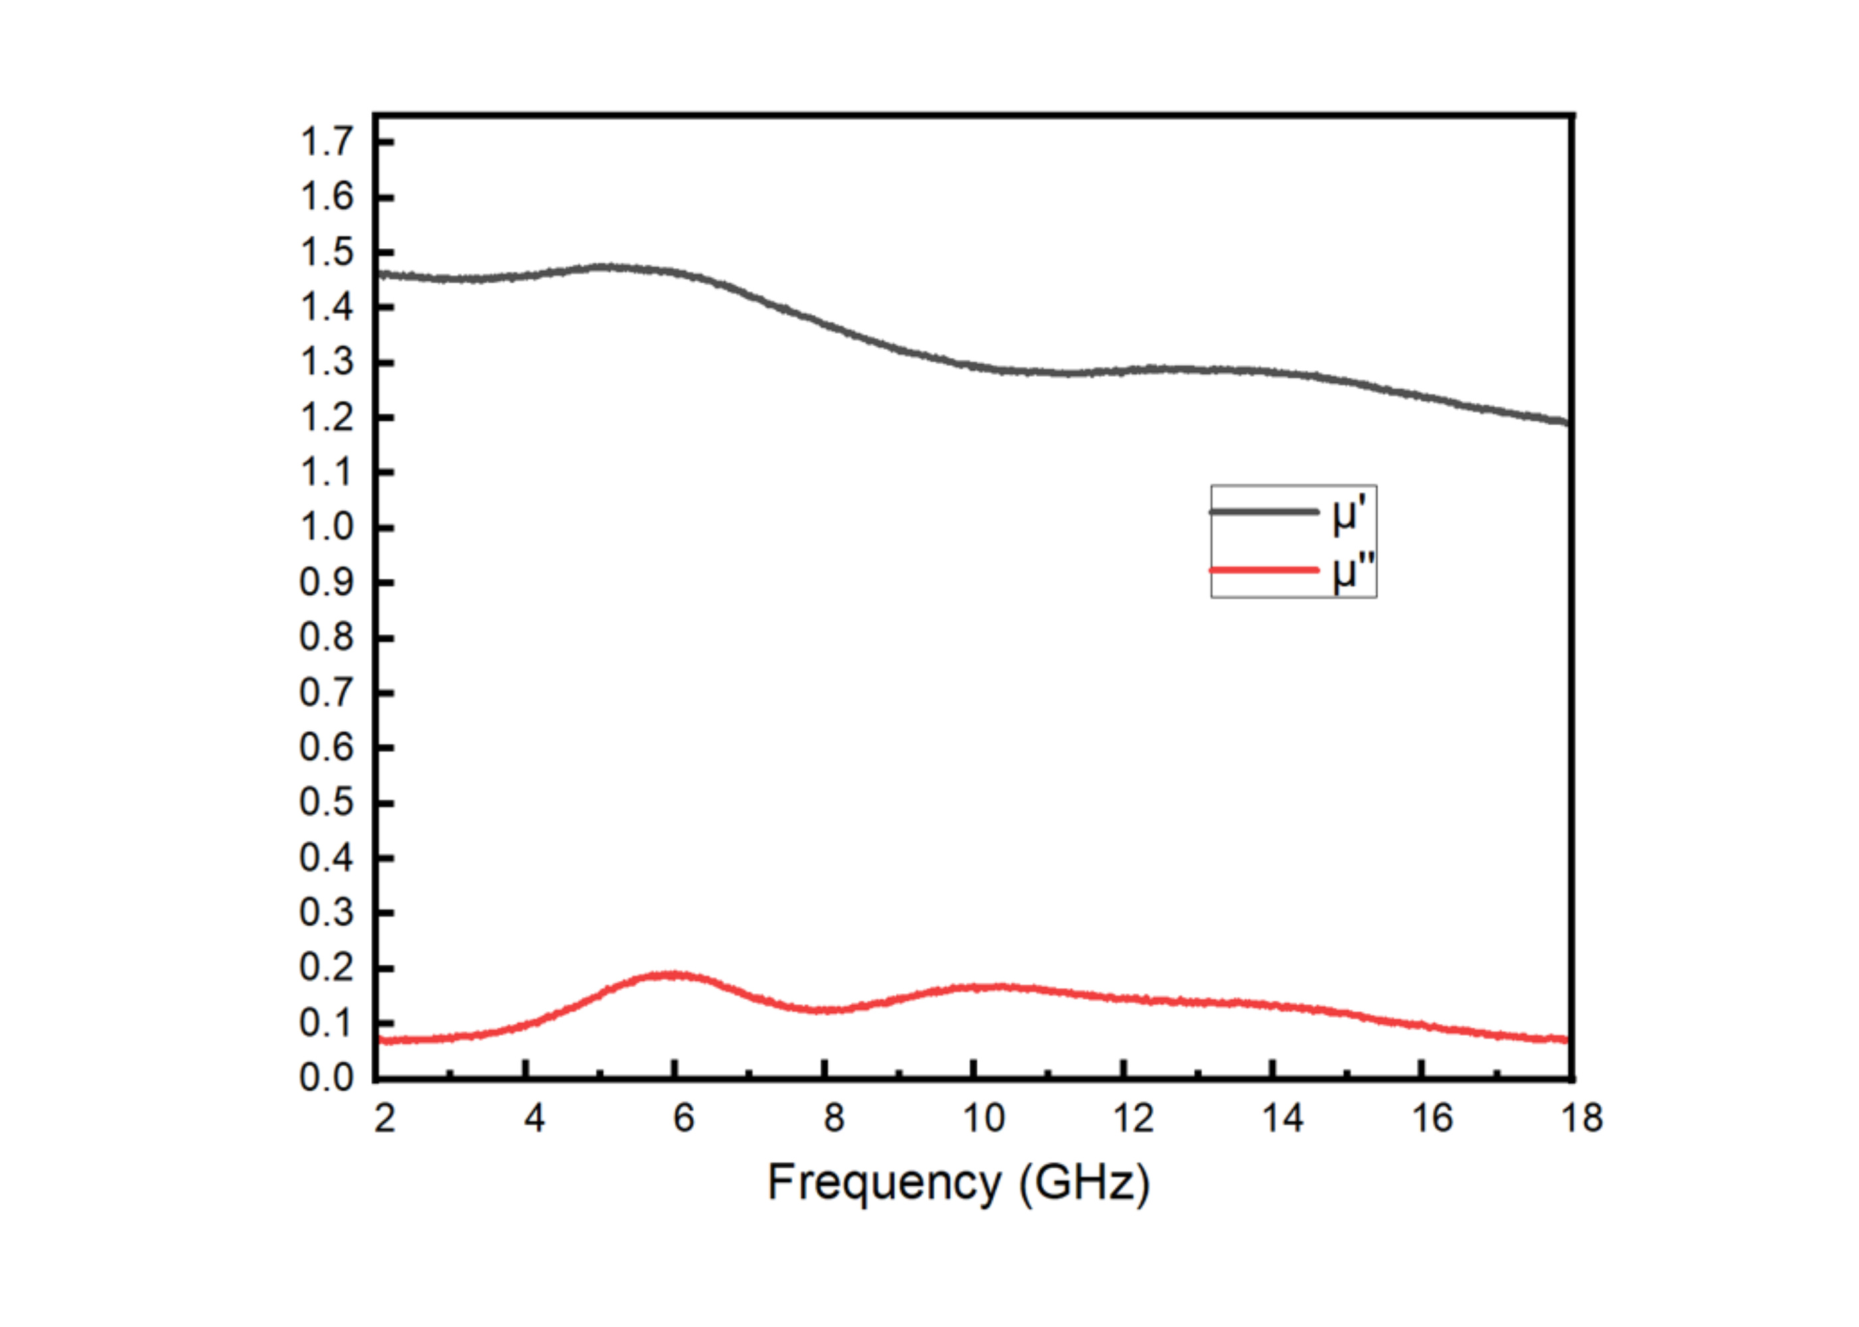
Figure S25. Representative real and imaginary permeability from 2 to 18 GHz. The specimen identity and compressive state need author confirmation.
Source: Original Supporting Information, S5 panel c.

Figure S26
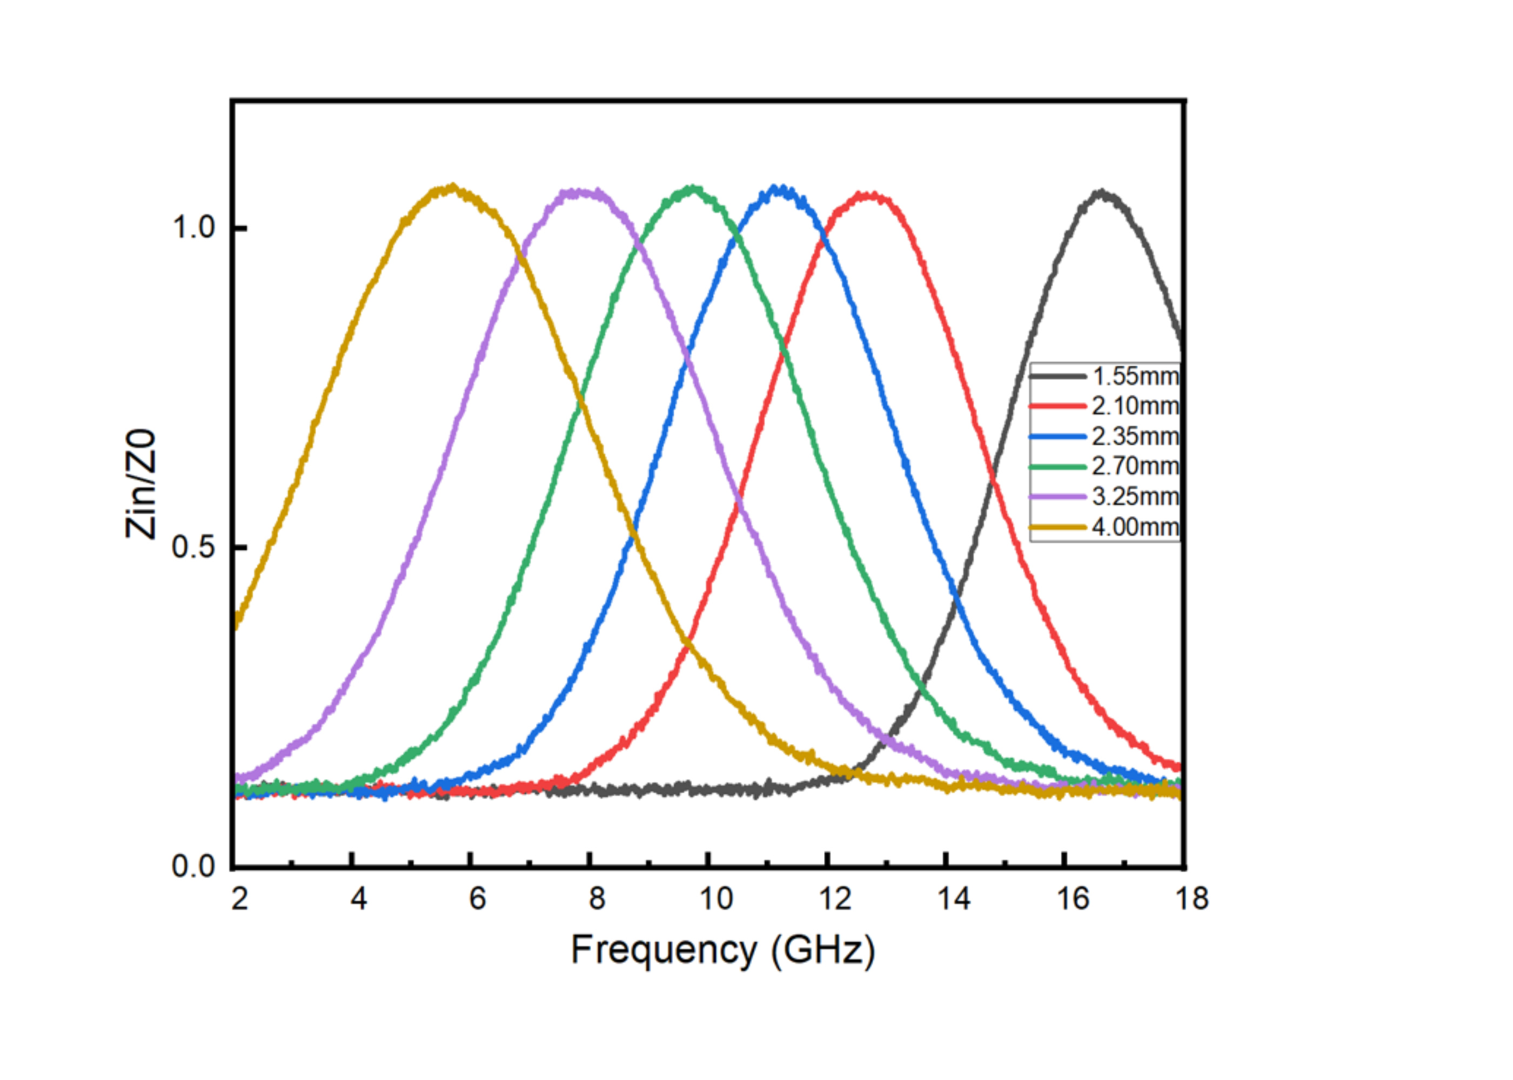
Figure S26. Magnitude of normalized input impedance for thicknesses labelled 1.55, 2.10, 2.35, 2.70, 3.25 and 4.00 mm. These curves compare thicknesses, not compressive strains.
Source: Original Supporting Information, S5 panel d.

Figure S27
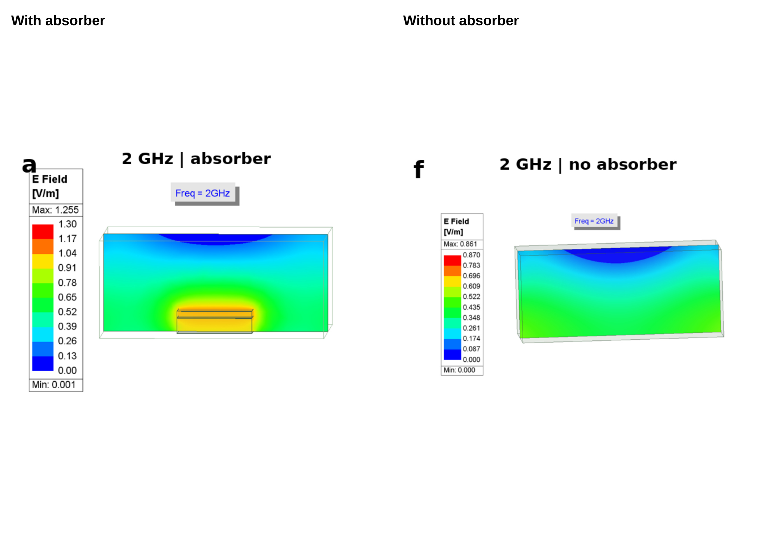
Figure S27. HFSS electric-field maps at 2 GHz with and without the absorbing layer. The original legends are retained. Their color-scale maxima differ, so color alone cannot quantify attenuation.
Source: Original Supporting Information Figure S6.

Figure S28
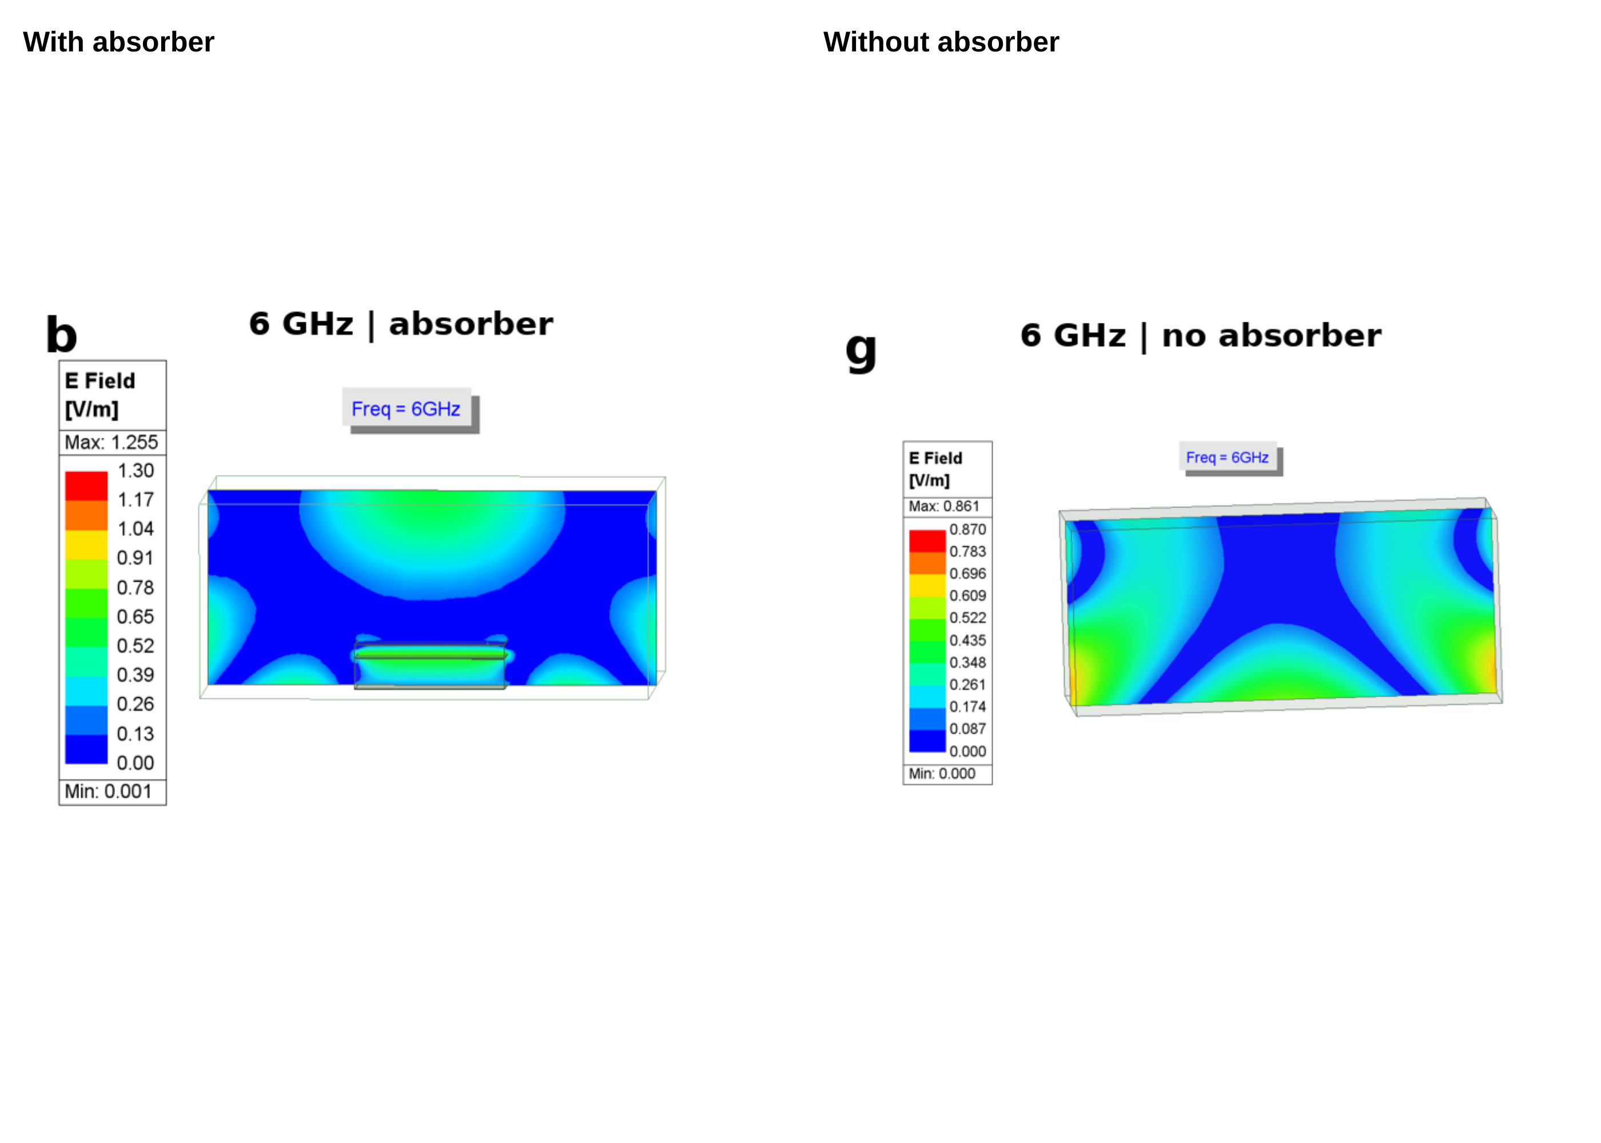
Figure S28. HFSS electric-field maps at 6 GHz with and without the absorbing layer. The original legends are retained. Their color-scale maxima differ, so color alone cannot quantify attenuation.
Source: Original Supporting Information Figure S6.

Figure S29
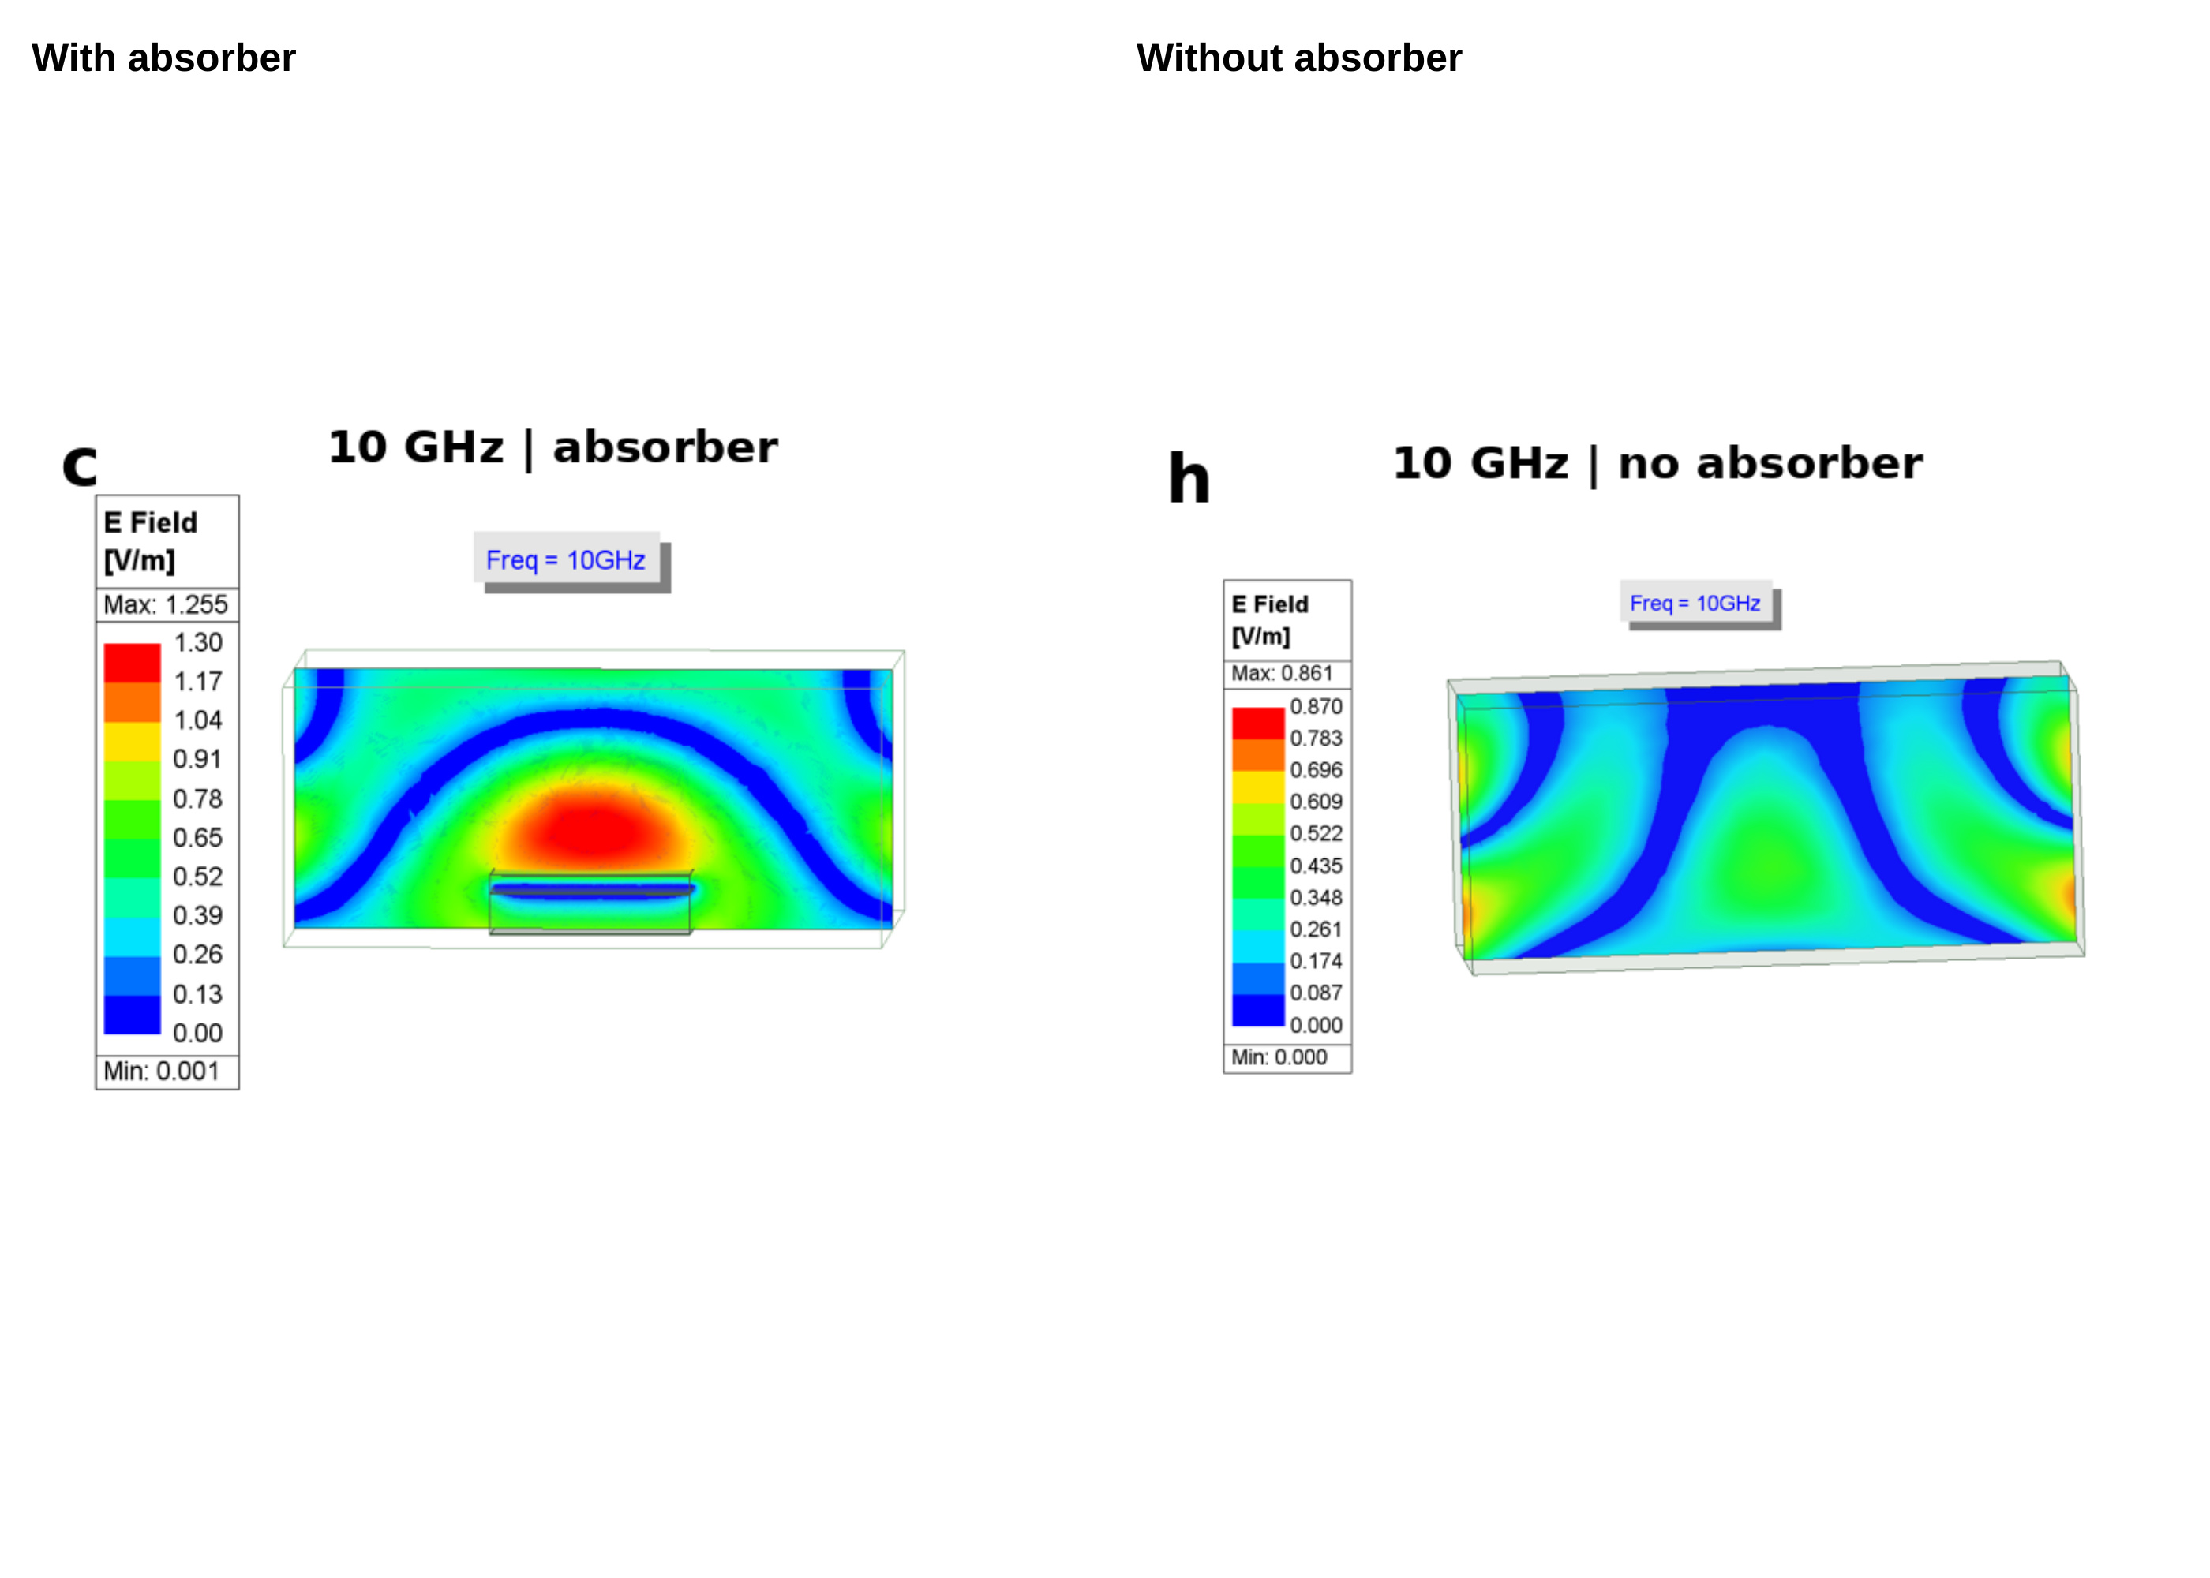
Figure S29. HFSS electric-field maps at 10 GHz with and without the absorbing layer. The original legends are retained. Their color-scale maxima differ, so color alone cannot quantify attenuation.
Source: Original Supporting Information Figure S6.

Figure S30
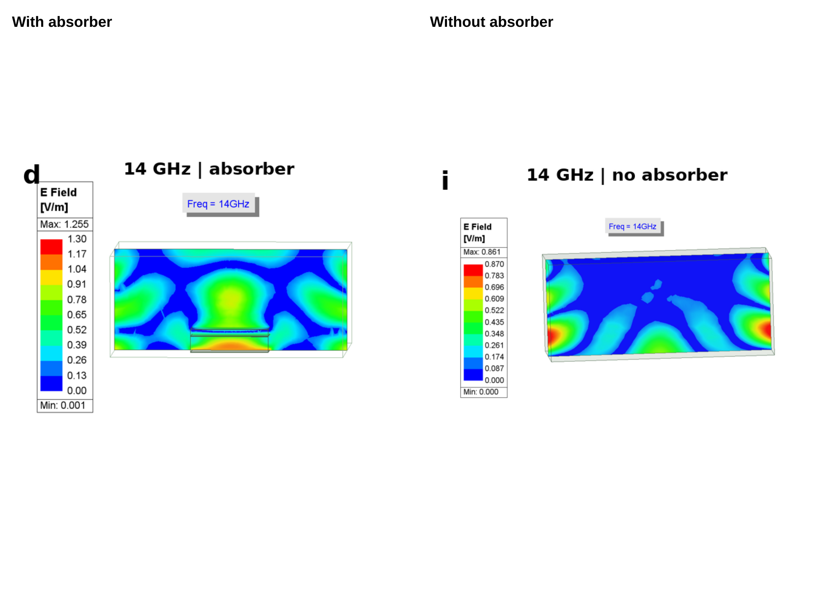
Figure S30. HFSS electric-field maps at 14 GHz with and without the absorbing layer. The original legends are retained. Their color-scale maxima differ, so color alone cannot quantify attenuation.
Source: Original Supporting Information Figure S6.

Figure S31
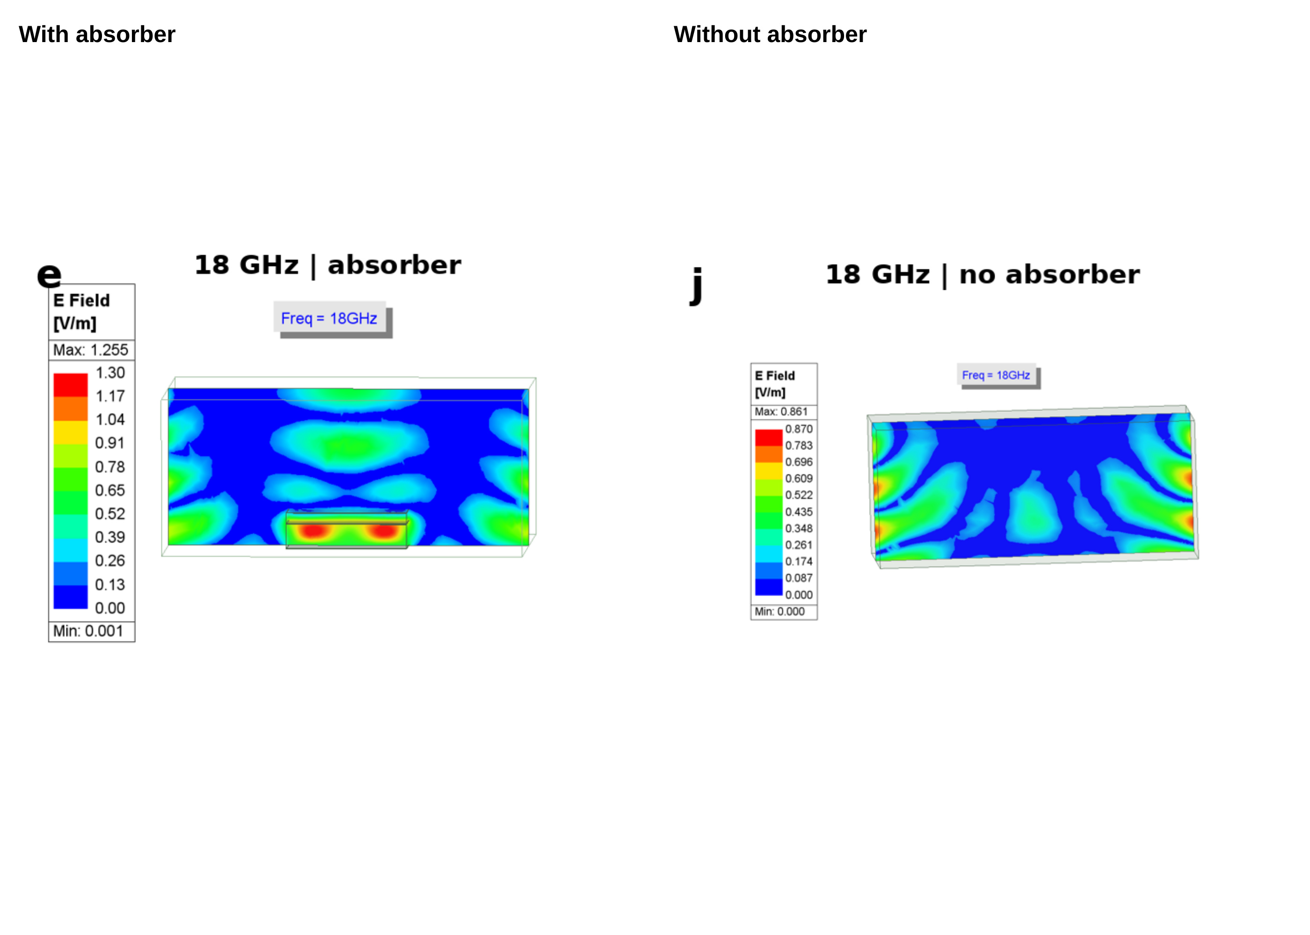
Figure S31. HFSS electric-field maps at 18 GHz with and without the absorbing layer. The original legends are retained. Their color-scale maxima differ, so color alone cannot quantify attenuation.
Source: Original Supporting Information Figure S6.

Figure S32
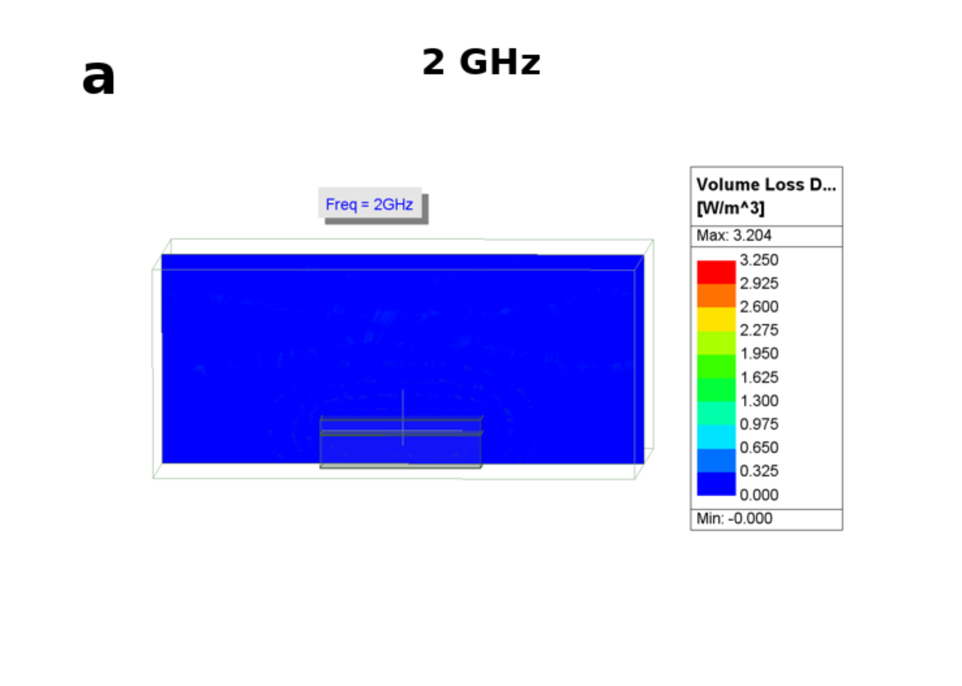
Figure S32. HFSS volumetric electromagnetic-loss-density map at 2 GHz. Original spatial field and legend are retained.
Source: Original Supporting Information Figure S7.

Figure S33
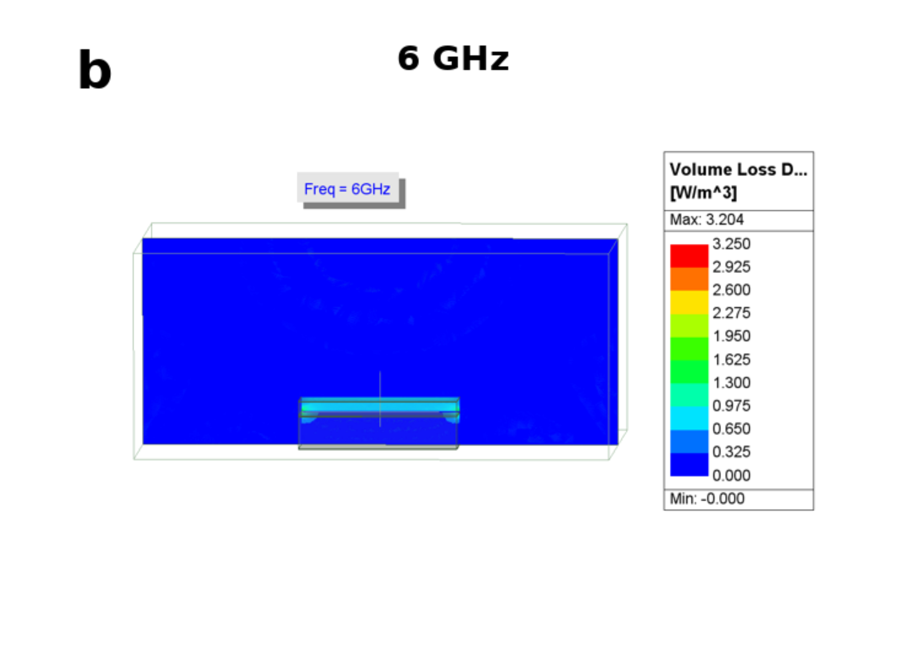
Figure S33. HFSS volumetric electromagnetic-loss-density map at 6 GHz. Original spatial field and legend are retained.
Source: Original Supporting Information Figure S7.

Figure S34
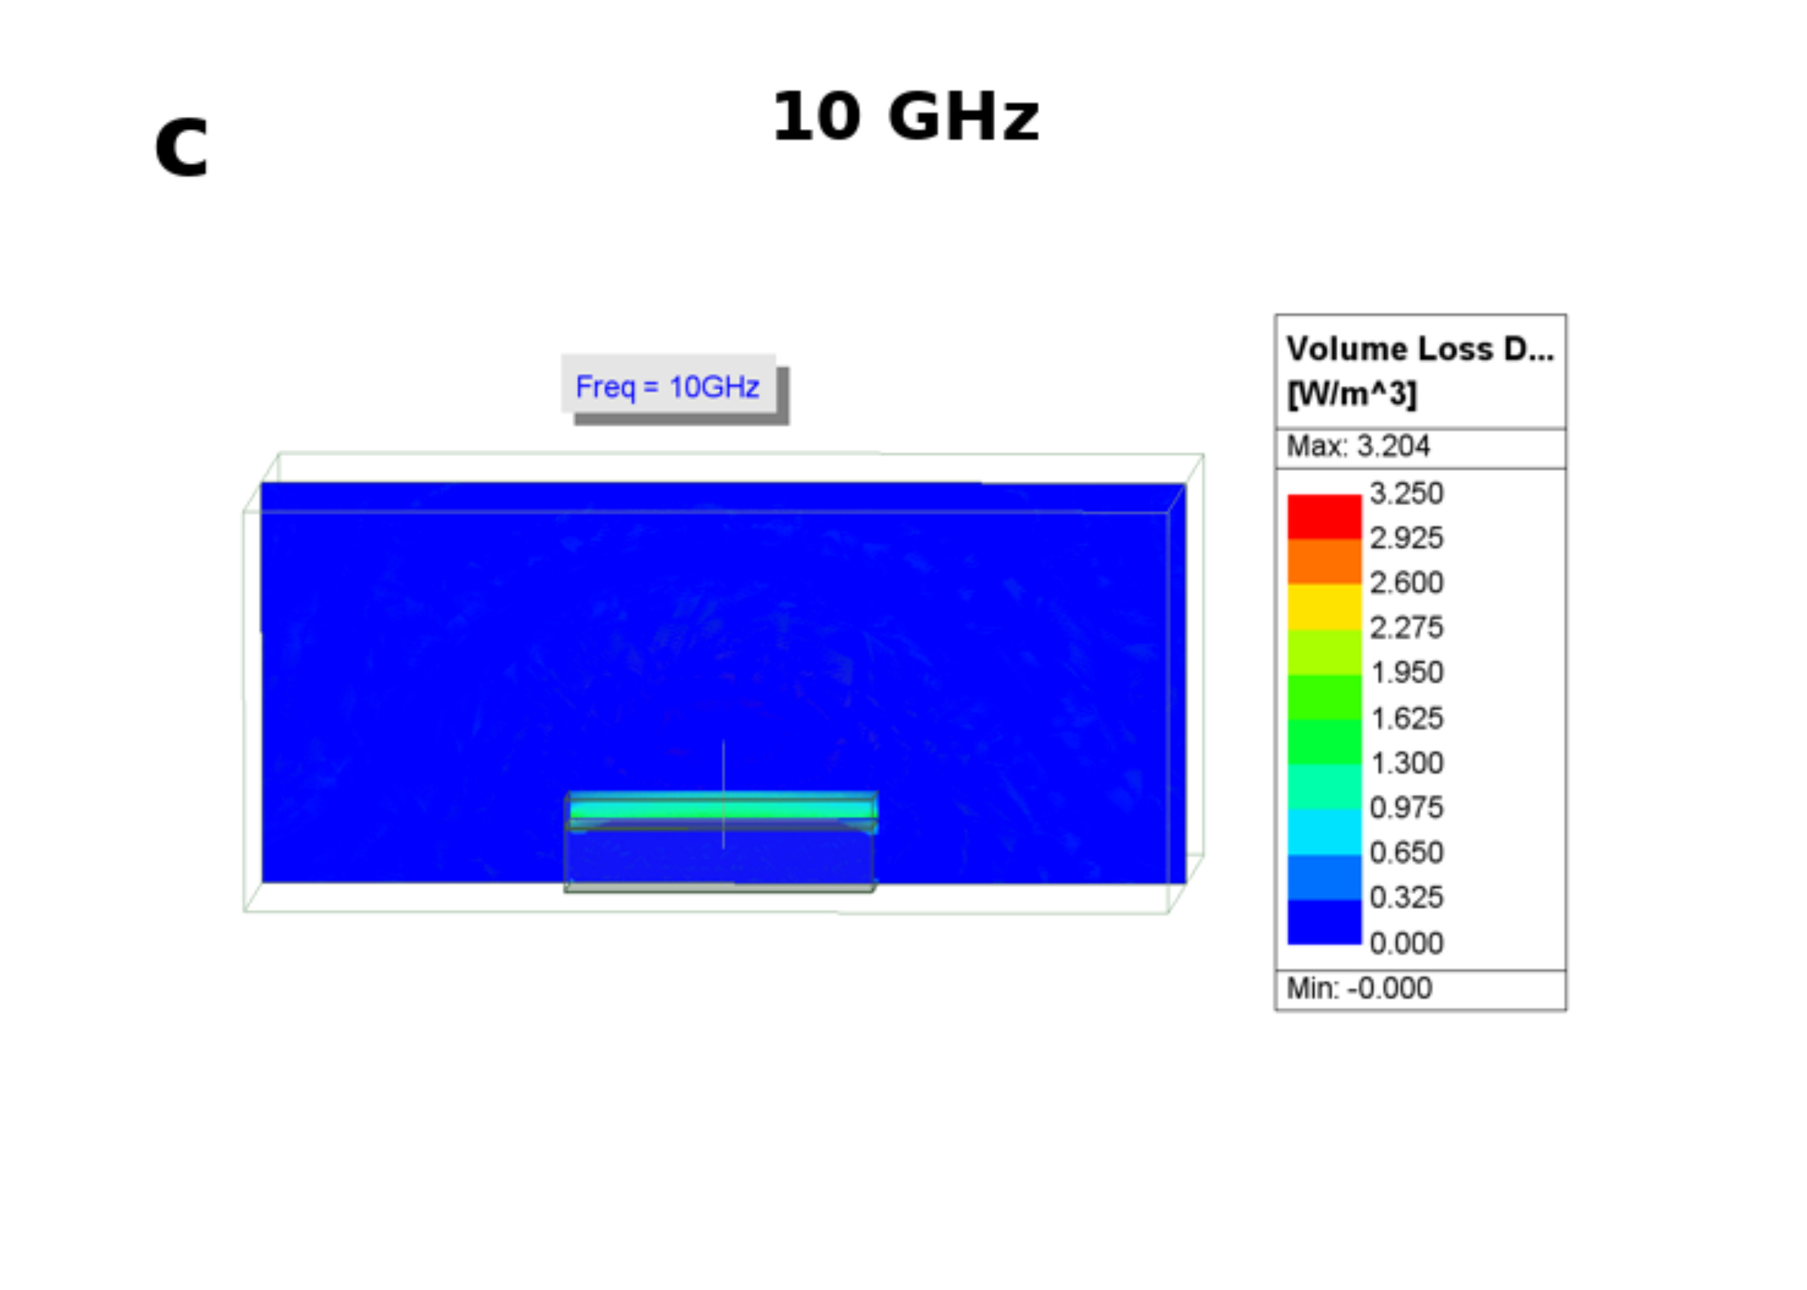
Figure S34. HFSS volumetric electromagnetic-loss-density map at 10 GHz. Original spatial field and legend are retained.
Source: Original Supporting Information Figure S7.

Figure S35
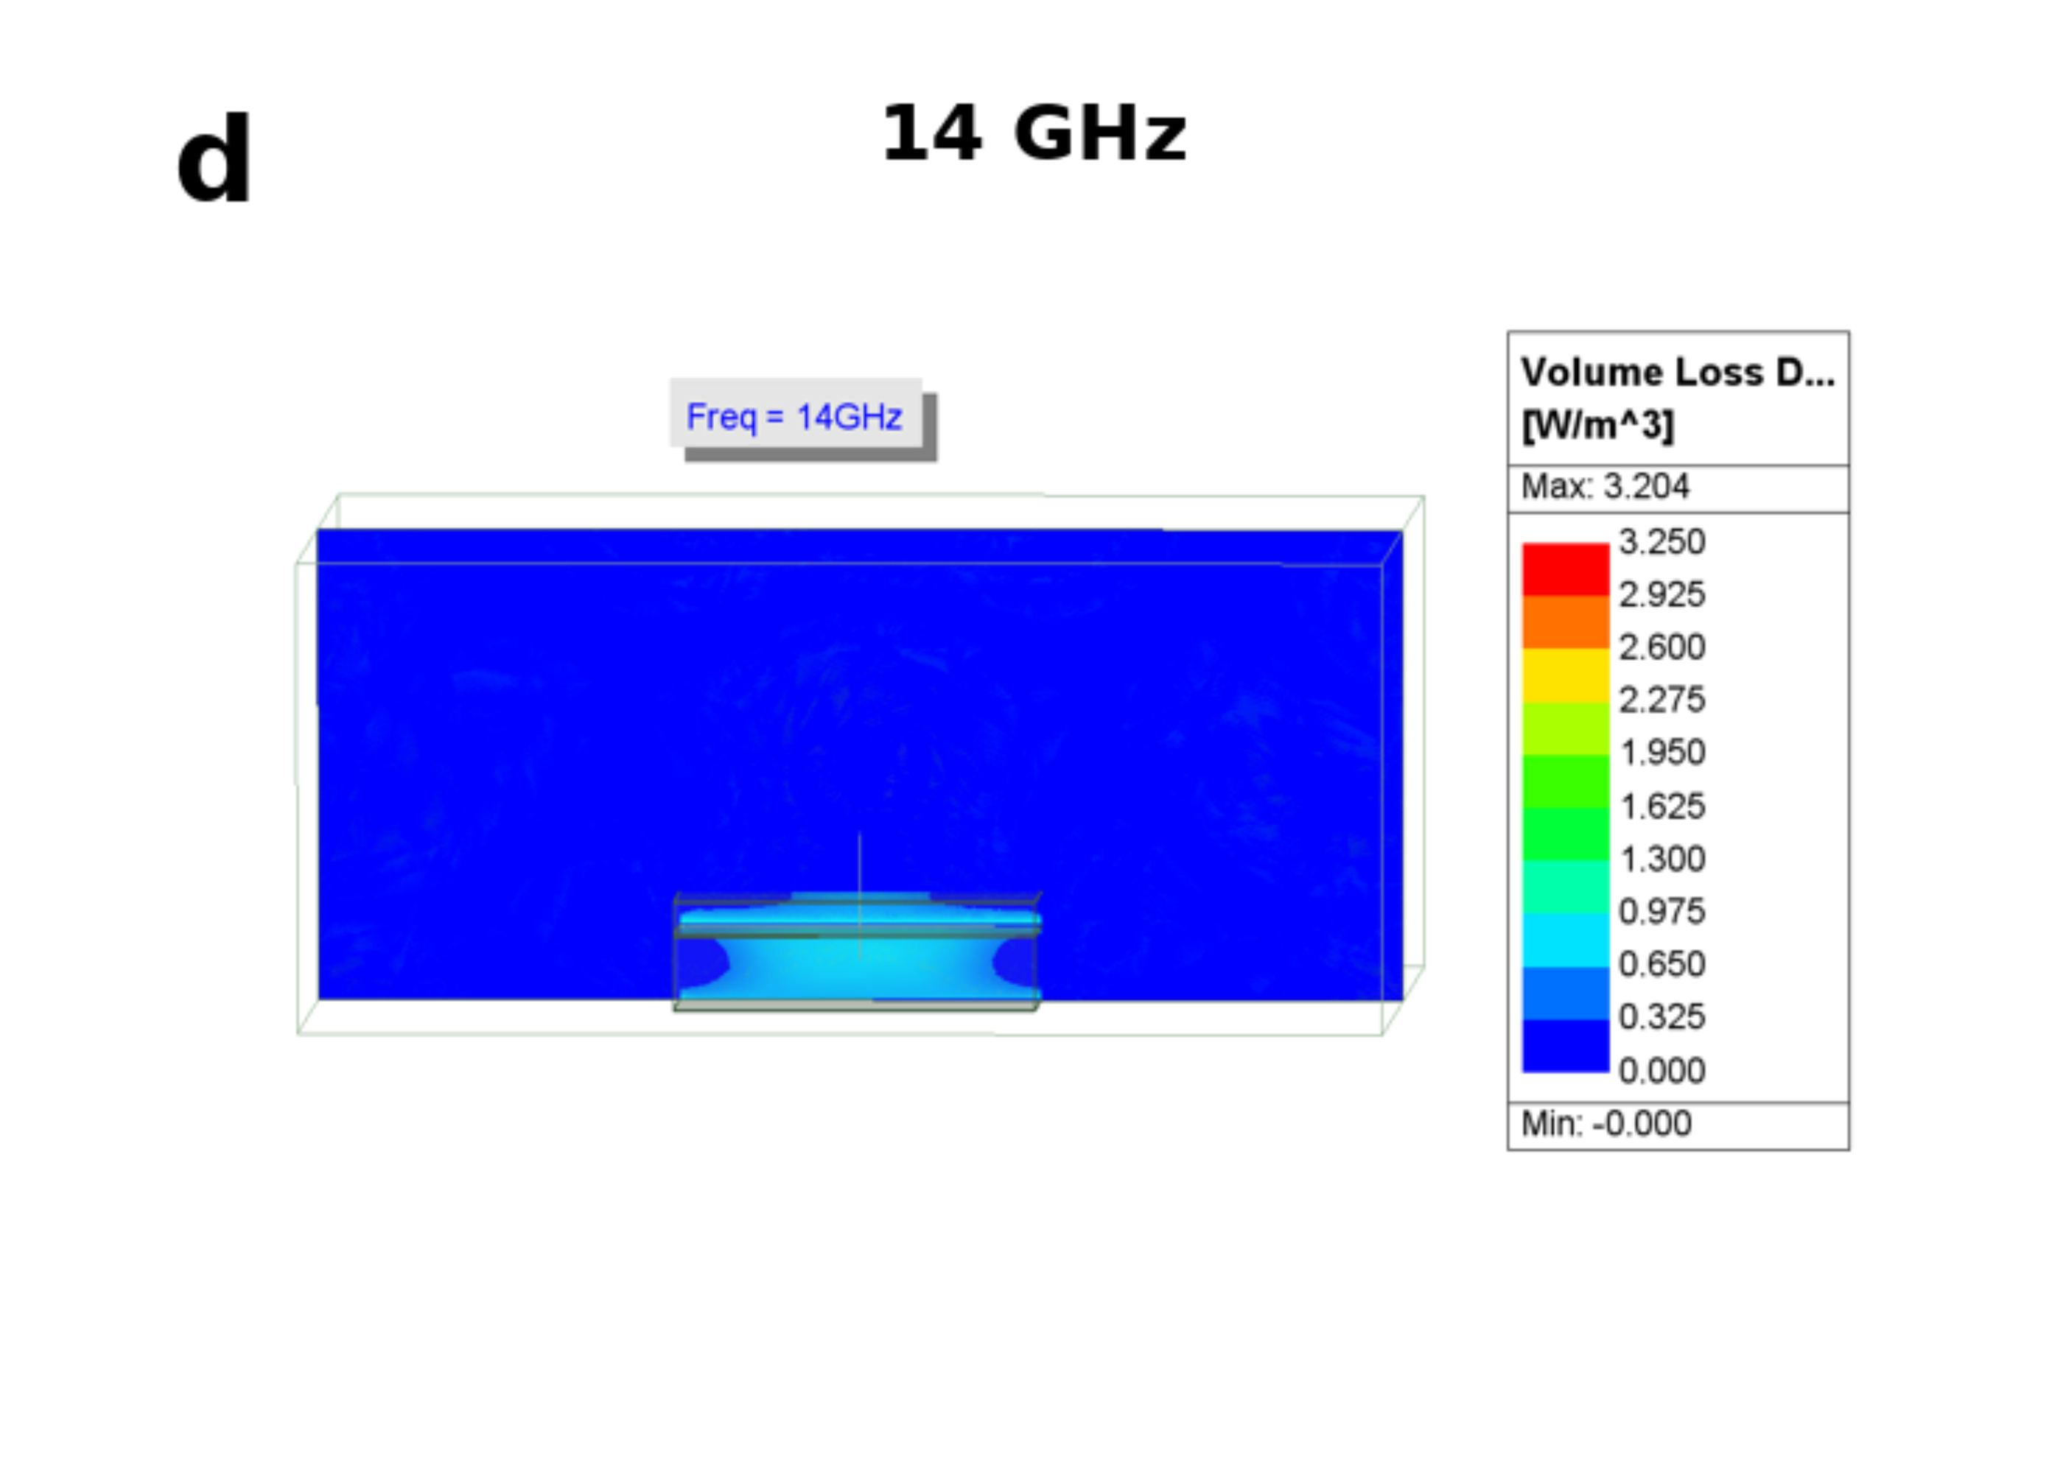
Figure S35. HFSS volumetric electromagnetic-loss-density map at 14 GHz. Original spatial field and legend are retained.
Source: Original Supporting Information Figure S7.

Figure S36
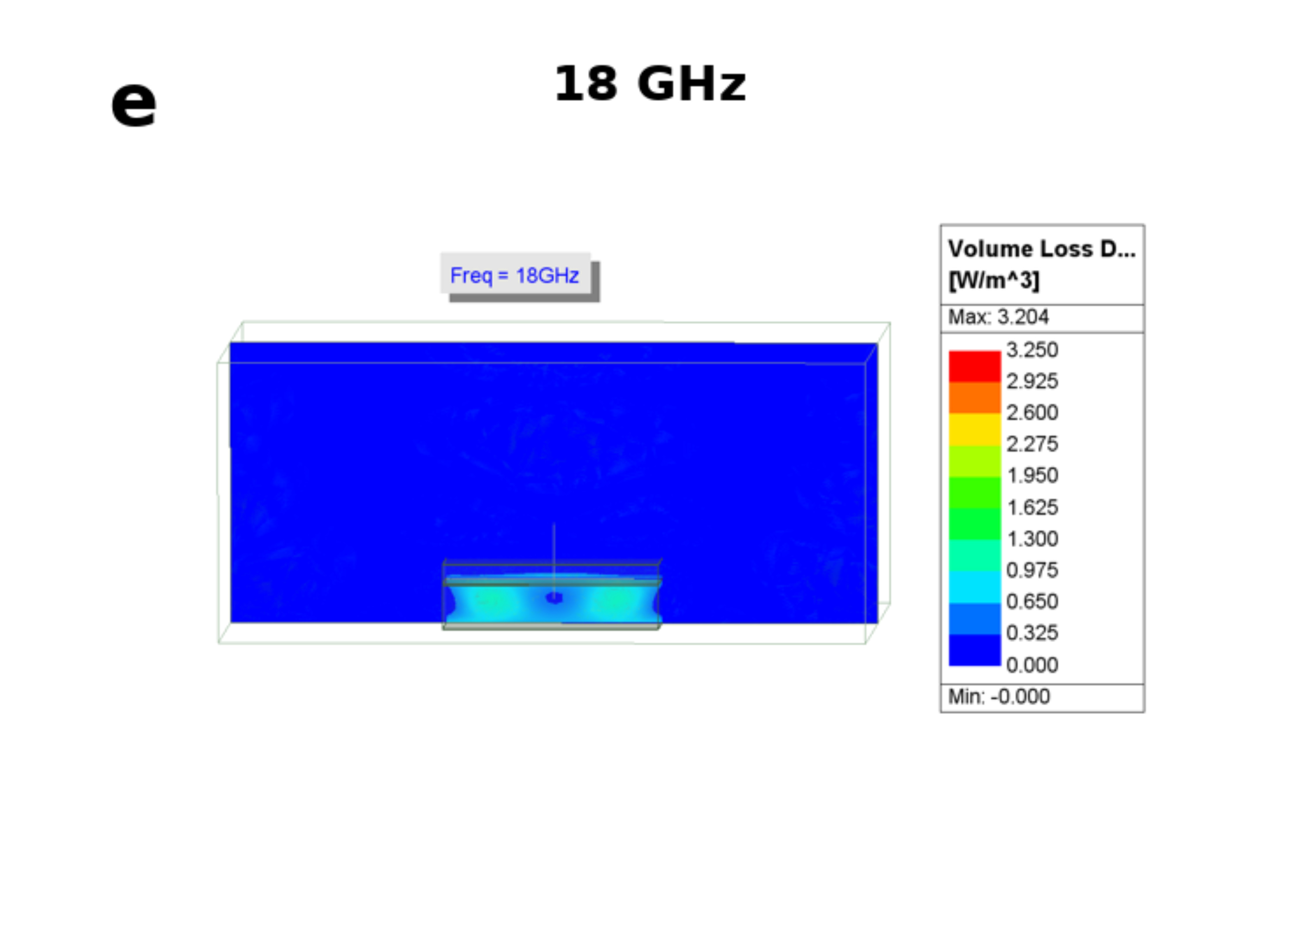
Figure S36. HFSS volumetric electromagnetic-loss-density map at 18 GHz. Original spatial field and legend are retained.
Source: Original Supporting Information Figure S7.

Figure S37
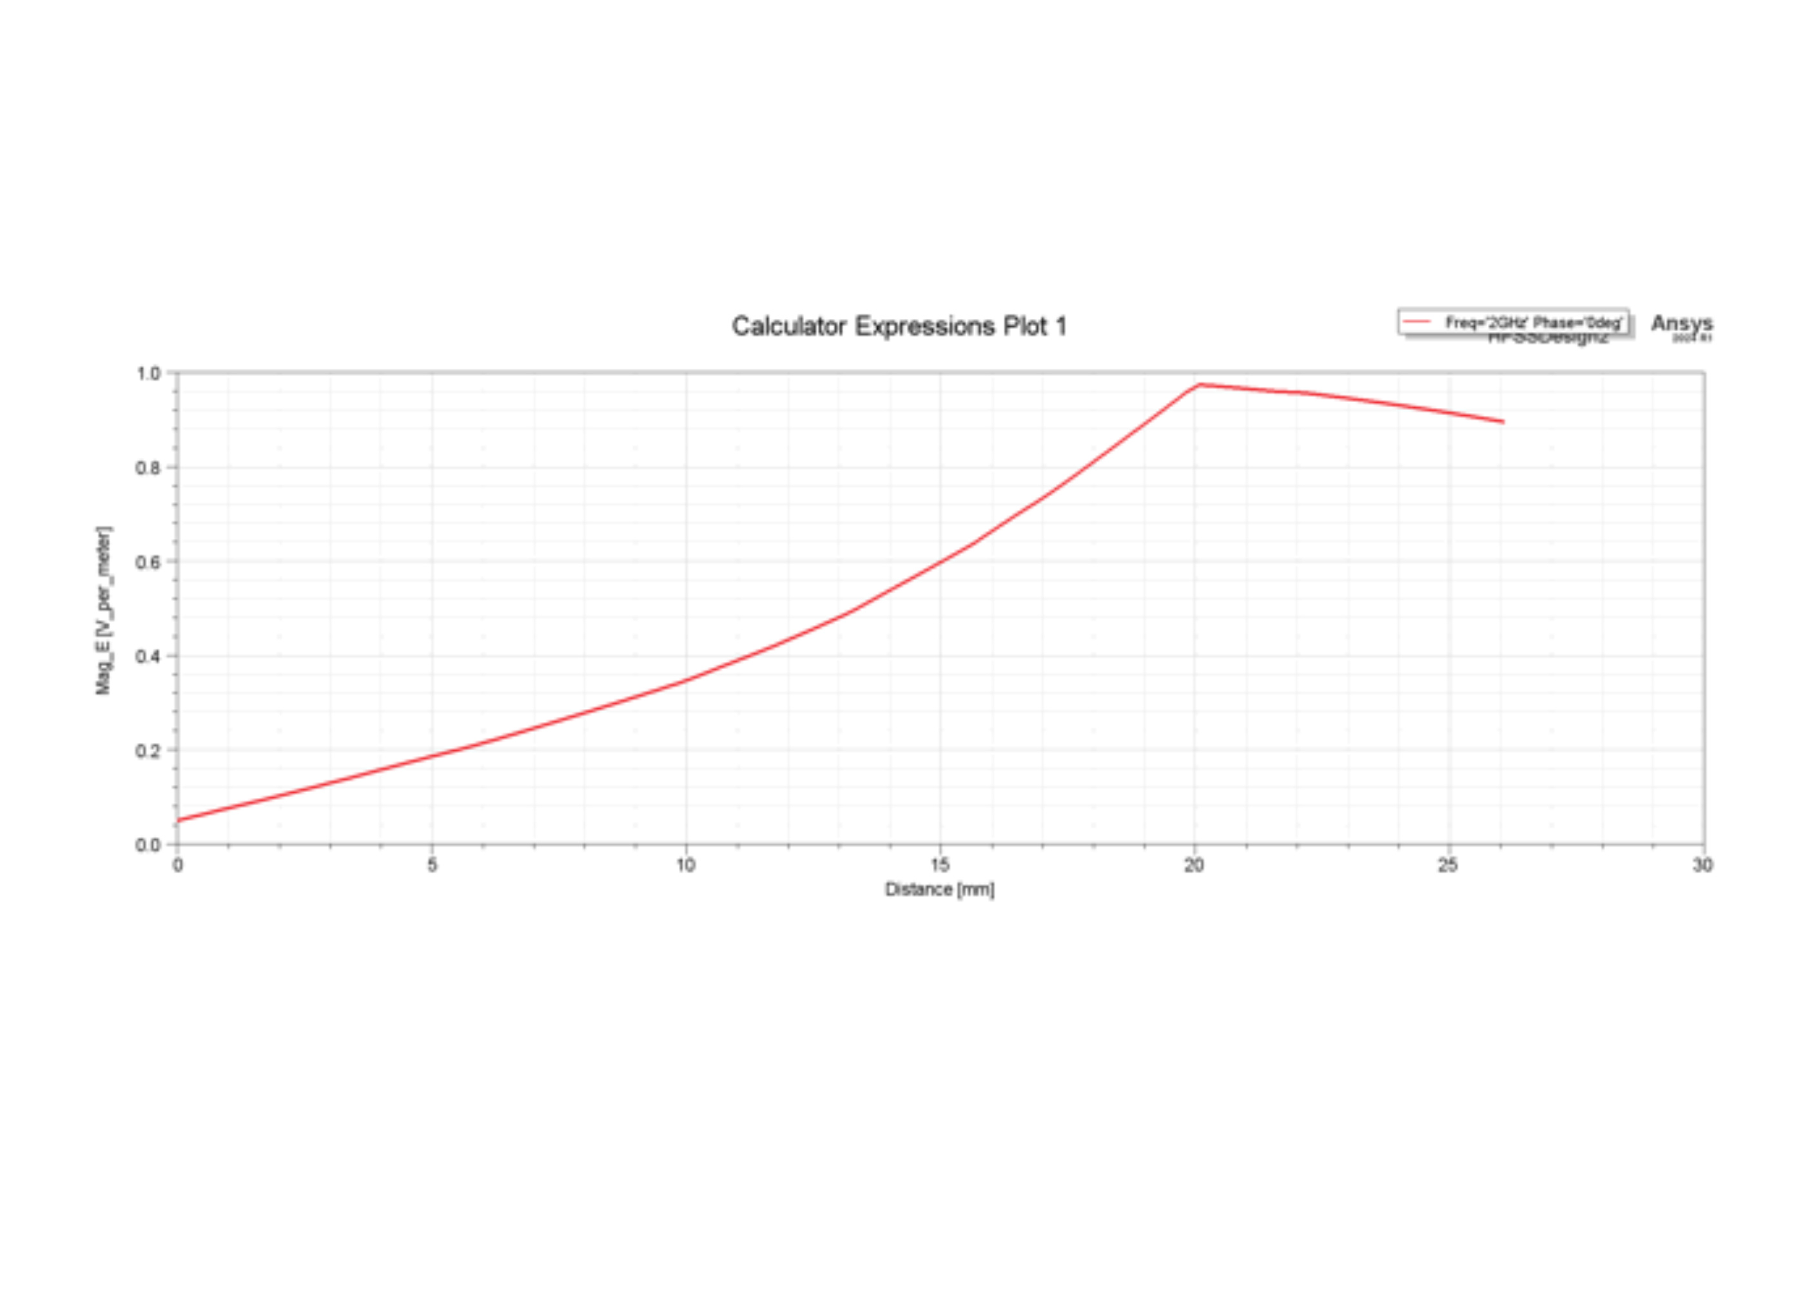
Figure S37. HFSS line profile at 2 GHz. Original quantity, distance axis and trace are retained. The path coordinates and normalization need author confirmation.
Source: Original Supporting Information Figure S8.

Figure S38
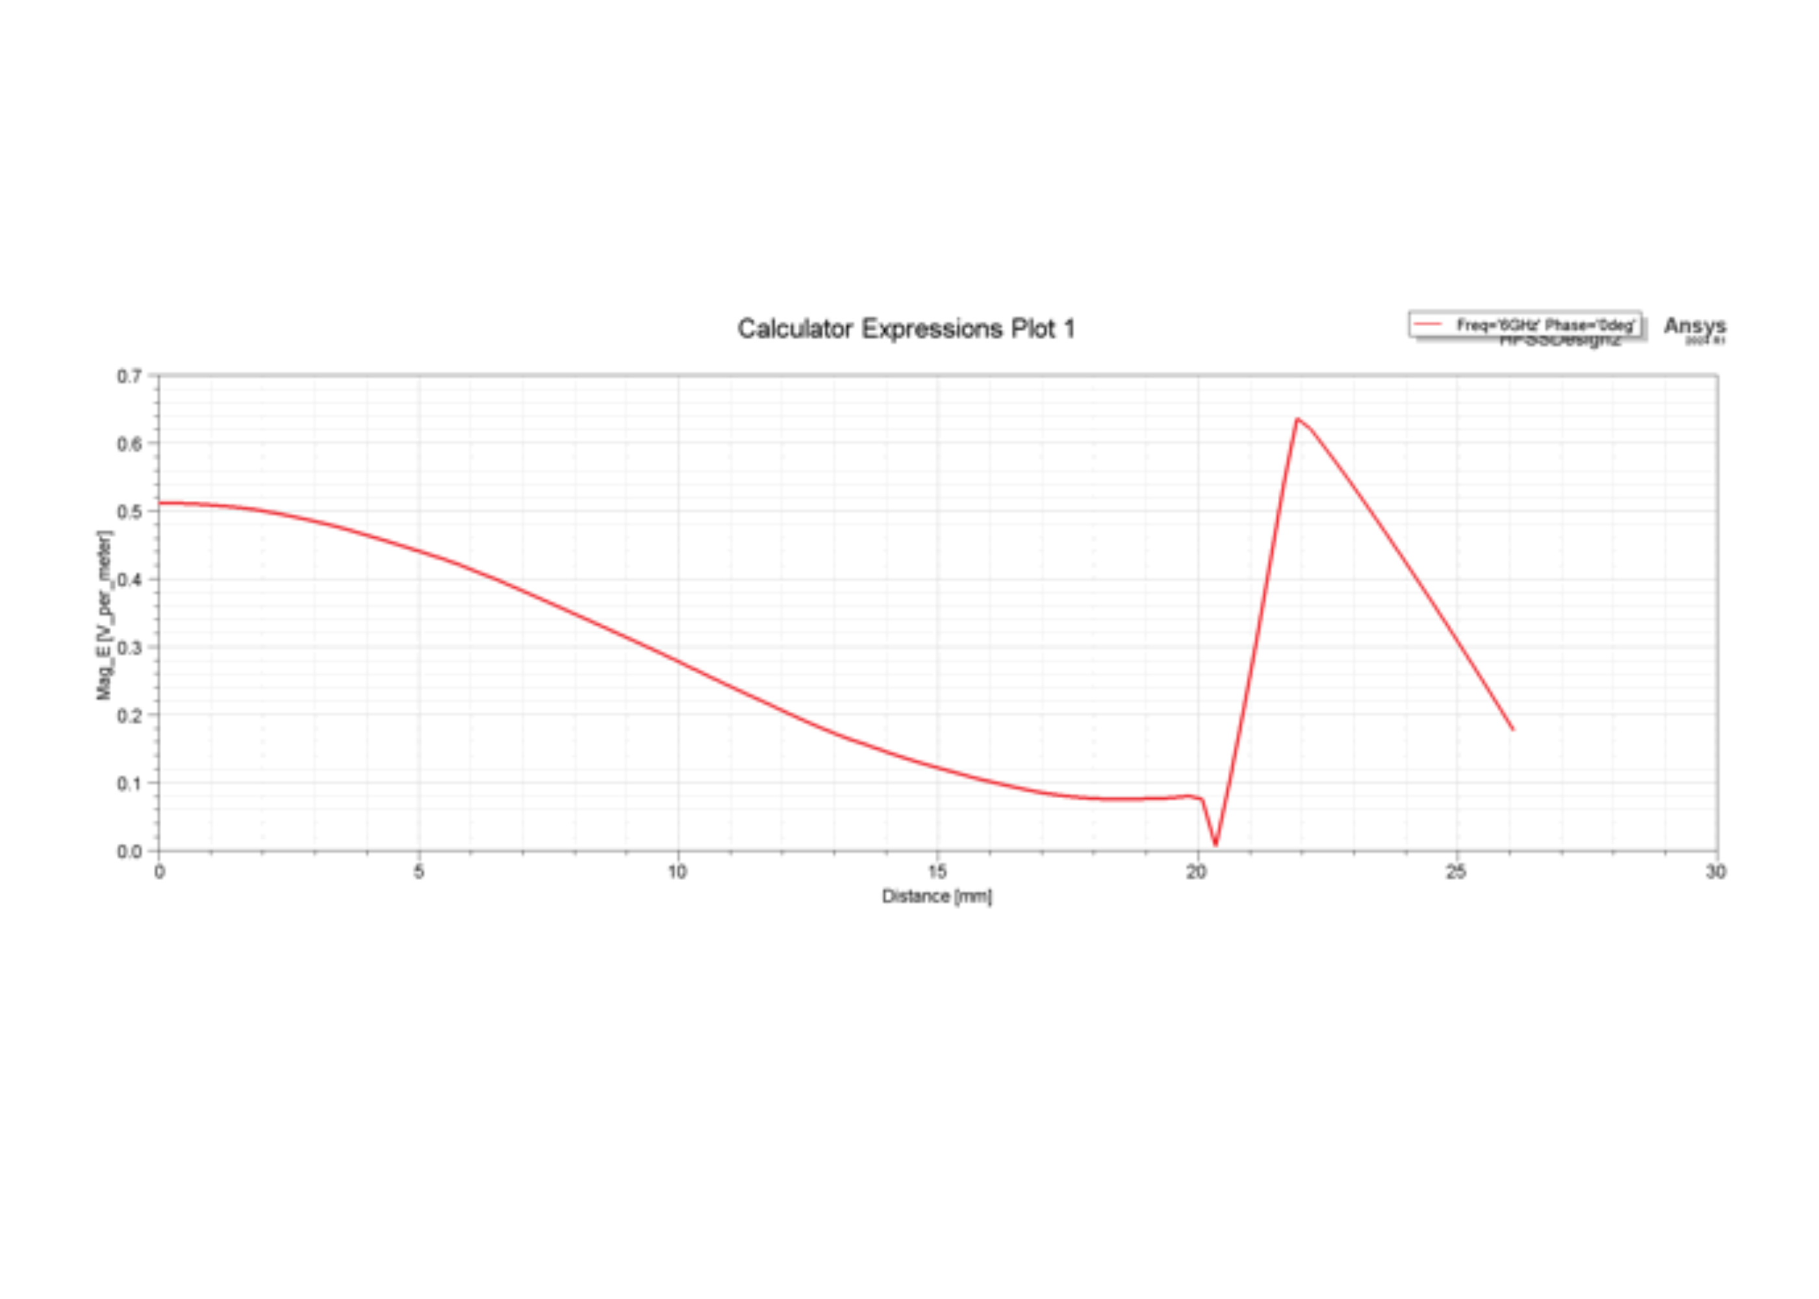
Figure S38. HFSS line profile at 6 GHz. Original quantity, distance axis and trace are retained. The path coordinates and normalization need author confirmation.
Source: Original Supporting Information Figure S8.

Figure S39
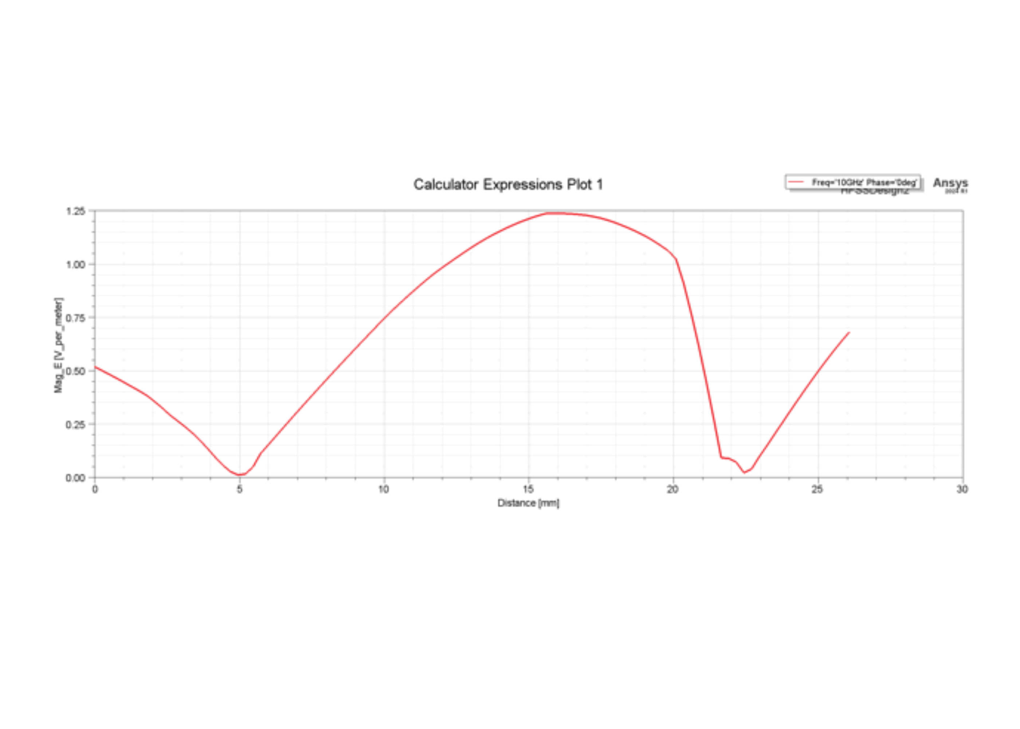
Figure S39. HFSS line profile at 10 GHz. Original quantity, distance axis and trace are retained. The path coordinates and normalization need author confirmation.
Source: Original Supporting Information Figure S8.

Figure S40
Figure S40. HFSS line profile at 14 GHz. Original quantity, distance axis and trace are retained. The path coordinates and normalization need author confirmation.
Source: Original Supporting Information Figure S8.

Figure S41
Figure S41. HFSS line profile at 18 GHz. Original quantity, distance axis and trace are retained. The path coordinates and normalization need author confirmation.
Source: Original Supporting Information Figure S8.

Supplementary references
[1] Sibt ul Hassan. Facile Synthesis and Microwave Absorption Properties of Medium- and High-Entropy Alloy/Carbon Composite Nanostructures. Doctoral thesis, Central South University, April 2025. Chapters 2 and 6.
[2] P. J. Taroni, G. Santagiuliana, K. N. Wan, et al., Adv. Funct. Mater., 2018, 28, 1704285.
[3] S. Han, N. U. H. Alvi, L. Granlof, H. Granberg, M. Berggren, S. Fabiano and X. Crispin, Adv. Sci., 2019, 6, 1802128.
[4] M. Li, J. Chen, W. Zhong, et al., ACS Sens., 2020, 5, 2545-2554.
[5] Y. Yang, G. Zhao, X. Cheng, H. Deng and Q. Fu, ACS Appl. Mater. Interfaces, 2021, 13, 14599-14611.
[6] F. Zhang, Y. Zang, D. Huang, C. A. Di and D. Zhu, Nat. Commun., 2015, 6, 8356.
[7] S. Xu, Z. Fan, S. Yang, X. Zuo, Y. Guo, H. Chen and L. Pan, ACS Sens., 2021, 6, 1120-1128.
[8] F. Li, Y. Liu, X. Shi, H. Li, C. Wang, Q. Zhang, R. Ma and J. Liang, Nano Lett., 2020, 20, 6176-6184.
[9] X. He, Y. Hao, M. He, X. Qin, L. Wang and J. Yu, ACS Appl. Mater. Interfaces, 2021, 13, 60498-60507.
[10] Y. Wang, H. Mao, Y. Wang, P. Zhu, C. Liu and Y. Deng, J. Mater. Chem. A, 2020, 8, 15167-15176.
[11] Y. Wang, H. Wu, L. Xu, H. Zhang, Y. Yang and Z. L. Wang, Sci. Adv., 2020, 6, eabb9083.

