**Program 1 (Home page)**

**/*Program for showing the home page of shopping Web page*/**

<html>

<frameset cols="15%,*%,15%" >

<frame src="ads1.html" scrolling=no>

<frame src="mainPage.html">

<frame src="ads2.html" scrolling=no>

<noframes>

Text to be displayed in browsers that do not support frames

</noframes>

</frameset>

</html>

**Program 2 (Mobile phones Web page)**

**/*Program for showing different brands of mobile phones in Webpage*/**

<html>

<head>

<title>main page</title>

</head>

<body bgcolor="black" text=#83EA50 link="white" alink="orange" vlink="#79E4F7">

<audio src="Samsung Galaxy S III Original Ringtone_(360p).mp4" autoplay></audio>

<marquee><div align="center"><img src="capturey.png" ></div></marquee><br><hr>

<img src="capture.jpg" alt=error>

<p><div align="right"><a href="samsungA3.html">See more images</a></div></p>

<font color=#F98B6F><P><h1>Let's go for MOBILE SHOPPING......</h1></P></font>

<font size=5><OL type=roman number start=n>

<LI><a href="asus.html">ASUS</a></LI>

<LI><a href="iBall.html">IBALL</a></LI>

<LI><a href="htc.html">HTC</a></LI>

<LI><a href="iPhone.html">IPHONE</a></LI>

<LI><a href="Micromax.html">MICROMAX</a></LI>

<LI><a href="nexus.html">NEXUS</a></LI>

<LI><a href="Nokia.html">NOKIA</a></LI>

<LI><a href="panasonic.html">PANASONIC</a></LI>

<LI><a href="samsung.html">SAMSUNG</a></LI>

<LI><a href="Sony.html">SONY</a></LI></font>

<p><font color=#FF75FF size=5>Click here for purchasing <a href=tablet.html>TABLETS</a></font></p>

</body>

</html>

**Program 3 (Advertisement Web page)**

**/*Program for showing advertisement on left side in a Webpage*/**

<!DOCTYPE html>

<html>

<head>

<title>ads</title>

</head>

<body>

<img src="capture7.jpg" height=700 width=170 alt=" error">

</body>

</html>

**Program 4 (Advertisement Web page)**

**/*Program for showing advertisement on right side in a Webpage*/**

<!DOCTYPE html>

<html>

<head>

<title>ads</title>

</head>

<body>

<img src="capture7.jpg" height=700 width=170 alt=" error">

</body>

</html>

**Program 5 (Samsung galaxy mobile web page)**

**/*Program for showing Samsung galaxy brand mobile phones in Webpage*/**

<html>

<head><title>Samsung galaxy A3</title><head>

<body bgcolor="black">

<img src="Samsung A3\capture002.png" alt=error height=500 width=900><br>

<img src="Samsung A3\capture003.png" alt=error height=500 width=900><br>

<img src="Samsung A3\capture004.png" alt=error height=500 width=900><br>

<img src="Samsung A3\capture005.png" alt=error height=500 width=900><br>

<img src="Samsung A3\capture006.png" alt=error height=500 width=900><br>

<img src="Samsung A3\capture007.png" alt=error height=500 width=900><br>

<img src="Samsung A3\capture008.png" alt=error><br>

<p><font color="white">Click here to </font><a href="form.html">Buy this phone<a></p>

<div align="right"><font color="white">Click here to go to</font><a href="mainPage.html"> Home Page</a></div>

</body>

</html>

**Program 6 (Asus mobile web page)**

**/*Program for showing Asus brand mobile phones in Webpage*/**

<html>

<head><title>Asus</title></head>

<body>

<div align="center"><img src="titleAsus.PNG" height=200 width=400></div><br><hr>

<a href=form.html><img src="Asus\capture1.PNG" border=2 hspace=25 vspace=25 height=350 width=170></a>

<a href=form.html><img src="Asus\capture2.PNG" border=2 hspace=25 vspace=25 height=350 width=170></a>

<a href=form.html><img src="Asus\capture3.PNG" border=2 hspace=25 vspace=25 height=350 width=170></a>

<a href=form.html><img src="Asus\capture4.PNG" border=2 hspace=25 vspace=25 height=350 width=170></a><br>

<a href=form.html><img src="Asus\capture5.PNG" border=2 hspace=25 vspace=25 height=350 width=170></a>

<a href=form.html><img src="Asus\capture6.PNG" border=2 hspace=25 vspace=25 height=350 width=170></a>

<a href=form.html><img src="Asus\capture7.PNG" border=2 hspace=25 vspace=25 height=350 width=170></a>

<a href=form.html><img src="Asus\capture8.PNG" border=2 hspace=25 vspace=25 height=350 width=170></a><br>

<a href=form.html><img src="Asus\capture9.PNG" border=2 hspace=25 vspace=25 height=350 width=170></a>

<a href=form.html><img src="Asus\capture10.PNG" border=2 hspace=25 vspace=25 height=350 width=170></a>

<a href=form.html><img src="Asus\capture11.PNG" border=2 hspace=25 vspace=25 height=350 width=170></a>

<a href=form.html><img src="Asus\capture12.PNG" border=2 hspace=25 vspace=25 height=350 width=170></a><br>

<a href=form.html><img src="Asus\capture13.PNG" border=2 hspace=25 vspace=25 height=350 width=170></a>

<a href=form.html><img src="Asus\capture14.PNG" border=2 hspace=25 vspace=25 height=350 width=170></a>

<p><font size=5 color=green>Click the <b>image</b> which you want to buy</font></p>

<div align="right">Click here to go to<a href="mainPage.html"> Home Page</a></div></body></html>

**Program 7 (iBall mobile web page)**

**/*Program for showing iBall brand mobile phones in Webpage*/**

<html>

<head><title>iBall</title></head>

<body bgcolor="#FF9797">

<div align="center"><img src="titleiBall.PNG" height=150 width=150></div><br><hr>

<a href=form.html><img src="iBall\capture1.PNG" border=2 hspace=25 vspace=25 height=350 width=170></a>

<a href=form.html><img src="iBall\capture2.PNG" border=2 hspace=25 vspace=25 height=350 width=170></a>

<a href=form.html><img src="iBall\capture3.PNG" border=2 hspace=25 vspace=25 height=350 width=170></a>

<a href=form.html><img src="iBall\capture4.PNG" border=2 hspace=25 vspace=25 height=350 width=170></a><br>

<a href=form.html><img src="iBall\capture5.PNG" border=2 hspace=25 vspace=25 height=350 width=170></a>

<a href=form.html><img src="iBall\capture6.PNG" border=2 hspace=25 vspace=25 height=350 width=170></a>

<a href=form.html><img src="iBall\capture7.PNG" border=2 hspace=25 vspace=25 height=350 width=170></a>

<a href=form.html><img src="iBall\capture8.PNG" border=2 hspace=25 vspace=25 height=350 width=170></a><br>

<a href=form.html><img src="iBall\capture9.PNG" border=2 hspace=25 vspace=25 height=350 width=170></a>

<a href=form.html><img src="iBall\capture10.PNG" border=2 hspace=25 vspace=25 height=350 width=170></a>

<a href=form.html><img src="iBall\capture11.PNG" border=2 hspace=25 vspace=25 height=350 width=170></a>

<a href=form.html><img src="iBall\capture12.PNG" border=2 hspace=25 vspace=25 height=350 width=170></a><br>

<p><font size=5 color=green>Click the <b>image</b> which you want to buy</font></p>

<div align="right">Click here to go to<a href="mainPage.html"> Home Page</a></div>

</body>

</html>

**Program 8 (HTC mobile web page)**

**/*Program for showing HTC brand mobile phones in Webpage*/**

<html>

<head><title>HTC</title></head><body bgcolor="#FFA245">

<div align="center"><img src="titleHtc.jpg" height=150 width=400 ></div><br><hr>

<a href=form.html><img src="htc\capture1.PNG" border=2 hspace=25 vspace=25 height=350 width=170></a>

<a href=form.html><img src="htc\capture2.PNG" border=2 hspace=25 vspace=25 height=350 width=170></a>

<a href=form.html><img src="htc\capture3.PNG" border=2 hspace=25 vspace=25 height=350 width=170></a>

<a href=form.html><img src="htc\capture4.PNG" border=2 hspace=25 vspace=25 height=350 width=170></a><br>

<a href=form.html><img src="htc\capture5.PNG" border=2 hspace=25 vspace=25 height=350 width=170></a>

<a href=form.html><img src="htc\capture6.PNG" border=2 hspace=25 vspace=25 height=350 width=170></a>

<a href=form.html><img src="htc\capture7.PNG" border=2 hspace=25 vspace=25 height=350 width=170></a>

<a href=form.html><img src="htc\capture8.PNG" border=2 hspace=25 vspace=25 height=350 width=170></a><br>

<a href=form.html><img src="htc\capture9.PNG" border=2 hspace=25 vspace=25 height=350 width=170></a>

<a href=form.html><img src="htc\capture10.PNG" border=2 hspace=25 vspace=25 height=350 width=170></a>

<a href=form.html><img src="htc\capture11.PNG" border=2 hspace=25 vspace=25 height=350 width=170></a>

<a href=form.html><img src="htc\capture12.PNG" border=2 hspace=25 vspace=25 height=350 width=170></a><br>

<a href=form.html><img src="htc\capture13.PNG" border=2 hspace=25 vspace=25 height=350 width=170></a>

<a href=form.html><img src="htc\capture14.PNG" border=2 hspace=25 vspace=25 height=350 width=170></a>

<a href=form.html><img src="htc\capture15.PNG" border=2 hspace=25 vspace=25 height=350 width=170></a>

<p><font size=5 color=green>Click the <b>image</b> which you want to buy</font></p><div align="right">Click here to go to<a href="mainPage.html"> Home Page</a></div></body></html>

**Program 9 (iPhone mobile web page)**

**/*Program for showing iPhone brand mobile phones in Webpage*/**

<html>

<head><title>iPhone</title></head>

<body bgcolor=#A6A6A6>

<div align="center"><img src="titleiPhone.PNG" ></div><br><hr>

<a href=form.html><img src="iPhone\capture1.PNG" border=2 hspace=25 vspace=25 height=350 width=170></a>

<a href=form.html><img src="iPhone\capture2.PNG" border=2 hspace=25 vspace=25 height=350 width=170></a>

<a href=form.html><img src="iPhone\capture3.PNG" border=2 hspace=25 vspace=25 height=350 width=170></a>

<a href=form.html><img src="iPhone\capture4.PNG" border=2 hspace=25 vspace=25 height=350 width=170></a><br>

<a href=form.html><img src="iPhone\capture5.PNG" border=2 hspace=25 vspace=25 height=350 width=170></a>

<a href=form.html><img src="iPhone\capture6.PNG" border=2 hspace=25 vspace=25 height=350 width=170></a>

<a href=form.html><img src="iPhone\capture7.PNG" border=2 hspace=25 vspace=25 height=350 width=170></a>

<a href=form.html><img src="iPhone\capture8.PNG" border=2 hspace=25 vspace=25 height=350 width=170></a><br>

<a href=form.html><img src="iPhone\capture9.PNG" border=2 hspace=25 vspace=25 height=350 width=170></a>

<a href=form.html><img src="iPhone\capture10.PNG" border=2 hspace=25 vspace=25 height=350 width=170></a>

<a href=form.html><img src="iPhone\capture11.PNG" border=2 hspace=25 vspace=25 height=350 width=170></a>

<a href=form.html><img src="iPhone\capture12.PNG" border=2 hspace=25 vspace=25 height=350 width=170></a><br>

<a href=form.html><img src="iPhone\capture13.PNG" border=2 hspace=25 vspace=25 height=350 width=170></a>

<a href=form.html><img src="iPhone\capture14.PNG" border=2 hspace=25 vspace=25 height=350 width=170></a>

<a href=form.html><img src="iPhone\capture15.PNG" border=2 hspace=25 vspace=25 height=350 width=170></a>

<a href=form.html><img src="iPhone\capture16.PNG" border=2 hspace=25 vspace=25 height=350 width=170></a><br>

<a href=form.html><img src="iPhone\capture17.PNG" border=2 hspace=25 vspace=25 height=350 width=170></a>

<a href=form.html><img src="iPhone\capture18.PNG" border=2 hspace=25 vspace=25 height=350 width=170></a>

<a href=form.html><img src="iPhone\capture19.PNG" border=2 hspace=25 vspace=25 height=350 width=170></a>

<a href=form.html><img src="iPhone\capture20.PNG" border=2 hspace=25 vspace=25 height=350 width=170></a><br>

<a href=form.html><img src="iPhone\capture21.PNG" border=2 hspace=25 vspace=25 height=350 width=170></a>

<a href=form.html><img src="iPhone\capture22.PNG" border=2 hspace=25 vspace=25 height=350 width=170></a>

<a href=form.html><img src="iPhone\capture23.PNG" border=2 hspace=25 vspace=25 height=350 width=170></a>

<a href=form.html><img src="iPhone\capture24.PNG" border=2 hspace=25 vspace=25 height=350 width=170></a><br>

<a href=form.html><img src="iPhone\capture25.PNG" border=2 hspace=25 vspace=25 height=350 width=170></a>

<a href=form.html><img src="iPhone\capture26.PNG" border=2 hspace=25 vspace=25 height=350 width=170></a>

<a href=form.html><img src="iPhone\capture27.PNG" border=2 hspace=25 vspace=25 height=350 width=170></a>

<a href=form.html><img src="iPhone\capture28.PNG" border=2 hspace=25 vspace=25 height=350 width=170></a><br>

<p><font size=5 color=green>Click the <b>image</b> which you want to buy</font></p>

<div align="right">Click here to go to<a href="mainPage.html"> Home Page</a></div>

</body>

</html>

**Program 10 (Micromax mobile web page)**

**/*Program for showing Micromax brand mobile phones in Webpage*/**

<html>

<head><title>Micromax</title></head>

<body bgcolor="#FFA245">

<div align="center"><img src="titleMicromax.jpg" height=150 width=400 ></div><br><hr>

<a href=form.html><img src="Micromax\capture1.PNG" border=2 hspace=25 vspace=25 height=350 width=170></a>

<a href=form.html><img src="Micromax\capture2.PNG" border=2 hspace=25 vspace=25 height=350 width=170></a>

<a href=form.html><img src="Micromax\capture3.PNG" border=2 hspace=25 vspace=25 height=350 width=170></a>

<a href=form.html><img src="Micromax\capture4.PNG" border=2 hspace=25 vspace=25 height=350 width=170></a><br>

<a href=form.html><img src="Micromax\capture5.PNG" border=2 hspace=25 vspace=25 height=350 width=170></a>

<a href=form.html><img src="Micromax\capture6.PNG" border=2 hspace=25 vspace=25 height=350 width=170></a>

<a href=form.html><img src="Micromax\capture7.PNG" border=2 hspace=25 vspace=25 height=350 width=170></a>

<a href=form.html><img src="Micromax\capture8.PNG" border=2 hspace=25 vspace=25 height=350 width=170></a><br>

<a href=form.html><img src="Micromax\capture9.PNG" border=2 hspace=25 vspace=25 height=350 width=170></a>

<a href=form.html><img src="Micromax\capture10.PNG" border=2 hspace=25 vspace=25 height=350 width=170></a>

<a href=form.html><img src="Micromax\capture11.PNG" border=2 hspace=25 vspace=25 height=350 width=170></a>

<a href=form.html><img src="Micromax\capture12.PNG" border=2 hspace=25 vspace=25 height=350 width=170></a><br>

<a href=form.html><img src="Micromax\capture13.PNG" border=2 hspace=25 vspace=25 height=350 width=170></a>

<a href=form.html><img src="Micromax\capture14.PNG" border=2 hspace=25 vspace=25 height=350 width=170></a>

<a href=form.html><img src="Micromax\capture15.PNG" border=2 hspace=25 vspace=25 height=350 width=170></a>

<a href=form.html><img src="Micromax\capture16.PNG" border=2 hspace=25 vspace=25 height=350 width=170></a><br>

<a href=form.html><img src="Micromax\capture17.PNG" border=2 hspace=25 vspace=25 height=350 width=170></a>

<a href=form.html><img src="Micromax\capture18.PNG" border=2 hspace=25 vspace=25 height=350 width=170></a>

<a href=form.html><img src="Micromax\capture19.PNG" border=2 hspace=25 vspace=25 height=350 width=170></a>

<p><font size=5 color=green>Click the <b>image</b> which you want to buy</font></p>

<div align="right">Click here to go to<a href="mainPage.html"> Home Page</a></div>

</body>

</html>

**Program 11 (Nexus mobile web page)**

**/*Program for showing Nexus brand mobile phones in Webpage*/**

<html>

<head><title>Nexus</title></head>

<body bgcolor="#BABABA">

<div align="center"><img src="titleNexus.PNG" ></div><br><hr>

<a href=form.html><img src="Nexus\capture.PNG" border=2 hspace=25 vspace=25 height=350 width=170></a>

<a href=form.html><img src="Nexus\capture2.PNG" border=2 hspace=25 vspace=25 height=350 width=170></a>

<a href=form.html><img src="Nexus\capture3.PNG" border=2 hspace=25 vspace=25 height=350 width=170></a>

<a href=form.html><img src="Nexus\capture4.PNG" border=2 hspace=25 vspace=25 height=350 width=170></a><br>

<a href=form.html><img src="Nexus\capture5.PNG" border=2 hspace=25 vspace=25 height=350 width=170></a>

<a href=form.html><img src="Nexus\capture6.PNG" border=2 hspace=25 vspace=25 height=350 width=170></a>

<a href=form.html><img src="Nexus\capture7.PNG" border=2 hspace=25 vspace=25 height=350 width=170></a>

<a href=form.html><img src="Nexus\capture8.PNG" border=2 hspace=25 vspace=25 height=350 width=170></a><br>

<a href=form.html><img src="Nexus\capture9.PNG" border=2 hspace=25 vspace=25 height=350 width=170></a>

<a href=form.html><img src="Nexus\capture10.PNG" border=2 hspace=25 vspace=25 height=350 width=170></a>

<p><font size=5 color=green>Click the <b>image</b> which you want to buy</font></p>

<div align="right">Click here to go to<a href="mainPage.html"> Home Page</a></div>

</body>

</html>

**Program 12 (Nokia mobile web page)**

**/*Program for showing Nokia brand mobile phones in Webpage*/**

<html>

<head><title>Nokia</title></head>

<body bgcolor="#80FFFF">

<div align="center"><img src="titleNokia.PNG" ></div><br><hr>

<a href=form.html><img src="Nokia\capture1.PNG" border=2 hspace=25 vspace=25 height=350 width=170></a>

<a href=form.html><img src="Nokia\capture2.PNG" border=2 hspace=25 vspace=25 height=350 width=170></a>

<a href=form.html><img src="Nokia\capture3.PNG" border=2 hspace=25 vspace=25 height=350 width=170></a>

<a href=form.html><img src="Nokia\capture4.PNG" border=2 hspace=25 vspace=25 height=350 width=170></a><br>

<a href=form.html><img src="Nokia\capture5.PNG" border=2 hspace=25 vspace=25 height=350 width=170></a>

<a href=form.html><img src="Nokia\capture6.PNG" border=2 hspace=25 vspace=25 height=350 width=170></a>

<a href=form.html><img src="Nokia\capture7.PNG" border=2 hspace=25 vspace=25 height=350 width=170></a>

<a href=form.html><img src="Nokia\capture8.PNG" border=2 hspace=25 vspace=25 height=350 width=170></a><br>

<a href=form.html><img src="Nokia\capture9.PNG" border=2 hspace=25 vspace=25 height=350 width=170></a>

<a href=form.html><img src="Nokia\capture10.PNG" border=2 hspace=25 vspace=25 height=350 width=170></a>

<a href=form.html><img src="Nokia\capture11.PNG" border=2 hspace=25 vspace=25 height=350 width=170></a>

<a href=form.html><img src="Nokia\capture12.PNG" border=2 hspace=25 vspace=25 height=350 width=170></a><br>

<a href=form.html><img src="Nokia\capture13.PNG" border=2 hspace=25 vspace=25 height=350 width=170></a>

<p><font size=5 color=green>Click the <b>image</b> which you want to buy</font></p>

<div align="right">Click here to go to<a href="mainPage.html"> Home Page</a></div>

</body>

</html>

**Program 13 (Panasonic mobile web page)**

**/*Program for showing Panasonic brand mobile phones in Webpage*/**

<html>

<head><title>Panasonic</title></head>

<body bgcolor="#FFFFA1">

<div align="center"><img src="titlePanasonic.png" ></div><br><hr>

<a href=form.html><img src="Panasonic\capture1.PNG" border=2 hspace=25 vspace=25 height=350 width=170></a>

<a href=form.html><img src="Panasonic\capture2.PNG" border=2 hspace=25 vspace=25 height=350 width=170></a>

<a href=form.html><img src="Panasonic\capture3.PNG" border=2 hspace=25 vspace=25 height=350 width=170></a>

<a href=form.html><img src="Panasonic\capture4.PNG" border=2 hspace=25 vspace=25 height=350 width=170></a><br>

<a href=form.html><img src="Panasonic\capture5.PNG" border=2 hspace=25 vspace=25 height=350 width=170></a>

<a href=form.html><img src="Panasonic\capture6.PNG" border=2 hspace=25 vspace=25 height=350 width=170></a>

<a href=form.html><img src="Panasonic\capture7.PNG" border=2 hspace=25 vspace=25 height=350 width=170></a>

<a href=form.html><img src="Panasonic\capture8.PNG" border=2 hspace=25 vspace=25 height=350 width=170></a><br>

<a href=form.html><img src="Panasonic\capture9.PNG" border=2 hspace=25 vspace=25 height=350 width=170></a>

<a href=form.html><img src="Panasonic\capture10.PNG" border=2 hspace=25 vspace=25 height=350 width=170></a>

<a href=form.html><img src="Panasonic\capture11.PNG" border=2 hspace=25 vspace=25 height=350 width=170></a>

<a href=form.html><img src="Panasonic\capture12.PNG" border=2 hspace=25 vspace=25 height=350 width=170></a><br>

<p><font size=5 color=green>Click the <b>image</b> which you want to buy</font></p>

<div align="right">Click here to go to<a href="mainPage.html"> Home Page</a></div>

</body>

</html>

**Program 14 (Samsung mobile web page)**

**/*Program for showing Samsung brand mobile phones in Webpage*/**

<html>

<head><title>Samsung</title></head>

<body bgcolor="#8E8EFF">

<div align="center"><img src="titleSamsung.PNG" ></div><br><hr>

<a href=form.html><img src="samsung\capture1.PNG" border=2 hspace=25 vspace=25 height=350 width=170></a>

<a href=form.html><img src="samsung\capture2.PNG" border=2 hspace=25 vspace=25 height=350 width=170></a>

<a href=form.html><img src="samsung\capture3.PNG" border=2 hspace=25 vspace=25 height=350 width=170></a>

<a href=form.html><img src="samsung\capture4.PNG" border=2 hspace=25 vspace=25 height=350 width=170></a><br>

<a href=form.html><img src="samsung\capture5.PNG" border=2 hspace=25 vspace=25 height=350 width=170></a>

<a href=form.html><img src="samsung\capture6.PNG" border=2 hspace=25 vspace=25 height=350 width=170></a>

<a href=form.html><img src="samsung\capture7.PNG" border=2 hspace=25 vspace=25 height=350 width=170></a>

<a href=form.html><img src="samsung\capture8.PNG" border=2 hspace=25 vspace=25 height=350 width=170></a><br>

<a href=form.html><img src="samsung\capture9.PNG" border=2 hspace=25 vspace=25 height=350 width=170></a>

<a href=form.html><img src="samsung\capture10.PNG" border=2 hspace=25 vspace=25 height=350 width=170></a>

<a href=form.html><img src="samsung\capture11.PNG" border=2 hspace=25 vspace=25 height=350 width=170></a>

<a href=form.html><img src="samsung\capture12.PNG" border=2 hspace=25 vspace=25 height=350 width=170></a><br>

<a href=form.html><img src="samsung\capture13.PNG" border=2 hspace=25 vspace=25 height=350 width=170></a>

<a href=form.html><img src="samsung\capture14.PNG" border=2 hspace=25 vspace=25 height=350 width=170></a>

<a href=form.html><img src="samsung\capture15.PNG" border=2 hspace=25 vspace=25 height=350 width=170></a>

<a href=form.html><img src="samsung\capture16.PNG" border=2 hspace=25 vspace=25 height=350 width=170></a><br>

<a href=form.html><img src="samsung\capture17.PNG" border=2 hspace=25 vspace=25 height=350 width=170></a>

<a href=form.html><img src="samsung\capture18.PNG" border=2 hspace=25 vspace=25 height=350 width=170></a>

<a href=form.html><img src="samsung\capture19.PNG" border=2 hspace=25 vspace=25 height=350 width=170></a>

<a href=form.html><img src="samsung\capture20.PNG" border=2 hspace=25 vspace=25 height=350 width=170></a><br>

<a href=form.html><img src="samsung\capture21.PNG" border=2 hspace=25 vspace=25 height=350 width=170></a>

<p><font size=5 color=green>Click the <b>image</b> which you want to buy</font></p>

<div align="right">Click here to go to<a href="mainPage.html"> Home Page</a></div>

</body>

</html>

**Program 15 (SONY mobile web page)**

**/*Program for showing SONY brand mobile phones in Webpage*/**

<html>

<head><title>Sony</title></head>

<body bgcolor="#A0A0A0">

<div align="center"><img src="titleSony.jpg" ></div><br><hr>

<a href=form.html><img src="Sony\capture1.PNG" border=2 hspace=25 vspace=25 height=350 width=170></a>

<a href=form.html><img src="Sony\capture2.PNG" border=2 hspace=25 vspace=25 height=350 width=170></a>

<a href=form.html><img src="Sony\capture3.PNG" border=2 hspace=25 vspace=25 height=350 width=170></a>

<a href=form.html><img src="Sony\capture4.PNG" border=2 hspace=25 vspace=25 height=350 width=170></a><br>

<a href=form.html><img src="Sony\capture5.PNG" border=2 hspace=25 vspace=25 height=350 width=170></a>

<a href=form.html><img src="Sony\capture6.PNG" border=2 hspace=25 vspace=25 height=350 width=170></a>

<a href=form.html><img src="Sony\capture7.PNG" border=2 hspace=25 vspace=25 height=350 width=170></a>

<a href=form.html><img src="Sony\capture8.PNG" border=2 hspace=25 vspace=25 height=350 width=170></a><br>

<a href=form.html><img src="Sony\capture9.PNG" border=2 hspace=25 vspace=25 height=350 width=170></a>

<a href=form.html><img src="Sony\capture10.PNG" border=2 hspace=25 vspace=25 height=350 width=170></a>

<a href=form.html><img src="Sony\capture11.PNG" border=2 hspace=25 vspace=25 height=350 width=170></a>

<a href=form.html><img src="Sony\capture12.PNG" border=2 hspace=25 vspace=25 height=350 width=170></a><br>

<p><font size=5 color=green>Click the <b>image</b> which you want to buy</font></p>

<div align="right">Click here to go to<a href="mainPage.html"> Home Page</a></div>

</body>

</html>

**Program 16 (Tablets web page)**

**/*Program for showing different brands of tablets in Webpage*/**

<html>

<head>

<title>Tablets</title>

</head>

<body bgcolor="black" text=#C69C7B alink=green vlink=#8383FF>

<audio src="tablet.mp3" autoplay></audio>

<div align="center"><img src="Capturey.png" alt=error></div><br><hr>

<div align="center"><img src="Capturei.PNG" alt=error></div>

<font color=#FF6262><P><h1> NOW Let's see amazing TABLETS......</h1></P></font>

<font size=5><OL type=roman number start=n>

<LI><a href="dell.html">DELL</a></LI>

<LI><a href="hcl.html">HCL</a></LI>

<LI><a href="hp.html">HP</a></LI>

<LI><a href="iPad.html">iPAD</a></LI>

<LI><a href="LenovoTablet.html">LENOVO</a></LI>

<LI><a href="MicromaxTablet.html">MICROMAX</a></LI>

<LI><a href="SamsungTablet.html">SAMSUNG</a></LI>

<LI><a href="OthersTablet.html">OTHER TABLETS</a></LI></font>

<p><font size=6 color=#77EC60>Best selling Tablets</font></p>

<a href=form.html><img src="others\capture1.PNG" border=2 hspace=25 vspace=25 height=300 width=200></a>

<a href=form.html><img src="others\capture2.PNG" border=2 hspace=25 vspace=25 height=300 width=200></a>

<a href=form.html><img src="others\capture3.PNG" border=2 hspace=25 vspace=25 height=300 width=200></a><br>

<a href=form.html><img src="others\capture4.PNG" border=2 hspace=25 vspace=25 height=300 width=200></a>

<a href=form.html><img src="others\capture5.PNG" border=2 hspace=25 vspace=25 height=300 width=200></a>

<a href=form.html><img src="others\capture6.PNG" border=2 hspace=25 vspace=25 height=300 width=200></a>

<div align="right">Click here to go to<a href="mainPage.html"> Home Page</a></div>

</body></html>

**Program 17 (Dell tablet web page)**

**/*Program for showing Dell brand tablets in Webpage*/**

<html>

<head><title>DellTablet</title></head>

<body bgcolor="#D99E8C">

<div align="center"><img src="titleDell.PNG" ></div><br><hr>

<a href=form.html><img src="Dell\capture1.PNG" border=2 hspace=25 vspace=25 height=350 width=170></a>

<a href=form.html><img src="Dell\capture2.PNG" border=2 hspace=25 vspace=25 height=350 width=170></a>

<a href=form.html><img src="Dell\capture3.PNG" border=2 hspace=25 vspace=25 height=350 width=170></a>

<a href=form.html><img src="Dell\capture4.PNG" border=2 hspace=25 vspace=25 height=350 width=170></a><br>

<a href=form.html><img src="Dell\capture5.PNG" border=2 hspace=25 vspace=25 height=350 width=170></a>

<a href=form.html><img src="Dell\capture6.PNG" border=2 hspace=25 vspace=25 height=350 width=170></a>

<a href=form.html><img src="Dell\capture7.PNG" border=2 hspace=25 vspace=25 height=350 width=170></a>

<a href=form.html><img src="Dell\capture8.PNG" border=2 hspace=25 vspace=25 height=350 width=170></a><br>

<a href=form.html><img src="Dell\capture9.PNG" border=2 hspace=25 vspace=25 height=350 width=170></a>

<a href=form.html><img src="Dell\capture10.PNG" border=2 hspace=25 vspace=25 height=350 width=170></a>

<p><font size=5 color=green>Click the<b>image</b> which you want to buy</font></p>

<div align="right">Click here to go to<a href="tablet.html"> Home Page</a></div>

</body>

</html>

**Program 18 (HCL tablet web page)**

**/*Program for showing HCL brand tablets in Webpage*/**

<html>

<head><title>HCLTablet</title></head>

<body bgcolor="#8E8EFF">

<div align="center"><img src="titleHcl.PNG" ></div><br><hr>

<a href=form.html><img src="hcl\capture1.PNG" border=2 hspace=25 vspace=25 height=350 width=170></a>

<a href=form.html><img src="hcl\capture2.PNG" border=2 hspace=25 vspace=25 height=350 width=170></a>

<a href=form.html><img src="hcl\capture3.PNG" border=2 hspace=25 vspace=25 height=350 width=170></a>

<a href=form.html><img src="hcl\capture4.PNG" border=2 hspace=25 vspace=25 height=350 width=170></a><br>

<a href=form.html><img src="hcl\capture5.PNG" border=2 hspace=25 vspace=25 height=350 width=170></a>

<a href=form.html><img src="hcl\capture6.PNG" border=2 hspace=25 vspace=25 height=350 width=170></a>

<a href=form.html><img src="hcl\capture7.PNG" border=2 hspace=25 vspace=25 height=350 width=170></a>

<a href=form.html><img src="hcl\capture8.PNG" border=2 hspace=25 vspace=25 height=350 width=170></a><br>

<a href=form.html><img src="hcl\capture9.PNG" border=2 hspace=25 vspace=25 height=350 width=170></a>

<a href=form.html><img src="hcl\capture10.PNG" border=2 hspace=25 vspace=25 height=350 width=170></a>

<a href=form.html><img src="hcl\capture11.PNG" border=2 hspace=25 vspace=25 height=350 width=170></a>

<p><font size=5 color=green>Click the<b>image</b> which you want to buy</font></p>

<div align="right">Click here to go to<a href="tablet.html"> Home Page</a></div>

</body>

</html>

**Program 19 (HP tablet web page)**

**/*Program for showing HP brand tablets in Webpage*/**

<html>

<head><title>HPTablet</title></head>

<body bgcolor="#76BB91">

<div align="center"><img src="titleHP.PNG" ></div><br><hr>

<a href=form.html><img src="HP\capture1.PNG" border=2 hspace=25 vspace=25 height=350 width=170></a>

<a href=form.html><img src="HP\capture2.PNG" border=2 hspace=25 vspace=25 height=350 width=170></a>

<a href=form.html><img src="HP\capture3.PNG" border=2 hspace=25 vspace=25 height=350 width=170></a>

<a href=form.html><img src="HP\capture4.PNG" border=2 hspace=25 vspace=25 height=350 width=170></a><br>

<a href=form.html><img src="HP\capture5.PNG" border=2 hspace=25 vspace=25 height=350 width=170></a>

<a href=form.html><img src="HP\capture6.PNG" border=2 hspace=25 vspace=25 height=350 width=170></a>

<a href=form.html><img src="HP\capture7.PNG" border=2 hspace=25 vspace=25 height=350 width=170></a>

<a href=form.html><img src="HP\capture8.PNG" border=2 hspace=25 vspace=25 height=350 width=170></a><br>

<a href=form.html><img src="HP\capture9.PNG" border=2 hspace=25 vspace=25 height=350 width=170></a>

<a href=form.html><img src="HP\capture10.PNG" border=2 hspace=25 vspace=25 height=350 width=170></a>

<a href=form.html><img src="HP\capture11.PNG" border=2 hspace=25 vspace=25 height=350 width=170></a>

<p><font size=5 color=green>Click the<b>image</b> which you want to buy</font></p>

<div align="right">Click here to go to<a href="tablet.html"> Home Page</a></div>

</body>

</html>

**Program 20 (iPad web page)**

**/*Program for showing iPad tablets in Webpage*/**

<html>

<head><title>iPad</title></head>

<body bgcolor=#A6A6A6>

<div align="center"><img src="titleiPad.PNG" ></div><br><hr>

<a href=form.html><img src="iPad\capture1.PNG" border=2 hspace=25 vspace=25 height=350 width=170></a>

<a href=form.html><img src="iPad\capture2.PNG" border=2 hspace=25 vspace=25 height=350 width=170></a>

<a href=form.html><img src="iPad\capture3.PNG" border=2 hspace=25 vspace=25 height=350 width=170></a>

<a href=form.html><img src="iPad\capture4.PNG" border=2 hspace=25 vspace=25 height=350 width=170></a><br>

<a href=form.html><img src="iPad\capture5.PNG" border=2 hspace=25 vspace=25 height=350 width=170></a>

<a href=form.html><img src="iPad\capture6.PNG" border=2 hspace=25 vspace=25 height=350 width=170></a>

<a href=form.html><img src="iPad\capture7.PNG" border=2 hspace=25 vspace=25 height=350 width=170></a>

<a href=form.html><img src="iPad\capture8.PNG" border=2 hspace=25 vspace=25 height=350 width=170></a><br>

<a href=form.html><img src="iPad\capture9.PNG" border=2 hspace=25 vspace=25 height=350 width=170></a>

<a href=form.html><img src="iPad\capture10.PNG" border=2 hspace=25 vspace=25 height=350 width=170></a>

<p><font size=5 color=green>Click the <b>image</b> which you want to buy</font></p>

<div align="right">Click here to go to<a href="tablet.html"> Home Page</a></div>

</body>

</html>

**Program 21 (Lenovo tablet web page)**

**/*Program for showing Lenovo brand tablets in Webpage*/**

<html>

<head><title>LenovoTablet</title></head>

<body bgcolor="#FFA9D4">

<div align="center"><img src="titleLenovo.jpg" height=100 width=200></div><br><hr>

<a href=form.html><img src="Lenovo Tablet\capture1.PNG" border=2 hspace=25 vspace=25 height=350 width=170></a>

<a href=form.html><img src="Lenovo Tablet\capture2.PNG" border=2 hspace=25 vspace=25 height=350 width=170></a>

<a href=form.html><img src="Lenovo Tablet\capture3.PNG" border=2 hspace=25 vspace=25 height=350 width=170></a>

<a href=form.html><img src="Lenovo Tablet\capture4.PNG" border=2 hspace=25 vspace=25 height=350 width=170></a><br>

<a href=form.html><img src="Lenovo Tablet\capture5.PNG" border=2 hspace=25 vspace=25 height=350 width=170></a>

<a href=form.html><img src="Lenovo Tablet\capture6.PNG" border=2 hspace=25 vspace=25 height=350 width=170></a>

<a href=form.html><img src="Lenovo Tablet\capture7.PNG" border=2 hspace=25 vspace=25 height=350 width=170></a>

<a href=form.html><img src="Lenovo Tablet\capture8.PNG" border=2 hspace=25 vspace=25 height=350 width=170></a><br>

<a href=form.html><img src="Lenovo Tablet\capture9.PNG" border=2 hspace=25 vspace=25 height=350 width=170></a>

<a href=form.html><img src="Lenovo Tablet\capture10.PNG" border=2 hspace=25 vspace=25 height=350 width=170></a>

<a href=form.html><img src="Lenovo Tablet\capture11.PNG" border=2 hspace=25 vspace=25 height=350 width=170></a>

<a href=form.html><img src="Lenovo Tablet\capture12.PNG" border=2 hspace=25 vspace=25 height=350 width=170></a><br>

<p><font size=5 color=green>Click the<b>image</b> which you want to buy</font></p>

<div align="right">Click here to go to<a href="tablet.html"> Home Page</a></div>

</body>

</html>

**Program 22 (Micromax tablet web page)**

**/*Program for showing Micromax brand tablets in Webpage*/**

<html>

<head><title>Micromax tabletTablet</title></head>

<body bgcolor="#FFA245">

<div align="center"><img src="titleMicromax.jpg" height=150 width=400></div><br><hr>

<a href=form.html><img src="Micromax tablet\capture1.PNG" border=2 hspace=25 vspace=25 height=350 width=170></a>

<a href=form.html><img src="Micromax tablet\capture2.PNG" border=2 hspace=25 vspace=25 height=350 width=170></a>

<a href=form.html><img src="Micromax tablet\capture3.PNG" border=2 hspace=25 vspace=25 height=350 width=170></a>

<a href=form.html><img src="Micromax tablet\capture4.PNG" border=2 hspace=25 vspace=25 height=350 width=170></a><br>

<a href=form.html><img src="Micromax tablet\capture5.PNG" border=2 hspace=25 vspace=25 height=350 width=170></a>

<a href=form.html><img src="Micromax tablet\capture6.PNG" border=2 hspace=25 vspace=25 height=350 width=170></a>

<a href=form.html><img src="Micromax tablet\capture7.PNG" border=2 hspace=25 vspace=25 height=350 width=170></a>

<a href=form.html><img src="Micromax tablet\capture8.PNG" border=2 hspace=25 vspace=25 height=350 width=170></a><br>

<p><font size=5 color=green>Click the <b>image</b> which you want to buy</font></p>

<div align="right">Click here to go to<a href="tablet.html"> Home Page</a></div>

</body>

</html>

**Program 23 (Samsung tablet web page)**

**/*Program for showing Samsung brand tablets in Webpage*/**

<html>

<head><title>SamsungTablet</title></head>

<body bgcolor="#8E8EFF">

<div align="center"><img src="titleSamsung.PNG" ></div><br><hr>

<a href=form.html><img src="Samsung Tablet\capture1.PNG" border=2 hspace=25 vspace=25 height=350 width=170></a>

<a href=form.html><img src="Samsung Tablet\capture2.PNG" border=2 hspace=25 vspace=25 height=350 width=170></a>

<a href=form.html><img src="Samsung Tablet\capture3.PNG" border=2 hspace=25 vspace=25 height=350 width=170></a>

<a href=form.html><img src="Samsung Tablet\capture4.PNG" border=2 hspace=25 vspace=25 height=350 width=170></a><br>

<a href=form.html><img src="Samsung Tablet\capture5.PNG" border=2 hspace=25 vspace=25 height=350 width=170></a>

<a href=form.html><img src="Samsung Tablet\capture6.PNG" border=2 hspace=25 vspace=25 height=350 width=170></a>

<a href=form.html><img src="Samsung Tablet\capture7.PNG" border=2 hspace=25 vspace=25 height=350 width=170></a>

<a href=form.html><img src="Samsung Tablet\capture8.PNG" border=2 hspace=25 vspace=25 height=350 width=170></a><br>

<a href=form.html><img src="Samsung Tablet\capture9.PNG" border=2 hspace=25 vspace=25 height=350 width=170></a>

<a href=form.html><img src="Samsung Tablet\capture10.PNG" border=2 hspace=25 vspace=25 height=350 width=170></a>

<a href=form.html><img src="Samsung Tablet\capture11.PNG" border=2 hspace=25 vspace=25 height=350 width=170></a>

<a href=form.html><img src="Samsung Tablet\capture12.PNG" border=2 hspace=25 vspace=25 height=350 width=170></a><br>

<p><font size=5 color=green>Click the<b>image</b> which you want to buy</font></p>

<div align="right">Click here to go to<a href="tablet.html"> Home Page</a></div>

</body>

</html>

**Program 24 (Other tablet web page)**

**/*Program for showing Other brand tablets in Webpage*/**

<html>

<head><title>OthersTablet</title></head>

<body bgcolor="#FF6783">

<div align="center"><img src="titleOthers.PNG" height=150 width=450></div><br><hr>

<a href=form.html><img src="others\capture7.PNG" border=2 hspace=25 vspace=25 height=350 width=170></a>

<a href=form.html><img src="others\capture8.PNG" border=2 hspace=25 vspace=25 height=350 width=170></a>

<a href=form.html><img src="others\capture9.PNG" border=2 hspace=25 vspace=25 height=350 width=170></a>

<a href=form.html><img src="others\capture10.PNG" border=2 hspace=25 vspace=25 height=350 width=170></a><br>

<a href=form.html><img src="others\capture11.PNG" border=2 hspace=25 vspace=25 height=350 width=170></a>

<a href=form.html><img src="others\capture12.PNG" border=2 hspace=25 vspace=25 height=350 width=170></a>

<a href=form.html><img src="others\capture13.PNG" border=2 hspace=25 vspace=25 height=350 width=170></a>

<a href=form.html><img src="others\capture14.PNG" border=2 hspace=25 vspace=25 height=350 width=170></a><br>

<a href=form.html><img src="others\capture15.PNG" border=2 hspace=25 vspace=25 height=350 width=170></a>

<a href=form.html><img src="others\capture16.PNG" border=2 hspace=25 vspace=25 height=350 width=170></a>

<a href=form.html><img src="others\capture17.PNG" border=2 hspace=25 vspace=25 height=350 width=170></a>

<a href=form.html><img src="others\capture18.PNG" border=2 hspace=25 vspace=25 height=350 width=170></a><br>

<a href=form.html><img src="others\capture19.PNG" border=2 hspace=25 vspace=25 height=350 width=170></a>

<p><font size=5 color=green>Click the <b>image</b> which you want to buy</font></p>

<div align="right">Click here to go to<a href="tablet.html"> Home Page</a></div>

</body>

</html>

**Program 25 (Delivery form web page)**

**/*Program for showing Delivery form in Webpage*/**

<!DOCTYPE html>

<html>

<head>

<title>Delivery form</title>

</head>

<body bgcolor="#FFA2D1">

<div align="center"><font size="5">

<table border=7 align="centre" bgcolor="#9292FF" bordercolor="#FF0000" bordercolordark><tr><td><p><h1><u>Enter the delivery address</u></h1></p>

<p><font size=5><b>Important note:</b></font></p>

<ol><li>When finished click submit button.</li>

<li>Payment after delivery.</li></ol>

<form action="http://www.example.com/signup.asp" method="post">

<b>

<p>Full name :</p> <p><input type="name" name="Name" size="30"></p>

<p>Address : </p><p><input type="name" name="Name" size="50"></p>

<p>Town/City : </p><p><input type="name" name="Name" size="20"></p>

<p>State : </p><p><input type="name" name="Name" size="20"></p>

<p>Pincode : </p><p><input type="name" name="Name" size="7"></p>

<p>Mobile number : </p><p><input type="name" name="Number" size="12"></p>

<p>I agree to the Terms and Conditions.

<input type="radio" value="Agree" name="R1"> Yes

<input type="radio" value="Disagree" checked name="R1"> No</p>

</b>

<p>

<input type="submit" value="Submit" name="Submit">

<input type="reset" value="Reset" name="Reset"></p>

</form>

<p><div align="right"><a href="mainPage.html">Go Back</a><div></td></tr></table>

</font></div>

</body>

</html>

**Output of all Programs**

**Output of programs 1, 2, 3 and 4**

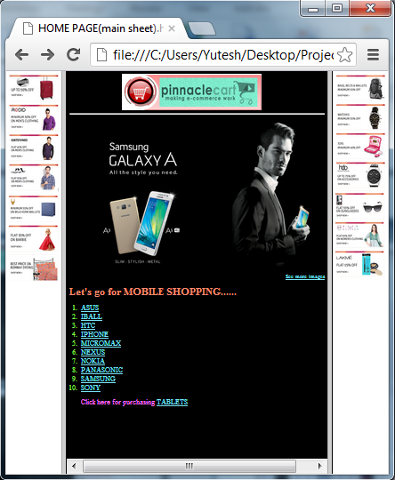

**Output of Program 5**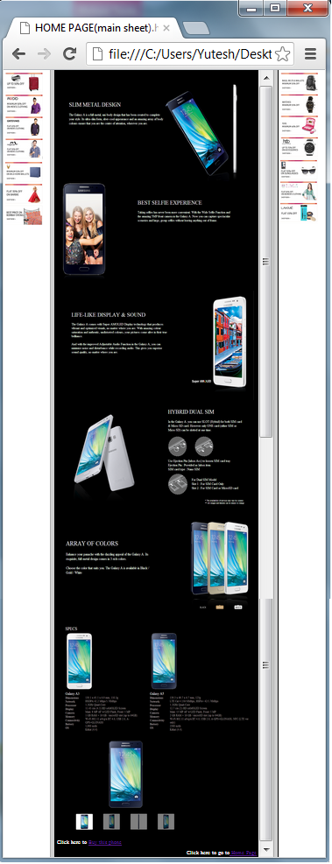

**Output of Program 6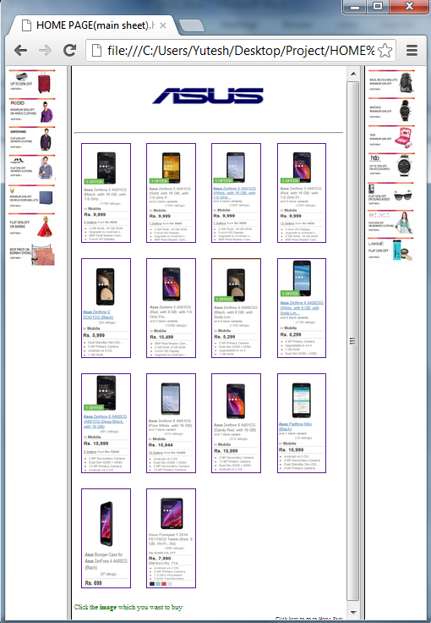Output of Program 7**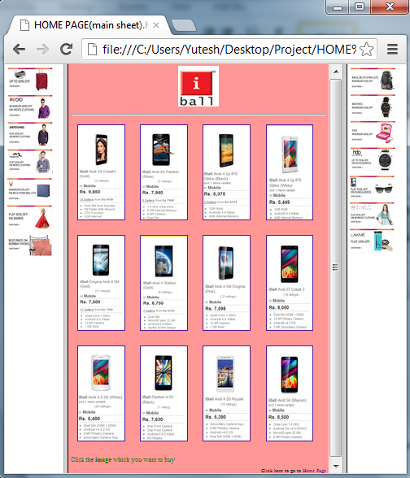

**Output of Program 8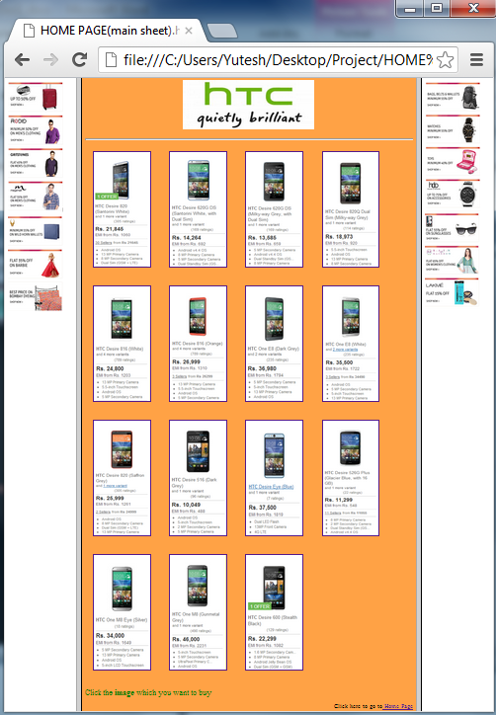Output of Program 9**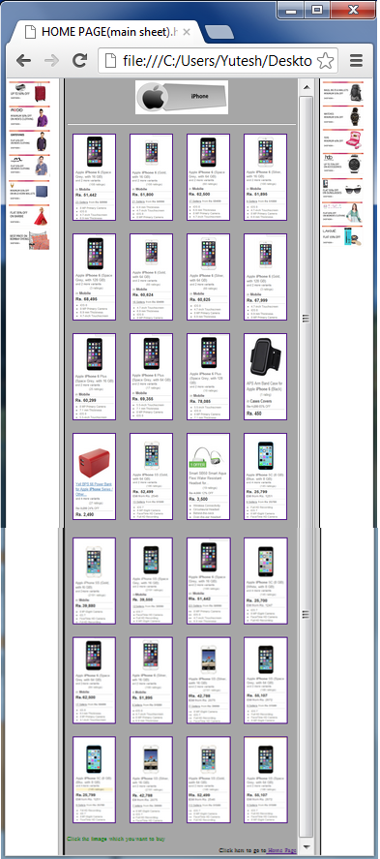

**Output of Program 10**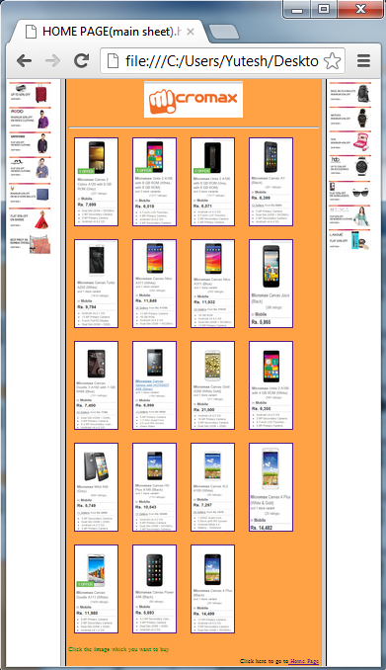

**Output of Program 11**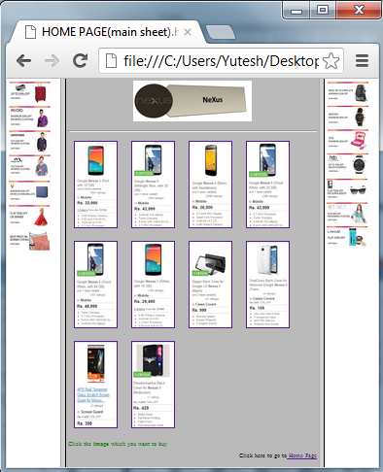

**Output of Program 12**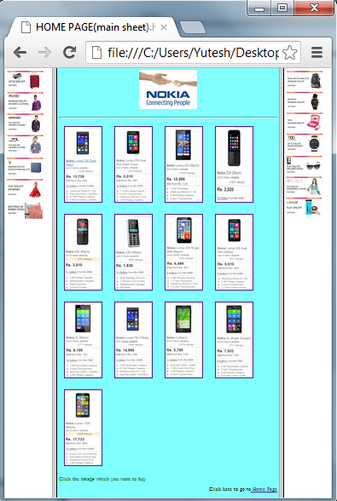

**Output of Program 13**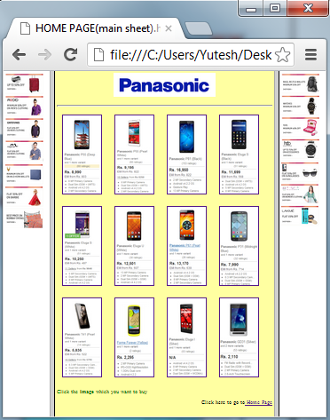

**Output of Program 14**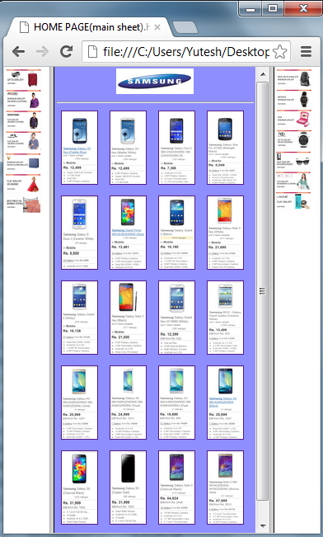

**Output of Program 15**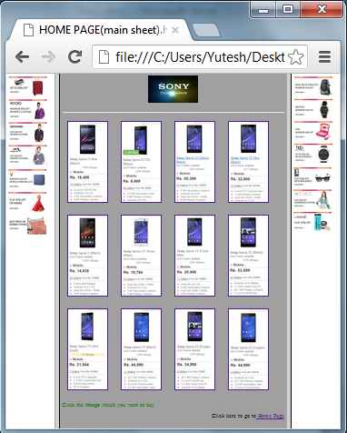

**Output of Program 16**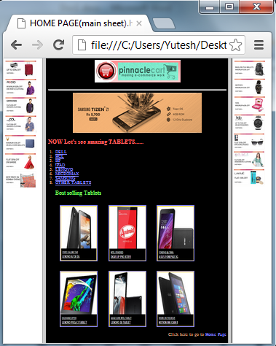

**Output of Program 17**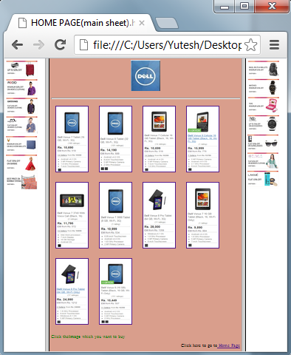

**Output of Program 18**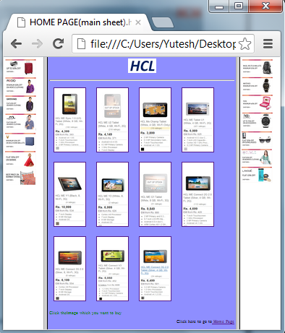

**Output of Program 19**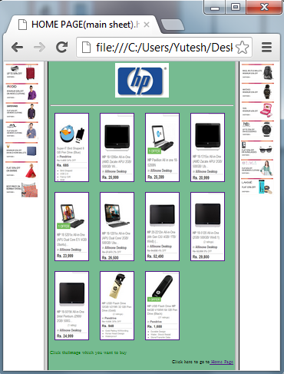

**Output of Program 20**

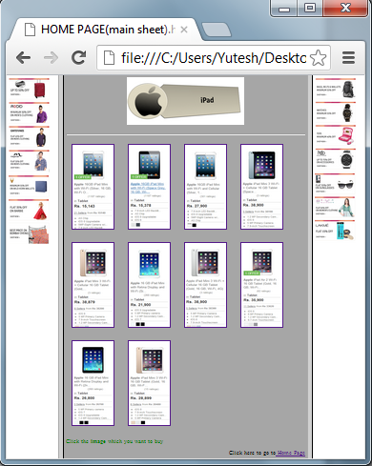

**Output of Program 21**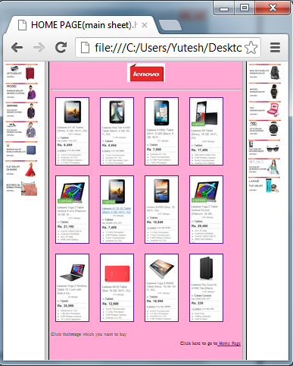

**Output of Program 22**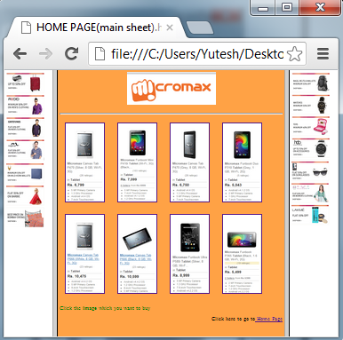

**Output of Program 23**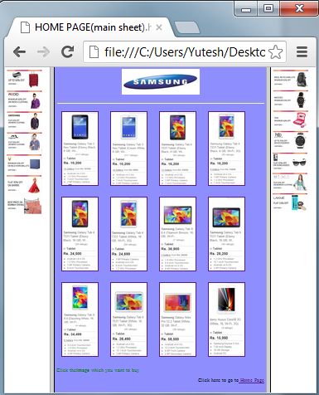

**Output of Program 24**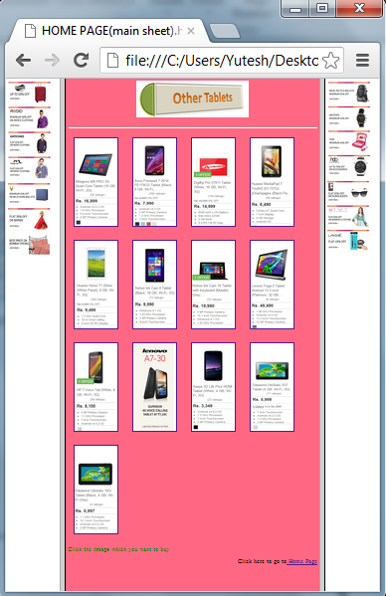

**Output of Program 25**