**Program 1**

**/*Program for showing the effect of different Text Formatting Tags*/**

<html>

<head><title> Learn HTML</title></head>

<body bgcolor=cyan>

<p>HTML supports six levels of heading </p>

<h1>main heading</h1>

<h2>sub heading,level 1</h2>

<h3>sub heading,level 2</h3>

<h4>sub heading,level 3</h4>

<h5>sub heading,level 4</h5>

<h6>sub heading,level 5</h6>

<p>you are required to<em>agree</em>with our terms and conditions</p>

<p>it is important to know the common<strong> HTML elements and attributes </strong></p>

<p> this is an example of text displayed in <b> bold </b></p>

<p>this is an example of text displayed in<u> underline </u></p> <big>SUN</big>is largest of all planets and<small>Mercury </small> is the smallest planet in our solar system</p>

<p> This is a example of subscript for formula H <sub> 2<sub> o </p>

<p> This ia a example of superscript for a formula (A+B) <sup> 2

<sup/></p>

<pre>

# include<stdio.h>

main()

{

printf("Hello world program");

}

</pre><hr>

</body></html>

**Output:-**

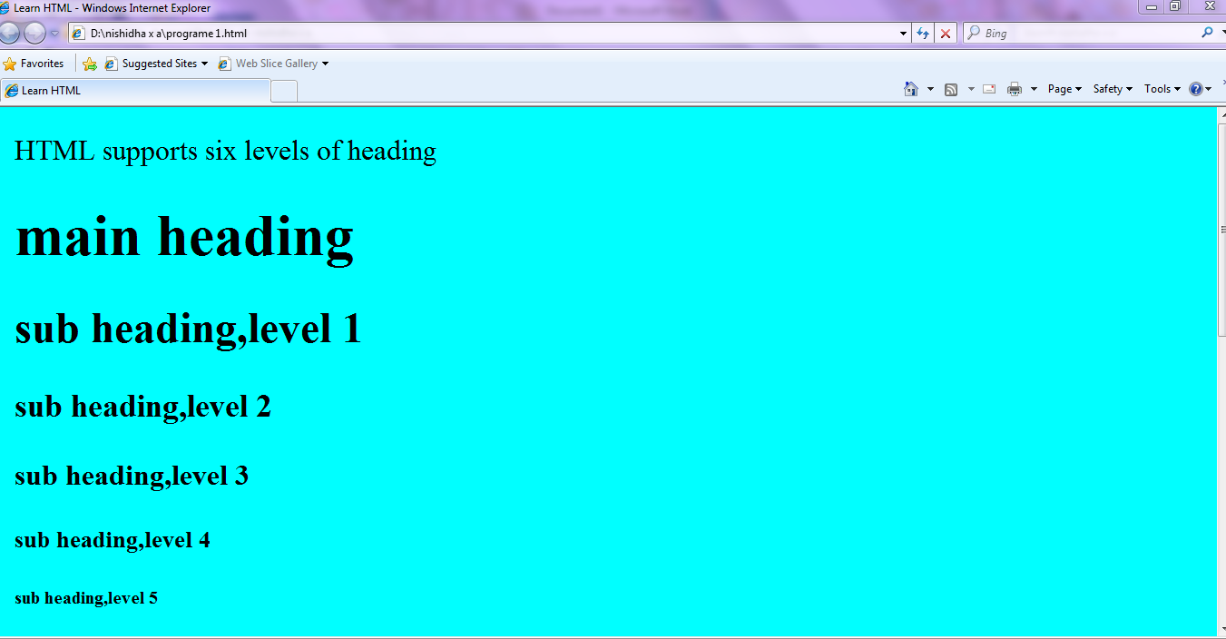

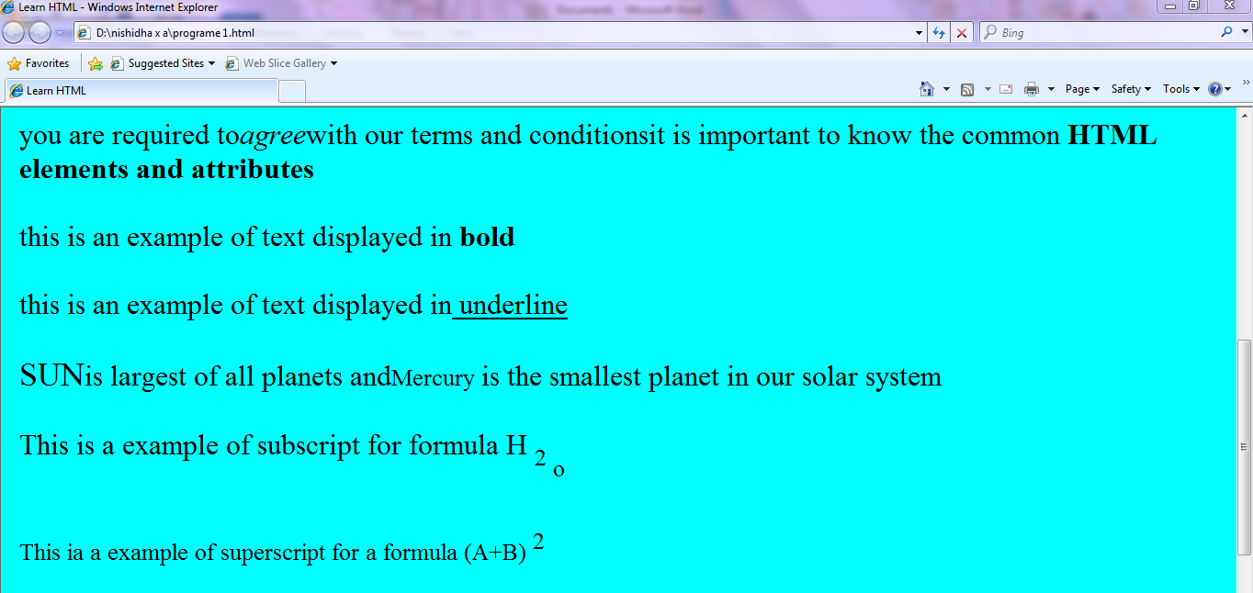

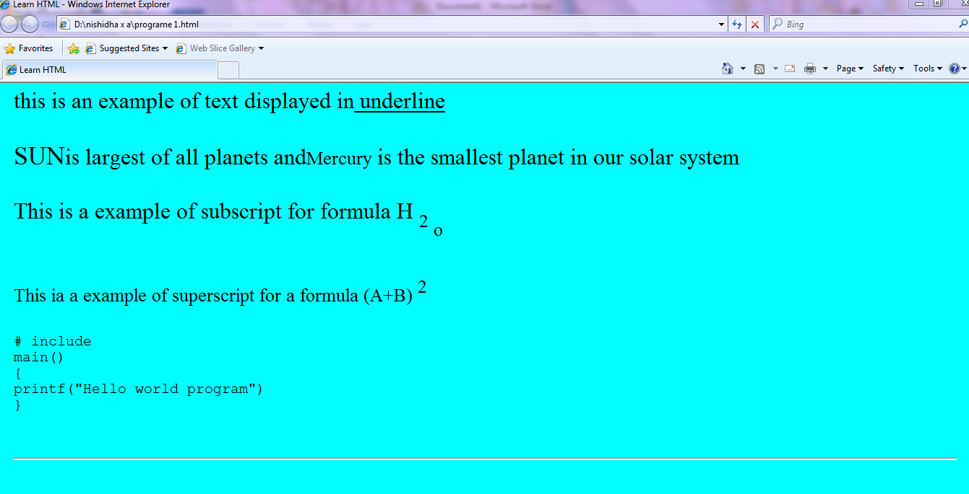

**Program 2**

**/*Program for creating a Table in a Webpage*/**

<html>

<head>

<title> Table </title>

</head>

<body>

<table border=1 bgcolor=red>

<th>Name </th>

<th> Age </th>

<th> city </th>

<tr>

<td>Student 1 </td>

<td> 21 </td>

<td>mumbai</td>

</tr>

<tr>

<td>Student 2</td>

<td> 22 </td>

<td>Nagpur</td>

</tr>

<tr>

<td>Student 3</td>

<td>25</td>

<td>Banglore</td>

</tr>

</table>

</body>

</html>

**Output:-**

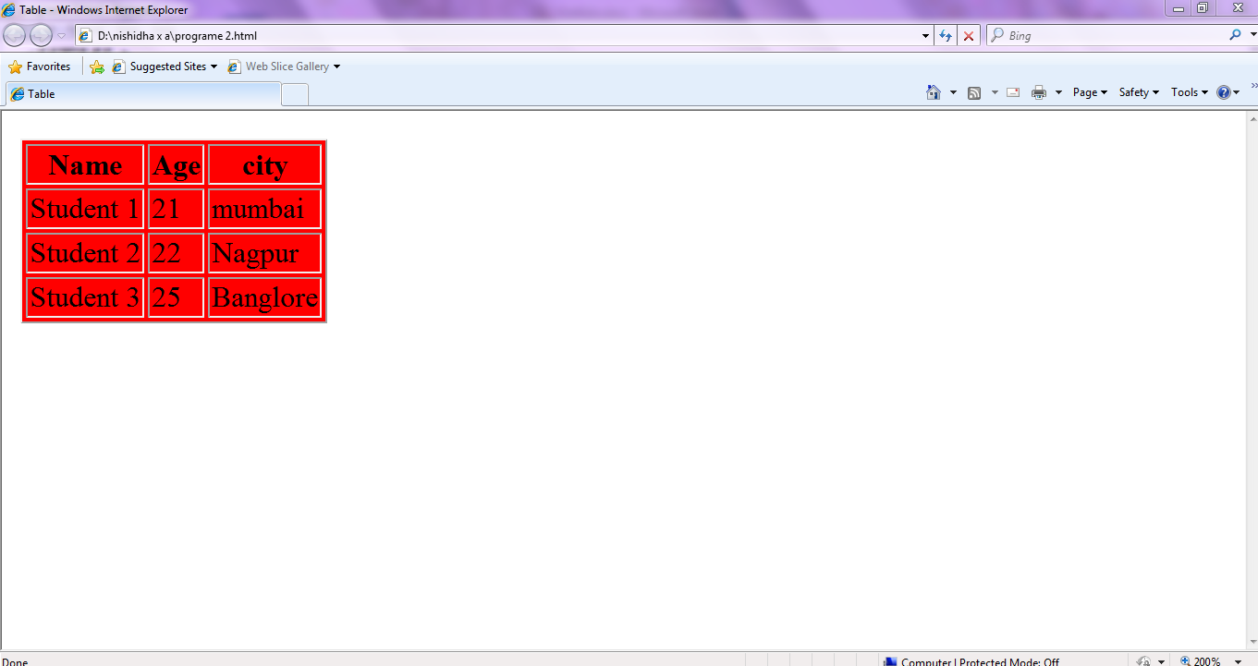

**Program 3**

**/*Program for inserting image in a webpage*/**

<html>

<head>

<title>

inserting image

</title>

</head>

</body>

<img src="D:\atul\animal1.jpg" height="300" width="300" alt="the image cannot be displayed because of some error" align=right border=”2”>

</body>

</html>

**Output:-**

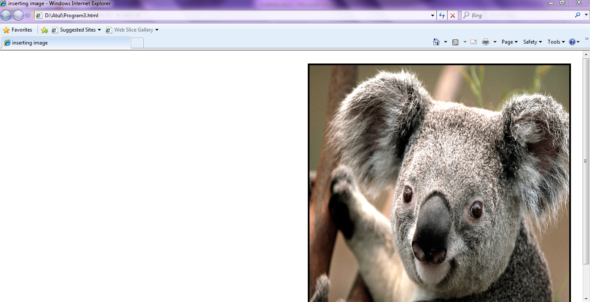

**Program 4**

**/*Program for adding Video, Audio, and Flash Animation in Webpage*/**

<html>

<!DOCTYPE html>

<head>

<title>

Adding audio, video and flash

</title>

</head>

<body>

<embed src="D:\abcd\abc.mp3" autoplay controls>

this is an audio file

</body>

</html>

**Output:-**

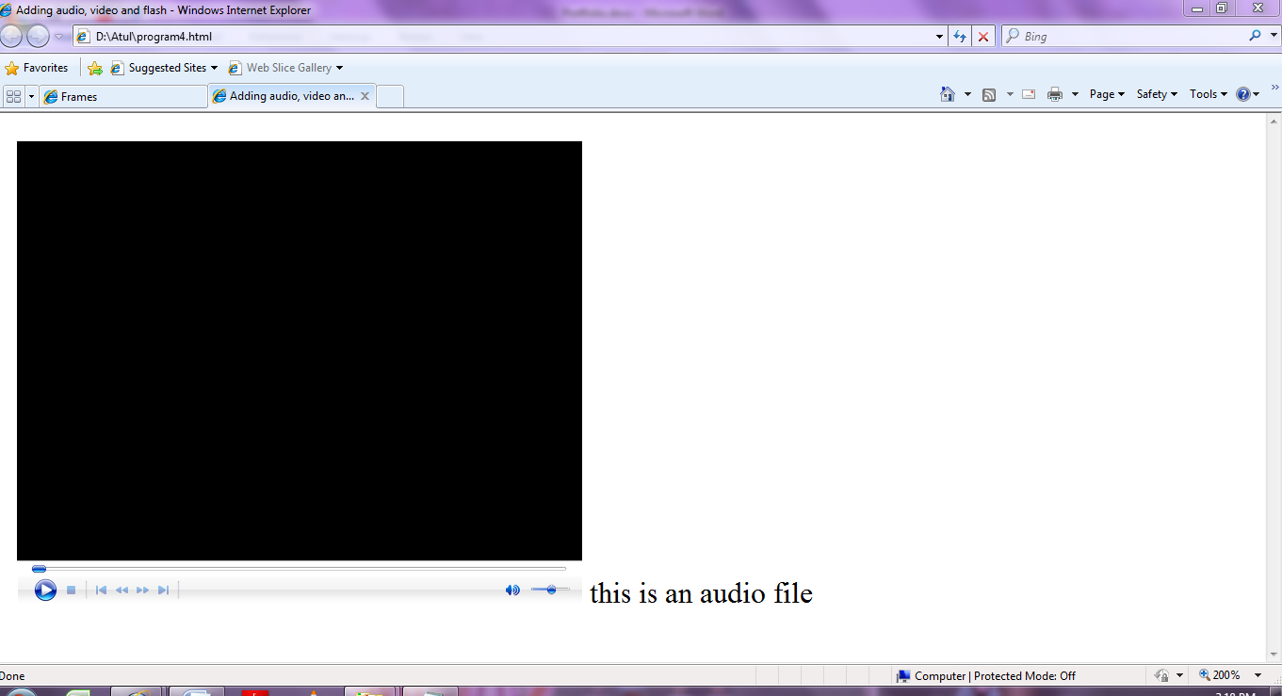

**Program 5**

**/*Program for designing a form in Webpage*/**

<html>

<head><title>creating form</title></head>

<body>

<p>Subscribe to your School site</p>

Name <input type="name" Name="Name" size="30">

Password <input type="pasword" Name="Name" size="30"><br><br>

Address:

<textarea rows="3" name="comments" colos="30">

</textarea>

<p>I agree to the terms and conditions

<input type="radio" value="agree" name="R1">Yes

<input type="radio" value="disagree" checked name="R1"> No</p>

<P> 10 <INPUT TYPE="CHECKBOX" name="10" value="on">

12 <INPUT TYPE="CHECKBOX" name="12" value="on">

Bachelors degree <INPUT TYPE="CHECKBOX" name="Bachelors degree" value="on">

Masters degree <INPUT TYPE="CHECKBOX" name="Masters degree" value="on"> </P>

<p> this is an example of dropdown menu (Single selection)</p>

<p> school education board <select size="1" name="school">

<option> State board </option>

<option> CBSE </option>

<option> ICSE </option>

</select> </p>

<p> <input type="Submit" value="submit" name="submit">

<input type="Reset" value="reset" name="reset">

</form>

</body>

</html>

**Output:-**

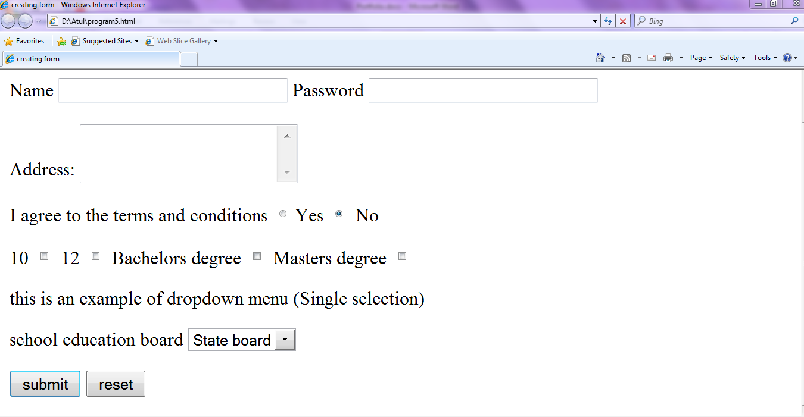

**Program 6**

**/*Program for creation of 3 frames in a webpage*/**

<html>

<head>

<title>

Frames

</title>

</head>

<frameset cols='30%,50%,20%'>

<frame src="program1.html">

<frame src="program2.html" name="Frame2" frameborder=2 marginheight=15 marginwidth=15 noresize scrolling=yes>

<frame src="program3.html" name="Frame3" frameborder=1 marginheight=10 marginwidth=15 noresize scrolling=no>

<noframes> Frame cannot be displayed due to some browser error </noframe>

</frameset>

</html>

**Output:-**

