UBER INDIA RIDES
Data Analytics Project Report
End-to-end analysis of 100,000 ride requests using MySQL, Python (pandas) and Power BI
Prepared by: Yuthika
Tools: MySQL · Python (pandas, SQLAlchemy, PyMySQL) · Power BI
Dataset: uber_rides_india_v2.csv — 100,000 rows, 20 columns, 10 Indian cities, calendar year 2024
Date: October 2026

1. Executive Summary
This project analyses 100,000 Uber ride requests across ten Indian cities in 2024 to understand where revenue comes from, how pricing and demand behave across the day, and where the business loses rides. Data was cleaned and queried in MySQL, explored further in Python, and presented in a two-page Power BI dashboard (Revenue and Driver views).
₹11.26M  Total revenue (completed rides) | ₹1.41M  Uber commission (profit) | ₹1.29M  Tips paid to drivers | 86.1%  Requests completed

Headline findings
- UberGo is the revenue engine. It earns ₹4.73M, 42% of all revenue, on 34% of completed rides. UberXL is second at ₹1.88M despite far fewer rides, because its average fare (₹274) is the highest.
- Five peak hours drive 39% of revenue. Surge pricing is applied only at 8–9 AM and 5–7 PM. Those hours hold 33% of rides but 39% of revenue, and surge rides pay about 41% more (₹169 vs ₹120).
- UPI dominates payments. It accounts for 40% of completed rides, more than twice as many as cash (18%).
- Roughly one request in seven is lost. 10.0% are cancelled and 3.9% end with no driver found, about ₹1.8M of potential revenue at the average fare.
- Demand is evenly spread by day and month. Weekdays carry 71.5% of rides, which is what five days out of seven predicts (71.4%). Daily and monthly revenue vary by only a few percent, so there is no strong weekend or seasonal effect in this data.
- Customer experience is healthy but has a tail. Average rating is 4.14 out of 5, with 7.9% of ratings at 1 or 2 stars and a 1.0% complaint rate.

2. Project Objectives and Approach
The goal was to turn raw ride-level data into business answers. The questions the project set out to answer were:
- Which cities and ride types generate the most revenue and the most profit?
- How does surge pricing affect fares, and when is it applied?
- At what hours is demand highest?
- How many requests fail (cancelled or no driver found), and does this differ by city?
- How do customers pay, rate and tip?
- Which drivers complete the most rides?

Workflow
Stage | Tool | What was done
1. Clean | MySQL | Fixed invalid dates, removed zero-fare completed rides, filled missing ratings, created a proper datetime column
2. Analyse | MySQL | Five business queries: KPIs, city, ride type, hourly demand, cancellations
3. Explore | Python | Loaded the cleaned table with SQLAlchemy and answered five further questions in pandas
4. Visualise | Power BI | Two-page dashboard: Revenue view and Driver view

3. Dataset
The source file uber_rides_india_v2.csv holds one row per ride request. Cancelled and no-driver requests have no fare, distance, duration or commission, which is why those columns are empty for about 13,900 rows.
Column | Type | Description
ride_id, driver_id | Integer | Identifiers for the ride and the driver
pickup_datetime, day_of_week, hour | Text / Integer | When the ride was requested (dd-mm-yyyy hh:mm)
city, ride_type | Text | 10 cities; 6 ride types (UberGo, UberMoto, UberAuto, UberPool, UberXL, Premier)
status | Text | Completed, Cancelled or No Driver Found
distance_km, duration_min | Numeric | Trip distance and duration (completed rides only)
fare_amount, surge_multiplier | Numeric | Fare in ₹ and surge factor (1.0, 1.2, 1.5 or 1.8)
Ubers Commission, Tips | Numeric | Uber's cut of the fare and the tip paid (v2 additions)
payment_method | Text | UPI, Cash, Credit Card, Debit Card, Uber Wallet
rating, customer_rating | Numeric | Rider's rating of the trip and driver's rating of the rider (1–5)
gender, driver_name, is_complaint | Text / Integer | Rider gender, driver name and a complaint flag

Of the 100,000 requests, 86,113 were completed, 10,020 cancelled and 3,867 had no driver found. All revenue figures in this report use completed rides only.

4. Data Cleaning (MySQL)
A profiling query first counted the problems in the raw table:
select count(*) AS total,
sum(pickup_datetime = '01-01-9999 00:00') AS bad_date,
SUM(status = 'Completed' AND fare_amount = 0) AS zero_fare,
SUM(status = 'Completed' AND rating = '') AS null_rating
from uber_rides_india;

Issue | Rows | Treatment
Placeholder date 01-01-9999 | 3 | Rows deleted. The text date was converted to a proper DATETIME column (pickup_ts) with STR_TO_DATE, and rows that failed to convert were removed.
Completed rides with fare = 0 | 2 | Rows deleted, because a completed ride with no fare is a recording error and would distort averages.
Completed rides with blank rating | 1,500 | Filled with the average completed-ride rating, rounded (4). Cancelled rides legitimately have no rating and were left blank.

After cleaning, the table held 99,995 rows, and 86,108 of them were completed rides. The Python analysis in section 6 uses this cleaned table. The Power BI dashboard and the charts in this report use the v2 file, which still contains the 5 removed rows. This changes totals by less than 0.01%.

5. SQL Analysis
Five queries were written in MySQL. The results below were computed on the full 100,000-row v2 file.

5.1 Overall KPIs
One query returns total rides, completed and cancelled counts, total revenue, average fare and average rating. Completed rides produced ₹11,260,883 in revenue at an average fare of ₹130.77, and Uber kept ₹1,407,516 in commission, an effective rate of 12.5% (every ride falls between 10% and 15%).

5.2 City performance
Mumbai, Delhi and Bangalore together generate 49% of revenue. Average fares are almost identical in every city (₹128–₹132), so differences in revenue come from ride volume, not pricing.
City | Completed rides | Revenue (₹) | Avg fare (₹) | Cancellation rate
Mumbai | 15,396 | 2,010,081 | 130.56 | 10.37%
Delhi | 13,694 | 1,790,804 | 130.77 | 10.01%
Bangalore | 12,805 | 1,689,179 | 131.92 | 9.82%
Hyderabad | 8,591 | 1,124,077 | 130.84 | 10.28%
Chennai | 7,904 | 1,035,706 | 131.04 | 9.80%
Kolkata | 7,876 | 1,031,293 | 130.94 | 10.33%
Pune | 6,873 | 891,143 | 129.66 | 10.23%
Ahmedabad | 5,196 | 687,734 | 132.36 | 9.07%
Jaipur | 4,297 | 549,349 | 127.84 | 9.43%
Lucknow | 3,481 | 451,518 | 129.71 | 10.13%
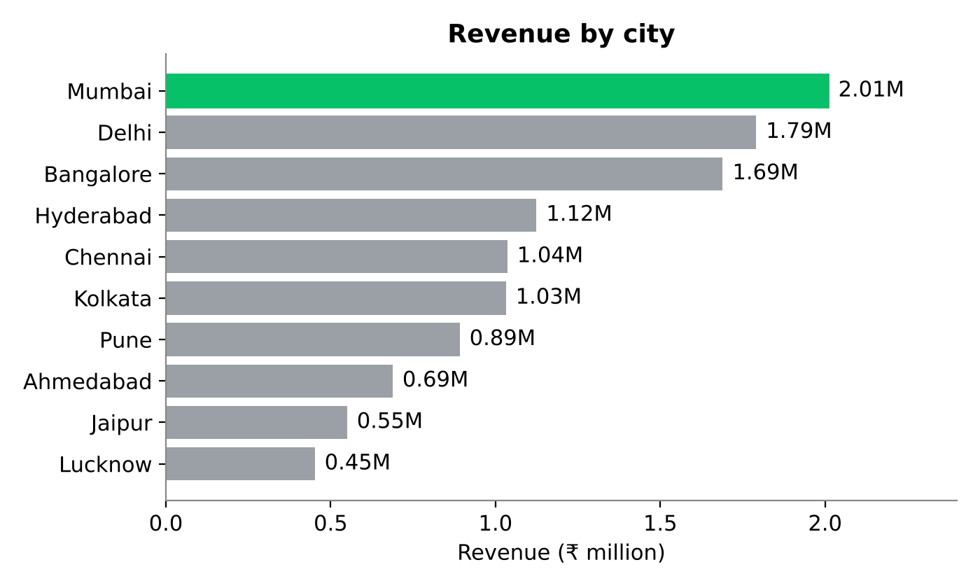
Figure 1: Revenue by city

5.3 Ride type performance
The ride type query adds distance and revenue per kilometre. UberXL and Premier earn the most per kilometre (₹47 and ₹38), while UberMoto earns the least (₹15) on the shortest trips.
Ride type | Rides | Revenue (₹) | Avg fare (₹) | Avg km | ₹ per km
UberGo | 29,395 | 4,729,558 | 160.90 | 5.77 | 27.89
UberXL | 6,861 | 1,879,364 | 273.92 | 5.79 | 47.35
UberAuto | 17,028 | 1,383,635 | 81.26 | 4.03 | 20.16
UberMoto | 19,002 | 1,134,499 | 59.70 | 3.99 | 14.96
Premier | 5,165 | 1,113,058 | 215.50 | 5.66 | 38.07
UberPool | 8,662 | 1,020,769 | 117.84 | 5.69 | 20.71
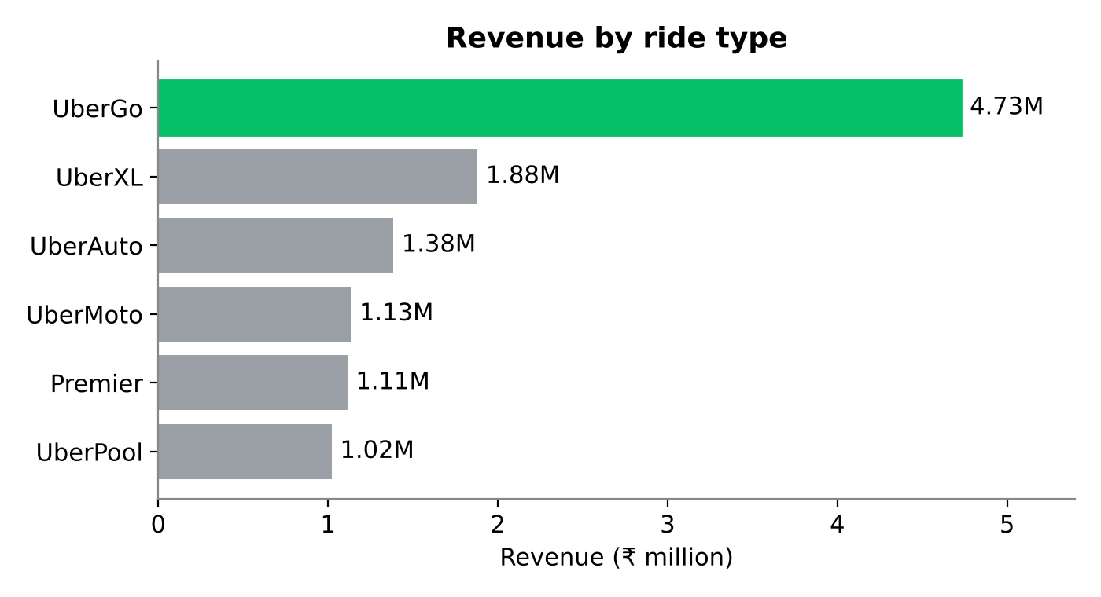
Figure 2: Revenue by ride type

5.4 Hourly demand
Requests peak at 6 PM (7.97% of all rides), 5 PM (7.95%) and 7 AM (7.14%). The quietest hours are 1–3 AM, with fewer than 800 requests each. There is a clear morning and evening commute pattern.
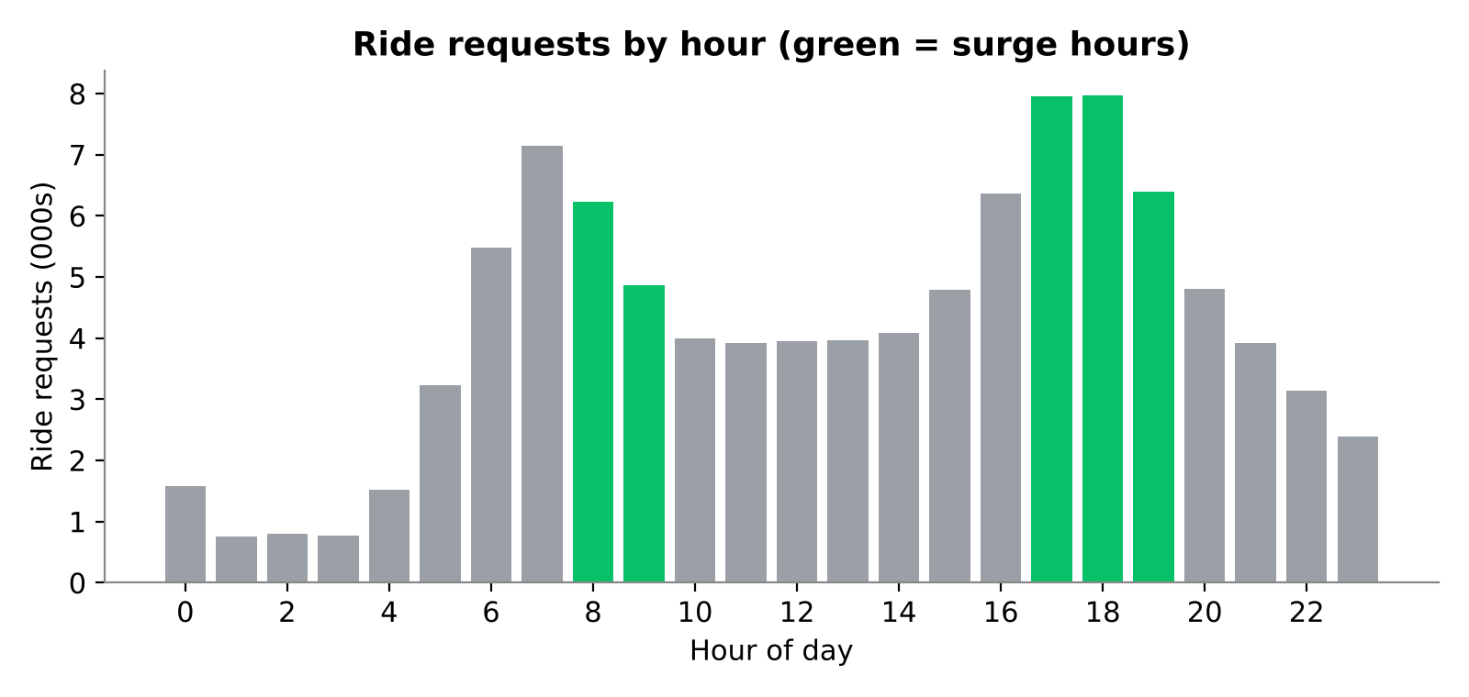
Figure 3: Ride requests by hour of day

5.5 Cancellation rate by city
Overall, 10.0% of requests are cancelled and a further 3.9% find no driver. Mumbai (10.37%), Kolkata (10.33%) and Hyderabad (10.28%) have the highest cancellation rates, and Ahmedabad (9.07%) the lowest. The spread is only 1.3 percentage points, so cancellation looks like a network-wide issue rather than a city-specific one.
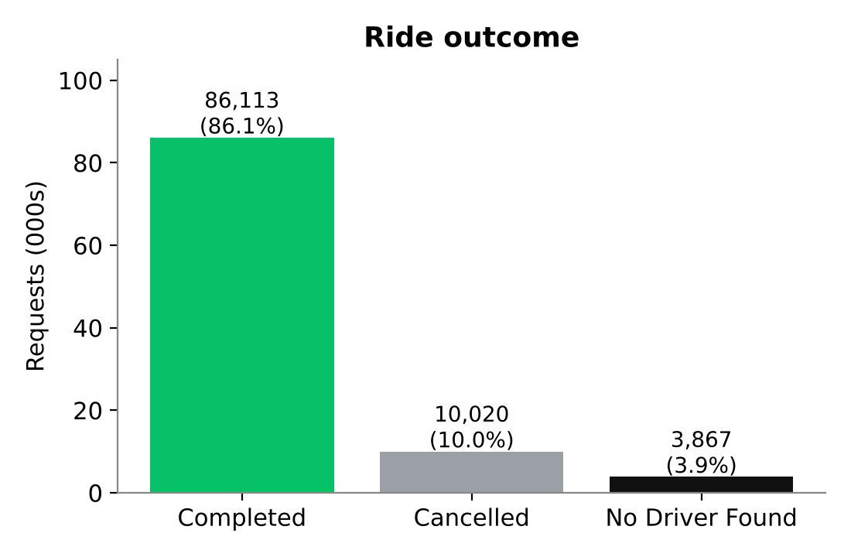
Figure 4: Outcome of all 100,000 requests

6. Python Analysis
The cleaned MySQL table was loaded into pandas through SQLAlchemy and PyMySQL (99,995 rows). Completed rides were filtered, text columns converted to numeric with pd.to_numeric, and five questions answered.

Q1. Rides by payment method
UPI is used for 34,716 of 86,108 completed rides (40.3%). Cash (15,409) and credit card (15,359) are roughly equal, followed by debit card (10,333) and Uber Wallet (10,291). Tipping behaviour does not depend on payment method: 34–36% of rides are tipped for every method.
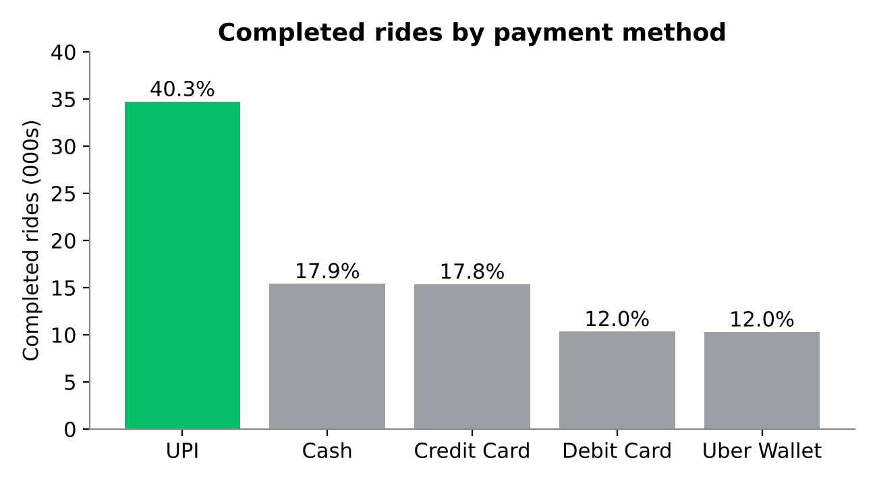
Figure 5: Completed rides by payment method

Q2. Average fare by ride type
UberXL ₹273.93, Premier ₹215.50, UberGo ₹160.91, UberPool ₹117.84, UberAuto ₹81.26 and UberMoto ₹59.70. Fares scale with vehicle class and distance; rides over 10 km average ₹302 against ₹59 for rides under 2 km.

Q3. Normal versus surge fares
Rides without surge average ₹120.17, against ₹169.46 for the 18,527 surge rides, a 41% premium. Surge levels are 1.2x (8,567 rides), 1.5x (7,176) and 1.8x (2,785).
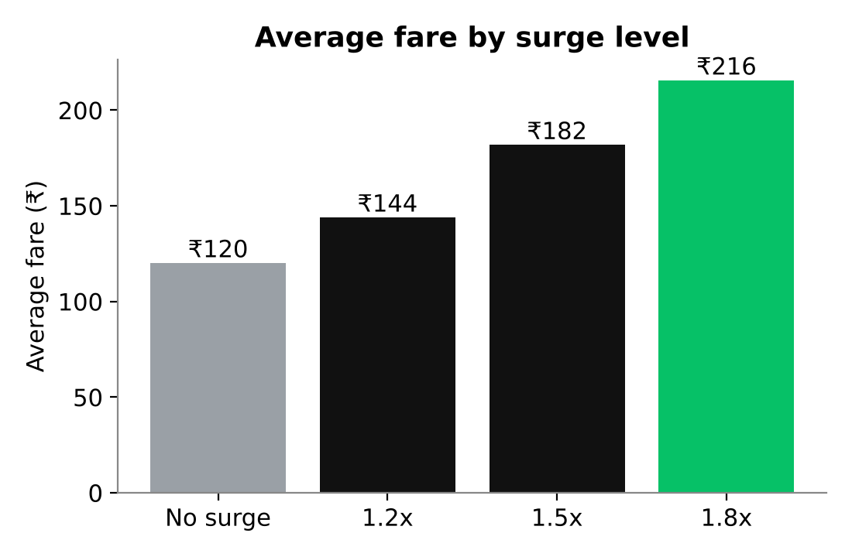
Figure 6: Average fare by surge level

Q4. Weekday versus weekend
Weekdays have 71,538 requests and weekends 28,457 (71.5% vs 28.5%). Because weekdays are 5 of 7 days (71.4%), the per-day demand is flat. Revenue per day of the week is within 2% of the average (₹1.59M to ₹1.62M each).

Q5. Top 10 drivers by completed rides
Driver 4027 leads with 41 completed rides, followed by drivers 2219 and 2692 (38 each). The top ten range from 36 to 41 rides. With 4,000 active drivers averaging 21.5 rides, workload is spread widely and the top ten drivers account for only 0.5% of revenue.
Driver ID | Completed rides
4027 | 41
2219 | 38
2692 | 38
4574 | 37
4271 | 37
1991 | 37
1673 | 37
2540 | 37
4706 | 36
4899 | 36

7. Power BI Dashboard
The dashboard has two pages, switched with the Revenue and Driver buttons, built on the uber_rides_india_v2 table and a Calendar table.

Page 1: Revenue
- KPI cards: Total Revenue ₹11.26M and Total Profit ₹1.41M (Uber commission).
- Rating Count bar chart, Gender-wise Revenue pie (male 59.8%, female 40.2%), Ride Type Revenue bar, and Day of the Week Revenue Split column chart.

Page 2: Driver
- KPI cards: Average Rating and Total Tips ₹1.29M.
- Ride Status waterfall (86K completed, 10K cancelled, 4K no driver found, 100K total), Tip Amount Breakdown donut (male 60.0%, female 40.0%) and Month-wise Fare Amount for 2024.
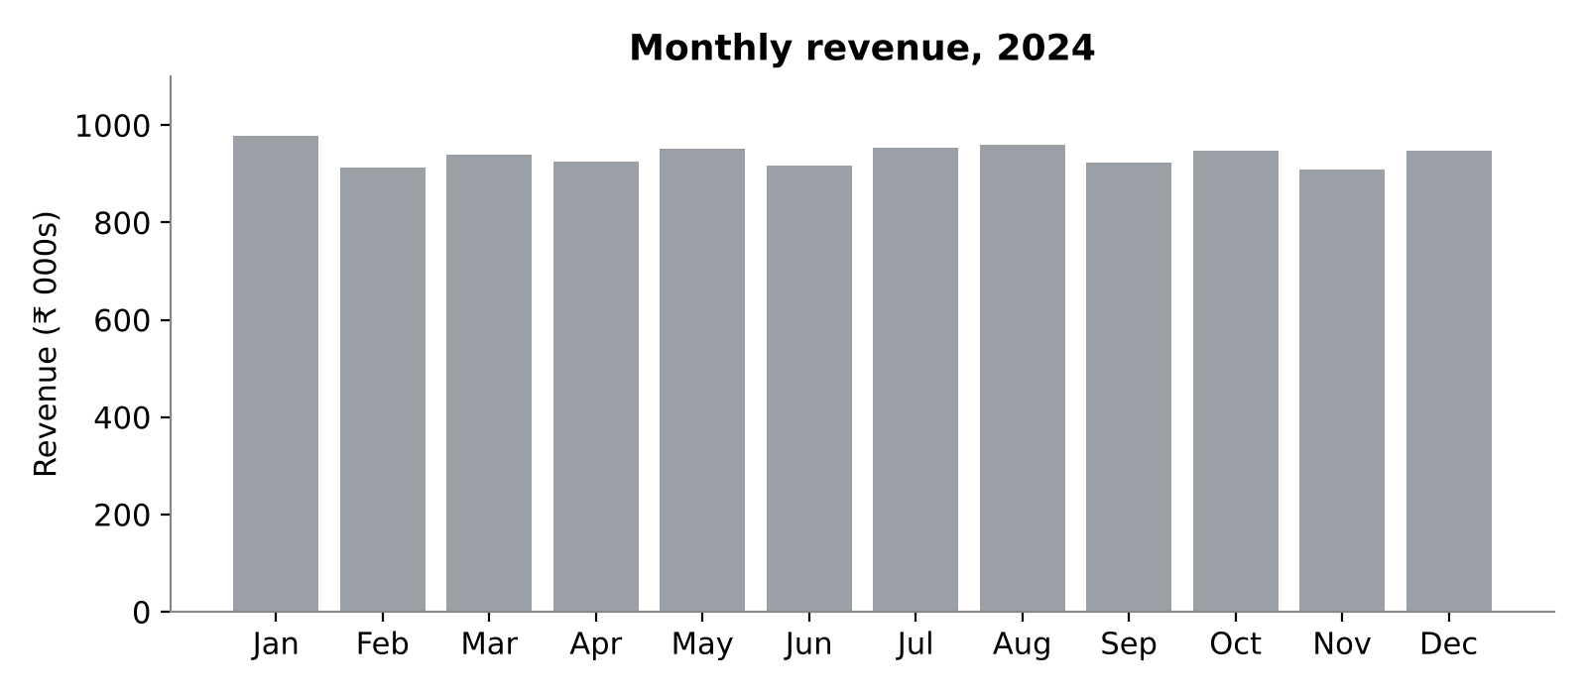
Figure 7: Monthly revenue in 2024 (recreated from the dataset)

Observations from the dashboard
- Gender split follows rider mix. Women are 39.9% of completed rides and 40.2% of revenue, so average fare per ride is nearly the same (₹131.59 vs ₹130.22). The same is true for tips.
- Monthly revenue is stable. It ranges from ₹908K (November) to ₹978K (January), with no seasonal swing.
- Average Rating needs correcting. The card shows 3.50, but the true average of rated rides is 4.14. The Rating Count chart shows a bar for rating "0" of about 15K, which suggests that blank ratings were loaded as 0. 15,387 blank ratings (13,887 cancelled or no-driver rides plus 1,500 completed rides) pull the average down. Use Power Query to keep these as null (or filter to rated rides); the card should then read 4.14.
- Three rows carry the placeholder year 9999. They are not in the 2024 monthly chart but still count towards totals. Filter them out in Power Query.

8. Key Insights

Revenue and profit
- Revenue is ₹11.26M and commission ₹1.41M, a steady 12.5% take rate.
- UberGo (42%) and UberXL (17%) deliver nearly 60% of revenue. UberMoto has the second-most rides but only 10% of revenue.
- Mumbai, Delhi and Bangalore deliver 49% of revenue. City fares are nearly identical, so growth depends on volume.

Pricing and demand
- Surge runs only at 8–9 AM and 5–7 PM (average multiplier about 1.26). These five hours bring 33% of rides, 39% of revenue and roughly ₹0.9M of extra fare from surge.
- 7 AM (7,145 requests) and 4 PM (6,368 requests) are among the busiest hours but have no surge at all.
- Hours 1–4 AM have only 5.4% of requests combined.

Service quality
- 13.9% of requests produce no ride, worth about ₹1.8M at the average fare. That is 16% of actual revenue.
- Average rating is 4.14; 7.9% of ratings are 1 or 2 stars. Complaints are 1.0% of completed rides.
- Tips: 35% of rides are tipped, averaging ₹42.76, which totals ₹1.29M or 11.5% of fare revenue.
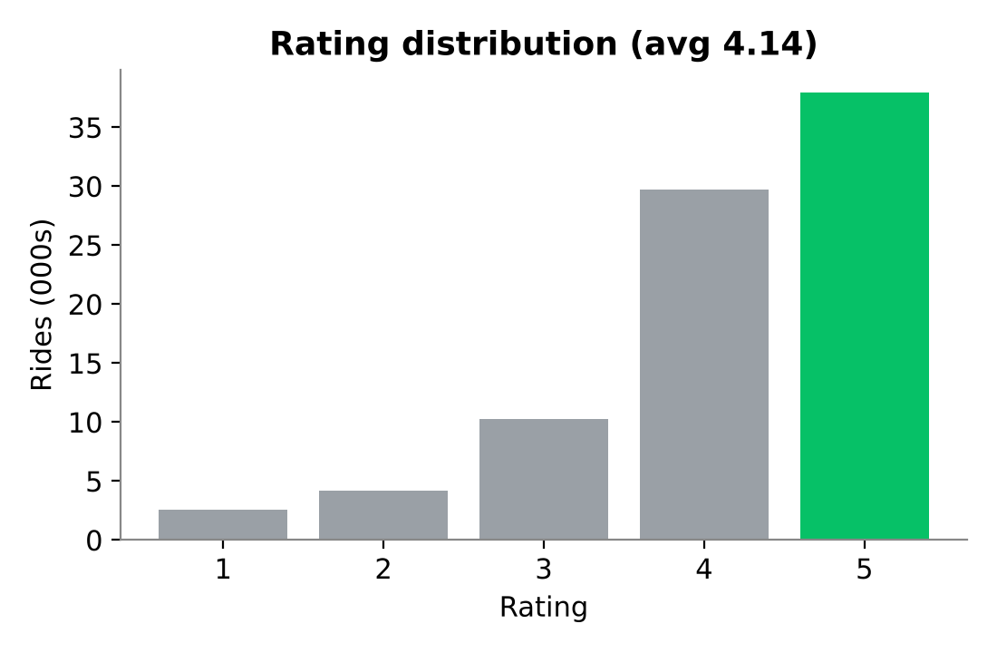
Figure 8: Distribution of ratings (blank ratings excluded)

9. Conclusions and Recommendations
Uber India's 2024 business in this dataset is large, stable and fairly uniform: it has a strong core in UberGo, a profitable premium segment in UberXL, and a commute-driven demand pattern. The biggest controllable weakness is the 13.9% of requests that never become rides.
- 1. Reduce failed requests. Even recovering a quarter of the lost rides would add roughly ₹0.45M. Target the three cities with the highest cancellation rates (Mumbai, Kolkata, Hyderabad) and add driver incentives at peak hours.
- 2. Test surge at 7 AM and 4 PM. These high-demand hours currently run at base fare. A modest 1.2x there is the most direct pricing opportunity in the data, and should be tested carefully against its effect on cancellations.
- 3. Grow premium categories. UberXL and Premier earn ₹47 and ₹38 per km against ₹15 for UberMoto. Promote them in high-fare corridors, especially for trips over 5 km.
- 4. Keep investing in UPI. With 40% of rides, UPI offers the lowest-friction checkout, so offers tied to UPI have the broadest reach.
- 5. Look into low-rated trips. About 8% of ratings are 1–2 stars; analyse them by driver and city to find a targeted quality programme.
- 6. Fix the dashboard rating. Correct the Average Rating card from 3.50 to 4.14 before sharing the dashboard.

10. Limitations
- The data covers one year (2024) and appears synthetic and highly regular: city fares, tipping rates and weekday patterns are almost uniform. Real-world data would show more variation, so conclusions about seasonality or weekends should not be generalised.
- Missing ratings on 1,500 completed rides were imputed with the mean, which slightly reduces rating variance.
- "Profit" is Uber's commission, not net profit, since operating costs are not in the data.
- The data has no cancellation reasons, driver wait times or customer identifiers, so causes of failed rides and repeat usage cannot be analysed.

