BRAZILIAN E-COMMERCE ANALYSIS
Sales, Delivery Performance and Customer Satisfaction on the Olist Marketplace
Project Report
Tools: Python (pandas), MySQL, Power BI
Dataset: Brazilian E-Commerce Public Dataset by Olist (Kaggle)
Author: Yuthika
Date: October 2026

1. Executive Summary
This project analyses roughly 99,000 orders placed on the Olist Brazilian e-commerce marketplace between September 2016 and October 2018. The data was cleaned and prepared with Python (pandas), loaded into a MySQL database, queried with seven business-focused SQL analyses, and presented in an Executive E-Commerce Dashboard built in Power BI.
The headline figures shown on the dashboard are:
Total Revenue | Total Orders | Average Order Value
13.59M | 99.4K | 136.68

Late Delivery Rate | Revenue trend
6.57% | Steady growth from early 2017, then a plateau around 1.0M per month through 2018

The key finding is that delivery performance drives customer satisfaction: the dashboard shows average review scores near 4 for orders delivered on or before the estimated date, falling steeply as orders arrive later than promised.

2. Business Objectives
The analysis was designed to answer questions an e-commerce leadership team would ask:
- How fast is revenue growing, and is growth consistent month to month?
- Which products lead sales within each category?
- Where, geographically, does delivery fall short of the promised date?
- How much does late delivery hurt customer review scores?
- How do payment methods and credit-card instalment plans relate to order value and volume?
- Which high-volume sellers are underperforming on delivery and ratings?

3. Dataset Description
The Olist dataset is distributed as nine relational CSV files. All nine were loaded into pandas and later written to MySQL.
Table | Content
customers | Customer ID, unique ID, zip prefix, city and state (99,441 rows)
orders | Order status and five timestamps: purchase, approval, carrier handover, customer delivery, estimated delivery (99,441 rows)
order_items | Products, sellers, price and freight for each order line
order_payments | Payment type, instalments and payment value
order_reviews | Review score, title and comment
products | Category name, dimensions, weight and photo count
sellers | Seller location
geolocation | Zip-code latitude and longitude (about 1 million rows)
product_category_name_translation | Portuguese to English category names

4. Data Preparation in Python

4.1 Loading and inspection
A loop reads every CSV in the project folder into a dictionary of DataFrames, keyed by a shortened table name. The .info() and .describe() methods were used to check data types, row counts and value ranges.

4.2 Missing values
Table | Missing values found | Treatment
order_reviews | review_comment_title (87,656); review_comment_message (58,247) | Filled with 'No Title' and 'No Message'
products | product_category_name (610); weight and dimensions (2 each) | Category filled with 'Unknown'; the 2 rows without weight dropped
orders | approval date (160); carrier date (1,783); customer delivery date (2,965) | Kept as null; these correspond to orders not yet approved, shipped or delivered

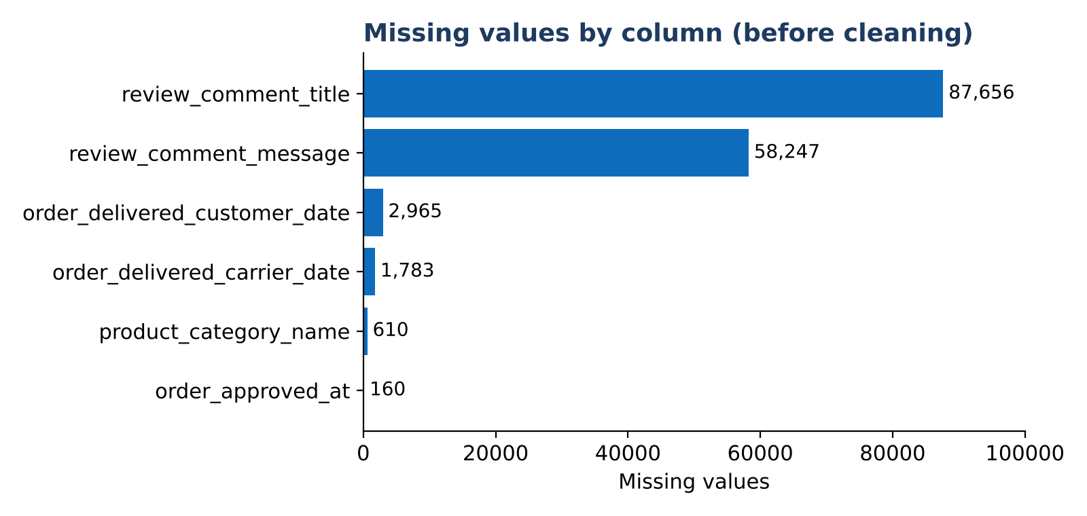
Figure 1: Missing values by column before cleaning

4.3 Type conversion and feature engineering
All five order timestamp columns were converted to datetime. A new feature, late_delivery, was engineered as the number of days between the actual delivery date and the estimated delivery date. Negative values mean the order arrived early; positive values mean it arrived late. Across delivered orders the average is about 11.9 days early, with a range from 147 days early to 188 days late.
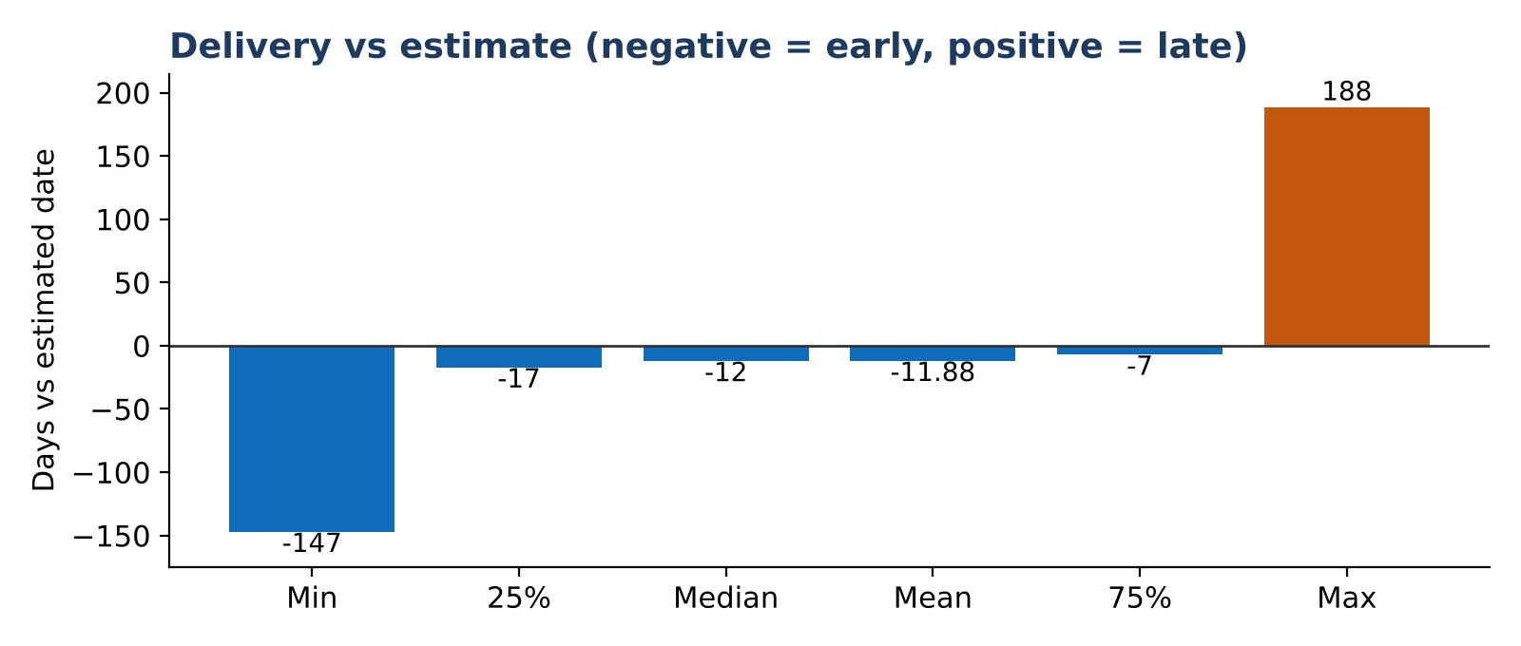
Figure 2: Distribution summary of late_delivery across delivered orders

4.4 Loading to MySQL
The cleaned tables were written to a MySQL database (olist_db) using SQLAlchemy and PyMySQL, so that the analysis could be done in SQL and connected to Power BI.

5. SQL Analysis
Seven queries were written in MySQL. They make use of common table expressions (CTEs), window functions (LAG, DENSE_RANK), conditional aggregation with CASE, multi-table joins and HAVING filters.

Q1. Month-over-month revenue growth
Approach: CTE sums item price per month for delivered orders; LAG() retrieves the previous month's revenue to compute percentage growth.
Purpose: Shows whether growth is steady or volatile and highlights seasonal peaks and dips.

Q2. Top 3 products in each category
Approach: Counts orders per product within each category and ranks them with DENSE_RANK() partitioned by category; keeps ranks 1 to 3.
Purpose: Identifies the hero products that anchor each category.

Q3. Delivery performance by state
Approach: Joins orders to customers and calculates the share of delivered orders where late_delivery is greater than zero, per customer state.
Purpose: Pinpoints regions where logistics fail to meet promised dates.

Q4. Impact of late delivery on review rating
Approach: Joins orders to reviews and compares average review score and order count for late versus on-time or early orders.
Purpose: Quantifies the satisfaction cost of late delivery.

Q5. Payment method impact
Approach: Groups by payment type to compare distinct orders, total revenue and average payment value; excludes 'not_defined'.
Purpose: Shows which payment methods drive volume and value.

Q6. Credit-card instalments vs spending
Approach: Buckets instalments into Single Payment, Short-Term (2 to 5), Mid-Term (6 to 10) and Long-Term (11+), then compares average payment value.
Purpose: Tests whether longer instalment plans enable larger purchases.

Q7. Underperforming high-volume sellers
Approach: Aggregates by seller with at least 50 orders and lists the ten with the lowest average review score, alongside revenue and average delivery lag.
Purpose: Flags sellers that put customer experience at risk at scale.

6. Power BI Executive Dashboard
The dashboard consolidates the analysis into a single page titled Executive E-Commerce Dashboard.
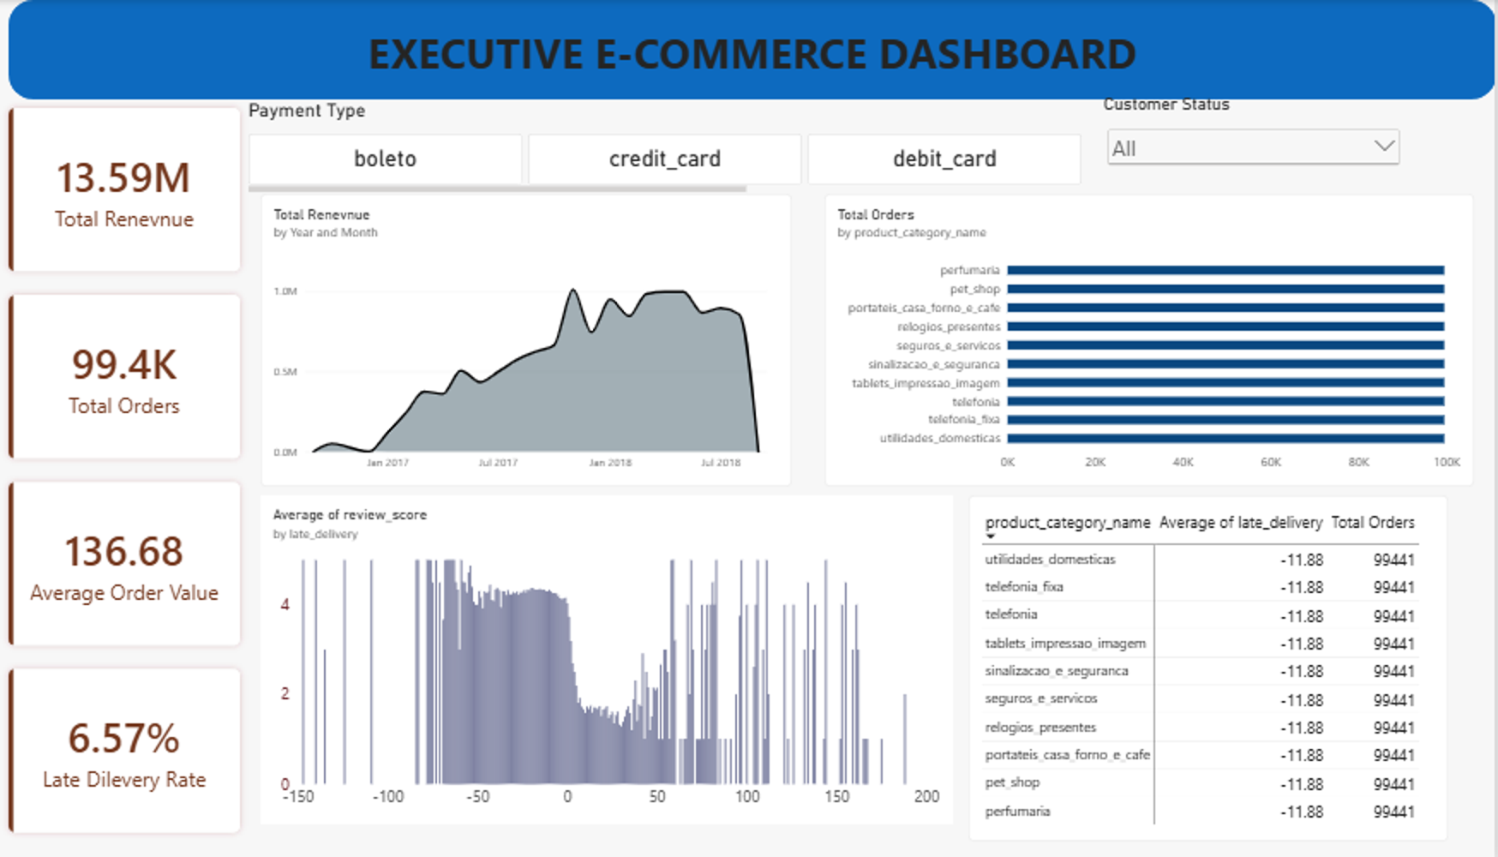
Figure 3: Power BI Executive E-Commerce Dashboard
It contains:
- Four KPI cards: Total Revenue (13.59M), Total Orders (99.4K), Average Order Value (136.68) and Late Delivery Rate (6.57%).
- A Total Revenue area chart by year and month, showing growth from early 2017 to a plateau of roughly 1.0M per month in 2018, with a drop at the end of the series.
- A Total Orders bar chart by product category (see Limitations).
- A chart of average review score by days of late delivery, showing the satisfaction penalty for late orders.
- A category table with average lateness and order count (see Limitations).
- Slicers for Payment Type (boleto, credit_card, debit_card) and Customer Status, allowing leaders to filter every visual.

7. Key Insights
- Growth then plateau. Monthly revenue climbed from early 2017 and levelled off near 1.0M in 2018. The sharp fall at the right edge of the chart reflects the dataset ending in October 2018 rather than a real collapse.
- Most orders arrive early. The average delivery is about 12 days ahead of the estimate, and only 6.57% of orders are late, so Olist's delivery estimates are conservative.
- Lateness hurts ratings. Review scores stay around 4 when orders arrive on time or early and drop sharply as delay grows, so the small share of late orders has a disproportionate effect on satisfaction.
- Payment mix matters. The dashboard's payment-type slicer lets stakeholders compare boleto, credit card and debit card behaviour; Q5 and Q6 quantify value and instalment effects.
- Seller quality is measurable. Q7 gives operations a ready shortlist of high-volume sellers with weak ratings and delivery lag.

8. Recommendations
- Tighten logistics in states with the highest late-delivery rates (Q3) and with carriers serving them.
- Set up an early-warning process that proactively contacts customers whose orders are at risk of being late, as lateness is the clearest driver of low ratings.
- Review or coach sellers flagged by Q7 before their ratings affect marketplace reputation.
- Promote instalment options where they are linked to higher basket values (Q6).
- Use the top-product lists (Q2) to guide inventory, promotion and homepage placement.

9. Limitations and Next Steps
- The data covers September 2016 to October 2018; the final months are incomplete, so the end-of-series revenue drop should not be read as a trend.
- Revenue is calculated from item price and excludes freight, while payment analyses use payment value; the two are not directly comparable.
- Review scores show association with late delivery, not proof of causation.
- In the Power BI file, the category-level visuals (Total Orders by product category and the category table) currently show the same order count and average lateness for every category, which indicates the products table is not related to orders through order_items. Fixing this relationship is the first next step.
- Next steps: add customer segmentation (RFM) and repeat-purchase analysis using customer_unique_id, build a delivery-time prediction model, and add seller and state maps in Power BI using the geolocation table.

10. Conclusion
The project takes raw relational data through cleaning, feature engineering, SQL analysis and an executive dashboard. It shows that the marketplace grew quickly and delivers ahead of schedule on most orders, but that the minority of late deliveries is where customer satisfaction is won or lost.

