OpenQuant
Getting Started Guide
OpenQuant入门指南
Version 3.2.2, 2011-07-31
Kevin Jameson
凯文 詹姆森

翻译：伍侃、张毅



1 Introduction引言 1
1.1 Intended Audience面向的读者 1
1.2 Goals of This Document编写目的 2
2 Installing the License File安装证书文件 3
3 Touring the OpenQuant IDE Interface浏览OpenQuant开发界面 4
3.1 Understanding IDE Menus了解IDE菜单 4
3.1.1 The File Menu文件菜单 5
3.1.2 The Edit Menu编辑菜单 6
3.1.3 The View Menu视图菜单 7
3.1.4 The Solution Menu解决方案菜单 11
3.1.5 The Data Menu数据菜单 12
3.1.6 The Tools Menu工具菜单 13
3.1.7 Using the Tools-Options Dialog to Solve Out of Memory Errors使用 “选项”对话框，解决内存溢出的错误 14
3.1.8 The Help Menu帮助菜单 15
3.2 Understanding IDE Toolbars了解IDE工具条 15
3.2.1 The File Toolbar文件工具条 15
3.2.2 The Edit Toolbar编辑工具条 15
3.2.3 The Instrument Toolbar合约工具条 16
3.2.4 The Solution Toolbar解决方案工具条 16
3.2.5 The Trading Mode Toolbar交易模式工具条 17
3.2.6 The Chart Toolbar图表工具条 18
3.2.7 The Solution View Toolbar解决方案视图工具条 19
3.2.8 The Window Pane Toolbar面板工具条 19
3.3 Working with Dockable Window Panes使用可停靠面板 20
3.3.1 The Instrument Window Pane合约面板 22
3.3.2 The Providers Window Pane 提供商面板 24
3.3.3 The Indicators Window Pane指标面板 25
3.3.4 The Output Window Pane输出面板 27
3.3.5 The Provider Errors Window Pane 提供商错误面板 27
3.3.6 The Properties Window Pane 属性面板 28
3.3.7 The Solution Explorer Window Pane 解决方案资源管理器面板 29
3.4 Working with the Center IDE Window使用中央IDE窗口 31
3.4.1 The Start Page Tab开始页选项卡 32
3.4.2 The Quote Monitor Tab报价监视器选项卡 33
3.4.3 The Instrument Chart Tab合约图表选项卡 34
3.4.4 The Instrument Data Series Tab合约数据序列选项卡 36
3.5 Working with Strategy Views使用策略视图 37
3.5.1 The Strategy Bar Chart View策略bar图表视图 37
3.5.2 The Strategy Portfolio View策略投资组合视图 39
3.5.3 The Strategy Performance View策略绩效视图 40
3.5.4 The Strategy Results View策略结果视图 41
3.5.5 The Strategy Market Scanner View策略市场扫描器视图 43
4 Acquiring Market Data获取市场数据 44
4.1 Types of Market Data市场数据类型 44
4.2 Importing Market Data市场数据导入 45
4.3 Viewing a Data Series查看数据序列 47
4.4 Editing Stored Data编辑存储的数据 48
4.5 Analyzing Data with Indicators通过指标分析数据 49
5 Running a Preconfigured Trading Strategy运行预置的交易策略 51
5.1 Running Your First Strategy运行你的第一个策略 51
6 Creating New Solutions,Projects,and Strategies新建解决方案、项目和策略 54
6.1 Solutions, Strategies, and Projects解决方案、策略和项目 55
6.2 Creating a New Solution新建解决方案 56
6.3 Adding a New Strategy to a Solution新加策略到解决方案 58
6.4 Adding an Instrument添加合约 60
6.5 Choosing a Market Data Type选择市场数据类型 61
6.6 Viewing Your Strategy Code查看策略代码 62
6.7 Correcting Code Errors更正代码错误 63
6.8 Code Editor Capabilities代码编辑器功能 64
6.9 Running Your New Strategy运行新策略 64
6.10 Setting Initial Simulation Values设置模拟初始化参数 66
6.11 Making Results More Realistic使结果更逼真 67
7 Configuring a Strategy for Paper or Live Trading配置仿真或实盘 69
7.1 Configure Trading Mode Options配置交易模式 69
7.2 Choose a Trading Mode选择交易模式 70
7.3 Check Provider Connections检查提供商连接 70
7.4 Check for Provider Errors检查提供商错误 71
7.5 Check Data Flow with the Quote Monitor使用行情监视器检查数据流 71
7.6 Check Live Execution Provider Functions检查实盘交易提供商功能 71
8 The Scenario Feature场景特性 73
8.1 The Default Scenario File默认场景文件 73
8.2 The Scenario Demo Solution File场景演示解决方案 73
8.3 Scenario File Algorithm Possibilities场景文件实现算法的可能性 76
8.3.1 Configure a Solution Object配置解决方案对象 76
8.3.2 Do Batch Back Tests批量回测 76
8.3.3 Do Walk Forward Back Tests 移动窗格检验 76
8.3.4 Do Monte Carlo Back Tests 蒙特卡罗回测 77
8.3.5 Do Continuous (Additive) Back Tests 连续回测 77
8.3.6 Run Back Test to Load Indicators then Switch to Live Trading回测时加载指标，然后切换到实盘 77
8.3.7 Do Custom Optimization of Strategies 自优化策略 77
8.3.8 Produce Custom Report Outputs 产生自定的报告输出 78
8.4 Scenario File Code Examples场景文件代码示例 78
8.4.1 Select and Load Liquid Instruments选择和加载大流动性合约 78
8.4.2 A Brute Force Optimization Loop穷举优化循环 79
8.4.3 Run Simulation on Historical Data and Switch to Live从模拟切换到实盘 80
9 OpenQuant and Visual StudioOpenQuant 和Visual Studio 81
9.1 Edit Strategy Files in Visual Studio在Visual Studio下编辑策略 81
10 Conclusion结论 84
11 Revision Notes修改说明 85

1 Introduction引言
OpenQuant is an IDE (integrated development environment) application for designing and executing computerized quantitative trading strategies on either historical or live market data. OpenQuant is a simpler, more modern, and less expensive version of the original professional QuantDeveloper IDE.
OpenQuant是一个利用历史或实时数据进行设计和执行量化交易的IDE（集成开发环境），它比面向专家的QuantDeveloper的更加简单、现代和便宜的产品。
In particular, the OpenQuant IDE has a modern look and feel, a better window docking system, better drag and drop capabilities, a simpler programming API, and an easy way of switching between Simulation Trading, Paper Trading, and Live Trading modes.
特别的是，这个IDE有一个现代的外观和风格，一个更好的窗口停靠系统，更方便的拖拽功能，更简单的编程API和在模拟、仿真和实盘之间转换的简易方式。
Here is a list of other SmartQuant documents that might be of interest to OpenQuant users. These other documents discuss general trading and strategy development topics. You might want to read the documents in the following order to maximize your learning speed.
以下是一些SmartQuant其他文档的列表，你也许会对它们感兴趣。这些文档讨论的主题是交易和策略开发，你可以考虑按下面的顺序阅读这些文档以便于加快学习速度。
- System Architecture Manual. This manual introduces SmartQuant system terminology, major system components, and system configurations for solving typical user goals.
系统构架手册。这本手册介绍了SmartQuant系统的术语、主要系统组件和典型的为了达到用户目标的系统配置。
- Getting Started Manual. This OpenQuant manual (the one you are reading now) shows you how to use the OpenQuant IDE to configure and execute a simple strategy on historical data stored in the IDE database. You can choose a financial instrument, run a strategy, and inspect the simulation results.
入门指南。该指南（即本手册）描述了如何使用该框架配置、执行一个基于存储在OpenQuant IDE数据库中的历史数据的简单策略。你可以选择一个金融产品，运行策略并且查看模拟结果。
- Strategy Development Manual. This manual shows you how to design and code user- defined strategies on user-specified financial instruments. The manual begins with an overview of trading system design, then moves on to SmartQuant system concepts, and finally discusses the SmartQuant code for several strategies in depth.
策略开发手册。该手册描述了如何基于用户自定义的金融产品去设计和编写策略。该手册以交易系统设计综述开始，然后描述了SmartQuant系统概念，最后深入讨论了SmartQuant中几个交易策略的代码。

1.1 Intended Audience面向的读者
This document is an introductory Getting Started document for the OpenQuant IDE, written at a level that is suitable for novice strategy developers. Experienced strategy developers will have no problems at all understanding the information provided here.
本文档是介绍OpenQuant IDE的入门文档。适合初学的策略开发人员。有经验的策略开发人员在理解本文的所有内容时不会有任何问题。

1.2 Goals of This Document编写目的
The main goal of this document is to show you how to use the new OpenQuant IDE to create and run computerized trading strategies on either historical or live market data, using either simulated or live trade execution modes. In particular, this document discusses the purpose and use of all IDE windows so you can use the IDE productively.
本文档的主要目的是说明如何使用新的OpenQuant IDE利用历史或实盘数据来模拟或实盘执行交易策略。此外，本文档讨论了所有IDE窗口的建立目的和使用方法，这样，你就能有效率的使用这个IDE了。
This document does not talk about the theory and classification of computerized trading strategies. Nor does describe how to write profitable and efficient trading systems using trend following, gap trading, volatility trading, or arbitrage trading strategies. For that kind of information, read the SmartQuant Strategy Development Manual.
本文档讨论的不是计算机交易策略的理论和分类，更没有描述如何编写有效的趋势跟随、跳空交易、波动率交易或者套利策略。想了解这些内容，请阅读SmartQuant策略开发手册。
After reading this document, you should have a good understanding of how the OpenQuant IDE works,and should be able to write and test your own trading strategies right away.
阅读这篇文档之后，你能深入了解OpenQuant IDE如何工作，并且能够立刻编写和测试自己的交易策略。

2 Installing the License File安装证书文件
The license file for the OpenQuant application is named OpenQuant.license. Copy this file into the SmartQuant Framework/bin/ directory, normally located here in a typical default installation on Windows7:
OpenQuant的证书文件被命名为OpenQuant.license。把这个文件复制到SmartQuant的Framework/bin/目录下，一般在Windows 7下默认安装在如下地址：
C:\Program Files\SmartQuant Ltd\OpenQuant\Framework\bin\OpenQuant.license
Once OpenQuant can find the license file, the splash screen will not show a ―“Demo version”warning.
只要OpenQuant能找到这个证书文件，启动画面就不会显示“Demo version”警告了。

3 Touring the OpenQuant IDE Interface浏览OpenQuant开发界面
This section provides an overview of the main elements of the OpenQuant user interface. The interface is intended to support the activities of
这一部分提供了OpenQuant用户界面主要元素的概述。界面能支持如下功能：
- Financial instrument analysis with technical indicators such as moving averages
使用技术指标对金融合约分析，如移动平均线
- Strategy development in C# using the OpenQuant programming API, and
使用C#语言，利用OpenQuant API进行策略开发
- Automatic trading in Simulation, Paper Trading, and Live Trading modes of operation
以模拟、仿真和实盘模式进行自动化交易
First, here is a screenshot of the entire IDE, showing menus, dockable toolbars (deliberately spread apart for visual separation), dockable side and bottom windows, and a chart of AMZN shown in the center window pane.
首先，这里有一张完整主界面的截图，展示了菜单、停靠工具栏（为了观看刻意展开），停靠侧边栏和底部窗口，还有一个在中心面板的图表窗口正显示股票AMZN。
The OpenQuant IDE is modeled after modern software development IDEs such as Visual Studio—the main difference being that OpenQuant is intended for computerized quantitative trading strategy development, whereas Visual Studio is intended for general software development.
OpenQuant集成开发环境是以时下流行的软件开发环境为模型，例如Visual Studio—主要区别是OpenQuant是面向计算机量化交易策略开发，而VS面向通用软件开发。

3.1 Understanding IDE Menus了解IDE菜单
This section introduces the IDE menus, one by one. A screenshot of each menu is followed by a brief description of the menu functionality.
这一部分一一介绍了IDE菜单。每个菜单都有一个截图和一段简短的菜单的功能描述。
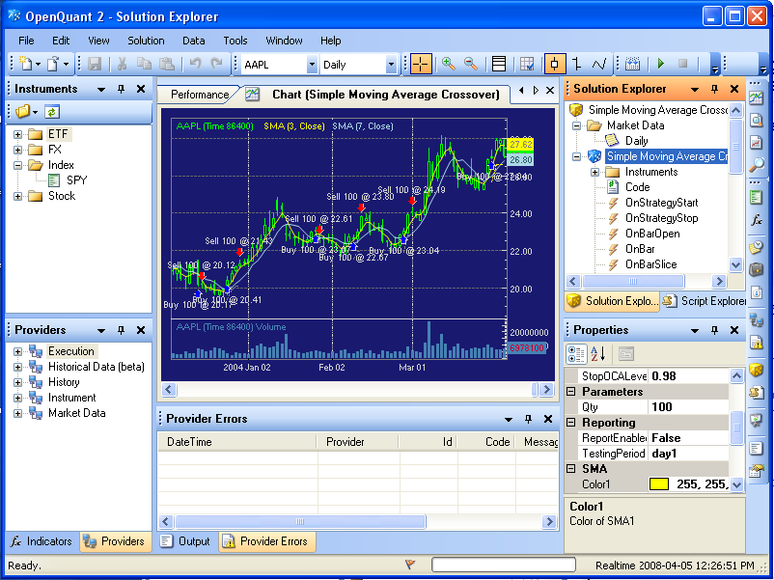

3.1.1 The File Menu文件菜单
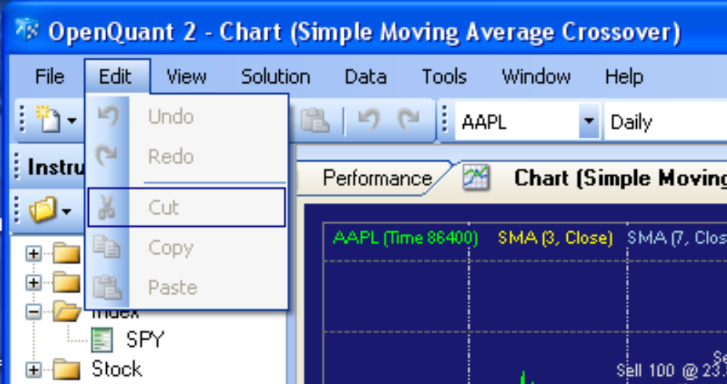
The File Menu provides the usual menu choices for creating new solution containers and strategy projects, opening existing solutions and strategies, and accessing recently used solutions and strategies. A solution container can contain multiple strategy projects. Each strategy within a solution can implement a different algorithm, using different instruments (tickers) and code blocks.
文件菜单提供了通用的菜单选项，如创建一个新的解决方案和策略项目，打开已存的解决方案和策略，访问最近使用的解决方案和策略。一个解决方案容器能包含多个策略项目。每个策略与解决方案结合，使用不同的合约和代码块能实现不同的算法。

3.1.2 The Edit Menu编辑菜单
The Edit Menu provides the usual cut / copy / paste / undo / redo options for editing C# strategy source code files. (No choices are selectable in this screenshot because the main window is a candlestick chart of AAPL—you must have some text (code) selected before any of these choices will become active.)
编辑菜单提供了通用的剪切/复制/粘贴/撤销/恢复选项，这些选项能编辑C#策略源文件。（在截图中没有选项能选择，这是因为主窗口是一个AAPL股票的蜡烛图——当你在使用这些选项之前，你必须有一些文本（代码）能选择。）

3.1.3 The View Menu视图菜单
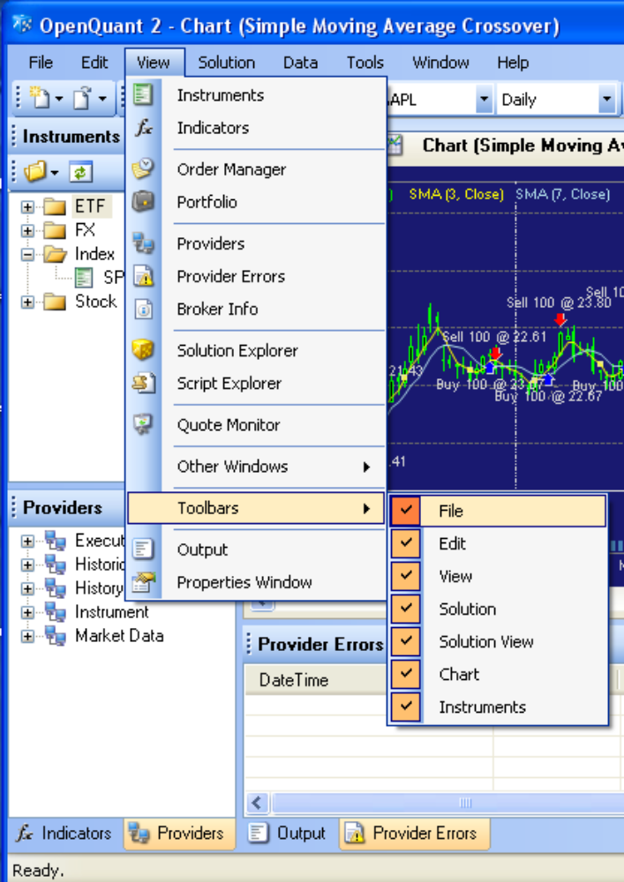
The View Menu provides choices for many different window panes and toolbars. Here is a brief description of the various window panes. Many of the window panes listed on the View menu are visible in the entire screenshot shown at the start of this section.
视图菜单提供了许多不同的面板和工具栏。这有个多种面板的简单描述。在视图菜单中罗列了许多面板，可以在本章节开始的完整截图中明显地看出来。
All of the docking panes on the left, bottom, and right side of the interface are modern “tear-off” windows panes. By grabbing the pane title bar with your mouse, you can tear off the panes and reposition them at other screen locations inside or outside of the main window boundaries.
左侧、底部、左侧的停靠面板都是现代的可分离面板，通过鼠标拖动窗口标题栏，可以分离面板或者把面板定位在界面的其他位置，主窗口边界内外均可。
The list below only gives a short introductory statement about each menu choice on the View menu. A more detailed picture and description of each window pane referenced by the View menu is shown later in this document.
以下列表只给出了每个视图菜单按钮的简短介绍。更多的细节图片和每个视图面板的描述会在这篇文档之后的内容中列出。
- The Instruments window pane (top left) shows financial instruments that are defined for use by the IDE. The Instruments is visible underneath the menu in this screenshot. You must define your favorite instruments here before you can use them in a trading strategy.
合约面板（左上）展示了已定义的金融合约。截图中的菜单遮挡了这些合约。你在交易策略中使用你喜欢的合约之前，必须先对这些合约下好定义。
- The Indicators window pane (bottom left) shows various technical indicators that you can drag and drop onto a chart of an instrument for analyzing instrument behavior. The Indicators tab is inactive in this screenshot.
指标面板（左下）展示了多种技术指标，你能拖拽它们到一个合约的图表上来分析这些合约的行为。指标选项卡在这个截图中非活动状态。
- The Order Manager grid (center tab) helps you to view, enter, and cancel trading orders that are sent to the Execution provider that is responsible for executing trading orders.
报单管理（中央选项卡）帮助你查看、入场和撤销已发送给交易接口的交易指令，负责执行交易指令。
- The Portfolio grid (center tab) shows all the trades for all the instruments that were executed as part of your strategy. A separate Portfolio is provided for each trading mode (Simulation, Paper Trading, or Live Mode). The Portfolio grid shows your open positions when you are in live trading mode, profit and loss for those positions, as well as Account values and Account transactions.
投资组合（中央选项卡）显示了作为你策略部分的已执行的所有合约的所有交易。一个分离的投资组合提供了各种交易模式（模拟、仿真或者实盘模式）。当你在实盘交易模式的时候，投资组合选项卡显示你的开仓头寸，这些头寸的盈亏，还有账户权益和交易记录。
- The Providers window pane (bottom left) shows providers for trade Execution, Historical Market Data, Instrument definitions, and real time Market Data. The dockable Providers pane shares docking space with the Indicators pane in the bottom left of the screen.
提供商面板（左下）显示了交易执行，历史数据、合约、实时行情提供商。提供商面板与指标面板共享左下停靠空间。
- The Provider Errors window pane (bottom center) shows error messages that might arise from providers. Typical errors include connection failure messages, and data request failures. Check this window for information if you have trouble with providers.
提供商错误面板（中下）显示提供商引发的错误。典型的错误包括连接失败信息，和数据请求失败。如果你的提供商出现问题，请查看这个窗口的信息。
- The Broker Info window pane (center tab) shows information about your current broker account, when you are paper trading or live trading with a real brokerage account. The center tab is empty if you are doing simulated trading.
账号信息面板（中央）。当你仿真或实盘交易一个实际账号时会显示账户信息。模拟下只显示空白。
- The Solution Explorer window pane (top right) shows key aspects of your trading strategy such as the size of bar data being used (Daily, 5-Minute, etc), the instruments being traded, and the C# source code and list of API software events that your strategy can utilize in its algorithms. To write some code for an event such as OnBarOpen, you double click the event name in this window to open up a code window in the center tab.
解决方案资源管理器面板（右上）显示了你的交易策略的关键点，如bar数据（每日、5分钟或其他）、要交易的合约、C#源代码以及在策略中可能用到的事件列表。要编辑事件，如OnBarOpen，双击这个事件名打开一个代码窗口。
- The Script Explorer window pane (top right) shows a list of scripts (actually, C# code) that you might write to perform simple programmatic data management tasks or to test coding ideas that can use the OpenQuant framework. In other words, scripts are utility C# programs for doing non-strategy sorts of things. For example, you might write scripts to add instruments to the database, convert market trade data into bar data of various lengths, and so on.
脚本资源管理器面板（右上）显示了一系列的脚本（事实上就是C#代码），这些脚本能执行简单的数据管理任务，或者使用OpenQuant框架的代码来测试自己的想法。例如，编写脚本去把合约添加到数据库，把市场交易数据转为不同长度的bar数据，等等。
- The Quote Monitor grid (center tab) displays incoming quotes for instruments of interest. Simply drag and drop instruments from the Instrument pane on to the Quote Monitor, and start the Quote Monitor to track instrument bid and ask prices in real time. If you are not connected to a market data provider when you drag an instrument on to the Quote Monitor, it will prompt you to establish a provider connection.
行情报价监示器网格（中）显示了接收到的感兴趣合约的报价。把合约从合约面板拖拽到行情报价监示器，运行监示器来实时追踪合约买价和卖价。如果你没有连接一个市场数据提供商，那当你拖拽合约到报价监视器时，它会提示你去建立一个提供商链接。
- The Other Windows menu choice currently has only the Start Page tab in the sub menu. The Start Page displays in the center tab, and shows a list of recent strategy solution links that you can click to load the referenced solution into the IDE for use.
其他窗口菜单目前只有开始页选项卡在子菜单里。开始页在中央选项卡显示最近的策略解决方案链接列表，你可以加载最近的解决方案到IDE中使用。
- The Toolbars (all of which are tear-off and dockable) provide fast access to common functions. Current there are seven toolbars—File, Edit, View, Solution, Solution View, Chart, and Instruments. Each toolbar is shown and described later in this document. Several of the toolbars are displayed vertically along the right side of the main IDE window.
工具条（都能分离和可停靠）提供了常用功能的快捷访问。通常，有7个工具条——文件、编辑、视图、解决方案、解决方案视图、图表、合约。每个工具条都将在本文档之后的内容中描述。部分工具条在主IDE窗口的右边竖着显示。
- The Output window pane (bottom center) shows printed output originating from the IDE and from print messages in your strategy. For example, compilation success messages appear here, as well as debugging messages from your strategy. Compilation errors are displayed in the Error List window, which shares docking space with the Output window.
输出面板（中下）显示从IDE和策略中输出而来的打印输出。例如，编译成功信息在这显示，策略的调试信息也在这显示。编译错误显示在错误列表窗口，它和输出窗口共享相同的空间。
- The Properties window pane (bottom right) shows the properties of whatever object is selected elsewhere in the IDE. Read-write properties can be modified here. Property values such as strategy parameters can be modified here between strategy runs.
属性面板（右下）显示了在IDE中选定的任意内容的属性。可以在这修改可读写的属性。属性值例如策略参数在策略运行时也可以在这修改。
For practice, here is another screenshot of the main screen. Now that you know more about the various tabs (eg Script Explorer) and where they are located (see the many vertical Toolbars on the right side of the main screen), see if you can identify the function of each window pane.
为了方便练习，这有另一张主界面截图。现在你可以更了解多种选项卡（如脚本资源管理器），知道它们的位置（看主界面右侧的大量垂直工具条），看看你能否识别每个面板的功能。
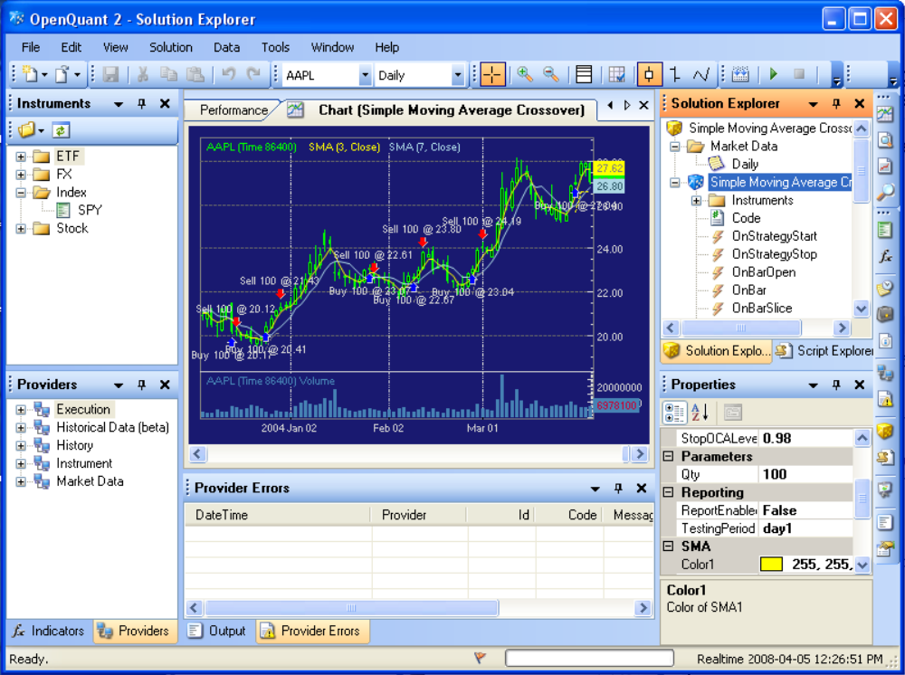

3.1.4 The Solution Menu解决方案菜单
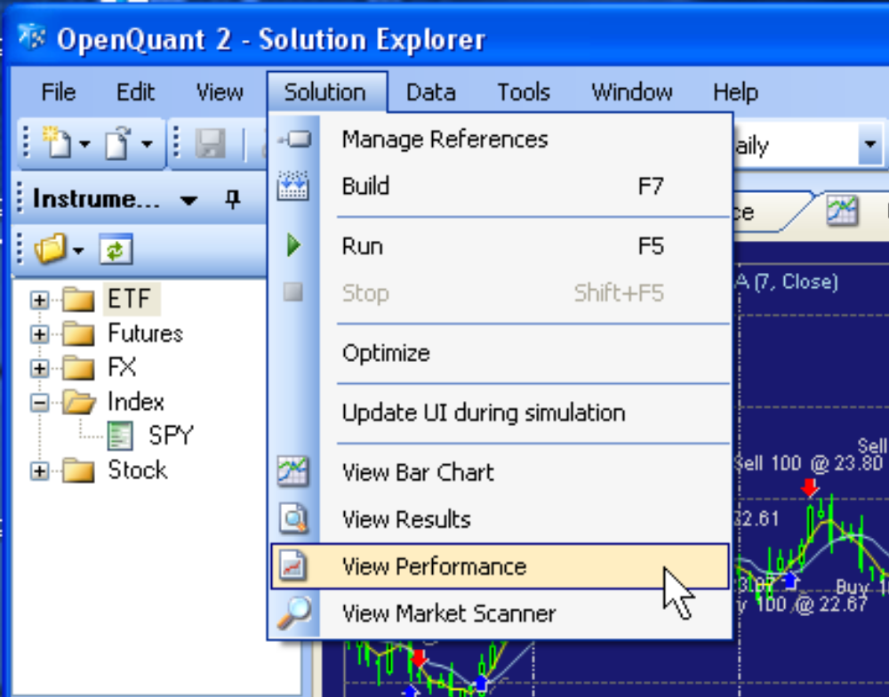
The Solution Menu provides functions for managing references to code libraries, and for building, running, pausing, stopping, and viewing the output of your strategy in various ways (chart, results, performance, and market scanner).
解决方案菜单提供了代码库的管理功能，构建、运行、暂停、停止，用多种方式（图表、结果、绩效、市场扫描）查看策略输出。
If you want to watch the bars and trades flash by on your screen as your strategy runs, you can tell the IDE to update the chart display during the simulation. Updating the IDE also means to update all other windows that show dynamic information—portfolio positions, account values, and transaction values. Updating the IDE slows down simulations significantly, so the default is not to update the IDE.
如果你想查看策略运行时屏幕上闪过Bar与交易，你可以让IDE在模拟中更新图表。更新IDE还意味着更新所有其他显示动态信息的窗口，证券投资组合持仓、账户权益、交易记录。更新IDE会显著地减慢模拟，所以默认是不更新IDE。
The Optimize choice displays the Optimization dialog so you can optimize various strategy parameters. To optimize, you must code optimization parameters (described later) and specify an optimization range and increment size for the parameters. Then OpenQuant loops and runs completely new simulations, one for each possible parameter set. A summary of results is displayed at the end of all runs.
优化选项显示优化对话框以便你能优化不同策略参数。为了优化，你必须编写优化参数（之后会说）、指定优化范围、步长。然后OpenQuant循环并完整运行新解决方案每个可能的参数集。在所有运行结束后会展示一个结果汇总。
The Solution menu also provides functions to view the following displays (Solution Views). Each of these views is also available on the Solution View toolbar on the right side of the main screen.
解决方案菜单也提供查看下列显示（解决方案视图）的功能。这些视图都可以在主界面右侧的解决方案视图工具条中操作。
- The bar chart of instrument prices and indicators
bar图表显示合约价格和指标
- The results of your strategy (bar chart, trade points, and transactions)
策略的结果（bar图表、交易点、交易记录）
- The performance of your strategy (statistics on average profit per trade, equity charts, etc)
策略的绩效（统计每次交易的平均利润、权益图表，等等）
- The code for your strategy (so you can examine and edit the code)
策略的代码（这样你就能检验和编辑代码了）

3.1.5 The Data Menu数据菜单
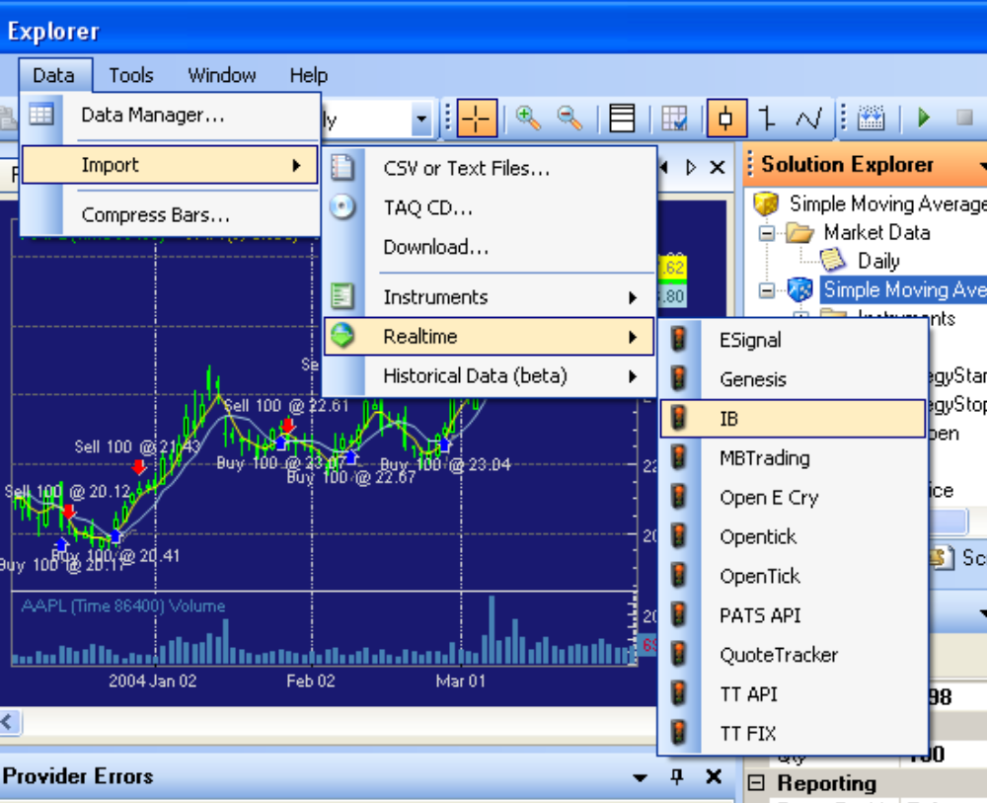
The Data Menu provides many useful functions for importing or downloading various kinds of data for use in your trading strategies.
数据菜单提供了多种有用的功能，能导入和下载多种数据，你能在你的交易策略中使用这些数据。
- Using the CSV or TAQ choices on this menu, you can import historical instrument data in the form of CSV (comma-separated values) or as text files from a TAQ (trade and quotes CD).
在菜单中使用CSV或者TAQ选项，你可以以CSV格式导入历史合约交易数据或者以TXT格式从TAQ CD导入数据。
- Using the Download choice, you can download historical market data from remote service providers such as ESignal.
使用下载选项，你能从远程的服务提供商下载历史数据，例如ESignal。
- Using the Instruments sub-menu, you can download lists of instruments from a provider so you don’t have to type them all in manually.
使用合约子菜单，你能从提供商下载合约列表，这样你就不必手工输入他们了。
- Using the Realtime choice, you can download market data from a market provider.
使用实时选项，你能从市场数据提供商获取市场数据。
- Using the Historical Data (beta) choice, you can download historical data from websites such as Yahoo, or from data service providers such as ESignal or Genesis.
使用历史数据（测试版）选项，你能从网站例如Yahoo等下载历史数据，或者从数据服务提供商如ESignal或者Genesis下载数据。
- Finally, you can compress fine-grained trade data series information into bars of larger size—by time (1 second to 6 hours), by tick (1 to 1000 ticks), by volume (10 to 100,000), or by price range (.001 to 1).
最后，你能压缩细粒度的成交序列为bars——按时间（1秒到6小时），按tick（1到1000），按成交量（10到100,000）或按价格范围(0.001到1)。

3.1.6 The Tools Menu工具菜单
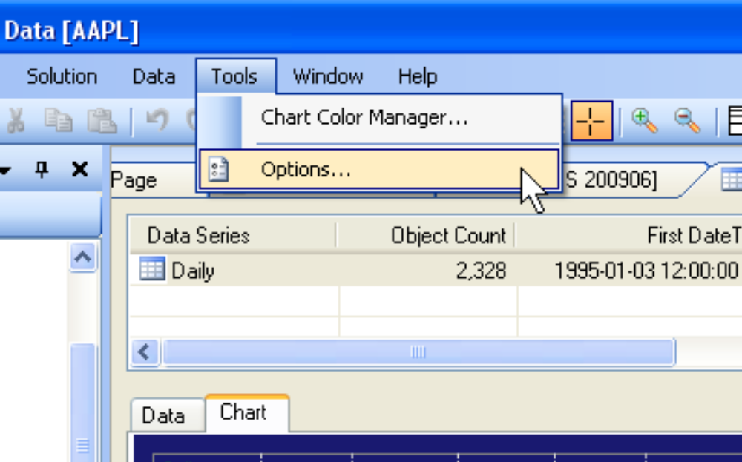
The Tools Menu provides functions for managing Chart Color Templates and for setting global application options.
工具菜单提供了管理图表颜色模板和设置全局应用程序的选项。
To change the default Midnight Blue chart color, use the chart color manager dialog to create a new template with your own favorite colors, and set it as the default. If you upgrade the program to a later version, the upgraded program (at least as of Version 2.7.3) will not remember your choice of default template, so you will have to reset the default. The upgrade process does not destroy your templates, but it does forget which one that you defined as the default.
要改变默认的午夜蓝图表颜色，使用图表颜色管理对话框来创建一个自己喜欢颜色的模板，然后设置为默认。如果你把程序升级为新版本，升级后的程序（至少在2.7.3版本之前）不会记录你设置的模板，所以不得不重新设置。升级进程不会删除你的模板，但它会忽略你定义的默认模板。

3.1.7 Using the Tools-Options Dialog to Solve Out of Memory Errors使用 “选项”对话框，解决内存溢出的错误
The options dialog is mostly self explanatory, except for some General settings that can help to prevent "Out of Memory" errors. During a back testing simulation, OpenQuant stores all incoming bars, quotes, and trades in arrays in internal memory. The stored bar, quote, and trade values are required (1) for chart replay, and (2) for portfolio value calculations that involve the whole simulation. Chart replay is obviously useful when you want to scroll the bar chart back to the beginning of the simulation to see all bars in the whole simulation.
选项对话框是不言自明的，除了一些常规设置还可以帮助以防止出现“内存不足”的错误。在回溯测试中，OpenQuant内部存储了所有传入的bar，quotes和trades。（1）存储的bar、quote、trade用于图表回放，（2）涉及整个模拟的投资组合的价值计算。当你想要在整个模拟中滚动图表回到模拟的开始阶段看所有的bar时，图表回放功能显然是必须的。
The portfolio statistics calculations are not always useful, but by default they are updated as each new trade arrives, and each separate value is stored in another internal array. These statistics can consume a lot of memory if you are processing a lot of trades, and are the source of many out of memory errors.
投资组合的统计计算并不总是需要，但默认情况下，有新交易到来时进行更新，每一个单独的值存储在另一个内部数组。如果你正在处理大量的交易（这就是内存不足错误的来源），这些统计数据会消耗大量的内存。
To avoid most out of memory errors, disable the calculation of portfolio statistics under the Backtesting section of the Options dialog. Not only will this free up lots of internal memory consumption, but it will also help your simulations to run noticeably faster because the statistics do not have to be calculated.
为了避免出现内存不足的错误，禁用“选项”对话框的回溯测试部分中的统计组合计算。这不仅会释放很多内存，也将帮助您的明显加快模拟运行，因为统计数据没有进行计算。

3.1.8 The Help Menu帮助菜单
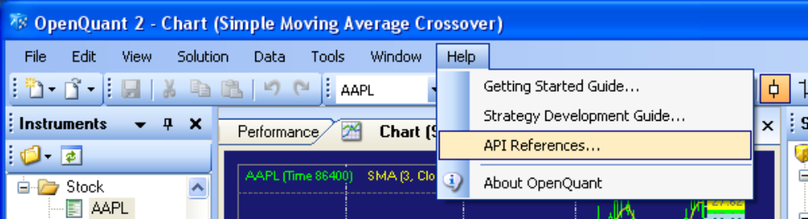
The Help Menu provides functions for accessing PDF documents (such as this one) and for searching and browsing API documentation in a searchable Help viewer window format.
帮助菜单提供了访问PDF文档（例如本文）的功能，也可以通过帮助查看器窗口搜索并浏览API文档。

3.2 Understanding IDE Toolbars了解IDE工具条
This section introductions the operations that are accessible through convenient toolbar buttons.
本部分介绍了通过快捷工具条按钮的业务操作。
I have reorganized the toolbars in the screenshots below to separate them and put them all into two rows for documentation convenience. By default, they are organized in a different pattern that you can see in the pictures of the main screen, but of course you can click and drag the toolbars to arrange them to suit your own taste.
我已经认识了下图的工具条，为了操作便利把它们变成了两行。默认它们都按不同的模式分组，如主界面所示，但是你也能单击和拖拽工具条来把它们按你自己的喜好来排列。

3.2.1 The File Toolbar文件工具条
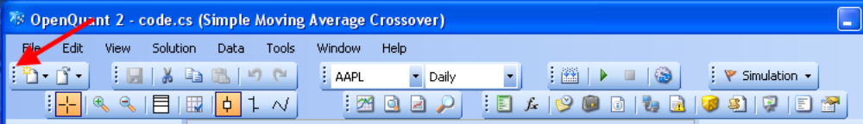
The File Toolbar provides only two buttons—one for creating New Solutions and Projects, and one for Opening existing solutions and projects.
文件工具条只提供2个按键——一个建立新的解决方案和项目，一个打开已存的解决方案和项目。

3.2.2 The Edit Toolbar编辑工具条

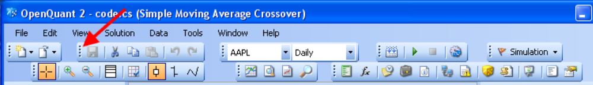
The Edit Toolbar provides buttons for Save, Cut, Copy, Past, Undo, and Redo operations.
编辑工具条提供保存、剪切、复制、粘贴、撤销和恢复操作按钮。

3.2.3 The Instrument Toolbar合约工具条
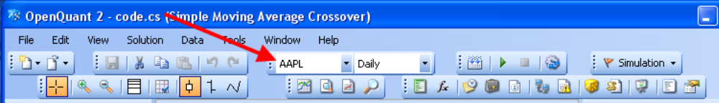
The Instrument Toolbar provides an easy way to choose an instrument and a bar size for viewing in the tabs of the center window. A single strategy can run against multiple instruments with multiple bar sizes, so you can use this toolbar to rapidly change instruments and bar sizes when you want to look at the results of a simulation for particular instruments and bar sizes.
合约工具条提供了一个简单的方法来选择一个合约或bar，你可以在中央窗口里查看。一个简单的策略运行时支持多个合约的多种bar，当你想看一个特定的合约和bar的模拟结果时，你能用这个工具条来迅速改变合约和bar。

3.2.4 The Solution Toolbar解决方案工具条
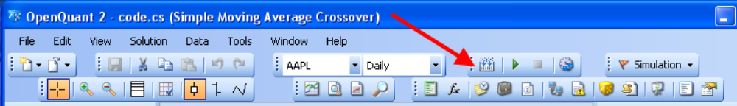
The Project Toolbar provides buttons for working on your strategy project:
项目工具条提供了运行策略项目的按钮：
- Build the strategy
构建策略
- Execute (run) the strategy
执行（运行）策略
- Pause execution of the strategy
暂停执行策略
- Stop execution of the strategy
停止执行策略
- Update UI during simulation (shown highlighted)
模拟中更新用户界面（高亮显示）
- View strategy bar chart
查看策略bar图表
- View strategy results
查看策略结果
- View strategy performance
查看策略绩效
- View strategy code
查看策略代码

3.2.5 The Trading Mode Toolbar交易模式工具条
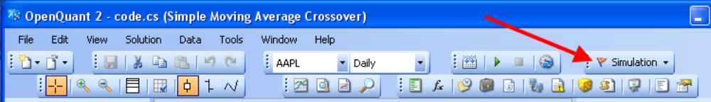
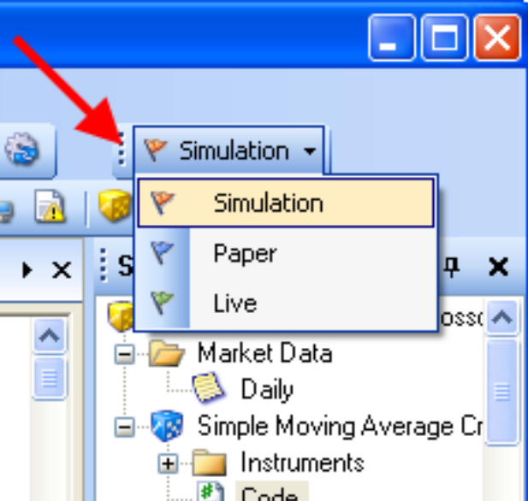
The Trading Mode toolbar provides three choices for selecting your trading mode:
交易模式工具条提供了三种选择来选择你的交易模式：
- Simulation (historical market data, simulated trade execution)
模拟（历史市场数据，模拟交易执行）
- Paper Trading (live market data, live trade execution on a test account with fake money)
仿真交易（实盘市场数据，用测试账户进行实盘交易执行测试）
- Live Trading (live market data, live trade execution on a real account with real money)
实盘交易（实盘市场数据，用真实账户进行实盘交易）

3.2.6 The Chart Toolbar图表工具条
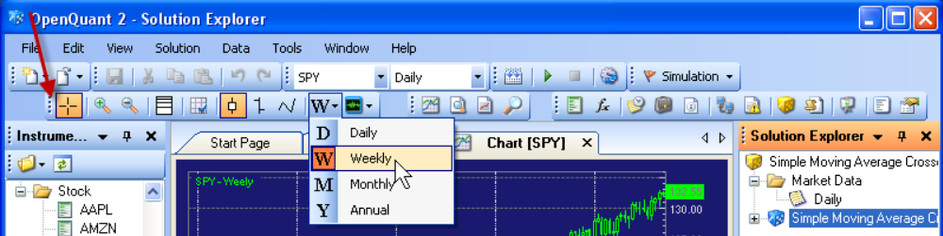
The Chart Toolbar provides buttons for controlling bar chart options:
图表工具条提供了控制bar图表选项的按钮：
- Show cursor as an arrow
显示光标为箭头
- Show cursor as crosshairs
显示为十字光标
- Zoom in
放大
- Zoom out
缩小
- Logarithmic chart scale for instrument prices (toggle on)
对数坐标系（切换开）
- Linear (Arithmetic) chart scale for instrument prices (toggle off, default)
线性（算术）坐标系（切换关，默认）
- Trailing mode (default, chart scrolls old bars off left as new bars are added on the right)
滚动模式（默认，旧Bar从左边移出图表，新Bar从右边添加）
- Fixed mode display (chart compresses instead of scrolling, and always shows all bars)
固定模式（图表压缩而不是滚动，总显示所有的bar）
- Show instrument prices as candlesticks (toggle on)
显示蜡烛图（切换开）
- Show instrument prices as bars (toggle on)
显示美国线（切换开）
- Show instrument prices as lines (toggle on)
显示折线图（切换开）
- Select Daily, Weekly, Monthly, or Yearly (Annual) chart views
按日、星期、月、或者按年（每年的）图表显示
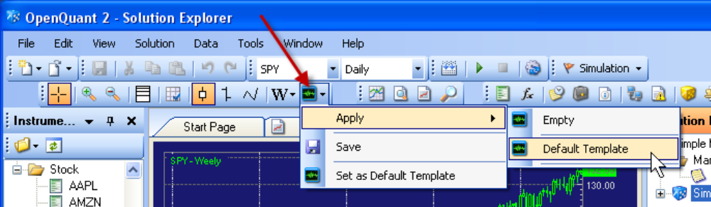
In addition, the chart toolbar provides menu choices for saving and applying your favorite chart templates. Configure a chart the way you like it and choose Save to save it. The next time you want to use it on a chart, choose Apply and select the chart template that you want to use.
另外，图表工具条提供了存储和应用你喜欢的图表模板的选项。把图表配置成你喜欢的模式，选择保存。下次你在一个图表中使用它，选择并应用你想用的图表模板。

3.2.7 The Solution View Toolbar解决方案视图工具条
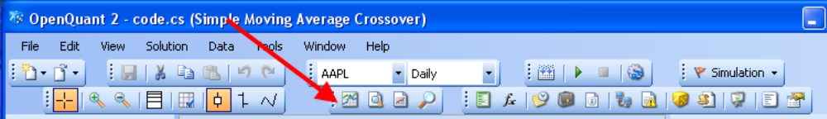
The Solution View Toolbar provides buttons to show various outputs of the current strategy:
解决方案视图工具条提供了查看当前策略不同输出的按钮:
- View Bar Chart
查看bar图表
- View Results
查看结果
- View Performance
查看绩效
- View Market Scanner
查看市场扫描器

3.2.8 The Window Pane Toolbar面板工具条
The Window Pane toolbar is usually located vertically on the right side of the IDE window. It provides buttons for displaying the various window panes and tabs mentioned above:
面板工具条总是垂直位于IDE窗口右侧。它提供了查看不同面板和选项卡的按钮，如下所示：
- Instrument pane (top left)
合约面板（左上）
- Indicators pane (bottom left)
指标面板（左下）
- Order Manager tab (center)
报单管理器选项卡（中央）
- Portfolio tab (center)
投资组合选项卡（中央）
- Broker Info tab (center)
经纪信息选项卡（中央）
- Providers pane (bottom left)
提供商面板（左下）
- Provider Errors pane (bottom center)
提供商错误面板（中下）
- Solution Explorer pane (top right)
解决方案资源管理器面板（右上）
- Script Explorer pane (top right)
脚本资源管理器面板（右上）
- Quote Monitor (center)
报价监视器（中央）
- Output pane (bottom center)
输出面板（中下）
- Properties pane (bottom right)
属性面板（右下）

3.3 Working with Dockable Window Panes使用可停靠面板
This section summarizes the functions of the various window panes in the OpenQuant IDE. All window panes are "tear-off and dockable," which means that you can tear off and relocate the window panes to suit your preferences in visual display structure. Any window that can be torn off can also be floated over top of the IDE, simply by not re-docking the window pane.
本部分总结了OpenQuant IDE中不同的面板功能。所有的面板都是“分离，可停靠”的。这就是说你能分离并把窗口拖放到显示器结构中适合你选择的位置。任何面板都可以脱离也能拉出在IDE之外，只要不重置面板就行
Here is a list of things you can do with dockable window panes:
这有一个能用停靠窗口来完成的事的列表：
- To auto-hide a dockable window, click the pin icon to unpin (sideways) the window. The window will slide into the edge of the IDE, and will leave a tab showing.
自动隐藏可停靠窗口，单击图钉按钮取消窗口固定。窗口会移动到IDE的边缘，然后会留下一个选项卡。
- To show a window temporarily, move your mouse over the tab to pop out the window.
要暂时显示窗口，把鼠标移动到选项卡上弹出窗口。
- To show a window permanently, click the pin icon to pin (upright) the window.
要一直显示窗口，点击图钉按钮来固定窗口。
- To tear off a window, click and drag the title bar. Pay attention—there is a difference between using the TITLE BAR of a window, and using the TAB of a window when there are multiple tabs in one pane.
要分离一个窗口，单击并拖拽标题栏。注意——当多个选项卡在一个窗体内时，使用窗口标题栏和使用窗口选项卡是不同的。
- If you drag and drop a TITLE BAR, you will see a PARTIAL set of drop indicators that will let you select the WINDOW PANE to hold the dropped window. The dropped window will occupy the whole window pane, and will show up as a TAB inside the window pane.
如果你拖拽一个标题栏，你可以看到一个局部的指示器来让你能选择窗体来固定分离的窗口。分离的窗口会占据整个面板，然后在面板内会出现一个选项卡。
- But if you drag and drop a TAB, then you will see a full set of drop indicators that will let you drop the tab in the upper / lower / left / right sections OF THE SAME WINDOW PANE. You will have to practice to see the different kinds of drop indicators, and their effects.
但是如果你拖拽一个选项卡，那么你能看到一个整体的分离指示器来让你把选项卡在同一窗体内移动更高/更低/左移/右移。你可以试着拖拽不同的指示线来看看它们的作用。
- To re-dock a window, tear it off and drop it (your mouse arrow) on one of the 8 re-docking indicators that appear. The four "outside" docking indicators located near the top, bottom, left and right sides of the main window will cause the tear off window to occupy the whole edge of the IDE.
为了重新停靠一个窗口，把他它分开然后放在出现的8个新停靠线中的一个（通过鼠标箭头）。四个“外部”的停靠线分别在主窗口的顶，底，左，右4个方向，这能把分离的窗口填满整个IDE的边界
- The four "inside" docking indicators will cause the tear off window to share the associated section of the center IDE window (e.g. dropping the tear off window on the top inside indicator will split the center pane with a horizontal line, and will show the tear off window in the top half of the center pane).
四个“内部”停靠线将分离窗口来分享中心IDE窗口的相关部分（如拉低指示线内的顶部窗口会通过水平线分离中心窗格，将在中心窗格中的上半部分显示分离的窗口）。
- In all cases, the new area to be occupied is indicated by a light blue shadow.
在任何情况下，要占据的新区域都会用淡蓝色阴影显示。
- To float a window, tear it off and drop it anywhere on a docking indicator.
要浮动一个窗口，把它分离开，放到停靠线的任意位置。
- To return a floating window to its previous docked location, double click its title bar.
要返回到其以前的停靠位置的浮动窗口，双击其标题栏。

3.3.1 The Instrument Window Pane合约面板
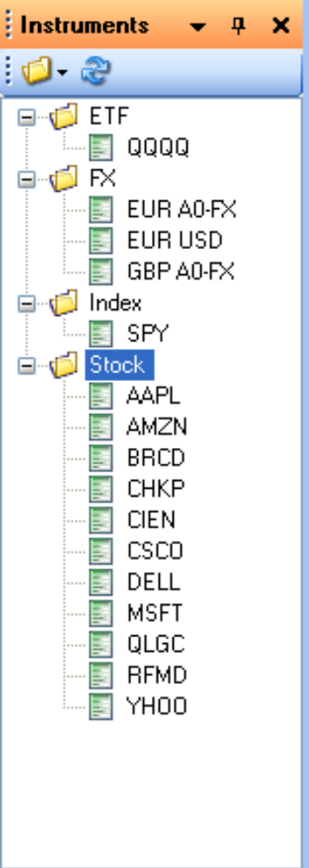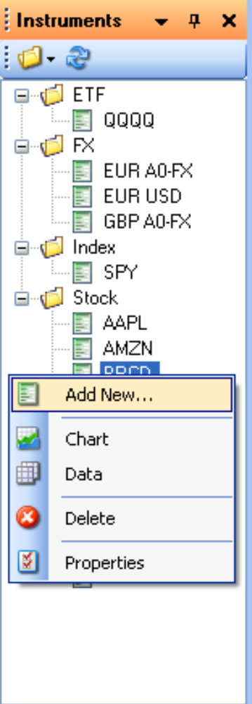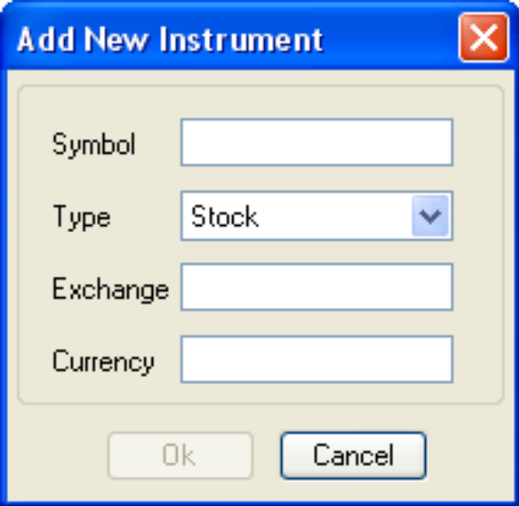
The Instrument Pane is where you define the financial instruments that interest you, either for technical analysis using charts and indicators, or for use in your trading strategy. Here is a list of things you can do with instruments in the Instruments pane:
合约面板定义金融合约的地方，既可以使用图表和指标进行技术性分析，也可以使用你自己的交易策略。下列是你能用合约窗口做到的操作的列表：
- To define an instrument, right click in the Instrument window somewhere (or on the type of instrument that you want to create, e.g. "Stock" above), and define the name and type of your instrument in the dialog that pops up (shown above). The dialog will provide appropriate data fields for you to complete. The instrument type is used to organize instruments of the same type into folders, so that all common stock instruments appear in the stock folder.
要定义一个合约，右键合约面板的任意地方（或者你想创建的合约的类型，例如上面的“Stock”），然后在弹出窗口对话框定义合约名字和类型（如上所示）。对话框也提供一些需要你完成的适当数据域。合约类型会被放到同类型合约的文件夹中，这样所有Stock合约就存在Stock文件夹里。
- Once you have defined the name of the instrument, you must also define properties of the instrument in the Properties window. To define properties, select an instrument in the Instrument pane, and then look in the Properties pane. You must define—at a minimum—the instrument Currency and the Exchange (where the instrument is traded).
一旦你定义了合约名，你也必须在属性面板定义合约属性。在合约窗口选择一个合约，然后查看属性面。你必须定义合约货币的“最小值”和交易所（合约交易的地方）。
- To view a chart of the instrument, select Chart from the right-click context menu.
查看合约图表，在右键弹出菜单选择图表。
- To view the trade or bar data of the instrument, select Data from the context menu.
查看交易或合约bar数据，在弹出菜单选择数据。
- To view properties of the instrument, select the instrument (left click) or right-click and select Properties from the context menu. Either way, you must set properties in the Properties pane—you don’t get a pop-up dialog by using the context menu.
查看合约属性，选择合约（左键）或者右键在弹出菜单选择属性。不论哪种方式，你都要在属性窗口设置属性——用弹出菜单你不能打开一个弹出对话框。
- To add an instrument to the quote monitor, drag and drop the instrument name from the Instrument pane into the Quote Monitor window. Or you can drag and drop the whole folder of instruments. (There is no other way of performing this operation with menus—drag and drop is the only way.
要在报价监视器增加一个合约，你要从合约面板拖拽一个合约名到报价监视器窗口。或者把整个合约文件夹拖过去。（没有别的方法去达到这个操作——拖拽是唯一方法）
- To delete an instrument from the Instrument pane or the Quote Monitor, right click the instrument name and choose Delete.
要从合约窗口或报价监视器删除一个合约，右键合约名选择删除。

3.3.2 The Providers Window Pane 提供商面板
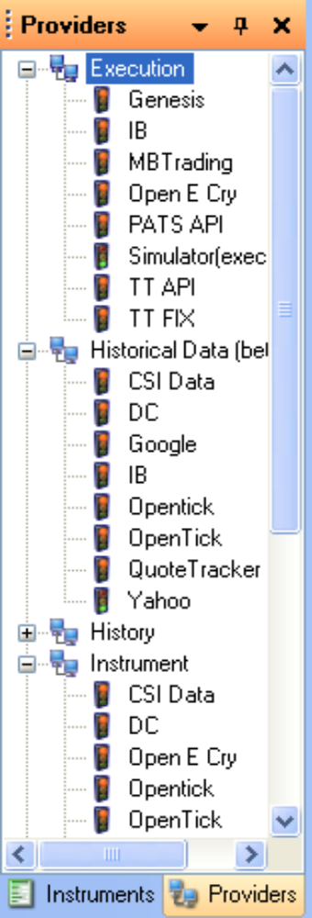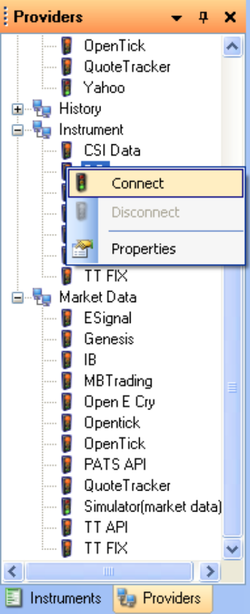
The Providers pane lists the available providers for trade Execution, Historical market data, Instrument definitions, and real time Market Data. The DC (Data Center) name refers to a separate SmartQuant product. All other names refer to non-SmartQuant vendors.
提供商面板显示了可用的交易执行、历史市场数据、合约定义和实时市场数据提供商。数据中心是SmartQuant的一个单独的产品，所有其他名字由非SmartQuant提供商命名。
- To set Provider properties, either select the provider name (left click) or select Properties on the context menu (right click). Either way, you must set up connection properties such as login names and IP addresses in the Properties window pane.
要设置提供商属性，既可以选择提供商名（左键），也可以选择弹出菜单属性（右键）。2种方式你都需要设置连接属性，例如在属性面板的登录名和IP地址。
- To avoid connection errors, you should probably set up connection properties before you try to connect (except for the Yahoo provider, which has its properties predefined). You can use Yahoo as a test case for downloading free historical market data, since Yahoo is predefined in the IDE, and does not require any more information from you.
为了避免连接错误，你也许要在试着连接之前就设置连接属性（除了Yahoo供应商，它有自己的预置属性）。你能使用Yahoo通过下载免费历史市场数据测试连接。这是因为yahoo在IDE中有预置属性，也不需要从你那获取任何信息。
- To connect to a provider, right click its name and select Connect. Look for error messages in the Provider Errors window pane (bottom center) if the connection does not work. If the connection works, the Red provider icon will turn Green.
为了连接一个提供商，右键提供商名选择连接。如果不能连接应在提供商错误窗口查找错误信息（中下），如果能连接，提供商按钮会由红变绿。

3.3.3 The Indicators Window Pane指标面板
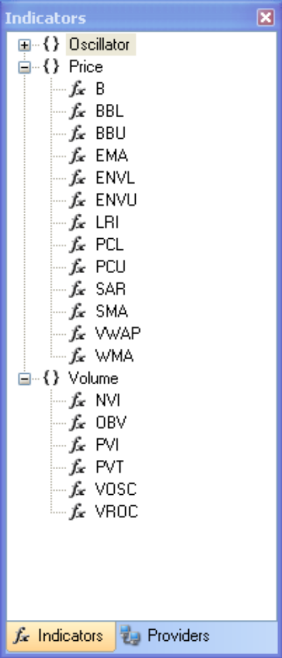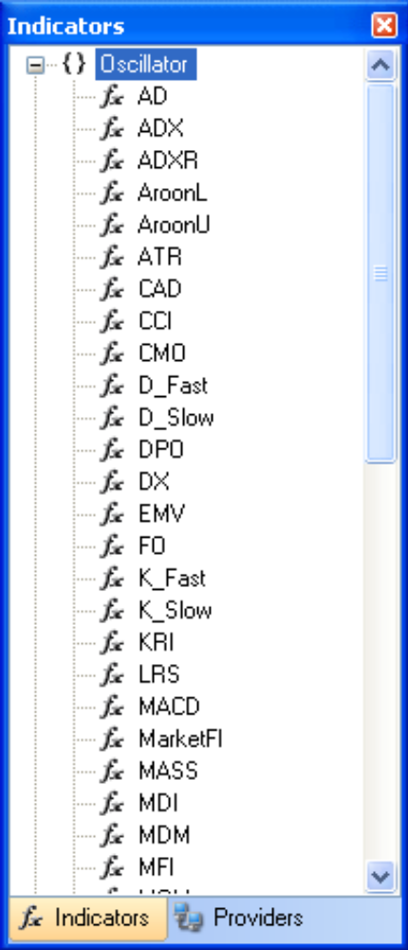
Here are two screenshots of indicators available in OpenQuant2. There are three categories of indicators—oscillators, price indicators, and volume indicators. Each indicator is explained in the online reference documentation.
下面是2张OpenQuant2的指标截图。在这有3类指标——震荡、价格指标、交易量指标。每个指标都会在网上的参考文档中解释。
The indicators pane is quite limited—it has no tooltips, no right-click context menu, and no visible responses to mouse clicks with your mouse. But the pane is still useful. Here is what you can do with indicators in the Indicators pane:
指标面板功能有限——没有工具提示，没有右键弹出菜单，没有明显鼠标操作反应。但此面板还是有用的。下面是你用指标面板能做的：
- To read up on the definition and function of a technical indicator, read the API documentation under the Help menu. Select Help, API References, and then (in the left side of the help viewer Contents pane) select the OpenQuant.API.Indicators help tree. This will show the documentation for all the available indicators.
阅读帮助菜单下API文档，查看技术指标的定义和功能。选择帮助，API参考，然后（在帮助目录窗口的左边）选择OpenQuant.API.Indicators帮助分支，查看所有可用指标的文档。
- To apply a technical indicator to a chart, right-click an instrument name, select Chart to show it, then drag and drop a technical indicator onto the chart. This will bring up a dialog box to help you configure the indicator. The screenshot above shows the dialog box for an Exponential Moving Average indicator. This dialog lets you choose a name, a data instrument and series to apply the indicator to, the color and width of the indicator line, and the period of the moving average.
想要在图表应用一个技术指标，右键一个合约名，选择图表显示它，然后把技术指标拖拽到图表上。会弹出一个对话框来帮助你设置指标。上边的截图显示了指数移动平均线指标的对话框。这个对话框允许设置名字，数据合约和序列去应用指标，还有指标线的颜色和宽度及移动平均数的周期。
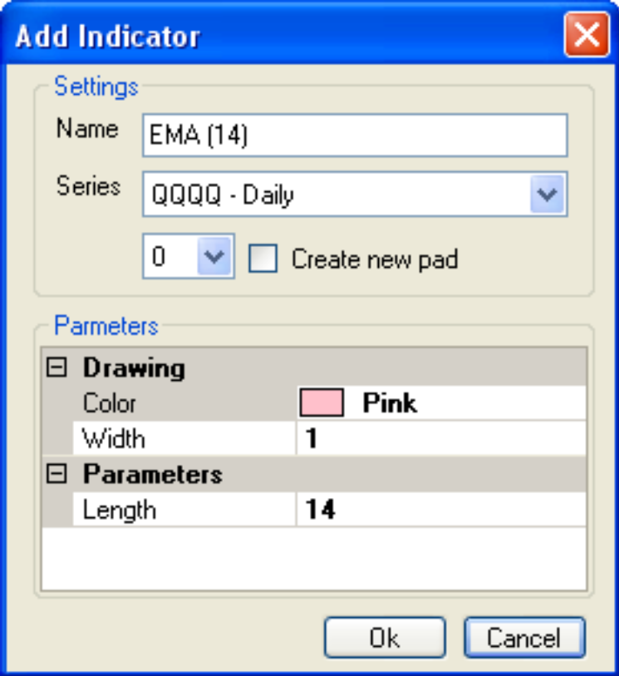
- To modify the properties of an indicator after you have applied it to a chart, left-click the indicator line in the chart—this requires precision mouse movements sometimes—and then modify the indicator properties in the Properties pane. Or right-click the indicator line on the chart, and select Properties from the context menu. Beware—if you use the right-click method, you don’t get to use the dialog box to modify properties—once the indicator is on the chart, the only way is to use the Properties window pane.
在你把指标应用到图表之后，想修改指标属性，左键图表中指标线——有时这需要精密的鼠标移动——然后在属性面板修改属性。或者右键图表中指标线，然后从弹出菜单选择属性。注意——如果你习惯使用右键，你不能打开对话框修改属性，——只要指标是在图表上，使用属性面板就是唯一的方法。
- To display the indicator on a separate section of the bar chart (not on top of the price bars), either select the desired "pad" (chart section) number in the spin box, or check the checkbox to create a new chart section (pad). The new chart pad will be added to the bottom of the chart.
要在bar图表分离的部分显示指标线（不是在价格bar顶部)，也可以选择要求的数字设定框的“pad”（图表部分）数字，或者查看复选框来创建新的图表部分（pad）。新的图表pad会增加到图表底部。

3.3.4 The Output Window Pane输出面板
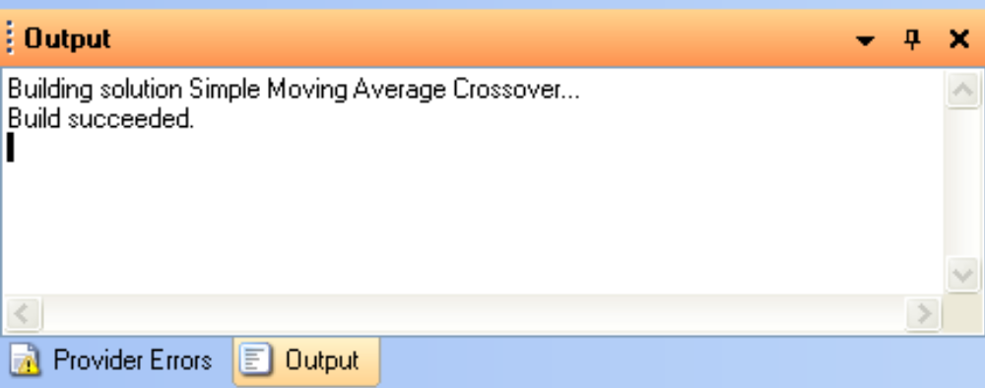
The output window pane is straightforward—it displays text output information generated by the IDE, or debugging text generated by your strategy. The example above shows the output that occurs when you press the "Build" button on the Project Toolbar when the "Stock 2% Gap" strategy is visible in the Solution Explorer window pane.
输出面板是直截了当的——它显示了IDE产生的输出信息，还有你的策略产生的调试文本。上边的例子显示了当“Stock 2% Gap”策略显示在解决方案资源管理器窗口时你按了项目工具条上“Build”按钮后的输出信息。

3.3.5 The Provider Errors Window Pane 提供商错误面板
The Provider Errors window pane displays a grid of error messages (if any) from various providers. In the example shown above, the error message says that the IDE could not connect to the IB (Interactive Brokers) TWS (Traders Workstation Software). The TWS software requires that you enable a particular TWS option ("Enable ActiveX…") before TWS will accept incoming connections such as the one from the IDE.
提供商错误窗口显示了不同提供商的错误信息（只要有）。在上边的例子中，错误信息显示IDE不能连接到IB(Interactive Brokers) TWS(Traders Workstation Software)。TWS在接受输入连接时必须在IDE中开启一个选项（“启用ActiveX…”）

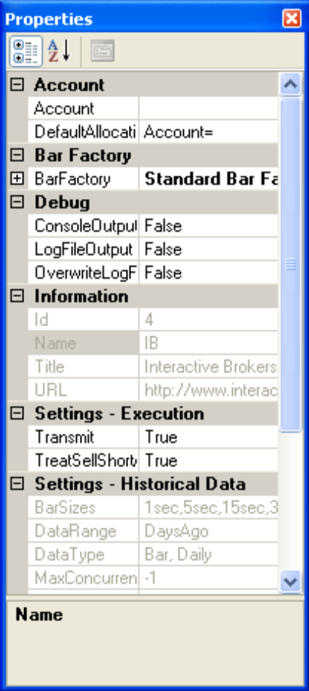
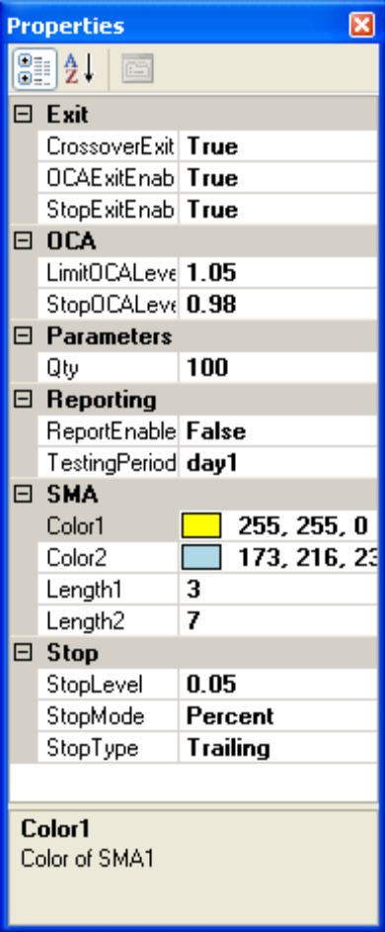
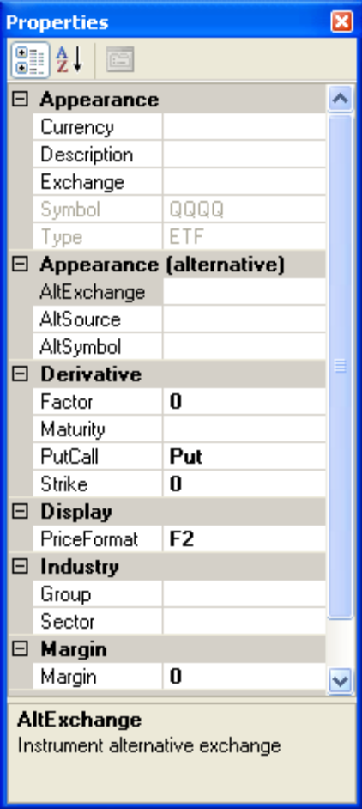
3.3.6 The Properties Window Pane 属性面板
The Properties Pane allows you to view and modify properties of elements that are selected (highlighted) in other IDE windows. Three example screenshots are shown above.
属性面板允许你查看修改在其他IDE窗口选择的基础属性。上边是3个截图示例
- The first example shows properties of the IB Interactive Brokers execution and market data provider. If you look closely, you can see the provider name, title, computer host name, TCP/IP port number, and connection status in the properties grid.
第一个例子显示了IB交易和市场数据提供商。如果你看的够细，你就能在属性网格看到提供商名字、标题、主机名、TCP/IP端口号、连接状态。
- The second example shows properties of the QQQQ (Nasdaq 100) ETF instrument. The currency is USD, but the Exchange has not yet been specified. Recall that the Exchange field must be specified for Live Trading mode, so the IDE knows where to send orders.
第二个例子显示了QQQQ（纳斯达克100）EFT（交易所交易基金）合约的属性。货币为美金，但是交易所并未被指定。注意在实盘模式下必须指定交易所，以便IDE指定订单发送到哪。
- The third example shows properties for a strategy (in this case, the "Simple Moving Average Crossover" strategy that ships with the IDE). Parameters for the strategy behavior include one for the type of trade exit to use (exit on crossover, exit on OCA (one cancels all), exit on stop loss) and another property for the Qty (number) of shares to trade ("100"). Each kind of strategy that you write will have a different set of properties.
第三个例子显示了策略的属性（在这，IDE中是“简单移动平均线交叉策略”）。策略行为参数包括一个出场类型（交叉出场， OCA出场(组内一报单成交，其它全撤)，止损出场）和另一个参数交易股票数（100）。每个策略都会有不同的属性。
- When you write your own strategies, you can code Parameters into the C# code that will appear in this same Properties window, so that you can modify and tune them between runs of the strategy, without recompiling the strategy code each time.
当你写了自己的策略，你可以把属性编译进C#代码里，这样同样会在属性面板中出现，这样就能在运行策略时不用每次重新编译策略代码就可修改、调整属性。

3.3.7 The Solution Explorer Window Pane 解决方案资源管理器面板
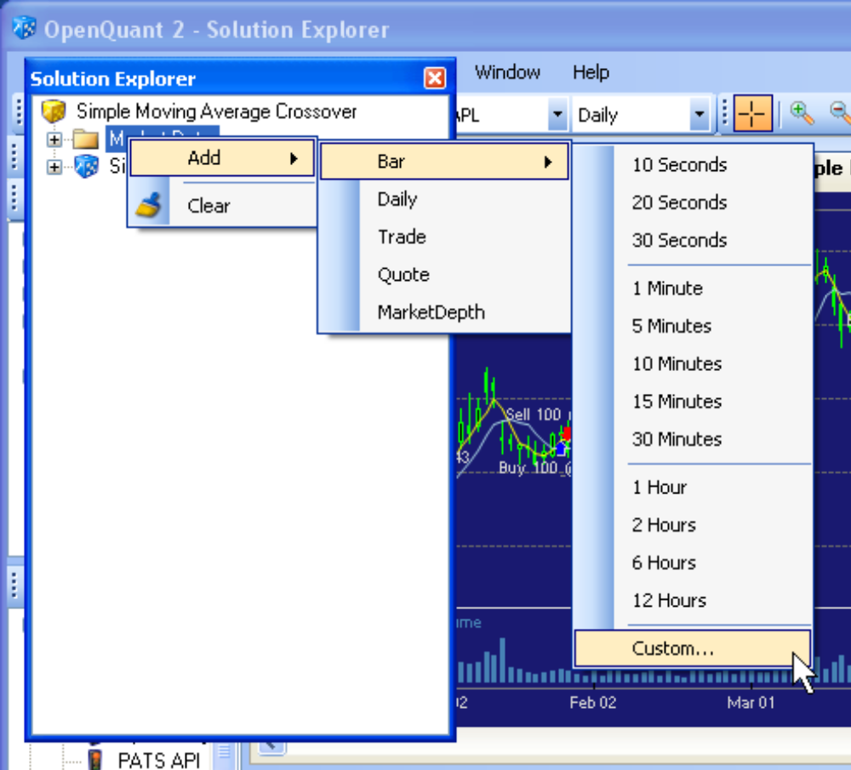
The Solution Explorer pane shows the structural elements of your strategy, such as the instruments that the strategy trades, the bar size(s) that it uses, and the C# code and events that control its behavior. (The screenshot above shows a floating explorer window to put the cascading menus over top of the chart.) Here are some of the things you can do with the Solution Explorer pane:
解决方案资源管理器窗口显示了你策略的结构元素，例如交易策略的合约，它使用的bar和能控制策略行为的C#代码及事件。（上图截屏显示了一个浮动资源管理器窗口来把层叠菜单放于图表顶部）下列是能用解决方案资源管理器面板做到的：
- Right click the strategy name for choices to Build, Run, and view strategy results (chart, results, performance) and code.
右键策略名能选择构建、运行、查看策略结果（图表，结果，绩效）和代码。
- Right click the Instruments folder to add or remove instruments.
右键合约文件夹能增加和删除合约。
- Right click an instrument to set its properties, or to remove it from the strategy. Removing an instrument from the strategy does not remove the instrument from the Instruments pane.
右键合约能设置合约属性或者把合约删除。从策略删除不会将合约面板中的合约删除。
- Right click the Market Data folder to add input data types (Bar, Trade, Quote) or input bar sizes (1, 5, 15 minutes, or custom bar sizes).
右键市场数据文件夹增加输入数据类型（Bar、Trade、Quote）或者输入bar大小(1、5、15分钟或者自定义bar大小)。
- The normal way to add bar sizes in simulation, paper trading, or live modes in OpenQuant is to use the Solution Explorer pane, right click the Market Data folder, Add a new data series (shown in the screenshots above), and choose a bar size from the pop-out menus (these pop-out menus are shown in a screenshot a following section).
在OpenQuant中的模拟、仿真、实盘中增加bar sizes的正常方式是使用解决方案资源管理器，右键Market Data文件夹，增加一个新的数据序列（如上图所示），然后从弹出菜单选择一个bar size（这些弹出菜单会在之后部分的截图中展示）。
- The screenshot below shows the dialog that appears when you choose Custom… from the bar size menu shown in the previous picture. This dialog lets you specify custom bar sizes for your strategy. Bars can be manufactured from Trade data if you check the checkbox. Otherwise, bars will be read from Bar data series directly (no manufacturing is required, because the IDE is reading bars, not trades.)
下图显示了当你选择bar size菜单（之前图片显示的）中的“自定义……”时出现的对话框。这个对话框允许你为你的策略自定义bar size，如果选上了复选框，就能从trade数据生成bar。否则的话，bar会直接从bar数据序列中得到（不需要加工，因为IDE直接读取bar，而非trade。)
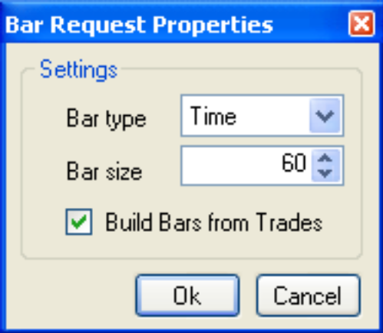
- Right click the C# code icon to edit the strategy code.
右键C#代码图标来编辑策略代码。
- Double click, or right click, an Event name to jump to that location in the code. Like Visual Studio, the OpenQuant IDE will generate template code for the event handler if it does not already exist.
双击或者右键一个事件名定位到代码。像VS一样，如果没有代码，OpenQuant IDE为事件处理程序生成模板代码。

3.4 Working with the Center IDE Window使用中央IDE窗口
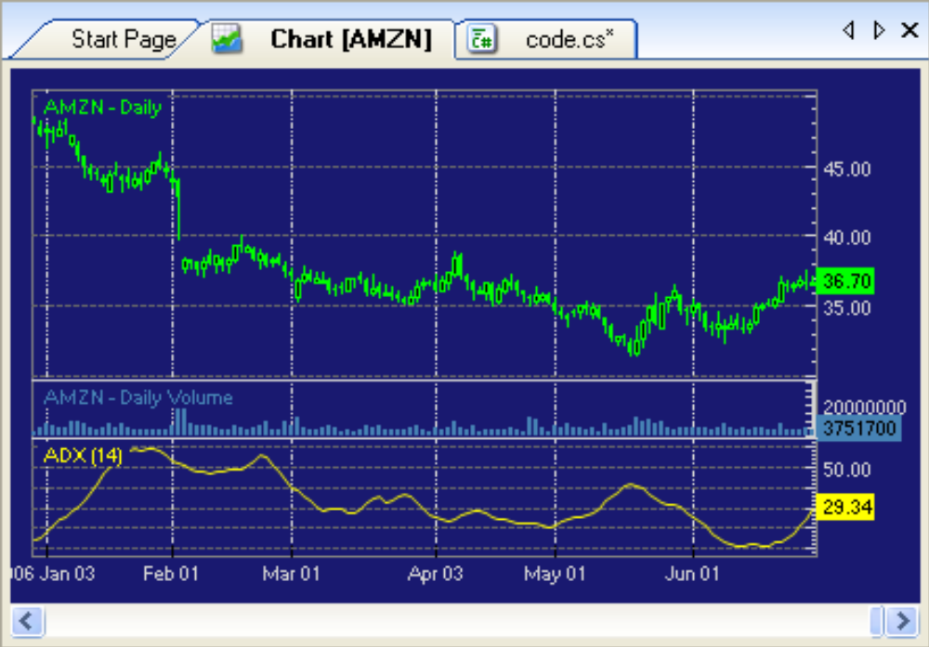
The center window pane of the IDE contains a tab control for displaying bar charts, portfolio grids, and code file editors. Each type of information is displayed on its own tab. Tabs can be torn off and docked in various ways to create side-by-side chart layouts, above-and-below layouts, or other layouts that suite your preferences. Lots of experimenting is required to understand the docking indicators that show up when you tear off a window pane. But the good news is that creating side by side displays in the center window only is a little easier.
中央IDE面板包含一个选项卡控件显示bar图表、投资组合和代码编辑器。每个类型的信息都在自己的选项卡上显示。选项卡能分离和停靠，这样能创建出并排或堆叠的图表布局，或者其他的适合你的布局。了解拖拽窗口时出现的停靠指示器需要大量的练习。但好消息是中央窗口的并行展示比较简单。
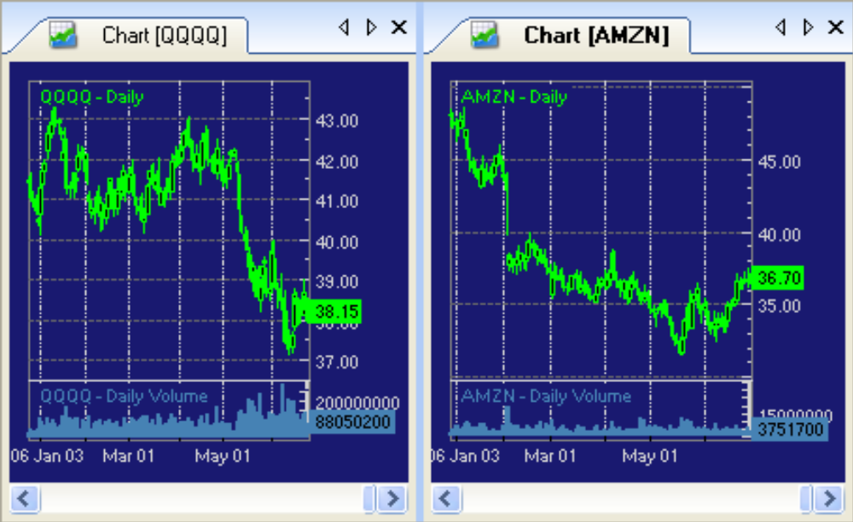
Each tab can be torn off and floated over the IDE. Tabs can also be docked on the sides and bottom of the IDE, with the Instruments pane, the Output pane, or the Solution Explorer pane. (But the Instrument pane and its friends are not allowed to dock in the center window.) Double click the title bar of a floating tab to dock it back into its previous docking location.
每个选项卡能分开并浮在IDE上面。选项卡也能停靠在IDE边上或底上、合约面板、输出面板，或者解决方案资源管理器面板。（但是合约面板和类似面板不允许在中央窗口停靠。）双击浮动选项卡的标题条可以把他停靠在之前的位置。

3.4.1 The Start Page Tab开始页选项卡
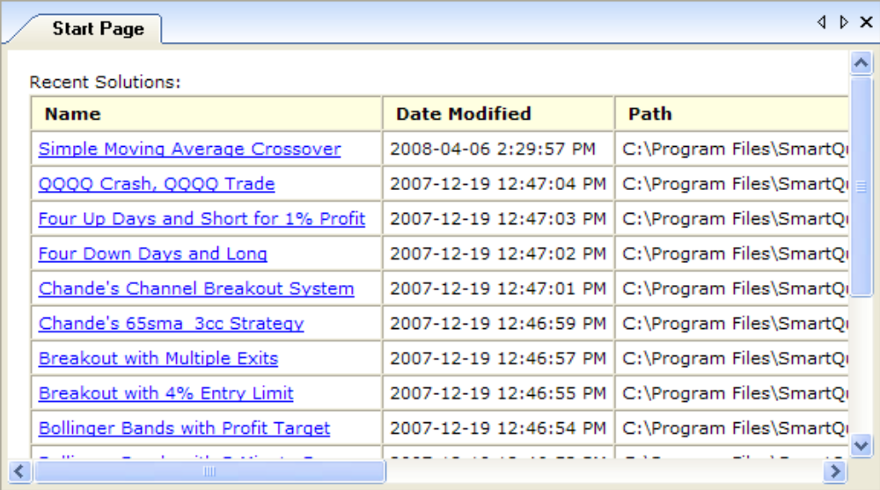
The Start Page Tab lists the names of recent projects, their most recent modification date, and their file system path location. Click on a link to open that particular project.
开始页选项卡罗列了最近项目的名字、最近的数据、文件的地址。单击链接可以打开项目。
- To hide the Start Page Tab, click the X at the top right corner (this applies to all Tabs).
隐藏开始页选项卡,单击右上方X（这对所有选项卡有效）。
- To make it visible again, use the View / Other Windows / Start Page menu.
要让他重新显示，可以使用View/Other Windows/Start Page菜单。

3.4.2 The Quote Monitor Tab报价监视器选项卡
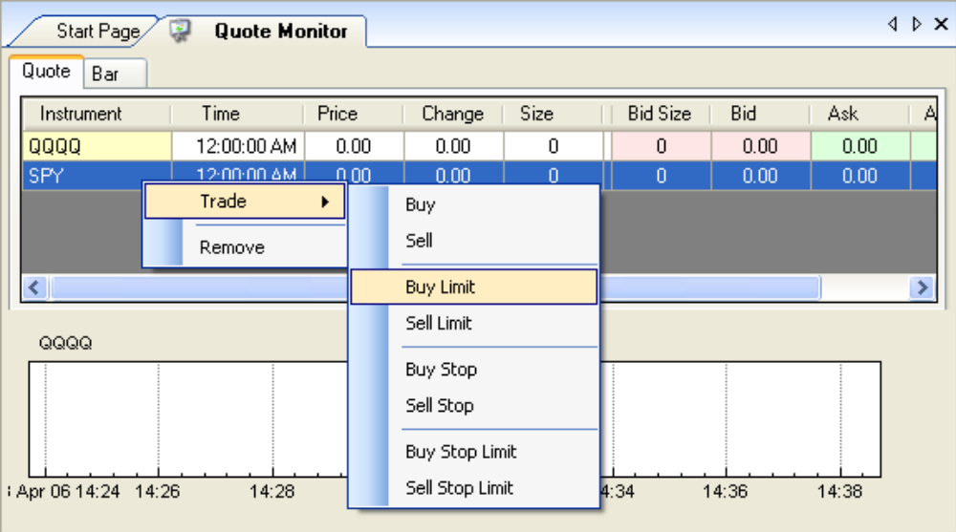
The Quote Monitor Tab monitors incoming bid/ask and trade prices for instruments that you drag and drop onto the Quote Monitor Tab. It helps you to see if your connection to a market data provider is actually working. If it is, the quote prices will change; if the connection is not working, then no price movement will be visible (in which case you should check the Provider Errors window for error messages).
报价监视器选项卡显示了接收到的叫价/卖价和成交价，这些都是你拖拽到报价监视器上才会显示。它能帮你查看你同市场数据提供商的连接实际上是否工作。如果在工作，那报价会改变，如果连接没有工作，那么价格看上去不会出现变化（这样你就要去查看提供商错误窗口的错误信息）。
- To add an instrument to the Quote Monitor Tab, drag and drop an instrument symbol from the Instruments pane on to the Quote Monitor Tab.
在报价监视器选项卡增加一个合约，从合约面板拖拽合约符合到报价监视器选项卡。
- To remove an instrument from the Quote Monitor list, right click it and select Remove.
从报价监视器选项卡移走一个合约，右键合约并选择Remove。
- To make a trade from the Quote Monitor, right click the instrument line and select the type of trade that you want to make. A pop-up dialog will appear to collect information for the trade order. Once you have entered the order, you can see the results of your trade in the Order Manager window (transaction status) and the Portfolio Manager window.
要在报价监视器进行交易，右键合约条，选择你想做的交易类型。会出现一个弹出的对话框设置交易指令。一旦你发出了指令，你需要查看你报单管理窗口（交易状态）和投资组合管理窗口的交易结果。

3.4.3 The Instrument Chart Tab合约图表选项卡
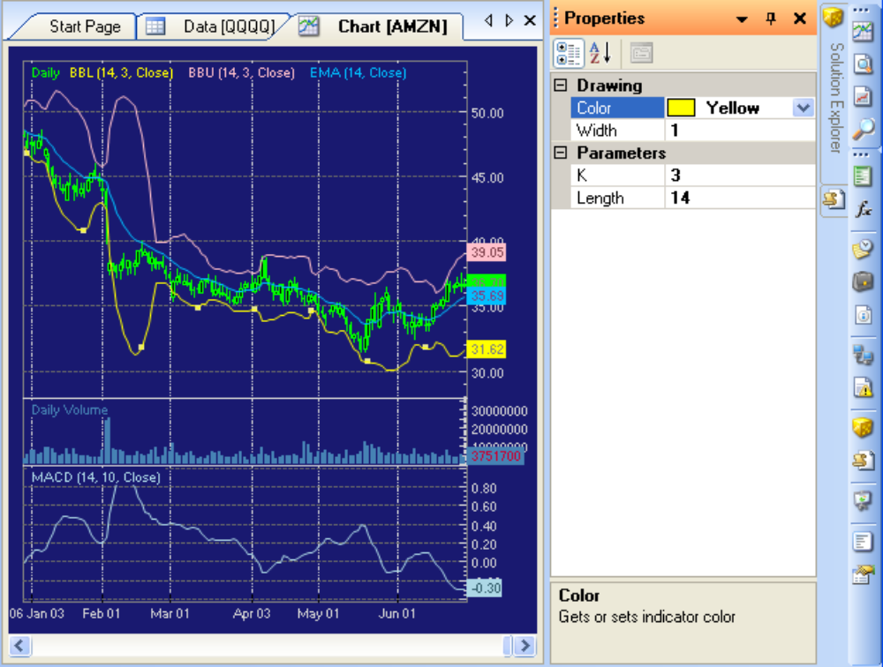
To show a chart of the bars for an instrument, right click an instrument in the Instrument pane, and choose the Chart option from the popup dialog. This shows a data series for the instrument only—it does not show a chart of strategy buy/sell signals applied to the instrument. (To see buy/sell strategy signals, right click on a strategy in the solution explorer window, and choose View Chart, or use the view chart toolbar button on the right side toolbar).
要显示一个合约的bar图表，右键选择一个合约面板中的合约，从弹出对话框中选择图表选项。会显示一个只有合约的数据序列——不会显示应用于合约的买卖信号图表。（要看买卖信号，在解决方案资源管理器右键选择一个策略，选择查看图表，或者使用右边工具条上的查看图表工具条按钮）。
The Chart Tab shows a chart of instrument prices and technical indicators. The example above shows a chart of AMZN price and volume, plus several technical indicators. The Chart Tab also shows indicators that are coded into your strategy with Draw(..) statements, as well as trade symbols as trades are made during Simulation, Paper Trading, and Live Trading executions. So you can watch your strategy display indicators and make trades in real time, all on this chart.
图表选项卡显示了合约价格和技术指标。上图显示的是AMZN的价格和成交量图表，还有几个技术指标。图表选项卡也显示那些编译进策略有Draw(..)的指标，还有在模拟、仿真、实盘执行中的交易符号。这样，你就在同一个图表上实时察看到指标和执行的交易。
- The first indicator BBL (Bollinger Band Low, in yellow) is a lower Bollinger band indicator, using a 14-day period with a K value of 3, and based on the closing price value of the bars in the chart. To change the properties of this indicator, left click on the line, and the associated properties will show up in the properties panel (see the Properties pane above).
第一个指标BBL(布林带下轨，黄色)是一个布林带下轨指标，周期14天，K值3，根据图表中bar的收盘价得出。要改变这些指标的属性，在线上点击左键，相关属性会出现在属性面板上（看上边的属性面板）。
- The second indicator listed at the chart top is an upper Bollinger Band (BBU) indicator, in pink.
第二个指标在图表的上端，是一个布林带上轨(BBU)指标,粉色。
- The third technical indicator (this time in its own chart section or "pad") is a MACD (Moving Average Convergence Divergence) with periods of 26 days (slow MA) and 12 days (fast MA), based on closing bar prices.
第三个技术指标（这次在它自己的图表区或“pad”）是一个MACD（指数平滑异同移动平均线），使用为26天周期（慢MA）和12天周期（快MA），由bar收盘价得出。
- To remove an indicator from the chart, click the line until you see some "handles" show up, as shown on the yellow BBL line above. Then right click the line, and choose the Delete option.
要从图表删除指标，点击线，看到一些“柄”出现，如黄色BBL线所示，然后线上右键，选择删除选项。
As you have seen previously, it is possible to create multiple chart tabs, and float them or rearrange them into side-by-side or above-below displays to suit your preferences.
正如你之前所看到的，创建多个图表选项卡是可以的，浮动、层叠或并排窗口来适应你的习惯。

3.4.4 The Instrument Data Series Tab合约数据序列选项卡
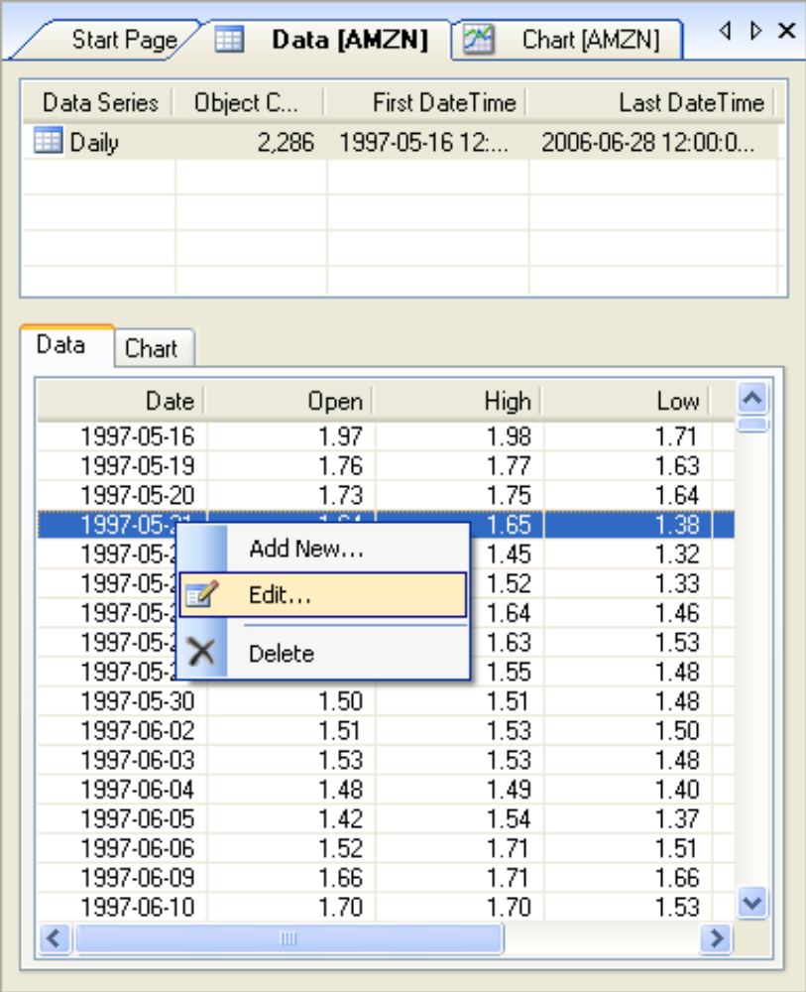
To show the objects (bars) in a data series for an instrument, right click an instrument in the Instrument pane, and choose the Data option from the popup dialog.
要在数据序列中为一个合约展示一个bar时，在合约窗口右键一个合约，从弹出窗口选择数据选项。
- Double click a bar series (Daily, 5-minute, etc) to load individual bars into the grid at the bottom of the window.
双击一个bar序列（每日、5分钟，等等）来把指定的bars载入窗口底部的网格。
- Double click a particular bar in the bottom window to see a dialog that will let you change the OHLCV (open, high, low, close, volume) for the bar.
双击一个底部窗口的bar来打开一个对话框，能改变OHLCV（开高低收量）。
- Right click in the bottom window to see a dialog that will let you add a new bar to the series, edit a bar in the series, or delete a bar from the series. The right click menu is shown in the picture above.
右键选择底部窗口打开对话框，给序列增加一个新的bar，编辑序列中的bar或删除序列中的一个bar。右键菜单如上图所示。

3.5 Working with Strategy Views使用策略视图
There are several different ways to investigate the results of your strategy. You can see trades on a bar chart, a grid listing of transactions in your portfolio account, an overall equity performance curve for the strategy, and individual trading results by individual instrument. Strategy views can be accessed from a right click menu (as shown in the next screenshot), or from the solution view icons on the right side vertical toolbar.
有几种不同的方式来研究你的策略的结果。你可以查看一个bar图表，一个你的投资组合帐户上交易的网格，一个整体策略的性能曲线，和个人的合约交易结果。策略视图，可以从右键菜单访问（如下面截图所示），或从右边垂直的工具栏上的解决方案视图图标访问。

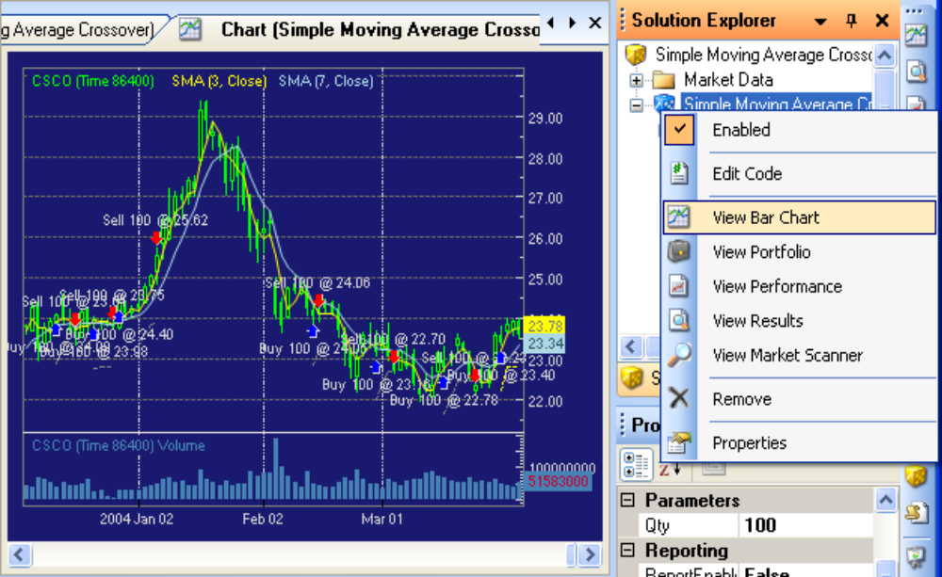
3.5.1 The Strategy Bar Chart View策略bar图表视图

The Strategy Bar Chart View shows strategy buy / sell signals on top of the Instrument bar chart view. This is a convenient view for seeing where your strategy issues buy and sell signals, either in profitable places or unprofitable places (sigh).
策略bar图表视图在合约bar图表的顶层显示策略的买卖信号。这是为方便查看你的策略如何发出的买卖信号，无论盈亏（叹气）。
To show different parts of the chart, you can move the scrollbar at the bottom of the window, or click somewhere on the chart and use your mouse wheel to compress or expand the chart. Here is a picture of a compressed chart made by moving the mouse wheel.
为了显示图表的不同部位，你可以移动窗口底部的滚动条，或单击图表上的某个地方，并使用鼠标滚轮来缩小或扩大图表。这里是一个通过移动鼠标滚轮缩小后图表的图片
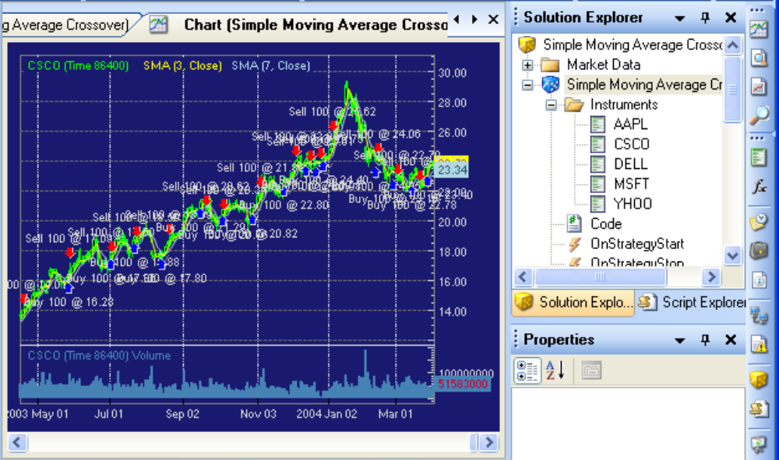
Once you have adjusted the chart scale by moving your mouse wheel, there is no way to disable the mouse wheel action, and no way to return the chart to its original scale. Instead, you must close the whole tab and open a new one (which will open up a new chart with the default horizontal scale).
一旦你通过移动鼠标滚轮调整图表的大小，就没有方法来禁用鼠标滚轮动作，并且没有办法使图表返回到原来的大小。你只能关闭整个选项卡，并打开一个新的（这将打开一个默认大小的新图表）。

3.5.2 The Strategy Portfolio View策略投资组合视图
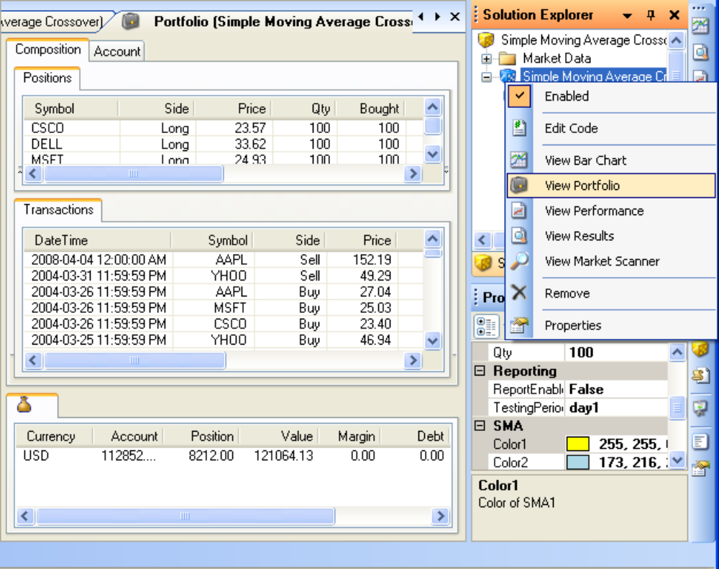
The Strategy Portfolio View shows how your strategy affects your portfolio. This is the view that you can use to see exactly what trades your strategy made, on what instruments, at what times, and at what prices (and profits).
投资组合策略组合视图显示了策略如何影响投资组合。这是你能用来看你的策略到底做了什么交易的视图，如交易了什么合约，在什么时候和什么价格（还有收益）。
The main use of the Portfolio Tab is to see your open positions during Paper Trading or Live Trading modes. But you can also look here (in the Transactions window) for specific trades that lost money, so you can go and debug your strategy to see what went wrong.
投资组合选项卡的主要用途是看你在仿真或实盘的开仓头寸。但你也可以通过这里（交易记录窗口）查看亏损的交易，这样你可以运行并调试你的策略，看什么地方出了错。

3.5.3 The Strategy Performance View策略绩效视图
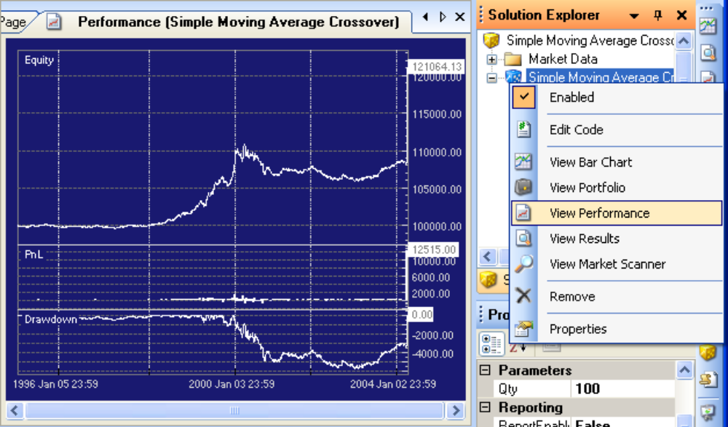
The Performance Tab shows several performance curves for the strategy.
绩效选项卡显示了策略的一些绩效曲线。
- The Equity curve shows how portfolio equity varies during the strategy. Ideally, this line should rise continuously and smoothly (that is, with low volatility) from bottom left to top right. This particular strategy started with 100,000 dollars in 1996 (starting cash, defined in the strategy Properties window that was shown earlier in this document). Then it earned about 2,000 dollars during the peak Dot-Com years (circa 2000), and then lost money into the bottom of the dot-com crash (circa January 2002). Finally (and thankfully!) the strategy recovered its losses and ended this simulation run with 1,204.50 dollars profit (which is about 1.2% over 8 years, or "not so good" :-).
净值曲线显示了在策略中组合投资的净值变化。理想的情况下，这条线应该持续上升，并平滑地（即低波动率）从底部左角升到右上角。这个策略开始于1996年，10万美元资金（初始资金，在这份文档之前的策略属性面板定义）。然后，互联网泡沫高峰年（公元2000年）期间获得约2000美元，然后互联网泡沫崩溃的底部（约2002）赔钱。最后（谢天谢地）策略挽回损失，最终盈利1,204.50美元（约1.2％，超8年，或者说“不太好”:-)。
- The PnL (profit and loss) curve shows the per-trade profit and losses. Ideally, this line should show consistently bigger bars above the line (profitable trades) and consistently smaller bars (or none) below the line (losing trades). As you can see from the bars, there were some huge losing trades (> $1000 loss) around January of 2000.
PnL（盈亏）曲线显示每次交易的利润和亏损。理想的情况下，这条线应该持继在直线上显示很高的bar（获益交易），持续地小bar（或无）低于线下（亏损交易）。正如你可以从bars看到，2000年一月左右有巨大的交易亏损（>1000美金损失）。
- The Drawdown curve shows the drawdown (loss of equity) of the strategy, including trades in progress. Ideally, the drawdown curve should be flat or shallow, indicating that the strategy did not have to dip into capital too much during its trades. The problem with deep drawdowns is that they are psychologically and emotionally very disturbing, and often cause traders to bail out at the very bottom of a trade, when they can’t take the losses any more. In the screenshot shown above, the maximum drawdown was nearly $3,000—3% of capital—and lasted from late 2001 until mid-2003, or for the best part of a year. Three percent loss is not bad at all for a loss, and probably would have been easy to take for the year. But if the 3% had been 30%, the drawdown would be more difficult.
回撤曲线显示策略的回撤（权益亏损），包括正在进行的交易。理想的情况下，回撤曲线应该平坦或浅，表明该策略没有在交易中动用太多资本。大回撤的问题是，他们在心理上和感情上非常令人不安，而且往往导致交易者无在法承受损失时在交易的底部止损出局。在上面的截图中，最大回撤接近$3,000——总资本的3％，并从2001年底持续至2003年年中，或者接近一年的时间。百分之三的损失对于一次损失来说不是很严重，并且承受一年都可能很容易。但是，如果从3％变成30％，回撤将令更加困难。

3.5.4 The Strategy Results View策略结果视图
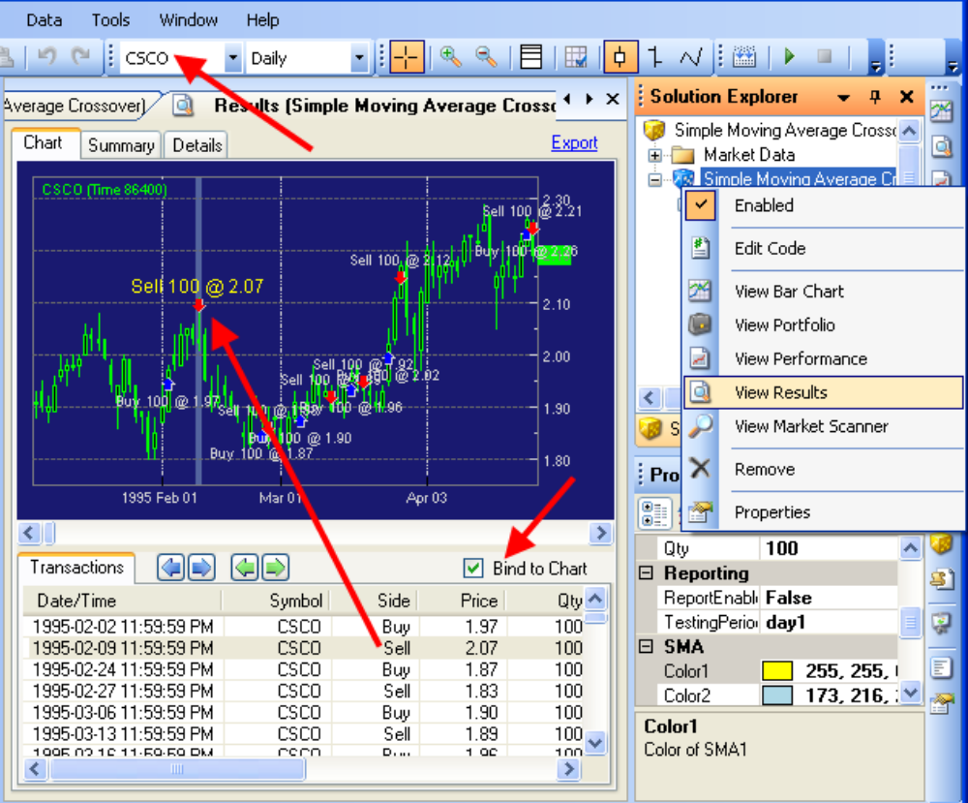
The Results Tab is a useful tab for stepping through the trades that your strategy has made.
结果选项卡是一个很有用的选项卡，能一步步检查策略发出的交易。
- The Results Tab is not shown on the View Menu or the View Toolbar. Instead, to see the Results Tab you must right click the strategy name in the Solution Explorer pane, and select View Results from the context menu.
结果选项卡不在视图菜单或者视图工具条上显示。要看结果选项卡，你要右键点击解决方案资源管理器中的策略名，从弹出菜单中选择查看结果。
- You can adjust the resolution of the chart by left-clicking the chart and scrolling the mouse wheel to zoom in or out on the X axis timeline of the chart.
你能通过左键点击图表滚动鼠标轮来放大或缩小图表的横向时间轴来调整图表。
- You can shift the chart left or right by using the bottom scrollbar on the chart.
你可以使用图表底部滚动条来左右移动图表。
- The red arrow in the picture above shows you how to examine the strategy trading results for a single instrument within a strategy. (Recall that a single strategy can trade multiple instruments—so you need a way to look at the strategy behavior instrument by instrument.)
上面图片中的红色箭头显示了你如何检查单个合约的策略交易结果。 （回想一下，一个单一的策略，可以交易多种合约——所以，你需要一种方法通过合约来查找策略行为。）
- You can lock (bind) the trading transactions to their locations on the chart by checking the "Bind to Chart" checkbox (top right of transaction window). This way, you can double click a transaction, and the chart will jump to that transaction and display the trade that was made, in the context of chart prices. This is a really nice feature.
您可以通过勾选“绑定到图表”复选框（交易记录窗口右上角）锁定（绑定）交易记录在他们的位置上。这样，您就可以双击交易记录，图表将跳转到该交易，并显示在图表的价格范围内的交易。这是一个很好的功能。
- You can jump to the next (or previous) transactions using the Blue and Green arrows at the top of the transaction window. The Blue arrows take you to the next transaction, no matter what Instrument was traded. The Green arrows take you to the next transaction in the same instrument that is shown by the current transaction. So use the Green arrows to follow trades in a single instrument, and the Blue arrows to follow all trades in all instruments in chronological order.
您可以使用交易记录窗口顶部的蓝色和绿色箭头跳转到下一条（或前一条）交易记录。蓝色箭头带你到下一条交易记录，不管是交易的是什么合约。绿色箭头带您到当前合约的下一条交易记录。因此，使用绿色箭头在单一合约下跟踪交易，蓝色箭头按时间顺序跟踪所有合约的所有交易。

3.5.5 The Strategy Market Scanner View策略市场扫描器视图
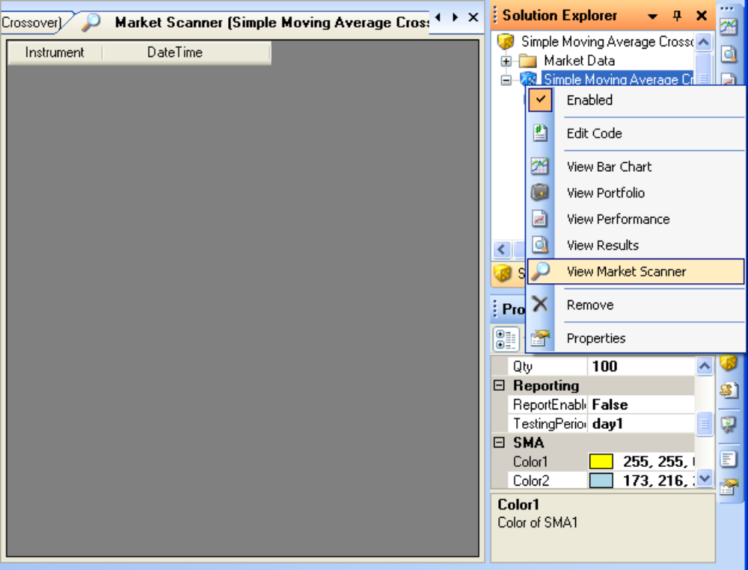
The Strategy Market Scanner screen shows various pieces of information from your brokerage account. The information shown varies with each different broker.
策略市场扫描器屏幕上显示各种从您的经纪帐户得到的信息。显示的信息随每个不同的经纪商而不同。
This brings us to the end of the tour of the main IDE menus, toolbars, window panes, and strategy result panes. Now we can move on to actually using the IDE to create and run a strategy against an instrument.
现在本章结束。主IDE菜单、工具栏、面板和策略结果面板的介绍结束。现在，我们实际使用IDE来创建和运行一个合约的策略。

4 Acquiring Market Data获取市场数据
This section talks about the different kinds of market data that you can use, sources of that data, and how to import or download the data. OpenQuant ships with a small amount of preconfigured market data, but you will probably want to obtain your own (more recent) market data to test out your strategies.
本部分介绍了可用的多种市场数据，这些数据的来源、怎样导入或下载这些数据。OpenQuant内置少量数据，但是你可能要获取你自己的（最新的）市场数据来测试你的策略。

4.1 Types of Market Data市场数据类型
Market data can be classified into several different types for convenience of understanding.
为了便于理解，市场数据一般分成以下几种类型。
- Historical data is instrument data from the past—good for back testing strategies, but not very effective for making money on future trades. In contrast, real time market data is more current, and can be used to make reasonable trades in the present.
历史数据是以前的数据——主要用于回测，但在未来的交易中并不能有效地获利。与之相对，实时数据更加及时，能让交易更加真实。
- Precisely speaking, all market data is historical, because by the time you can capture a trade price and volume at the exchange, the price is already part of history (if only a few microseconds "in the past" behind the present moment in time).
准确地说，所有的数据都是历史数据，因为你从交易所获得一个成交价和成交量的时候，这个价格已经是历史的一部分了（哪怕比当前时间过去几微秒）。
- The only question that matters is whether the "real time" data that you can obtain is sufficient for your strategy. For example, if your strategy only needs daily bars, then free 20-minute delayed prices would be good enough. But in contrast, if your arbitrage trading program needs to trade prices 150 milliseconds after they happen in order to make a profit, then even a 1 second delay makes the data useless to you.
唯一问题是你获得的“实时"数据是否对你的策略足够。例如，如果你的策略只需要每日数据，那么免费的20分钟延时报价已经足够了。相反地，如果你的套利交易程序为了获利需要在价格出现的150微秒内交易，那么就连1秒钟的延迟都会令这些数据对你毫无用处。
- Quote data consists of pairs of bid / ask prices that people are willing to pay to buy or sell an instrument. The presence of a bid-ask pair does not mean that trading will always occur—if the spread is too big, no trades will occur until the market makers step in to facilitate some trades.
Quote数据包含多对人们愿意去买或卖一个合约的买价、卖价。这个买卖价对的存在不意味着这个交易一定会发生——如果价差太大，直到做市商干预才会产生交易。
- Trade data consists of single prices (and volumes) at which trades actually occurred. These are the normal prices that are used to make up an OHLCV (open, high, low, close, volume) Bar.
Trade数据包含了单一的成交价（和成交量）。这些价格会用来生成OHLCV(开高低收量)Bar
- Bar data is manufactured by OpenQuant from Trade data. To pick a bar size for your strategy, you should use the right-click menu (shown previously) on the Market Data folder in the Solution Explorer pane. That menu lists several different bar sizes that you can chose from (or you can create custom bar sizes as shown in the dialog below.
Bar数据是OpenQuant从Trade数据中计算得出的。为了挑选一个适合你策略的Bar，你需要使用解决方案资源管理器窗口的Market Data文件夹的右键菜单（之前展示过）。这个菜单列举了几种不同的Bar，你可以从中选择（或者创建自定义的Bar，如下对话框所示）。
- TAQ data is an abbreviation for Trade and Quote data, and is commonly associated with the DVDs of actual NYSE TAQ data that you can buy from the NYSE. These DVDs contain real time TAQ data for all the stocks and options traded at the NYSE, and are available by monthly subscription. (They are for institutional traders, and are expensive.)
TAQ数据是交易和报价数据的缩写（Trade and Quote data）,纽交所的TAQ数据通常通过DVD发行，你能在纽约证券交易所买到。这些DVD包含了在纽交所交易的所有股票和期权的实时TAQ数据，并且可以每月订阅。（它们面向机构交易者，并且十分昂贵。）

4.2 Importing Market Data市场数据导入
Computerized quantitative trading strategies can consume very large quantities of trade and quote data, so it is important that the software that processes the data is fast and high performance. For this reason, SmartQuant wrote their own high performance database to store trade data.
计算机量化交易策略需要大量的数据，所以软件处理数据的高速和高效是十分重要的。因此SmartQuant编写了自己的高性能数据库来存储数据。
When you import or download market data, it is converted into the format used by the high performance SmartQuant database. Here is a screenshot of the data import wizard for importing data from a CSV (Comma Separated Values) or TXT (text) file.
当你导入或下载市场数据时，它会被修改为可供高性能SmartQuant数据库使用的格式。这有一个通过数据导入向导导入CSV或TXT格式的截图。
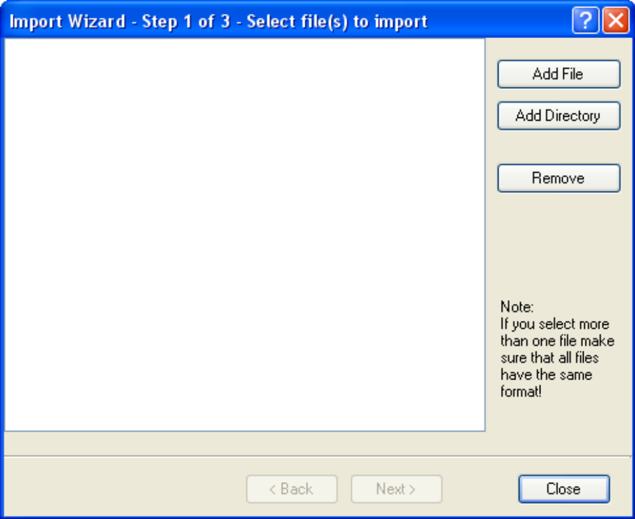
- To import data from CSV (comma separated values) and TXT (text) files, use the Data / Import menu on the IDE. This will pop up a data import wizard dialog that will help you to perform the import operation.
导入CSV和TXT格式的文件数据时，使用IDE中的Data/Import菜单。这样会弹出数据导入向导来帮助你完成导入。
- To import data from a TAQ CD, use the Data / Import menu on the IDE to get a different dialog box that is designed specifically for importing from the TAQ CDs.
从TAQ CD导入数据时，使用IDE中Data/Import菜单，得到一个专为导入TAQ CD数据设计的对话框。
- To download market data from a network data provider, use the Data / Import menu on the IDE to get a wizard dialog sequence for downloading. Choose your desired data provider from the list, and continue with the wizard. You should probably try to download free daily bars from Yahoo first, to see how downloading works.
从网络数据提供商下载市场数据时，使用IDE中Data/Import菜单，打开对话框向导来下载。从列表中选择提供商，继续。你应该先试着从Yahoo下载免费的每日数据，看看如何下载。
- Downloading data also automatically imports the data and stores it in the SmartQuant high-performance database. There is no need for you to import after downloading.
下载数据会自动导入数据并存储在SmartQuant高性能数据库。这样就不需要你下载后再自己导入了。

4.3 Viewing a Data Series查看数据序列
Right click an instrument in the instrument pane to view the underlying data series or chart. This right-click menu is also the mechanism for adding a new instrument to the instrument pane.
右击合约面板的合约来查看底层的数据序列或图表。这个右键菜单也是增加新合约的途径。
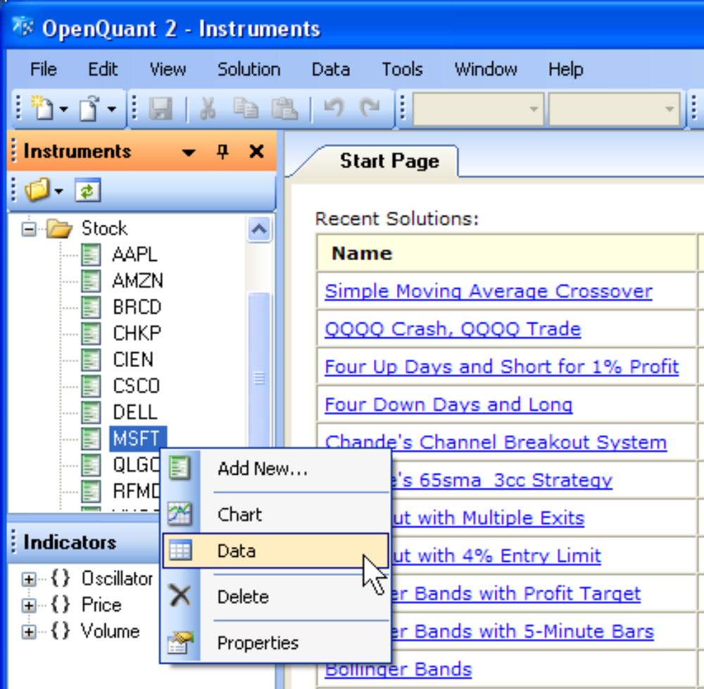
Here is a screenshot of the various preloaded data series for the MSFT instrument. You must left click a series to select it before the corresponding bar data will appear in the bottom window.
下图为MSFT股票预置的数据序列。你必须左键点击一个序列去选择数据，之后相应的Bar数据会出现在底部窗口。
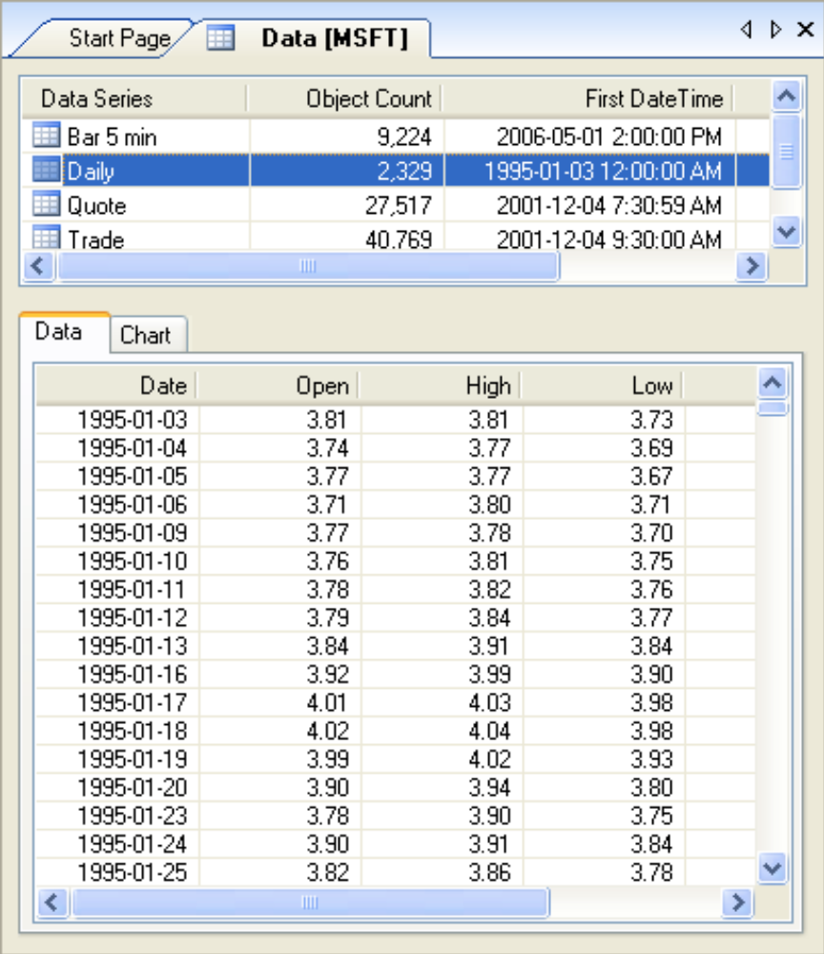

4.4 Editing Stored Data编辑存储的数据
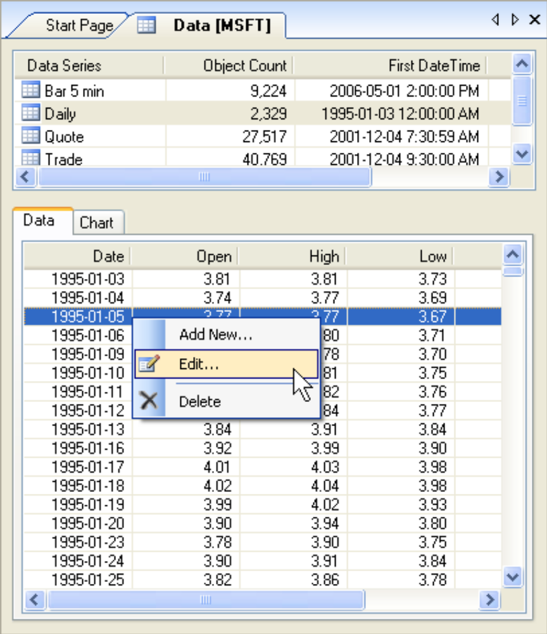
- To add a new bar to the series, right click anywhere in the bottom data window, and choose Add New… from the pop-up context menu.
要在序列中增加一个新条目时，右击底部数据窗口任意位置，在弹出的菜单中选择Add New…
- To edit a particular bar from the series, double-click the bar line, or right-click the bar that you want to modify and choose Edit from the pop-up context menu.
要编辑序列中条目时，双击序列，右击条目中你需要修改的地方，从弹出菜单中选择编辑EDIT选项。
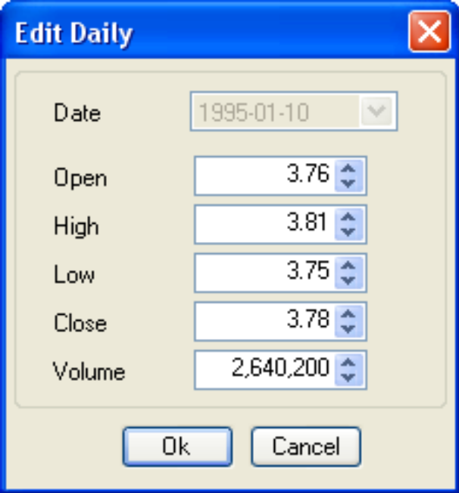
- To delete stored data series entries, select the bars that you want to delete, right click them, and choose Delete from the pop-up context menu.
要删除序列，选择你想要删除的序列，右击，然后从弹出菜单选择Delete删除。

4.5 Analyzing Data with Indicators通过指标分析数据
The procedure for analyzing stored data with technical indicators was described above under the Instruments pane and the Indicators pane. Here it is again:
利用合约面板与指标面板，使用技术指标分析数据的过程已经在前面提到过，在这再次示范：
- Right click an instrument name in the Instruments pane, and show Chart.
右击一个合约面板中的合约，打开图表。
- Drag and drop an Indicator name from the Indicators pane to the Chart Tab.
从指标面板拖拽一个指标到图表。
- Configure the new indicator for the first time using the dialog box that appears (shown below). Be sure to check the "Create a new pad" checkbox if you want to show the indicator in a new chart section at the bottom of the chart.
首次使用新的指标，会出现对话框配置（如下图所示）。如果你想在图表的底部新区域看到指标请勾选“Create a new pad”复选框。
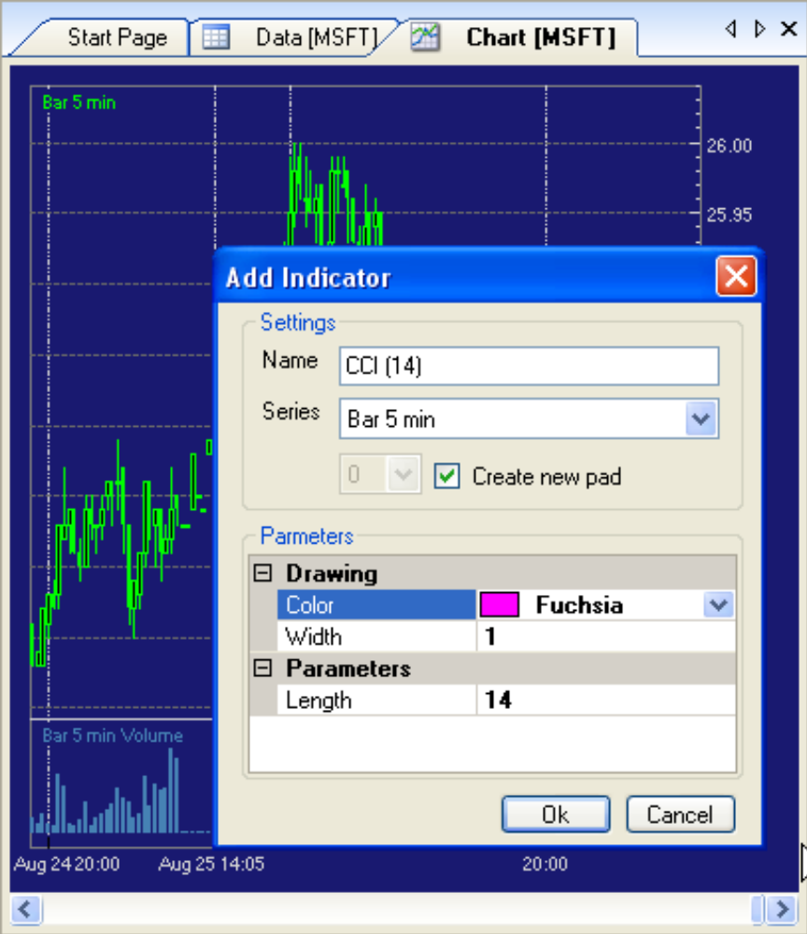
- Edit indicator properties by left-clicking the indicator line in the Chart Tab. This can be tricky for narrow lines. Once you have the indicator line selected, you will see several selection handles on the indicator line, and the corresponding indicator properties will show up in the Properties pane for editing.
左键图表中指标线来编辑指标属性。对于窄线来说有点困难。一旦你选择了指标线，你就能看到指标线上的多个选择手柄，在属性面板中会出现相应的指标属性供编辑。
- To delete an indicator, select it in the chart window (as just described), then right-click it and choose Delete from the pop-up menu. The indicator will leave a blank area on the chart. There is no way of removing the blank area. Instead, delete the whole chart window tab from the center window pane (use the upper right X icon), and rebuild the chart again by dragging and dropping indicators.
要删除一个指标，在图表窗口中选择它（刚刚提到过），然后右键从弹出菜单选择Delete。指标会在图表上留出一个不可消除的空白区。不过可以从中央窗口删除整个图表窗口（使用上方的X按钮），重新建立图表，拖拽指标。

5 Running a Preconfigured Trading Strategy运行预置的交易策略
Finally, we can start to talk about running the preconfigured trading strategies!
我们终于开始讨论运行预置的交易策略！

5.1 Running Your First Strategy运行你的第一个策略
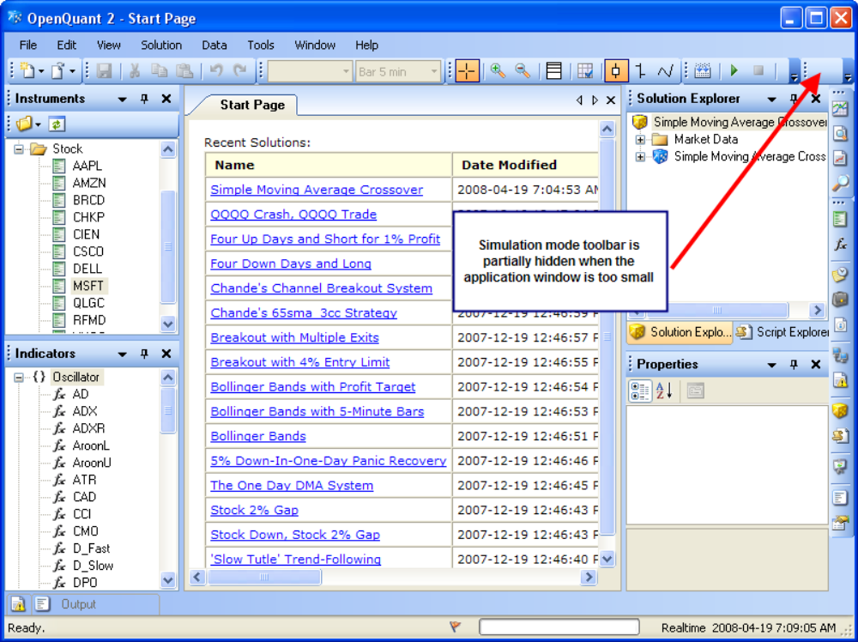
To run your first strategy, run one of the preinstalled strategies. Show the start page with View / Other Windows / Start Page, then click on the Simple Moving Average Crossover Strategy. That should load the strategy into the Solution Explorer pane. If it is not visible, use the View / Solution Explorer menu to make it visible.
要运行你的第一个策略，请运行默认的策略。打开View/Other Windows/Start Page，然后单击简单移动平均线交叉策略。载入策略到解决方案管理器面板。如果不可见，点击View/Solution Explorer菜单显示。
- Use the Trading Mode toolbar to select Simulation mode. The toolbar might be hidden or partially hidden if you have set the application window size too small (like I did for the screenshots in this document, to make the screenshots consistent in size, 800x600). If you can’t see the Trading Mode toolbar, drag some toolbar handles (the vertical four dots on each toolbar) to make two rows of toolbars. Select simulation mode when you can see the toolbar.
通过交易模式工具条选择模拟模式。如果你的屏幕分辨率太低，此工具条可能会隐藏或部分隐藏（就像我在本文档中截图所做的一样，屏幕分辨率为800x600)。如果看不到交易模式工具条，你可以拖拽工具条把手（每个工具条顶端四点）来使工具条排成两行。当你能看到工具条时选择模拟模式。
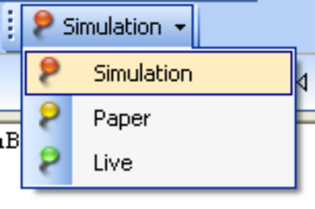
- To run the strategy, click the Run arrow icon (tiny light green arrow) on the Solution toolbar (about 1 inch to the left of the long red arrow in the screenshot above). Or right-click the project name "Simple Moving Average Crossover" and choose Run from the context menu. (Now that you know which icon means Run, you can use the Solution Toolbar to run the strategy next time.)
要运行策略，单击解决方案工具条（在屏幕截图的红色长箭头的左侧一英寸左右）的Run箭头按钮（绿色小窄箭头）。或者右键项目名“Simple Moving Average Crossover”从弹出菜单选择Run按钮。（现在你知道了哪个按钮是“运行”，你下次可以使用解决方案工具条运行策略）
- Once the strategy run has completed, a performance chart will show up in the center pane.
一旦策略运行完成，绩效图表会在中央窗口出现。
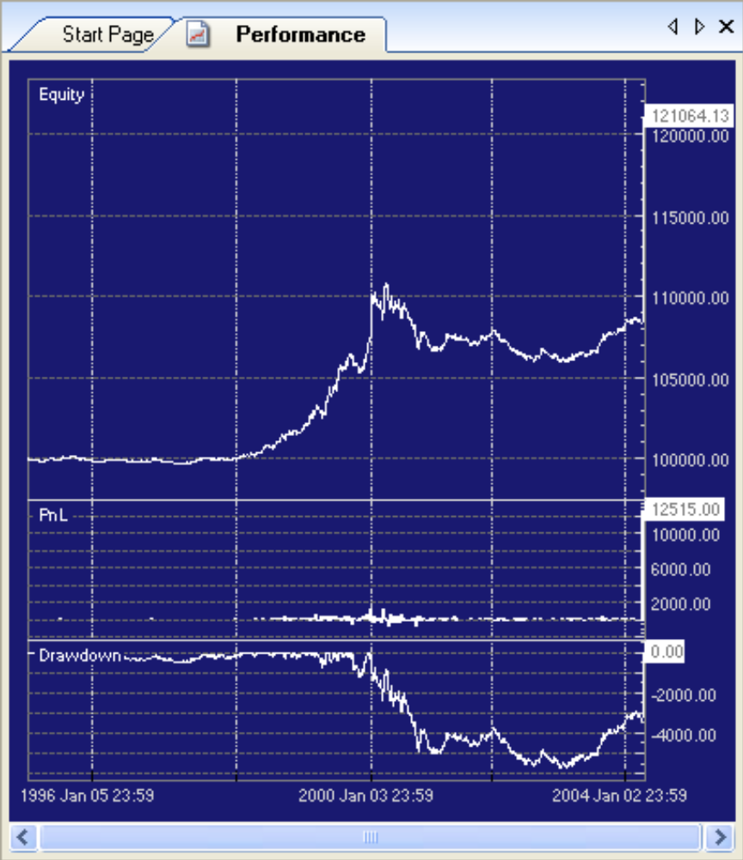
Previous parts of this document have already showed how to analyze strategy results, so you can inspect the results of this strategy for yourself. Remember that you must use "View Results" on the Strategy context menu (shown earlier) to show the Results tab. Recall that the Results tab locks the trades on the chart to the trade transactions in the bottom window of the Results tab.
本文档之前的部分已经说明了如何分析策略结果，你可以自行检验这些策略结果。记住你必须使用策略弹出菜单（之前出现过）的“View Results”来查看结果选项页。结果选项页将图表中的交易信号与底部的交易记录绑定。
Be sure to have a careful look at the Performance curves (Equity, PnL (Profit and Loss) and Drawdown) for all of the preconfigured strategies. They should show you that writing a good strategy that performs well is not as easy as it looks!
仔细查检所有预置策略的绩效曲线（净值、损益、回撤）。你可以发现写出一个好的策略并不是那么容易。

6 Creating New Solutions,Projects,and Strategies新建解决方案、项目和策略
This section summarizes the steps required to create completely new solution containers and strategy projects, without going into the theory or details of good strategy design (this document is only a Getting Started Guide). See the other SmartQuant PDF documents for a deeper discussion of trading strategy design.
本节总结了创建完整的新解决方案和策略项目需要的步骤，不涉及设计良好策略的理论和细节（这个文档只是入门指南）。想更深入的讨论交易策略请查看SmartQuant的另一文档。
To avoid confusion concerning the meaning of the word "project", this document always refers to solution containers and strategy projects, or to (short names) solutions and strategies. For example, this document will never call a solution a project. In fact, this document tries to never use the word "project" at all, since it is so confusing.
为避免混淆，本文中的project是指解决方案容器和策略项目或解决方案和策略的简称。例如，此文档中决不会叫解决方案为项目，实际上为了不混淆，此文档试着不使用此词。
In contrast, the application software uses the terms Solution Project ("New Solution", "New Project") to refer to solution containers and strategy projects. Now imagine that you named your first solution "My New Project." When you say "my new project" to someone or in a document, are you referring to the solution or to the strategy? (As you will see, if you happened to create the new solution and project simultaneously with the File Toolbar New Project button, names and terminology get even more confusing!)
相比之下，软件使用解决方案项目（“新解决方案”，“新项目”）来表示解决方案容器和策略项目。想象一下，第一个解决方案叫“我的新项目”，当你说“我的新项目”时，你说的是解决方案还是策略呢？（正如你所见，如果你碰巧新建的解决方案和项目与工具栏中新建项目同名，名称和术语变得更加混淆）
It will be much easier for you to learn to think in terms of solutions and strategies and to avoid thinking about projects—the project terminology is too confusing for a Getting Started guide.
这将更容易让你学会以解决方案和策略来思考，避免以项目来思考——项目这个术语对入门指南来说太容易混淆。
The software allows one solution container to contain multiple strategies, because it is often convenient to run multiple simultaneous strategies within one simulation run. The following screenshot shows how you can enable individual strategies by using their right-click menus.
该软件允许一个解决方案容器包含多个策略，因为它很容易在一个模拟环境中运行多个策略。下面的截图显示了如何通过右键菜单使用单个的策略。
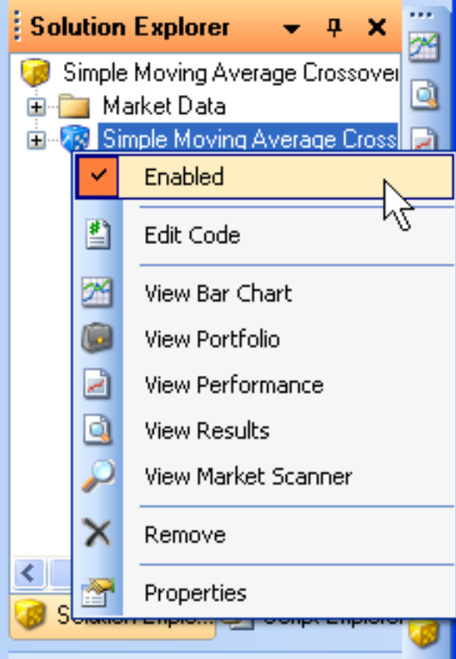

6.1 Solutions, Strategies, and Projects解决方案、策略和项目
The current OpenQuant menus enable you to do three kinds of actions easily:
当前的OpenQuant菜单让你做3种动作时很轻松：
- (Recommended) Create a new solution container (use the File / New / Solution menu). This method is recommended, and creates a new (empty) solution container that can have a name that is clearly distinct from any strategy name.
(推荐)新建解决方案容器(使用File / New / Solution)，解决方案的名字明确的与策略名区别开来。
- (Recommended) Create a new strategy project inside of an open container (right click the solution name). This method is recommended because it clearly separates solution creation actions from strategy creation actions, and makes it easier to treat solutions and strategies—and their names—as completely separate objects (which they are, within the software).
（推荐）在已经在打开的容器中新建策略项目（右击解决方案名）.因为能明确区分创建解决方案和创建策略，并且更易于处理解决方案和策略，并且名字是完全独立的对象(在软件中)
- (NOT Recommended) Create both a solution and a strategy simultaneously (use the confusing File / New / Project menu). This method is NOT recommended in this Getting Started Guide, because it makes it too easy to confuse solution names with strategy names, to easy to confuse solution projects with strategy projects, and too easy to pick a solution name that is coupled to a strategy name.
（不推荐）同时创建解决方案和策略(使用File/New/Project)，入门指南中不推荐，因为容易将解决方案名与策略名混淆，容易将解决方案项目与策略项目混淆，容易在选择解决方案名时选中了策略名。
It also makes it too easy to think that you can use an existing solution name in the dialog box to put a new strategy into an existing solution container (which is NOT possible).
这也容易使人联想到是否可以使用已有的解决方案名来添加策略到解决方案容器(这是不可能的)。
Furthermore, since renaming solutions and strategies is not that easy to do in OpenQuant (not all references to the old name are automatically removed from all software objects), it is important that you get your solution and strategy names right the first time around. For all these reasons, this Getting Started Guide recommends that you create solutions and strategies separately, and think that way, as described by the two previous paragraphs.
此外，对解决方案和策略改名也是不容易的(并非所有旧名称的引用会自动删除)，第一次就定好名称是相当重要。基于此原因，推荐以前面两个段落中的方法来分别创建解决方案和策略。

6.2 Creating a New Solution新建解决方案
To create a new strategy, use the File / New Solution menu or the New Solution button on the File Toolbar. Enter a solution name in the dialog that pops up. New solutions are stored in the "C:\Program Files\SmartQuant Ltd\OpenQuant\Solutions” folder.
要新建策略，使用File/New Solution菜单，或文件工具条上的New Solution按钮。在弹出的对话框中输入解决方案名。新解决方案保存在“C:\Program Files\SmartQuant Ltd\OpenQuant\Solutions”文件夹。
If you ever want to delete a solution, you must delete the solution folder at the end of that pathname. One of doing the deletion from the OpenQuant application is to choose File / Open / Solution, which will bring up a standard Windows file open dialog. Then right click the folder you want to delete and choose delete from the popup context menu.
如果想册除解决方案，你必须到解决方案的目录下。一种删除的方法是在OpenQuant中选择File / Open / Solution，这时会弹出个标准Windows文件打开对话框，选择你想删除的文件夹，右键菜单中删除。
Deleting a folder does not remove all references to the solution or strategy (such as the references on the Start Page).
删除文件夹不会删除解决方案或策略的引用(如开始页中的记录)
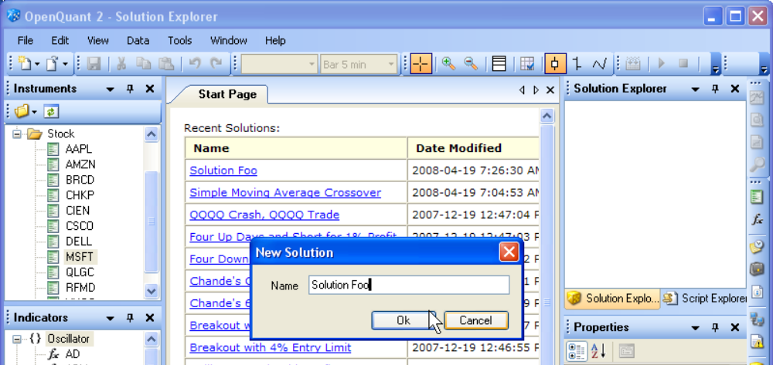
- A new (blank) Solution will be created in the Solution Explorer pane.
一个空白的解决方案将被创建在解决方案资源管理器面板
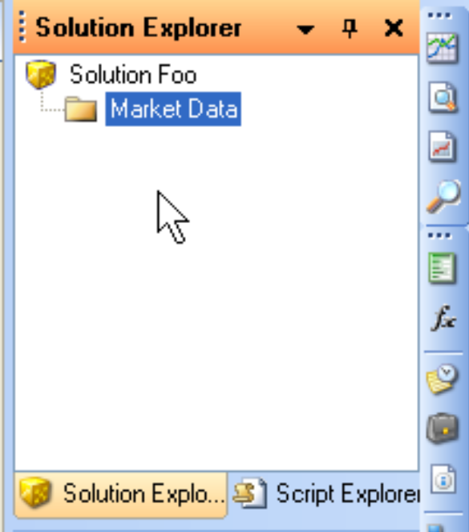
- As you can see from the screenshot above, the new blank solution has no Strategies, no Market Data types, and no Instruments in the solution. We must define all of those things before we can run a strategy. The screenshot below shows what the window should look like after all the missing pieces have been defined.
正如上面截图所示，新的空白解决方案没有策略，没有市场数据类型，没有合约。我们必须在策略运行前定义这些。下面的截图是是所有东西都定义好的样子。
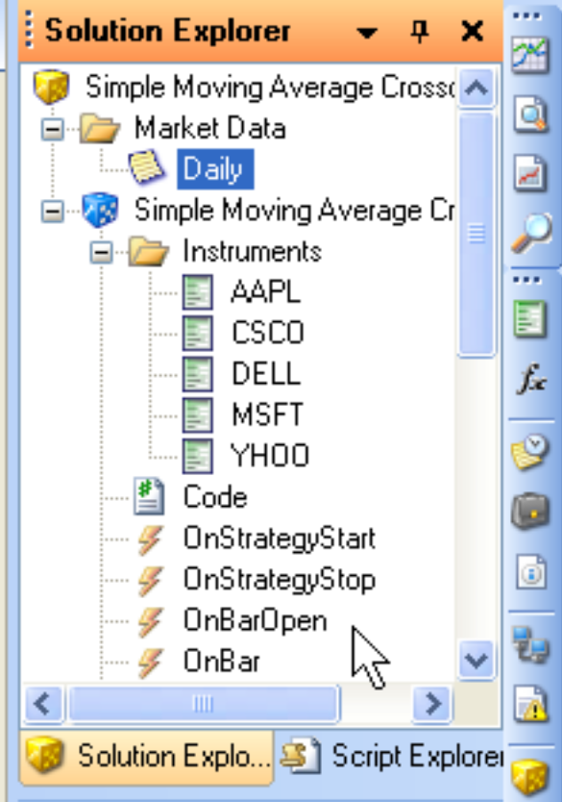

6.3 Adding a New Strategy to a Solution新加策略到解决方案
- To add a new strategy to the current (open) solution, right click the solution name and choose Add / New (Strategy) Project from the context menu.
添加新策略到当前解决方案，右击解决方案名并选择Add / New (Strategy) Project。
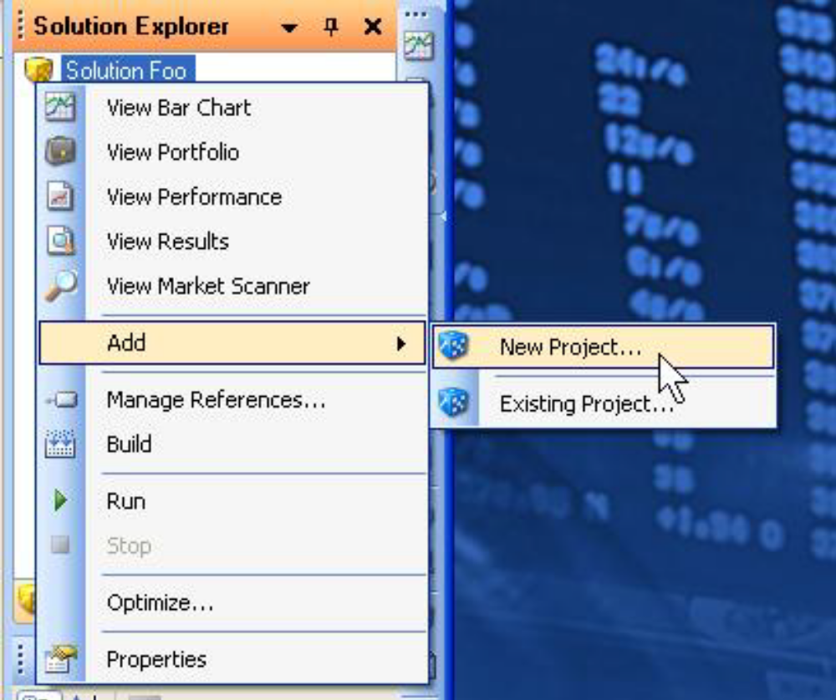
Notice that the context menu also gives you the choice of adding an existing strategy project to the current open solution. This software organization—which stores solutions and strategies in separate folders on the computer disk—enables multiple solutions to share the same single copy of a strategy.
注意，菜单中也提供了让你选择已有的策略到当前解决方案。这个软件通过磁盘文件夹来组织解决方案和策略。允许多个解决方案共享同一个策略。
- Then fill in the dialog box that appears to create your new (blank) strategy. Notice how the solution name is automatically filled in for you, since you are using the recommended way of adding a strategy to a solution (right click the solution name).
然后填写对话框来新建策略。注意解决方案的名称是如何自动填充的，因为你是以推荐的方式来添加策略(解决方案上右击)
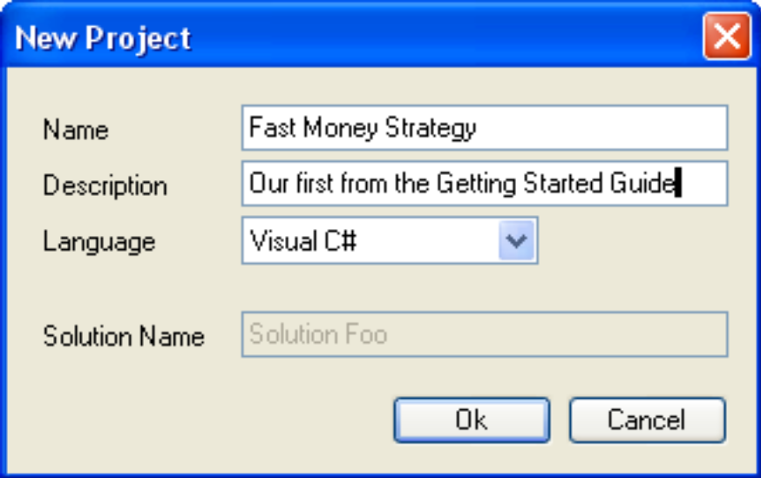
- Your new strategy will now appear in the Solution Explorer pane. But the strategy still doesn’t have any instruments defined, and the solution doesn’t have any market data types defined (Daily, 10 minute bars, etc). We’ll add both of those next.
新策略将显示在解决方案资源管理器面板，但此策略还没有添加任何合约，也没有添定任何市场数据类型(日线，10分钟)。下一步将添加这两项。
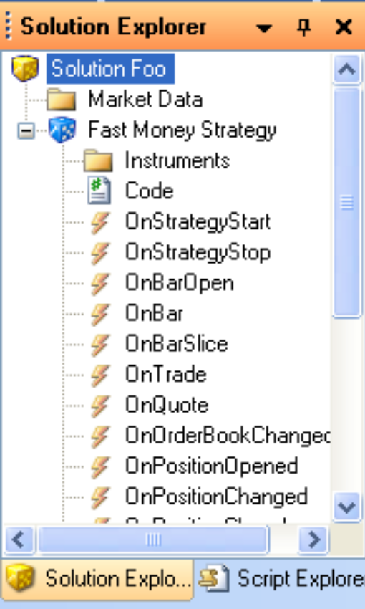

6.4 Adding an Instrument添加合约
- To add an instrument with menus, right click the Instruments icon below the strategy name in the Solution Explorer pane, and select "Add an Instrument." Choose whatever instrument you like. We picked AMZN in this example.
通过菜单添加合约，在解决方案浏览面板中的策略名下的合约图标上右击，选择“Add an Instrument”，选择需要的合约，在这我们选择"AMZN".
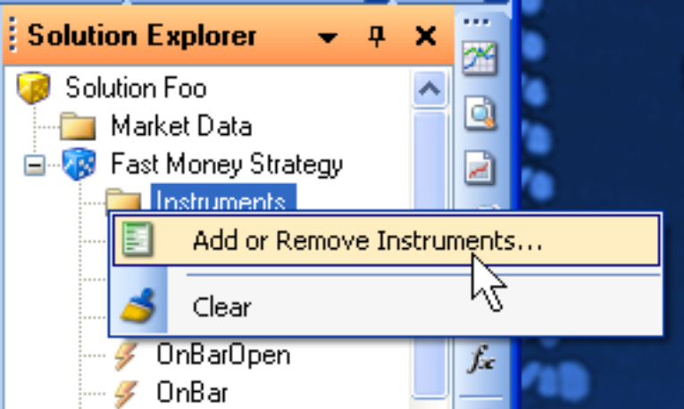
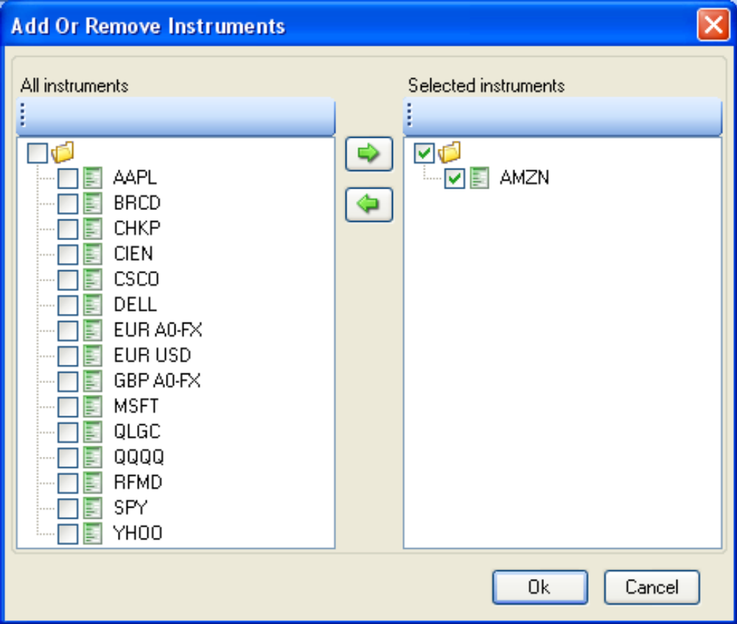
- To add an instrument using drag and drop, drag an Instrument from the Instruments pane and drop it somewhere within the current strategy within the Solution Explorer pane. This method is fast and easy, but it does not let you add and remove multiple instruments easily.
使用拖放添加合约，从合约面板中拖动一个合约放到解决方案面板中的当前策略，这种方法快速简单，但不方便同时添加删除多个合约。
- Either way, you now have an Instrument defined for your strategy, and you can see the Instrument properties in the Properties pane. Normally you would access the instrument properties by working with instruments through the Instruments pane, but you can also edit them by selecting an instrument within a strategy. Be aware that changing instrument properties within one strategy affects the underlying instrument definition for all strategies.
无论用哪种方式，你已经为策略添加了合约，你可以通过属性面板查看合约属性。通常你会通过合约面板来修改合约，你也可以选择策略中的合约来进行编辑，注意。改变一个策略的合约属性会影响所有定义了此合约的策略。
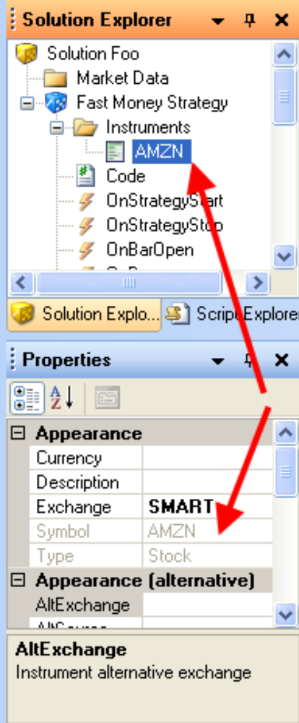

6.5 Choosing a Market Data Type选择市场数据类型
- To choose a market data type, right click the Market Data icon in the Solution Explorer pane. Then choose Add / Daily. We want to choose Daily bars because the IDE has a preconfigured data series for AMZN already installed.
要选择市场数据类型，在解决方案浏览面板中右击市场数据图标，然后选择Add/Daily，我们选择日线因为IDE中内置了AMZN的日线数据。
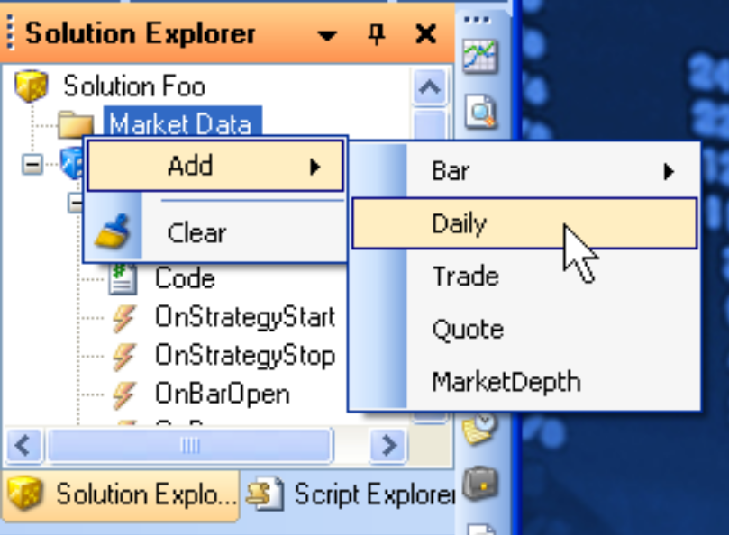
- At this point, the Solution Explorer should display both AMZN and Daily bars.
这时，解决方案资源管理器同时显示日线bar和AMZN
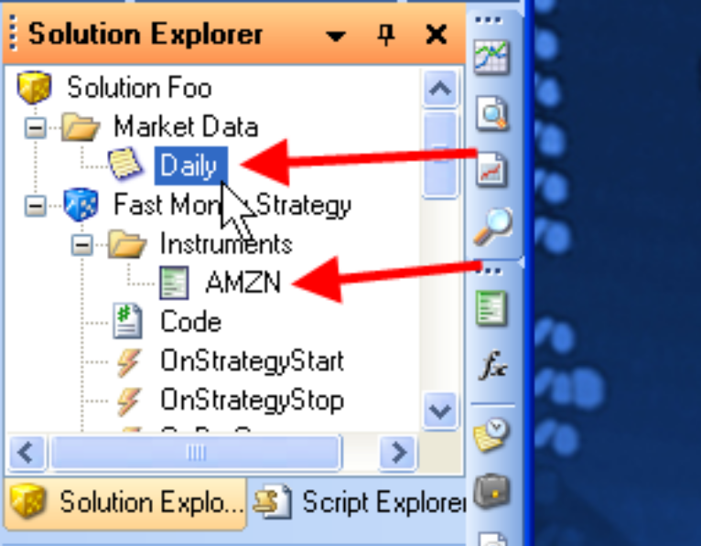

6.6 Viewing Your Strategy Code查看策略代码
- To view your new strategy code (it will be almost empty), double click the C# code icon in the Solution Explorer pane. This will display your C# code in the Code Editor tab.
要查看新策略代码(总是空的)，双击解决方案面板的C#代码图标，将在代码编辑选项卡中显示。
- Add some code of your choice to make the strategy run. Since this document is only a Getting Started guide, it will not show you how to code a strategy. Instead, cut and paste the code from one of the preconfigured strategies into your strategy, so that you can get your strategy to work.
添加一些代码让策略可以运行，由于这只是本入门指南，不会指导你如何编写策略。你可以粘贴代码到你的策略中，让策略立即工作。
- Once you have copied code from another strategy, your strategy should be ready to run. Click the Build icon on the Project Toolbar, or right-click the strategy name in the Solution Explorer pane and choose Build from the context menu.
一旦你已经从其他策略复制了代码，你的策略应当可以运行了，在项目工具条上点击Build图标，或在策略名上右击选择Build。
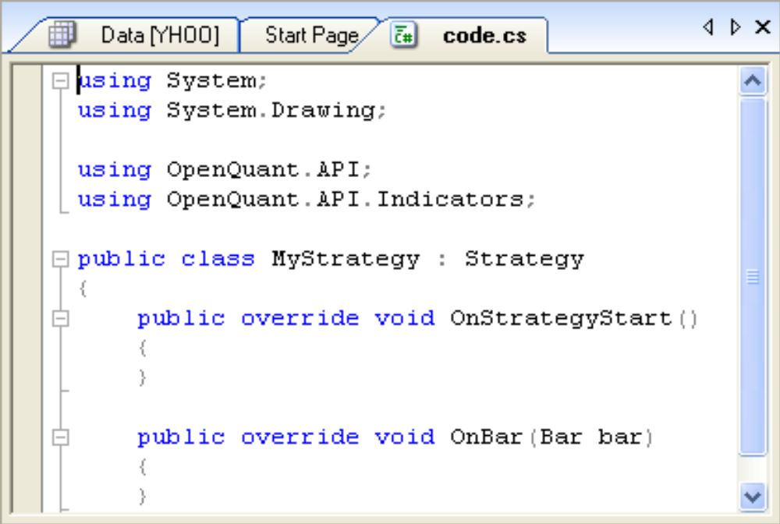

6.7 Correcting Code Errors更正代码错误
- If you make a coding mistake and try to build the project, you will see error messages in the Error List Pane. The Error List pane was not shown previously in this document, because there is no way for you to make it appear unless you generate a coding error. It does not appear on the View menu or View Toolbar.
如果构建项目时代码出现错误，你可以在Error List面板中看到错误信息。Error List面板并没有预先显示，因为只有代码出错时才有必要。他不显示在View菜单或工具条。
- A picture of the Error List pane is shown below. It shares docking space with the Output and Provider Errors panes. If you double click an error line in the Error Pane, the editor will move the code editor cursor to the source code line that generated the coding error. After you fix the error and rebuild (or Run) the project successfully, the main Output window will again get the focus, and the Error List pane will lose focus and will be inactivated.
下面是Error List截图，与Output和Provider Error共用一块区域。如果你在Error面板中单击一条错误，将会定位光标到产生错误的那一行。修复完错误后，然后重新Build或Run，Output窗口将获得焦点，Error List面板将失去焦点并变为非激活状态。
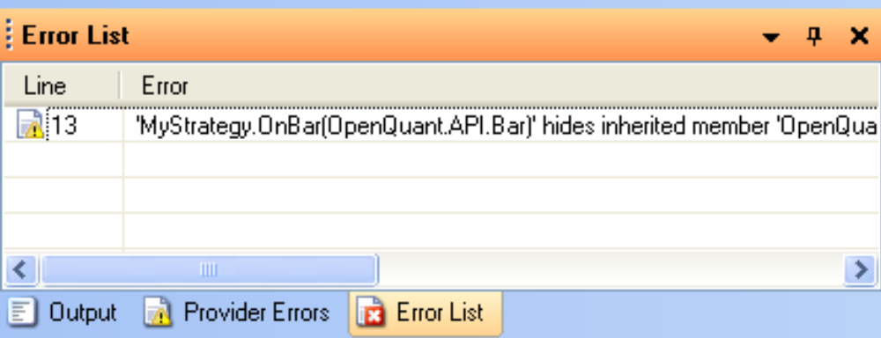

6.8 Code Editor Capabilities代码编辑器功能
- The code editor in the IDE is capable of color syntax highlighting, automatic formatting, and code completion suggestions, as the following screenshot (of code completion) shows.
代码编辑器支持语法高亮、格式化、自动完成，如下所示（自动完成）。
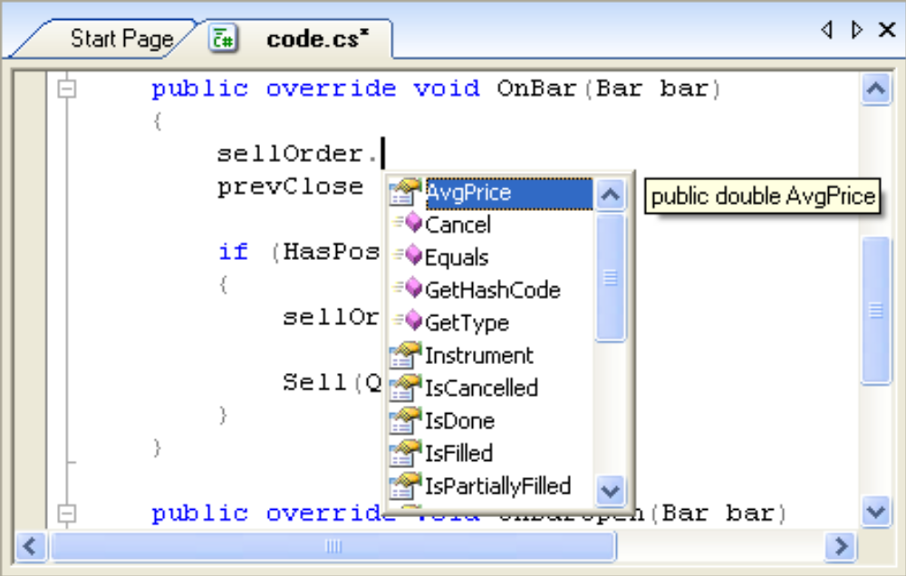

6.9 Running Your New Strategy运行新策略
- To keep things simple, let’s cut and paste the strategy code from the Simple Moving Average Crossover strategy into the new Fast Money Strategy that we created above.
为让事情简单，我们从简单移动平均线交叉这个策略中复制代码到我们刚才创建的策略中。
- Click on the Start Page tab in the center window (or show it using the View menu), click on the Crossover link to load the Crossover solution, click the Code icon, click inside the code editor window, type Ctrl-A to select all the crossover code, and click Ctrl-C to copy the code. Now let’s go back to our own strategy and paste the code there.
点击起始页选项卡（或通过View菜单），单击交叉策略链接，打开解决方案，点击代码图标，点击代码编辑器窗口，按Ctrl+A选择所有代码，按Ctrl+C复制，然后回到自己的策略粘贴。
- Click on the Start Page tab, click on the Fast Money Strategy link, click the code icon in the Solution Explorer pane, click within the code editor window, type Ctrl-A to select all the (empty) code in our strategy, and finally type Ctrl-V to paste the crossover code into our own code editor window. If you can see a pile of code, then we can move on. Otherwise, repeat these steps until you get the code, or use your own cut and paste method.
点击起始页选项卡，点击快钱策略链接，点击解决方案资源管理器面板中的代码图标，在代码编辑器中Ctrl+A选择所有代码，按Ctrl+V粘贴。如果你能看到一堆代码就继续，否则重复以上步骤，直到你得到代码。
- Because we have used a preconfigured instrument (AMZN) and a preconfigured bar size (Daily), there is no need for further configuration in order to run the new strategy.
因为我们已经预设了合约（AMZN）和周期（Baily）,没有必要再进一步的配置。
- Make sure that you are in Simulation mode (use the Trading Mode toolbar)
确保你在模拟模式(使用交易模式工具条)
- Run the strategy as usual (click the little green Run arrow) and examine the Performance chart that appears. Here is what the chart for AMZN using the Fast Money Strategy looks like (really it’s the code from the Simple Moving Average Crossover strategy).
像往常一样运行策略（点击绿色的Run箭头），然后查看出现的性能图表，下面的是AMZN的使用快钱策略(实际上是从移动平均线策略复制过来)
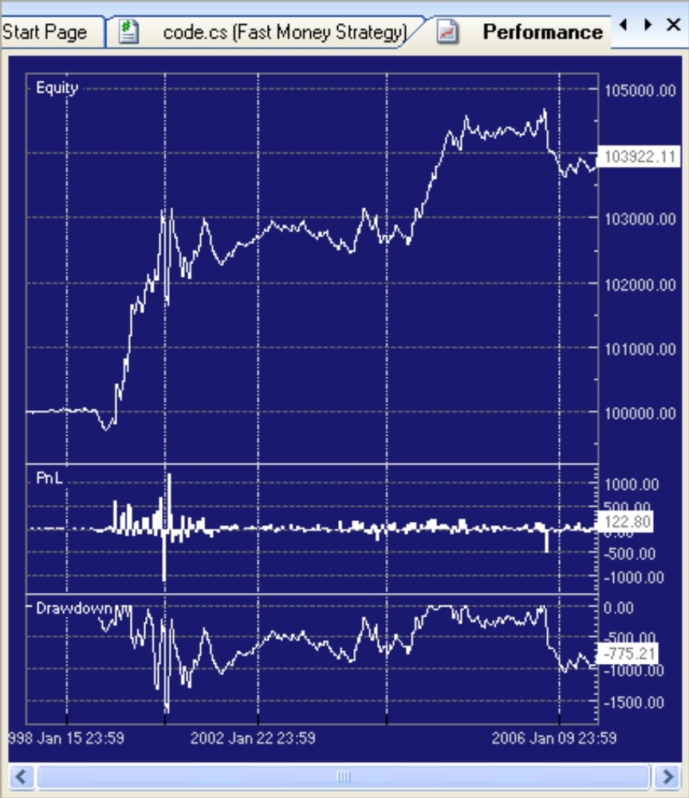
- As you can see, the crossover strategy worked OK between 1998 and 2006—the equity curve climbed quickly during the dot-com era (1998-2001), oscillated a bit during the dotcom crash, but then recovered a bit in the 2003-2005 time frame. But the strategy did not earn much money—it started with 100K in 1998, and ended up with about 104K in 2006. Only 4K for 8 years is not that good—but the good news is that the strategy did not LOSE a pile of money during that time. Hopefully your strategies will perform better.
如你所见，交叉策略在1998年到2006年工作得很好，资金曲线在互联网泡沫(1998-2001)时迅速攀升，泡沫破灭时震荡了一下。在2003-2005得到恢复。但策略实际上并没有挣多少钱。策略从98年启动10万，结束于2006年的10.4万，8年时间只有4千。但好消息是这个策略在这期间并没有亏钱。希望你的策略能比这工作得要好。
- You should try to modify the strategy code by changing the names of some parameter variables or parameter text descriptions. Then look for your changes in the Properties pane after you rebuild the project. That will convince you that you can add strategy parameters and have them show up in the Properties pane with all the other parameters.
你应当尝试改变参数的名称或参数的文字描述。重新构建后查看下你的属性面板，这将说服你给策略加参数，并让所有参数显示在属性面板中。

6.10 Setting Initial Simulation Values设置模拟初始化参数
For Simulation mode only, you can specify particular start and finish dates for a strategy execution, regardless of what trading mode you are using. Of course, it doesn’t make much sense to specify dates when you are live trading, because you are always trading in the present.
仅适用于模拟模式。你可以指定特定策略的开始和结束日期，无论何种交易模式。当然指定日期在实盘下是无意义的，因为你总是在正在交易。
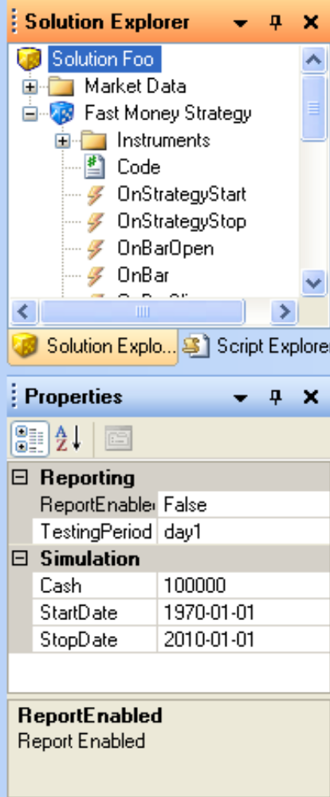
- To set initial simulation values, select the solution name in the Solution Explorer pane. This action will load the simulation properties into the Properties pane. (If you mistakenly select the strategy name, you will load the strategy parameters into the Properties pane, not the simulation run parameters.)
设置初始的模拟值。在解决方案资源管理器面板中选中解决方案名。这将在属性面板中加载模拟的属性（如果你错误的选择了策略名，将会加载策略的参数，而不是模拟运行参数）
- You can also specify the amount of starting cash that the strategy gets to spend. In the example above, the strategy is blessed with 100,000 dollars of initial capital. (You would probably want to be _very_ sure you had a good strategy before you traded that much capital in a live trading mode.) The starting Cash is used in Live Trading as a starting point for equity, and return calculations. (But of course the Cash you specify in the IDE is not the same real Cash that resides in your brokerage account.)
你也可以指定初始化资金量。上面的例子中是10万美元。（当你投入大把资金实盘前，你会非常想确保策略很好）。启动资金在实盘中是权益和收益计算的起始点。（当然了，IDE中的资金与你的经纪账户的资金还是不同的。）

6.11 Making Results More Realistic使结果更逼真
There are a variety of simulation parameters that you can change to make your simulations more realistic. Some of the most common parameters are commission costs, and price slippage amounts (the slippage between the market price when the simulation trigger fires, and the actual fill price that you might get from a trade execution provider).
有多种参数可以改变，以使你的模拟更加真实。一些常用的参数如手续费、滑价(滑价是市场价格在模拟触发的滑移，你将从交易提供商那得到你真实的成交价)
- To choose the simulation execution provider, select the provider in the Providers pane. The little green dot on the icon indicates that the simulation execution provider is connected (active), since we selected Simulation on the Trading Mode toolbar when we ran our new strategy a few paragraphs ago (above).
选择模拟交易提供商，在提供商面板中选择，绿色的小点指明模拟是否连接，在前面我们运行策略时，在交易模式工具条中选择了模拟。
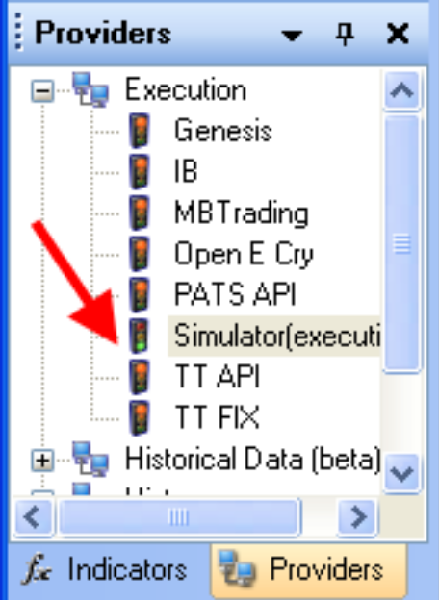
- Here is a screenshot of some of the parameters for the Simulation execution provider.
下面是模拟交易提供商的参数。
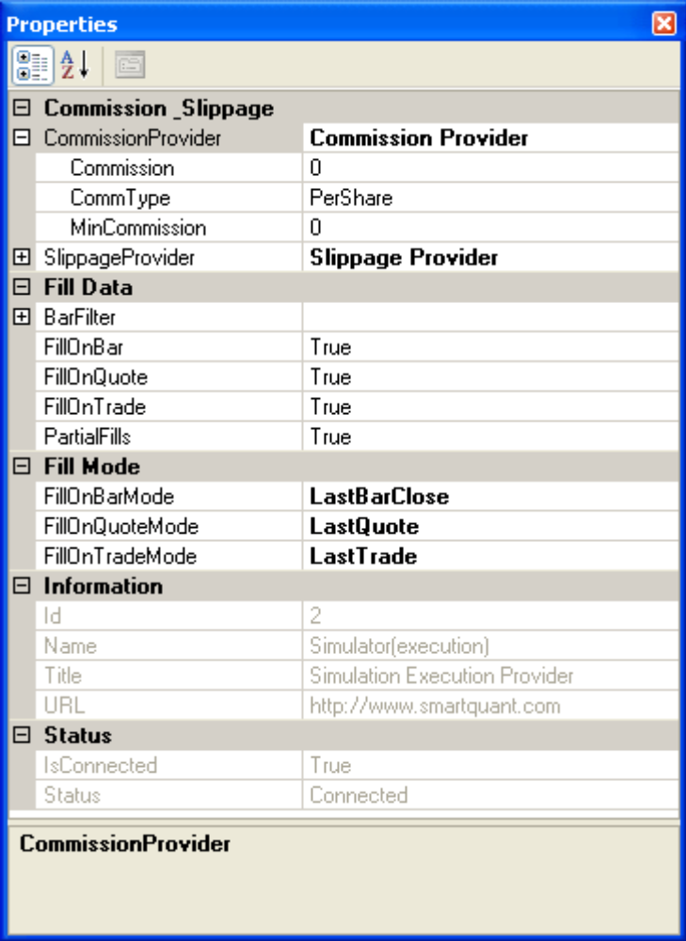
- For simulation mode (and the Simulation Execution Provider) only, make sure that you have specified reasonable values for Commission and Slippage charges in the Properties pane for the Simulation execution provider. This is a good thing to do because it helps your strategy to report more realistic profit results. A significant amount of profit in a computerized trading strategy can be consumed by commissions and price slippages during order fills. (If you are using a Live execution provider, the broker will automatically use their actual values for commissions and price slippage in your live transactions, so there is nothing for you to configure there.)
只适用于模拟（和模拟提供商）。确保在提供商面板中能设置合理的手续费和滑点。这是一个很好的事情，因为它可以让你的策略报告的利润更真实。在程序化交易策略中，最重要的利润总是被手续费和滑点所消耗。（如果你使用的是实盘，手续费自动使用实际值，滑点基于你的实际交易，所以你不需要配置什么）
- For Simulation mode only, select the type of Order Fill that you prefer for Bars, Trades, and Quotes. The defaults are to fill orders on the close of the bar, or on the most recent Trade or Quote (if you are using Trade or Quote data directly).
只适用于模拟。为Bars\Trades\Quotes设置订单成交类型，默认是bar结束后成交，或者大部分情况是最新Trade或Quote (如果你直接使用Trade或Quote数据)

7 Configuring a Strategy for Paper or Live Trading配置仿真或实盘
You have already seen most of what you need to know in order to create and run a strategy, and to analyze its results and performance behavior. The only remaining topic to discuss is how to connect your strategy to a live market data provider and a live trade execution provider.
你已经知道如何去创建和运行策略，去分析业绩和表现。唯一的问题如何将你的策略连接实时行情提供商和交易执行商。
Switching from simulation mode (which we have been using so far) to paper trading or live mode is not difficult, as the following paragraphs will show.
从模拟模式(我们很早就在使用)切换到仿真或实盘如下面将展示的一样容易。

7.1 Configure Trading Mode Options配置交易模式
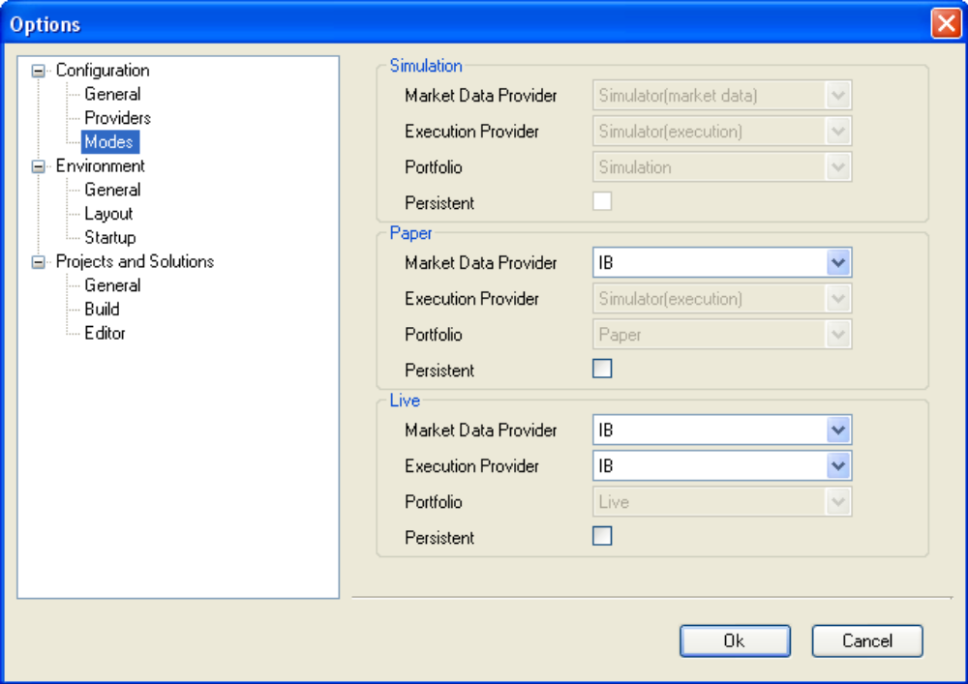
- The Tools / Options / Configuration / Modes dialog is shown above. It specifies which providers will be used for each of the three trading modes.
Tools /Options /Configuration/Modes对话框将显示如上。它指定三种交易模式分别用什么提供商。
- For Simulation Mode, you cannot set any options. This mode connects your strategy to a simulated market data provider, and to a simulated trade execution provider. Results are stored in the "Simulation" Portfolio (recall that there is a separate portfolio for each trading mode.)
模拟模式，不可以设置任何选项。这种模式连接你的策略到模拟行情和模拟交易。结果保存在名为“Simulation”的投资组合中（记得，每种模式都有独立的投资组合）
- For Paper Trading mode, you can choose your favorite (live) market data provider. The IDE will connect your strategy to a simulated trade execution provider. Results are stored in the "Paper" Portfolio. In this example, the data provider is IB Interactive Brokers.
仿真模式，自己选择真实的行情，IDE将策略连接到模拟交易，结果保存在名为“Paper”的投资组合中，如数据接盈透。
- For Live Trading mode, you can choose both the market data provider and the live trade execution provider. In this example, both have been set to IB Interactive Brokers. Results from live trading are stored in the "Live" Portfolio.
实盘交易，用户同时选择真实行情和真实交易，例如同时接IB,结果保存在“Live”投资组合中。

7.2 Choose a Trading Mode选择交易模式
- Choose a trading mode using the Trading Mode toolbar, as shown above. When you select one of the modes, the configuration values (explained above) for that mode are used to connect your strategy to the desired providers and portfolio database.
在工具条中选择交易模式。当你选择了一个模式后，模式对应的配置会被连接到你的策略、提供商和投资组合数据。

7.3 Check Provider Connections检查提供商连接
- When you switch trading mode to something other than Simulation mode, it is a good practice to check for successful connections to the providers for the newly selected trading mode. That way you can be sure that all connections are working before trying to run your strategy with live data or live trade execution.
当你从模拟切换到其它模式时是一个很好的方式检查新设置的交易模式是否正常。你可以在实盘运行策略前确保所有的连接正常工作。
- Use the View / Providers and View / Provider Errors menus to show both the Providers pane and the Provider Errors pane. If a provider is properly connected, its icon in the Providers pane will be Green.
使用View / Providers、View / Provider Errors菜单显示提供商面板和提供商错误面板，如果提供商已经连接，它的图标会变成绿色。

7.4 Check for Provider Errors检查提供商错误
- Check for Provider Errors even if the provider icon is green. This is because the Green state only covers the provider connection, not the messages or content sent across the connection. For example, if you forget to specify an Exchange property for an instrument, a live execution provider will return an error message saying that it doesn’t know where to trade the instrument.
即使图标是绿色的也要检查提供商错误。因为绿色只是表示连接上，并不包含连接发出的信息或其它内容。例如，如果你忘了设置合约的交易所信息，实盘提供商会返回信息表示不知道在哪交易。

7.5 Check Data Flow with the Quote Monitor使用行情监视器检查数据流
- Once you have defined matching bar sizes, and have successfully connected to a live market data provider during trading hours, check for a flow of market data by using the Quote Monitor to make sure that your strategy has access to input trade and bar data.
一旦定好了Bar的大小后，并且在交易时段成功连接到实时行情上，你可以通过行情报价监视器检查策略运行时输入的行情数据流。
- View the Quote Monitor with the View / Quote Monitor menu. Drag and drop the instrument(s) used by your strategy on to the Quote Monitor window. Watch to see if prices change. If they do, you have data flow for your strategy.
查看View / Quote Monitor，拖放合约到行情报价监视器窗口，观察价格是否改变，如果改变，你的策略也接收到了数据流。

7.6 Check Live Execution Provider Functions检查实盘交易提供商功能
- Check that all your instruments have at least a currency and an exchange value specified (perhaps your trade execution provider will require other fields as well).
检查你的合约至少有币种和交易价格(也许你的交易商还需要其它的值)
- Check for a good connection to the live execution provider.
检查交易提供商连接是否正常
- Check that you can successfully send trading orders to your live execution provider using the Quote Monitor. Right click an instrument line in the Quote Monitor to send a trade order to the execution provider. Some execution providers such as IB Interactive Brokers provide test accounts that are identical to real accounts, except that they do not use real money. These accounts are useful for testing your strategy in a realistic environment.
检查你能通过行情监视器向交易提供商发送报单，右击行情监视器中的合约，发送报单。有些提供商如IB提供与真实账号一样的测试账号，你可以不使用真钱。这些账号在现实环境测试策略非常有用。
- Check that you can cancel an order too, if possible.
如果可能，也可以检查下撤单。

8 The Scenario Feature场景特性
OpenQuant includes a new Scenario feature that enables users to programmatically run strategies in a sequential fashion, under the control of scenario code contained in the scenario.cs code file. Each new project created in OpenQuant is created with a skeleton scenario file that simply runs the new strategy. Here is a screenshot showing where you can find the scenario file, and a picture of its default contents.
OpenQuant新添加了一个场景特性，能让用户在场景代码控制下连续运行策略。每个新建的工程都会有一个基本的场景文件能直接运行策略。下面的截图显示了如何找到场景文件，以及默认的内容。
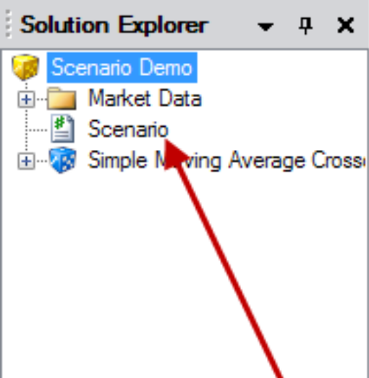

8.1 The Default Scenario File默认场景文件
Here are the default contents of a scenario file. The default code simply starts the current strategy, but you can add more code to do many other useful things.
以下是场景文件默认内容。简单的运行当前策略，你也可以添加自己的一些功能。
using System;
using OpenQuant.API;
using OpenQuant.API.Engine;

public class MyScenario : Scenario
{
public override void Run()
{
Start(); // run the current strategy
}
}

8.2 The Scenario Demo Solution File场景演示解决方案
Here is the scenario.cs file from the solution Scenario Demo. As you can see from the code, this scenario code does the following things:
这个解决方案Scenario Demo中的scenario.cs文件，这个场景代码完成以下工作
- Runs the default strategy solution
运行默认策略
- Removes the daily bars and all instruments, and adds 1 minute bars for MSFT
移除日线Bars和所有合约，并添加MSFT的1分钟Bars
- Changes two parameters, and runs the strategy again
改变两个参数，并继续运行策略
- Prints some PnL (profit/loss) results from the second run
第二次运行时打印盈亏
- Changes some strategy parameters again
再次改变策略参数
- Runs the strategy a third time, and prints the results again.
第二次运行策略并打印结果。
As you can see, the scenario file makes it easy to code complex sequences of strategy runs with different parameters, enabling you to write complete and complex back testing or optimization scenarios for your strategy solutions. Since the scenario file resides at the solution level, it can reference all the projects within the solution.
如你所见，场景文件可以很容易的使用不同的参数编写复杂的一组策略，能让你编写复杂的回测或优化方案。由于方案是驻留在解决方案层面，它可以引用所有项目。
// from Scenario Demo solution
using System;
using System.Collections.Generic;
using System.Text;
using OpenQuant.API;
using OpenQuant.API.Engine;
using OpenQuant.API.Indicators;

public class
MyScenario : Scenario
{
public override void Run()
{
// start solution
Console.WriteLine("Running solitiom with default settings");
Start();
Console.WriteLine();

// remove Daily request
Solution.Requests.RemoveDaily();

// add 1 min bar request
Solution.Requests.Add(BarType.Time, 60, true);

// get project object
Project project = Solution.Projects[0];

// clear project instrument list and add MSFT
project.Instruments.Clear();
project.AddInstrument("MSFT");

// start the solution a second time, and print statistics
Console.WriteLine(
string.Format("Running solution with sma1 length = {0}, sma2 length = {1}",
project.Parameters["Length1"].Value,
project.Parameters["Length2"].Value));
Start();

Console.WriteLine(
string.Format("Portfolio value = {0}, PnL per Trade = {1}",
Solution.Portfolio.GetValue(),
Solution.Statistics.PnLPerTrade.ToString("F2")));

// Run the solution a third time
// change project parameters and start the solution again
Console.WriteLine();
project.Parameters["Length1"].Value = 10;
project.Parameters["Length2"].Value = 28;
Console.WriteLine(
string.Format("Running solution with sma1 length = {0}, sma2 length = {1}",
project.Parameters["Length1"].Value,
project.Parameters["Length2"].Value));
Start();
Console.WriteLine(
string.Format("Portfolio value = {0}, PnL per Trade = {1}",
Solution.Portfolio.GetValue(),
Solution.Statistics.PnLPerTrade.ToString("F2")));
}
}

8.3 Scenario File Algorithm Possibilities场景文件实现算法的可能性
Here are some code examples that show possible ways of implementing strategy actions. This code has not been tested, and is provided as a guide to general syntax only.
以下代码显示了实施策略的可能方式，没有经过测试，只是用于语法指导。

8.3.1 Configure a Solution Object配置解决方案对象
// configure solution object
Solution.StartDate = new DateTime(1995, 1, 1);
Solution.StopDate = new DateTime(2001, 1, 1);

Project myproject = Solution.Projects[0];
myproject.AddInstrument(instrument);
myproject.Parameters["Length"].Value = 14;
Start();

8.3.2 Do Batch Back Tests批量回测
- Read parameter sets from a file 文件中读取参数集
- Loop over all parameter sets 循环所有的参数集
  - Install new parameters 设置新参数
  - Start();
  - Write out results 输出结果

8.3.3 Do Walk Forward Back Tests 移动窗格检验
- Loop over calendar intervals within the data set数据集内日历间隔循环
  - Set up the in-sample interval within the data set 设置样本内数据集间隔
  - Run strategy multiple times to optimize parameters 多次运行策略来优化参数
  - Set the out-of-sample interval within the data set 设置样本外数据集间隔
  - Run the optimized strategy on the out-of-sample data set 运行优化的过的策略在样本外数据

8.3.4 Do Monte Carlo Back Tests 蒙特卡罗回测
- Read original data series 读取原始数据序列
- Create and define a derived Monte Carlo (MC) data set 定义一个派生的蒙特卡罗数据集
- Loop over all MC data sets 循环所有的蒙特卡罗数据集
  - Clear out data in the historical database 清除历史数据
  - Install the MC data set into the historical database 导入蒙特卡罗数据
  - Run the strategy 运行策略
  - Store the results 保存结果
- Build up the MC distribution from all results 通过结果建立蒙特卡罗分布

8.3.5 Do Continuous (Additive) Back Tests 连续回测
- Set run interval (Date1, Date2) 设置运行时段
- Run the strategy 运行策略
- ResetOnStart = false; // keep existing performance results so far 保持当前的绩效结果
- Set new parameters 设置新参数
- Set interval (Date2, Date3) 设置新时段
- Run the strategy again // results are added to previous results 运行策略，结果会合并到上次的结果

8.3.6 Run Back Test to Load Indicators then Switch to Live Trading回测时加载指标，然后切换到实盘
- Set interval (Date1, Date2); 设置运行时段
- Run a simulation strategy (eg, to load up indicators) 运行模拟策略（如加载指标）
- ResetOnStart = false;
- Start (Mode.Live) 切换到实时

8.3.7 Do Custom Optimization of Strategies 自优化策略
- Loop over many parameter sets 循环多个参数
  - Install a set of optimization parameters 设置优化参数
  - Run the strategy, then fetch the final result 运行策略，获取最终结果
  - Objective = Solution.Portfolio.GetValue();
- Choose the best optimized parameters 选择最好的优化参数
- Start(); // run strategy one more time with the best parameters 再次用最好的参数运行策略

8.3.8 Produce Custom Report Outputs 产生自定的报告输出
- Run the strategy 运行策略
- Write out interesting results: 输出感兴趣的结果
  - Solution.Portfolio.GetValue()
  - Statistics.AnnualReturn
  - Statistics.Duration
  - Statistics.FinalWealth
  - Statistics.LongTrades
  - Statistics.LongTradesPnL

8.4 Scenario File Code Examples场景文件代码示例

8.4.1 Select and Load Liquid Instruments选择和加载大流动性合约
// get reference to strategy project
Project project = Solution.Projects[0];
// clear project instrument list
project.ClearInstruments();
// add most liquid stocks to instrument list
foreach (Instrument instrument in InstrumentManager.Instruments)
{
if (instrument.Type == InstrumentType.Stock)
{
BarSeries series = DataManager.GetHistoricalBars(instrument, BarType.Time, 86400);
if (series.Count != 0 && series.Last.Volume > 50000000)
{
Console.WriteLine("Adding " + instrument);
project.AddInstrument(instrument);
}
}
}
// start backtest
Start();

8.4.2 A Brute Force Optimization Loop穷举优化循环
// set in-sample data interval
Solution.StartDate = new DateTime(1995, 1, 1);
Solution.StopDate = new DateTime(2001, 1, 1);
// get reference to strategy project
Project project = Solution.Projects[0];
// define variables
int best_length1 = 0;
int best_length2 = 0;
double best_objective = 0;
// brute force optimization loop
for (int length1 = 3; length1 <= 7; length1++)
{
for (int length2 = 3; length2 <= 7; length2++)
{
if (length2 > length1)
{
// set new parameters
project.Parameters["Length1"].Value = length1;
project.Parameters["Length2"].Value = length2;
// print parameters
Console.Write("Length1 = " + length1 + " Length2 = " + length2);
// start backtest
Start();
// calculate objective function
double objective = Solution.Portfolio.GetValue();
// print objective
Console.WriteLine(" Objective = " + objective);
// check best objective
if (objective > best_objective)
{
best_objective = objective;
best_length1 = length1;
best_length2 = length2;
}
}
}
}
// print best parameters
Console.WriteLine("BEST PARAMETERS");
Console.WriteLine();
Console.WriteLine("SMA1 Length = " + best_length1);
Console.WriteLine("SMA2 Length = " + best_length2);
Console.WriteLine("Objective = " + best_objective);
// run strategy with the best parameters on out-of-sample data interval
project.Parameters["Length1"].Value = best_length1;
project.Parameters["Length2"].Value = best_length2;
Solution.StartDate = new DateTime(2001, 1, 1);
Solution.StopDate = new DateTime(2005, 1, 1);
Start();

8.4.3 Run Simulation on Historical Data and Switch to Live从模拟切换到实盘
// first run simulation from historical data up to "now"
this.Solution.StartDate = new DateTime(1996, 1, 1);
this.Solution.StopDate = Clock.Now;
Start(StrategyMode.Simulation);
// make sure all objects: portfolios, orders,
// indicators and strategy state remain the same
// on next strategy start
this.ResetOnStart = false;
// now start solution in Live mode
Start(StrategyMode.Live);

9 OpenQuant and Visual StudioOpenQuant 和Visual Studio
Some people prefer to use Visual Studio for their main editing environment, especially if they use a external library source files to support their strategies. This section shows how you can combine OpenQuant with Visual Studio to improve your strategy development environment.
有些人喜欢使用Visual Studio做为主要的开发环境，特别是如果他们使用扩展库的源文件来开发策略。这个部分将介绍如何结合OpenQuant和Visual Studio来改进你的策略开发环境。
This section only shows how to edit files in Visual Studio. You cannot use the VS debugger to debug your strategies that are run under the OpenQuant IDE, because the code is being run under the IDE, and not through Visual Studio.
这一节只介绍了如何在Visual Studio中编辑文件，而不能使用VS调试器进行策略调试，因为这策略是运行在OpenQuant下，而不是在Visual Studio下。

9.1 Edit Strategy Files in Visual Studio在Visual Studio下编辑策略
The main technique to use is to create a VS project file, and then add your code files to the VS project—being careful to add your code files as links to the VS project.
主要的技巧就是创建一个VS项目，然后将你的代码文件添加到项目，注意以链接的方式添加文件到项目。
This approach keeps the physical strategy file where it must reside within the SmartQuant folder hierarchy (C:\Program Files\SmartQuant Ltd\OpenQuant\Strategies\ Stock 2% Gap\*.cs). But it also allows the code file to be part of a VS project.
这种方法能让代码在SmartQuant的目录(C:\Program Files\SmartQuant Ltd\OpenQuant\Strategies\ Stock 2% Gap\*.cs)下，又能让此文件成为VS项目的一部分。
To link an OpenQuant code file to a Visual Studio project, follow these steps:
想链接OpenQuant代码文件到Visual Studio项目，按以下步骤操作：
- Create a new strategy project using the IDE. The new strategy project should be located within the OpenQuant file system (see the pathname above). If you can find your new strategy code file, you have a strategy code file to edit.
创建一个策略项目，此策略项目应当在OpenQuant的文件系统中(参考前面的路径)，如果你能找到策略文件，你就可以去编辑了。
- Create a new VS project and add DLL references to the OpenQuant DLL libaries that you need (located at C:\Program Files\SmartQuant Ltd\OpenQuant\Bin\*.dll). Now you have a VS project that can include the code file that you created in the previous step.
创建一个VS项目，并且添加引用OpenQuant的库(C:\Program Files\SmartQuant Ltd\OpenQuant\Bin\*.dll)。现在你有一个VS项目可以导入你上步创建的代码文件了。
- Right click the VS project (or a folder within the project), choose Add -> Existing Item, and browse to your OpenQuant strategy code file in the OpenQuant folder hierarchy (e.g. C:\Program Files\SmartQuant Ltd\OpenQuant\Strategies\ Stock 2% Gap\*.cs). Now we come to the key action that makes this approach work.
右击VS项目（或项目中的一个文件夹），选择Add -> Existing Item，然后定位到OpenQuant的策略文件所在目录（如：C:\Program Files\SmartQuant Ltd\OpenQuant\Strategies\Stock 2% Gap\*.cs）。现在我们到了最关键的一步。
- Instead of clicking the "Add" button in the file browsing dialog in the previous step, be careful to click the tiny little arrow beside the Add button, and select "Add as Link." Here is a picture of what the button looks like, indicated by the red arrow.
不是在文件浏览对话框中直接点击“Add”,而是单击“Add”旁边的小箭头，并选择“Add As Link”。这有图片显示了按钮的样式，用红色箭头指明。
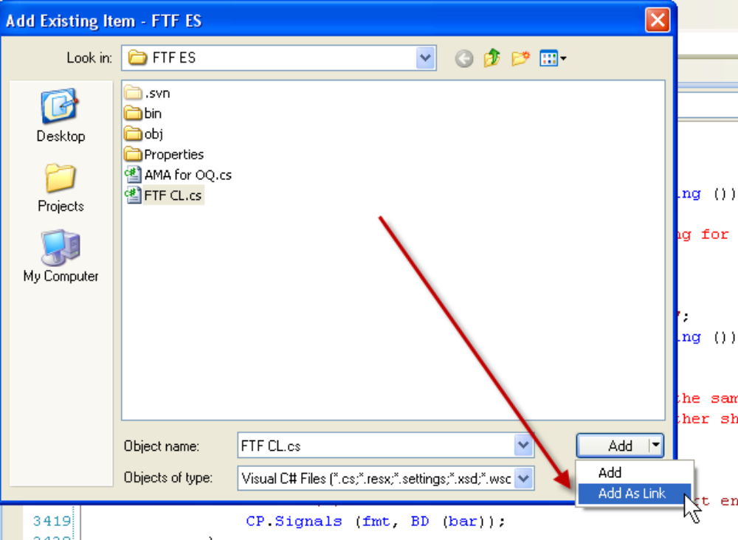
- The dialog shown above is from Visual Studio (VS). The contents of the dialog are OpenQuant code files that I want to add to my VS project.
上面的对话框是Visual Studio的，选择的文件是我想添加到VS项目下的OpenQuant代码文件。
- After you add an OpenQuant file to the VS project as a link, you can edit the file in the VS editor, then type Alt-TAB to switch from VS to OpenQuant, and run the strategy code that you just edited. The process works quite well, without too much hassle. You get to use all your favorite VS editor key bindings and editing power, at the minor cost of a few ALT-TAB key sequences to flip back and forth between applications.
以链接方式添加OpenQuant文件到VS工程后，你可以在VS编辑器中编辑文件，然后按Alt+Tab从VS切换到OpenQuant然后运行前头编辑的代码。这个过程相当不错，没有太多的麻烦。你可以使用你所喜爱的VS编辑器的功能，以最小的成本通过Alt+Tab在应用程序间切换。

10 Conclusion结论
That’s all for this Getting Started Guide document. Now you can spend many happy hours writing and running profitable trading strategies. It’s certainly a good feeling when you see good results from a computerized trading strategy simulation. See the Strategy Development Manual for some introductory information on strategy writing.
以上就是入门指南的全部内容。现在你可以花美好时光去编写和运行盈利的交易策略了。当你看到策略在复盘下跑出很好的绩效后会感觉相当好。查看《策略开发手册》学习如何编写策略。
And because this is a Getting Started Guide, I can offer this last piece of common sense advice—before switching to LIVE trading with real money, it’s probably a good idea to spend lots and lots of time back-testing your strategies using multiple different time periods, using multiple different instruments, and using multiple different stress-testing scenarios (like the crash of 1987 (Dow down 23% in ONE DAY), the recessions of 1990-1991, the dotcom rise and fall of 1998-2003, the recovery until 2007, and the recent market corrections (Jan 2008 – Apr 2008).
因为这是份入门指南，我提供一条常识建议：在你切换到实盘以前，花大量的时间，使用不同周期、不同合约、不同的压力测试场景(1987年崩盘(道琼斯指数一天下跌23%)，1990-1991年的经济衰退，1998-2003的互联网泡沫，直到2007年的复苏和最近的市场调整(2008年1月-2008年4月))进行历史回测是个明智的选择。
Finally, if you find out later that you need more strategy development power than is provided by OpenQuant, more powerful products are mentioned on the SmartQuant web site.
最后，如果你发现你需要比OpenQuant更强的策略开发产品可以访问我们的SmartQuant网站。

11 Revision Notes修改说明
- 2009-10-15 – Initial version created from previous OpenQuant2 version.
2009-10-15 – 基于OpenQuant 2编写
- 2011-07-26 – Added doc and code examples for scenario.cs file
2011-07-26 – 添加scenario.cs的文档与代码示例

