QuantDeveloper Documentation
Table Of Contents
Getting Started 1
Welcome 1
What is QuantDeveloper? 2
What is QuantDeveloper used for? 2
Features: 2
Event Driven Model 4
Order Flow 8
QuantDeveloper IDE Reference 11
Instruments 11
What are Instruments? (IDE) 11
Create Instruments (IDE) 13
Remove Instruments (IDE) 15
Instrument Properties 16
Set Instrument Properties (IDE) 20
Legs (IDE) 22
Instruments with multiple Symbol Names (IDE) 23
Data 25
What is Financial Data? (IDE) 25
Historical Data Import (IDE) 26
Market/Real Time Data Import (IDE) 29
Providers 30
What are Providers? (IDE) 30
Connecting to a Provider (IDE) 32
Connecting to ESignal 33
Adding a Custom Provider (IDE) 37
Simulation Provider (IDE) 38
Quote Monitor (IDE) 39
Bar Factory (IDE) 40
Portfolios 42
What are Portfolios? (IDE) 42
Working with Portfolios (IDE) 43
Portfolio Event Flow 48
Portfolio Persistency (IDE) 51
Order Manager 52
Working with the Order Manager (IDE) 52
Components 57
What are Components (IDE) 57
Simulation (IDE) 58
Execution (IDE) 59
Entry (IDE) 61
Exit (IDE) 63
Exposure (IDE) 64
Money (IDE) 65
Risk (IDE) 67
Market (IDE) 68
Optimization (IDE) 69
Adding a Component (IDE) 70
Indicators 71
What are Indicators? (IDE) 71
Built-in Indicators (IDE) 72
Using Indicators (IDE) 74
QuantServer 79
QuantServer Data Engine 79
Introduction 79
How to use QuantServer? 79
How to work with data objects? 82
How to work with all this? 83
A few words about underlying technology and MaxBlockSize and ZipLevel attributes 84
Closing files and flushing buffers 85
QuantDeveloper Framework Reference 87
Instruments 87
What are Instruments? (Framework) 87
Create Instruments (Framework) 88
Remove Instruments (Framework) 89
Accessing Instruments (Framework) 90
Instrument Properties 91
Set Instrument Properties (Framework) 95
Instruments with multiple Symbol Names (Framework) 97
Add Custom Fields to Instrument (Framework) 98
Legs (Framework) 99
Custom/Synthetic Instruments (Framework) 100
Pricers (Framework) 101
InstrumentServer (Framework) 102
Data 104
What is Financial Data? (Framework) 104
Historical Data Import (Framework) 105
Real Time Data Import (Framework) 107
Custom Data Types 108
Providers 111
What are Providers? (Framework) 111
Connecting to a Provider (Framework) 113
Portfolios 114
What are Portfolios? (Framework) 114
Tutorials 115
Instruments 115
Create Instruments from Text-File/CSV (Framework) 115
Set up Instrument for use with IB 117
Set up Instrument for Data/Execution Provider 119
Providers 120
Writing a custom provider 120
Creating Crossover Strategy 128
Creating Crossover Strategy 128
Creating Crossover Strategy Walkthrough 1 129
Creating Crossover Strategy Walkthrough 2 133
Creating Crossover Strategy Walkthrough 3 137
Creating Crossover Strategy Walkthrough 4 146
Creating Crossover Strategy Walkthrough 5 155
Creating a Strategy 163
Creating a new strategy solution 163
Defining Strategy Components 164
Running the Strategy 170
Strategy Output 171
Switch from Backtesting to Live Trading 176
Live Trading 176
Paper Trading 177
Creating a Code (Research) Project 178
Microsoft Visual Studio & QuantDeveloper 182
Microsoft Visual Studio & DemoApp 184
Functionality 184
Usage Guide 184
Creating an Indicator 187
Sending Orders 192
FAQ 197
Strategy Development 197
Strategy Project 207
How to set DateTime Format in Import Wizard 208

Getting Started

Welcome


You start developing a trading strategy with an idea that you test on historical data by applying quantitative analysis. You need a tool like Matlab to do the job but will spend up to 80% of your time developing the historical data interface to give your analytics access to market data. You will test new strategies on end-of-day data first but will still require real-time data for testing afterwards. You will make the decision of whether to rebalance your portfolio at the end of the day based on closing prices but you will still need to track stop loss and position closing orders throughout the day to minimize risk. You will also need to collect and store historical tick data and process it.

If testing of your system is profitable on historical data you will need to paper-trade it. This requires integration of a real-time feed and usually a new data feed interface. Backtesting is done by processing ticks from disk while the real-time data feed requires an event-driven approach. You will probably need to change your analysis and decision-making code to support the event-driven nature of real-time data. You will also need to ask your traders to simulate buy/sell orders in the current market using their trading expertise. If paper trading works then you will need to integrate trade execution into the system or develop a production version in C++. You will also need to link your newly minted system to your back office, risk management, reporting and other processes.

QuantDeveloper frees you from all of the unneeded hassle. We include in our framework all of the blocks required for building a trading system. Our macro and script editor is designed for fast prototyping. It's not just a text editor with a .NET compiler attached. No, we include a whole user front-end! When you run the macro editor you are instantly plugged into our market data warehouse, data feeds, execution, etc. You can jump up in the middle of the night and test your strategy without spending any time on unnecessary groundwork. This is what we call fast prototyping.
You can work with a simulated data feed and virtual trade execution. You can play back historical tick data to simulate a real-time market data feed. You can quickly prove that your strategy works on true real-time market data. Just plug in a ESignal datafeed adapter instead of the included simulated data provider into your code. Simulate stop, limit, stop limit and other types of orders with our simulated execution interface and quickly switch over to Interactive Brokers. You can collect executed orders into a portfolio and compile performance statistics of your trading strategy.

What is QuantDeveloper?
QuantDeveloper is a framework and IDE (Integrated Development Environment) for trading strategies development, debugging, backtesting, simulation, optimization and automation.
QuantDeveloper is built on top of SmartQuant's flagship products: QuantStudio, a financial data analysis and trading framework, and QuantServer, an advanced time series data engine.
Def. Framework: A framework is a defined support structure in which another software project can be organized and developed. Internal structure, data management (e.g. DB connectivity, provider connectivity, etc.), low level functionality, etc. are all being taken care of in the framework. In a nutshell, a framework provides you with a lot of functionality that you can easily access without having to reinvent the wheel.

What is QuantDeveloper used for?
- Off-line data analysis and strategy research
- High level component based strategy development and backtesting
- Low level ATS development
Def. ATS: ATS stands for Automated Trading Strategy. Low level ATS in particular define trading strategies at the tick level with individual order control mechanisms. In addition to low level ATS, QuantDeveloper introduces the model of component based strategies which offer a higher abstraction level that make it easier for you to build set to go strategies by encapsulating all low level functionality.
- Custom/stand alone application development (canned/black box strategies)

Features:
- Component based strategy design. A user can build a strategy from Entry, Exit, Money Manager, Risk Manager, Exposure Manager, Execution Manager components
- Use a pre-defined set of components and design your strategy with a few mouse clicks and no single line of code or use any flavour of .NET languages: C#, VB.NET, etc. to develop complex components and strategies
- No scripting. QuantDeveloper always runs compiled code, providing you with the highest possible performance
- Once your strategy is developed and properly tested with QuantDeveloper in both simulation and live modes, you can import the strategy as a MSVS .NET solution or as a canned executable. You can run your strategy as a stand-alone application on a dedicated server at your trading floor or deliver canned black-box solutions to your clients
- Multiple strategies can run within a meta-strategy. You can enable or disable any individual strategy within the meta-strategy, study correlations between individual strategies and so on
- Strategy debugging mode lets you run strategies with user-defined time step interval to trace internal event, signal and execution flow with high resolution
- High performance backtesting, up to 500.000+ ticks per seconds and more (built-in QuantServer data engine)
- FIX object layer supports any type of financial instruments (equities, derivatives, bonds, swaps, multi-legged instruments, etc.)
- Portfolio level system backtesting and trading
- Multi-currency accounting and simulations
- Event-driven design. There is no artificial "for" backtesting loop. Strategies run in the simulation mode exactly the same way as they run in the live trading mode.
- Intraday backtesting and trading (quotes, trades, intraday bars, daily, news, fundamentals, custom data support).
- Multiple time-frame support
- Advanced performance tracking engine with more than hundred of pre-defined performance statistics
- Technical analysis library with more than sixty indicators. Plug-in mechanism for user-defined indicator.
- Strategy optimization, including stochastic optimization
- Use full power of QuantStudio analytics : statistics, financial mathematics, linear algebra, pricing, time series analyses, scientific & 3D graphics, histograms, neural networking and more.
- Auto-execution, order routing, FIX support. One click switch from simulation to live trading mode.
- QuickFIX built-in engine support
- Low level strategy automation
- IB, MyTrack, TAL, ESignal, Photon Trader, MB Trading, TAQ, Open Tick, IQ Feed, Bloomber, TT X_Trader® via TT FIX Adapter, FIX providers support

Event Driven Model
QuantDeveloper employs an event driven model for strategy simulation as well as real world trading rather than a "for loop" type of model like most of its competitors. Trading is an event based process (quotes come in, news come in, trades are placed, fills are reported, etc.) and thus it is reflected that way in QuantDeveloper. Understanding how the event driven model works will help you to understand how QuantDeveloper works and how it all comes together.
- The first step is to create a MetaStrategy project and a strategy.
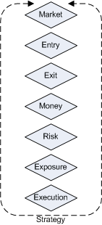
The above picture shows which components make up a strategy. For further reference see What are Components (IDE).
- Once you run the strategy, several things happen. First, the Market, Entry and Exit component subscribe to MarketDataProvider events. The MarketDataProvider in turns, sends a request to the DataProvider API for MarketData and receive any incoming MarketData. The MarketDataProvider can be any live provider like eSignal, etc. but it can also be the SimulationProvider if you want to backtest trading ideas with historical data.
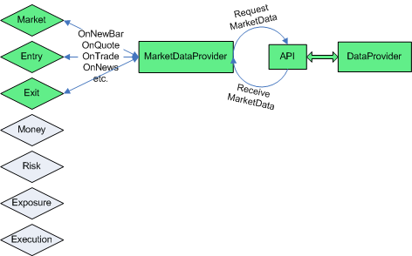
- Every component that has subscribed to the specific MarketData event, will receive an event containing the incoming market data. So, when the Entry component has subscribed to OnBar events by overriding OnBar method like this:
public override void OnBar(Bar bar)
{
}
... whenever a new bar event will be created by the MarketDataProvider, OnBar will be triggered. Any other component that has overridden OnBar, will receive bar events as well. If you want to build a system whose entry is based on bar data, OnBar in the entry component would be the place to put your algorithm.
- Let's build some very simple logic in OnBar of the Entry component:
public override void OnBar(Bar bar)
{
if(bar.Open < bar.Close)
{
LongEntry();
}
}
Whenever the MarketDataProvider issues a new bar, the OnBar method will be evaluated. If the newly issued bar has a close that is higher than its open, we want to enter a long position.
- What happens when we call LongEntry() is that a new signal is created. This signal has to pass Money, Risk, Exposure and Execution components from top to bottom and finally the signal is converted to an order by the execution component if everything was passed.
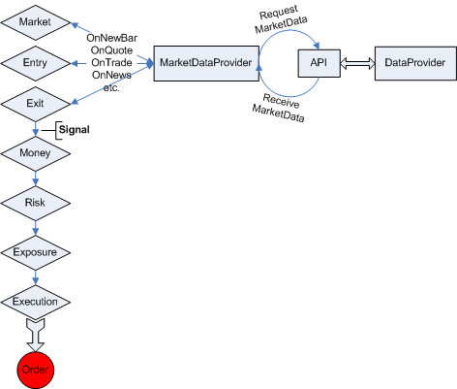
- In the next step, what happens is that the order registers itself in the OrderManager for later reference. The order is then passed on to the ExecutionProvider which can be either the Simulation ExecutionProvider or a "real" ExecutionProvider. The ExecutionProvider sends the order to the corresponding broker via the broker API and receives a response. The ExecutionProvider generates an ExecutionReport from this response and sends it to the OrderManager. The OrderManager updates the status of the previously referenced order and generates a portfolio record.
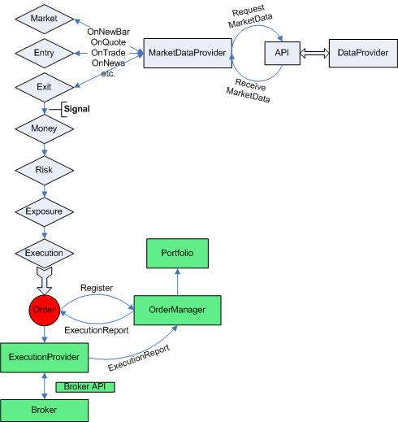
- The last thing that happens is that the order and portfolio are sending out various events, consumable by subscribers.
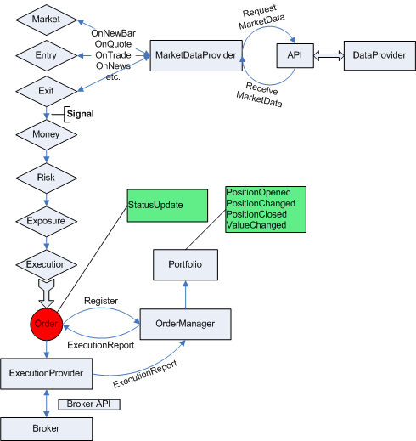
You have now seen the general event flow concept of QuantDeveloper. In the following chapters we are going to introduce a more in depth view at individual parts of the whole schema.

Order Flow
This chapter is going to discuss the order flow in QuantDeveloper. We are going from the very start of creating a new order, to execution and order management.
- In the first step, a new instance of an order is created. Consequently all the order properties like its quantity, order type, instrument, etc. are assigned and finally it's sent off to the execution provider. Parallel to this process, the order is registered in the OrderManager for later reference. The OrderManager in turn emits a NewOrder() event. Finally, the ExecutionProvider consumes the order and calls SendNewOrderSingle().
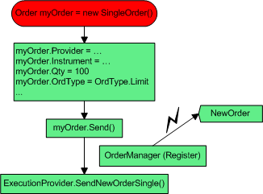
- The next step in the order flow is that the Broker API receives the sent order and passes it on to the brokers' order server. In case of Simulation ExecutionProvider, the broker reflects a class in QuantDeveloper that simulates order fills. The broker sends a response back to the Broker API, which passes it on to the ExecutionProvider and a new ExecutionReport is generated. This ExecutionReport is then sent to the OrderManager and ExecutionReport and OrderStatusChanged events are called.
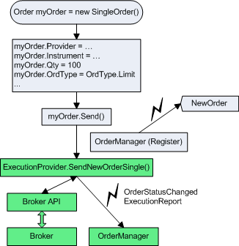
- In the 3rd and last step, the OrderManager updates the previously referenced order according to the ExecutionReport. Its status and or properties (e.g. AvgPx) are updated. Simultaneously, the ExecutionReport is passed on to the portfolio, and adds a transaction according to the ExecutionReport. The position and or account is updated. Finally, the following events can be called: TransactionAdded, PositionOpened/Closed/Changed and ValueChanged.
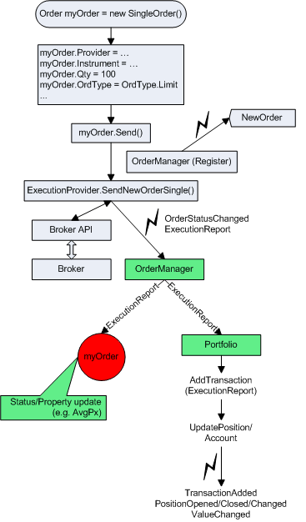

QuantDeveloper IDE Reference

Instruments

What are Instruments? (IDE)
Financial instruments package financial capital into readily tradable forms - they do not exist outside the context of the financial markets. Their diversity of forms mirrors the diversity of risk that they manage.

Financial Instruments can be categorised according to whether they are securities, derivatives of other instruments, or so called cash securities. If they are a derivative, they can be further categorised depending on whether they are traded as standard derivatives or traded over the counter (OTC).

Alternatively they can be categorised by 'asset class' depending on whether they are equity based (reflecting ownership of an asset) or debt based (reflecting a loan the investor has made to the owner of an asset). If it is a debt security, it can be further categorised into short term (less than one year) or long term. Foreign Exchange instruments and transactions are neither debt nor equity based and belong in their own category.

Combining the above methods for categorisation, the main instruments can be organised into a matrix as follows:

ASSET CLASS | INSTRUMENT TYPE
ASSET CLASS | Cash | Standard Derivative | OTC Derivative
Debt (Long Term) | Bond  Floating rate note | Bond future option  Bond future | Interest rate swap  Interest rate cap & Interest rate floors  Cross currency swap  Interest rate option  Exotic instruments
Debt (Short Term) | Deposit/loan  Bill  CD (Certificate of deposit)  CP (Commercial paper) | Futures | Forward rate agreement  Foreign exchange swap
Equity | Stock  (Equity index) | Stock options  Equity futures | Stock Options  Exotic instruments
Foreign Exchange | Foreign exchange spot | Foreign exchange futures | Foreign exchange options  Foreign exchange forwards  Currency Future

Most of the standard derivatives, like Futures and Stock Options are exchange traded. This means that actual execution of a trade takes place at an exchange either via a physical Broker or an Electronic Communications Network (ECN). OTC derivatives however, are traded directly between parties and not through an exchange.

At any given point in time, an instrument, whether a .NET class or a real world financial instrument, can be described by a combination of static and dynamic properties.

Static Properties:
- Instrument type (e.g. common stock)
- Ticker name (e.g. MSFT)
- Description (e.g. Microsoft Corporation)
- Exchange (e.g. NASDAQ)
- Currency (e.g. USD)
- etc.
Thus, a static property is everything that is included in the issuer note and usually doesn't change during the lifetime of an instrument.

Dynamic Properties:
- Last price (e.g. 25.80)
- Closing price (e.g. 25.60)
- Traded volume (e.g. 64,000,000)
Dynamic properties change throughout the lifetime of a security. Thus, every property that is exposed to the market and can be influenced by it can be considered a dynamic property.

Create Instruments (IDE)
- Go to View->Instruments. The instrument window pops-up or is attached to a pane.
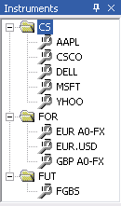
- Right-click in the instruments window and click New. The New Instrument dialog pops-up
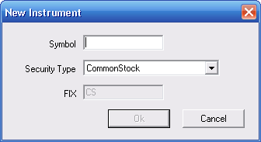
- Enter IBM in the symbol text box and leave SecurityType set to CommonStock
Def. SecurityType: SecurityType defines the type of the instrument. For a more in depth look at the various instrument asset types see What are Instruments?
Note: Symbol and Security type is the minimum amount of information that is needed to create and identify an instrument.
- Click Ok. The dialog closes and the Instrument "IBM" is added to the instruments window in the specific security type folder.
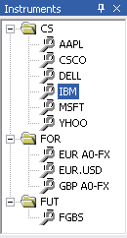
Note:
- If you want to add a different security type, choose the desired security type from the combo box in the New Instrument dialog. The corresponding instrument security folder will be automatically created. If your security type is not listed, choose USER DEFINED TYPE... as your security type and enter the FIX instrument type for it in the corresponding text box.
- Symbol names are unique across the framework. Use "Symbol - Exchange" or other popular notation if you want to distinguish between the same issue traded on different exchanges. For example, use "MSFT US" for MSFT traded in USD on NASDAQ and "MSFT GR" for MSFT traded in EUR on DAX.

Remove Instruments (IDE)
- Go to View->Instruments.
- Select the symbol you wish to delete from the Instruments window.
- Right-click on it and Click Delete.
Note: When you delete an instrument from the IDE and data is associated with this instrument in the QuantServer data storage, the data will not be deleted. To delete all data for this instrument from QuantServer, follow the next step.

Remove Data History for Instrument from QuantServer
- Go to Data->QuantServer Explorer.... The QuantServer Explorer pops-up.
- Double-click SmartQuant .NET in the Tree View.
- Select FILE
- Right-click on the symbol you wish to delete and click Delete
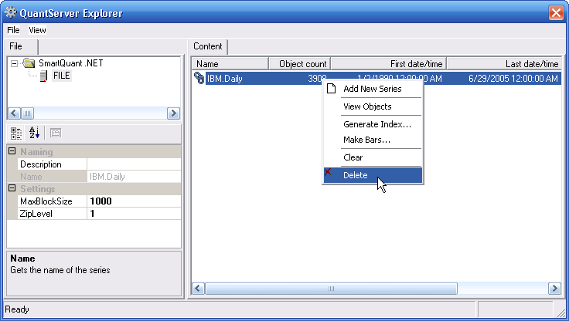

Instrument Properties
The following standard FIX properties are available for instruments:
Appearance
CFICode | Indicates the type of security using ISO 10962 standard, Classification of Financial Instruments (CFI code) values. ISO 10962 is maintained by ANNA (Association of National Numbering Agencies) acting as Registration Authority. See also the Product (460) and SecurityType (167) fields. It is recommended that CFICode be used instead of SecurityType (167) for non-Fixed Income instruments.
Currency | Identifies currency used for price. Absence of this field is interpreted as the default for the security. It is recommended that systems provide the currency value whenever possible.
Product | Indicates the type of product the security is associated with. See also the CFICode (461) and SecurityType (167) fields.  Valid values:  1 = AGENCY  2 = COMMODITY  3 = CORPORATE  4 = CURRENCY  5 = EQUITY  6 = GOVERNMENT  7 = INDEX  8 = LOAN  9 = MONEYMARKET  10 = MORTGAGE  11 = MUNICIPAL  12 = OTHER  13 = FINANCING
SecurityAltIDGroup
SecurityDesc | Security description.
SecurityExchange | Market used to help identify a security.
SecurityID | Security identifier value of SecurityIDSource (22) type (e.g. CUSIP, SEDOL, ISIN, etc). Requires SecurityIDSource.
SecurityIDSource | Identifies class or source of the SecurityID (48) value. Required if SecurityID is specified.  Valid values:  1 = CUSIP  2 = SEDOL  3 = QUIK  4 = ISIN number  5 = RIC code  6 = ISO Currency Code  7 = ISO Country Code  8 = Exchange Symbol  9 = Consolidated Tape Association (CTA) Symbol (SIAC CTS/CQS line format)  A = Bloomberg Symbol  B = Wertpapier  C = Dutch  D = Valoren  E = Sicovam  F = Belgian  G = "Common" (Clearstream and Euroclear)  H = Clearing House / Clearing Organization  I = ISDA/FpML Product Specification  J = Options Price Reporting Authority  100+ are reserved for private security identifications
SecuritySubType | Sub-type qualification/identification of the SecurityType (e.g. for SecurityType="REPO").  Example Values:  General = General Collateral (for SecurityType=REPO)  For SecurityType="MLEG" markets can provide the name of the option or futures strategy, such as Calendar, Vertical, Butterfly, etc.  NOTE: Additional values may be used by mutual agreement of the counterparties
SecurityType | Indicates type of security.
Symbol | Ticker symbol. Common, "human understood" representation of the security. SecurityID (48) value can be specified if no symbol exists (e.g. non-exchange traded Collective Investment Vehicles)  Use “[N/A]” for products which do not have a symbol.
SymbolSfx | Additional information about the security (e.g. preferred, warrants, etc.). Note also see SecurityType (167).  Valid values:  As defined in the NYSE Stock and bond Symbol Directory and in the AMEX Fitch Directory  Fixed Income use:  WI = “When Issued” for a security to be reissued under an old CUSIP or ISIN  CD = a EUCP with lump-sum interest rather than discount price

Attributes
Legs | List of instrument legs
Underlyings | List of instrument underlyings

Fixed income
ContractSettlMonth | Specifies when the contract (i.e. MBS/TBA) will settle.
CouponPaymentDate | Date interest is to be paid. Used in identifying Corporate Bond issues.
CouponRate | The rate of interest that, when multiplied by the principal, par value, or face value of a bond, provides the currency amount of the periodic interest payment. The coupon is always cited, along with maturity, in any quotation of a bond's price.
InterestAccrualDate | The start date used for calculating accrued interest on debt instruments which are being sold between interest payment dates. Often but not always the same as the Issue Date and the Dated Date
Pool | For Fixed Income, identifies MBS / ABS pool.
RedemptionDate | *** DEPRECATED FIELD - See "Deprecated (Phased-out) Features and Supported Approach" ***  Return of investor's principal in a security. Bond redemption can occur before maturity date.

Industry
IndustryCode
IndustryGroup
IndustrySector
IndustrySubGroup

Issue
CountryOfIssue | ISO Country code of instrument issue (e.g. the country portion typically used in ISIN). Can be used in conjunction with non-ISIN SecurityID (48) (e.g. CUSIP for Municipal Bonds without ISIN) to provide uniqueness.
CPProgram | The program under which a commercial paper is issued  Valid values:  1 = 3(a)(3)  2 = 4(2)  99 = Other
CPRegType | The registration type of a commercial paper issuance
CreditRating | An evaluation of a company's ability to repay obligations or its likelihood of not defaulting. These evaluation are provided by Credit Rating Agencies, i.e. S&P, Moody's.
DatedDate | The effective date of a new securities issue determined by its underwriters. Often but not always the same as the Issue Date and the Interest Accrual Date
InstrRegistry | The location at which records of ownership are maintained for this instrument, and at which ownership changes must be recorded.  Valid values:  BIC (Bank Identification Code—Swift managed) = the depository or custodian who maintains ownership Records  ISO Country Code = country in which registry is kept  "ZZ" = physical or bearer
IssueDate | The date on which a bond or stock offering is issued. It may or may not be the same as the effective date ("Dated Date") or the date on which interest begins to accrue ("Interest Accrual Date")
Issuer | Name of security issuer (e.g. International Business Machines, GNMA).  see also Volume 7: "PRODUCT: FIXED INCOME - Euro Issuer Values"
LocaleOfIssue | Identifies the locale. For Municipal Security Issuers other than state or province. Refer to  http://www.atmos.albany.edu/cgi/stagrep-cgi  Reference the IATA city codes for values.  Note IATA (International Air Transport Association) maintains the codes at www.iata.org.
StateOrProvinceOfIssue | A two-character state or province abbreviation.

Price format
PriceDisplay

Repo
RepoCollateralSecurityType | *** DEPRECATED FIELD - See "Deprecated (Phased-out) Features and Supported Approach" ***  Identifies the collateral used in the transaction.
RepurchaseRate | *** DEPRECATED FIELD - See "Deprecated (Phased-out) Features and Supported Approach" ***  Percent of par at which a Repo will be repaid. Represented as a percent, e.g. .9525 represents 95-1/4 percent of par.
RepurchaseTerm | *** DEPRECATED FIELD - See "Deprecated (Phased-out) Features and Supported Approach" ***  Number of business days before repurchase of a repo.

Trade
DeliveryForm | Identifies the form of delivery.  Valid values:  1 = BookEntry [the default]  2 = Bearer
ExpirationCycle | Part of trading cycle when an instrument expires. Field is applicable for derivatives.  Valid values:  0 = Expire on trading session close (default)  1 = Expire on trading session open
MinTradeVol | The minimum trading volume for a security
PctAtRisk | Percent at risk due to lowest possible call.
RoundLot | The trading lot size of a security
TradingSessionID | Identifier for Trading Session  Can be used to represent a specific market trading session (e.g. “PRE-OPEN", "CROSS_2", "AFTER-HOURS", "TOSTNET1", "TOSTNET2", etc).  To specify good for session where session spans more than one calendar day, use TimeInForce = Day in conjunction with TradingSessionID.  Values should be bi-laterally agreed to between counterparties.  Firms may register Trading Session values on the FIX website (presently a document maintained within “ECN and Exchanges” working group section).
TradingSessionSubID | Optional market assigned sub identifier for a trading session. Usage is determined by market or counterparties.  Used by US based futures markets to identify exchange specific execution time bracket codes as required by US market regulations.

Set Instrument Properties (IDE)
- Go to View->Instruments.
- Right-click on the instrument, Click Properties. Properties windows pops-up.
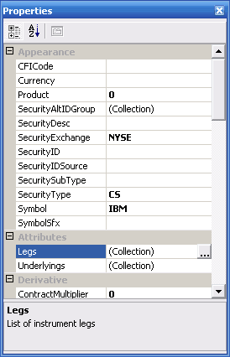
Instrument properties contain a full set of FIX 4.4. (Financial Information eXchange, www.fixprotocol.org) Instrument Component Block fields. This allows us to comply with financial industry standards and simplify communication with third party software, such as data provider/broker APIs, backoffice and order management systems. FIX business object model also allows us to add custom fields to instrument definitions.
You may want to set Currency, Security Description, Security Exchange and Security ID to make instrument definition complete. In general you should decide what fields you need to maintain to e.g. send a successful request to your data feed provider or broker. IB, for example would require Currency and SecurityExchange among other fields (also MaturityDate for derivatives). QuantDeveloper will use the default currency (which you can set in the Configuration window, Tools->Configuration menu) and other default settings if you leave corresponding fields blank in the Properties window.
Note: You can also set different symbols for different data/execution providers for the same instrument. Assume that you would like to have EUR-USD FOREX rate instrument in QuantDeveloper and you want QuantDeveloper Symbol to be EUR.USD. IB (Interactive Brokers) local symbol for EUR/USD rate is EUR, currency is USD and exchange is IDEALPRO.
- Create EUR.USD instrument in QuantDeveloper.
- Click on SecurityAltIDGroup in the Properties Window to define instrument settings for IB. SecurityAltID is instrument symbol and SecurityAltIDSource is data vendor / broker identifier (name).
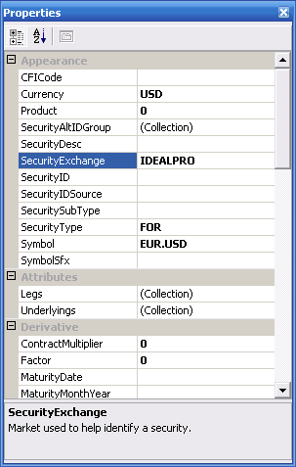
Note: QuantDeveloper allows you to define and work with multi-legged instruments and derivative instruments based on multiple underlying instruments. Click Legs or Underlyings field in the Properties Window to define instrument legs or underlyings.
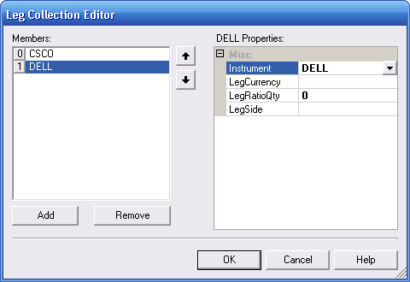

Legs (IDE)
If you want to create an instrument that is composed of several legs, you can do so by adding legs to the instrument. Legged instruments can be synthetic instruments like pairs, performance swaps or indexes for example

- Right-click on the desired instrument in the instrument window
- Click Properties, the properties window for that instrument will show up
- Find Legs in the properties window and left-click in the (Collection) box right next to it. Click on
- Click Add and choose MSFT for Instrument, USD as LegCurrency, LegRatioQty 0.5 and LegSide 1.
- Click Add again and choose AAPL for Instrument, USD as LegCurrency, LegRatioQty 0.5 and LegSide 0.
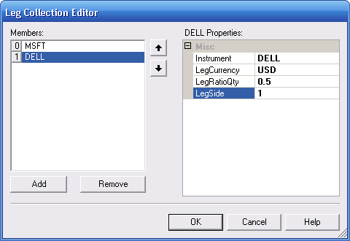
  - Instrument specifies the instrument for the specific leg
  - LegCurrency specifies the currency in which the instrument is traded
  - LegRatioQty specifies the %-contribution of the leg to the overall instrument
  - LegSide specifies the side of the individual leg (1 for long, 0 for short)
- Click OK. The instrument is now set up as a multi legged instrument.

Instruments with multiple Symbol Names (IDE)
QuantDeveloper offers the ability to assign several symbol names to a specific instrument. Different providers, use different symbol codes for the same instruments. Therefore, symbol codes have to be set individually for various providers. A simple usage scenario for this would be when you use a different provider for data and execution and they use different symbol codes for the same instrument.

Let's assume you're using InteractiveBrokers for execution, eSignal as your datafeed and you want to trade the S&P E-Mini.
The symbol for the S&P E-mini at InteractiveBrokers would be ES, whereas it would be ES #F at eSignal for the continuous contract or e.g. ESU5 if you want a specific front month. To solve the problem of contradicting symbol names for a specific instrument, you can assign several symbol names with the corresponding data/execution provider to an instrument.

- Create a new Instrument, call it ES and set SecurityType to Future
- Right-click the instrument and click Properties
- Find SecurityAltIDGroup in the Properties window and click into the (Collection) field. Click on
- The SecurityAltIDGroup window pops up
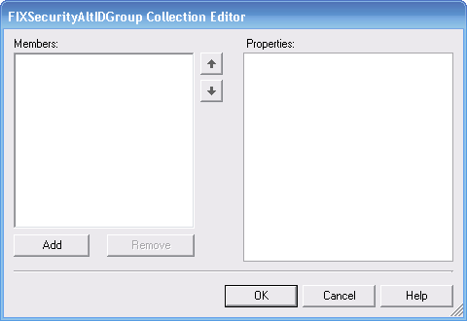
- Click Add
- Enter ES #F in SecurityAltID and eSignal in SecurityAltIDSource
SecurityAltID specifies the desired symbol name
SecurityAltIDSource specifies the data/execution provider name string
- Click Add again and enter ES in SecurityAltID and IB in SecurityAltIDSource
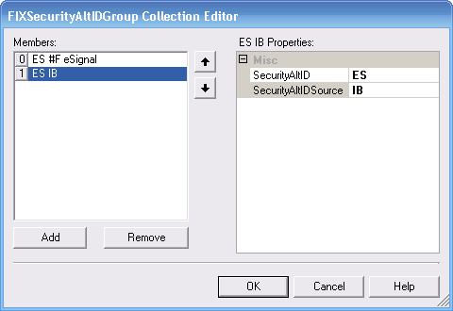
- Click OK
Your instrument is now set up for use with eSignal and IB and will use the correct symbol for each of the data/execution providers.
Note: Your instrument might need additional setup to work with your data/execution provider. Please refer to Set up Instrument for Data Execution Provider

Data

What is Financial Data? (IDE)
When you subscribe to a service like eSignal to receive financial data, usually there are 3 forms of data that you can receive:
- Quote data
- Trade data
- Bar data

Quote data
Quote data, being the most low level form of all financial data, contains the current bid and offer price as well as volume bid and offered for one or more tiers. Essential information that a quote should contain is:
- DateTime - In order to sequentially identify a quote in time it needs an associated DateTime stamp
- Ask - The current price offered
- Bid - The current bid price
- Ask Volume - The current volume posted at the ask price
- Bid Volume - The current volume posted at the bid price
Note: The volume posted at bid and ask prices can be misleading as it doesn't represent the real volume held at these price levels. The reason for this is that there are possibilities to post Iceberg or Stealth orders that allow to place an order with larger size than actually published.

Trade data
Trade data, also referred to as tick data represents information about all trades that took place. Therefore, trade data needs the following information:
- DateTime - In order to sequentially identify a quote in time it needs an associated DateTime stamp
- Price - The price where the actual trade took place
- Volume - The volume traded at that specific trade

Bar data
Bar data represents an aggregated form of trade data. To build bar data, one takes all trade data within a specific period (e.g. 5 minutes or 100Ticks) and finds the highest and the lowest price traded within that period. The actual bar will hold:
- Open - The first price traded at the beginning of the specified period
- High - The highest price traded within the specified period
- Low - The lowest price traded within the specified period
- Close - The last traded price within the specified period
- Volume - The aggregated volume of all trades within the specified period

Historical Data Import (IDE)
You have 3 different options to import historical data into QuantDeveloper's QuantServer database:
- Data import from CSV/TXT files
- Data import from TAQ CD
- Data import with History provider (currently eSignal and Yahoo are supported)

Importing data from CSV/TXT files
- Go to Data->Import->CSV or Text
- Click on Add files ...
Tip: You can also click on Add directory ... to add a whole directory with CSV/TXT files in case you want to import multiple files at once. However, you have to make sure that all the files have the same format or import will fail.
- Select the file to import and click Open
- Click Next
Tip: You can add additional files from other directories before you proceed as long as they have all the same format.
- Now you have to set the field delimiter that your file uses. In our case, this is a Comma
- Since our sample file contains header definitions in the first row, we set Number of skipped rows to 1
- We are using a historical data file with daily data. Therefore, we set Data type to Daily
- In the next step we have to tell QuantDeveloper which column contains what. To achieve that, we click on the individual headers of the ListView and assign the specific type for each column. If you don't want to import specific columns you can leave them <skipped>
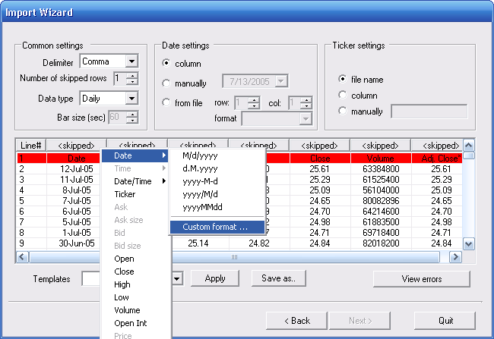
Note: You have to make sure to choose the correct format for Date. If the date format that your historical data file uses is not available, you can specify a Custom format in the Custom format ... dialog.
- When you're done assigning the headers, click Next
- Click Start

Importing data from TAQ CD
- Go to Data->Import->TAQ CD
- Click Browse and locate TAQ data files (*.bin)
- Set Data type (trades or quotes)
- Set Data format (TAQ or TAQ2)
- Click Import

Import data with History provider
- Go to Data->Import->History
- Click Next
- Choose the historical data provider that you want to use (Yahoo and eSignal are currently supported)
- Click Next
- Select the instruments for which you want to import historical data
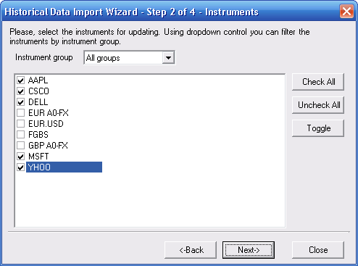
- Click Next
- Select the data type to import. If you choose Yahoo, only Daily is available. If you chose eSignal, you can choose between Daily and Bar and have to possibility to specify a custom bar size. If you chose daily, check Dividend and Split Adjusted if you want the imported data to be dividend and split adjusted.
- Click Next
- Specify the start and end data for the data import
- Click Next
- Set the amount of threads and the priority of the data import
- Click Start
- Click Close when the import is done

Market/Real Time Data Import (IDE)
QuantDeveloper offers you the ability to live record real time data to the QuantServer database. Currently, eSignal, IB and TT Fix are natively supported.

QuantServer can store real time:
- Trades
- Quotes
- Bars
- Market Depth
This tutorial will show you how to use IB for Realtime Data Import. It is the same process for any other real time data provider.
- Go to Data->Import-Realtime->IB
- Connect to IB Market Data, data provider. For instructions see
- Go to View->Instruments
- Left-click the instrument and drag it in the Realtime Data Import ListView
- Check which data to capture
- Click the Start Capture arrow to start capturing
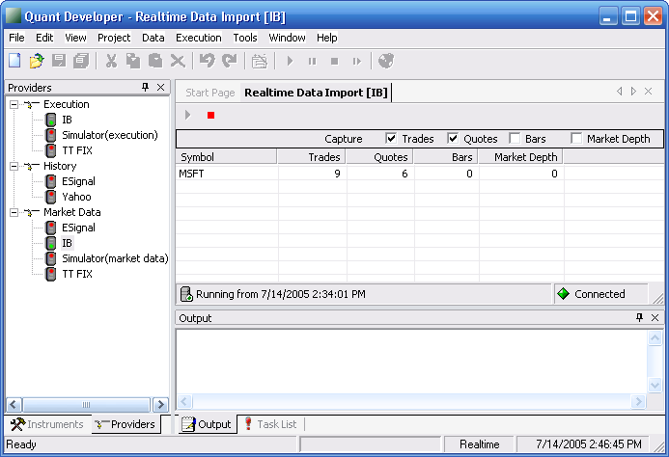

Providers

What are Providers? (IDE)
In QuantDeveloper, providers request services from third party data and execution services. All providers support two way communication processes. So, if you place an order, you can get a fill response back in QuantDeveloper or you will receive market data once you request it for a specific symbol. There are three different kinds of providers supported in QuantDeveloper:

History Providers
History providers can request historical data from 3rd party services. The following forms of historical data are supported:
- Quote
- Trade
- Bar
- Daily

Market Data Providers
Market data providers can request real time streaming data from 3rd party services. The following forms of real time data are supported:
- Quote
- Trade
- Market Depth
- Bar

Execution Providers
Execution providers can implement the following methods and thus offer this kind of functionality from within QuantDeveloper
- Send orders
- Cancel orders
- Receive order status reports
- Receive execution reports

Natively supported Providers
Provider | History Data | Market Data | Execution
eSignal | x | x
Genesis |  | x
InteractiveBrokers |  | x | x
MBT |  | x
OpenTick |  | x
QuoteTracker | x | x
Simulator |  | x | x
TAL | x
TT FIX |  | x | x
TT XTAPI |  | x | x
Yahoo | x

Extensibility
The provider model employed by QuantDeveloper allows easy implementation of additional providers. Therefore, any market data or execution service with an consumable API can be used together with QuantDeveloper.

Connecting to a Provider (IDE)
- Go to View->Providers, the provider window will show up
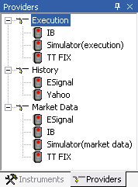
- Right-click on the desired provider and click Properties
- Check the properties for the provider and make sure your settings are correct (e.g. set UserName for eSignal provider)
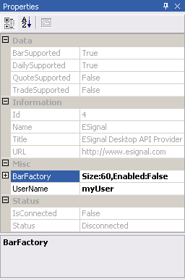
- When everything is ok, right click your provider and click Connect. If the connection was successful, the provider icon will light up green.
Tip: In case your connection failed, you can look up details in the Provider Log. Right-click your provider and click on Provider Log to see it.
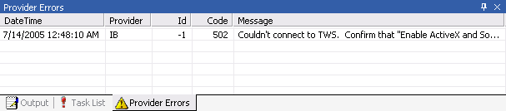

Connecting to ESignal
First of all you should be sure that ESignal software is installed on your computer.

Note: QuantDeveloper's ESignal provider uses ESignal Desktop API, so you should have a subscription to ESignal Desktop API.

Preparation
- Make sure that the ESignal provider is registered in QuantDeveloper. Open the Configuration Tool window, using Tools->Configuration in the main menu.
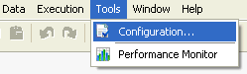
The Configuration Tool window will appear. Switch to the Providers tab and make sure that the SmartQuant.ESignal.ESignalDesktop item is checked.
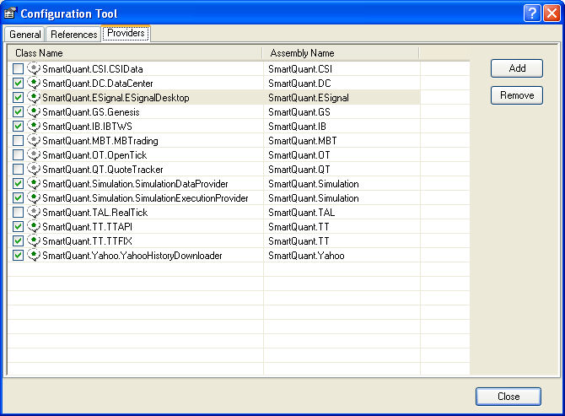
- Open the Providers window, using View->Providers path in the main menu. Expand the MarketData node.
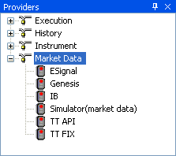
Right-click on the ESignal node and choose "Properties". The Properties window will appear.
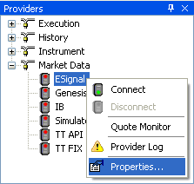
Locate the "Username" property of the ESignal provider in the Properties window. Change it to your ESingal login.
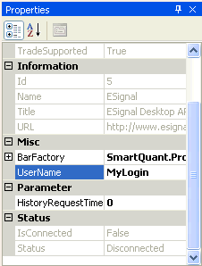
Now you are ready to connect to the ESignal provider.

Establishing a connection to the ESignal provider.
Locate the Providers window. Expand the MarketData node. Right-click on the ESignal node, select "Connect".
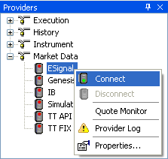
Follow the ESignal's instruction for establishing a connection (Login, Password etc.).

When the ESignal provider becomes connected, the icon near the ESignal node in the Providers window shows a green light.
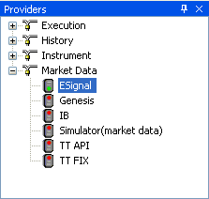
To disconnect from the ESignal provider, right-click on the ESignal node in the Providers window, choose "Disconnect".
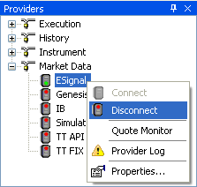
Note, that if the ESignal provider isn't connecting or disconnecting, you could examine errors occurred in the Provider Errors window. To open it, right-click on the ESignal node in the Providers window, choose "Provider Log".
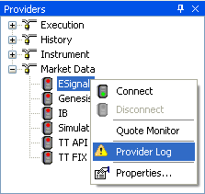
The Provider Errors window will appear.
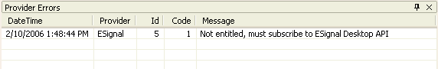
You are able to double-click on the error and the Error Details window will show up.
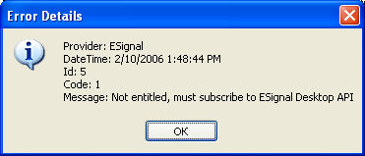

"Non entitled, must subscribe to ESignal Desktop API" error.
If you can't connect to ESignal and get "Non entitled, must subscribe to ESignal Desktop API" error, check if you have a subscription to ESignal Desktop API. This subscription allows you to receive data from ESignal using external applications, such as QuantDeveloper.

For more information about ESignal Desktop API, please look at the following link:
http://www.esignal.com/esignal/features/activex/default.asp

Adding a Custom Provider (IDE)
When you have written your own data/execution provider or received one from a 3rd party, installing the provider can be done by following the steps outlined below:
- Go to Tools->Configuration, the Configuration Tool will pop up
- Click on the Providers tabs
- Click on Add,select your provider in the open file dialog and click Open
- The provider will show up in the list of providers, click the checkbox in front of it and confirm that you want to immediately load it by clicking Yes in the Load Provider dialog
- If everything went well, it should look like in the picture below:
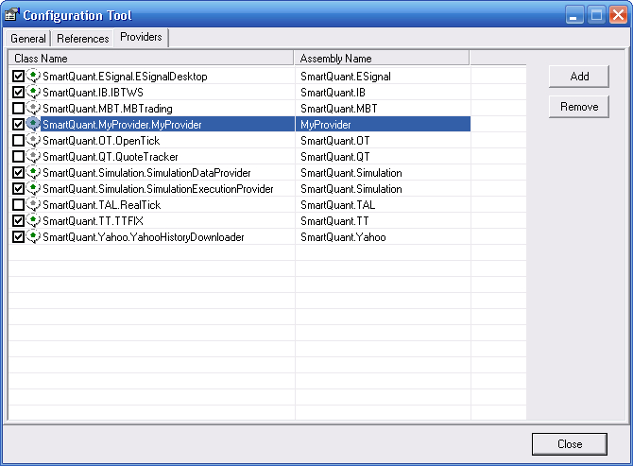
- The provider will now show up in the provider window
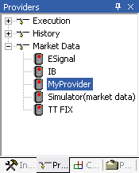

Simulation Provider (IDE)
Type topic text here.

Quote Monitor (IDE)
The Quote Monitor is a tool to live monitor incoming market data from a market data provider. In order use the Quote Monitor, follow the guideline below:
- Connect to a provider that supports market data (e.g. IB)
- Right-click on the connected provider and click Quote Monitor, the Quote Monitor for the connected market data provider shows up in the main window
- Go to View->Instruments
- Drag the desired instruments for which to receive market data on the Quote list view. If the provider supports that symbol, QuantDeveloper will start to receive market data for it.
- Double-click on the instrument in the Quote list view and a bid/ask chart that is being constructed from the incoming market data will show up
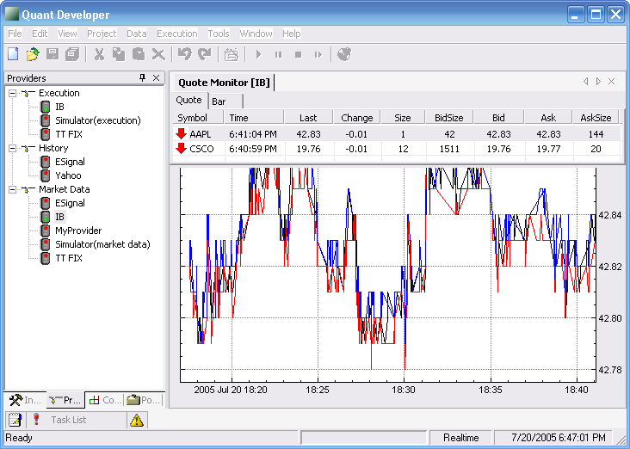
Tip: You can stop to receive market data for an instrument and remove it from monitoring, by right-clicking on the instrument in the quote list view and clicking Remove.
Note: Make sure to set up the instrument correctly for use with the specific market data provider. Different market data providers use different symbol codes and therefore have to be set individually. See Instruments with multiple Symbol Names for further reference.

Bar Factory (IDE)
In brief, a BarFactory tells QuantDeveloper how to construct bars from trade (tick) data. You can visualize a BarFactory as some sort of compressor that takes incoming tick data as input and spits out bars according to your desired form of aggregation. Natively, BarFactory supports time spans (1 minute, 60 minute, etc.) as well as ticks (100 ticks, 1000 ticks, etc.) as aggregation forms. However, the BarFactory class is extensible, so you can easily implement your custom aggregation methods (e.g. %-Range Bars).

BarFactory is specific to each provider and can support several aggregation forms at once. The following guideline will show you how to alter BarFactory for the Simulation Provider:
- Create a new MetaStrategy project plus Strategy
- Create a new , call it Trade_Simulation, place SendMarketDataRequest("Trade"); in its Init() method and assign it as your Simulation component.
- Choose Aroon_Entry as your Entry component
- Choose Aroon_Exit as your Exit component
- Choose Flat_MoneyManager as your Money component
- Create a new , place AddInstrument("CSCO"); in its Init() method and assign it as your MarketManager component.
- Run the strategy
- Right-click on the MetaStrategy project and go to View->Performance
You will notice that there is no equity curve, since no trades were taken. Why is that the case?

Understanding BarFactory
The reason why no trades were taken is that although there is a BarFactory item in the Simulation provider BarFactory, by default it is not enabled. To change this, follow these steps:
- Go to View->Providers
- Right-click on the Simulator(market data) and go to Properties...
- In the Properties window, expand BarFactory and open the BarFactoryItem Collection Editor by going to Items, clicking in the (Collection) text box and clicking
- Click on 60-False and set Enabled to True
- Click OK
- Now rerun the strategy
- Go to the performance report
You will notice that there is an equity curve now as trades were generated. So, by enabling the BarFactory item, we told QuantDeveloper to generate bars from the trade data input and call OnBar() method, whenever there is a bar that consists of a 60 second aggregation of tick data.

BarFactory BarTypes
BarFactory items natively support the following BarTypes:
- Time
- Tick
- Volume
- Dynamic
The BarType specifies on which criteria the BarFactory should build a bar. To set the BarType, follow these steps:
- Go to View->Providers
- Select the desired MarketData provider (Simulator for backtesting)
- Go to View->Properties to open the Properties window if it's not already open.
- Expand BarFactory Node and open BarFactoryItem Collection Editor by clicking on next to Items
- Select the desired BarFactoryItem and choose your desired BarType from the dropdown menu
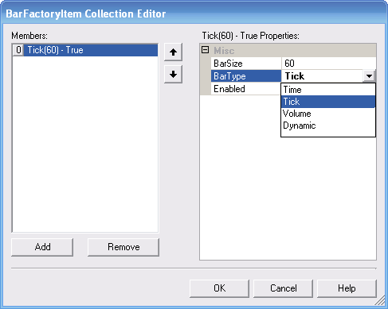
- Click OK

Time:
The BarType "Time" is the most commonly used. For this, you set the BarSize in seconds and the BarFactory will emit a new bar whenever the specified seconds have passed. So, if you set BarSize to 60 for example, the BarFactory will emit a bar after each minute, no matter how many trades or what volume was traded in this bar.

Tick:
BarType "Tick" means that the BarFactory aggregates the bar by the amount of ticks per bar rather than based on a static time span. Therefore, if you for example set BarSize to 1000, a new bar will be emitted whenever 1000 trades happened since bar open. Tick BarTypes are good for filtering market action. As more trades happen in active market hours than in inactive hours (e.g. lunch hour), more bars will be emitted in the active hours and therefore giving you a cleaner view of the market action.

Volume:
BarType "Volume" specifies bars that are aggregated by volume. If you, for example, set BarSize to 10000, a new bar will be emitted whenever 10000 shares/contracts were traded since bar open.

Dynamic:
...

Portfolios

What are Portfolios? (IDE)
In finance, a portfolio is a collection of investments held by an institution or a private individual. Holding a portfolio is part of an investment and risk-limiting strategy called diversification.
In QuantDeveloper, a portfolio is a collection of transactions and positions for a specific strategy.

Working with Portfolios (IDE)

Creating a Portfolio
When you create a new MetaStrategy solution and a strategy for backtesting purposes, a portfolio with the same name as the strategy is automatically created. However, you can create your own portfolio as well and assign your strategy to do it. To do so, follow these steps:
- Go to View->Portfolios, the Portfolio pane will show up
- Right-click in the empty space in the Portfolio pane and click New
- Name it MySamplePortfolio and give it a description (optional) "This is a sample portfolio"
- Click Add. MySamplePortfolio will now show up in the list of available portfolios

Using a Portfolio
The portfolio stores and lets you examine all transactions and positions for a certain strategy.
- Create a simple MetaStrategy solution and a simple test strategy. If you don't know how this is done see Creating a Strategy
- Run the strategy and wait until it's finished
- Right-click on the strategy node in the Solution Explorer and go to View->Portfolios
- If your strategy created trades, you will see a detailed transaction history and a current position overview in the Composition tab
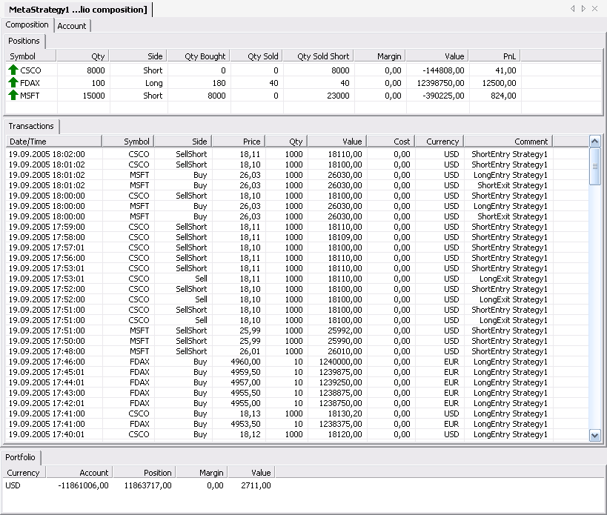
Here is an explanation of the available columns in the Composition tab:
  - Symbol - The instrument traded
  - Qty - Current net amount of shares/contracts in the portfolio
  - Side - Current position side (long/short)
  - Qty Bought - Total amount of shares/contracts bought
  - Qty Sold - Total amount of shares/contracts sold
  - Qty Sold Short - Total amount of shares/contracts sold short
  - Margin - Amount of margin used
  - Value - Current net value of position
  - PnL - Profit & Loss - Current net amount of profit or loss in the portfolio for a single instrument
Available columns in Transactions tab:
  - Date/Time - Date and time when transaction occurred
  - Symbol - The instrument for which the transaction occurred
  - Side - Order type (Buy, Sell, SellShort, etc.)
  - Price - The price at which the transaction was executed
  - Qty - The amount of shares/contracts executed
  - Value - Net value of transaction
  - Cost - Additional charges (commissions, carry fee, etc.)
  - Currency - Currency of transaction (USD, EUR, etc.)
  - Comment - An additional comment for each transaction to better track and understand the purpose of each transaction
Available columns in the Portfolio tab:
  - Currency - The portfolio tab lists the sum of all positions converted to the base currency of the portfolio. By default it converts different currencies 1:1, however, you can either specify a fixed conversion rate or set your own CurrencyConverter.
  - Account - Total account value
  - Position - Current net value of positions
  - Margin - Current margin value
  - Value - (Account + Position value - Margin)
- Click on Account tab
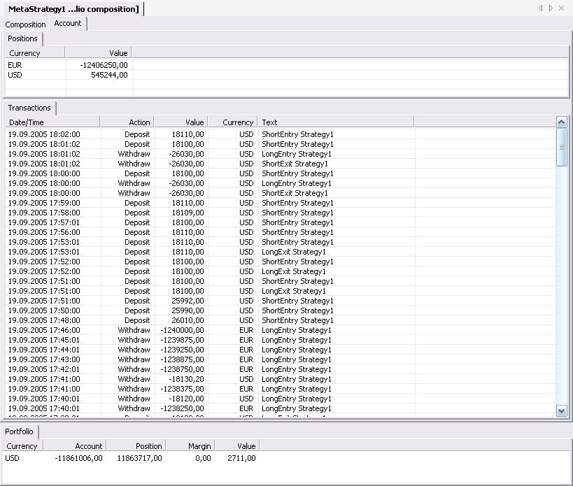
The account tab lists your position values grouped by currency in the Positions tab. The Transactions tab lists all transactions that occurred in the given account.

Saving a Portfolio
By default, portfolio transactions and composition for strategies running in simulation mode are not stored and therefore will be lost when you close QuantDeveloper. However, you can explicitly save that information if you do not want to lose it.
- Go to View->Portfolios, the Portfolio pane will show up
- Right-click on the portfolio that you want so save
- Click Save
- Click Yes in the confirmation dialog
Your portfolio data will now be saved even if you restart QuantDeveloper

Clearing a Portfolio
You might want to clear all information that a portfolio contains. To do so, follow these steps:
- Go to View->Portfolios, the Portfolio pane will show up
- Right-click on the portfolio that you want to clear
- Click Clear
- Click Yes in the confirmation dialog
Your portfolio is now cleared

Deleting a Portfolio
- Go to View->Portfolios, the Portfolio pane will show up
- Right-click on the portfolio that you want to delete
- Click Delete
- Click Yes in the confirmation dialog

Portfolio Event Flow
In this chapter we are going to cover the event flow surrounding the portfolio class.

- In the first steps what happens, like already covered in the Order Flow documentation is that a new order is created, passed on to the ExecutionProvider which in turn sends an order to the Broker, receives back a status message, converts it to an ExecutionReport and passes it on to the OrderManager. Finally, the OrderManager sends the ExecutionReport to the Portfolio.
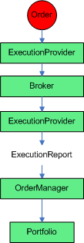
- In the next step, the Portfolio evaluates the ExecutionReport and adds transactions to the portfolio if the ExecutionReport contained any. Also, the Positions are updated and if the portfolio class already contained positions for the same instrument, their value is updated due to the ValueChanged event emitted by the OrderManager. In consequence, the portfolio class can emit the following events:
  - Transaction Added
  - Position Opened
  - Position Closed
  - Position Changed
  - Value Changed
  - Composition Changed
  - Cleared

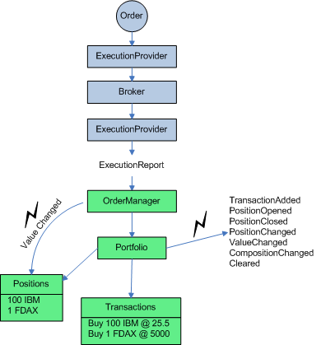
- In the last step, the portfolio class updates the account class. All money deposits/withdrawals caused by transactions are reflected in the account class, so are the monetary positions. Whenever an update in the account class happens, the account class emits an AccountChanged event.
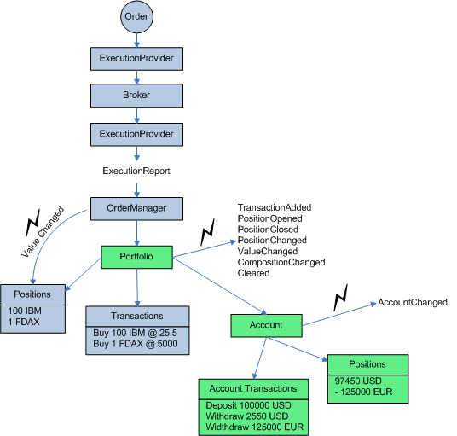

Portfolio Persistency (IDE)
Type topic text here.

Order Manager

Working with the Order Manager (IDE)
The OrderManager monitors and collects orders and execution reports. Orders are filtered and grouped by type (All, Pending, Filled, Cancelled, Rejected).
- To experience the Order Manager functionality, create a new MetaStrategy solution and a simple strategy. If you don't know how to do this, see Creating a Strategy
- Run the strategy and wait until it's finished
- Go to Execution->Order Manager to open up the Order Manager window. What you will see in there at first, is a list of all orders that were generated while you ran your sample strategy
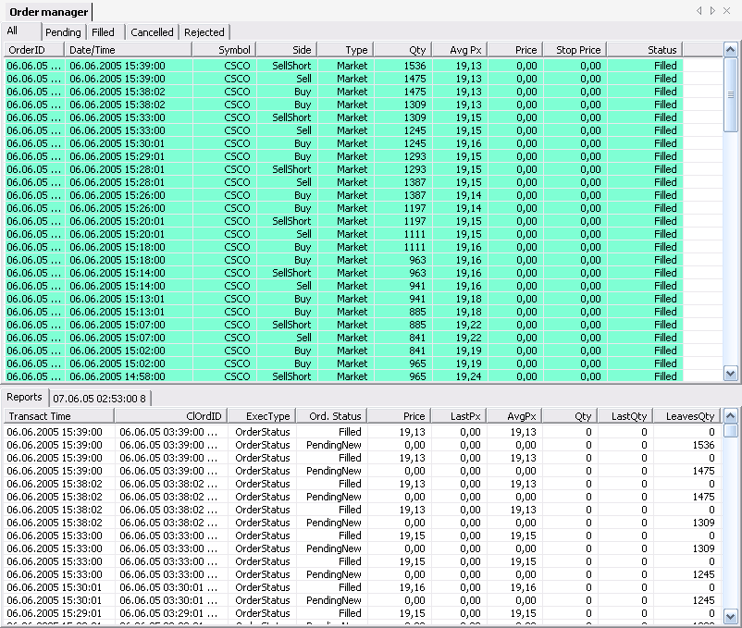
Here is an explanation for all columns. These are the same for All, Pending, Filled, Cancelled and Rejected tab:
  - OrderID - Every order needs an unique identifier. QuantDeveloper uses an DateTime stamp for this
  - Date/Time - Date & Time when order was issued or modified
  - Symbol - The instrument for which the order was generated
  - Side - The side of the order (Buy, Sell, SellShort)
  - Type - Order type (Market, Limit, Stop, etc.)
  - Qty - Amount of shares/contracts traded
  - Avg Px - Average price
  - Price - Price at which order was placed
  - Stop Price - If order was as stop order, this column holds the stop price
  - Status - The order status (Pending, Filled, Cancelled, Rejected)
By default the All tab opens up first. This tab list all orders, no matter what the status of the order is. For a filtered view, click at one of the tabs: Pending, Filled, Cancelled, Rejected.

Execution Reports
Another important part of the OrderManager are execution Reports, which you will see in the Reports top of every order status tab.
- Click on an order with status Filled in the list of orders. See, how the tab next to Reports changes its name to the OrderID of the selected order
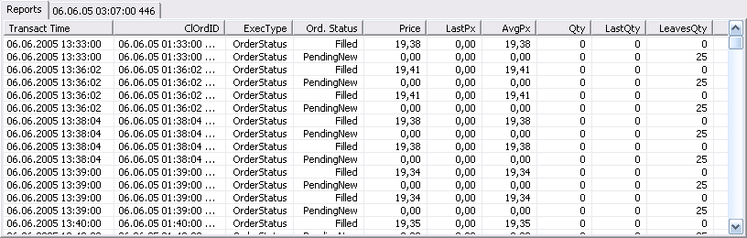
- Clock on the tab with the OrderID next to reports
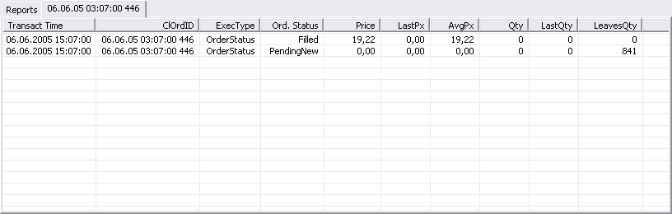
What you see in there is a list of statuses that the selected order went through. To be more precise, what happens when you place a new order is not that you are immediately filled, but rather more that the order is pending at first before it is filled. This is because it takes time to emit the order in QuantDeveloper, send it to the corresponding broker, which in turn sends the order to the exchange, which then sends a status report back. This might be a fill or that the order is still pending or maybe even rejected or cancelled by the exchange. Therefore, every order you place can have several statuses.
What should be noted here is the LeavesQty column. This column indicates how many shares/contracts are still to be filled. So, for the example picture above, an order to buy 841 shares is issued and waiting for a fill, thus LeavesQty is 841. As soon as we get a fill, LeavesQty is set to 0 as all 841 shares got filled. If we only got a partial fill, we would get another order entry that reduces the original order quantity by the amount filled.
The Reports tab itself lists all order statuses for all orders as they occurred and not filtered by a single order.

Order Properties Window
In addition to the order lists, there is the Order Properties window which holds all property for every single order.
- To view the Order Properties window, simply click on an order and all the properties will be reflected in the Order Properties window. If the properties window is not currently opened, you can open it by going to View->Properties
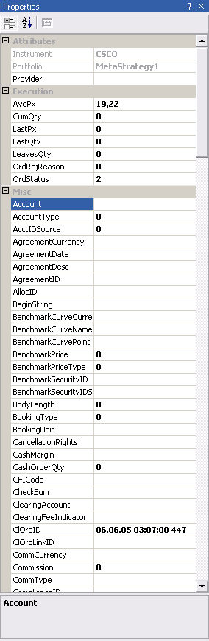
This window really holds every information for that window. Amongst the most important are:
  - Portfolio - The portfolio to which the order belongs
  - Strategy - The strategy that initiated the order
  - StrategyComponent - The component of the strategy that initiated the order (Entry, Exit, Risk, etc.)

Tips
Tip: You can cancel pending orders in the OrderManager by right-clicking on them and hitting Cancel
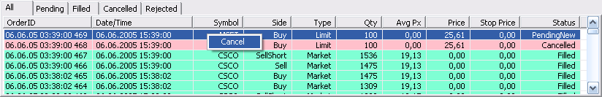

Components

What are Components (IDE)
In QuantDeveloper, components are what make up a strategy project. The following components exist in QuantDeveloper:
- - Which instruments should be traded?
- - When to enter a position?
- - When to exit a position?
- - How much to buy/sell?
- - How much to risk?
- - How much to risk on a portfolio level?
- - How to simulate?
- - How to execute orders?
The component model employed by QuantDeveloper allows for fast and effective testing of various component combinations and offers the ability to add custom components and make a system as simple or as complex as one desires.

Simulation (IDE)
The simulation component allows to adjust various settings for backtesting purposes and determines what data time frame is used for testing. The basic code template for a simulation component looks like this:
using System;
using SmartQuant.Trading;
[StrategyComponent("{c9e7b078-9793-4872-a883-49462ef0090e}", ComponentType.SimulationManager, Name = "MySimulation", Description = "")]
public class MySimulation : SimulationManager
{
public override void Init()
{
// Add your code here
}
}
If you would run a backtest for you strategy with that empty simulation component nothing would happen because QuantDeveloper would not know which data to work with. To tell QuantDeveloper which data it should request from QuantServer and work with, the SimulationManager has a method called SendMarketDataRequest(string series). So, if you would want to request daily data, your code would look like:
public override void Init()
{
SendMarketDataRequest("Daily");
}
Instead of "Daily" you can use any series name that exists for the instruments that you are working with (e.g. Trade, Quote, Bar, Bar5Min, etc.)

Execution (IDE)
Execution manager converts strategy signals into execution orders. This allows a user to implement custom smart order routing and order matching algorithms.

Default Execution Manager simply converts incoming signals into orders and sends orders to strategy execution provider (broker).

public virtual SingleOrder Execute(Signal signal, IExecutionProvider provider)
{
SingleOrder order = new SingleOrder();

order.Provider = provider;
order.Portfolio = MetaStrategy.Portfolio;

order.Instrument = signal.Instrument;
order.OrderQty = signal.Qty;
order.Text = signal.Text;

switch (signal.Side)
{
case SignalSide.Buy:
order.Side = Side.Buy;
break;
case SignalSide.Sell:
order.Side = Side.Sell;
break;
case SignalSide.SellShort:
order.Side = Side.SellShort;
break;
case SignalSide.BuyCover:
order.Side = Side.Buy;
break;
default:
throw new NotSupportedException();
}

switch (signal.Type)
{
case SignalType.Market:
order.OrdType = OrdType.Market;
break;
case SignalType.Limit:
order.OrdType = OrdType.Limit;
order.Price = signal.LimitPrice;
break;
case SignalType.Stop:
order.OrdType = OrdType.Stop;
order.StopPx = signal.StopPrice;
break;
case SignalType.StopLimit:
order.OrdType = OrdType.StopLimit;
order.StopPx = signal.StopPrice;
order.Price = signal.LimitPrice;
break;
default:
throw new NotSupportedException();
}

order.Send();
}

Entry (IDE)
The Entry component tells QuantDeveloper when to enter a position. It holds all the code logic for the entry criteria and emits a signal to enter a position when the criteria matches.
The basic code template for an Entry component looks like this:
using System;
using SmartQuant.Data;
using SmartQuant.Instruments;
using SmartQuant.Trading;
[StrategyComponent("{e10e3df2-8e69-46a6-89d2-d7da81b4bc91}", ComponentType.Entry, Name = "MyEntry_Entry", Description = "My custom entry component")]
public class MyEntry_Entry : Entry
{
public override void Init()
{
// Add your code here
}
public override void OnBar(Bar bar)
{
// Add your code here
}
}
In the Init() method you would add all startup declarations, variable assignments, etc. that can be determined before the system is running. All the code logic to actually place a trade would go into OnBar() method.
To issue an entry signal when last bar's close is smaller than the current bar close, the code for something like this would look like:
public override void OnBar(Bar bar)
{
if (Bar.Last.Close < bar.Close)
{
LongEntry();
}
}
What happens is that OnBar() is called every time when the provider issued a new bar. This means, the bar passed as argument in OnBar() always is the last closed bar. However, there a are a lot of other methods that can be utilized for entry signals:

Market Data
- OnBarOpen()
- OnBar()
- OnQuote()
- OnTrade()
- OnMarketData()
- OnCorporateAction()
- OnFundamental()
- OnNews()
Portfolio
- OnPositionOpened()
- OnPositionClosed()
- OnPositionChanged()
- OnPositionValueChanged()
Execution
- OnNewOrder()
- OnOrderStatusChanged()

Exit (IDE)
The Exit component tells QuantDeveloper when to exit a position. It holds all the code logic for the exit criteria and emits a signal to exit a position when the criteria matches.

Exposure (IDE)
Type topic text here.

Money (IDE)
The money component determines how much to buy/sell.
Let's have a look at the Risk_MoneyManager that ships with QuantDeveloper
using System;
using System.ComponentModel;
using SmartQuant.Instruments;
using SmartQuant.Trading;
[StrategyComponent("{da847c61-cd6c-411d-bd20-fb8a63e06ae1}", ComponentType.MoneyManager, Name = "Risk_MoneyManager", Description = "")]
public class Risk_MoneyManager : MoneyManager
{
private double portfolioRisk = 0.1;
[Category("Parameter"), Description("Risk allocated to portfolio position")]
public double PortfolioRisk
{
get { return portfolioRisk; }
set { portfolioRisk = value; }
}
public override double GetPositionSize(Signal signal)
{
switch (signal.Side)
{
case SignalSide.Buy:
case SignalSide.SellShort:
if (!HasPosition)
return (int)(Portfolio.GetTotalEquity() / Instrument.Price() * portfolioRisk / GetPositionRisk());
break;
case SignalSide.Sell:
if (HasPosition)
if (Position.Side == PositionSide.Long)
return Position.Qty;
break;
case SignalSide.BuyCover:
if (HasPosition)
if (Position.Side == PositionSide.Short)
return Position.Qty;
break;
}
return 0;
}
}
What happens here is that GetPositionSize is called whenever there was a new entry/exit signal issued and QuantDeveloper does now need to know how much to buy/sell.
Depending on what type of signal was issued, the position size varies. Therefore we start by evaluating what type of signal we have (buy/buycover/sell/sellshort).
If the signal side is a buy or a short sale
case SignalSide.Buy:
case SignalSide.SellShort:
and we currently have no position
if (!HasPosition)
then we want to enter a position according to that formula:
return (int)(Portfolio.GetTotalEquity() / Instrument.Price() * portfolioRisk / GetPositionRisk());
So, assume our portfolio is worth $25,000 (GetTotalEquity()), Instrument.Price() is $100, portfolioRisk is 0.1 and GetPositionRisk() returns 1, we would buy or sell short a total of 2500 shares.
However, if the signal is a sell
case SignalSide.Sell:
and we already have a position
if (HasPosition)
and the current position is long
if (Position.Side == PositionSide.Long)
then we return current position size
return Position.Qty;
thus, causing to flatten out the position. The same logic applies when the signal is a BuyCover. If none of the above applies, we return 0.

Risk (IDE)
Type topic text here.

Market (IDE)
The market component determines which instruments the system trades.
The simplest form of a market component would look like this:
using System;
using SmartQuant.Instruments;
using SmartQuant.Trading;
[StrategyComponent("{db83970e-e869-48cb-ad0a-9b4028382387}", ComponentType.MarketManager, Name = "Demo_MarketManager", Description = "")]
public class Demo_MarketManager : MarketManager
{
public override void Init()
{
AddInstrument("MSFT");
}
}
This would result in MSFT being the only instrument traded for the specified strategy. If you would like to expand that to trade all instruments that are of type CommonStock, you would use a code snippet like this:
public override void Init()
{
foreach(Instrument instrument in InstrumentManager.Instruments)
if (instrument.SecurityType == SecurityType.CommonStock)
AddInstrument(instrument);
}
So, the essential method is AddInstrument() and whatever instrument is passed into it will be traded in the specified strategy.

Optimization (IDE)
Type topic text here.

Adding a Component (IDE)
As QuantDeveloper's goal is to be expandable as possible, you are provided the possibility to write your custom component for any component type and use it in your strategy project. To do so, follow the guideline below:
- Go to View->Component Manager
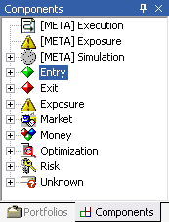
In the Component Manager window you can see all types of components that QuantDeveloper uses. For this example we are going to create a new Entry component
- Right-click the Entry component tree and click Add new...
- Fill in MyEntry_Entry in the Name text box, give it a description (optional) and leave the Type set at Entry
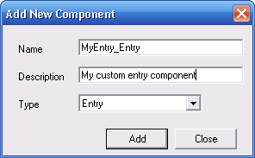
- Click Add
- Expand the Entry component tree and double-click on MyEntry_Entry. The code explorer for your component will show up and you are ready to fill it with code.
- When you are done, right-click MyEntry_Entry in the Entry component tree and click Rebuild
- If the component is ok, QuantDeveloper will tell you Build succeeded, if not, you will get compiler errors in the Task List which tell you where the problems are.
Note: If your component does not build correctly and you close QuantDeveloper, the next time you open it, the component will show up in the Unknown tree in the Component window rather than in the corresponding component tree. As soon as you fix the error that kept the component from building correctly, hit Rebuild and the component will be moved back to the corresponding component tree if the build succeeded.

Indicators

What are Indicators? (IDE)
A technical indicator is a series of data points that are derived by applying a formula to the price data of a security. Price data includes any combination of the open, high, low or close over a period of time. Some indicators may use only the closing prices, while others incorporate volume and open interest into their formulas. The price data is entered into the formula and a data point is produced.

For example, the average of 3 closing prices is one data point ((41+43+43)/3=42.33). However, one data point does not offer much information and does not make an indicator. A series of data points over a period of time is required to create valid reference points to enable analysis. By creating a time series of data points, a comparison can be made between present and past levels. For analysis purposes, technical indicators are usually shown in a graphical form above or below a security’s price chart. Once shown in graphical form, an indicator can then be compared with the corresponding price chart of the security. Sometimes indicators are plotted on top of the price plot for a more direct comparison.

A technical indicator offers a different perspective from which to analyze the price action. Some, such as moving averages, are derived from simple formulas and the mechanics are relatively easy to understand. Others, such as Stochastics, have complex formulas and require more study to fully understand and appreciate. Regardless of the complexity of the formula, technical indicators can provide unique perspective on the strength and direction of the underlying price action.

Built-in Indicators (IDE)
AD | Accumulation/Distribution (AD)
ADX | Average Directional Index (ADX)
ADXR | Average Directional Index Rating (ADXR)
AroonL | Aroon Lower (AroonL)
AroonU | Aroon Upper (AroonU)
ATR | Average True Range (ATR)
B | % Bollinger Bands (B)
BBL | Bollinger Bands Lower (BBL)
BBU | Bollinger Bands Upper (BBU)
CAD | Chaikin A/D Oscillator (CAD)
CCI | Commodity Channel Index (CCI)
CMO | Change Momentum Oscillator (CMO)
D_Fast | %D Fast (D_Fast)
D_Slow | %D Slow (D_Slow)
DPO | Detrended Price Oscillator (DPO)
DX | Directional Movement Index (DX)
EMA | Exponential Moving Average (EMA)
EMV | Ease of Movement (EMV)
ENVL | Envelope Lower (ENVL)
ENVU | Envelope Upper (ENVU)
FO | Forecast Oscillator (FO)
K_Fast | %K Fast (K_Fast)
K_Slow | %K Slow (K_Slow)
KRI | Kairi- KRI (KRI)
LRI | Linear Regression indicator (LRI)
LRS | Linear Regression Slope (LRS)
MACD | Moving Average Convergence Divergence (MACD)
MarketFI | Market Force Index (MarketFI)
MASS | Mass Index (MASS)
MDI | Minus Directional Indicator (MDI)
MDM | Minus Directional Movement (MDM)
MFI | Money Flow Index (MFI)
MOM | Momentum (MOM)
NVI | Negative Volume Index (NVI)
OBV | On Balance Volume (OBV)
OSC | Oscillator (OSC)
PCL | Price Channel Lower (PCL)
PCU | Price Channel Upper (PCU)
PDI | Plus Directional Indicator (PDI)
PDM | Plus Directional Movement (PDM)
PERF | Performance indicator (PERF)
PVI | Positive Volume Index (PVI)
PVT | Price and Volume Trend (PVT)
R | Williams' %R (R)
ROC | Price Rate of Change (ROC)
RSI | Relative Strength Index (RSI)
SMA | Simple Moving Average (SMA)
SMD | Standard Deviation (SMD)
SMV | Standard Variance (SMV)
TH | True High (TH)
TL | True Low (TL)
TR | True Range (TR)
TRIX | TRIX Index (TRIX)
UltOsc | Ultimate Oscillator (UltOsc)
VCH | Chaikin's Volatility (VCH)
VHF | Vertical Horizontal Filter (VHF)
VOSC | Volume Oscillator (VOSC)
VROC | Volume Rate of Change (VROC)
VWAP | Volume Weighted Average Price (VWAP)
WAD | Williams' Accumulation/Distribution (WAD)

Using Indicators (IDE)
This guide will show you how to use any indicator in QuantDeveloper, be it an inbuilt indicator or one you created yourself like shown in Creating an Indicator.

Set-up and draw an Indicator
- Create a new QuantDeveloper Meta Strategy Project with a Strategy
- Expand Components and Strategy tree in the Solution Explorer
- Right-click on Simulation and choose Daily_Simulation
- In Strategy node select Demo_MarketManager as your market manager
- Select Flat_MonyManager as your money manager
- Next, go to View->Components, right click on Entry in the Components viewer and click Add New...
- Name it IndicatorTest_Entry and click on Add
- Double click on the newly created IndicatorTest_Entry component in the Component viewer . The source view will open up
- Add the following code in IndicatorTest_Entry:
using System;
using System.Drawing;
using SmartQuant.Data;
using SmartQuant.Instruments;
using SmartQuant.Trading;
using SmartQuant.Indicators;
using SmartQuant.Series;
[StrategyComponent("{9aa85e1a-ff7e-4080-a0a7-a535c8e38a6a}", ComponentType.Entry, Name = "IndicatorTest_Entry", Description = "")]
public class IndicatorTest_Entry : Entry
{
// We declare the new Single Moving Average indicator here
private SMA sma;
public override void Init()
{
// We create a new instance of the SMA, give the BarSeries for the specific instrument
// as input and a smooting period of 12 bars
sma = new SMA(Bars[Instrument], 12);
// We assign the SMA indicator the color red
sma.Color = Color.Red;
// We need to set a DrawStyle for the indicator. Options are Line/Bar/Circle
sma.DrawStyle = EDrawStyle.Line;
// This method calls tells QD where that it should draw the indicator and where
// it should draw. Setting the pane to 0, draws the indicator in the pane of the bar chart
Draw(sma, 0);

}
}
- Right-click on the MetaStrategy node in the Solution Explorer and go to View->BarChart.
- Now run the project
- You will see how the indicator draws live on top of the BarChart
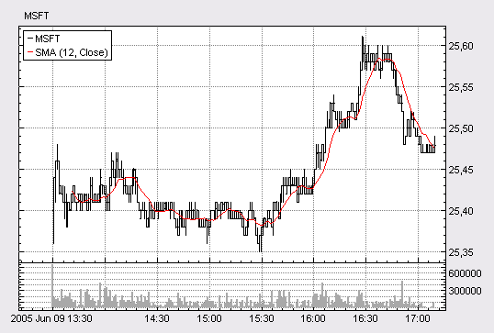

Working with Indicators
So, now you know how to set-up an indicator and draw them on a chart. In the next step we'll see how you can develop a simple Moving Average crossover system. A Moving Average crossover system uses 2 moving averages. Whenever, the "faster" MA crosses the "slower" one from above to below, we want to sell short, whenever the "faster" one crosses the "slower" one from below to above, we want to buy.
- Extend the IndicatorTest_Entry source code from the listing above, whit the following code:
using System;
using System.Drawing;
using SmartQuant.Data;
using SmartQuant.Instruments;
using SmartQuant.Trading;
using SmartQuant.Indicators;
using SmartQuant.Series;
[StrategyComponent("{9aa85e1a-ff7e-4080-a0a7-a535c8e38a6a}", ComponentType.Entry, Name = "IndicatorTest_Entry", Description = "")]
public class IndicatorTest_Entry : Entry
{
private SMA sma;
// In addition to the 1st SMA, we need a 2nd SMA to build a crossover system
private SMA smaSlow;
public override void Init()
{
sma = new SMA(Bars[Instrument], 12);
sma.Color = Color.Red;
sma.DrawStyle = EDrawStyle.Line;
// smaSlow is instantiated with a longer period and therefore is "slower"
smaSlow = new SMA(Bars[Instrument], 30);
sma.Color = Color.Blue;
sma.DrawStyle = EDrawStyle.Line;

Draw(sma, 0);
Draw(smaSlow, 0);
}
// We override OnBar method to handle OnBar events, whenever the MarketDataProvider
// issues a new bar
public override void OnBar(Bar bar)
{
// We need to check if the indicator series contains data for the current bar
if (sma.Contains(bar.DateTime) && smaSlow.Contains(bar.DateTime))
{
// Crosses method compares the sma series to smaSlow series at the DateTime
// of the current bar and reports back what the cross status is
ECross cross = sma.Crosses(smaSlow, bar.DateTime);
// If sma crossed smaSlow from below to above, we want to buy
if (cross == ECross.Above)
LongEntry();
// If sma crossed smaSlow from above to below, we want to sell short
else if (cross == ECross.Below)
ShortEntry();
}
}
}
- Now run the project and open up the bar chart. You will see that trades are generated, whenever the 2 SMA cross each other
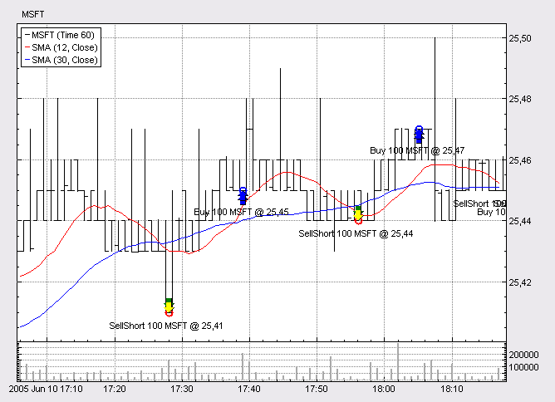

QuantServer

QuantServer Data Engine

Introduction
Many contemporary tasks require fast and handy processing of large amounts of data. Financial data analysis as well as many other data analysis domains require heavy operations with time series, collections of data objects where all objects are ordered in time. Sometimes these series are too large and cannot be easily processed because they simply can not fit into memory. And if you need to process several such series at the same time, the situation will get even worse. In many cases you will need to store these series on your HDD. If you consider the fact that these series can vary while being processed (for example new data objects can arrive), things will get complicated.

That is why SmartQuant Ltd has developed a special product which operates with time series of data objects on disk as if they were stored in memory. The product is called QuantServer and it is based on SmartQuant.File technology. QuantServer can perfectly cope with all the problems mentioned above giving its user a unique opportunity not to get bored by all kinds of technical problems and to consider only his main task (data capture and analysis).

Where can QuantServer be applied? Its application area has no boundaries though first it was developed in order to solve certain range of problems. SmartQuant Ltd, a company which develops software for financial data analysis, was trying to find a way to quickly store and process great amounts of data coming from different stock exchanges and financial data providers. More often these are quotes and trades (time and sales) data objects.

How to use QuantServer?
Using QuantServer is very easy. Based on the principle that the tasks of saving and recovery are laid on the objects being saved, it offers an opportunity to use almost all kinds of objects meeting certain requirements. This particular task is not cumbersome at all as the object class only has to implement ISeriesObject interface. Let’s take a look at the details of this interface.
- DateTime { get; } property must return date/time of an object in order to correctly place it in a time series.
- ReadFrom(BinaryReader reader) is called by the engine in order that an object could recover its state.
- WriteTo(BinaryWriter writer) method is called by the engine in order that an object could recover its state.
- NewInstance() method is needed when the engine must create an object of the “right” type. In fact its implementation leads to the creation of an empty object of the type needed. We don’t use Reflection technology from .NET framework on purpose because it would slower down this operation significantly.
- Clone() method from ICloneable interface is needed in order to create an object copy before it will be placed into a time series. This method is needed so that an object placed into a time series wouldn’t get changed before it will be saved in the data base.
Now let’s get back to ReadFrom and WriteTo methods. As in case of NewInstance method we don not use .NET Reflection in order to save/recover the object state. First, it would make read/write operations much slower; second, it will make us introduce additional conditions for the objects being saved (for example, assigning attributes to the fields that are and are not supposed to be saved). That’s why when operating with these methods, the user can choose by himself which fields to save and to recover and which type of field saving/recovery procedure he really needs. QuantServer package includes several standard data classes. These are Trade, Quote, Bar and Daily. Below we will consider the implementation of ISeriesObject interface taking Trade class as an example.
public class Trade : ISeriesObject
{
// Class members
protected DateTime datetime;
protected double price;
protected int size;

/// Constructor
public Trade(DateTime datetime, double price, int size)
{
this.datetime = datetime;
this.price = price;
this.size = size;
}

/// Constructor
public Trade(Trade trade)
: this(trade.datetime, trade.price, trade.size)
{
}

/// Constructor
public Trade() {}

/// Gets the date/time
public DateTime DateTime
{
get { return datetime; }
}

/// Gets the price
public double Price
{
get { return price; }
}

/// Gets the size
public int Size
{
get { return size; }
}

/// Returns the new instance of the object
public virtual ISeriesObject NewInstance()
{
return new Trade();
}

/// Returns a copy of this Trade object
public virtual object Clone()
{
return new Trade(this);
}

/// Reads the data from the stream
public virtual void ReadFrom(BinaryReader reader)
{
datetime = new DateTime(reader.ReadInt64());
price = reader.ReadDouble();
size = reader.ReadInt32();
}

/// Writes the data in to the stream
public virtual void WriteTo(BinaryWriter writer)
{
writer.Write(datetime.Ticks);
writer.Write(price);
writer.Write(size);
}
}

Pay attention to the fact that date/time should also be saved/read through ReadFrom and WriteTo methods. You can avoid this if you can inherit your object from SeriesObject class, which is a standard implementation of ISeriesObject interface. This class already contains date/time field, implements ISeriesObject.DateTime property and saves/reads it through ReadFrom and WriteTo methods. When you need to overwrite these methods, don’t forget to call base.ReadFrom and base.WrietTo in the inherited class. For example, let us design our MyTrade class and add one more data field to it.
public class MyTrade : Trade
{
// Class members
private string symbol;

// Constructor
public MyTrade(string symbol, DateTime datetime, double price, int size)
: base(datetime, price, size)
{
this.symbol = symbol;
}

// Constructor
public MyTrade(MyTrade trade)
: this(trade.symbol, trade.datetime, trade.price, trade.size)
{
}

// Constructor
public MyTrade() {}

// Gets the symbol
public string Symbol
{
get { return symbol; }
}

// Overloaded.
public override ISeriesObject NewInstance()
{
return new MyTrade();
}

// Overloaded.
public override object Clone()
{
return new MyTrade(this);
}

// Overloaded.
public override void ReadFrom(BinaryReader reader)
{
base.ReadFrom(reader);

symbol = reader.ReadString();
}

// Overloaded.
public override void WriteTo(BinaryWriter writer)
{
base.WriteTo(writer);

writer.Write(symbol);
}
}

How to work with data objects?
QuantServer class that implements time series data container is called FileSeries. It contains a set of methods for carrying out all the operations needed. Let us consider them step by step.
- Name { get; } property returns a name of the series.
- Description { get; set; } property is a brief description created by user for the series, e.g. “This series is created from historical data ”.
- MaxBlockSize { get; set; } property defines the size of the buffer of the series given.
- ZipLevel { get; set; } property defines the level of data compression.
- Flush() method automatically flushes series buffers in memory on the HDD.
- Count { get; } property returns the number of objects in series.
- FirstDateTime { get; } property returns date/time of the first object in series.
- LastDateTime { get; } property returns date/time of the last object in series.
- Add(ISeriesObject obj) adds an object to the series placing it according to its date/time. If an object with such date/time already exists, then the new object will be placed after it.
- Indexer [int index] returns ISeriesObject placed in the series at the given position. [DateTime, SearchOption] indexer returns an object with date/time given. If object with the same date/time is found, it will be returned (if there are several such objects, the first of them will be returned). If such an object isn’t found, then according to SearchOption further operations are carried out:
- Exact returns null.
- Prev returns the previous object that is the object with the closest date/time before the date/time needed.
- Next returns the following object that is the object with the closest date/time after the date/time needed.
- Indexer [DateTime] is similar to the call of [DateTime, SearchOption.Exact].
- GetArray(DateTime1, DateTime2) method returns an ordered array of objects, which date/time values are in the range from DateTime1 to DateTime2 inclusive.
- GetArray(index1, index2) method returns an ordered array of objects choosing them between index1 and index2 from the series.
- GetArray() method returns an ordered array of all the objects of the series.
- IndexOf(DateTime, SearchOption) method returns the zero based position of the object in the series according to date/time given. Search is conducted the same way as with [DateTime, SearchOption] indexer.
- IndexOf(DateTime) method is similar to the call of IndexOf (DateTime, SearchOption.Exact).
- Contains(DateTime) method defines whether the object with date/time given exists in the series.
- Remove(DateTime) method removes the object with date/time given from the series.
- RemoveAt(index) method removes the object from the series at a certain position.
- Clear() method removes all objects from the series.
- DateTimeAt (index) returns date/time of the object with the index given.
- Position { get; set; } property and Read() method This pair remotely resembles the way how classes working with streams are designed. Using Position property you can place cursor to any place in the series and then read from it through Read() method which returns an object from the current position and moves cursor to the next position.

How to work with all this?
File series cannot be created directly. All manipulations with series are implemented through series collection (class SeriesCollection). One can get a reference to this collection from DataFile class. Now let’s take a look at how SmartQuant.File library is arranged.
The core class of the library is DataFile.
First you should open a file where data are stored. “File” is a conventional name as in fact this is a set of system files. This means that QuantServer “file” can be compared with the “database” notion of relational database architecture. To open it one should set a working directory which will contain or already contains system files. This directory should exist before being opened. If the directory doesn’t contain files needed, then these files will be created automatically. These are .data, .header, .index, file.xml, types.xml files. One can get a reference to DataFile object in two different ways:
DataFile file = new DataFile(<path_to_data_dir>);
or
DataFile file = DataFile.Open (<path_to_data_dir>);
Note: one cannot open a file if this file has already been opened because underlying system files are blocked by the operational system and such an attempt will lead to error and an exception wil be thrown in your application.
After you have opened a file you can read/assign its properties.
Description { get; set; } property assigns a brief description for a file.
DefaultBlockSize { get; set; } property assigns the size of the buffer in memory that will be set for new series.
DefaultZipLevel {get; set; } property assigns the level of compression that will be set for new series.
When the files is opened, we can start managing the collection of data series stored in this File.
Series { get; } property returns a SeriesCollection object. SeriesCollection contains a standard set of methods, which Add, Remove, Count, index etc. data series. Please refer to API documentation for further details. Attention! All changes made to the collection are automatically written down onto the disk!
In the following example we will read and print objects from the series.
DataSeries series = file.Series["MSFT.Trade_"]; // we imply that the series exists, otherwise the series will be equal to
null
// 1.Reading all objects as an array
ISeriesObject[] array = series.GetArray();
or
ISeriesObject[] array = series.GetArray(DateTime.MinValue, DateTime.MaxValue);
or
ISeriesObject[] array = series.GetArray(0, series.Count - 1);
// Printing
foreach (Trade trade in array)
{
Console.WriteLine(trade.DateTime.ToString());
Console.WriteLine(trade.Price.ToString());
Console.WriteLine(trade.Size.ToString());
}
// 2.Reading through index
for (int i = 0; i < series.Count; i++)
{
Trade trade = series[i] as Trade;
...
}
// 3.Reading through Position
series.Position = 0;
while (series.Position < series.Count)
{
Trade trade = series.Read() as Trade;
...
}

A few words about underlying technology and MaxBlockSize and ZipLevel attributes
QuantServer uses buffered ways of writing and reading objects. This allows us to reduce time needed for input/output operations with HDD. Buffers are stored on the disk in compressed state; this significantly reduces physical size of data files. MaxBlockSize and ZipLevel properties are supposed to be tuned to optimize tradeoff between speed, size of memory being used and size of data files according to your certain task.
Speed is affected by ZipLevel, as it is clear that the higher is the level of compression the more time is needed in order to compress/decompress a block before writing/reading it to/from the disk. MaxBlockSize also affects speed though not as obviously as the level of compression (the more data is stored in a buffer the more time is needed to compress it).
The size of memory being used is affected only by MaxBlockSize as it defines how many objects will be placed in memory at the same time. Note: each series has its own buffer in memory.
The size of the used disk space is affected by both parameters; and, what’s more, the higher is the level of compression and the larger is buffer size; the smaller is the space being used.
One cannot give certain recommendations which values in which cases should be used for these parameters. One should proceed from one’s experience and specific tasks. For example, it is clear that if you have one or two series in a file, it is better to make the size of the block bigger; because when you increase buffer size in memory you win in speed. On the other hand, if you have tens of thousands of series then you need to reduce block size because otherwise you may face memory shortage problem. You can experiment with parameters using QuantServer Benchmark application.
QuantServer assigns values for ZipLevel equal to 1 and for MaxBlockSize equal to 1000 (objects in buffer) by default.
Considering that different series may have different values you obtain additional flexibility. File class also has Defragment() method, which main task is data file defragmentation but it also allows you to rewrite buffers on disk using new buffer size and compression level.
Defragment(newZipLevel, newMaxBlockSize) method defragments file at the same time assigning new values of ZipLevel and MaxBlockSize for all series. If one of parameters (or both of them) is (are) assigned to -1, then it (they) doesn’t (don’t) get changed and only defragmentation is carried out.
Defragment() method is similar to the call of Defragment(file.DefaultZipLevel, file.DefaultBlocksize).

Closing files and flushing buffers
It is highly recommended to close data file by calling its Close() method when you finish your work. If you don’t do this, then the last changes in the current buffer will be lost. Sometimes one needs an opportunity to fix changes of series by hand without closing a file. For such cases Flush() method is provided, it flushes the current buffer to the disk. But we do not recommend to call it after every change (of course, if a specific task doesn’t require this) because it considerably increases data file fragmentation.

QuantDeveloper Framework Reference

Instruments

What are Instruments? (Framework)
In QuantDeveloper, the instrument class inherits from FIXInstrument class, which in turn inherits from FIXGroup class. The FIXGroup class has a list of FIXField objects. A FIXField object represents one FIX field, which is a "tag-value" structure.

Create Instruments (Framework)
Instrument class overloads:
public Instrument(string symbol);
public Instrument(string symbol, string securityType);
Hence, you can create a new instrument either with the symbol name only, or by additionally specifying the security type:
Instrument myInstrument = new Instrument("IBM");
or
// "CS" is the FIX code for Common Stock
if(InstrumentManager.Instruments["IBM"] == null)
{
Instrument myInstrument = new Instrument("IBM", "CS");
}
Note: It is good practice to check if a symbol already exists before creating it as an exception will be thrown if you try to create an already existing instrument.
Note: Instead of using the appropriate FIX string for the security type, you can also take use of the SecurityType enum found in the SmartQuant.FIX namespace. In this particular example, you could use SecurityType.CommonStock instead of "CS".
To save the instrument to the QuantDeveloper instrument database call:
myInstrument.Save();

Remove Instruments (Framework)
Instrument myInstrument = InstrumentManager.Instruments["IBM"];
InstrumentManager.Remove(myInstrument);
You can also remove an instrument using its symbol.
InstrumentManager.Remove("IBM");

Accessing Instruments (Framework)
In QuantDeveloper, instruments can easily be accessed by the help of the InstrumentManager class.
Instrument myInstrument = InstrumentManager.Instruments["IBM"];
If you want to retrieve a InstrumentList of instruments, with all of the instruments being of security type CommonStock, this can be done like this:
InstrumentList myInstruments = new InstrumentList();
foreach (Instrument myInstrument in InstrumentManager.Instruments)
{
if (myInstrument.SecurityType == SecurityType.CommonStock)
{
myInstruments.Add(myInstrument);
}
}
Instead of filtering by SecurityType, you can filter by any other instrument property and thereby get exactly the list of instruments that you want to work with.

Instrument Properties
The following standard FIX properties are available for instruments:
Appearance
CFICode | Indicates the type of security using ISO 10962 standard, Classification of Financial Instruments (CFI code) values. ISO 10962 is maintained by ANNA (Association of National Numbering Agencies) acting as Registration Authority. See also the Product (460) and SecurityType (167) fields. It is recommended that CFICode be used instead of SecurityType (167) for non-Fixed Income instruments.
Currency | Identifies currency used for price. Absence of this field is interpreted as the default for the security. It is recommended that systems provide the currency value whenever possible.
Product | Indicates the type of product the security is associated with. See also the CFICode (461) and SecurityType (167) fields.  Valid values:  1 = AGENCY  2 = COMMODITY  3 = CORPORATE  4 = CURRENCY  5 = EQUITY  6 = GOVERNMENT  7 = INDEX  8 = LOAN  9 = MONEYMARKET  10 = MORTGAGE  11 = MUNICIPAL  12 = OTHER  13 = FINANCING
SecurityAltIDGroup
SecurityDesc | Security description.
SecurityExchange | Market used to help identify a security.
SecurityID | Security identifier value of SecurityIDSource (22) type (e.g. CUSIP, SEDOL, ISIN, etc). Requires SecurityIDSource.
SecurityIDSource | Identifies class or source of the SecurityID (48) value. Required if SecurityID is specified.  Valid values:  1 = CUSIP  2 = SEDOL  3 = QUIK  4 = ISIN number  5 = RIC code  6 = ISO Currency Code  7 = ISO Country Code  8 = Exchange Symbol  9 = Consolidated Tape Association (CTA) Symbol (SIAC CTS/CQS line format)  A = Bloomberg Symbol  B = Wertpapier  C = Dutch  D = Valoren  E = Sicovam  F = Belgian  G = "Common" (Clearstream and Euroclear)  H = Clearing House / Clearing Organization  I = ISDA/FpML Product Specification  J = Options Price Reporting Authority  100+ are reserved for private security identifications
SecuritySubType | Sub-type qualification/identification of the SecurityType (e.g. for SecurityType="REPO").  Example Values:  General = General Collateral (for SecurityType=REPO)  For SecurityType="MLEG" markets can provide the name of the option or futures strategy, such as Calendar, Vertical, Butterfly, etc.  NOTE: Additional values may be used by mutual agreement of the counterparties
SecurityType | Indicates type of security.
Symbol | Ticker symbol. Common, "human understood" representation of the security. SecurityID (48) value can be specified if no symbol exists (e.g. non-exchange traded Collective Investment Vehicles)  Use “[N/A]” for products which do not have a symbol.
SymbolSfx | Additional information about the security (e.g. preferred, warrants, etc.). Note also see SecurityType (167).  Valid values:  As defined in the NYSE Stock and bond Symbol Directory and in the AMEX Fitch Directory  Fixed Income use:  WI = “When Issued” for a security to be reissued under an old CUSIP or ISIN  CD = a EUCP with lump-sum interest rather than discount price

Attributes
Legs | List of instrument legs
Underlyings | List of instrument underlyings

Fixed income
ContractSettlMonth | Specifies when the contract (i.e. MBS/TBA) will settle.
CouponPaymentDate | Date interest is to be paid. Used in identifying Corporate Bond issues.
CouponRate | The rate of interest that, when multiplied by the principal, par value, or face value of a bond, provides the currency amount of the periodic interest payment. The coupon is always cited, along with maturity, in any quotation of a bond's price.
InterestAccrualDate | The start date used for calculating accrued interest on debt instruments which are being sold between interest payment dates. Often but not always the same as the Issue Date and the Dated Date
Pool | For Fixed Income, identifies MBS / ABS pool.
RedemptionDate | *** DEPRECATED FIELD - See "Deprecated (Phased-out) Features and Supported Approach" ***  Return of investor's principal in a security. Bond redemption can occur before maturity date.

Industry
IndustryCode
IndustryGroup
IndustrySector
IndustrySubGroup

Issue
CountryOfIssue | ISO Country code of instrument issue (e.g. the country portion typically used in ISIN). Can be used in conjunction with non-ISIN SecurityID (48) (e.g. CUSIP for Municipal Bonds without ISIN) to provide uniqueness.
CPProgram | The program under which a commercial paper is issued  Valid values:  1 = 3(a)(3)  2 = 4(2)  99 = Other
CPRegType | The registration type of a commercial paper issuance
CreditRating | An evaluation of a company's ability to repay obligations or its likelihood of not defaulting. These evaluation are provided by Credit Rating Agencies, i.e. S&P, Moody's.
DatedDate | The effective date of a new securities issue determined by its underwriters. Often but not always the same as the Issue Date and the Interest Accrual Date
InstrRegistry | The location at which records of ownership are maintained for this instrument, and at which ownership changes must be recorded.  Valid values:  BIC (Bank Identification Code—Swift managed) = the depository or custodian who maintains ownership Records  ISO Country Code = country in which registry is kept  "ZZ" = physical or bearer
IssueDate | The date on which a bond or stock offering is issued. It may or may not be the same as the effective date ("Dated Date") or the date on which interest begins to accrue ("Interest Accrual Date")
Issuer | Name of security issuer (e.g. International Business Machines, GNMA).  see also Volume 7: "PRODUCT: FIXED INCOME - Euro Issuer Values"
LocaleOfIssue | Identifies the locale. For Municipal Security Issuers other than state or province. Refer to  http://www.atmos.albany.edu/cgi/stagrep-cgi  Reference the IATA city codes for values.  Note IATA (International Air Transport Association) maintains the codes at www.iata.org.
StateOrProvinceOfIssue | A two-character state or province abbreviation.

Price format
PriceDisplay

Repo
RepoCollateralSecurityType | *** DEPRECATED FIELD - See "Deprecated (Phased-out) Features and Supported Approach" ***  Identifies the collateral used in the transaction.
RepurchaseRate | *** DEPRECATED FIELD - See "Deprecated (Phased-out) Features and Supported Approach" ***  Percent of par at which a Repo will be repaid. Represented as a percent, e.g. .9525 represents 95-1/4 percent of par.
RepurchaseTerm | *** DEPRECATED FIELD - See "Deprecated (Phased-out) Features and Supported Approach" ***  Number of business days before repurchase of a repo.

Trade
DeliveryForm | Identifies the form of delivery.  Valid values:  1 = BookEntry [the default]  2 = Bearer
ExpirationCycle | Part of trading cycle when an instrument expires. Field is applicable for derivatives.  Valid values:  0 = Expire on trading session close (default)  1 = Expire on trading session open
MinTradeVol | The minimum trading volume for a security
PctAtRisk | Percent at risk due to lowest possible call.
RoundLot | The trading lot size of a security
TradingSessionID | Identifier for Trading Session  Can be used to represent a specific market trading session (e.g. “PRE-OPEN", "CROSS_2", "AFTER-HOURS", "TOSTNET1", "TOSTNET2", etc).  To specify good for session where session spans more than one calendar day, use TimeInForce = Day in conjunction with TradingSessionID.  Values should be bi-laterally agreed to between counterparties.  Firms may register Trading Session values on the FIX website (presently a document maintained within “ECN and Exchanges” working group section).
TradingSessionSubID | Optional market assigned sub identifier for a trading session. Usage is determined by market or counterparties.  Used by US based futures markets to identify exchange specific execution time bracket codes as required by US market regulations.

Set Instrument Properties (Framework)
Instrument myInstrument = InstrumentManager.Instruments["IBM"];
myInstrument.Currency = "USD";
myInstrument.SecurityExchange = "NYSE";
myInstrument.Save();
Let's look what happens under the hood when setting an Instrument symbol:
public string Symbol
{
get { return GetStringValue(EFIXField.Symbol); }
set { SetStringValue(EFIXField.Symbol, value); }
}
SetStringValue creates FIXStringField object with Symbol FIX Tag = 55 and Value = value and adds this object to the list of fields.
GetStringValue finds FIXField object with Symbol FIX Tag = 55 in the list of fields and returns its Value.
EFIXField class defines FIX tags, so that EFIXField.Symbol is defined as:
public sealed class EFIXField
{
...
public const int Symbol = 55;
...
}
Thus an Instrument maintains a dynamic list of FIXFields that can be accessed via Instrument properties. This list of fields can be stored in the data base providing high level of flexibility.

FIXInstrument component block defines a set of instrument properties according to FIX 4.4 Instrument Component Block definitions. There are several extensions defined in the Instrument class, for example Industry Code group of fields that is not present in FIX 4.4.
#region Industry Code
[Category("Industry"), Description("Industry code")]
[FIXField("10100", EFieldOption.Optional)]
public string IndustryCode
{
get { return GetStringValue(EFIXField.IndustryCode); }
set { SetStringValue(EFIXField.IndustryCode, value); }
}
[Category("Industry"), Description("Industry sector")]
[FIXField("10101", EFieldOption.Optional)]
public string IndustrySector
{
get { return GetStringValue(EFIXField.IndustrySector); }
set { SetStringValue(EFIXField.IndustrySector, value); }
}
[Category("Industry"), Description("Industry group")]
[FIXField("10102", EFieldOption.Optional)]
public string IndustryGroup
{
get { return GetStringValue(EFIXField.IndustryGroup); }
set { SetStringValue(EFIXField.IndustryGroup, value); }
}
[Category("Industry"), Description("Industry sub group")]
[FIXField("10103", EFieldOption.Optional)]
public string IndustrySubGroup
{
get { return GetStringValue(EFIXField.IndustrySubGroup); }
set { SetStringValue(EFIXField.IndustrySubGroup, value); }
}
#endregion
You can use these fields in your code to define instrument industry code
Instrument.IndustryCode = NYSEIndustryCode.TelecommunicationsEquipment;
or simply
Instrument.IndustryCode = "114B";
and then use it in the instrument filter to select specific group of Instruments
if (Instrument.IndustryCode == NYSEIndustryCode.TelecommunicationsEquipment)
do something
The same works for Sector/Group/SubGroup.

Instruments with multiple Symbol Names (Framework)
QuantDeveloper offers the ability to assign several symbol names to a specific instrument. A simple usage scenario for this would be when you use a different provider for data and execution.
Let's assume you're using InteractiveBrokers for execution, eSignal as your datafeed and you want to trade the S&P E-Mini.
The symbol for the S&P E-mini at InteractiveBrokers would be ES, whereas it would be ES #F at eSignal for the continuous contract or e.g. ESU5 if you want a specific front month. To solve the problem of contradicting symbol names for a specific instrument, you can assign several symbol names with the corresponding data/execution provider to an instrument.
This can be easily achieved with the code snippet below:

Instrument myInstrument = InstrumentManager.Instruments["ES"];
FIXSecurityAltIDGroup ibGroup = new FIXSecurityAltIDGroup();
ibGroup.SecurityAltID = "ES";
ibGroup.SecurityAltIDSource = "IB";
FIXSecurityAltIDGroup eSignalGroup = new FIXSecurityAltIDGroup();
eSignalGroup.SecurityAltID = "ES #F";
eSignalGroup.SecurityAltIDSource = "eSignal";
myInstrument.AddGroup(ibGroup);
myInstrument.AddGroup(eSignalGroup);
myInstrument.Save();

Add Custom Fields to Instrument (Framework)

Legs (Framework)
If you want to create an instrument that is composed of several legs, you can do so by adding legs to the instrument. Legged instruments can be synthetic instruments like performance swaps or indexes for example.

Custom/Synthetic Instruments (Framework)
QuantDeveloper supports the creation of custom/synthetic instruments. A common usage scenario for this would be if you want to create your own index. An index like the Dow Jones has usually a weighting algorithm built in to properly evaluate all of its components and output one final price.

In the following steps we are going to build a custom index. For the sake of simplicity, this index will consist of two stocks only (MSFT, IBM) and return the mean price.

- Create a your custom instrument class and inherit from Instrument
public class TwoStockIndex : Instrument
{
}
- Of particular interest to us in this example is how the price for our index is calculated. To implement our own pricing algorithm we have to override GetPrice(DateTime dateTime)
public class TwoStockIndex : Instrument
{
public override double GetPrice(DateTime dateTime)
{
double price = 0;
// Iterate through the LegList and get the price for the specified DateTime
foreach (Leg leg in Legs)
{
price += leg.Instrument.GetPrice(dateTime);
}
// We divide the total price by the number of legs to get the average price
return price / Legs.Count;
}
}
Tip: Instead of overriding the GetPrice method in the instrument class, you can create a Pricer and assign it to your custom instrument. See Pricers for further reference.
- The last step that you have to take is assigning 2 legs to your instrument (MSFT, IBM). For further reference, see

Pricers (Framework)
A pricer is a class that can be assigned to an instrument and exposes the following methods:
- Delta()
- Gamme()
- GetPrice()
- Rho()
- Theta()
- Vega()
- Volatility()
The instrument class contains the same methods, however as soon as a pricer is assigned to an instrument, the pricer's implementation of the aforementioned methods overrides those in the instrument class.
Assume you built your Custom/Synthetic Instrument and want to test a different weighting algorithm for your custom index than the one implemented in the instrument class. Instead of overriding the GetPrice() method directly in the instrument class, you can build several pricers and dynamically assign them to your instrument without having to change anything in the instrument class.

Example:
public class MyPricer : Pricer
{
public override double GetPrice(Instrument instrument, DateTime dateTime)
{
double price = 0;
foreach (Leg leg in instrument.Legs)
{
price += leg.Instrument.GetPrice(dateTime);
}
return price / (instrument.Legs.Count * 0.5);
}
}
Your custom pricer can be used like this:
Instrument myInstrument = new Instrument("MYINDEX");
myInstrument.Pricer = new MyPricer();
You have now assigned your custom pricer to an instrument and it will therefore calculate the price as in the algorithm specified in the overridden GetPrice() method.
Note: When assigning a pricer to an instrument and saving the instrument, the pricer will get stored in the instrument database as well. Therefore, you only need to assign the pricer once.

InstrumentServer (Framework)
QuantDeveloper uses the concept of an InstrumentServer to store instruments and its properties (not the historical data) in an Access database. However, you might occur the need to build your own InstrumentServer and store your instruments in a CSV file or MySql database for example. This can be easily achieved, following the example below.
Note: This example is scaled down to keep it simple and only stores a small fraction of the available instrument properties.
In this example we are going to store our instruments in a flat text file (CSV)
- Create a new VisualStudio class library project
- Create a new class CsvInstrumentServer and inherit from IInstrumentServer
using System;
using System.IO;
using SmartQuant.Instruments;
public class CsvInstrumentServer : IInstrumentServer
{
public void Open()
{
}
public void Open(string dataBase)
{
}
public InstrumentList Load()
{
return new InstrumentList();
}
public void Save(Instrument instrument)
{
}
public void Remove(Instrument instrument)
{
}
public void Close()
{
}
}
This is the basic skeleton that we need to implement our CsvInstrumentServer.
- In the next step we write some code for the InstrumentServer methods, so our CsvInstrumentServer actually does something.

Data

What is Financial Data? (Framework)
When you subscribe to a service like eSignal to receive financial data, usually there are 3 forms of data that you can receive:
- Quote data
- Trade data
- Bar data

Quote data
Quote data, being the most low level form of all financial data, contains the current bid and offer price as well as volume bid and offered for one or more tiers. Essential information that a quote should contain is:
- DateTime - In order to sequentially identify a quote in time it needs an associated DateTime stamp
- Ask - The current price offered
- Bid - The current bid price
- Ask Volume - The current volume posted at the ask price
- Bid Volume - The current volume posted at the bid price
Note: The volume posted at bid and ask prices can be misleading as it doesn't represent the real volume held at these price levels. The reason for this is that there are possibilities to post Iceberg or Stealth orders that allow to place an order with larger size than actually published.

Trade data
Trade data, also referred to as tick data represents information about all trades that took place. Therefore, trade data needs the following information:
- DateTime - In order to sequentially identify a quote in time it needs an associated DateTime stamp
- Price - The price where the actual trade took place
- Volume - The volume traded at that specific trade

Bar data
Bar data represents an aggregated form of trade data. To build bar data, one takes all trade data within a specific period (e.g. 5 minutes or 100Ticks) and finds the highest and the lowest price traded within that period. The actual bar will hold:
- Open - The first price traded at the beginning of the specified period
- High - The highest price traded within the specified period
- Low - The lowest price traded within the specified period
- Close - The last traded price within the specified period
- Volume - The aggregated volume of all trades within the specified period

Historical Data Import (Framework)
Importing historical data into the QuantServer database is an easy task as you can see in the code snippet below. For demonstration purposes we used a daily historical CSV file which you can get from Yahoo (MSFT Daily CSV).

- Create a new Solution and Code Project in QuantDeveloper
- Double-click StartUp.cs
- Paste the code snippet into StartUp.cs
using System;
using System.IO;
using SmartQuant.Instruments;
using SmartQuant.Data;
public class StartUp
{
static void Main(string[] args)
{
Console.WriteLine("Starting data import...");
Instrument myInstrument = InstrumentManager.Instruments["MSFT"];
string path = @"C:\MSFT.csv";
int lineCount = 0;
using (StreamReader sr = new StreamReader(path))
{
// Check if we reached end of file
while (sr.Peek() >= 0)
{
// Read a line of quotes
string line = sr.ReadLine();
if (lineCount > 0) // skip the first line
{
string[] dailyArr = line.Split(',');
Daily daily = new Daily();
daily.Date = Convert.ToDateTime(dailyArr[0]);
daily.Open = Convert.ToDouble(dailyArr[1]);
daily.High = Convert.ToDouble(dailyArr[2]);
daily.Low = Convert.ToDouble(dailyArr[3]);
daily.Close = Convert.ToDouble(dailyArr[4]);
daily.Volume = Convert.ToInt32(dailyArr[5]);
// Adds the data to the QuantServer instrument data database
myInstrument.Add(daily);
}
lineCount++;
}
sr.Close();
Console.WriteLine("{0} daily bars added to database", lineCount - 1);
}
}
}
Tip: The same procedure applies for trades, quotes, bars and market depth. Instrument.Add method has 9 overrides which allow you to add any kind of data to the database.
Note: If you are running the sample as a stand alone program outside of QD, you have to call DataManager.Init() before inserting the data and DataManager.Close() when you are finished inserting data.
- Right-click your project in the solution explorer and click Run or click the Start button
- Data import will start. In the output window you can see how many bars got added once the import has finished

Real Time Data Import (Framework)
Type topic text here.

Custom Data Types
You can extend standard QuantDeveloper data classes or create new data classes. Objects of these classes can be stored in the QuantDeveloper data base and used in the strategy development.

The example below shows how to create a custom MyTrade class that adds new Expiration property to standard set of Trade properties.

MyTrade Library - compile as a class library dll and put into QD/DC binary directory.

using System;
using System.Collections.Generic;
using System.Text;
using System.IO;
using SmartQuant.Data;
namespace MyTradeLibrary
{
public class MyTrade : Trade
{
private const byte VERSION = 1;

private DateTime expiration;

[View]
public DateTime Expiration
{
get { return expiration; }
set { expiration = value; }
}

public MyTrade()
{

}

public MyTrade(DateTime datetime, double price, int size, DateTime expiration) : base(datetime, price, size)
{
this.expiration = expiration;
}

public MyTrade(MyTrade trade) : base(trade)
{
this.expiration = trade.expiration;
}

public override ISeriesObject NewInstance()
{
return new MyTrade(this);
}

public override object Clone()
{
return new MyTrade(this);
}

public override void WriteTo(BinaryWriter writer)
{
base.WriteTo(writer);

writer.Write(VERSION);

writer.Write(expiration.Ticks);
}

public override void ReadFrom(BinaryReader reader)
{
base.ReadFrom(reader);

int version = reader.ReadByte();

expiration = new DateTime(reader.ReadInt64());
}
}
}

QuantDeveloper CodeProject

using System;

using SmartQuant.Data;
using SmartQuant.Instruments;

using MyTradeLibrary;

public class StartUp
{
static void Main(string[] args)
{
MyTrade trade = new MyTrade(DateTime.Now, 120.5, 100, DateTime.Now.AddYears(-10));

Instrument instrument = InstrumentManager.Instruments["TEST"];

instrument.Add(trade);
}
}

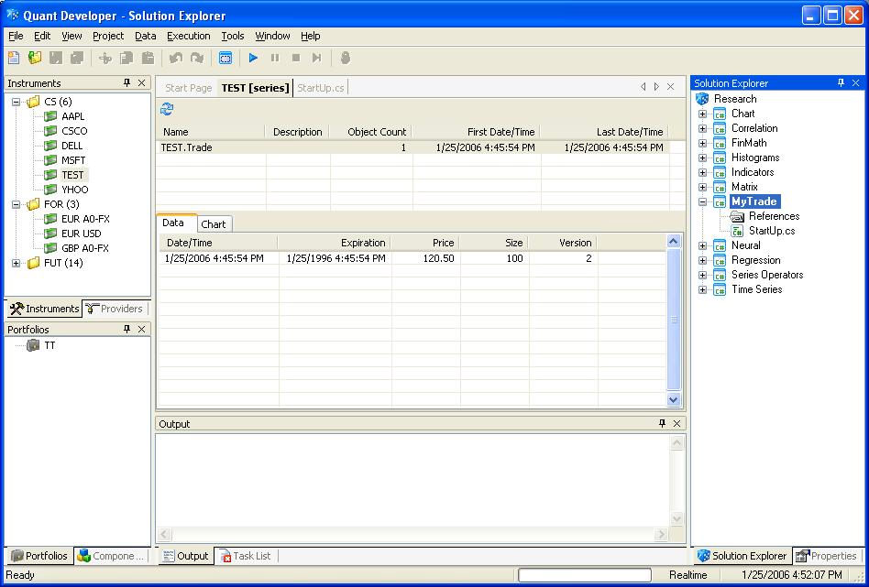

Providers

What are Providers? (Framework)
In QuantDeveloper, providers request services from third party data and execution services. All providers support two way communication processes. So, if you place an order, you can get a fill response back in QuantDeveloper or you will receive market data once you request it for a specific symbol. There are three different kinds of providers supported in QuantDeveloper:

History Providers
History providers can request historical data from 3rd party services. The following forms of historical data are supported:
- Quote
- Trade
- Bar
- Daily

Market Data Providers
Market data providers can request real time streaming data from 3rd party services. The following forms of real time data are supported:
- Quote
- Trade
- Market Depth
- Bar

Execution Providers
Execution providers can implement the following methods and thus offer this kind of functionality from within QuantDeveloper
- Send orders
- Cancel orders
- Receive order status reports
- Receive execution reports

Natively supported Providers
Provider | History Data | Market Data | Execution
eSignal | x | x
InteractiveBrokers |  | x | x
MBT |  | x
OpenTick |  | x
QuoteTracker | x | x
Simulator |  | x | x
TAL | x
TT FIX |  | x | x
Yahoo | x

Extensibility
The provider model employed by QuantDeveloper allows easy implementation of additional providers. Therefore, any market data or execution service with an consumable API can be used together with QuantDeveloper.

Connecting to a Provider (Framework)
You can connect to a provider, either by using the associated name:
ProviderManager.Providers["IB"].Connect();
or the ID:
ProviderManager.Providers[1].Connect();

Portfolios

What are Portfolios? (Framework)
Type topic text here.

Tutorials

Instruments

Create Instruments from Text-File/CSV (Framework)
Assume you want to add all 30 stocks of the Dow Jones Industrial Index to the instrument database, doing so by hand would take some time. However, we can achieve this quite easily with the help of the QuantDeveloper Framework.

- Download the Dow Jones components spreadsheet from biz.yahoo.com (Spreadsheet) and save it to C:\
This spreadsheet contains the symbols of all Dow 30 stocks and their current price, volume, etc in CSV format (comma separated values). We can utilize this to retrieve all Dow 30 symbol names and create instruments from them.
- Open up QuantDeveloper, go to File->New->Blank Solution...
- Create a new solution ("InstrumentImport")
- Add a new project ("Project1")
- Double-click StartUp.cs and enter the following code
using System;
using System.IO;
using SmartQuant.Instruments;
using SmartQuant.FIX;
public class StartUp
{
static void Main(string[] args)
{
string dowSpreadsheet;
using (StreamReader sr = new StreamReader(@"C:\quotes.csv"))
{
// Read the content from the spreadsheet we got from yahoo
// and remove unnecessary strings
dowSpreadsheet = sr.ReadToEnd().Replace("\"", String.Empty).Replace("\r", String.Empty);
}
// split the string up by line
string[] dowSpreadsheetArray = dowSpreadsheet.Split('\n');
// Iterate through the array
foreach (string s in dowSpreadsheetArray)
{
// We split up the current line by ',' and retrieve the first item,
// which represents the symbol
string symbol = s.Split(',')[0];
// We check if the instrument database already contains the symbol
if (!InstrumentManager.Instruments.Contains(symbol) && symbol.Length > 0)
{
// Create a new instrument with the specific symbol
Instrument myInstrument = new Instrument(symbol, SecurityType.CommonStock);
// Save the symbol to the instrument database
myInstrument.Save();
Console.WriteLine("Instrument {0} added to instrument database.", symbol);
}
}
}
}
- Click the Start button or right-click on Project1 and click Run
- All instruments that are not currently in InstrumentManager will be added to the QuantDeveloper instrument database. You can see which instruments got added in the output window.
Tip: While creating the instruments you can set additional properties as well. In the above posted example, you could for example check if a stock symbol length is 4 characters or less. If it is 4, you could set myInstrument.SecurityExchange = "NASDAQ" or myInstrument.SecurityExchange = "NYSE" when less than 4 characters.

Set up Instrument for use with IB
If you want to add an instrument of SecurityType Future for the use with InteractiveBrokers, the following settings have to be done:

- Go to View->Instruments
- Right-click in the instruments window and click New...
- Enter symbol ES, and choose Future as SecurityType (ES is the S&P E-Mini)
- Click Ok
- Right-click on the just created instrument ES and go to Properties
- In the Properties window do the following settings:
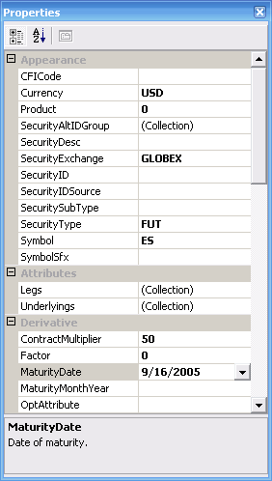
As you can see in the image, the properties that you have to set are:
- Currency: Set to USD for ES
- SecurityExchange: ES trades at GLOBEX
- ContractMultiplier: Set the correct contract multiplier. In the case of ES it is 50.
- MaturityDate: Set the expiration date for the specific contract. At the time this tutorial was written, the current front month was September 2005. A quick look at the CME website tells us that the last trading day for the ES was 09/16/2005.
Tip: The day for the MaturityDate is not really important and can be any day in the month. Just make sure that you use the correct month.
The instrument is now set up for use with InteractiveBrokers. See Related Topics if you want to know how to receive data from InteractiveBrokers for the newly set up instrument.

Set up Instrument for Data/Execution Provider
- Set up Instrument for use with InteractiveBrokers

Providers

Writing a custom provider
The following tutorial will guide you through the process of creating a custom provider for market data and execution by the example of a dummy provider that can be used within QuantDeveloper.
- Create a new Visual Studio Class Library project and call it DummyProvider
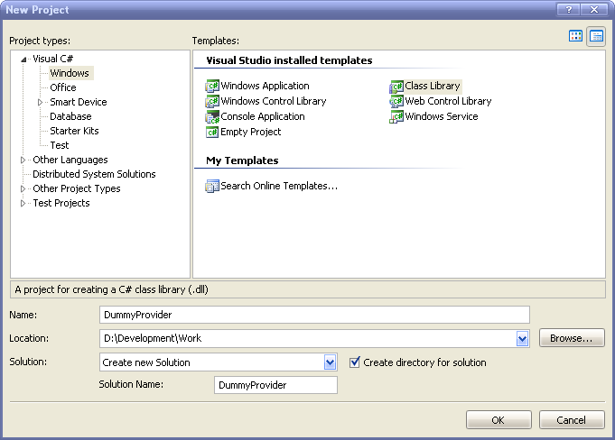
- Add the following References to the DummyProvider project:
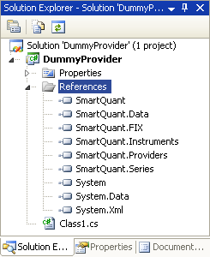
- Rename Class1.cs to MyProvider.cs
- Open MyProvider.cs and inherit from IProvider and IMarketDataProvider
- Right-click on each of the inherited interfaces and select Implement Interface->Implement Interface
- In the next step we start to implement code for all IProvider members:
using System;
using System.Collections.Generic;
using System.Text;
using SmartQuant.Providers;
using System.ComponentModel;
namespace DummyProvider
{
public class MyProvider : IProvider, IMarketDataProvider, IExecutionProvider
{
#region IProvider Members
public void Connect(int timeout)
{
this.Connect();
ProviderManager.WaitConnected(this, timeout);
}

public void Connect()
{
isConnected = true;
if (Connected != null)
Connected(this, new EventArgs());
}
public event EventHandler Connected;

public void Disconnect()
{
isConnected = false;
if (Disconnected != null)
Disconnected(this, new EventArgs());
}

public event EventHandler Disconnected;
public event ProviderErrorEventHandler Error;

public byte Id
{
get { return 80; }
}

private bool isConnected = false;

[Category("Information")]
public bool IsConnected
{
get { return isConnected; }
}
[Category("Information")]
public string Name
{
get { return "DummyProvider"; }
}

[Category("Information")]
public ProviderStatus Status
{
get
{
if (!IsConnected)
return ProviderStatus.Disconnected;
else
return ProviderStatus.Connected;
}
}

public event EventHandler StatusChanged;

public string Title
{
get { return "This is a dummy provider."; }
}

public string URL
{
get { return String.Empty; }
}
#endregion

#region IMarketDataProvider Members
#region IExecutionProvider Members
}
}
Implementing IProvider members should be straight forward. You need to implement Connect and Disconnect method and call the appropriate events. As this is a dummy provider, it does not need to connect to any 3rd party market data or execution provider. The logic to do so for your 3rd party providers would be implemented here. Also, you need to give your provider an unique name and byte ID.
- Now we are going to implement all IMarketDataProvider members which is a little bit more tricky and we need to add some dummy code to actually output market data:
using System;
using System.Collections.Generic;
using System.Text;
using SmartQuant.Providers;
using System.ComponentModel;
using SmartQuant.Instruments;
using SmartQuant.FIX;
using System.Timers;
using SmartQuant;
namespace DummyProvider
{
public class MyProvider : IProvider, IMarketDataProvider, IExecutionProvider
{
#region IProvider Members

#region IMarketDataProvider Members
public IBarFactory BarFactory
{
get
{
throw new Exception("The method or operation is not implemented.");
}
set
{
throw new Exception("The method or operation is not implemented.");
}
}
public event MarketDataSnapshotEventHandler MarketDataSnapshot;
public event BarEventHandler NewBar;
public event BarEventHandler NewBarOpen;
public event CorporateActionEventHandler NewCorporateAction;
public event FundamentalEventHandler NewFundamental;
public event BarEventHandler NewMarketBar;
public event MarketDataEventHandler NewMarketData;
public event MarketDepthEventHandler NewMarketDepth;
public event QuoteEventHandler NewQuote;
public event TradeEventHandler NewTrade;
private Timer tickTimer;
private List<string> subscribedSymbols = new List<string>();
public void SendMarketDataRequest(SmartQuant.FIX.FIXMarketDataRequest request)
{
lock (this)
{
// check connection
if (!IsConnected)
{
EmitError(-1, -1, "Not connected.");
return;
}
switch (request.SubscriptionRequestType)
{
case DataManager.MARKET_DATA_SUBSCRIBE:
for (int i = 0; i < request.NoRelatedSym; i++)
{
FIXRelatedSymGroup group = request.GetRelatedSymGroup(i);
RequestSymbol(group.Symbol);
}
break;
case DataManager.MARKET_DATA_UNSUBSCRIBE:
for (int i = 0; i < request.NoRelatedSym; i++)
{
FIXRelatedSymGroup group = request.GetRelatedSymGroup(i);
UnsubscribeSymbol(group.Symbol);
}
break;
default:
throw new ArgumentException("Unknown subscription type: " + request.SubscriptionRequestType.ToString());
}
}
}
private void RequestSymbol(string symbol)
{
if (!subscribedSymbols.Contains(symbol))
subscribedSymbols.Add(symbol);
if (tickTimer != null)
{
tickTimer = new Timer();
tickTimer.Interval = 1000;
tickTimer.Elapsed += new ElapsedEventHandler(tickTimer_Elapsed);
tickTimer.Start();
}
}
private void UnsubscribeSymbol(string symbol)
{
if (subscribedSymbols.Contains(symbol))
subscribedSymbols.Remove(symbol);
if (subscribedSymbols.Count == 0 && tickTimer != null)
{
tickTimer.Elapsed -= tickTimer_Elapsed;
tickTimer.Stop();
}
}
void tickTimer_Elapsed(object sender, ElapsedEventArgs e)
{
if (NewTrade != null)
{
Random rand = new Random();
foreach (string symbol in subscribedSymbols)
NewTrade(this, new TradeEventArgs(new SmartQuant.Data.Trade(Clock.Now, rand.Next(), 1), InstrumentManager.Instruments[symbol], this));
}
}
#endregion
#region IExecutionProvider Members

private void EmitError(int id, int code, string message)
{
if (Error != null)
Error(new ProviderErrorEventArgs(new ProviderError(Clock.Now, this, id, code, message)));
}
}
}
The main method of interest is SendMarketDataRequest(SmartQuant.FIX.FIXMarketDataRequest request). This method is responsible for subscribing to and unsubscribing from market data. First off, we check if the provider is connected at all and emit an error if it is not.
In the next step we check which request.SubscriptionRequestType the request is (subscribe/unsubscribe). The next piece of code is important as it acquires the correct symbol for the data provider in use as specified by SecurityAltIDGroup in instrument setup:
for (int i = 0; i < request.NoRelatedSym; i++)
{
FIXRelatedSymGroup group = request.GetRelatedSymGroup(i);
RequestSymbol(group.Symbol);
}
RequestSymbol and UnsubscribeSymbol are the methods where you would implement the logic to request market data from the API of your data feed vendor. In our Dummy Provider I add every subscribed symbol to a generic list and start a timer that emits a trade with a random price every 1000ms for every symbol in the generic list. In this example we only emit NewTrade event, however there are a lot of other events that you can implement as well:
  - MarketDataSnapshot
  - NewBar
  - NewBarOpen
  - NewCorporateAction
  - NewFundamental
  - NewMarketBar
  - NewMarketData
  - NewMarketDepth
  - NewQuote
- Implementing IExecutionProvider members is the next step:
using System;
using System.Collections.Generic;
using System.Text;
using SmartQuant.Providers;
using System.ComponentModel;
using SmartQuant.Instruments;
using SmartQuant.FIX;
using System.Timers;
using SmartQuant;
namespace DummyProvider
{
public class MyProvider : IProvider, IMarketDataProvider, IExecutionProvider
{
#region IProvider Members

#region IMarketDataProvider Members

#region IExecutionProvider Members
public event SmartQuant.FIX.ExecutionReportEventHandler ExecutionReport;
public void SendNewOrderSingle(SmartQuant.FIX.NewOrderSingle order)
{
if (ExecutionReport != null)
{
if (order.OrdType == OrdType.Market)
{
ExecutionReport report = new ExecutionReport();
report.Account = order.Account;
report.AvgPx = order.Price;
report.OrdType = OrdType.Market;
report.OrderQty = order.OrderQty;
report.ClOrdID = order.ClOrdID;
report.OrdStatus = OrdStatus.Filled;
report.SendingTime = Clock.Now;
report.TransactTime = Clock.Now;

ExecutionReport(this, new ExecutionReportEventArgs(report));
}
}
}
public void SendOrderCancelReplaceRequest(SmartQuant.FIX.FIXOrderCancelReplaceRequest request)
{
throw new Exception("The method or operation is not implemented.");
}
public void SendOrderCancelRequest(SmartQuant.FIX.FIXOrderCancelRequest request)
{
throw new Exception("The method or operation is not implemented.");
}
public void SendOrderStatusRequest(SmartQuant.FIX.FIXOrderStatusRequest request)
{
throw new Exception("The method or operation is not implemented.");
}
#endregion
private void EmitError(int id, int code, string message)
{
if (Error != null)
Error(new ProviderErrorEventArgs(new ProviderError(Clock.Now, this, id, code, message)));
}
}
}
IExecutionProvider consists of 4 method and only one event that can be called:
  - SendNewOrderSingle(SmartQuant.FIX.NewOrderSingle order)
  - SendOrderCancelReplaceRequest(SmartQuant.FIX.FIXOrderCancelReplaceRequest request)
  - SendOrderCancelRequest(SmartQuant.FIX.FIXOrderCancelRequest request)
  - SendOrderStatusRequest(SmartQuant.FIX.FIXOrderStatusRequest request)
  - public event SmartQuant.FIX.ExecutionReportEventHandler ExecutionReport;
- If you look at the code sample above we only implemented some code for SendNewOrderSingle. Whenever an order or request is sent to the IExecutionProvider you need to handle it in those 4 methods and pass it on to your broker API. When you get a response you need to build an ExecutionReport from that response and emit it. As you can see in our SendNewOrderSingle example, we check if the order is a Market order and if it is we pretend that it was filled, assign the required properties and call the ExecutionReport event to emit it.
- Your dummy provider is now ready for testing. Thus, compile it and copy the assembly to QuantDeveloper\bin directory.
- Open up QuantDeveloper and go to Tools->Configuration->Providers. Click Add, select DummyProvider.dll from the bin directory and agree to load it.
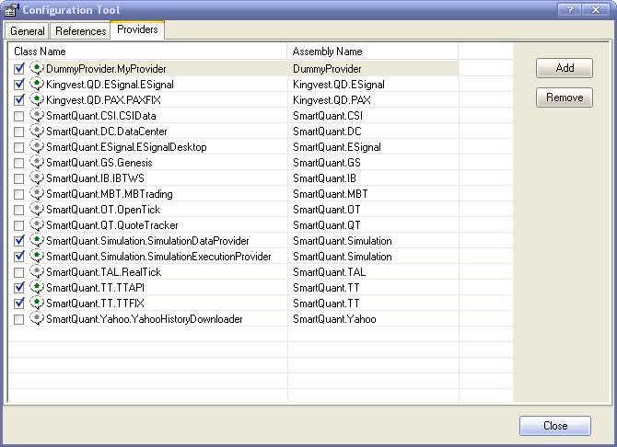

Creating Crossover Strategy

Creating Crossover Strategy
Let's create a simple but quite popular trading strategy "Crossover". This is one of the trend following strategies. This Strategy uses two, long and short term, simple moving averages (SMA). The trading rules are simple:
- if long term SMA crosses above short term SMA, then a buy order should be executed
- if long term SMA crosses below short term SMA, then a sell order should be executed.
Natural parameters of "Crossover" strategy are lengths of the long term and short term SMAs.

After creating this strategy we will explain how to test it on different instruments and time periods, to optimize its parameters, to gather and to look into statistics of our trading process.

Besides, we will add a risk management functionality to our strategy:
- we will add stop and limit orders to the trading process
- we will add an restriction on duration of opened positions
Also, it will be shown how to switch from testing of the strategy on historical data to a live trading using a few mouse clicks.
- - Creating Crossover Strategy Walkthrough #1 describes how to create MetaStrategy Project for "Crossover" strategy and how to create the new Sample_Crossover ATS component, which encapsulates trading rules described above.
- - Creating Crossover Strategy Walkthrough #2 shows how to add trading logic to the Sample_Crossover component.
- - Creating Crossover Strategy Walkthrough #3 considers how to run the Crossover Trading Strategy and how to view Results.
- - Creating Crossover Strategy Walkthrough #4 tells you how to optimize the Crossover Trading Strategy.
- - Creating Crossover Strategy Walkthrough #5 displays how to add Stop and Limit orders and how to setup Time Stops.

Creating Crossover Strategy Walkthrough 1

Preparation
- Creating a QD solution and a MetaStrategy project, customizing them
- Adding the new "Crossover_Sample" ATS component

Creating a QD solution and a MetaStrategy project, customizing it.
- Go to File->New->Blank Solution
- Name it DemoSolution and click Create
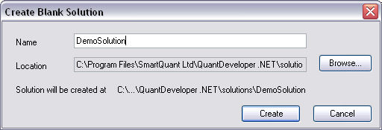
- An empty solution tree in the Solution Explorer window will show up
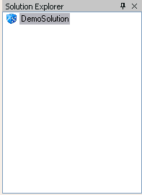
- Right-click on the DemoSolution node in the Solution Explorer window and click Add New Project...
- Click on the ATSMetaStrategy Project item, name it CrossoverProject and click Create
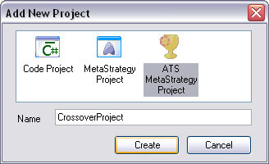
- Expand the DemoSolution tree in the Solution Explorer window, right-click on the CrossoverProject node and click Add New Strategy...
- Name it Strategy1 and click OK. The new strategy will be added to the Solution Explorer window
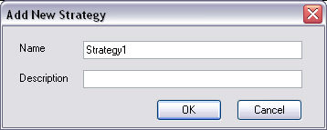
Now the MetaStrategy Project for Crossover Trading Strategy is created and you are able to customize it.
Let's set components for our metastrategy.
- expand CrossoverProject node in Solution Explorer
- expand Components sub-node of CrossoverProject node. You will see all available MetaStrategy components. Pay your attention that all components have the "Default" prefix, it means that they actually do nothing. You could change any of them to one of built-in components or to a custom component. For more information about creating custom components please take a look at "Creating Custom Components". At this stage we will change only one component, Simulation Manager, which defines what kind of data will our Metastrategy use. Simulation Manager is described in more details in "Using SimulationManager" topic.
Setting SimulationManager
- Right-click on the Simulation node and choose the Daily_SimulationManager component
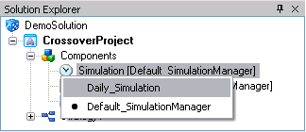
Customizing the MetaStrategy Project for the Crossover Trading Strategy is complete.

Now let's customize the Strategy object:
- expand Components sub-node of Strategy node. You will see all available Strategy components. Pay your attention that all components have the "Default" prefix, it means that they actually do nothing. You could change any of them to one of built-in components or to a custom component. For more information about creating custom components please take a look at "Creating Custom Components". At this stage we will change only the MarketManager component, which defines what instruments will our Strategy use.
Setting SimulationManager:
- Right-click on the Market node and choose the Demo_MarketManager component
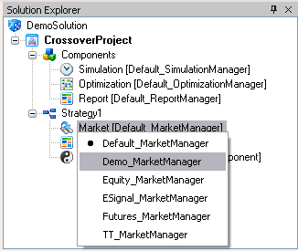
Choosing the Demo_MarketManager results that the Strategy will use two instruments - MSFT and CSCO. For more information about the MarketManager see "Using MarketManager".
Customizing of the CrossoverProject is almost ready. Let's create the new ATS component, which will contain trading logic of our Crossover Trading Strategy.

Adding new "Crossover_Sample" ATS component
- Locate the Component Manager window, if you can't see it, use View -> Component Manager path in the main menu. You will see the following window:
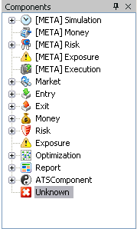
- right-click on the ATSComponent node and click Add New...
- name the new component "Sample_Crossover" and click "Add"
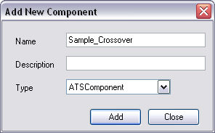
- make sure that the Samlpe_Crossover component appeared in the Component Manager window. You should see it if you expand the ATSComponent node in the Component Manager window
We have created the Sample_Crossover component for the Crossover Trading Strategy. Let's make it a component of the Strategy1:
- expand the Components sub-node of the Strategy node
- right-click on the ATSComponent node and choose the Sample_Crossover component
Final version of the DemoSolution at this stage should looks like following:
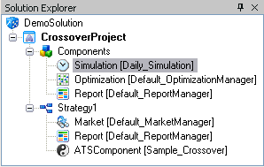
Note, that several instances of the Sample_Crossover component will be created by the Strategy1, one for every instrument which the Strategy1 uses. In our case there are two instruments MSFT and CSCO, so there will be two instances of Sample_Crossover component.

Click "Build" button in the toolbar to make sure that the CrossoverProject was created correctly.
The Output window will show the result of the project's build:
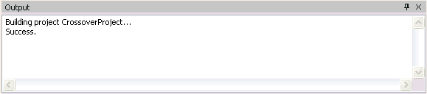

Creating Crossover Strategy Walkthrough 2

Adding trading logic to Sample_Crossover component.
In Creating Crossover Strategy Walkthrough #1 we discussed how to create the DemoSolution with the CrossoverProject in it and how to create the Sample_Crossover ATS component. Open the DemoSolution if it's closed, see "How to open existing solution" topic for more information. Now we are ready to implement the Crossover trading logic:
- locate the Component Manager. If it's closed, use View -> Component Manager path in the main menu
- expand the ATSComponent node, you should see the following window:
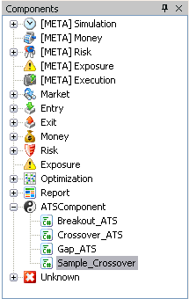
- double click on the Sample_Crossover node and an editor with the code of the Sample_Crossover component will appear
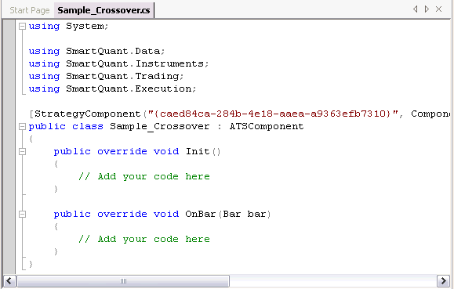
Now, let's add two SMAs (long end short term) to this component:
[StrategyComponent("{caed84ca-284b-4e18-aaea-a9363efb7310}", ComponentType.ATSComponent , Name="Sample_Crossover", Description="")]
public class Sample_Crossover : ATSComponent
{
SMA longSMA;
SMA shortSMA;

int longLength = 14;
int shortLength = 10;

public override void Init()
{
longSMA = new SMA(Bar, longLength);
shortSMA = new SMA(Bar, shortLength);
}
public override void OnBar(Bar bar)
{
// Add your code here
}
}
Pay your attention to how the SMAs are initialized. As it was described in Creating Crossover Strategy Walkthrough #1 the Strategy1 will create two instances of the Sample_Crossover component, since there are two instruments (MSFT and CSCO) that the Strategy1 uses.

The "Bar" property of the ATSComponent defines a default series of the instrument the ATSComponent corresponds to.

Because we use the Daily_SimulationManager, there will be only one series "Daily" and this series naturally is default. You can get more minutely information about accessing to series from components in "Accessing series from components" topic. So, the "Bar" property in the current strategy is a series of Daily bars. The SMA as every indicator needs an input seres (series of Daily bars now) and specific parameters (Length for SMA) which should be passed into the constructor of this indicator. To understand concepts of Indicators and TimeSeries, please take a look at following topics "Indicators", "TimeSeries".

It's time to add our trading rules to the Sample_Crossover component. As they was described in Creating Crossover Strategy topic:
- if long term SMA crosses short term SMA above, then a buy order should be executed
- if long term SMA crosses short term SMA below, then a sell order should be executed
So, let's change the body of the OnBar method:
public override void OnBar(Bar bar)
{
ECross cross = shortSMA.Crosses(longSMA, bar.DateTime);
if (cross == ECross.Above)
Console.WriteLine(bar.DateTime + " - Time to buy " + Instrument);

if (cross == ECross.Below)
Console.WriteLine(bar.DateTime + " - Time to sell " + Instrument);
}
What is OnBar method? This method is called every time a strategy gets the new bar (from the simulation data provider or from a real provider). The OnBar method is one of market data handlers. For more information about market data events and handlers use "Handling Market Data Events in Components".

The Instrument property defines the instrument the ATSComponent corresponds to.

Here we simply print out the Output Window all actions we want to perform. We will replace this printing to output with real sending orders below in this chapter.

Click the "Build" button in the main toolbar to make sure that the Sample_Crossover component is compiled correctly.
The Output window will show the result of the project's build:
Now we are ready to test how our Sample_Crossover component works. Just click the "Start" button in the main toolbar:
The MetaStrategy will run. And it will give output in console:
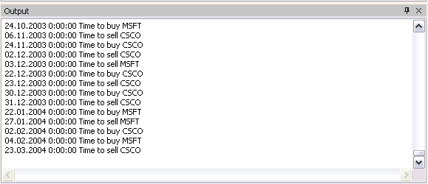
So, we can see that MetaStrategy works and we are ready to replace printing out the console with sending real orders to Execution Provider (Simulation Execution provider in our case).

To create an order you should
- create an instance of the SingleOrder class
- set required properties of this instance
- send this order, calling the Send() method
Let's look at the code:
using System;
using SmartQuant.Indicators;
using SmartQuant.Series;
using SmartQuant.Data;
using SmartQuant.FIX;
using SmartQuant.Instruments;
using SmartQuant.Trading;
using SmartQuant.Execution;
[StrategyComponent("{caed84ca-284b-4e18-aaea-a9363efb7310}", ComponentType.ATSComponent , Name="Sample_Crossover", Description="")]
public class Sample_Crossover : ATSComponent
{
int qty = 100;

SMA longSMA;
SMA shortSMA;

int longLength = 14;
int shortLength = 10;

public override void Init()
{
longSMA = new SMA(Bar, longLength);
shortSMA = new SMA(Bar, shortLength);
}
public override void OnBar(Bar bar)
{
ECross cross = shortSMA.Crosses(longtSMA, bar.DateTime);
if (cross == ECross.Above)
{
SingleOrder marketOrder = MarketOrder(Instrument, Side.Buy, qty);

marketOrder.Text = "Buy";
marketOrder.Send();
}

if (cross == ECross.Below)
{
SingleOrder marketOrder = MarketOrder(Instrument, Side.Sell, qty);

marketOrder.Text = "Sell";
marketOrder.Send();
}
}
}

Let's consider the following line:
SingleOrder marketOrder = MarketOrder(Instrument, Side.Sell, qty);

Note that there is no "new" keyword, but the MatkerOrder method of the ATSComponent is called instead. This method creates an order and registers it as an order created from the strategy. It is critical for correct order management in the strategy. Look at "Sending Orders" topic for more detailed information.
Click the "Build" button on the main toolbar. Make sure, that the project was build successfully.

So, the base for the "Crossover" trading strategy is created and we can move forward to actually running it. Please, follow to the next steps in Creating Crossover Strategy Walkthrough #3, which describe how to run created strategy and how to view results.

Creating Crossover Strategy Walkthrough 3

Running Crossover Trading Strategy and Viewing Results
In Creating Crossover Strategy Walkthrough #2 chapter we have created the code for the "Crossover" trading strategy. The current chapter describes how to run it and how to view results. The code of the "Crossover" trading strategy will be modified a bit in this chapter.

First of all, let's run our project. Click the "Run" button in the main toolbar:
Now, wait until the "Ready" text will appear in the left bottom side of the QuantDeveloper main window.
It's time to view results of the Crossover Trading Strategy.

Let's take a look at the Equity curve. For that you should right-click on the CrossoverProject node in the Solution Explorer window, select "View" and click on the "Performance" menu item.
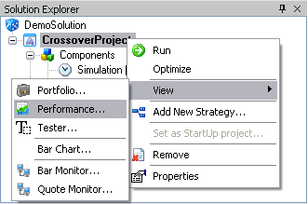
You should see the Performance window, for more detailed information about the Performance window, use following link "Performance Window".
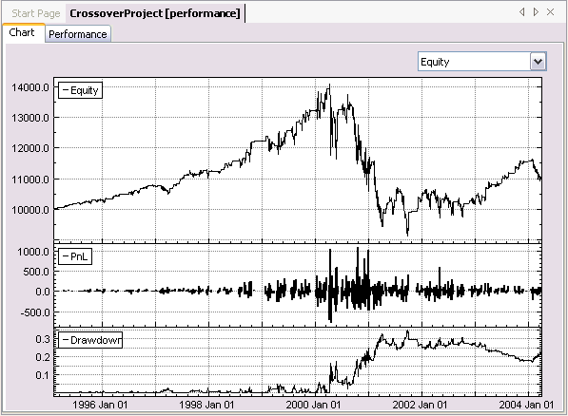
Here, you can see the Equity curve, PnL and Drawdown series. You can see other statistics using the drop down list in the top right side of the window.

Now, let's take a look at the portfolio for our strategy. For that you should right-click on the CrossoverProject node in the Solution Explorer window, select "View" and click on the "Portfolio" menu item.
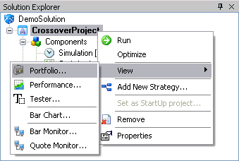
There is the list of all transactions, opened positions and information about current state of the portfolio. You can get more information about the Portfolio Composition window in "Portfolio Composition Window" topic.
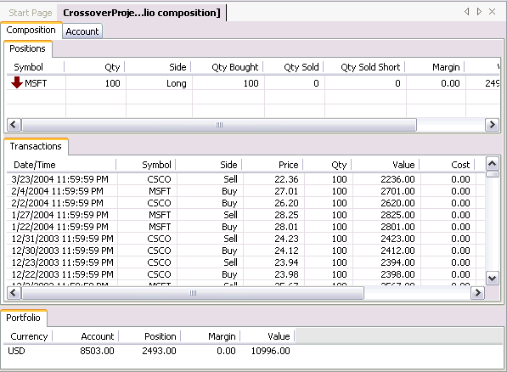
To view orders, which the strategy have created, go to Execution -> Order Manager in the main menu. The following window should appear:
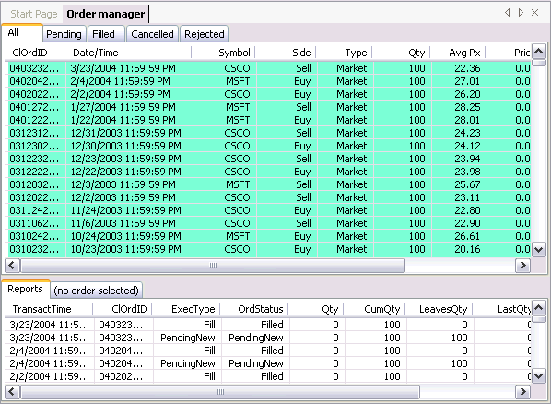
In this window you could examine information about orders sent by the strategy, reports belonging to them etc. Use "Order Manager Window" link you could get more about this window.

Let's change the code of Sample_Crossover component to make our indicators (SMAs) visible on the BarChart window, on which we take a look in the next step.

To make any series visible on the BarChart, you should call the Draw method and pass required series to it as a parameter. Now, open the code of the Sample_Crossover component as it is described in the Creating Crossover Strategy Walkthrough #2 or in "How to edit component's code" topic.

Add following lines at the end of the Init method:

longSMA .Color = Color.Green;
shortSMA.Color = Color.Brown;

Draw(longSMA , 0);
Draw(shortSMA, 0);

This code simply sets "Color" properties of our indicators and draws onto the BarChart. First parameter of the Draw method is a series or another object to draw, second argument defines a pad number, in which the object should be drawn.
- to draw onto the price pad - pass "0" as second argument
- to draw onto the volume pad- pass "1"
- to draw onto a separated pad - pass another number.

So, the last version of the Sample_Crossover component looks like this:

using System;
using SmartQuant.Indicators;
using SmartQuant.Series;
using SmartQuant.Data;
using SmartQuant.FIX;
using SmartQuant.Instruments;
using SmartQuant.Trading;
using SmartQuant.Execution;
[StrategyComponent("{caed84ca-284b-4e18-aaea-a9363efb7310}", ComponentType.ATSComponent , Name="Sample_Crossover", Description="")]
public class Sample_Crossover : ATSComponent
{
int qty = 100;

SMA longSMA;
SMA shortSMA;

int longLength = 14;
int shortLength = 10;

public override void Init()
{
longSMA = new SMA(Bar, longLength);
shortSMA = new SMA(Bar, shortLength);

longSMA .Color = Color.Green;
shortSMA.Color = Color.Brown;

Draw(longSMA , 0);
Draw(shortSMA, 0);
}
public override void OnBar(Bar bar)
{
ECross cross = longSMA.Crosses(shortSMA, bar.DateTime);
if (cross == ECross.Above)
{
SingleOrder marketOrder = MarketOrder(Instrument, Side.Buy, qty);

marketOrder.Text = "Buy";
marketOrder.Send();
}

if (cross == ECross.Below)
{
SingleOrder marketOrder = MarketOrder(Instrument, Side.Sell, qty);
marketOrder.Text = "Sell";
marketOrder.Send();
}
}
}
To view the BarChart window, you should right-click on CrossoverProject node in the Solution Explorer window, select "View" and click on the "Bar Chart" menu item.
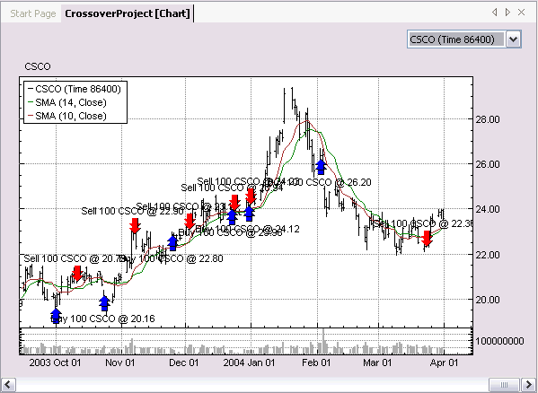
Here you can see a plotted bar series (CSCO 86000, 86000 means that it is daily data, 1 day has 86000 seconds), transactions and two SMAs, which are drawn due to our last changes in the code of the Sample_Crossover component. You can try to comment the last added lines in the code and you will see that the indicators will disappear. You can select a bar series to be drawn using drop down list in the top right side of the window. For more information about the BarChart window see "BarChart Window" topic.

Besides of statistics in Performance Window, you could also gather statistic using the Tester. Tester's results could be displayed in the Tester window, which we will examine later. There is a ReportManager component for customizing the Tester. You could add or remove sets of statistics in the code of a ReportManager. There are several built-in ReportManager's:
- DisableAll_ReportManager, which disables all available statistics
- EnableAll_ReportManager, which enables all available statistics
- Performance_ReportManager, which enables only statistics displayed on the Performance Analysis tab in the Tester window
- Risk_ReportManager, which enables only statistics displayed on the Risk Analysis tab in the Tester window
- RollingAndRisk_ReportManager, which enables only statistics displayed on the Rolling Statistics and Risk Analysis tabs in the Tester window
- RoundTrips_ReportManager, which enables only statistics displayed on the RoundTrips tab in the Tester window
- TimePeriod_ReportManager, which enables only statistics displayed on the Daily, Monthly and Annual tabs in the Tester window.

You could change ReportManager of MetaStrategy in following way:
- expand CrossoverProject node in Solution Explorer.
- expand Components subnode of CrossoverProject node.
- Right-click on ReportManager node and choose required component.

Please, change the ReportManager of MetaStrategy to the EnableAll_ReportManager:
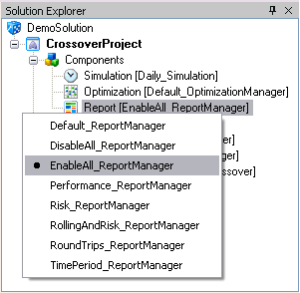
Now, before starting the CrossoverProject close all opened windows like the Portfolio Composition window, Performance window, BarChart, OrderManager etc. You should do it, because all these widows will be updating during running of the project and it will take really huge time. Another way is to freeze the GUI, in this case all windows described above will not be updating during project's run, but they will displays correct results, when the project stops. You can freeze GUI using the "Freeze GUI" button in the main toolbar, you can always defreeze GUI pushing the same button one more time:
Now, start the CrossoverProject again, using the "Start" button in the main toolbar.

Note that the second run of the CrossoverProject takes more time than the first one. It happens, because a lot of time is devoted to the calculation of statistics when you use the EnableAll_ReportManager . So, the more statistics are enabled, the more time a running of the project takes.

It's time to look at the Tester. For that you should right-click on the CrossoverProject node in the Solution Explorer window, select "View" and click on the "Tester" menu item. The following window will appear:
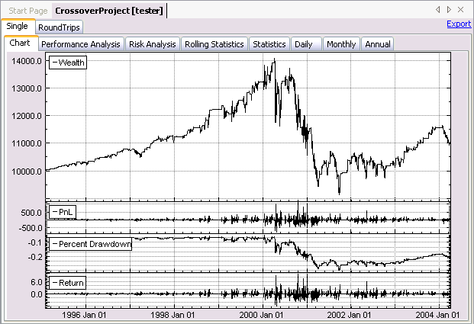
You can see that almost all of the tabs have data, except:
- Short Round Trips tab, because there was no short round trips
- Statistics, Daily, Monthly and Annual tabs, because these tabs are disabled by default, for performance reasons. You can make these tabs enabled, by setting corresponding properties in the Property window, which will appear, when you click on the Tester window.
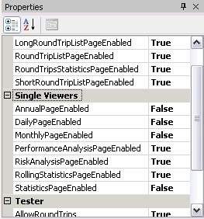

Try to change the ReportManager of the MetaStrategy to the RollingAndRisk_ReportManager, run the project and you will see, that only two tabs will contain data: the Risk Analysis and the Rolling Statistics:
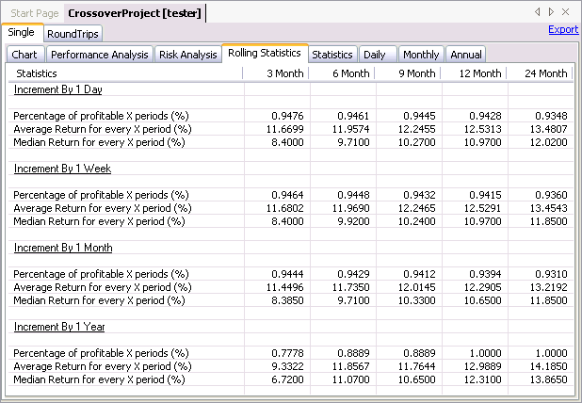
Try to change the ReportManager of the MetaStrategy to the RoundTrips_ReportManager, run the project and you will see, that only tabs corresponding to Round Trips will contain data:
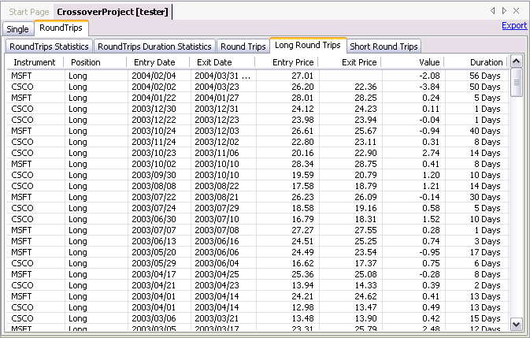
You can learn more about ReportManager, using "All about ReportManager" topic. For more information about the Tester window see "Tester Window".

Note, that the Tester's and Performance's statistics calculation is based on the specific Portfolio. There are two portfolios now - the CrossoverProject's portfolio and the Strategy1's portfolio, so you can observe the Tester, the Performance and the Portfolio Composition of the Strategy1. You should simply do analogous actions with the Strategy1 node in the Solution Explorer window, instead of the CrossoverProject node.

The next step is to find optimal parameters for the Crossover Trading Strategy, which runs on daily data of two instruments (MSFT and CSCO). Follow to the Creating Crossover Strategy Walkthrough #4.

Creating Crossover Strategy Walkthrough 4

Optimizing Crossover Trading Strategy
In this chapter we will find optimal parameters for the Crossover Trading Strategy, which runs on daily data of two instruments (MSFT and CSCO).

There are several ways to find optimal parameters. One is to look over all possible values of these parameters in specific parameter's intervals (Brute Force). But the Brute Force often takes really huge amount of time if there are a lot of parameters and investigated intervals include many possible values of parameters. Another way is to use one of optimization algorithms, which do not look over all possible values, the Simulated Annealing for example. This algorithm does not guarantees that found parameters are optimal, but in some cases it will be faster and gives the same results as the Brute Force algorithm. One more advantage of the Simulated Annealing is that it can work with double parameters, while the Brute Force algorithm can't look over all double values into the specific interval. For more information about optimization algorithms take a look at the "Optimization Algorithms" topic.

Natural parameters of our strategy are lengths of SMAs (Simple Moving Averages). So, we will try to find a pair of these parameters which give us the best results by some criterion. The one of possible criteria is the Final Wealth. An optimization criterion is also called "Objective Function".

You can set an Objective Function by selecting one of available OptimizationManagers. Let's select the Wealth_OptimizationManager for our CrossoverProject, it will return the Final Wealth of the strategy run. First of all, you should open the Solution Explorer window, then:
- expand the CrossoverProject node in the Solution Explorer
- expand the Components subnode of the CrossoverProject node
- right-click on the Optimization node and choose the Wealt_OptimizationManager component
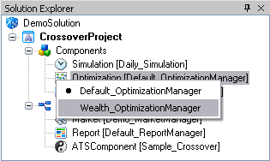
The Optimizer of MetaStrategies in the QuantDeveloper uses one of available optimization algorithms. It runs MetaStrategy with parameters set according to selected optimization algorithm, after each run it calls the "Objective" method of the OptimizationManager of the MetaStrategy and determines whether current parameters are optimal. Note, that when the Optimizer finds optimal parameters, it will run the MetaStrategy with the best parameters.

One more thing we should do before optimizing is to define parameters to optimize. The Optimizer searches public properties with "get" and "set" accessors through all of the MetaStrategy's and Strategies's components. Besides, properties should have "OptimizatioParameter" attribute to be accepted by the Optimizer.

The OptimizationParameter attribute takes three values:
- lower bound of the optimization interval for the parameter
- upper bound of the optimization interval for the parameter
- step, which is used by the Brute Force algorithm to increment the parameter.
So, we should make public properties in our Sample_Crossover component:
[OptimizationParameter(10, 30, 3)]
public int LongLength
{
get { return longLength; }
set { longLength = value; }
}

[OptimizationParameter(10, 30, 3)]
public int ShortLength
{
get { return shortLength; }
set { shortLength = value; }
}
We set lower bound of both parameters to 10, upper bound to 30, step to 3. So, the Brute Force will make 49 runs. Simulated Annealing will ignore step, but will select parameters according to the upper and lower bounds.

The last version of the code of the Sample_Crossover component is:
using System;
using System.Drawing;
using SmartQuant.Indicators;
using SmartQuant.Series;
using SmartQuant.Data;
using SmartQuant.Optimization;
using SmartQuant.FIX;
using SmartQuant.Instruments;
using SmartQuant.Trading;
using SmartQuant.Execution;
[StrategyComponent("{caed84ca-284b-4e18-aaea-a9363efb7310}", ComponentType.ATSComponent , Name="Sample_Crossover", Description="")]
public class Sample_Crossover : ATSComponent
{
int qty = 100;

SMA longSMA;
SMA shortSMA;

int longLength = 14;
int shortLength = 10;

[OptimizationParameter(10, 30, 3)]
public int LongLength
{
get { return longLength; }
set { longLength = value; }
}

[OptimizationParameter(10, 30, 3)]
public int ShortLength
{
get { return shortLength; }
set { shortLength = value; }
}

public override void Init()
{
longSMA = new SMA(Bar, longLength);
shortSMA = new SMA(Bar, shortLength);

longSMA .Color = Color.Green;
shortSMA.Color = Color.Brown;

Draw(longSMA , 0);
Draw(shortSMA, 0);
}
public override void OnBar(Bar bar)
{
ECross cross = longSMA.Crosses(shortSMA, bar.DateTime);
if (cross == ECross.Above)
{
SingleOrder marketOrder = MarketOrder(Instrument, Side.Buy, qty);

marketOrder.Text = "Buy";
marketOrder.Send();
}

if (cross == ECross.Below)
{
SingleOrder marketOrder = MarketOrder(Instrument, Side.Sell, qty);
marketOrder.Text = "Sell";
marketOrder.Send();
}
}
}
Now, we are ready to optimize our strategy.
- click the "Build" button in the main toolbar and make sure that the project have been built successfully
- right-click on the CrossoverProject and click Optimize.
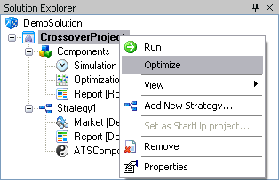
The following window will appear:
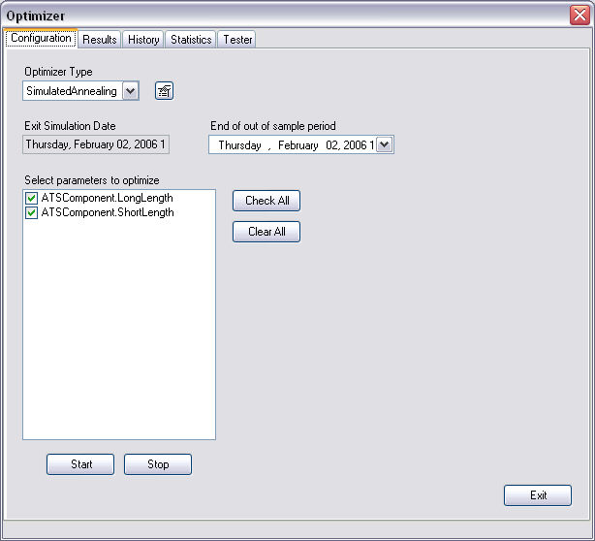
Please, change "Optimizer Type" to the Brute Force and click the "Start" button. An Optimization run will start.

In the "Results" tab you can follow the optimization process:
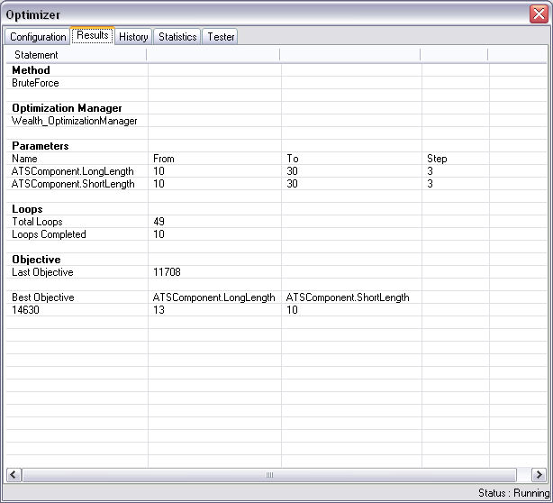
The "History" tab displays combinations of optimization parameters and the value of the Objective Function (Final Wealth in our case) corresponding to them:
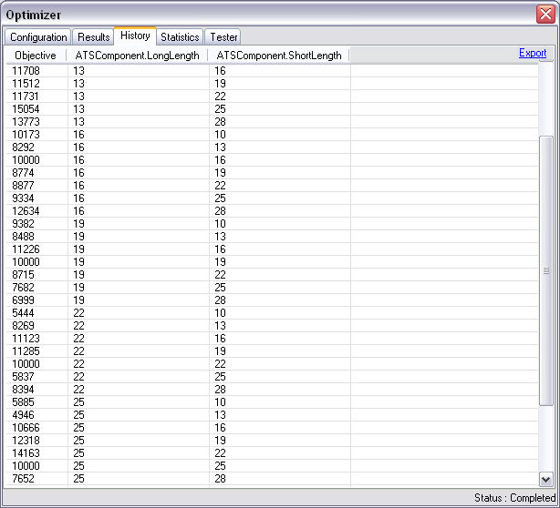
When optimization becomes completed, you can switch to the "Statistics" tab, examine a displacement of the Objective function (in "2D Histogram" tab or in "3D Histogram" tab):
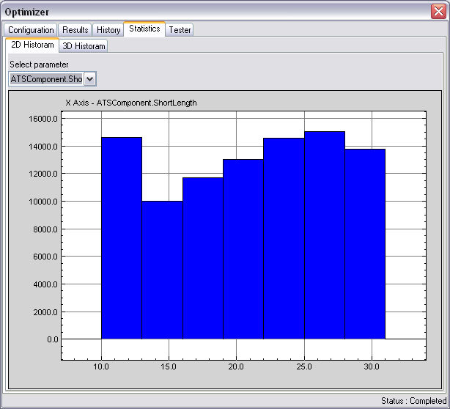
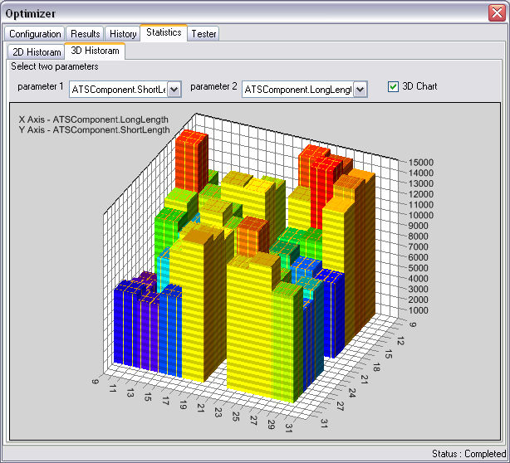
The "Tester" tab contains information about the last MetaStrategy run with optimal parameters.
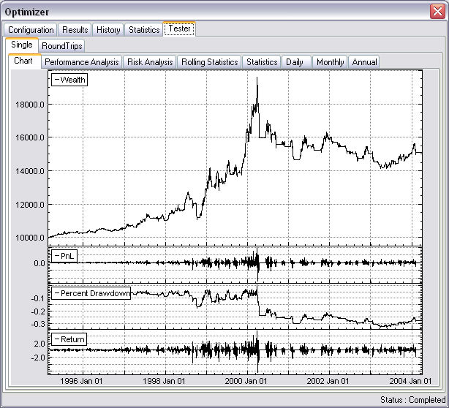
Note, that although chosen ReportManager (which configures Tester) has an effect on the duration of running of the MetaStrategy, in the optimization mode it's not important what ReportManager do you use. All statistics, which are used directly in MetaStrategy's or Strategies's components will be enabled automatically.

To get more detailed information about the Optimizer window see "Optimizer Window".

So, we have created "Crossover" Trading Strategy, we have optimized it. Let's add a risk management functionality to our strategy, it is described in Creating Crossover Strategy Walkthrough #5.

Creating Crossover Strategy Walkthrough 5

Adding Risk Management Functionality to Crossover Trading Strategy
In this chapter we will discuss how to send limit and stop orders and how to set Time stops on positions.
We start with setting stop and limit orders. Let's consider the following code:
limitOrder = LimitOrder(Side.Sell, 100, 30);
limitOrder.Text = "Limit";

stopOrder = StopOrder(Side.Sell, 100, 25);
stopOrder.Text = "Stop";

limitOrder.Send();
stopOrder.Send();
This code creates and sends stop and limit orders, which are associated with a long position. Both orders are created to sell 100 contracts, when a price moves to 25 or 30 correspondingly.

One more thing we want to do is to cancel the stop order, if the limit order becomes filled and to cancel the limit order if the stop order becomes filled. For this reason a concept of OCA Groups is used. If several orders are in one OCA Group, then filling or canceling one of the orders causes canceling of all others. To define OCA Group for an order, you should use the OCAGroup property of this order. Look at the following code block:
limitOrder = LimitOrder(Side.Sell, 100, 30);
limitOrder.OCAGroup = "OCA 1";
limitOrder.Text = "Limit";

stopOrder = StopOrder(Side.Sell, 100, 25);
limitOrder.OCAGroup = "OCA 1";
stopOrder.Text = "Stop";

limitOrder.Send();
stopOrder.Send();
Besides, we want to cancel Limit and Stop orders, if our long position becomes closed due to Crossover logic (SMAs becomes intercepted again). To do that, let's override the OnPositionClosed method:

public override void OnPositionClosed()
{
if (!(limitOrder.IsFilled || limitOrder.IsCancelled))
limitOrder.Cancel();
}
This code cancels the limit order. The stop order will be canceled automatically, because it belongs to the same OCA Group with the limit order. The OnPositionClosed method is one of Portfolio Event Handlers set, which is described in more details in "Portfolio Event Handlers" topic. This method will be called every time when some Position in Strategy's Portfolio becomes closed.

Also, let's suggest that all positions will be opened in the Long side. So, the new version of the code of the Sample_Crossover component looks like that:
using System;
using System.ComponentModel;
using System.Drawing;
using SmartQuant.Indicators;
using SmartQuant.Series;
using SmartQuant.Data;
using SmartQuant.Optimization;
using SmartQuant.FIX;
using SmartQuant.Instruments;
using SmartQuant.Trading;
using SmartQuant.Execution;
[StrategyComponent("{caed84ca-284b-4e18-aaea-a9363efb7310}", ComponentType.ATSComponent , Name="Sample_Crossover", Description="")]
public class Sample_Crossover : ATSComponent
{
int qty = 100;

SMA longSMA;
SMA shortSMA;

int longLength = 14;
int shortLength = 10;

int OCACount = 0;

bool entryEnabled = true;

[OptimizationParameter(10, 30, 3)]
public int LongLength
{
get { return longLength; }
set { longLength = value; }
}

[OptimizationParameter(10, 30, 3)]
public int ShortLength
{
get { return shortLength; }
set { shortLength = value; }
}

public override void Init()
{
longSMA = new SMA(Bar, longLength);
shortSMA = new SMA(Bar, shortLength);

longSMA .Color = Color.Green;
shortSMA.Color = Color.Brown;

Draw(longSMA , 0);
Draw(shortSMA, 0);
}
public override void OnBar(Bar bar)
{
ECross cross = longSMA.Crosses(shortSMA, bar.DateTime);
if (entryEnabled)
{
if (cross == ECross.Above)
{
SingleOrder marketOrder = MarketOrder(Instrument, Side.Buy, qty);

marketOrder.Text = "Buy";
marketOrder.Send();

SingleOrder limitOrder = LimitOrder(Side.Sell, qty, 1.05 * bar.Close);
limitOrder.OCAGroup = "OCA " + Instrument.Symbol + " " + OCACount;
limitOrder.Text = "Limit OCA " + OCACount;
SingleOrder stopOrder = StopOrder(Side.Sell, qty, 0.95 * bar.Close);
stopOrder.OCAGroup = "OCA " + Instrument.Symbol + " " + OCACount;
stopOrder.Text = "Stop OCA " + OCACount;
limitOrder.Send();
stopOrder .Send();
OCACount++;
}
}
else
{
if (cross == ECross.Below)
{
SingleOrder marketOrder = MarketOrder(Instrument, Side.Sell, qty);

marketOrder.Text = "Sell";
marketOrder.Send();
}
}
}

public override void OnPositionClosed()
{
// cancel OCA
if (ocaExitEnabled && !(limitOrder.IsFilled || limitOrder.IsCancelled))
limitOrder.Cancel();
// can entry again now
entryEnabled = true;
}
}
First of all, we introduce a boolean variable "entryEnabled", which is used to make sure that all positions will be Long.

Now, pay attention to the following code block:
public override void OnBar(Bar bar)
{
...
limitOrder.OCAGroup = "OCA " + Instrument.Symbol + " " + OCACount;
...
stopOrder.OCAGroup = "OCA " + Instrument.Symbol + " " + OCACount;
...
OCACount++;
}
The OCAGroup property of order should define unique identifier of the OCA Group. So, incremented "OCACount" is used to be sure that OCAGroup ID will not be repeated. However, as we created one ATS Component for each instrument that the Strategy uses, additional part of ID could be the instrument's symbol.

Now, let's test our changes. First of all let's set ShortLength and LongLength properties of the Sample_Crossover component. Find corresponding node in the Solution Explorer window and click on it. In the Properties window you will see all properties of this component. Here you can always change properties of any component if MetaStrategy is not running

Set LongLength to 14 and ShortLength to 10.
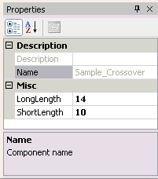
Let's run the changed strategy. Click the "Build" button in the main toolbar and make sure that the CrossoverProject was built successfully. Click the "Start" button.

When finished, please take a look at Order Manager: Data -> Order Manager.
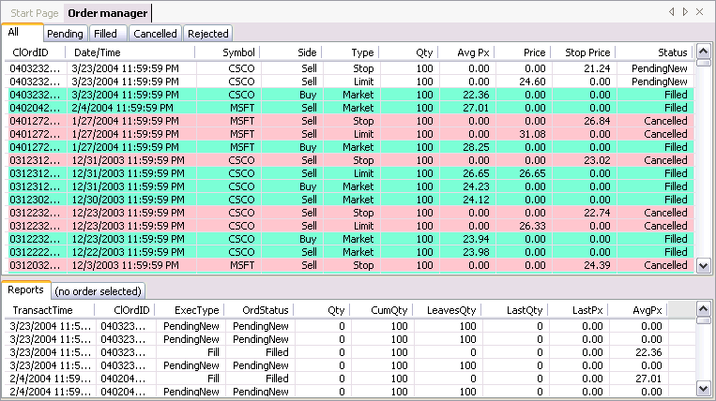
Here you can see all orders produced by the MetaStreategy. Two orders are still have the PendingNew status, while others are Filled or Cancelled. You can find more information about order's statuses in "Order Status" topic.

Let's look at the BarChart:
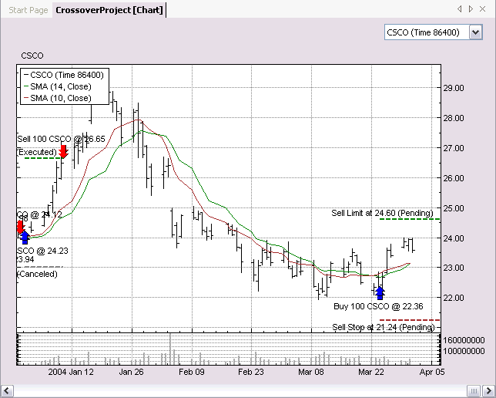
In the BarChart window you can see those two Pending orders.

Second addition we want to do is to add ability to close positions when the defined time expires. These ability is provided by an ATSStop object. There are several types of ATSStops: Fixed, Trailing, Time and two modes: Absolute and Percent. To get detailed information about ATSStops see "Using Stops" topic. We will use ATSStop with Time type. All ATSStops raise StopExecuted event, which is handled by the Strategy and the OnStopExecuted method is called. You could override it to implement your logic there. Look at the following code block:
public override void OnPositionOpened()
{
stop = base.SetStop(Clock.Now.AddDays(15));
}

public override void OnStopExecuted(ATSStop stop)
{
marketOrder = MarketOrder(Side.Sell, qty);
marketOrder.Text = "Stop Exit";
marketOrder.Send();
}
The OnPositionOpened method will cause setting a Stop when a Position becomes opened. A Time Stop will raise the StopExecuted event, when the stop will be active more than 15 days. As you can see the "Clock.Now" property is used. The Clock.Now corresponds to the current time of the Framework. This time always shows a usual System time, but during simulation Clock.Now shows the time of the last emitted object by the Simulator. You can find more detailed information about Clock object in the "SmartQuant Clock" topic. Simulator is described in "Simulator" topic.

Note, that stops are set on a specific position. You can manually define a position on which a stop is set. But any stop is set on the current opened position by default. This position can be accessed using "Position" property of ATSComponent. Besides, any stop will become canceled when corresponding position becomes closed.

So, final version of our Sample_Crossover component looks like following:
using System;
using System.ComponentModel;
using System.Drawing;
using SmartQuant;
using SmartQuant.Indicators;
using SmartQuant.Series;
using SmartQuant.Data;
using SmartQuant.Optimization;
using SmartQuant.FIX;
using SmartQuant.Instruments;
using SmartQuant.Trading;
using SmartQuant.Execution;
[StrategyComponent("{caed84ca-284b-4e18-aaea-a9363efb7310}", ComponentType.ATSComponent , Name="Sample_Crossover", Description="")]
public class Sample_Crossover : ATSComponent
{
int qty = 100;

SMA longSMA;
SMA shortSMA;

int longLength = 14;
int shortLength = 10;

int OCACount = 0;

bool entryEnabled = true;

SingleOrder marketOrder;

SingleOrder limitOrder;
SingleOrder stopOrder;

ATSStop stop;

[OptimizationParameter(10, 30, 3)]
public int LongLength
{
get { return longLength; }
set { longLength = value; }
}

[OptimizationParameter(10, 30, 3)]
public int ShortLength
{
get { return shortLength; }
set { shortLength = value; }
}

public override void Init()
{
longSMA = new SMA(Bar, longLength);
shortSMA = new SMA(Bar, shortLength);

longSMA .Color = Color.Green;
shortSMA.Color = Color.Brown;

Draw(longSMA , 0);
Draw(shortSMA, 0);
}
public override void OnBar(Bar bar)
{
ECross cross = shortSMA.Crosses(longSMA, bar.DateTime);
if (entryEnabled)
{
if (cross == ECross.Above)
{
SingleOrder marketOrder = MarketOrder(Instrument, Side.Buy, qty);

marketOrder.Text = "Buy";
marketOrder.Send();

limitOrder = LimitOrder(Side.Sell, qty, 1.1 * bar.Close);
limitOrder.OCAGroup = "OCA " + Instrument.Symbol + " " + OCACount;
limitOrder.Text = "Limit OCA " + OCACount;
stopOrder = StopOrder(Side.Sell, qty, 0.95 * bar.Close);
stopOrder.OCAGroup = "OCA " + Instrument.Symbol + " " + OCACount;
stopOrder.Text = "Stop OCA " + OCACount;
limitOrder.Send();
stopOrder .Send();
OCACount++;

entryEnabled = false;
}
}
else
{
if (cross == ECross.Below)
{
SingleOrder marketOrder = MarketOrder(Instrument, Side.Sell, qty);

marketOrder.Text = "Sell";
marketOrder.Send();
}
}
}

public override void OnPositionClosed()
{
// cancel OCA
if (!(limitOrder.IsFilled || limitOrder.IsCancelled))
limitOrder.Cancel();
// can entry again now
entryEnabled = true;
}

public override void OnPositionOpened()
{
stop = base.SetStop(Clock.Now.AddDays(15));
}

public override void OnStopExecuted(ATSStop stop)
{
marketOrder = MarketOrder(Side.Sell, qty);
marketOrder.Text = "Stop Exit";
marketOrder.Send();
}
}
Now, let's look at stops, that our strategy produces. For that you should open the Stops window. Locate the Strategy1 node in the Solution Explorer window, right-click on it and select View->Stops. The following window will appear:
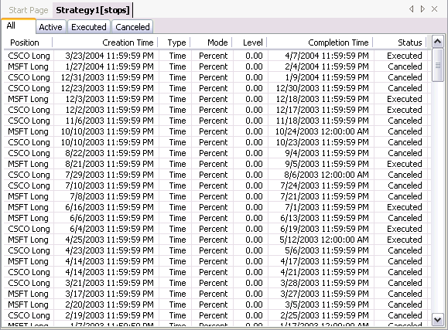
See "Stops Window" for more information about using of the Stop window.

Creating a Strategy
This tutorial will show you how to quickly create a strategy project in the QuantDeveloper IDE.

Creating a new strategy solution
- Go to File->New->Blank Solution
- Name it DemoSolution and click Create
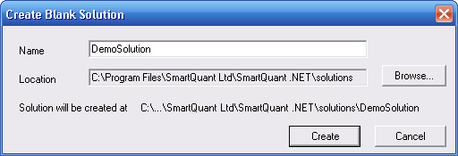
- An empty solution tree in the Solution Explorer window will show up
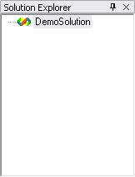
- Right-click on DemoSolution in the Solution Explorer window and click Add New Project...
- Click on MetaStrategy Project, name it DemoStrategyProject and click Create
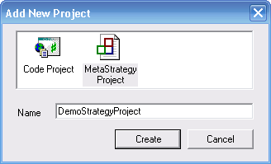
- Expand the DemoSolution tree in the Solution Explorer window, right-click on DemoStrategyProject and click Add New Strategy ...
- Name it Strategy1 and click OK
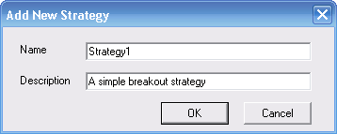
- The new strategy will be added to the Solution Explorer window
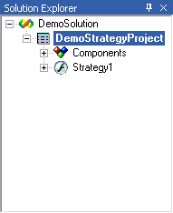

Defining Strategy Components
- Expand the Strategy1 node in the Solution Explorer window.
- Right-click on the Entry component and select Breakout_Entry from the list of available
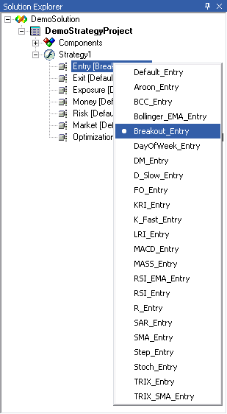
Tip: Optionally you can see the list of available components in the Component Manager. To get there, go to: View->Component Manager and the Component Manager window will show up. Navigate to the Entry node and expand it. You will find Breakout_Entry in there. By double-clicking on the Breakout_Entry component, the Component Code Editor will show up and you will be able to see the code logic for the selected component.
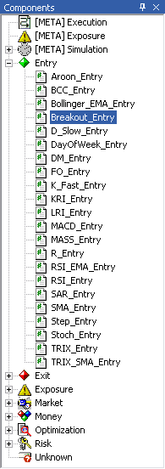
Tip: You can change the component properties in the Properties window. If it is not already open, you can open it by going to View->Properties
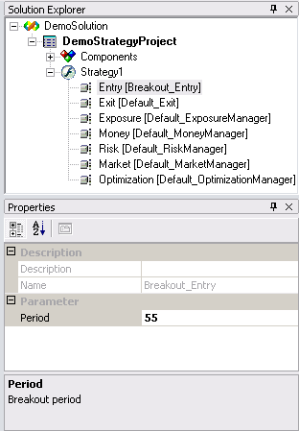
Tip: You can modify the component's source code by double-clicking on the component in the Solution Explorer. This will pop up the Component Code Editor window.
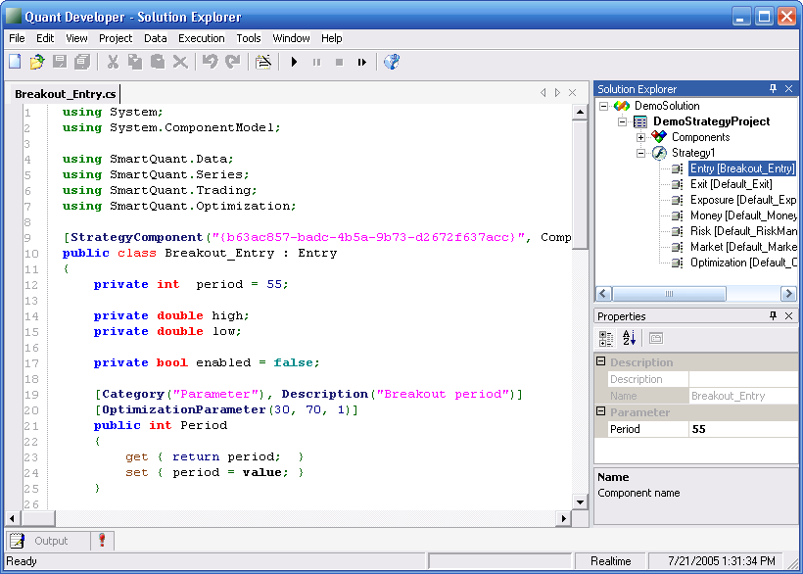
Note that you can not edit default built-in strategy components. You will get the following message box if you try to double-click on a default component:
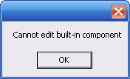
- Select Breakout_Exit as your
- Select Flat_MoneyManager as your
- Select ATR_RiskManager as your
- Select Equity_MarketManager as your
- Expand the Components node, right click on Simulation and select Daily_Simulation from the list
- If the Properties window is not already visible, go to View->Properties to open it up. This will allow you to edit the properties for the Daily_Simulation SimulationManager
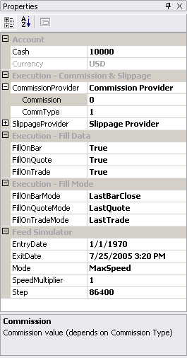
  - Account
    - Cash - amount of Currency allocated to Strategy Portfolio Account when you run the strategy
  - Execution - Commission & Slippage
    - CommissionProvider
      - Commission - commission amount per trade transaction (dollar or percent value depenfing on commission type, see below). Example - set 0.02 and CommType = 1 (per unit) to indicate 2 cents per share per trade commission.
      - CommType - commission type (1 = per unit, 2 = percentage, 3 = absolute)
    - SlippageProvider
      - Slippage - slippage percent amount that will be added to execution price during simulations.
    - Execution - Fill Data
      - FillOnBar - set to true if you would like to use bar (daily or intraday) data to simulate order execution
      - FillOnQuote - set to true if you would like to use quote data to simulate order execution
      - FillOnTrade - set to true if you would like to use trade data to simulate order execution
    - Execution - FillMode
      - FillOnBarMode - select which bar and bar field will be used to simulate order fills (LastBarClose, NextBarOpen, NextBarClose)
      - FillOnQuoteMode - select which quote will be used to simulate order fills (LastQuote, NextQuote)
      - FillOnTradeMode - select which trade will be used to simulate order fills (LastTrade, NextTrade)
    - Feed Simulator
      - EntryDate - start date of the simulation period
      - ExitDate - end date of the simulation period
      - Mode - the feed simulator can run in MaxSpeed or UserDefinedSpeed modes
      - SpeedMultiplier - when the feed simulator runs in the UserDefinedSpeed mode, this parameter indicates speed multiple
      - Step - when the feed simulator runs in the Step Mode (see below), the Step parameter indicates the step length in seconds

Running the Strategy
You can run the strategy using Strategy Build/Run toolbox in the main menu.
The Build button allows you to build active strategy projects to check if all strategy components can be built and run properly. You will see build successful message in the output window if your strategy project was successfully compiled:
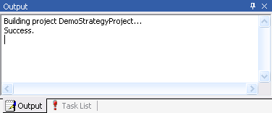
You will see error message in the Output window if there are errors in the strategy component code:
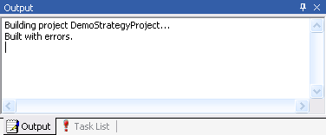
You can find error diagnostics in the Task List window
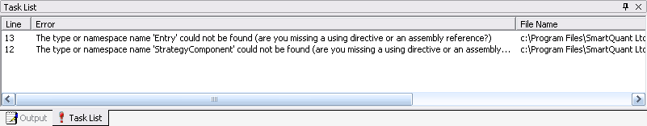
Run the strategy with the Run button , Pause with the Pause Button and Stop with the Stop button . The Step button allows you to run strategy simulations in the debug mode, where the market data simulator runs for a specified time interval (e.g. an hour, a day or a week) and then pauses simulated market data feed, allowing you to inspect current status of the strategy, signals and transactions that have been generated during step interval. You can define the step size by editing properties of the Meta Strategy Simulation Manager component.

You can also run a strategy from MetaStrategy popup menu in the Solution Explorer window
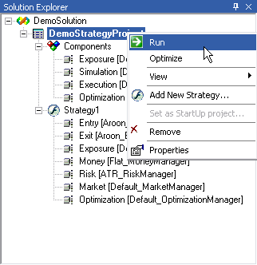
Tip: A running strategy generates a huge amount of information (signals, orders, portfolio transactions and positions, market data, price and indicator charts, performance reports and so on). Updating this information on the screen in real time can drastically slow down simulation speed. Toggle the Freeze GUI button to update this information only once at the end of the strategy simulation run.

Strategy Output
Once you successfully ran the strategy, there are several outputs that will be of interest to you. All of them can be accessed by right-clicking on DemoStrategyProject in the Solution Explorer and going to:
- View->Portfolio
- View->Performance
- View->Tester
- View->Bar Chart
- View->Signal Flow
Portfolio
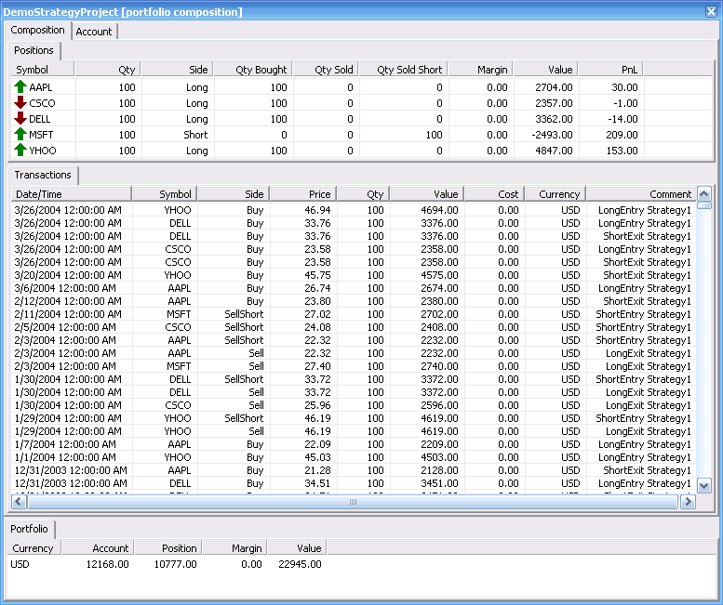
Performance
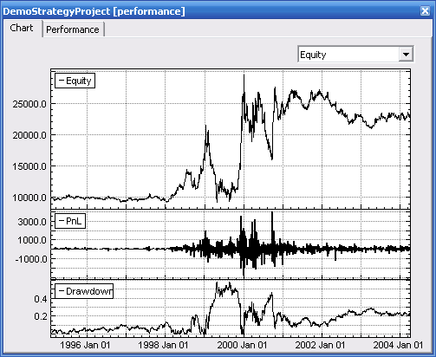
Tester
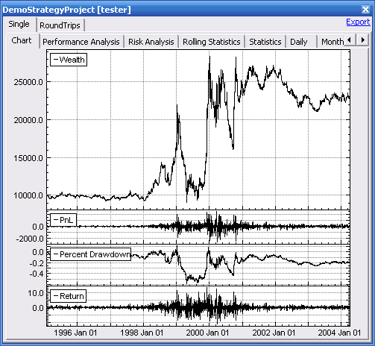
Tip: You can export all the statics generated by the Tester to Excel, by clicking on Export in the upper right corner.
Bar Chart
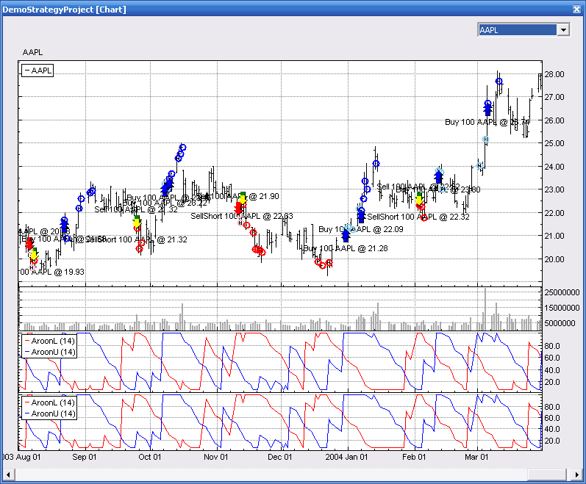
Tip: You can review the signals generated on every instrument by selecting the specific instrument from the combo box in the upper right corner.
Signal Flow
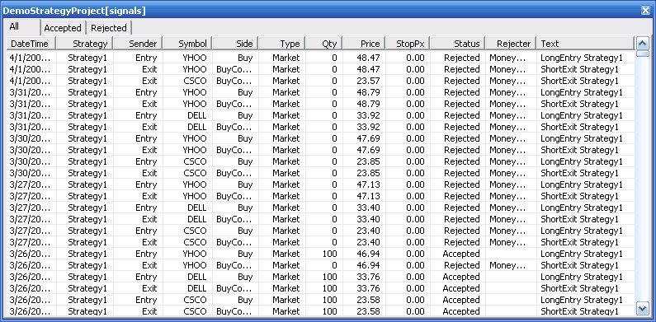

Switch from Backtesting to Live Trading
Assuming that you have successfully developed a trading systems that performs well when backtested, you might now want to take the next step to trade this system live.
Note: Live trading can cause severe financial damage and should only be employed if properly understood.

Live Trading
- Open your MetaStrategy project that you want to trade live
- If the Properties window is not open, go to View->Properties
- Click on MetaStrategy node
- Set MetaStrategyMode to Live in the Properties window
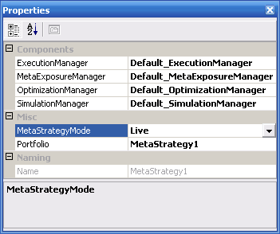
- Expand Components node in the SolutionExplorer tree, and set all components to the default
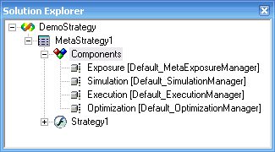
- Click on the Strategy node in the SolutionExplorer tree
- In the Properties window select your DataProvider and ExecutionProvider. We are going to select IB for both here
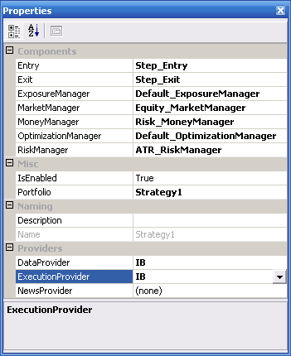
Tip: It is possible to select different Data- and ExecutionProviders. So, for example you could use eSignal as your DataProvider and TT as your ExecutionProvider.
- That's it. Your system is now set up for live trading. As soon as you run your MetaStrategy project, it will start to receive live market data and execute trades via your ExecutionProvider

Paper Trading
If you want to test your system on live market data rather than on historical data but do not want to take the trades in a live trading account, you could do so by selecting Simulator(execution) as your ExecutionProvider in the Strategy Properties window. This will cause the system to evaluate trades based on the live market data of your DataProvider but fills will only be simulated.

Creating a Code (Research) Project
In QuantDeveloper you can either create a MetaStrategy Project or a Code Project.

- Go to File->New->Blank Solution..., enter ResearchSolution in the Name field and hit Create.
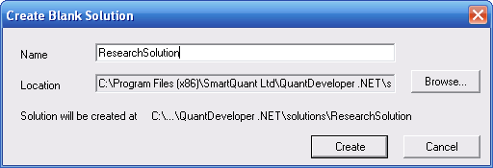
- Go to View->Solution Explorer, right click the ResearchSolution node and click Add New Project... Select Code Project and enter Research1 in the Name field. Hit Create
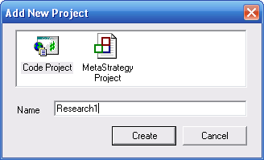
- Expand the Research1 node and double click on StartUp.cs
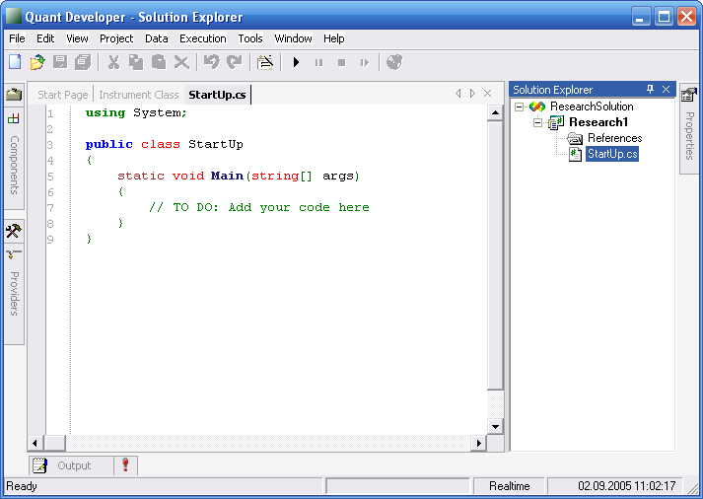
- You can now start adding your code in the class. Of course you can additional class files just as in a Microsoft Visual Studio solution. For this example we are going to add some simple code to draw a TimeSeries chart. Insert the following code in StartUp.cs:
using System;
using System.Windows.Forms;
using SmartQuant.Charting;
using SmartQuant.Series;
public class StartUp
{
static void Main(string[] args)
{
DoubleSeries series = new DoubleSeries("Demo Series");
series.Add(new DateTime(2001, 01, 01), 10);
series.Add(new DateTime(2002, 01, 01), 40);
series.Add(new DateTime(2003, 01, 01), 20);
series.Add(new DateTime(2004, 01, 01), 50);
series.Add(new DateTime(2005, 01, 01), 30);
series.Add(new DateTime(2006, 01, 01), 70);
Console.WriteLine("Min = {0:F2}", series.GetMin ());
Console.WriteLine("Max = {0:F2}", series.GetMax ());
Console.WriteLine("Mean = {0:F2}", series.GetMean ());
Console.WriteLine("Var = {0:F2}", series.GetVariance ());
Console.WriteLine("StdDev = {0:F2}", series.GetStdDev ());
Console.WriteLine("Asymmetry = {0:F2}", series.GetAsymmetry());
Console.WriteLine("Excess = {0:F2}", series.GetExcess ());
series.Print();
Canvas canvas = new Canvas("Time Series Demo", 600, 400);
series.Draw();
Application.Run(canvas);
}
}
- Now run the code project by either clicking the start button or right click on the Research1 node and click Run. Your output should be like this:
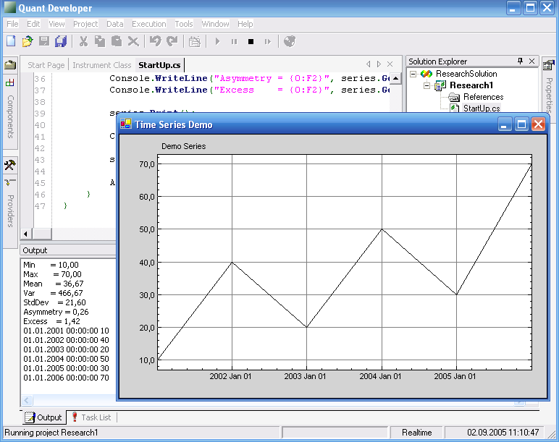
As you can see, this is an easy way to quickly test some code or build a whole research solution with several code projects.
Note: You can also add 3rd party assemblies by right clicking on References->Add References... Then choose the appropriate assembly either from the GAC or from a local file path.
Tip: Make sure to check out the Research solution shipped with QuantDeveloper for more ideas of what you can do.

Microsoft Visual Studio & QuantDeveloper
Since QuantDeveloper IDE is built on top of the QuantDeveloper API and the API are simple .NET assemblies, the API can be fully accessed in a Microsoft Visual Studio Project.

- Create a new Microsoft Visual Studio Console Application (of course you can create any other project type as well, e.g. ASP.NET Web Project, Windows Forms Project, etc.) and call it QuantDeveloperDemo. Hit OK
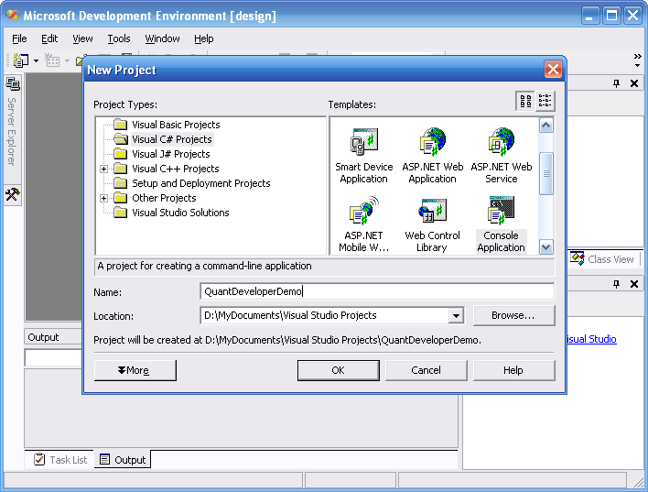
- In the next step you have to add the QuantDeveloper .NET assemblies as references, so you can use them in your MSVS project. Right click on References node in the Solution Explorer and click Add Reference... Click on Browse and navigate to the QuantDeveloper bin folder. This folder is most likely in: C:\Program Files\SmartQuant Ltd\QuantDeveloper .NET\bin
- Now you have to add the assemblies that you need. The assembly that you're always going to need is SmartQuant.dll, and those that you are most likely going to need are: SmartQuant.Data.dll, SmartQuant.Instruments.dll and SmartQuant.FIX.dll. Of course there are many more and you have to add those that you need. Check out the API documentation to see which assembly holds which classes.
- Add some simple code in Class1.cs and run the application
using System;
using SmartQuant;
using SmartQuant.Data;
using SmartQuant.Instruments;
namespace QuantDeveloperDemo
{
/// <summary>
/// Summary description for Class1.
/// </summary>
class Class1
{
/// <summary>
/// The main entry point for the application.
/// </summary>
[STAThread]
static void Main(string[] args)
{
Framework.Init();
foreach(Instrument instrument in InstrumentManager.Instruments)
{
Console.WriteLine(instrument.ToString());
}
Console.ReadLine();
}
}
}
This will output all the instruments that you have in your instrument database.
Note: You always have to call Framework.Init() to initialize the QuantDeveloper framework
Note: If you are working with data from QuantServer, you have to call DataManager.Init() and DataManager.Close()

Microsoft Visual Studio & DemoApp
QuantDeveloper ships with the source code of DemoApp, a sample application built with Microsoft Visual Studio. DemoApp shows you how to develop applications with QuantDeveloper assemblies. Here, we are going to give a quick overview of DemoApp's functionality and how to use it.

Functionality
- Monitor market data (Connecting to a MarketDataProvider, monitoring live data)
- Execution (Send and cancel orders via a ExecutionProvider)
- Portfolio (Shows the use of the Portfolio, monitoring trades)

Usage Guide
Market data
- Open the DemoApp solution in Visual Studio, build and run the project
- Go to Providers tab and expand the Market data node
- Right-click on Simulator(market data) and click Connect. The icon will change to a green checkmark
- Locate the Provider combobox in the upper left and select Simulator(market data) in the dropdown list
- Go to Instruments tab and drag the instrument MSFT into the market data view on the left. Note, that MSFT gets added in the list of sybmols
Note: Simulator(market data) replays data for an instrument from the data series stored in QuantServer. If you have deleted the sample market data that shipped with QuantDeveloper, you will have to choose another instrument for which you have data in QuantServer.
- Go back to the providers tab, select Simulator(market data) again and open its properties, by clicking on next to Simulator in the Misc group
- In the Simulator settings window, locate Intervals, click on
- Click on Add, leave the interval as is and click OK
- Set SimulationMode to UserDefinedSpeed, SpeedMultiplier to 1 and Step 0
- Now click Start. and close the Simulator settings window. You will notice that the instrument MSFT is now showing replayed market data from the market data simulator
Execution
- Go to Providers tab and expand Execution node
- Right-click on Simulator(execution) and click Connect
- Go to Portfolios tab
- Right-click in the white Portfolios tab space and click Add
- Name it SamplePortfolio and click Add
- Go to the Orders tab
- Select Simulator(execution) from the Broker combobox
- Select SamplePortfolio
- Select MSFT from Instrument combobox
- Set Qty to 100 and hit Buy
- You will see how an order is going to be placed
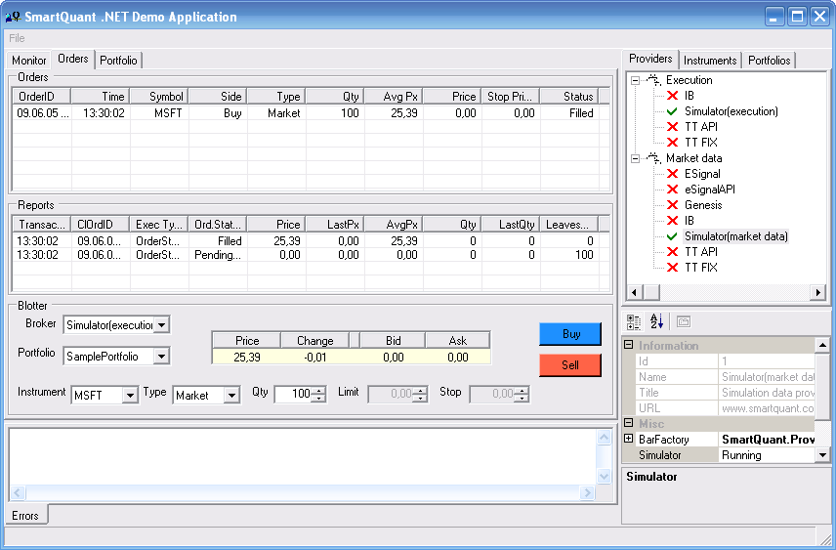
- If you go to Portfolio tab, you will see how the position and transaction is reflected in the portfolio
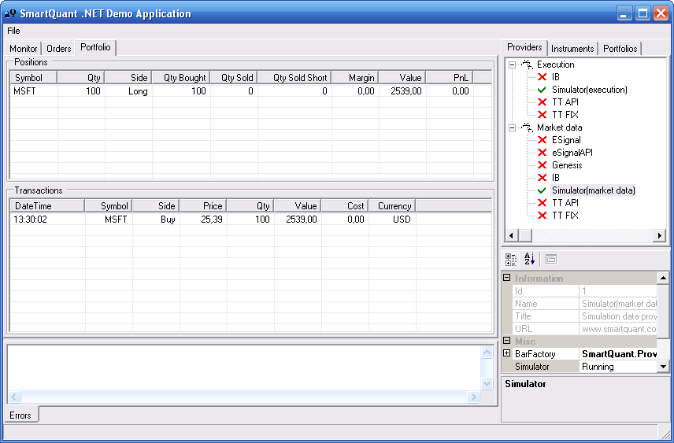

Creating an Indicator
This tutorial will show you how to build and compile your own indicator with Microsoft Visual Studio 2003.
- Open Microsoft Visual Studio 2003
- Go to File->New->Project
- Choose a C# Windows Class Library project
- Name it MyMovingAverage and hit OK
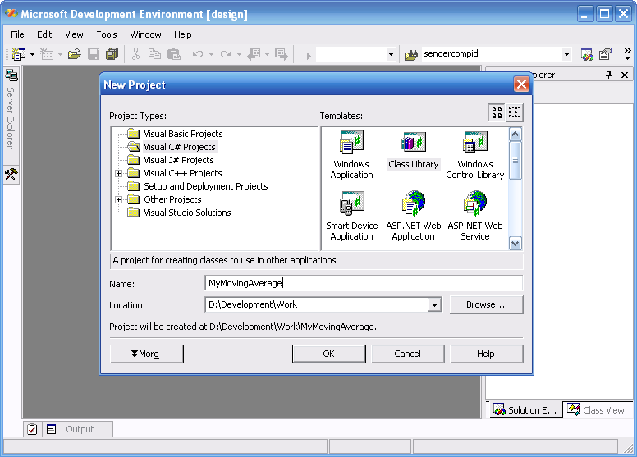
- In the next step you have to add the QuantDeveloper .NET assemblies as references, so you can use them in your MSVS project. Right click on References node in the Solution Explorer and click Add Reference.... Click on Browse and navigate to the QuantDeveloper bin folder. This folder is most likely in: C:\Program Files\SmartQuant Ltd\QuantDeveloper .NET\bin
- Now you have to add the required assemblies, which are:
SmartQuant.Indicators
SmartQuant.Data
SmartQuant.Series
- Rename Class1.cs into MyMovingAverage.cs and copy the following code into the class (We are going to use the class for a Simple Moving Average here):
using System;
using System.ComponentModel;
using SmartQuant.Data;
using SmartQuant.Series;
namespace SmartQuant.Indicators
{
// Any Indicator has to inherit from Indicator and implement all required methods and properties.
[Serializable]
public class MySMA : Indicator
{
protected int fLength = 14;
protected BarData fOption = BarData.Close;
// Price option of MySMA
[Category("Parameters"), Description("")]
[IndicatorParameter(1)]
public BarData Option
{
get{ return fOption;}
set{ fOption = value; Init(); }
}
// Length of MySMA
[Category("Parameters"), Description("")]
[IndicatorParameter(0)]
public int Length
{
get{ return fLength;}
set{ fLength = value; Init(); }
}
// Init SMA indicator
protected override void Init()
{
fName = "MySMA (" + fLength + ")";
fTitle = "Simple Moving Average";
fType = EIndicatorType.Price;
Clear();
fCalculate = true;
if (fInput == null)
return;
if (fInput is BarSeries)
fName = "SMA (" + fLength + ", " + fOption + ")";
if (fNameOption == ENameOption.Long)
fName = fInput.Name + " " + fName;
}
// Constructor of MySMA , which calls the Init() method
public MySMA()
{
Init();
}
// This is the normal constructor that one should use when instantiating the SMA.
// The indicator takes a TimeSeries (e.g. a BarSeries) as its input, as well
// as the length in the case of the MySMA to calculate the smooting period.
public MySMA(TimeSeries input, int length, BarData option) : base(input)
{
fLength = length;
fOption = option;
Init();
}
// Same as the constructor above but allows you to specify the BarData that you want
// to work with (e.g. BarData.Close, BarData.Volume, etc.) and also a color for the indicator
public MySMA(TimeSeries input, int length, BarData option, System.Drawing.Color color) : base(input)
{
fLength = length;
fOption = option;
Init();
Color = color;
}
// This constructor additionally allows to set a DrawStyle for the indicator (Bar/Circle/Line)
public MySMA(TimeSeries input, int length, BarData option, System.Drawing.Color color, EDrawStyle drawStyle) : base(input)
{
fLength = length;
fOption = option;
Init();
Color = color;
DrawStyle = drawStyle;
}
// This constructor only takes the TimeSeries and the length of the smoothing
public MySMA(TimeSeries input, int length) : base(input)
{
fLength = length;
Init();
}
// Calculate MySMAat the specific index
protected override void Calculate(int index)
{
double MySMA= double.NaN;

if (index >= fLength - 1 + fInput.FirstIndex)
{
MySMA = 0;

int syncShift = - (Indicator.SyncIndex ? 0 : 1) * 2 * fLength;

if (index >= fLength - 1 + fInput.FirstIndex)
for(int i = index; i >= index - fLength + 1; i--)
MySMA += fInput[i, fOption] / fLength;
else
MySMA = this[index - 1 + syncShift] + (fInput[index, fOption] - fInput[index - fLength, fOption]) / fLength;
}
Add(fInput.GetDateTime(index), MySMA);
}
// Calculate MySMA for the specific instance of TimeSeries, index, length and price option
public static double Value(TimeSeries input, int index, int length, BarData option)
{
if (index >= length - 1 + input.FirstIndex)
{
double MySMA = 0;
for(int i = index; i >= index - length + 1; i--)
MySMA += input[i, option];
return MySMA / length;
}
else
return double.NaN;
}
// Calculate MySMA for the specific instance of DoubleSeries, index and length
public static double Value(DoubleSeries input, int index, int length)
{
return Value(input, index, length, BarData.Close);
}
// Recalculate MySMA indicator, when new item added to input TimeSeries.
// If index of the new bar is less then input.Count - 1, than MySMA must be recalculated in the interval
// from new bar index to the new bar index minus 1 plus length.
public override void OnInputItemAdded(object sender, DateTimeEventArgs EventArgs)
{
if (fMonitored)
{
int index = fInput.GetIndex(EventArgs.DateTime);
if (index != -1)
for(int i = index; i <= Math.Min(fInput.Count - 1, index + fLength - 1); i++)
Calculate(i);
}
}
}
}
- Compile the indicator by going to Build->Build MyMovingAverage
- Open QuantDeveloper and go to Tools->Configuration->References->User Defined->Add. Locate the newly compiled MyMovingAverage.dll, select it and click OK. It will show up in the user defined references. Make sure that it is checked.
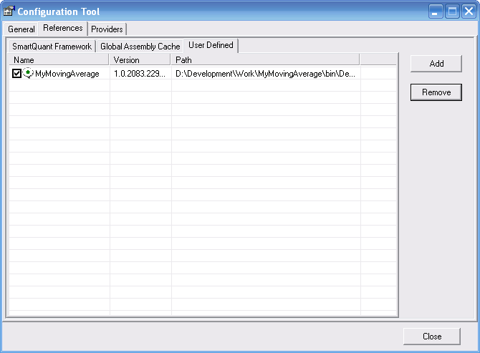
- Click Close
Your indicator is now ready for use in QuantDeveloper. To use it you have to access it as MySMA. For further reference on how to use indicators in QD look at: Using Indicators (IDE)

Sending Orders
The concepts of sending orders in Strategy and ATSStrategy are different. While in ATSStrategy you can create and send orders directly, in Strategy's Entry and Exit components you could only send a Signal, which represents an order to send. Let's consider these concepts in more details.

Sending orders in Strategy.

Common mechanism of sending orders could be represented by following table

 | Action | Components
1 | Creating and sending Signals | Entry, Exit
2 | Cusromizing Signals | MoneyManager (RiskManager)
3 | Verifying Signals | ExposureManager
4 | Verifying Signals | MetaExposureManager
5 | Creating and sending Orders | Execution Manager

As it is mentioned above you can't create and send orders directly in Strategy's Entry and Exit components. Instead, you can create a Signal with description of an order to send. This Signal will be validated and modified by several other components. It can even become canceled, so that any order will not be sent. Now let's consider how send Signals.

Each Signal contains 4 main properties:

Type | Market  Stop  Limit  StopLimit
Side | Buy  BuyCover  Sell  SellShort
Size | number of contracts to order
StopPrice | valid only for Stop and StopLimit Signals and defines corresponding Stop level
LimitPrice | valid only for Limit and StopLimit Signals and defines corresponding Limit level
There are two components of Strategy to send signals - Entry and Exit.

Note, that you should not create neither Signals nor Orders manually, instead you should call one of the Entry' or Exit' methods, which will create and send a Signal automatically.

Here is the table, which describes destination of each method for sending orders in Entry and Exit.
Buy | Creates and sends a Signal to buy.
Buy with a price parameter. | Creates and sends a Signal to buy. If the Strategy uses the Simulation Execution provider, then corresponding order will be filled on the specified price.
Buy with FillOnBarMode parameter | Creates and sends a Signal to buy. If the Strategy uses the Simulation Execution provider, then corresponding order will be filled according to the specified FillOnBarMode (The FillOnBarMode property of the Simulation Manager will be ignored for this order).
BuyMarket | Creates and sends a Signal to buy. If the Strategy uses the Simulation Execution provider the order will be filled on the first available market data (trade, quote or the close price of bar).
BuyLimit | Creates and sends a Signal to set a Buy Limit order.
BuyStop | Creates and sends a Signal to set a Buy Stop order.
BuyStopLimit | Creates and sends a Signal to set a Buy Stop Limit order.
Sell | Creates and sends a Signal to sell.
Sell with a price parameter. | Creates and sends a Signal to sell. If the Strategy uses the Simulation Execution provider, then corresponding order will be filled on the specified price.
Sell with FillOnBarMode parameter | Creates and sends a Signal to sell. If the Strategy uses the Simulation Execution provider, then corresponding order will be filled according to the specified FillOnBarMode (The FillOnBarMode property of the Simulation Manager will be ignored for this order).
SellMarket | Creates and sends a Signal to sell. If the Strategy uses the Simulation Execution provider the order will be filled on the first available market data (trade, quote or the close price of bar).
SellLimit | Creates and sends a Signal to set a Sell Limit order.
SellStop | Creates and sends a Signal to set a Sell Stop order.
SellStopLimit | Creates and sends a Signal to set a Sell Stop Limit order.
LongEntry (Entry's specific) | Does the same thing as the Buy method.
ShortEntry (Entry's specific) | Does the same thing as the Sell method.
LongExit (Exit's specific) | Does the same thing as the Sell method.
ShortExit (Exit's specific) | Does the same thing as the Buy method.
SellShort | Does the same thing as the Sell method.

When you call any of the methods described in the table above, Signal is created and starts its way through Strategy and MetaStrategy components.

First of all it goes to the MoneyManager. The GetPositionSize method of the MoneyManager is called, which return a Size for the Signal. You can override this method in your custom MoneyManager. Note, that you could call the GetPositionRisk method of the MoneyManager to receive estimated risk for this Signal and, in dependence of this risk, MoneyManager could decide how many contracts to order. The GetPositionRisk calls the similar GetPositionRisk method of the RiskManager component of the Strategy. You can override it in your custom RiskManager and put there required risk management logic. Let's consider the following example.

MoneyManager:
public class SampleMoneyManager : MoneyManager
{
public override double GetPositionSize(Signal signal)
{
double risk = GetPositionRisk();

if (risk > 0.5)
return 0;
else
return 100;
}
}

RiskManager:

public class SampleRiskManager : RiskManager
{
public override double GetPositionRisk()
{
if (SMV.Value(Bar, 14) / SMA.Value(Bar, 14) < 0.2)
return 1;
else
return 0;
}
}

The SampleRiskManager's GetPositionRisk method returns 1 if a deviation of the price series is too high, or 0 if it's not.

The SampleMoneyManager GetPositionSize method uses this risk to choose the size to return. If the risk is too high it returns 0, which means that it not allow to buy or sell anything. If the risk is relatively low, the GetPositionSize method returns 100, which means that MoneyManager choose to buy or to sell 100 contracts.

Note, that the Default_MoneyManager's GetPositionsSize method returns 0, so you should implement custom MoneyManager or use one of the built-in components in your Strategy. The Default_RiskManager's GetPositionRisk method returns 1.

If the size of the Signal is greater than zero, Signal goes to the ExposureManager component of the Strategy. The Validate method of the ExposureManager is invoked and if it returns true, Signal goes further. Note, that the Default_ExposureManager's Validate method returns true, so you should implement your custom ExposureManager to put a custom logic into Validate method.

If the Strategy's ExposureManager component validates the Signal, the it goes to the MetaStrategy's MetaExposureManager. The Validate method of the MetaExposureManager invoked and if it returns true, Signal goes to the MetaStrategy's ExecutionManager. Note, that the Default_MetaExposureManager Validate method returns true, so you should implement your custom MetaExposureManager to put a custom logic into Validate method.

In the Default_ExecutionManager component the new order is created. Order's properties are filled according to Signal's properties (side, size, limit price etc.) and the order is sent to the Execution Provider. Generally, the Default_ExecutionManager could be used in most MetaStrategy's, so you might not to implement your custom ExecutionManager. For more information about ExecutionManager see "ExecutionManager".

The whole way of the Signal, you created in Entry or Exit, is represented in the following picture:

FAQ

Strategy Development
We are going to discuss strategy development with QuantDeveloper IDE step by step, focusing on every detail of this fascinating process.

Let's assume that we develop our strategy from scratch - we do not have pre-defined components or ready to modify strategy project.

When you start QuantDeveloper for the first time, you will see a layout shown on the screen shot below.. If you have a different layout, you can use View menu to make windows visible and then drag and drop them over the main IDE workspace to create a similar layout.

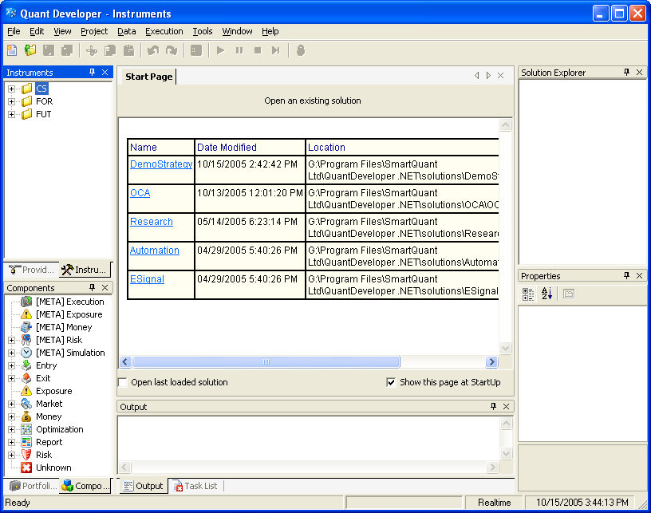

Now we should create a QuantDeveloper solution. A solution is a collection of projects, where each project is a collection of items, such as source code files or strategy components. Solutions allow you to centrally organize all of the projects and files needed to design, develop, and deploy your strategies or applications.

Navigate to File->New->Blank Solution.. in the main menu

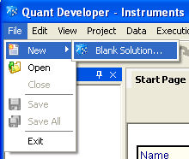

or click New button in the main toolbox pane

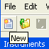

to invoke Create Blank Solution dialog window

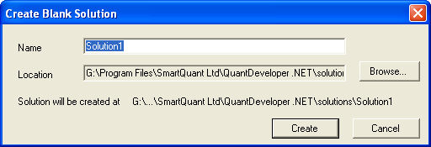

Let's call our first solution MySolution. Type MySolution in the Name text box and click Create or press Enter.

An interface for viewing and managing solution, projects and their associated items, Solution Explorer, is provided as part of the IDE.

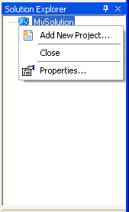

You can see MySolution solution as the root node in the Solution Explorer window. You can see solution properties in the Properties window if you select solution item in the Solution Explorer window.

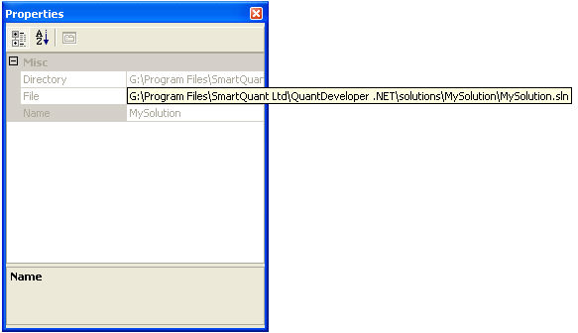

A solution itself is just a container that we need to populate with projects. Right click on the MySolution item in the Solution Explorer. Solution context menu will pop up. Select Add New Project item from the menu.

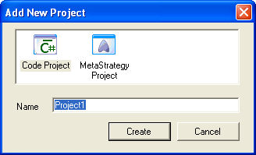

You have an option to select a Code Project or a MetaStrategy Project. A code project is basically a collection of C# code files similar to Microsoft Visual Studio project. You can use code project to develop and run simple programs helping you with your strategy development. That's why we sometimes call code projects "research projects" - they help analyzing historical data in "off-line" mode during initial test phase of your trading ideas. It's possible to have both code projects and metastrategy projects in one QuantDeveloper solution. We actually don't need a code project in our solution at this point but let's create a simple code project to see how it works.

Type MyCodeProject in the Name text box and click Create button or press Enter key. You will see MyCodeProject added to the MySolution tree in the Solution Explorer window.

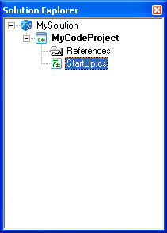

Now it's time for some coding. Double click on the StartUp.cs item in the MyCodeProject. You will see a new editor window in the main QuantDeveloper tab.

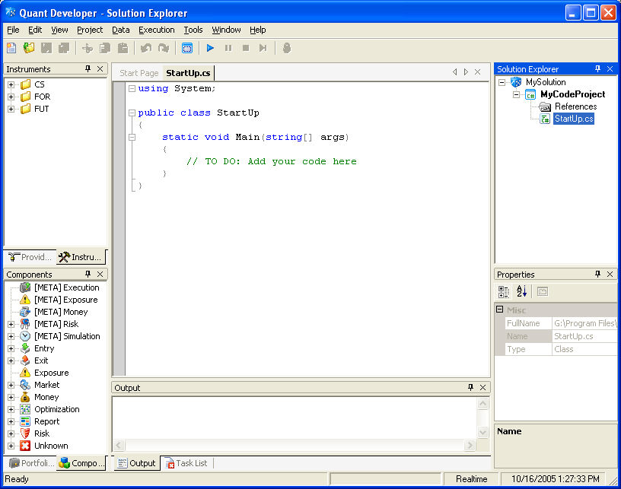

The code is a usual .NET C# program. It has using clause where you can add namespaces (such as SmartQuant.Indicators) which you want to use in your code, and the StartUp class with Main method. Let's start with a standard Hello World! example. Replace TO DO: line with Console.WriteLine("Hello World!");

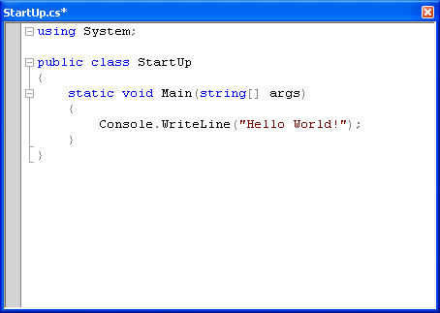

Note intellisense features of QuantDeveloper code editor. When you type a dot after Console, you will get a drop down list with code completion suggestions. The editor also supports syntax highlighting, syntax error checking, code auto-formatting and other helpful features.

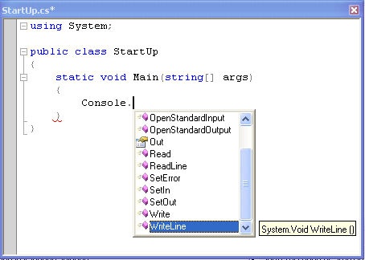

Now we are ready to build and run our project. You can do it in several ways. You can just click the Start toolbox button in the main QuantDeveloper menu

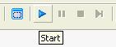

you can select Start in QuantDeveloper Project menu

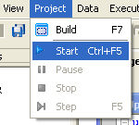

you can press Ctrl-F5 shortcut combination, or you can select Run in the project context menu in the Solution Explorer

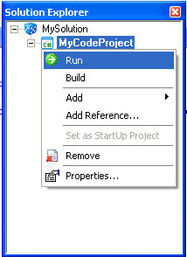

Note that MyCodeProject is shown in bold in the Solution Explorer. This indicates that MyCodeProject is QuantDeveloper current StartUp project. This means that this project will be executed when we press start button in QuantDeveloper IDE. We can have several code projects in one solution. We have three projects: MyCodeProject, MyCodeProject A and MyCodeProject B on the following screen shot

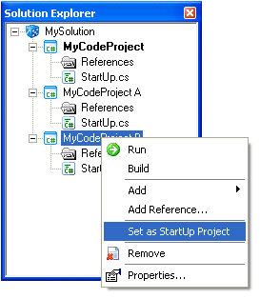
If you click on the MyCodeProject B and select Set as StartUp Project from the context menu, MyCodeProject item will be shown in bold

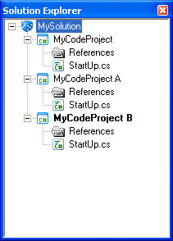

and this project will be executed when you click the Start button.

OK, let's run our project. You will see Building project MyCodeProject and then Running project MyCodeProject messages in QuantDeveloper status bar

You should also see the result of project execution, namely Hello World! text, in the Output window

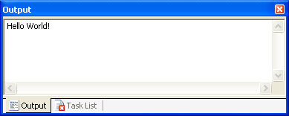

You may want to build the project without running it. This feature is useful when you want to check that your code is written correctly and your project doesn't generate errors during compilation. You can click Build toolbox button in the main menu

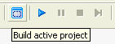

select Build in the main menu

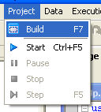

press F7 key or select Build in the project context menu in the Solution Explorer

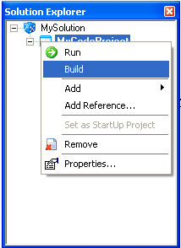

You will see Build with Errors message in the output window

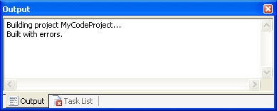

and a list of error messages in the Task List window

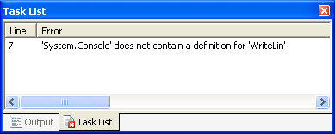

if your project can not be built. You can double click on the error line in the Task List window to navigate to the corresponding line in the Code Editor window.

QuantDeveloper compiles code and strategy projects into .NET executable assembly in memory and then runs this assembly. This means that there is no performance loss comparing to ordinary Windows executable - QuantDeveloper runs compiled code, not a pseudo-executable or line by line interpreted script.

A powerful feature of QuantDeveloper Code Projects is that their transparent interaction with the framework and development environment. This means that 1) a code project can access all objects of the framework and b) whenever a code project creates new or changes framework objects, these changes will be immediately reflected in QuantDeveloper IDE. Let's see how it works.

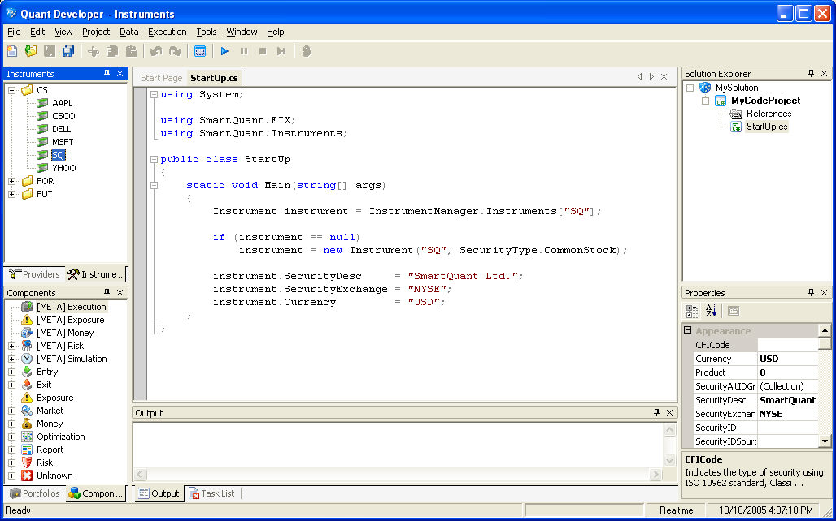

This code checks if there already is an instrument named SQ in the QuantDeveloper InstrumentManager and creates such an instrument (a common stock) if it does not exist. Then the code sets security description, security exchange and currency fields of SQ instrument. This code interacts with the environment and IDE. Firstly, it requests a list of available instruments from the InstrumentManager. These instruments were loaded during QuantDeveloper startup and you can see them in the Instruments window. Secondly, it creates a new instrument and sets its property. After you run the code, you will see SQ instrument in CS folder in the Instruments window. click on SQ instrument in the Instrument window and view SQ properties in the Properties window.

Strategy Project

How to set DateTime Format in Import Wizard
Let's consider how, for example, the 25th November of 2004 could be represented in several formats

DateTime | Format
25-11-2004 | dd-MM-yyyy
25/11/2004 | dd/MM/yyyy
25-11-04 | dd-MM-yy
25/11/04 | dd/MM/yy
25112004 | ddMMyyyy
251104 | ddMMyy
25 11 2004 | dd MM yyyy
11-25-2004 | dd-MM-yyyy
11-25-04 | dd-MM-yy
11252004 | ddMMyyyy
25/Nov/2004 | dd/MMM/yyyy
25-Nov-04 | dd-MMM-yy
04-25-Nov | yy-dd-MMM
25 Nov 2004 | dd MMM yyyy

The following example shows several formats for intraday data. It describes how 25th November of 2004 15:04 could be represented in different formats

DateTime | Format
25-11-2004 15:04 | dd-MM-yyyy HH:mm
25-11-2004-15-04 | dd-MM-yyyy-HH-mm
25/11/2004/15:04 | dd/MM/yyyy/HH:mm
11-25-2004 15:04 | MM-dd-yyyy HH:mm
11-25-2004-15-04 | MM-dd-yyyy-HH-mm
11/25/2004/15:04 | MM/dd/yyyy/HH:mm
25 Nov 04 15:04 | dd MMM yy HH:mm
Nov 25 04 15 04 | MMM dd yy HH dd
15:04 25 Nov 2004 | HH:mm dd MMM yyyy
25-11-2004 03:04 PM | dd-MM-yyyy hh:mm tt
25-11-2004 3:40 PM | dd-MM-yyyy h:mm tt
25-11-2004 3:4 PM | dd-MM-yyyy h:m tt

For more information about DateTime formats see "DateTime formats".

