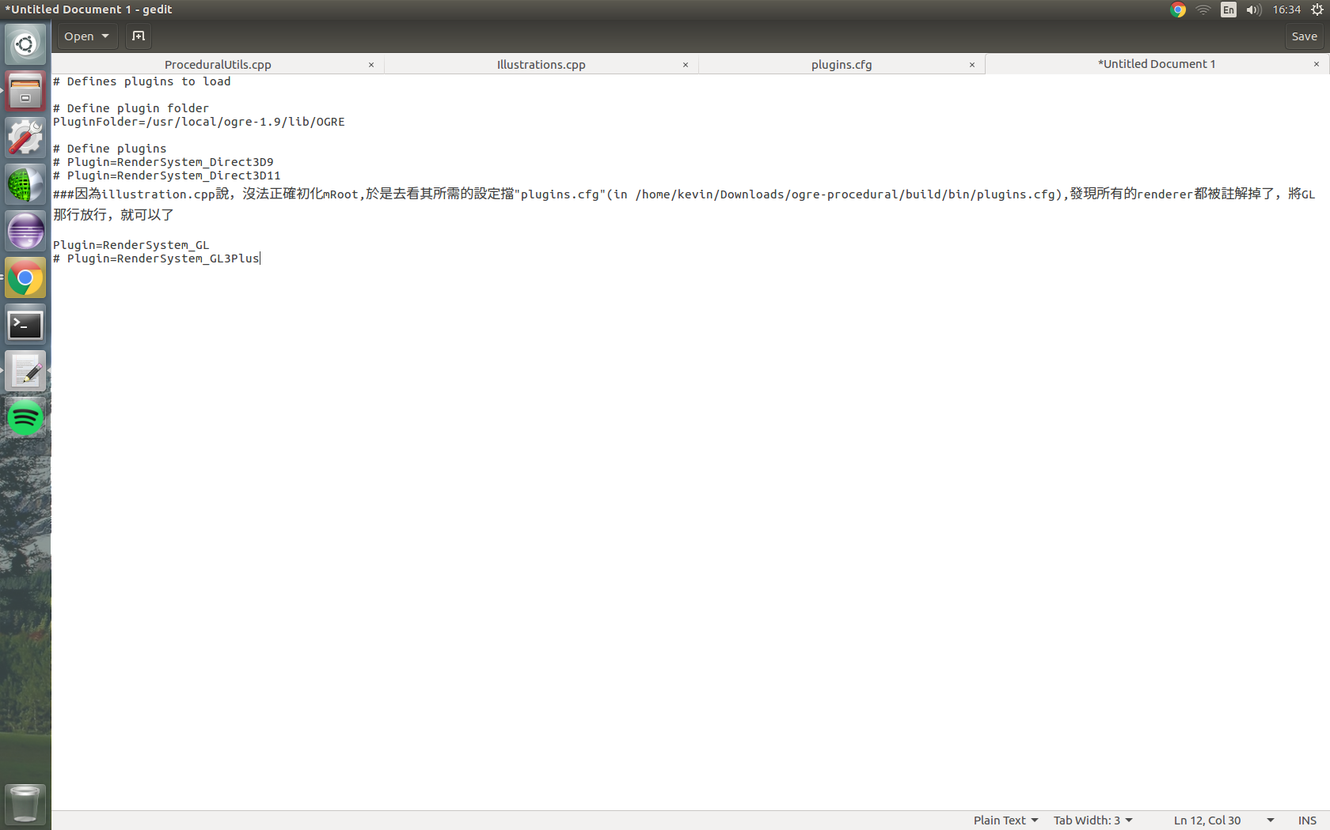
Ogre-Procedural building tips:

