**Domain Model**

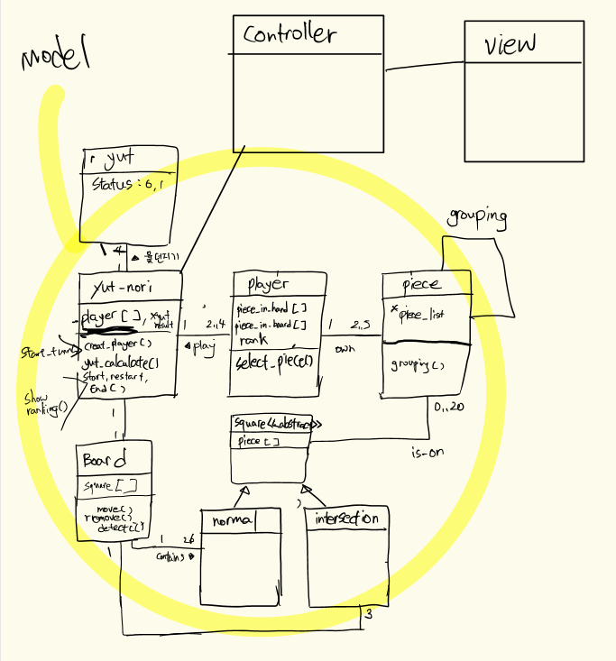

**Class Diagram**



**Sequence Diagram**



Goal-in

Not goal-in

playnum || piecenum

!(playnum || piecenum)

**State Chart**

