**Methodology Summary**

In this exercise we implement matching logic and Dutch auction logic for Everclear.

* Proof-of-concept style implementation due to lack of real time liquidity data.

Simulation parameters:

* Discount rates in main chain and long tail chain.

Optimization target:

* Minimize daily discount applied to orders (reduce loss and incentivize usage).
* Minimize remaining orders at end of simulation.

In this iteration we just simply present results in both parameters. Can design reward function to find optimal setting from grid search.

Model heuristic:

* Handle different tokens separately in 30-minute incremental epochs.
* For each epoch, aggregate results from previous epoch.
  + Search for cycles to match orders.
  + Match orders greedily. From longest cycle with largest minimal weight, until no cycle found.
* Model clearing of the remaining orders using simple heuristics:
  + Hard code chain slippage (should use real time volume data / model in production).
  + Assume arbitrager purchase token on destination chain and sell on source chain.
  + Slippage for arbitrager = source slippage + destination slippage
  + Arbitrage amount = discount / slippage
* Roll-over remaining orders from epoch to the next, record discount amount.

**Summary results**

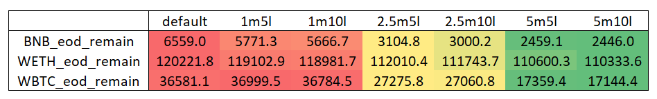

**Discussion**

**Discount rates**

* Discount rates could be a variable parameter depending on liquidity than fixed parameter.
* Fix % of orders we want to clear in each epoch, and backout discount rate from market liquidity.
* Can Everclear handle the market orders?

**Market makers**

* Model assumes arbitrager take source chain token and offer destination chain token.
* If Everclear could find institutional takers on the other side, slippage is reduced in half.

**Monetization**

* Balance sheet of TVL -> how to utilize to increase profitability.