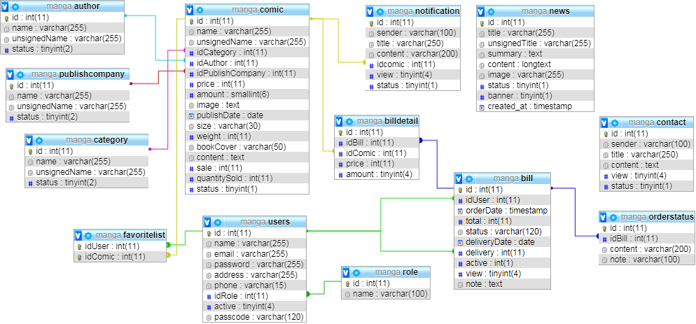

Entity: author

|  |  |  |  |  |
| --- | --- | --- | --- | --- |
| Column Name | Data type | Primary Key | Not Null | Description |
| id | Integer | Y | Y | ID Author |
| name | Varchar (255) | N | Y | Name Author |
| unsignedName | Varchar (255) | N | Y | Unsigned Name Author |
| status | Smallint | N | Y | Show/Hide Author |

Entity: publishcompany

|  |  |  |  |  |
| --- | --- | --- | --- | --- |
| Column Name | Data type | Primary Key | Not Null | Description |
| id | Integer | Y | Y | ID Publishing Company |
| name | Varchar (255) | N | Y | Name Publishing Company |
| unsignedName | Varchar (255) | N | Y | Unsigned Name Publishing Company |
| status | Smallint | N | Y | Show/Hide Publishing Company |

Entity: category

|  |  |  |  |  |
| --- | --- | --- | --- | --- |
| Column Name | Data type | Primary Key | Not Null | Description |
| id | Integer | Y | Y | ID Category |
| name | Varchar (255) | N | Y | Name Category |
| unsignedName | Varchar (255) | N | Y | Unsigned Name Category |
| status | Smallint | N | Y | Show/Hide Category |

Entity: favoritelist

|  |  |  |  |  |
| --- | --- | --- | --- | --- |
| Column Name | Data type | Primary Key | Not Null | Description |
| iduser | Integer | Y | Y | ID Users |
| idtruyen | Integer | Y | Y | ID Comic |

Entity: users

|  |  |  |  |  |
| --- | --- | --- | --- | --- |
| Column Name | Data type | Primary Key | Not Null | Description |
| id | Integer | Y | Y | ID User |
| name | Varchar (255) | N | Y | Name User |
| email | Varchar (255) | N | Y | Email User |
| password | Varchar (255) | N | Y | Password |
| address | Varchar (255) | N | Y | Address |
| phone | Varchar (15) | N | Y | Phone |
| role | Integer | N | Y | Role: Admin, Customer,… |
| active | Smallint | N | Y | Active Account (1: actived, 0: inactive) |
| passcode | Varchar (120) | N | N | Use when change password |

Entity: comic

|  |  |  |  |  |
| --- | --- | --- | --- | --- |
| Column Name | Data type | Primary Key | Not Null | Description |
| id | Integer | Y | Y | id |
| name | Varchar (255) | N | Y | Name Comic |
| unsignedName | Varchar (255) | N | Y | Unsigned Name Comic |
| idCategory | Integer | N | Y | ID Category |
| idAuthor | Integer | N | Y | ID Author |
| idPublishCompany | Integer | N | Y | ID Publishing Company |
| price | Integer | N | Y | price |
| amount | Smallint | N | Y | amount |
| image | Text | N | Y | Image |
| PublishDate | Date | N | Y | Publishing Date |
| Size | Varchar (30) | N | N | Size |
| weight | Integer | N | N | Weight |
| bookCover | Varchar (50) | N | N | Book Cover |
| content | Text | N | N | Content |
| sale | Integer | N | N | Sale |
| quantitySold | Integer | N | Y | Quantity Sold |
| status | Smallint | N | Y | Show/Hide Comic |

Entity: role

|  |  |  |  |  |
| --- | --- | --- | --- | --- |
| Column Name | Data type | Primary Key | Not Null | Description |
| id | Int | Y | Y | ID Role |
| name | Varchar(100) | N | Y | Name Role |

Entity: billdetail

|  |  |  |  |  |
| --- | --- | --- | --- | --- |
| Column Name | Data type | Primary Key | Not Null | Description |
| id | Integer | Y | Y | ID Bill Detail |
| idBill | Integer | N | Y | ID Bill |
| idComic | Integer | N | Y | ID Comic |
| price | Integer | N | Y | Price |
| amount | Smallint | N | Y | Amount |

Entity: bill

|  |  |  |  |  |
| --- | --- | --- | --- | --- |
| Column Name | Data type | Primary Key | Not Null | Description |
| id | Integer | Y | Y | ID Bill |
| idUser | Integer | N | Y | ID User |
| orderDate | Timestamp | N | Y | Order Date |
| total | Integer | N | Y | Total |
| status | Smallint | N | Y | Status Bill |
| deliveryDate | Date | N | Y | Delivery Date |
| delivery | Integer | N | Y | Delivery |
| active | Smallint | N | Y | Active Bill (1: actived, 0: inactive) |
| view | Smallint | N | Y | For Admin (1: seen, 0: not seen |
| note | Text | N | N | Note |

Entity: news

|  |  |  |  |  |
| --- | --- | --- | --- | --- |
| Column Name | Data type | Primary Key | Not Null | Description |
| id | Integer | Y | Y | ID News |
| title | Varchar (255) | N | Y | Title News |
| unsignedTitle | Varchar (255) | N | Y | Unsigned Title |
| summary | Text | N | Y | Summary |
| content | LongText | N | Y | Content |
| image | Varchar (255) | N | Y | Image |
| status | Smallint | N | Y | Show/Hide News |
| banner | Smallint | N | Y | Show News on banner |
| created_at | Timestamp | N | Y | Publish Date |

Entity: notification

|  |  |  |  |  |
| --- | --- | --- | --- | --- |
| Column Name | Data type | Primary Key | Not Null | Description |
| id | Integer | Y | Y | ID |
| sender | Varchar (100) | N | Y | Email Sender |
| title | Varchar (255) | N | Y | Title |
| content | Varchar (200) | N | Y | Content |
| idcomic | Integer | N | Y | ID Comic |
| view | Smallint | N | Y | Seen or not seen |
| status | Smallint | N | Y | Status |

Entity: orderstatus

|  |  |  |  |  |
| --- | --- | --- | --- | --- |
| Column Name | Data type | Primary Key | Not Null | Description |
| id | Integer | Y | Y | ID |
| idBill | Integer | N | Y | ID Bill |
| content | Text | N | Y | Content |
| note | Text | N | N | Note |

Entity: contact

|  |  |  |  |  |
| --- | --- | --- | --- | --- |
| Column Name | Data type | Primary Key | Not Null | Description |
| id | Integer | Y | Y | ID |
| sender | Varchar (100) | N | Y | Email Sender |
| title | Varchar (255) | N | Y | Title |
| content | Varchar (200) | N | Y | Content |
| view | Smallint | N | Y | Seen or not seen |
| status | Smallint | N | Y | Status |