**EE 468**

**Image-Based Plant Disease Classification Challenge**

by

Eray Kuru

Muhammet Hakan Taştan

Yasemin Köse



Faculty of Engineering

Department of Electrical and Electronics Engineering

Istanbul, 2023

Yeditepe University

# ABSTRACT

**Image-Based Plant Disease Classification Challenge**

Agriculture is crucial in nations that are developing, but food security is still a major concern. Most harvests are lost owing to a lack of storage facilities, transporting, and plant diseases. Diseases kill more than 15% of crops, making it one of the most pressing issues to address. There is a need for an automated system that can identify these illnesses and assist farmers in taking proper actions to recover from crop loss. Farmers have used the conventional approach of detecting plant illnesses with the naked eye, and not all farmers can identify these diseases in the same way. With the advancement of Artificial Intelligence, there is a need to apply computer vision capabilities into the agricultural area. Deep Learning's vast libraries, as well as the user and developer pleasant environment in which to work, all contribute to Deep Learning being the preferred way for getting started with this topic. In this article, we chose Deep Learning because of the benefits it provides when working with photos, particularly image classification, to get better outcomes. The process entails labelling contaminated crop leaves according to disease pattern. Images of contaminated leaves are analysed, and pixel-based techniques are used to increase the image's information. The following phase is feature extraction, followed by picture segmentation, and lastly crop disease classification based on patterns recovered from diseased leaves. CNN is utilized for illness classification; for instance, a typical data set consisting of roughly 50 thousand images (RGB type images) including healthy and sick leaves is employed. This project employs the Inceptionv3 model. When we trained the model after pre-processing, we attained a high accuracy of 99.13% and validation accuracy 98.33%.

**Table of Contents**

ABSTRACT 2

LIST OF FIGURES 4

LIST OF TABLES 5

LIST OF SYMBOLS/ABBREVIATIONS 6

1. INTRODUCTION 1

2. LITERATURE REVIEW 4

3. PROPOSED WORK 6

4. EXPERIMENTAL RESULTS 10

5. CONCLUSION AND FEATURE WORK 13

6. REFERENCES 14

# LIST OF FIGURES

Figure 1 Plant Diseases 1

Figure 2 Workflow 8

Figure 3: Train Loss Plot 10

Figure 4: Train Accuracy Plot 11

Figure 5: Validation Loss Plot 12

Figure 6: Validation Accuracy Plot 12

Figure 7: Comparison of Loss Plot 12

Figure 8: Comparison of Accuracy Plot 12

# LIST OF TABLES

Table 1: Training data randomly separated to train, validation and test 7

Table 2: Performance Table 11

# LIST OF SYMBOLS/ABBREVIATIONS

|  |  |
| --- | --- |
| CNN | Convolutional Neural Network |
| RGB | Input matrix |
| KNN | K-nearest Neighbour |
| FLD | Fisher Linear Discriminant |
| ANN | Artificial Neural Network |
| RF | Random Forest |
| SIFT | Scaler Invariant Feature Transform scalar |
| WDD2017 | Wheat Disease Database 2017 |
| *ReLU* | Rectified Linear Unit |
|  |  |
|  |  |

# INTRODUCTION

Plant diseases have a severe impact on agricultural productivity, and if plant diseases are not recognized in time, food insecurity will develop. The primary crops, in particular rice, maize, and so on, are critical for ensuring food supply and agricultural productivity. Early warning and forecasting are the foundations of efficient plant disease prevention and management. They serve critical roles in agricultural production management and decision-making. Until date, however, visual observations of experienced producers have been the major method for plant disease identification in rural parts of poor nations; this, nevertheless, necessitates ongoing monitoring of specialists, which may be prohibitively expensive in big farms. Furthermore, in certain isolated places, farmers may have to travel significant distances to get professionals, making advice extremely expensive and time-consuming. Nonetheless, this technique is restricted in scope and cannot be widely applied. Automatic detection of plant illnesses is an important study issue because it has the potential to benefit enormous fields of crops by automatically detecting disease signs as soon as they occur on plant leaves. As a result, finding for a rapid, automated, less expensive, and accurate technique to identify plant diseases is quite important.

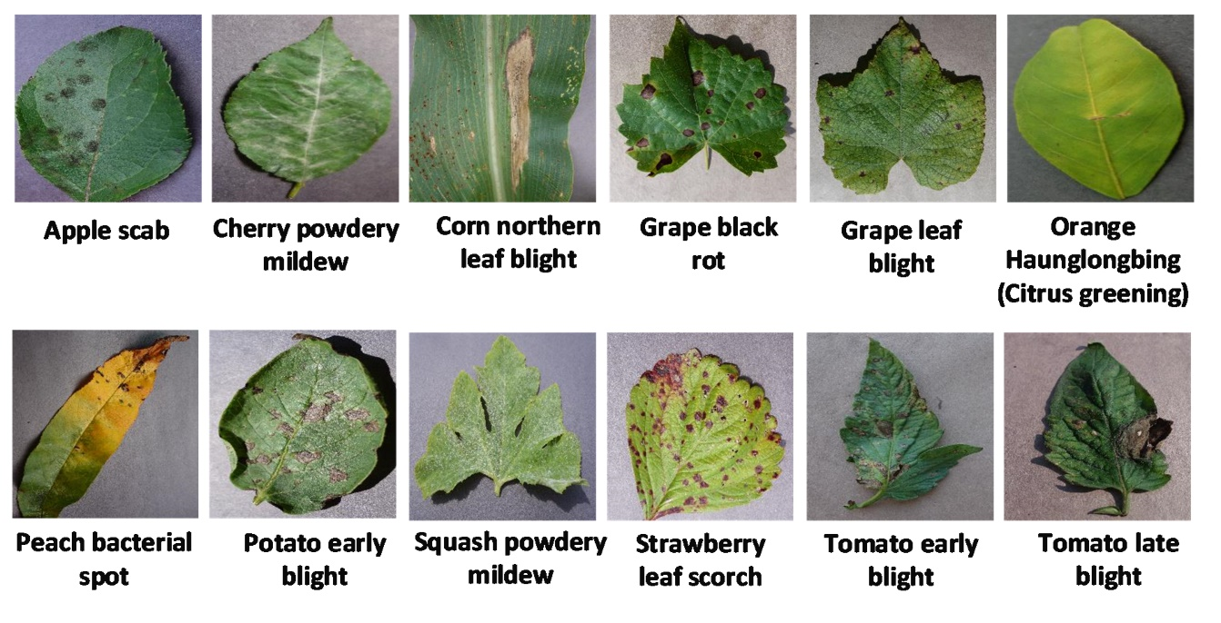

Figure 1 Plant Diseases

A specific classifier is utilized to categorize the photos into those that are healthy or those that are unhealthy. A lot of earlier works have examined image recognition. The symptoms of the majority of plant illnesses may begin to show on the leaves, which are typically the first place to look for them when identifying a disease in a plant. For identifying plant diseases in the past, KNN, SVM, FLD, ANN, RF, and other fundamental classification approaches were often utilized. As everyone is aware, lesion segmentation and hand-designed features using various algorithms, such as seven invariant moments, SIFT, Gabor transform, global-local singular value, and sparse representation, etc., play a significant role in the disease detection rates of conventional techniques. The traits that were intentionally created, however, need both expensive labor and specialized expertise, both of which are somewhat subjective.

In general, it might be challenging to select from the large number of retrieved traits the ones that are best and most reliable for illness detection. Additionally, most approaches are unable in successfully separating the leaf and associated lesion picture from its backdrop when the background is complex, which will produce erroneous disease detection results. As a result, due to the intricacy of photos of damaged leaves, automated detection of plant disease images remains a difficult issue.

CNNs, in particular, have lately emerged as the go-to strategies for overcoming a number of difficulties. For image identification in both big and little issues, CNN is the most often used classifier. It has demonstrated exceptional proficiency in image processing and categorization. To identify 14 crop species and 26 agricultural illnesses, for instance, Mohanty, Hughes, and Marcel developed a deep learning model. On a held-out test set, their trained model had a 99.35% accuracy rate. Four cucumber diseases, downy mildew, anthracnose, powdery mildew, and target leaf spots, were identified symptomatically by Ma et al. using a deep CNN. They succeeded in achieving a 93.4% recognition accuracy. In order to identify cucumber leaf disease, Kawasaki et al. developed a system based on CNN; it achieves an accuracy of 94.9%, etc. Investigations to date have employed picture datasets with little diversity, despite the fact that extremely positive results have been published in the literature. The majority of photography resources only show photographs in controlled environments rather than in the natural world. Images taken in cultivation field circumstances do, in fact, feature a broad variety of backgrounds and a vast array of symptom features. Additionally, a sizable number of parameters must be taught for CNN and its variations, and evaluating the performance of these CNN architectures takes several labelled samples and a sizable amount of computing power.

This report is divided into three sections, one for the literature study and the other for the technical and practical aspects of the project. Therefore, the first part focuses on generalizations and information obtained from literature research. In the next section, defining the data set under the proposed working title, after information about the models and techniques used, the data processing process will be discussed. In the next part, the results obtained from the used model will be compared with the accuracy graphs and loss graphs, and the results will be shown and discussed. The last part is the final part, and if it is here, are the results we have obtained satisfactory enough to solve your problem? Which part of your work is not good enough and why? Satisfactory/insufficient parts will be discussed.

# LITERATURE REVIEW

We examine preliminary related work in plant leaf disease detection in this part, concentrating on major techniques and breakthroughs. Papers made in the literature on plant leaf disease detection will be discussed below.

In the paper, the author describes an in-field automatic wheat disease diagnosis system based on a weekly supervised deep learning framework, i.e., deep multiple instance learning, which integrates identification for wheat diseases and localization for disease areas with only image-level annotation for training images in natural conditions. In order to confirm the efficiency of our approach, a fresh infield image collection for wheat disease called Wheat Disease Database 2017 (WDD2017) is gathered. Our system outperforms two conventional CNN frameworks, namely VGG-CNN-VD16 and VGG-CNN-S, which achieve mean recognition accuracies of 93.27% and 73.00% respectively under two different architectures, namely VGG-FCNVD16 and VGG-FCN-S.

In a different article, the author demonstrated how convolutional neural network models were created utilizing deep learning techniques to conduct plant disease identification and diagnosis using straightforward photos of healthy and sick leaves. An open database including 87,848 photos and 25 different plant species in 58 different classes of [plant, illness] pairs, including healthy plants, was used to train the models. The best model architecture out of the ones that were trained was able to identify the matching [plant, illness] pair (or healthy plant) with a success percentage of 99.53%. The model's extremely high success rate makes it a very valuable advising or early warning tool, and it is a strategy that might be developed further to enable an integrated plant disease diagnosis system that can function under actual cultivation circumstances.

Artificial neural network technology and a variety of image processing techniques are used by the author of paper to provide a methodology for early and precise plant disease identification. The suggested method produces superior results with a recognition rate of up to 91% since it is based on an ANN classifier for classification and a Gabor filter for feature extraction. An ANN-based classifier employs a mix of textures, colors, and characteristics to categorize various plant diseases and identify them.

Li and He chose five different apple leaf illnesses to study: rust disease, yellow leaf disease, round spot disease, and speckled deciduous disease. by taking the apple leaf spot image's eight qualities, including its color, texture, and form. The disorders were categorized and identified using the BP neural network model, and the average identification accuracy was 92.6%. [1]

Guan et al. used step-based discriminant analysis and the Bayesian discriminant method to classify and identify three rice diseases (blast, stripe blight, and bacterial leaf blight), with the highest recognition accuracy of 97.2%. They also extracted 63 parameters from rice leaf disease spots, including morphology, color, and texture features. [2]

# PROPOSED WORK

Convolutional neural networks (CNNs) are a potent class of deep learning neural networks noted for their outstanding performance in image recognition tasks. We decided to employ CNNs in our project for the following reasons:

CNNs have revolutionized the field of image recognition due to their superior ability to analyse visual data. They are frequently used in tasks like image classification, object detection, and segmentation, significantly advancing the field. Unlike many other image classification algorithms, CNNs require very little pre-processing of the input data. They can learn and extract features directly from raw images without the need for custom filters or time-consuming pre-processing steps. This trait streamlines and enhances development effectiveness.

Processing 2D image data is an excellent application for CNNs since they use 2D convolutional layers. These layers' efficient convolutional operations effectively capture regional patterns and spatial dependencies, enabling the network to learn hierarchical representations of the images. CNNs are widely used in various tasks and industries, including image and video recognition, image classification, recommender systems, natural language processing, and medical image analysis. Their adaptability makes them a popular choice in many industries.

CNNs consist of different types of layers, including the input layer, output layer, and hidden layers. Convolutional, ReLU, pooling, and fully connected layers are commonly found as hidden layers in CNNs. Convolutional layers apply convolutional operations to the input data to extract useful features, which are then passed on to the following layers.

The introduction of non-linearity by ReLU layers enables the network to learn intricate relationships between features. Pooling layers combine the outputs of groups of neurons into a single neuron, reducing the number of spatial dimensions while preserving critical information. Fully connected layers link every neuron in one layer to every neuron in the following layer, facilitating high-level feature learning and decision-making.

In a convolutional layer, neurons only receive input from a particular local receptive field within the preceding layer. This localized connectivity allows the network to focus on capturing local patterns and interactions within the image. In contrast, fully connected layers create connections between every neuron in one layer and every neuron in the following layer, enabling global connectivity. This integration of information from all the neurons in the previous layer enables higher-level abstractions and complex decision-making.

In our project implementation, we aimed to take advantage of CNNs' strong image recognition capabilities, effective processing of 2D images, and adaptability to various tasks. We utilized CNNs, specifically the Inception v3 model, and leveraged the features learned up until the mixed7 layer.

## DETAILED INFORMATION

Training dataset contains 29 different classes. Validation and test set were randomly selected from the training dataset. ImageDataGenerator was used to normalize and augment the dataset. It was normalized with Rescale and, rotation, zoom, flip values were determined. The 256 x 256 format of the images has not been changed because in order to avoid data loss. Training set consists of 31231 images belonging to 39 classes. The validation set consists of 10407 images belonging to 39 classes. The test set consists of 10407 images belonging to 39 classes.

|  |  |
| --- | --- |
|  | Number of samples |
| Training set | 31231 |
| Validation set | 10407 |
| Test set | 10444 |

Table 1: Training data randomly separated to train, validation and test

In our project, two specific activation functions were used: ReLU and Sigmoid. Regarding the loss function, Categorical Crossentropy was selected. By using ReLU and Sigmoid as activation functions and Categorical Crossentropy as the loss function, our project leverages these tools to ensure effective learning, handle non-linearity, and optimize the model's performance in image recognition tasks.

## WORKFLOW

Figure 2 Workflow

**Training Data Separation**:

The images of plant diseases that make up the training data are randomly divided into three sets: train, validation, and test. The validation set is used to fine-tune hyperparameters and monitor model performance during training, while the test set is used to assess the trained model's final performance. The training set is used to train the model.

**Encoding Class Labels**:

The classification labels for plant diseases are encoded as numerical values. The majority of machine learning models, including CNNs, demand numerical inputs, so this is essential. To represent each distinct class label, a distinct numeric value is given.

**Normalization and Augmentation**:

In order to make model training easier, the images in the training set are pre-processed using normalization techniques, which typically entail scaling the pixel values to a specific range (for example, [0, 1]). The diversity and volume of training data are frequently increased through the use of data augmentation techniques. The use of random flips, zooms, rotations, and other transformations on the images is one type of augmentation technique.

**Initialization of the Model Architecture**:

Up until the mixed7 layer, the Inception v3 model is initialized. This entails setting up the model's layers, connections, and parameters in accordance with Inception v3's predefined architecture. A specific stage in the model where features are learned and extracted is represented by the mixed7 layer.

**Loss Function and Optimizer Selection**:

A loss function is selected to quantify the difference between the model's training results and the true labels. Given the numerous classes involved, categorical cross-entropy loss is frequently used to classify plant diseases. Additionally, Adam is chosen to optimize the model's settings while it is being trained.

**Model training**:

Using the training data, the model is trained with the goal of minimizing the selected loss function. The model is trained by feeding it batches of training images, computing the loss, and updating the model's parameters using gradient descent and backpropagation. The training data is iterated over several times during this process, which is typically carried out for several epochs.

**Performance Evaluation**:

The validation set is used to evaluate the trained model's performance. The validation images are fed into the model during this evaluation, and the model's predictions are then computed and compared to the actual labels. The model's performance metrics, including accuracy, precision, recall, and F1-score, can be computed to assess how well it categorizes plant diseases.

**Making Predictions**:

After the model has been trained and assessed, predictions on fresh, unforeseen data can be made using it. To accomplish this, the test or real-world images are typically fed into the model to produce the predicted class labels or probabilities for each image. These forecasts can be further examined and applied for a number of objectives, such as identifying plant diseases in real-world scenarios.

# EXPERIMENTAL RESULTS

The experimental findings from our project to classify plant diseases using a Convolutional Neural Network (CNN) with the Inception v3 model up to the mixed7 layer show how our strategy performs. To assess the trained model's precision and robustness in correctly identifying and categorizing a range of plant diseases, we carried out extensive experiments. This section contains a thorough presentation of the experimental findings, along with comparisons to other approaches and analyses of the model performance and evaluation metrics. We also go over how important elements like model architecture, data pre-processing, and hyperparameter settings affect classification accuracy. The outcomes offer insightful information about the capabilities of our CNN-based strategy and its potential for use in diagnosing and treating plant diseases.

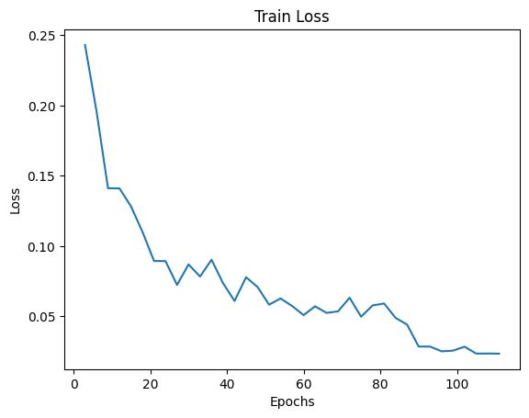

Figure 3: Train Loss Plot

|  |  |  |
| --- | --- | --- |
|  | Accuracy | Number of samples |
| Training Set | 99.16% | 31231 |
| Validation Set | 98.32% | 10407 |
| Test Set | 98.15% | 10444 |
| Evaluation Test Set | 97.82% | 3352 |

Table 2: Performance Table

We started our training with a learning rate of 0.0001 and saw a steady improvement for about 60 epochs. However, after 60 epochs, the trend slowed down and stuck around 98% levels. To surpass that, learning rate is reduced to 0.0001 after epoch 81. As we can see in the figures below training accuracy started to climbed again and validation accuracy also followed this trend after a few epochs. In fact, it is evident that model quickly converged after a small number of epochs. Rest of the epochs are there to push the performance.

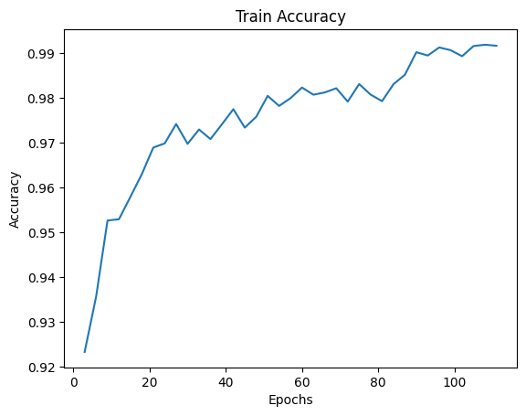

Figure 4: Train Accuracy Plot

Table 2 shows the experimental results about the recognition performance of our proposed architecture. The low difference between the performance metrics shows that the test and validation set error tends to correlate very well.

|  |  |
| --- | --- |
| Figure 5: Validation Loss Plot | Figure 6: Validation Accuracy Plot |

|  |  |
| --- | --- |
| Figure 7: Comparison of Loss Plot | Figure 8: Comparison of Accuracy Plot |

# CONCLUSION AND FEATURE WORK

In conclusion, our plant disease classification project has shown promising results in precisely identifying and classifying plant diseases by using a Convolutional Neural Network (CNN) with the Inception v3 model until the mixed7 layer. The results of the experiments validate the efficacy of our strategy and its potential for use in real-world plant disease detection and diagnosis applications. By utilizing CNNs and the strength of the Inception v3 architecture, we were able to distinguish different plant diseases with high accuracy rates. The model's performance was further improved by the effective integration of pre-processing techniques like normalization and data augmentation.

We achieved a 99.16% train accuracy and 98.32% validation accuracy after training 111 epochs. While the accuracy on our own test set is 98.15%, the model achieved 97.82% accuracy in separately given test set to evaluate the model. It is quite possible to increase the performance had we not have a separate test set. If we used test set for training, a higher performance would be inevitable as the test set also contains quite number of images. Another thing to note is the 20 epochs without improvement around epoch 60 and epoch 80. If the learning rate is reduced much earlier, the training should be completed much earlier.

Even though our project has made progress, there are still a number of areas that call for more exploration and improvement. The current project has focused on specific plant species and a limited set of plant diseases which includes 39 classes. The scope of future work might be widened to incorporate a wider variety of plant species and related diseases. To develop a thorough plant disease classification system that can handle different plant species and their individual diseases, this would necessitate gathering and annotating a larger and more varied dataset.

Plant diseases can display distinctive characteristics that can be identified using other types of sensor data in addition to visual information from images. Additional sensor data from measurements related to plant health, such as hyperspectral imaging, thermal imaging, or other measurements, may be integrated in future work. Combining data from various sources could boost the classification system's overall performance and increase the accuracy and reliability of disease detection.

# REFERENCES

1. Z. R. Li and D. J. He, ‘‘Research on identify technologies of apple’s disease based on mobile photograph image analysis,’’ Comput. Eng. Des., vol. 31, no. 13, pp. 3051–3053 and 3095, Jul. 2010.
2. Z.-X. Guan, J. Tang, B.-J. Yang, Y.-F. Zhou, D.-Y. Fan, and Q. Yao, ‘‘Study on recognition method of rice disease based on image,’’ Chin. J. Rice Sci., vol. 24, no. 5, pp. 497–502, May 2010
3. Qiang, Zhenping & He, Libo & Dai, Fei. (2019). Identification of Plant Leaf Diseases Based on Inception V3 Transfer Learning and Fine-Tuning. 10.1007/978-981-15-1301-5_10.
4. L. S. Puspha Annabel, T. Annapoorani and P. Deepalakshmi, "Machine Learning for Plant Leaf Disease Detection and Classification – A Review," 2019 International Conference on Communication and Signal Processing (ICCSP), Chennai, India, 2019, pp. 0538-0542, doi: 10.1109/ICCSP.2019.8698004.