Yujin Hwang

CS 3600

Mark Riedl

11/8/2023

1. The original Bayesian network is a richer representation because it accounts for the interdependencies between symptoms and how they relate to each other. For example, it captures how flu can cause fever, which in turn can cause headaches, and how headache can be caused by both fever and coughing. This model provides a more detailed and realistic representation of the complex causal relationships between symptoms and conditions. The Naïve Bayes model is a simplification that assumes independence between symptoms, which might not hold in real life. It cannot represent the complex interdependencies and causal relationships present in the original Bayesian network. This simplification is computationally convenient but may not accurately represent real-world scenarios where symptoms can be interrelated.

2.



Transition Probabilities (P(SICKt | SICKt-1, SICKt-2)):

Cough Probability (P(COUGHt | SICKt)):

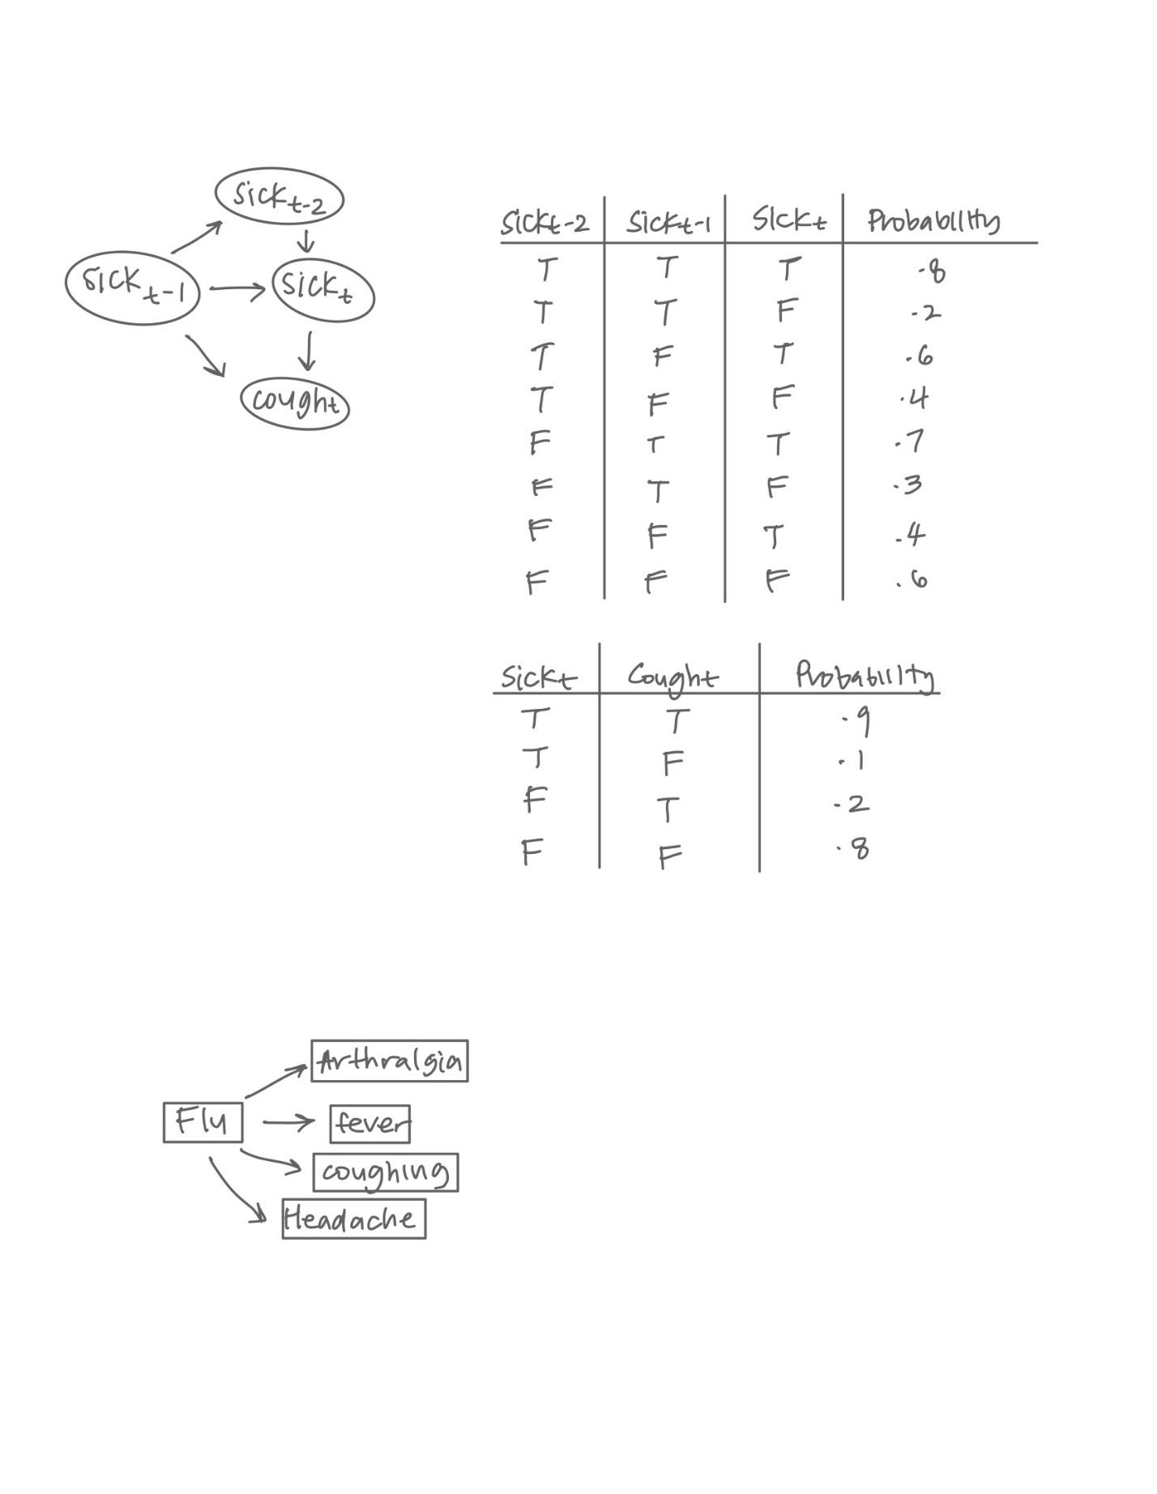3. Requiring a human supervisor to accept or override the decision of the AI diagnosis system is crucial because despite the advancements in AI and Bayesian network-based diagnosis models, they are not infallible and can still make errors. Two potential sources of error that are mitigated by involving a trained healthcare professional in the final diagnosis decision are complex or rare cases and cases that require contextual information. AI diagnosis systems are typically trained on large datasets and are excellent at recognizing common patterns and conditions. However, they may struggle with complex or rare cases that present atypical symptoms or combinations of symptoms. These systems might not have enough data to accurately assess such situations and could provide incorrect or incomplete diagnoses. On the other hand, healthcare professionals can recognize these nuances and consider the unique aspects of each patient, making informed judgments that AI might miss. Additionally, AI systems rely heavily on structured data and may not consider the broader context of a patient's life, medical history, or emotional state. Human healthcare professionals can factor in the patient's personal circumstances, family history, and psychological factors, which can significantly influence the diagnosis.

4. Providing a free online service with Bayes-net-based medical diagnosis can have both negative and positive impacts on human behavior. On the negative side, such a service might lead to unnecessary anxiety and self-diagnosis, as individuals may misinterpret their symptoms or overestimate the likelihood of serious medical conditions. An example of this negative impact is when someone, upon inputting mild symptoms into the system, becomes convinced that they have a life-threatening illness. This could result in people seeking unnecessary medical attention, which burdens healthcare systems, or causes distress when their fears are unfounded. On the positive side, Bayes-net-based diagnosis tools can also empower individuals to make informed decisions about their health. Such services can offer valuable insights and suggest potential conditions, which may prompt users to consult healthcare professionals when necessary. For instance, someone experiencing persistent symptoms might use the service to identify potential causes and subsequently seek appropriate medical advice. In this case, the service acts as a helpful information resource, potentially facilitating earlier diagnosis and treatment.