Unit 5: Define Audience, Tone, and Website Structure for Stitchery website.

Step 1: Define Audience and Tone.

**Who will visit your website?**

People who are interested in purchasing dresses from niche sellers will visit Stitchery.

**Who are your competitors in similar industries?**

Etsy merchants, dressmakers, rennes and other small batch apparel manufacturers.

**What can make you and/or your product stand out against your competitors?**

* Minimalist design aesthetic balanced with a sprinkling of few feminine pieces
* handcrafted unique garments
* innovative design and construction techniques

**How would you speak to your clientele if you were communicating in person? How could you translate that style and tone digitally?**

Communicating in person with my clientele i would strive for a tone and style that is cheerful, bright, welcoming, respectful, quiet, calm, unhurried.

To convey this same style and tone in a digital format on my website I would like to make use of business graphic, shades of blue, yellow.

**What colors represent your business?**

Shades of blue with touches of gray, white, yellow and ocher for accent.

**What images illustrate your message?**

A dashed line to subtly call attention to the hand stitched nature of our garments, an image of the sun. Also, business name in a clean uncluttered typeface to tie into the clean, minimalistic aesthetic of the dresses. Image of sun image is shown below.

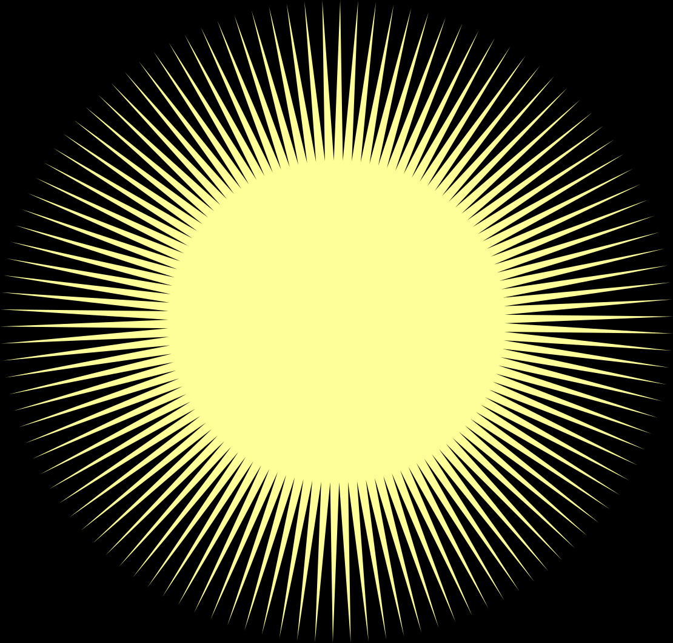

Step 2: Site Structure

**What are your web pages titled?**

The website will have two levels of navigation. On the first level there will be four primary web pages: Home, Dresses, Policies, About. I will also provide a Contact Form on every page to allow visitors to communicate with the business.

Second level navigation of the website will branch out from the Dresses page. Each dress photograph on the Dresses page will link to separate pages. Each page will have a large image and detail images of the dress which has been selected along with descriptive text, size chart link, a drop down box to select fabric/color, drop down box to select size and buy button.

**What should each page contain? Will there be text content? Or just images?**

Home page will be the primary landing page and entry to the website. It will contain the business name, logo image, brief copy and navigation bar at the top of the web page.

Dresses page will consist primarily of images but it will also contain name of business, navigation bar. This page will not have text aside from hover text.

Policies page will primarily be a text page providing payment, returns and shipping information. Business name, logo and navigation bar will also be provided.

About page will be a text page and communicate the business identity. This page will also have business name, logo, navigation bar.