《Spark应用开发技术》实验报告 |  |  |  | 得分：
实验题目： Spark SQL编程实践 |  |  |  | 日期 | 2026年4月7日
班级 | 大数据2302 | 学号 | 3231316213 | 姓名 | 洪舒婷
实验环境：
操作系统：Linux（Ubuntu 22.04）
JDK版本：11
Scala版本：2.12.19
Spark版本：3.5.1
Hadoop版本：3.4.x
IDE：IDEA + Scala插件
数据库：MySQL 8.0.41
实验内容与完成情况(记录所有的实验过程)：
实验1：RDD转换为DataFrame
package com.experiment

import org.apache.spark.sql.{SparkSession, Row}
import org.apache.spark.sql.types.{StructType, StructField, StringType, IntegerType}
import org.apache.spark.sql.functions._

object EmployeeRDDToDF {
def main(args: Array[String]): Unit = {
val spark = SparkSession.builder()
.appName("EmployeeRDDToDF")
.master("local[*]")
.getOrCreate()

import spark.implicits._

val filePath = "/home/os_46_hst/IdeaProjects/SparkSQLExperiment/data/employee.txt"

// 读取文件为RDD
val rdd = spark.sparkContext.textFile(filePath)

// 转换为RDD[Row]
val rowRDD = rdd.map(line => line.split(",")).map(arr =>
Row(arr(0).toInt, arr(1), arr(2).toInt, arr(3))
)

// 定义schema
val schema = StructType(Seq(
StructField("id", IntegerType),
StructField("name", StringType),
StructField("age", IntegerType),
StructField("sex", StringType)
))

// 创建DataFrame并添加gender列
val df = spark.createDataFrame(rowRDD, schema)
val resultDF = df.withColumn("gender",
when($"sex" === "男", "M")
.when($"sex" === "女", "F")
.otherwise("U")
).drop("sex")

// 格式化输出
println("=" * 50)
println("实验1结果：")
println("=" * 50)
resultDF.collect().foreach(row => {
println(s"id:${row(0)},name:${row(1)},age:${row(2)},gender:${row(3)}")
})

spark.stop()
}
}
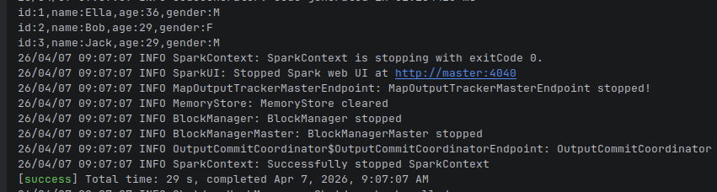
实验2：订单数据分析与MySQL存储
package com.experiment

import org.apache.spark.sql.SparkSession
import org.apache.spark.sql.functions._
import org.apache.spark.sql.SaveMode

object OrderAnalysis {
def main(args: Array[String]): Unit = {
val spark = SparkSession.builder()
.appName("OrderAnalysis")
.master("local[*]")
.getOrCreate()

import spark.implicits._

val filePath = "/home/os_46_hst/IdeaProjects/SparkSQLExperiment/data/bagOrders.csv"

// 1. 读取CSV文件
val df = spark.read
.option("header", "true")
.option("delimiter", ",")
.option("inferSchema", "true")
.csv(filePath)

// 2. 过滤退货订单
val validDF = df.filter($"OrderAmount" > 0)
println(s"过滤退货后剩余记录数: ${validDF.count()}")

// 3. 删除空值记录
val cleanedDF = validDF.na.drop(Seq("BILLDATE", "QTY", "OrderID",
"ClassI", "ProductName", "ProductID", "OrderAmount"))
println(s"删除空值后剩余记录数: ${cleanedDF.count()}")

// 4. 增加Year列
val withYearDF = cleanedDF.withColumn("Year",
split(split($"BILLDATE", " ")(0), "/")(0).cast("int"))

// 5. 按年份统计
withYearDF.createOrReplaceTempView("orders")
val resultDF = spark.sql(
"""
|SELECT Year, ROUND(SUM(OrderAmount), 2) AS TotalAmount
|FROM orders
|GROUP BY Year
|ORDER BY Year
""".stripMargin
)

println("按年份统计实际订单金额总和：")
resultDF.show()

// 6. 存储到MySQL
val mysqlUrl = "jdbc:mysql://localhost:3306/spark_experiment?useSSL=false&serverTimezone=UTC&allowPublicKeyRetrieval=true"
val mysqlUser = "root"
val mysqlPassword = ""

resultDF.write
.mode(SaveMode.Overwrite)
.option("driver", "com.mysql.cj.jdbc.Driver")
.jdbc(mysqlUrl, "Hongshuting", new java.util.Properties() {
{ setProperty("user", mysqlUser); setProperty("password", mysqlPassword) }
})

println("结果已成功保存到MySQL数据库表Hongshuting")
spark.stop()
}
}
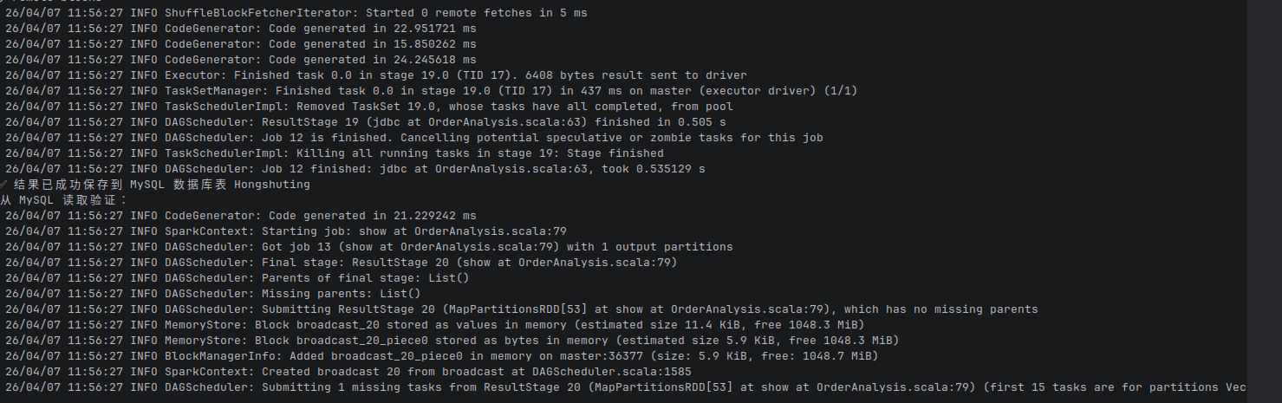
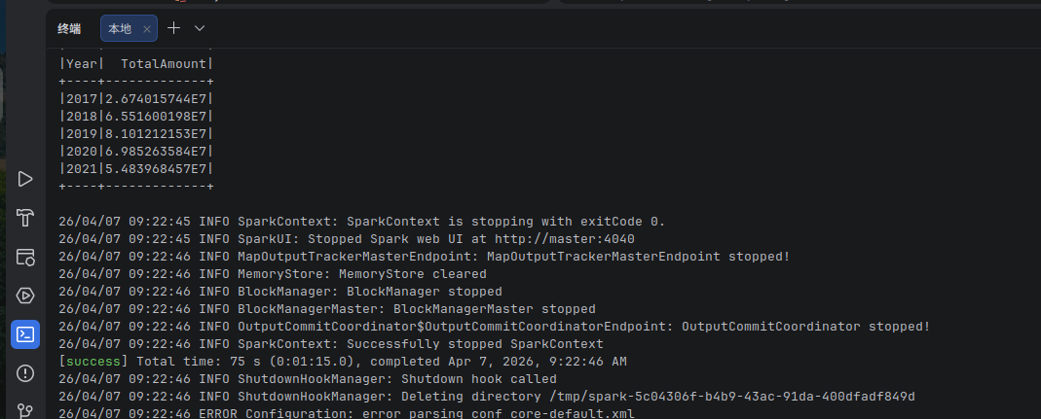
出现的问题：
1、sbt构建失败：IDEA无法识别Spark依赖，编译报错
2、$符号无法识别：代码中使用$"列名"时报错"value $ is not a member of StringContext"
3、类找不到错误：运行时报ClassNotFoundException: com.experiment.OrderAnalysis
4、MySQL连接失败：Public Key Retrieval is not allowed、Access denied for user 'root'@'localhost'、MySQL服务无法正常启动

解决方案（列出遇到的主要问题和解决办法，列出没有解决的问题）：
1、sbt构建问题：在build.sbt中添加正确的依赖配置、使用阿里云镜像加速依赖下
2、$符号问题：在代码中添加import spark.implicits._
3、类找不到问题：确保文件开头有package com.experiment
4、使用sbt clean compile重新编译：确认目录结构与包名一致
5、MySQL问题：在URL中添加allowPublicKeyRetrieval=true；重置root密码为空，ALTER USER 'root'@'localhost' IDENTIFIED BY ''

